DBS311 D - Lab 4 – In-Lab submission only, unless you have a permission from me to submit by e-mail. Your Word or TXT Document must have both SELECT statements and the OUTPUTS. You may also submit your Lab Printout to our Reception Office, Room A3058 by due date.

Due by Thursday, February 15th by 4pm

Questions 1 and 2 use DEMO (HR) schema, while questions 3 to 6 use PRODUCT schema

- The HR department needs a list of Department IDs for departments that do not contain the job ID of ST_CLERK. Exclude NULL departments from your result. Use a SET operator to create this list.
SELECT department_id
FROM employee
WHERE department_id IS NOT NULL
MINUS
(SELECT department_id
FROM employee
WHERE job_id='ST_CLERK'); 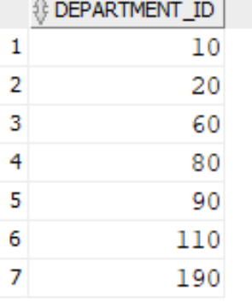
- Display list with employee’s Id, Job Id and Salary that will include the current job and salary and all previous Jobs , if they have them (here you will display salary of -1). Use a SET operator for this report.
SELECT employee_id, job_id, salary
FROM employee
UNION ALL
SELECT employee_id, job_id, -1
FROM job_history
ORDER BY employee_id;

- Display cities that no warehouse is located in them. Use SET operator to answer this question.
SELECT city FROM locations
MINUS
SELECT l.city FROM locations l
JOIN warehouses w
ON l.location_id=w.location_id;
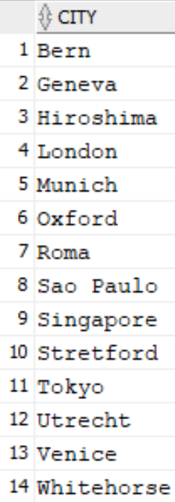
- Display the category ID, category name, and the number of products in category 1, 2, and 5. In your result, display first the number of products in category 5, then category 1 and then 2. Use JOIN or SET method to solve this problem.
SELECT pc.category_id, pc.category_name,
COUNT(p.product_id) AS num_products
FROM product_categories pc
LEFT JOIN products p ON pc.category_id=p.category_id
WHERE pc.category_id IN (5, 1, 2)
GROUP BY pc.category_id,pc.category_name
ORDER BY
CASE pc.category_id
WHEN 5 THEN 1
WHEN 1 THEN 2
WHEN 2 THEN 3
END;
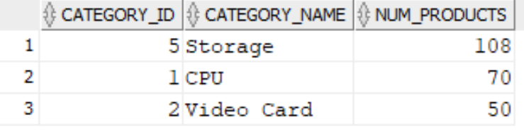
- Display product ID for ordered products whose quantity in the inventory is greater than 250. (You are not allowed to use JOIN for this question.)
SELECT PRODUCT_ID
FROM order_items
INTERSECT
SELECT PRODUCT_ID
FROM inventories
WHERE QUANTITY > 250;
- We need a single report to display all warehouses and the city and state that they are located in, also all states regardless of whether they have warehouses in them or not.
If state value is blank, display No State.
(You are not allowed to use JOIN for this question.). Here is a partial output:

Loc# City State Warehouse
------- -------------------- ----------------- -----------------
1 Roma No State
2 Venice No State
3 Tokyo Tokyo Prefecture
4 Hiroshima No State
5 Southlake Texas
5 Southlake, Texas
6 South San Francisco California
6 San Francisco

SELECT location_id "Loc#", city AS "City", NVL(state, 'N0 State') AS "State", TO_CHAR(' ') "Warehouse"
FROM locations
UNION
SELECT location_id , TO_CHAR(' '), TO_CHAR(' '), warehouse_name
FROM warehouses;

