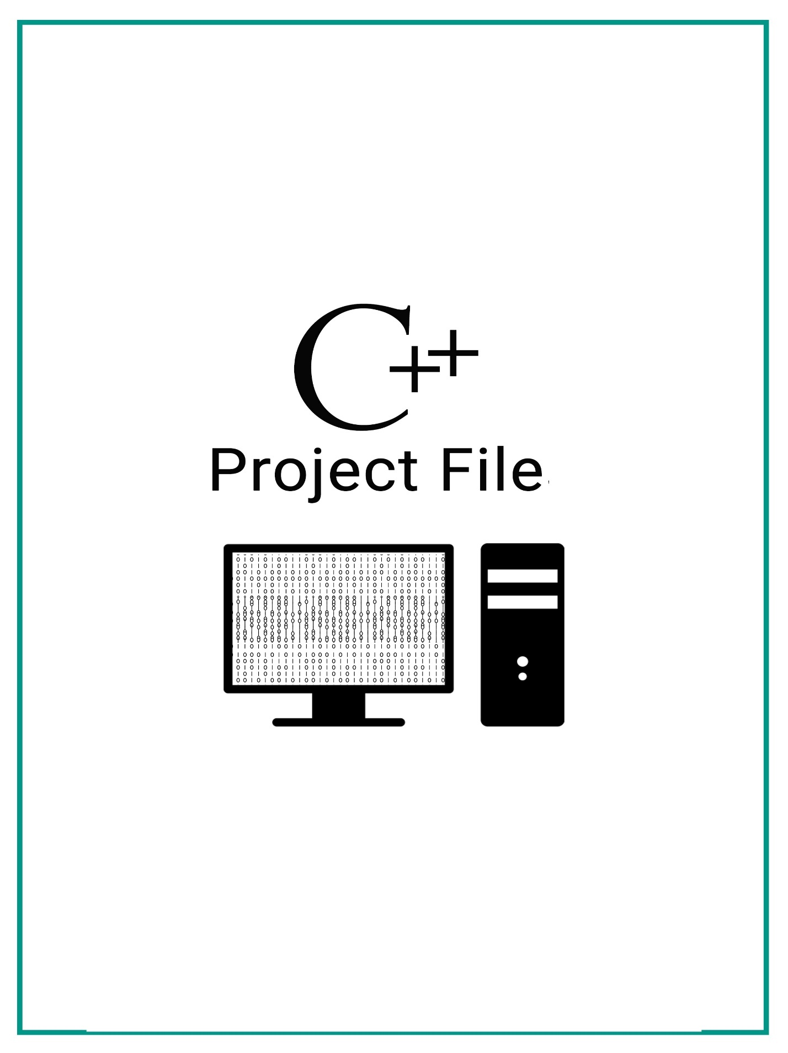

**Certificate**

This is to certify that the project

**RAILWAY RESERVATION SYSTEM**

has been sincerely and honestly made by **Shubham Gajra**

of class XII-B for the academic session **2016-2017**

towards the partial fulfillment of the requirement for the computer practical for senior secondary conducted by Central Board of Secondary Education (CBSE).

Mrs. Mona Rastogi Mrs. S. Meena Gunasekaran

**ACKNOWLEDGEMENT**

I gratefully acknowledge my indebtedness to all those who have rendered me direct or indirect support in completion of this project and giving it the present shape.

I owe my very special thanks to

Mrs. S. Meena Gunasekaran, my computer teacher, for her guidance, help and encouragement in completing my project.

**-Shubham Gajra**

SOURCE CODE

#include<fstream>

#include<stdio>

#include<process>

#include<conio>

#include<iomanip>

using namespace std;

class travellers

{

int t_code;

char t_telno[20];

char t_name[25];

char t_add[20];

int age;

char gender[10];

int train_no;

public:

void readdata();

void writedata();

void writefile();

void readfile();

void searchfile();

void modify();

void Delete();

void Insert();

};

class train

{

int f_no;

char from[20];

float charges;

char to[20];

int no_of_seats;

public:

void Input();

void Output();

void writefile();

void readfile();

void searchfile();

void modifile();

void delfile();

void insertfile();

};

void travellers::readdata()

{

clrscr();

cout<<"\n\tEnter traveller code ";

cin>>t_code;

cout<<"\n\tEnter name ";

gets(t_name);

cout<<"\n\tEnter address ";

gets(t_add);

cout<<"\n\tEnter telephone number ";

cin>>t_telno;

cout<<"\n\tEnter age ";

cin>>age;

cout<<"\n\tEnter gender ";

cin>>gender;

cout<<"\n\tEnter train number ";

cin>>train_no;

clrscr();

}

void travellers::writedata()

{

cout<<"\t________________________________________\n";

cout<<"\n\t Traveller code : "<<t_code;

cout<<"\n\t Traveller name : "<<t_name;

cout<<"\n\t Traveller address : "<<t_add;

cout<<"\n\t Traveller telephone number : "<<t_telno;

cout<<"\n\t Traveller age : "<<age;

cout<<"\n\t Traveller gender : "<<gender;

cout<<"\n\t Train number is : "<<train_no<<"\n\n";

}

void travellers::writefile()

{

travellers t;

int n,i;

ofstream onfile("travellers.dat",ios::binary|ios::out);

cout<<"\n\tEnter no. of travellers ";

cin>>n;

for(i=0;i<n;i++)

{

t.readdata();

onfile.write((char*)&t,sizeof(t));

}

onfile.close();

}

void travellers::readfile()

{

ifstream infile("travellers.dat",ios::binary);

travellers t;

if(!infile)

cout<<"\nFile does not exist\n";

else

{

infile.read((char*)&t,sizeof(t));

while(infile)

{

t.writedata();

infile.read((char*)&t,sizeof(t));

}

infile.close();

}

}

void travellers::searchfile()

{

travellers t;

int t_no,f=0;

cout<<"\tEnter traveller code\n\t";

cin>>t_no;

ifstream infile("travellers.dat",ios::binary);

if(!infile)

cout<<"File does not exits";

else

{

infile.read((char*)&t,sizeof(travellers));

while((infile)&&(f==0))

{

if(t_no==t.t_code)

{

t.writedata();

f++;

}

infile.read((char*)&t,sizeof(travellers));

}

if(f==0)

cout<<"\n\t Traveller code does not exist";

infile.close();

}

}

void travellers::Insert()

{

travellers t1,t2;

int f=0;

ifstream infile("travellers.dat",ios::binary);

ofstream onfile("temp.dat",ios::binary);

if(!infile)

cout<<"\nFile does not exist\n";

else

cout<<"\nEnter traveller's information you want to insert\n";

{

t1.readdata();

infile.read((char*)&t2,sizeof(travellers));

while((infile)&&(f==0))

{

if(t1.t_code<t2.t_code)

{

f=1;

onfile.write((char*)&t1,sizeof(travellers));

}

else

{

onfile.write((char*)&t2,sizeof(t2));

infile.read((char*)&t2,sizeof(t2));

}

}

}

if(f==1)

{

while(infile)

{

onfile.write((char*)&t1,sizeof(travellers));

infile.read((char*)&t2,sizeof(travellers));

}

}

onfile.write((char*)&t1,sizeof(travellers));

onfile.close();

infile.close();

remove("travellers.dat");

rename("temp.dat","travellers.dat");

}

void travellers::Delete()

{

travellers t2,t1;

int t_no,f=0;

ifstream infile("travellers.dat",ios::binary);

ofstream onfile("temp.dat",ios::binary);

if(!infile)

cout<<"\nFile does not exist\n";

else

{

cout<<"\n\tEnter any traveller code\n\t";

cin>>t_no;

while(infile.read((char*)&t1,sizeof(travellers)))

{

if(t_no==t1.t_code)

f=1;

else

onfile.write((char*)&t1,sizeof(travellers));

}

infile.close();

onfile.close();}

if(f==0)

cout<<"Traveller code does not exist";

else

{

remove("travellers.dat");

rename("temp.dat","travellers.dat");

}

}

void travellers::modify()

{

ifstream infile("travellers.dat",ios::binary);

ofstream onfile("temp.dat",ios::binary);

travellers t;

int t_no,f=0;

if(!infile)

cout<<"File does not exist";

else

{

cout<<"\tEnter traveller code you want to modify\n";

cin>>t_no;

while(infile.read((char*)&t,sizeof(t)))

{

if(t.t_code==t_no)

{

t.readdata();

onfile.write((char*)&t,sizeof(t));

f=1;

}

else

onfile.write((char*)&t,sizeof(t));

}

onfile.close();

infile.close();

if(f==0)

cout<<"Traveller code not found in our database\n";

else

{

remove("travellers.dat");

rename("temp.dat","travellers.dat");

}

}

}

void train::Input()

{

cout<<"\n\tEnter train number : ";

cin>>f_no;

cout<<"\n\tEnter place of departure : ";

gets(from);

cout<<"\n\tEnter destination place : ";

gets(to);

cout<<"\n\tEnter train charges(Rs.) : ";

cin>>charges;

cout<<"\n\tEnter number of seats : ";

cin>>no_of_seats;

}

void train::Output()

{

cout<<"\t_________________________________________________\n\n";

cout<<"\tTrain number : "<<f_no<<"\n\n";

cout<<"\tPlace of departure : "<<from<<"\n\n";

cout<<"\tDestination place : "<<to<<"\n\n";

cout<<"\tEnter train charges(Rs.) : "<<charges<<"\n\n";

cout<<"\tEnter number of seats : "<<no_of_seats<<"\n\n";

}

void train::writefile()

{

ofstream onfile("train.dat",ios::binary);

train t[10];

int n,i;

cout<<"\n\tEnter total train ";

cin>>n;

for(i=0;i<n;i++)

{

t[i].Input();

cout<<"\n";

onfile.write((char*)&t[i],sizeof(t[i]));

}

onfile.close();

}

void train::readfile()

{

ifstream infile("train.dat",ios::binary);

train t;

if(!infile)

cout<<"File does not exist";

else

{

while(infile.read((char*)&t,sizeof(t)))

{

t.Output();

}

infile.close();

}

}

void train::searchfile()

{

ifstream infile("train.dat",ios::binary);

train t;

int tno,f=0;

if(!infile)

cout<<"File does not exist";

else

{

cout<<"\n\tEnter train number\n\t";

cin>>tno;

while(infile.read((char*)&t,sizeof(t))&&(f==0))

{

if(t.f_no==tno)

{

f=1;

t.Output();

}

}

if(f==0)

cout<<"Train not exist";

}

infile.close();

}

void train::modifile()

{

ifstream infile("train.dat",ios::binary);

ofstream onfile("Temp.dat",ios::binary);

train t;

int tno,f=0;

if(!infile)

cout<<"File does not exist";

else

{

cout<<"\tEnter train number\n";

cin>>tno;

while(infile.read((char*)&t,sizeof(t)))

{

if(t.f_no==tno)

{

t.Input();

onfile.write((char*)&t,sizeof(t));

f=1;

}

else

onfile.write((char*)&t,sizeof(t));

}

onfile.close();

infile.close();

if(f==0)

cout<<"Train not exist\n";

else

{

remove("train.dat");

rename("Temp.dat","train.dat");

}

}

}

void train::delfile()

{

ifstream infile("train.dat",ios::binary);

ofstream onfile("Temp.dat",ios::binary);

train t;

int tno,f=0;

if(!infile)

cout<<"File does not exist";

else

{

cout<<"\n\n\tEnter train to be deleted ";

cin>>tno;

while(infile.read((char*)&t,sizeof(t)))

{

if(tno==t.f_no)

f=1;

else

onfile.write((char*)&t,sizeof(t));

}

infile.close();

onfile.close();

if(f==0)

cout<<"Train Does Not Exist";

else

{

remove("train.dat");

rename("Temp.dat","train.dat");

}

}

}

void train::insertfile()

{

train t1,t2;

int f=0;

ifstream infile("train.dat");

ofstream onfile ("temp.dat");

if(!infile)

cout<<"File does not exist ";

else

{

cout<<"\n\tEnter New Train Information ";

t1.Input();

while((infile.read((char*)&t2,sizeof(t2))&&(f==0)))

{

if (t1.f_no<t2.f_no)

{

f=1;

onfile.write((char*)&t1,sizeof(t1));

}

onfile.write((char*)&t2,sizeof(t2));

}

if(f==1)

{

while(infile)

{

onfile.write((char*)&t2,sizeof(t2));

infile.read((char*)&t2,sizeof(t2));

}

}

else

{

onfile.write((char*)&t1,sizeof(t1));

onfile.close();

infile.close();

remove("train.dat");

rename("temp.dat","train.dat");

}

}

}

void startproject()

{

int i;

clrscr();

}

int main()

{

startproject();

int choice,c1,c2,c3;

train f1;

travellers t1;

i:

do

{

clrscr();

cout<<"\t-+-+-+-+-+-+-+-+-+-+-+-+-+-+-+-+-+-+-+-+-+-+-+-+-\n";

cout<<"\t\t |WELCOME TO| \n\t\t |INDIAN RAILWAYS| \n";

cout<<"\t-+-+-+-+-+-+-+-+-+-+-+-+-+-+-+-+-+-+-+-+-+-+-+-+-\n";

cout<<"\n\t\t*****************************";

cout<<"\n\t\t* 1.For train details.";

cout<<"\n\t\t* 2.For travellers details.";

cout<<"\n\t\t* 3.Exit.\n";

cout<<"\t\t*****************************\n";

cout<<'\n';

cout<<"\t\tEnter your choice : ";

cin>>choice;

switch (choice)

{

case 2:

do

{

clrscr();

cout<<"\t********************************\n";

cout<<"\t |Travellers details| \n";

cout<<"\t********************************\n\n";

cout<<"\t**********************************************************";

cout<<"\n\t* 1.Write into the traveller database. ";

cout<<"\n\t* 2.Read from the traveller database. ";

cout<<"\n\t* 3.Search traveller details from database. ";

cout<<"\n\t* 4.Insert a new entry in traveller database. ";

cout<<"\n\t* 5.Delete a traveller information from database. ";

cout<<"\n\t* 6.Modify travellers details in database. ";

cout<<"\n\t* 7.Exit. \n";

cout<<"\t**********************************************************";

cout<<"\n\n\tEnter your Choice : ";

cin>>c1;

switch(c1)

{

case 1:t1.writefile();

break;

case 2:t1.readfile();

getch();

break;

case 3:t1.searchfile();

getch();

break;

case 4:t1.Insert();

getch();

break;

case 5:t1.Delete();

getch();

break;

case 6:t1.modify();

getch();

break;

case 7:goto i;

}

}

while((c1!=7));

case 1:

do

{

clrscr();

cout<<"\t*******************************\n";

cout<<"\t\t |Train Details|";

cout<<"\n\t*******************************\n\n";

cout<<"\t**********************************************************";

cout<<"\n\t* 1.Write into the train file. ";

cout<<"\n\t* 2.Read from the train file. ";

cout<<"\n\t* 3.Search from the existing train file. ";

cout<<"\n\t* 4.Insert a new entry into the train file. ";

cout<<"\n\t* 5.Delete an existing entry from the train file. ";

cout<<"\n\t* 6.Modify an entry from the train file. ";

cout<<"\n\t* 7.Exit. \n";

cout<<"\t**********************************************************";

cout<<"\n\n\tEnter your choice : ";

cin>>c2;

switch(c2)

{

case 1:f1.writefile();

break;

case 2:f1.readfile();

getch();

break;

case 3:f1.searchfile();

getch();

break;

case 4:f1.insertfile();

getch();

break;

case 5:f1.delfile();

getch();

break;

case 6:f1.modifile();

getch();

break;

case 7:goto i;

}

}

while((c2!=7));

}

}

while(choice!=3);

}

OUTPUT

Outputs for Train

Welcome Screen

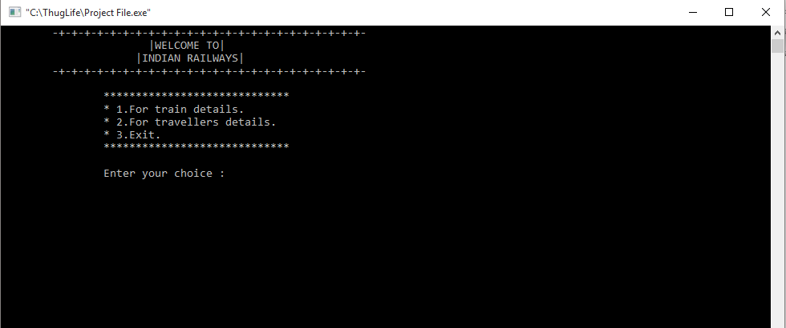

Train Details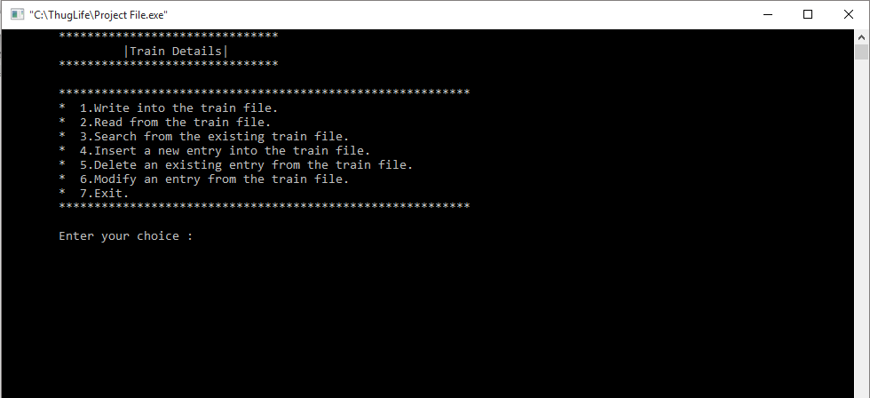

1.Write into the train file

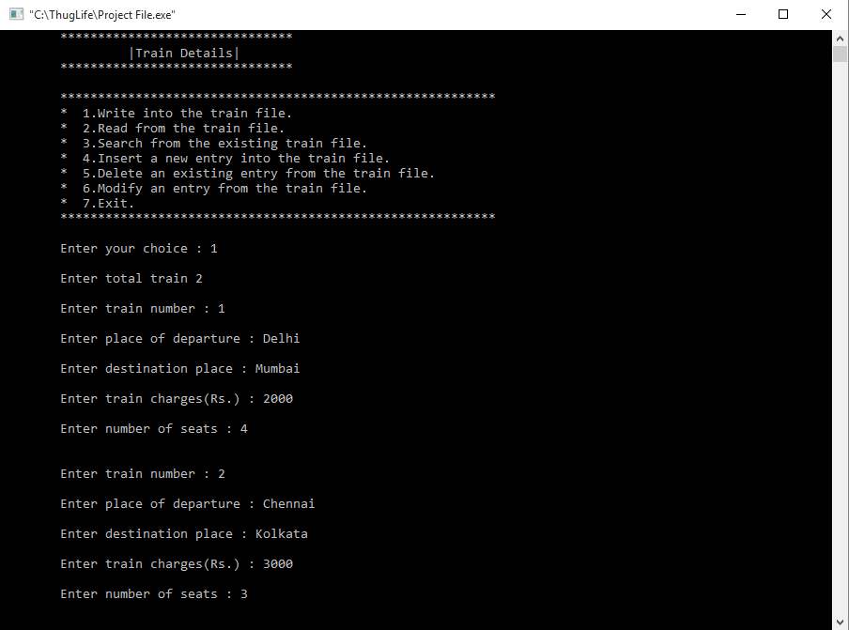

2.Read from the train file

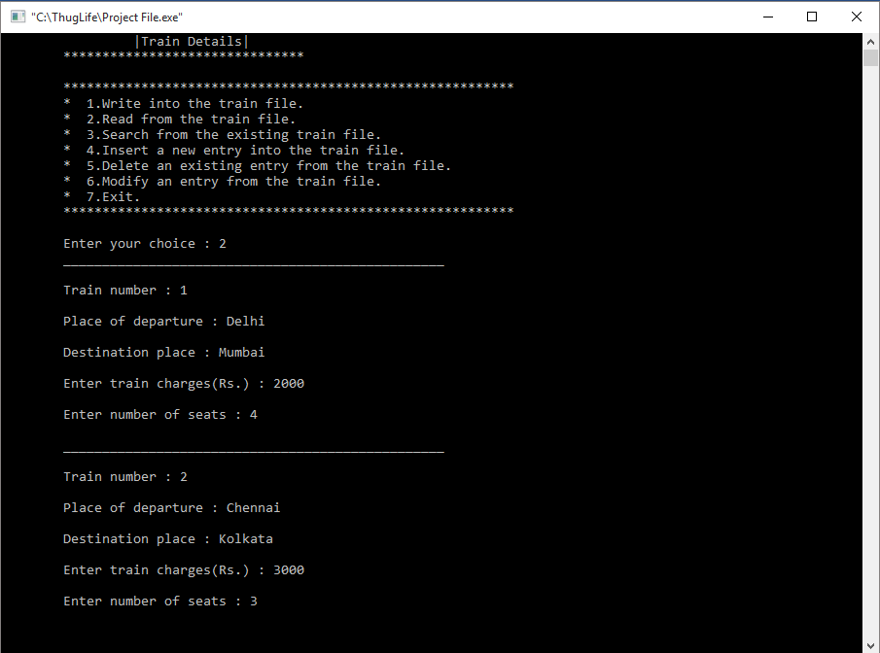

3.Search from the existing train file

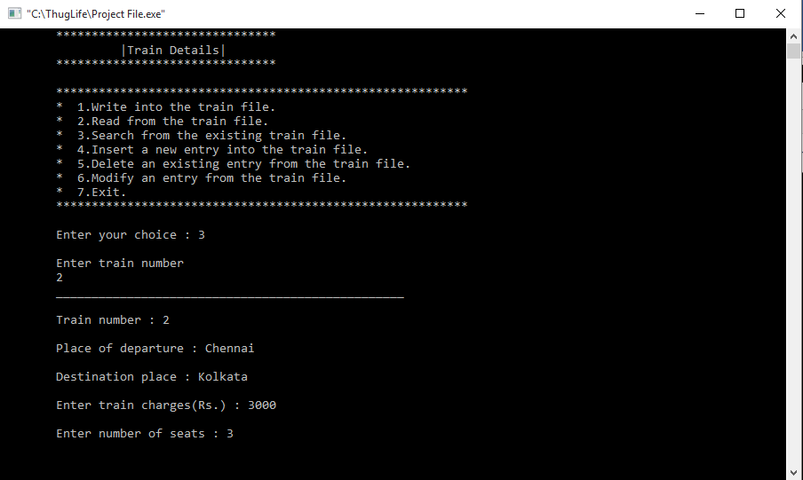

4. Insert a new entry into the train file

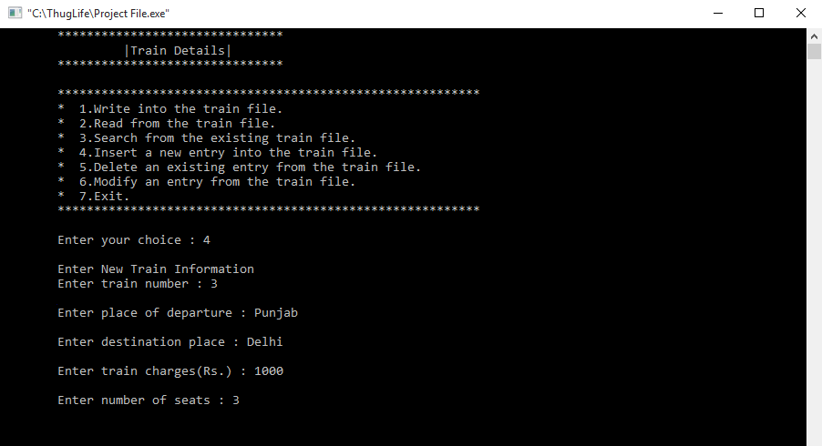

5. Delete an existing entry from the train file

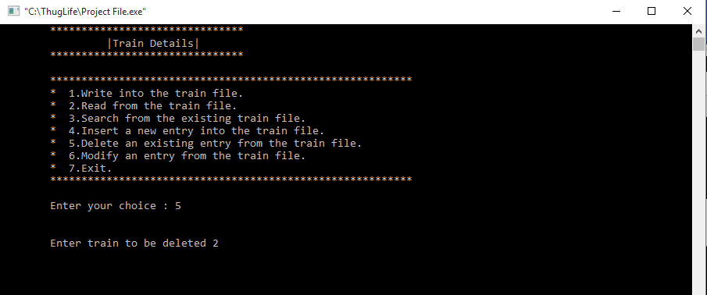

6. Modify an entry from the train file

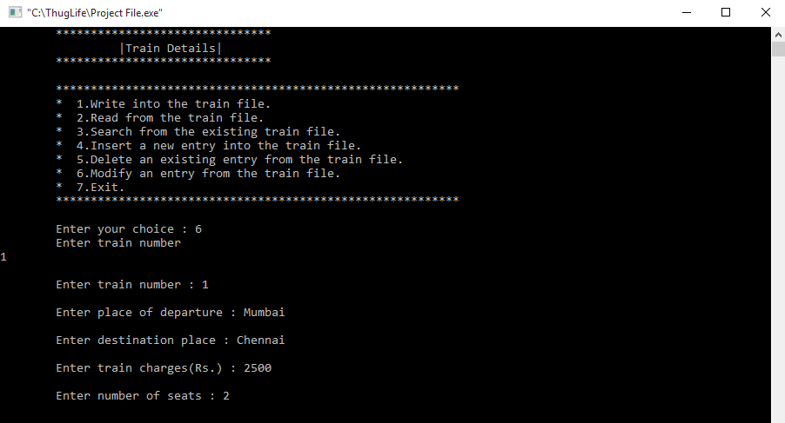

Outputs for Travellers

Travellers details

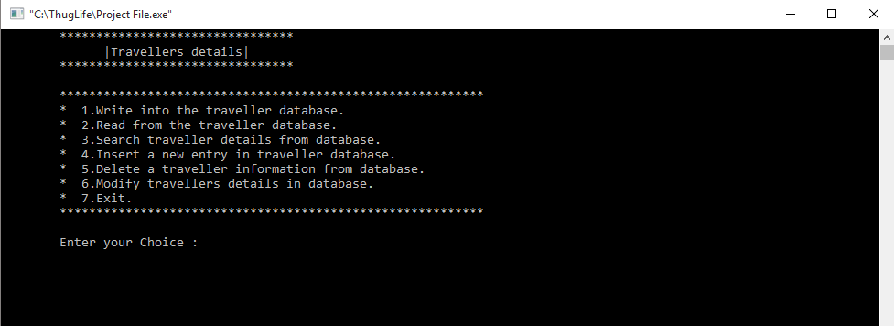

1.Write into the traveller database

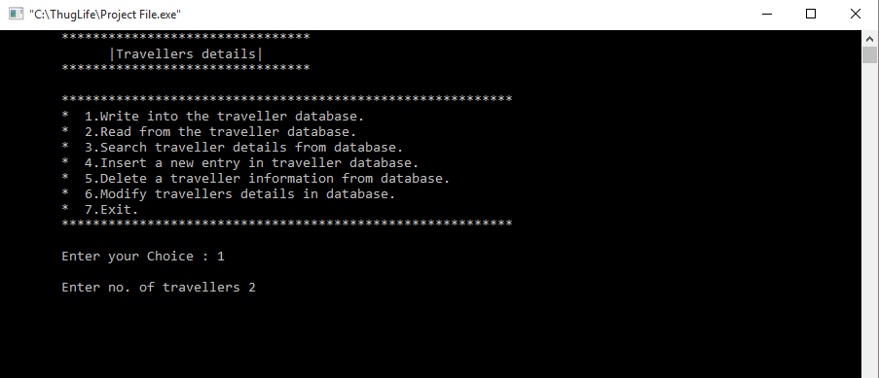

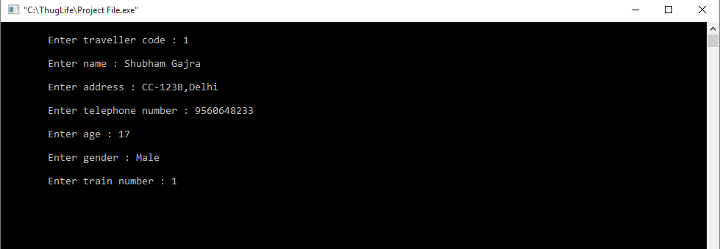

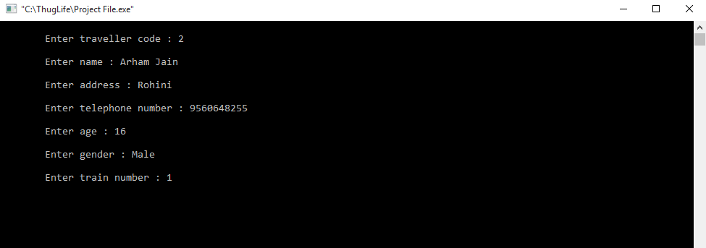

2. Read from the traveler database

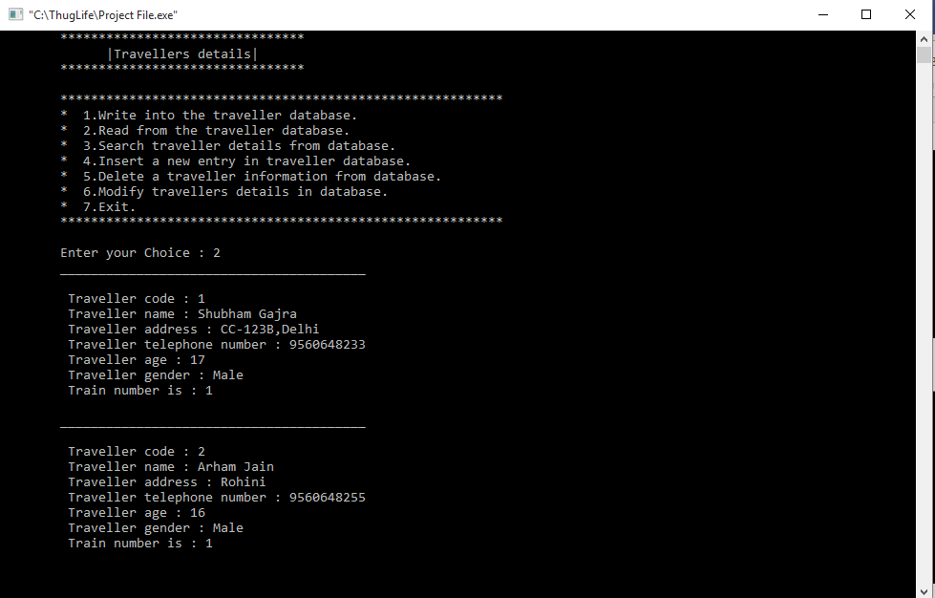

3. Search traveler details from database

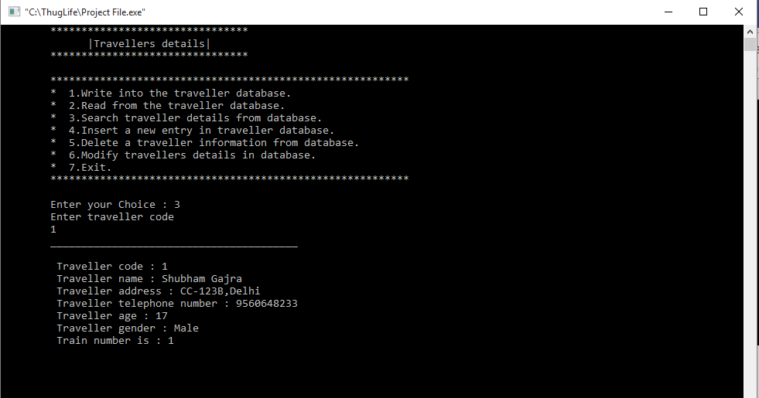

4. Insert a new entry in traveler database

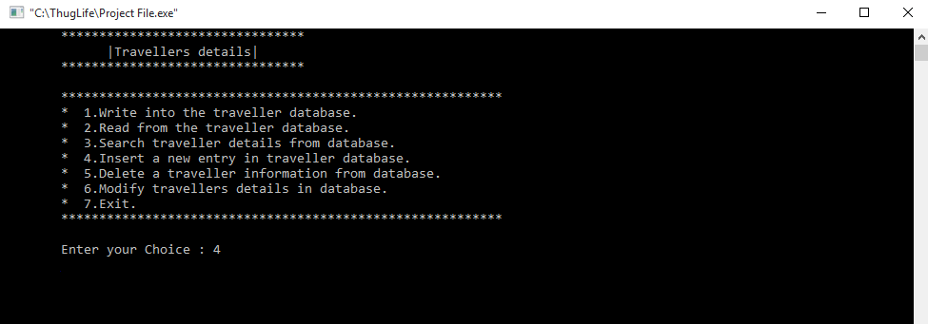

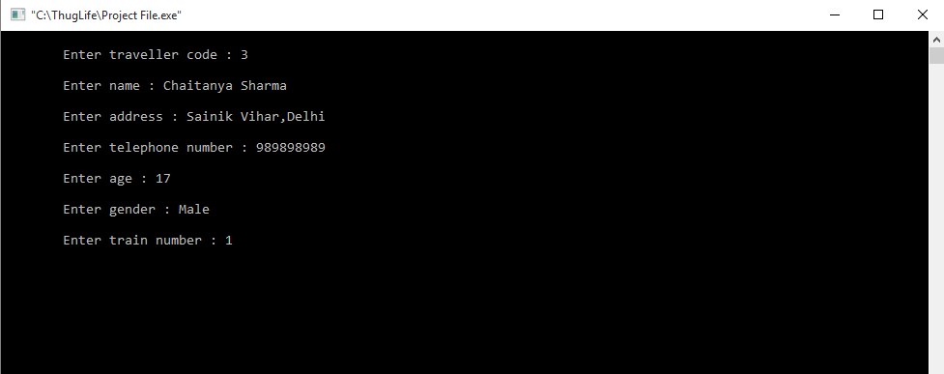

5. Delete a traveler information from database

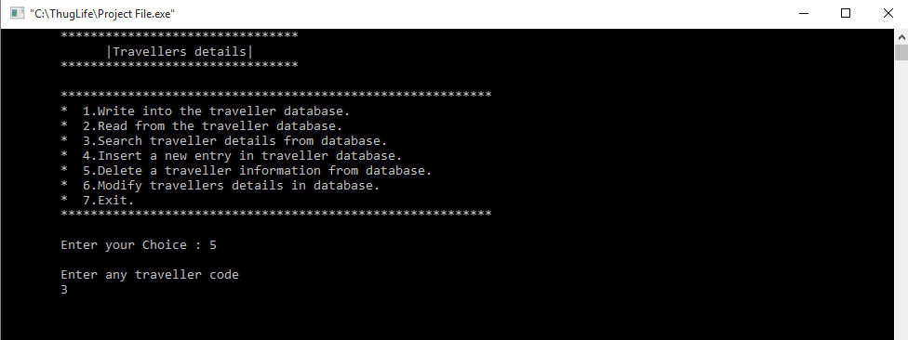

6. Modify travellers details in database

