
សាកលវិទ្យាល័យបៀលប្រាយ
BUILD BRIGHT UNIVERSITY

កិច្ចការស្រាវជ្រាវ

មហាវិទ្យាល័យវិទ្យាសាស្រ្តនិងបច្ចេកវិទ្យា
ជំនាញ បច្ចេកវិទ្យាព័ត៌មាន

ប្រធានបទស្តីអំពី
ប្រព័ន្ធគ្រប់គ្រងសាលារៀន
(School Management System)

Professor in charge: Din Saren
រៀបរៀងដោយក្រុមនិស្សិតជំនាន់ទី២៥ (P25S1_Group3)

No | Full Name | ឈ្មោះ (គោត្តនាម-នាម) | ភេទ | Remarks
1 | Keo Chansothea | កែវ ច័ន្ទសុធា | ប្រុស | Project Lead
2 | Sen Sophoeut | សែន សុភឿត | ប្រុស | System Design and Development

Final Project Proposal (version 1.0)
Full Stack Developer Course

Project Title

School Management System

Table of Contents
1. Introduction 4
1.1 Purpose 4
1.2 Scope 4
1.3 Definitions and Abbreviations 4
2. Development Environment 4
2.1 IDE — Android Studio / VS Code 4
2.2 Java Development Kit and Backend Stack 5
2.3 Flutter and Dart 5
3. System Requirements 5
3.1 Actors 5
3.2 Functional Requirements 6
3.3 Non-Functional Requirements 7
3.4 Key User Stories 8
4. System Architecture and Design 8
4.1 Overview 8
4.2 Backend Package Structure 9
4.3 Design Decisions 10
4.4 API Conventions 10
5. Database Design 10
5.1 Configuration 10
5.2 Conventions 10
5.3 Entity–Relationship Diagram 11
5.4 Data Dictionary — Key Constraints 12
5.5 Database Migrations with Flyway 13
5.6 Seed Data and How to Load It with Flyway 14
6. API Design (REST) 18
6.1 Authentication Endpoints 18
6.2 Endpoint Catalog by Module 18
6.3 Interactive Documentation 19
7. Security Design 19
7.1 Authentication Flow (JWT + Refresh Token) 19
7.2 Authorization (Role-Based Access Control) 19
7.3 Audit Logging 20
7.4 Other Measures 20
8. Frontend Design (Flutter + GetX) 20
8.1 Clean Architecture 20
8.2 Transparent Token Refresh 21
8.3 Screen Specifications 21
8.4 Additional Features 22
9. Push Notifications (Firebase Cloud Messaging) 23
9.1 How a Notification Travels 23
9.2 Backend Implementation 23
9.3 What Triggers a Notification 24
9.4 Data Model (Migration V5) 24
9.5 API Endpoints 24
9.6 Flutter Client Implementation 25
9.7 Configuration and Dry-Run Mode 25
9.8 Testing Without a Device 26
10. Testing Strategy 26
11. Setup and Deployment 27
12. Conclusion 27
13. Appendixes 27
Appendix 1: Mobile Application Screens 27

Full Stack Developer Final Project Report: School Management System

1. Introduction

1.1 Purpose
This report documents the School Management System (SMS) developed as the final project of the Full Stack Developer Course, guided by the professor in charge, Mr. Din Saren, for the Master of Science program at Build Bright University (BBU), academic year 2025–2026. It covers the system requirements, development environment, system architecture and design, database design, REST API design, security design, the Flutter mobile application design, testing strategy, and setup/deployment of the completed system.

1.2 Scope
The system is a secure back-office for a school’s core records. It manages the users of the system (with roles and permissions), master data (students, teachers, subjects, classes), and the business transactions that connect them (enrollments and grades), together with a live dashboard and a complete audit trail. The solution consists of two projects:
- springboot-jwt-api — a Spring Boot 3.5 (Java 21) REST API on PostgreSQL with Flyway migrations, JWT security with refresh tokens, role/permission-based authorization (RBAC), validation, audit logging via AOP, Swagger/OpenAPI documentation, and a lightweight Bootstrap 5 admin web UI served by the same application.
- school_management_app — a Flutter mobile application (GetX pattern, Material 3) that covers every endpoint of the API, with JWT auto-refresh, permission-gated UI, PDF/Excel export, QR student badges, and Firebase Cloud Messaging push notifications.

1.3 Definitions and Abbreviations
Term | Meaning
JWT | JSON Web Token — signed token used for stateless authentication
RBAC | Role-Based Access Control — roles group fine-grained permissions (e.g. student.create)
ERD | Entity Relationship Diagram
CRUD | Create, Read, Update, Delete
DTO | Data Transfer Object — request/response model separated from the entity
AOP | Aspect-Oriented Programming — used for the cross-cutting audit log
Soft delete | Records are flagged status = DEL instead of being physically removed
Flyway | Database migration tool — every schema change is a versioned SQL script
GetX | Flutter state-management / dependency-injection / routing framework
FCM | Firebase Cloud Messaging — push notification service

2. Development Environment

2.1 IDE — Android Studio / VS Code
Item | Value
IDE (mobile app) | Android Studio with the Flutter and Dart plugins; Android emulator for testing
IDE (backend) | Visual Studio Code / IntelliJ-compatible; Gradle build
Version control | Git with a GitHub remote repository
API testing | Postman (SchoolManagementSystem.postman_collection.json) and Swagger UI

2.2 Java Development Kit and Backend Stack
Item | Value
Java | JDK 21 (LTS) — enforced via the Gradle toolchain
Framework | Spring Boot 3.5.6 (Web, Data JPA, Security, Validation, AOP)
Build tool | Gradle (wrapper included)
Database | PostgreSQL 17 (Docker container school-postgres), schema managed by Flyway V1–V4
API documentation | springdoc-openapi / Swagger UI
Containerization | Dockerfile and docker-compose.yml provided; Jenkinsfile for CI

2.3 Flutter and Dart
Item | Value
Flutter SDK | Stable channel, Dart SDK ^3.9.0
State management / DI / routing | GetX 4.6.x (GetX design pattern: View → Controller → Repository)
HTTP client | http package wrapped by a single ApiClient with JWT auto-refresh
Token storage | flutter_secure_storage (iOS Keychain / Android Keystore)
Preferences | get_storage (theme mode, remembered username, cached profile)
Other packages | firebase_core, firebase_messaging, flutter_local_notifications, pdf, excel, share_plus, qr_flutter, open_filex, intl

3. System Requirements

3.1 Actors
Actor | Description | Typical actions
Admin | System administrator (school office) | Manage users/roles, manage all master data, view dashboard & audit log
Teacher | Teaching staff | View master data, manage enrollments and grades for their classes
Student | Enrolled student (read-only account) | View own profile, enrollments, and grades
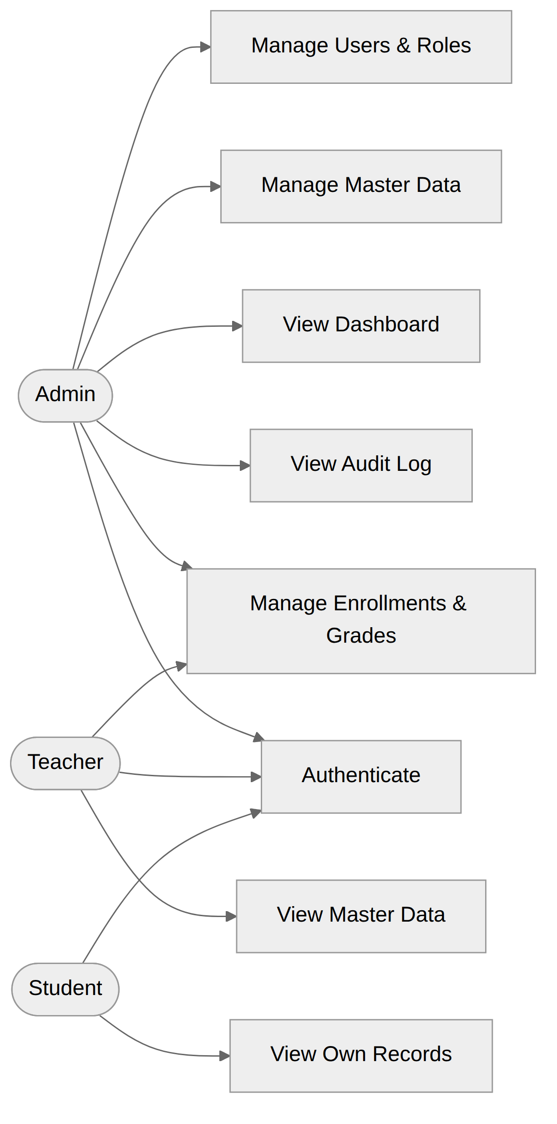
Figure 1: Use case overview — the three actors and their main use cases

3.2 Functional Requirements
ID | Requirement
FR-A1 | Users can log in with username/email and password and receive an access token (JWT) and a refresh token
FR-A2 | Users can refresh an expired access token using a valid refresh token
FR-A3 | Users can log out; the refresh token is revoked server-side
FR-A4 | Users can request a password reset; a single-use token is sent to their registered email and expires after 30 minutes
FR-A5 | Passwords are stored only as BCrypt hashes; access tokens are short-lived (~15 minutes)
FR-U1 | Admin can create, read, update, and deactivate (soft-delete) users
FR-U2 | Admin can assign one or more roles to a user
FR-U3 | Each role carries a set of permissions (e.g. student.create, grade.update); endpoints are guarded by permission
FR-U4 | Users can view and update their own profile and change their own password
FR-D1 | Dashboard returns counts of students, teachers, subjects, classes, and enrollments
FR-D2 | Dashboard returns recent activity (latest enrollments, latest audit entries)
FR-M1 | CRUD for Students, Teachers, Subjects, and Classes
FR-M2 | Every list endpoint supports pagination (page, size) and sorting
FR-M3 | Every list endpoint supports search (by code/name/keyword)
FR-M4 | Records use a status flag (ACT/DEL) — deletes are soft deletes
FR-M5 | Business codes (student code, subject code, …) are unique
FR-B1 | Admin/Teacher can enroll a student into a class; a student cannot be enrolled twice in the same class
FR-B2 | Admin/Teacher can record and update a grade (score per subject, per enrollment)
FR-B3 | Grades are validated (0–100) and stamped with who graded them
FR-B4 | Enrollments and grades can be listed per class and per student
FR-L1 | Every write operation (create/update/delete, login, logout) produces an audit entry: who, what action, which entity, when, and from which IP
FR-L2 | Admin can search the audit log by user, action, entity type, and date range (paginated)
FR-X1 | All request bodies are validated (Jakarta Bean Validation); errors return a consistent JSON error format
FR-X2 | All endpoints are documented in Swagger UI / OpenAPI 3
FR-X3 | A Postman collection is provided for API integration testing
FR-N1 | A signed-in device registers its FCM token with the API; logging out deactivates it so the device stops receiving push
FR-N2 | A student receives a push notification when a grade is recorded or updated for them, and when they are enrolled in a class
FR-N3 | Admin/Teacher can broadcast an announcement to a whole role or to a chosen list of users
FR-N4 | Every user has an in-app notification inbox with an unread badge, unread-only filter, and read markers

3.3 Non-Functional Requirements
ID | Category | Requirement
NFR-1 | Security | Stateless JWT auth; BCrypt password hashing; role/permission-based authorization on every protected endpoint
NFR-2 | Validation | Server-side validation on all inputs; no stack traces leaked to clients
NFR-3 | Maintainability | Layered architecture (controller → service → repository); one module = one package
NFR-4 | Data integrity | All schema changes via Flyway migrations; FKs and unique constraints in the database, not only in code
NFR-5 | Documentation | Swagger UI available in dev; README + design docs kept in docs/
NFR-6 | Auditability | Write operations traceable to a user and timestamp
NFR-7 | Usability | Modern, responsive Material 3 mobile UI plus a simple admin web UI for the demo

3.4 Key User Stories
ID | Story | Acceptance criteria
US-01 | As a user, I log in and receive tokens | Wrong password → 401; success → access + refresh token; login audited
US-02 | As a user, I refresh my access token | Expired/revoked refresh token → 403 with clear error code
US-03 | As a user, I reset my forgotten password | Token sent by email, single-use, expires; old password stops working
US-04 | As an admin, I manage users and their roles | CRUD works; deactivated user cannot log in; role change takes effect on next token
US-05 | As an admin, I manage students | Create/update validated; list is searchable and paginated; delete is soft
US-06 | As an admin, I manage teachers, subjects, classes | Same criteria as US-05
US-07 | As a teacher, I enroll students into my class | Duplicate enrollment rejected with a clear message
US-08 | As a teacher, I record grades | Score outside 0–100 rejected; grade saved with grader identity
US-09 | As an admin, I see the dashboard | Counts match database contents
US-10 | As an admin, I inspect the audit log | Filter by user/action/date works; entries are immutable

4. System Architecture and Design

4.1 Overview
The backend is a classic three-layer Spring Boot monolith exposing a versioned REST API under /api/v1, with a lightweight static admin UI served by the same application. Security is stateless JWT; the database schema is owned by Flyway. The Flutter mobile application, the admin web UI, Swagger UI, and Postman are all equal clients of the same API.
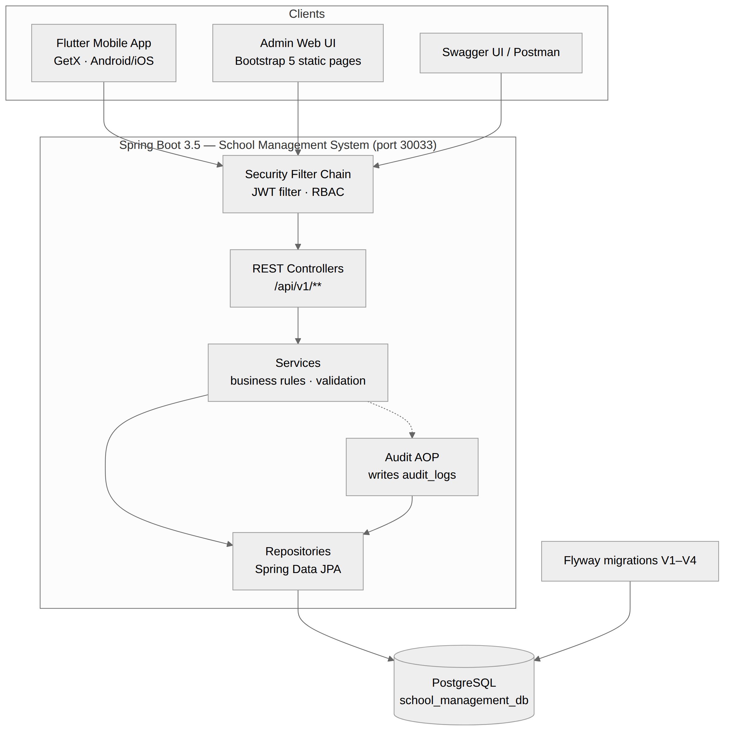
Figure 2: System architecture — request flow from the clients through the security filter chain, controllers, services, and repositories to PostgreSQL
Component | Technology | Key responsibilities
Flutter App | Flutter + GetX + http | Mobile UI, state management, routing, JWT storage (flutter_secure_storage), API calls, auto token refresh
Admin Web UI | Bootstrap 5 + vanilla JS | Demo CRUD screens served from src/main/resources/static
REST API | Spring Boot 3.5 (Java 21) | Security filter chain (JWT + RBAC), controllers, services (business rules, validation), audit AOP, repositories
Database | PostgreSQL + Flyway | Persistent storage; versioned migrations V1–V4; constraints in the database

4.2 Backend Package Structure
- config — WebSecurityConfig, OpenApiConfig, CORS.
- security — JWT token provider, auth filter, entry point, UserDetails services.
- common — ApiResponse/PageResponse envelopes, constants, exceptions and global handler, audit AOP, BaseEntity.
- auth — login, logout, refresh, forgot/reset password.
- user — users, roles, and permissions management.
- masterdata — student, teacher, subject, clazz modules (CRUD + search + paging).
- enrollment — enrollments and grades (business module).
- dashboard — summary statistics endpoint.
- auditlog — immutable audit trail and its search API.
- notification — device token registry, the notification inbox, and the Firebase Cloud Messaging client.
Each module keeps the same internal shape — XController → XService → XRepository → X (entity) + dto/ — so the structure itself documents the flow.

4.3 Design Decisions
Decision | Choice | Rationale
Architecture | Single Spring Boot monolith | Right-sized for the project; one deployable, simple demo, clean layering inside
Schema management | Flyway only (ddl-auto: none) | Reproducible schema; migration history is part of the deliverable
API style | REST, JSON, versioned under /api/v1 | Standard, easy to document with Swagger
Authorization | Roles → permissions; endpoints guarded by permission (@PreAuthorize) | Fine-grained control; roles stay a grouping mechanism
Deletes | Soft delete via status column (ACT/DEL) | Preserves referential integrity and audit history
Audit log | AOP aspect + @Auditable annotation | One cross-cutting implementation instead of per-module code
Error handling | Global @RestControllerAdvice with a fixed error JSON shape | Consistent client experience, no leaked stack traces
Mobile HTTP client | http package + hand-written ApiClient | Small dependency surface; refresh queue and error typing fully unit-tested

4.4 API Conventions
- Base path /api/v1; public: /api/v1/auth/**, Swagger, static UI — everything else authenticated.
- Success envelope: { "code": "OK", "message": "Success", "data": … }.
- Error shape: { "code": "E4xx/E500", "message": "…", "errors": [{field, message}] } — E400 validation, E401 authentication, E403 permission, E404 not found, E409 conflict.
- List endpoints: ?search=&page=0&size=10&sort=id,desc returning {content, page, size, totalElements, totalPages}.

5. Database Design

5.1 Configuration
Setting | Value
Database | school_management_db (PostgreSQL, single public schema)
Connection | jdbc:postgresql://localhost:5432/school_management_db
Schema management | Flyway (ddl-auto: none), migrations in src/main/resources/db/migration

5.2 Conventions
- Table names are plural snake_case; primary keys are SERIAL/BIGSERIAL id columns.
- Every business table carries audit columns created_at, created_by, updated_at, updated_by (filled by the JPA BaseEntity superclass) and a status VARCHAR(3) soft-delete flag (ACT active / DEL deleted).
- Foreign keys and unique constraints live in the database, not only in application code.

5.3 Entity–Relationship Diagram
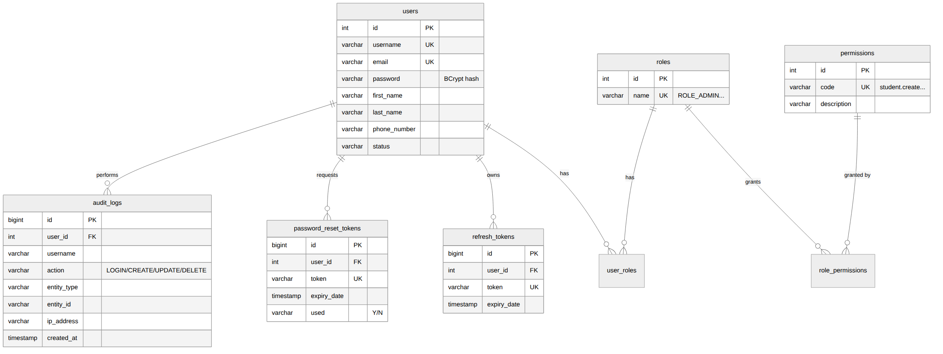
Figure 3: ERD — security and audit tables (users, roles, permissions, refresh/reset tokens, audit_logs)
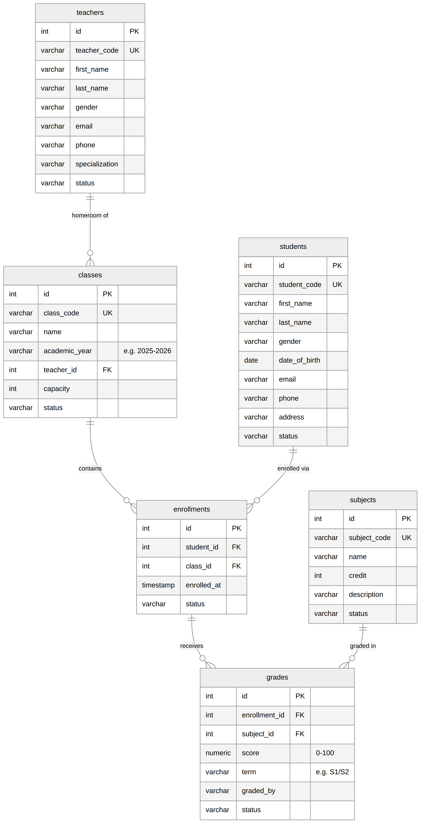
Figure 4: ERD — school tables (students, teachers, subjects, classes, enrollments, grades)

5.4 Data Dictionary — Key Constraints
Table | Constraint | Purpose
users | UNIQUE(username), UNIQUE(email) | No duplicate accounts
user_roles | PK(user_id, role_id), FKs to both | Many-to-many users ↔ roles
role_permissions | PK(role_id, permission_id), FKs to both | Many-to-many roles ↔ permissions
refresh_tokens | UNIQUE(token), FK to users | One token per session, revocable
password_reset_tokens | UNIQUE(token), used flag | Single-use reset tokens
students | UNIQUE(student_code) | Business identifier
teachers | UNIQUE(teacher_code) | Business identifier
subjects | UNIQUE(subject_code) | Business identifier
classes | UNIQUE(class_code), FK teacher_id → teachers | Homeroom teacher optional (NULL allowed)
enrollments | UNIQUE(student_id, class_id), FKs to both | Prevents double enrollment (FR-B1)
grades | UNIQUE(enrollment_id, subject_id, term), CHECK (score BETWEEN 0 AND 100) | One grade per subject per term (FR-B3)
audit_logs | FK user_id → users (nullable for failed logins) | Insert-only trail

5.5 Database Migrations with Flyway

5.5.1 What Is Flyway?
Flyway is an open-source database migration (schema versioning) tool, now maintained by Redgate. It applies plain SQL scripts to a database in a fixed order, exactly once each, and keeps a record of what it has already applied. In short, it does for the database what Git does for the source code: the schema stops being something that lives only inside a running server and becomes a set of reviewable, version-controlled files that any team member or CI server can replay to reach an identical database.
This project therefore sets Hibernate to ddl-auto: none — Hibernate never creates or alters a table. Flyway is the single source of truth for the schema and for the demo data, which is what makes ./gradlew bootRun on an empty PostgreSQL container produce a fully populated, ready-to-demo system.
How Flyway works at start-up:
- Migration scripts live in src/main/resources/db/migration and are named V<version>__<description>.sql — note the two underscores between version and description.
- Spring Boot auto-configures Flyway as soon as flyway-core is on the classpath. On start-up Flyway scans that folder, sorts the scripts by version, and compares them with the flyway_schema_history table (which it creates on first run).
- Every script not yet recorded is executed inside a transaction, in version order. Flyway then writes one row per script — version, description, checksum, installed_by, execution time and success flag — into flyway_schema_history.
- On the next start those scripts are skipped, so migrating is safe to repeat. If a file that was already applied has since been edited, its checksum no longer matches and Flyway aborts with a validation error instead of silently letting environments drift apart.
Flyway recognises three kinds of script by their filename prefix:
Prefix | Example filename | When it runs
V — versioned | V4__seed_data.sql | Once only, in ascending version order. This is the normal case and the one used throughout this project.
R — repeatable | R__dashboard_view.sql | After all versioned scripts, and again every time the file’s checksum changes. Suited to views, functions and lookup data that can simply be re-created.
U — undo | U4__seed_data.sql | Rolls back the matching versioned script. Available in the paid Flyway editions only; not used here.
Table: Flyway script types and their execution rules
Version note: the backend pins flyway-core and flyway-database-postgresql at 10.17.0, the release line that matches Spring Boot 3.5. The current Flyway release at the time of writing is 12.7.0 (May 2026); upgrading is a one-line change in build.gradle, but the 10.x line is kept here for a reproducible build.

5.5.2 Migration Plan for This Project
The schema is built up by three DDL migrations and completed by one seed migration; a fifth migration later added the push-notification tables. Because the scripts are numbered, a brand-new database always ends up in exactly this state:
Version | File | Content
V1 | V1__create_auth_tables.sql | users, roles, permissions, user_roles, role_permissions, refresh_tokens, password_reset_tokens, audit_logs
V2 | V2__create_master_data_tables.sql | students, teachers, subjects, classes
V3 | V3__create_business_tables.sql | enrollments, grades
V4 | V4__seed_data.sql | Roles, permissions, role–permission mapping, admin user, sample master data
V5 | V5__create_notification_tables.sql | device_tokens, notifications; students.user_id link; notification permissions
Table: Flyway migration plan — versioned scripts and their content

5.5.3 Flyway Configuration Used
Two pieces of configuration are all that Flyway needs. First, the dependencies in build.gradle — PostgreSQL 15+ requires the separate database module in Flyway 10.x:
dependencies {
implementation "org.flywaydb:flyway-core:10.17.0"
implementation "org.flywaydb:flyway-database-postgresql:10.17.0"
runtimeOnly "org.postgresql:postgresql"
}

Second, the spring.flyway block in src/main/resources/application.yml:
spring:
jpa:
hibernate:
ddl-auto: none # Hibernate never touches the schema

flyway:
enabled: true
locations: classpath:db/migration
baseline-on-migrate: true
baseline-version: 0

Property | Value | Why
ddl-auto | none | Hibernate validates nothing and creates nothing; Flyway owns the schema.
flyway.enabled | true | Runs the migration automatically during application start-up.
flyway.locations | classpath:db/migration | Folder scanned for scripts. It is on the classpath, so the scripts are packaged inside the JAR and ship with the build.
baseline-on-migrate | true | Lets Flyway adopt a database that already contains objects but no history table, instead of refusing to start.
baseline-version | 0 | Baseline is recorded as version 0, so V1 onwards are still applied.
Table: Flyway settings in application.yml and their purpose

5.6 Seed Data and How to Load It with Flyway
All demo data is loaded by a single Flyway migration, V4__seed_data.sql, so the database is never seeded by hand and every developer, marker and CI run sees exactly the same records. What the script inserts:
- Roles: ROLE_ADMIN, ROLE_TEACHER, ROLE_STUDENT.
- Permissions: user, role, student, teacher, subject, class, enrollment, grade × create/read/update/delete, plus audit.read and dashboard.read.
- Mapping: ADMIN → all; TEACHER → all *.read + enrollment.* + grade.*; STUDENT → read on own data (enforced in the service layer).
- Sample data: ~10 students, 4 teachers, 6 subjects, 3 classes, plus enrollments and grades so the dashboard and lists are not empty on first run.
- Notifications (added by V5): the permissions notification.read (all three roles) and notification.send (ADMIN and TEACHER). The same migration links the seeded student1 account to student S001, so that student can be notified about their own grades and enrollments.

5.6.1 Why Seed Through Flyway Instead of by Hand
Seeding could also be done with a SQL dump, a CommandLineRunner in Java, or by typing INSERT statements into pgAdmin. Flyway was chosen because it is the only option that is versioned, automatic and repeatable at the same time:
- Reproducible — a clean checkout plus an empty database gives a working, populated system with one command.
- Reviewable — the seed data is a text file in Git; changes to it appear in pull requests like any other code.
- Ordered — the seed script is guaranteed to run after the tables that it fills, because V4 sorts after V1–V3.
- Applied exactly once — no duplicate rows when the application restarts, and no "did anyone remember to run the script?" step in the setup guide.
- Environment-independent — the same artefact seeds a developer laptop, the Docker Compose stack and the Jenkins pipeline.

5.6.2 Step-by-Step: Seeding Data with Flyway
Step 1 — Add the dependencies. Flyway only needs to be on the classpath; Spring Boot does the rest. In build.gradle (Maven users add the equivalent org.flywaydb:flyway-core dependency):
implementation "org.flywaydb:flyway-core:10.17.0"
implementation "org.flywaydb:flyway-database-postgresql:10.17.0"

Step 2 — Point Spring Boot at the migration folder and hand schema ownership to Flyway, as shown in section 5.5.3. The important line is spring.jpa.hibernate.ddl-auto: none — if Hibernate is allowed to create tables, it races Flyway and the migration fails.
Step 3 — Create the seed migration file. Put it in src/main/resources/db/migration and follow the naming rules exactly, or Flyway will ignore the file:
Rule | Correct | Wrong
Prefix V for a versioned migration | V4__seed_data.sql | v4-seed-data.sql
Version number unique and higher than every applied one | V4, V5, V5.1 | reusing V3
Exactly two underscores between version and description | V4__seed_data.sql | V4_seed_data.sql
Lower-case .sql extension, file placed directly under db/migration | db/migration/V4__seed_data.sql | db/seed/V4__seed_data.txt
Table: Flyway file-naming rules for a seed migration
Step 4 — Write the seed SQL. Insert the parent rows first and resolve foreign keys with sub-queries rather than hard-coded ids, so the script stays correct whatever the sequence values happen to be. Passwords are stored as pre-computed BCrypt hashes, never as plain text. An excerpt from V4__seed_data.sql:
-- roles first, because users reference them
INSERT INTO roles (name, description, created_at, created_by) VALUES
('ROLE_ADMIN', 'Full system access', NOW(), 'SYSTEM'),
('ROLE_TEACHER', 'Manage enrollments and grades', NOW(), 'SYSTEM'),
('ROLE_STUDENT', 'Read-only access to own records', NOW(), 'SYSTEM');

-- default accounts (passwords are BCrypt hashes, e.g. admin / admin@123)
INSERT INTO users (username, email, password, first_name, last_name,
status, created_at, created_by) VALUES
('admin', 'admin@school.edu.kh', '$2a$10$ZBHfXV.zJJOtQr8iuq8G4e...',
'System', 'Administrator', 'ACT', NOW(), 'SYSTEM');

-- link user to role by looking the ids up, not by hard-coding them
INSERT INTO user_roles (user_id, role_id)
SELECT u.id, r.id FROM users u JOIN roles r
ON (u.username = 'admin' AND r.name = 'ROLE_ADMIN');

Tip: adding ON CONFLICT DO NOTHING to each INSERT makes the script safe to replay against a database that already holds some of the rows — useful while the seed script is still being written.
Step 5 — Run it. Start PostgreSQL, then start the API; Flyway migrates before the first bean that needs the DataSource is used:
cd springboot-jwt-api/postgres && docker compose up -d # PostgreSQL on :5432
cd .. && ./gradlew bootRun # Flyway runs automatically

The start-up log confirms what happened:
Flyway Community Edition 10.17.0 by Redgate
Database: jdbc:postgresql://localhost:5432/school_management_db (PostgreSQL 16.x)
Successfully validated 4 migrations (execution time 00:00.041s)
Creating Schema History table "public"."flyway_schema_history" ...
Migrating schema "public" to version "1 - create auth tables"
Migrating schema "public" to version "4 - seed data"
Successfully applied 4 migrations to schema "public" (execution time 00:00.612s)

Step 6 — Verify. Check the history table and count a few seeded rows:
psql -h localhost -U postgres -d school_management_db

SELECT version, description, success, installed_on
FROM flyway_schema_history ORDER BY installed_rank;

SELECT COUNT(*) FROM students; -- 10
SELECT COUNT(*) FROM teachers; -- 4
SELECT COUNT(*) FROM subjects; -- 6

A successful run leaves one row per script with success = true. Logging in to the app as admin / admin@123 and seeing a populated dashboard is the end-to-end confirmation.

5.6.3 Adding or Changing Seed Data Later
The golden rule of Flyway: never edit a migration that has already been applied. Its checksum is stored in flyway_schema_history, and any change makes the next start-up fail validation. Instead:
- To add data, create the next version — V5__seed_more_students.sql — containing only the new INSERT statements.
- To correct data, add a migration with the UPDATE or DELETE, e.g. V6__fix_subject_credits.sql.
- For lookup data that is regenerated wholesale, a repeatable script such as R__reference_data.sql (delete-then-insert) re-runs by itself whenever the file changes.
- While still developing locally, the simplest fix is to throw the database away and let all migrations run again from scratch (see 5.6.4).

5.6.4 Resetting the Demo Database
Because every table and every row is produced by a migration, resetting is destroying the database and restarting the API. With the provided Docker Compose file:
cd springboot-jwt-api/postgres
docker compose down -v # -v also removes the data volume
docker compose up -d
cd .. && ./gradlew bootRun # V1..V4 run again on the empty database

Without Docker, the equivalent is to drop and re-create the schema, then restart:
DROP SCHEMA public CASCADE;
CREATE SCHEMA public;

Flyway also offers flyway clean for the same purpose. It is deliberately not enabled in this project — on a production connection it would delete everything, which is why cleanDisabled defaults to true in Flyway 10 and later.

5.6.5 Running Flyway Outside the Application (Optional)
Seeding does not have to happen at application start-up. The same scripts can be executed by the Gradle plugin or by the Flyway command-line tool, which is what a CI/CD pipeline usually does so that the migration step is separate from the deployment step:
# Gradle plugin — add id "org.flywaydb.flyway" version "10.17.0" to build.gradle
./gradlew flywayInfo # list applied and pending migrations
./gradlew flywayMigrate # apply pending migrations, including the seed
./gradlew flywayValidate # verify checksums without changing anything

# Flyway CLI via Docker — no local install needed
docker run --rm -v "$(pwd)/src/main/resources/db/migration:/flyway/sql" \
redgate/flyway:10.17.0 \
-url=jdbc:postgresql://host.docker.internal:5432/school_management_db \
-user=postgres -password=12345678 migrate

5.6.6 Troubleshooting Common Seeding Errors
Message seen at start-up | Cause | Fix
Validate failed: Migration checksum mismatch for version 4 | An already-applied migration file was edited. | Restore the original file, or reset the dev database; in a shared database run flyway repair to realign the checksum.
duplicate key value violates unique constraint | The seed ran against a database that already contains those rows. | Add ON CONFLICT DO NOTHING to the INSERTs, or reset the database as in 5.6.4.
Found non-empty schema "public" without schema history table | Flyway met an existing database it did not create. | baseline-on-migrate: true (already set) lets it adopt the schema and continue.
Detected resolved migration not applied to database: 4 | A lower version number was added after a higher one had already run. | Give the new script a higher version number, or set spring.flyway.out-of-order: true for development only.
relation "students" does not exist | The seed script sorts before the DDL that creates the table. | Renumber the seed script so it is the highest version, and keep DDL and data in separate files.
No migrations found / tables never created | Wrong folder or a typo in the filename (single underscore, wrong prefix). | Check spring.flyway.locations and rename the file to V<n>__<description>.sql.
Table: Common Flyway errors when seeding, and how to resolve them

6. API Design (REST)
The API exposes 56 endpoints under the base path /api/v1, all documented with Swagger/OpenAPI (springdoc). Except for the public auth endpoints, every request requires an Authorization: Bearer <access token> header, and every protected endpoint is guarded by a permission code. List endpoints support search, sorting, and pagination via query parameters (search, page, size, sort).

6.1 Authentication Endpoints
Method | Endpoint | Description | Access
POST | /api/v1/auth/login | Authenticate with username (or email) and password; returns access + refresh tokens | Public
POST | /api/v1/auth/refresh | Exchange a valid refresh token for a new access token | Public
POST | /api/v1/auth/logout | Revokes all refresh tokens of the current user | Authenticated
POST | /api/v1/auth/forgot-password | Sends a single-use reset token to the registered email | Public
POST | /api/v1/auth/reset-password | Sets a new password using a valid reset token | Public

6.2 Endpoint Catalog by Module
Module | Method & path (relative to /api/v1) | Permission
Users | GET/POST /users · GET/PUT/DELETE /users/{id} · PUT /users/{id}/roles · GET /users/me · PUT /users/me/password | user.* (me: authenticated)
Roles | GET /roles · GET /permissions · PUT /roles/{id}/permissions | role.*
Dashboard | GET /dashboard/summary | dashboard.read
Students | GET/POST /students · GET/PUT/DELETE /students/{id} | student.*
Teachers | GET/POST /teachers · GET/PUT/DELETE /teachers/{id} | teacher.*
Subjects | GET/POST /subjects · GET/PUT/DELETE /subjects/{id} | subject.*
Classes | GET/POST /classes · GET/PUT/DELETE /classes/{id} | class.*
Enrollments | GET/POST /enrollments · DELETE /enrollments/{id} · GET /classes/{id}/enrollments · GET /students/{id}/enrollments | enrollment.*
Grades | POST /grades · PUT/DELETE /grades/{id} · GET /enrollments/{id}/grades · GET /students/{id}/grades | grade.*
Audit log | GET /audit-logs?username=&action=&entityType=&from=&to= | audit.read
Devices | POST /devices · GET /devices · DELETE /devices?token= | Authenticated
Notifications | GET /notifications?unreadOnly= · GET /notifications/unread-count · PUT /notifications/{id}/read · PUT /notifications/read-all · POST /notifications/send | notification.read, notification.send

6.3 Interactive Documentation
What | URL
Swagger UI — browse and try every endpoint | http://localhost:30033/swagger-ui.html
OpenAPI 3 spec (JSON) | http://localhost:30033/v3/api-docs
OpenAPI 3 spec (YAML) | http://localhost:30033/v3/api-docs.yaml

7. Security Design

7.1 Authentication Flow (JWT + Refresh Token)
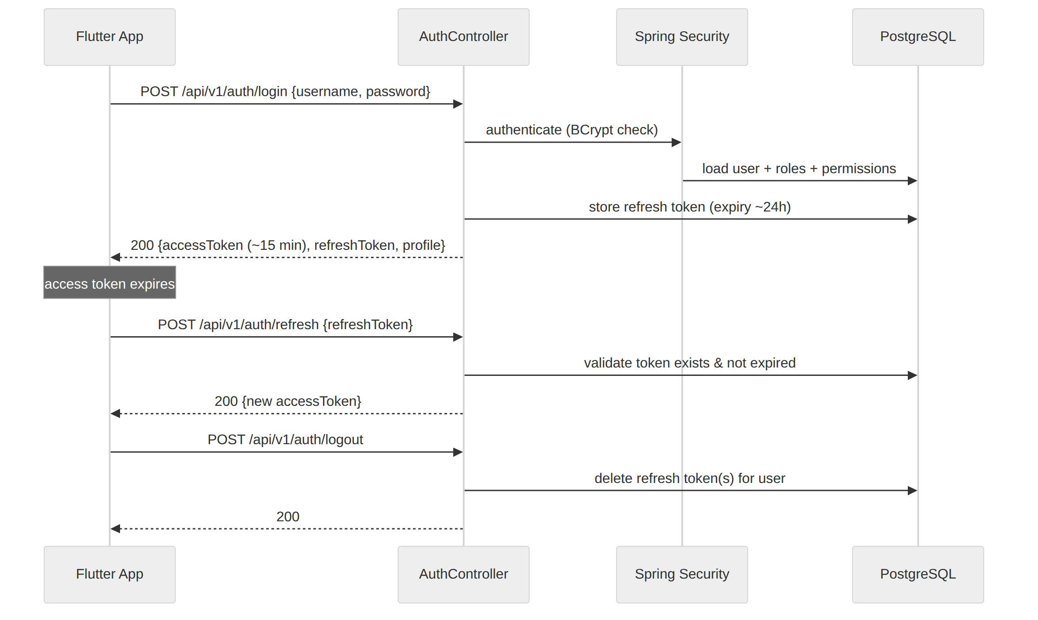
Figure 5: Login, refresh, and logout sequence between the client, the Auth module, Spring Security, and PostgreSQL
- Access token: JWT signed with an HMAC secret, ~15 minutes, carries username + authorities.
- Refresh token: opaque UUID stored in refresh_tokens, ~24 hours, deleted on logout.
- Forgot password: POST /auth/forgot-password generates a single-use token (30-minute expiry); POST /auth/reset-password consumes it and BCrypt-hashes the new password. Used and expired tokens are rejected.

7.2 Authorization (Role-Based Access Control)
User ──< user_roles >── Role ──< role_permissions >── Permission. JWT authorities are the union of the user’s roles (ROLE_ADMIN) and permission codes (student.create). Controllers use @PreAuthorize with permissions; roles are the grouping mechanism.
Role | Capabilities
ROLE_ADMIN | Full CRUD on users, roles, students, teachers, subjects, classes, enrollments, grades; dashboard; audit log
ROLE_TEACHER | Read all master data; manage enrollments and grades; dashboard
ROLE_STUDENT | Read-only access to own profile, enrollments, and grades
The Flutter app mirrors the same model: the login/profile response carries the user’s flattened permission codes, and every menu entry, button, and row action is permission-gated in the UI, while the backend still enforces the same rules with HTTP 403.

7.3 Audit Logging
- @Auditable(action, entity) on service write methods; a Spring AOP aspect records username, action, entity type and id, request IP, and timestamp into audit_logs after a successful return.
- Login success/failure and logout are audited directly in AuthService.
- Audit entries are insert-only; no update or delete API exists.

7.4 Other Measures
- Passwords stored only as BCrypt hashes; JWT tokens on the device live in flutter_secure_storage (Keychain/Keystore), never in plain storage.
- All request bodies validated server-side; the global exception handler never leaks stack traces.
- Soft deletes preserve history; unique and check constraints are enforced in the database.

8. Frontend Design (Flutter + GetX)

8.1 Clean Architecture
The app follows Clean Architecture adapted to Flutter + GetX: three layers with dependencies pointing inwards, plus a thin composition root (main.dart + bindings).
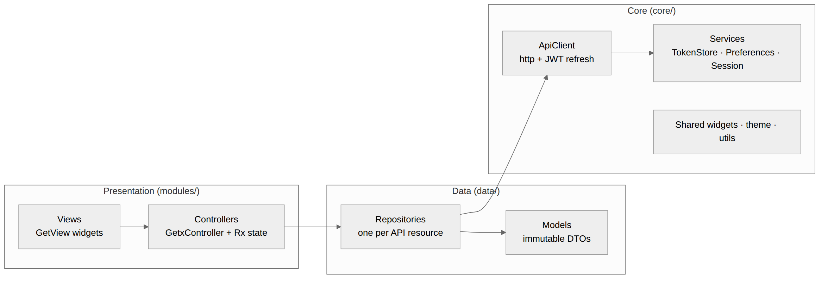
Figure 6: Flutter app layering — Views → Controllers → Repositories → ApiClient/Services
- Core (lib/app/core/) — ApiClient (the only place HTTP happens: attaches the Bearer token, decodes the {code, message, data} envelope, single-flight refresh on 401), TokenStore/TokenStorageService, PreferencesService, SessionService, PagedListController<T>, theme, shared widgets.
- Data (lib/app/data/) — immutable models with fromJson/toJson and one repository per API resource; controllers never build URLs or touch JSON.
- Presentation (lib/app/modules/) — one folder per feature (auth, splash, shell, dashboard, students, teachers, subjects, classes, enrollments, users, roles, audit, profile), each with a GetX controller, binding, and view.

8.2 Transparent Token Refresh
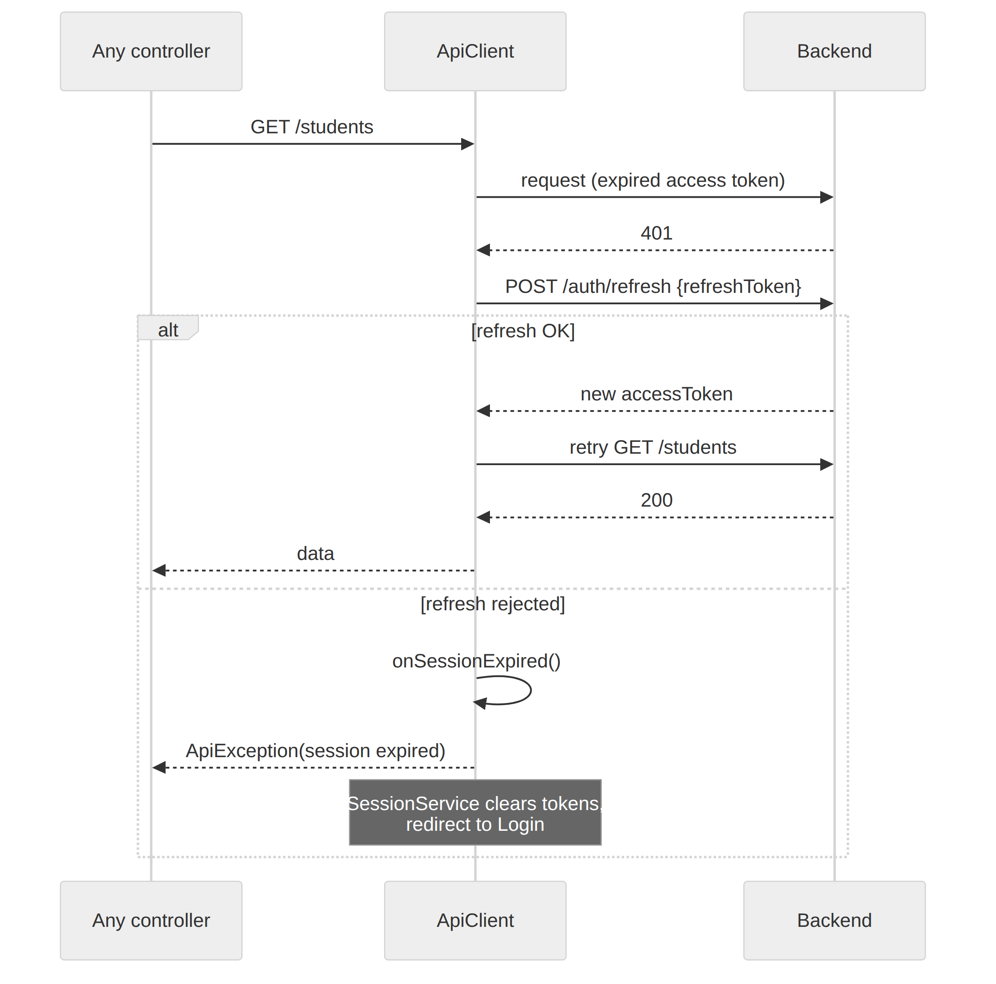
Figure 7: Automatic refresh on 401 — the request is retried once with the new token; an irrecoverable session redirects to Login

8.3 Screen Specifications
Screen | Main elements | Backing APIs
Splash | Session restore from cached profile + stored tokens | /users/me
Login | Username + password with validation, remembered username, loading state, error banner | /auth/login
Forgot / Reset password | Request reset token; set new password with token | /auth/forgot-password, /auth/reset-password
Dashboard | Live counters (students, teachers, subjects, classes, enrollments), recent enrollments, recent audit activity | /dashboard/summary
Students | Paginated + debounced search list, create/edit dialogs, soft delete, PDF/XLSX export, per-student report card | /students
Student detail | Profile, enrollments card (enroll/remove), grades card (record/edit/delete, letter grades), QR badge | /students/{id}, /students/{id}/enrollments, /students/{id}/grades
Teachers / Subjects / Classes | Same list pattern with create/edit/delete; class roster dialog per class | /teachers, /subjects, /classes, /classes/{id}/enrollments
Enrollments | Global list with student & class filters, per-enrollment grades dialog | /enrollments, /enrollments/{id}/grades
Users & Roles (Admin) | User CRUD, role assignment, role-permission matrix editor | /users, /roles, /permissions
Audit Logs (Admin) | Filters for username, action, entity type, and date range | /audit-logs
My Profile | Profile view, change password, FCM device token, personal QR badge, theme toggle | /users/me, /users/me/password
Notifications | Inbox list with unread-only filter, tap to mark read, mark-all-read, and a compose dialog for users holding notification.send | /notifications, /notifications/send

8.4 Additional Features
- Theming — light/dark Material 3 theme, persisted with GetStorage.
- PDF / Excel export — students list as PDF or XLSX via the share sheet, and a per-student report-card PDF with enrollments, grades, and average.
- QR badges — ID-card dialog with a JSON QR payload for every student and for the signed-in user.
- Push notifications — Firebase Cloud Messaging with an in-app inbox and a live unread badge in the app bar; grades, enrollments, and admin announcements reach the device. See chapter 9.
- Android emulator support — the app automatically switches the API host to 10.0.2.2 so the emulator can reach the development machine’s localhost.

9. Push Notifications (Firebase Cloud Messaging)
Push notifications close the loop between the back office and the people it serves: a student learns that a grade was recorded without opening the app, and the school can reach a whole role with one announcement. The feature spans both projects — a notification module in the Spring Boot API and a Firebase Cloud Messaging (FCM) integration in the Flutter client — and it is designed so that the rest of the system keeps working whether or not Firebase credentials are present.

9.1 How a Notification Travels
FCM is Google’s free message-delivery service. The backend never contacts a phone directly: it hands FCM a message plus a list of device tokens, and FCM delivers to Android and iOS. The full path is:
- Register — after every successful sign-in the app asks for notification permission, reads this device’s FCM token, and POSTs it to /api/v1/devices with the user’s JWT. The backend stores it in device_tokens (unique per token, owned by one user).
- Trigger — a grade is recorded or updated, a student is enrolled, or an administrator composes an announcement. The service layer calls PushNotificationService.notifyUser(…) or send(…).
- Persist — one row per recipient is written to notifications, which is the in-app inbox. This happens even when push delivery is unavailable, so nothing is ever lost.
- Deliver — all active tokens of those recipients are sent to FCM in a single multicast call. Tokens FCM rejects as UNREGISTERED or INVALID_ARGUMENT (app uninstalled, token expired) are deactivated automatically so dead devices are never retried.
- Display — in the foreground the app raises a system banner itself; in the background the operating system shows it. Tapping the banner opens the app and refreshes the inbox and the unread badge.
- Revoke — logging out deactivates every device token of that user, so a signed-out phone stops receiving notifications.

9.2 Backend Implementation
The module lives in com.school.management.notification and follows the same shape as every other module in the project:
Class | Responsibility
DeviceController | Register, list, and unregister the current user’s FCM device tokens.
NotificationController | Inbox, unread count, mark-read, mark-all-read, and the announcement broadcast.
PushNotificationService | All business logic: stores the notification rows, resolves recipients to device tokens, calls FCM, and deactivates invalid tokens.
FirebaseMessagingClient | Thin wrapper over the Firebase Admin SDK. Loads the service account key, or stays in dry-run mode when there is none.
DeviceToken, Notification | JPA entities over device_tokens and notifications, with the usual repositories.
Table: Classes in the notification module
Delivery is deliberately isolated from the operation that triggers it. notifyUser(…) runs with @Transactional(propagation = REQUIRES_NEW) and swallows its own exceptions, so a Firebase outage or a bad token can never roll back a saved grade. The trigger in GradeService is a single call:
private void notifyStudent(Integer studentId, GradeResponse grade, String title) {
studentRepository.findById(studentId)
.map(Student::getUserId)
.ifPresent(userId -> pushNotificationService.notifyUser(userId, title,
"You scored %s in %s (term %s)"
.formatted(grade.score(), grade.subjectName(), grade.term()),
PushNotificationService.TYPE_GRADE, "GRADE", String.valueOf(grade.id())));
}

The only new dependency is the Firebase Admin SDK in build.gradle:
implementation 'com.google.firebase:firebase-admin:9.4.1'

9.3 What Triggers a Notification
Event | Recipient | Title | type
A grade is recorded | The graded student | New grade recorded | GRADE
A grade is updated | The graded student | Grade updated | GRADE
A student is enrolled in a class | That student | Class enrollment | ENROLLMENT
POST /notifications/send | A whole role, or a chosen list of users | the title supplied by the sender | ANNOUNCEMENT
Table: Events that produce a notification
A student only receives grade and enrollment notifications if their students row is linked to a login account through students.user_id. Migration V5 creates that column and links the demo account student1 to student S001; other students are linked by setting the same column.

9.4 Data Model (Migration V5)
Table / column | Purpose
device_tokens | One row per (user, FCM token). Columns: user_id → users, token (unique), device_type (ANDROID/IOS/WEB), device_name, status.
notifications | The in-app inbox — one row per recipient: user_id → users, title, body, type, entity_type, entity_id, is_read (Y/N), sent_status.
students.user_id | New nullable, unique FK linking a student record to a login account so the student can be notified.
sent_status | SENT — handed to FCM · SKIPPED — the user has no registered device · DISABLED — dry-run, no service account configured.
Table: Objects added by V5__create_notification_tables.sql
The migration also inserts the permissions notification.read and notification.send, granting both to ADMIN and TEACHER and read-only access to STUDENT — so authorisation for the new feature is seeded exactly like every other permission (see section 5.6).

9.5 API Endpoints
Method & path | Purpose | Access
POST /api/v1/devices | Register this device’s FCM token | Authenticated
GET /api/v1/devices | List my registered devices | Authenticated
DELETE /api/v1/devices?token=… | Unregister one device | Authenticated
GET /api/v1/notifications | My inbox — paginated, with an unreadOnly=true filter | notification.read
GET /api/v1/notifications/unread-count | Badge counter (plain integer) | notification.read
PUT /api/v1/notifications/{id}/read | Mark one notification as read | notification.read
PUT /api/v1/notifications/read-all | Mark the whole inbox as read | notification.read
POST /api/v1/notifications/send | Broadcast to a role or a list of user ids | notification.send
Table: The eight endpoints added by the notification module
The push payload itself carries notification.title and notification.body plus a data map of {type, entityType, entityId} — all values are strings, as FCM requires — so the client can open the right screen when the user taps the banner.

9.6 Flutter Client Implementation
Three packages are involved: firebase_core, firebase_messaging and flutter_local_notifications. All FCM handling is concentrated in one injectable service, PushNotificationService (a GetxService), which:
- requests notification permission (required on iOS and on Android 13+),
- obtains the device token, sends it to POST /devices, and re-registers automatically on onTokenRefresh — FCM rotates tokens,
- subscribes the device to the announcements topic,
- shows a real system banner even while the app is in the foreground — on Android through a high-importance local-notification channel (announcements_channel), on iOS through FCM’s native foreground presentation options,
- exposes an onMessageReceived callback so the inbox list and the unread badge refresh the moment a push arrives.
final messaging = FirebaseMessaging.instance;
final settings = await messaging.requestPermission();

fcmToken.value = await messaging.getToken();
messaging.onTokenRefresh.listen((token) { // FCM rotates tokens
fcmToken.value = token;
registerDeviceWithBackend(); // POST /devices
});
await messaging.subscribeToTopic('announcements');

FirebaseMessaging.onMessage.listen((message) { // app in foreground
onMessageReceived?.call(); // refresh inbox + badge
_localNotifications.show(...); // Android banner
});
FirebaseMessaging.onMessageOpenedApp.listen((m) => onMessageReceived?.call());

The service degrades gracefully instead of crashing where push cannot work: on the web it reports that push is configured for Android and iOS builds; on the iOS simulator, where no APNs token is issued, it records a readable unavailableReason rather than throwing; and a failed device registration is logged but never blocks sign-in.
On screen the feature appears as a bell in the app bar with a live unread badge (visible only to users holding notification.read), a paginated inbox with an unread-only filter, tap-to-read and mark-all-read, and — for holders of notification.send — a compose dialog that broadcasts to a role or to selected user ids.

9.7 Configuration and Dry-Run Mode
Two different Firebase credentials are involved, and they are not interchangeable:
Credential | Used by | Needed for
Service account JSON (private key) | Spring Boot backend | Authorising the server to send messages through FCM
google-services.json / GoogleService-Info.plist | Flutter app (Android / iOS) | Letting the device register with FCM and receive messages
Table: The two Firebase credentials and what each one is for
The backend runs fine without either. With no service account present the application starts normally, notifications are still created in the database and returned by the API, and only the delivery step is replaced by a log line — the same approach MailService takes when it prints password-reset tokens instead of emailing them. The whole project therefore stays runnable, and demonstrable, on a machine with no Firebase account at all:
WARN FirebaseMessagingClient : Firebase service account not found — push notifications run in dry-run mode.
INFO FirebaseMessagingClient : [PUSH dry-run] 1 device(s) | New grade recorded |
You scored 88.25 in Physics (term S2) | data={type=GRADE, entityId=52}

Real delivery is switched on by dropping a Firebase service account key on the machine; the relevant settings are:
app:
firebase:
enabled: true
credentials-path: ${FIREBASE_CREDENTIALS:${user.home}/.secrets/firebase-service-account.json}
project-id: ${FIREBASE_PROJECT_ID:}

The key is read from the home directory by default and can be moved with the FIREBASE_CREDENTIALS environment variable; it is never committed, because this repository is public and a leaked private key would let anyone send messages as the project. Setting app.firebase.enabled: false forces dry-run mode even when a key is present. The step-by-step procedure for creating the Firebase project, downloading the key, and adding the mobile app config files is kept in springboot-jwt-api/docs/06-push-notifications.md.

9.8 Testing Without a Device
Device tokens are just strings until FCM is enabled, so the whole flow can be exercised from any HTTP client — the code path is identical to the one a real phone takes:
# 1. register a fake device for student1
curl -X POST http://localhost:30033/api/v1/devices \
-H "Authorization: Bearer $STUDENT_TOKEN" -H 'Content-Type: application/json' \
-d '{"token":"demo-fcm-token-abc123","deviceType":"ANDROID","deviceName":"Demo"}'

# 2. as teacher1, record a grade for that student
# -> a notification row is created and the push is logged

# 3. read the inbox
curl http://localhost:30033/api/v1/notifications -H "Authorization: Bearer $STUDENT_TOKEN"

With a real service account and a real device token, step 2 makes the phone buzz.

10. Testing Strategy
- Static analysis: flutter analyze passes with 0 issues.
- Unit + widget tests (flutter test): models (JSON round-trips), ApiClient single-flight refresh flow with MockClient, export service, and widget tests.
- Backend: manual testing of all flows through Swagger UI and the provided Postman collection (run Auth/Login first — it stores the JWT for all other requests).
- Demo verification: the seeded database gives every screen data on first run.

Username | Password | Role
admin | admin@123 | ROLE_ADMIN — full access
teacher1 | teacher@123 | ROLE_TEACHER — read master data, manage enrollments & grades
student1 | student@123 | ROLE_STUDENT — read-only

11. Setup and Deployment
- 1. PostgreSQL — cd springboot-jwt-api/postgres && docker compose up -d (starts the school-postgres container on localhost:5432 and creates school_management_db automatically).
- 2. Backend — ./gradlew bootRun (requires JDK 21). Flyway creates all tables and seeds demo data on first start; the API and admin web UI listen on http://localhost:30033.
- 3. Mobile app — flutter pub get && flutter run, picking an Android emulator, iOS simulator, or Chrome. On the Android emulator the app talks to the backend via 10.0.2.2:30033.
- 4. Container deployment — a Dockerfile and docker-compose.yml package the backend, and a Jenkinsfile is provided for CI.

What | URL
Admin web UI | http://localhost:30033/
Swagger UI | http://localhost:30033/swagger-ui.html
OpenAPI JSON | http://localhost:30033/v3/api-docs

12. Conclusion
The School Management System delivers a complete, working full-stack solution for the course’s evaluation criteria: a Spring Boot 3.5 / Java 21 REST API with stateless JWT authentication and refresh tokens, fine-grained role/permission authorization, a normalized 13-table PostgreSQL schema fully under Flyway control, consistent validation and error handling, an immutable audit trail, and 48 documented endpoints; and a Flutter mobile application built on Clean Architecture with GetX that covers every endpoint of the API, adds transparent token refresh, permission-gated UI, light/dark Material 3 theming, PDF/Excel export, QR badges, and Firebase push notifications. The system was developed with an Agile Scrum approach across two sprints — Sprint 1 producing the requirement analysis, system design, and database design documents, and Sprint 2 delivering the implemented backend, mobile application, tests, and this report.

13. Appendixes

Appendix 1: Mobile Application Screens
The following screens were captured from the running application on an Android emulator (signed in as the admin demo account).
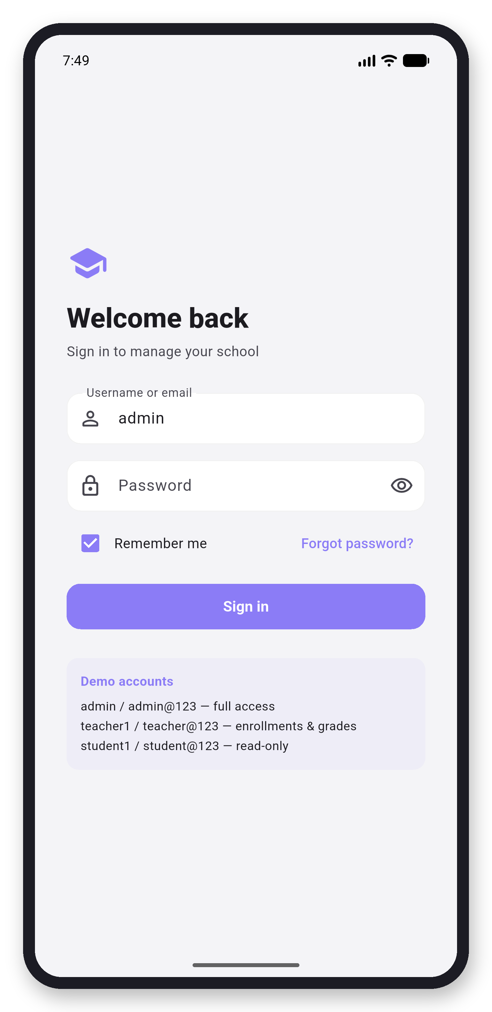  Screen 1: Login | 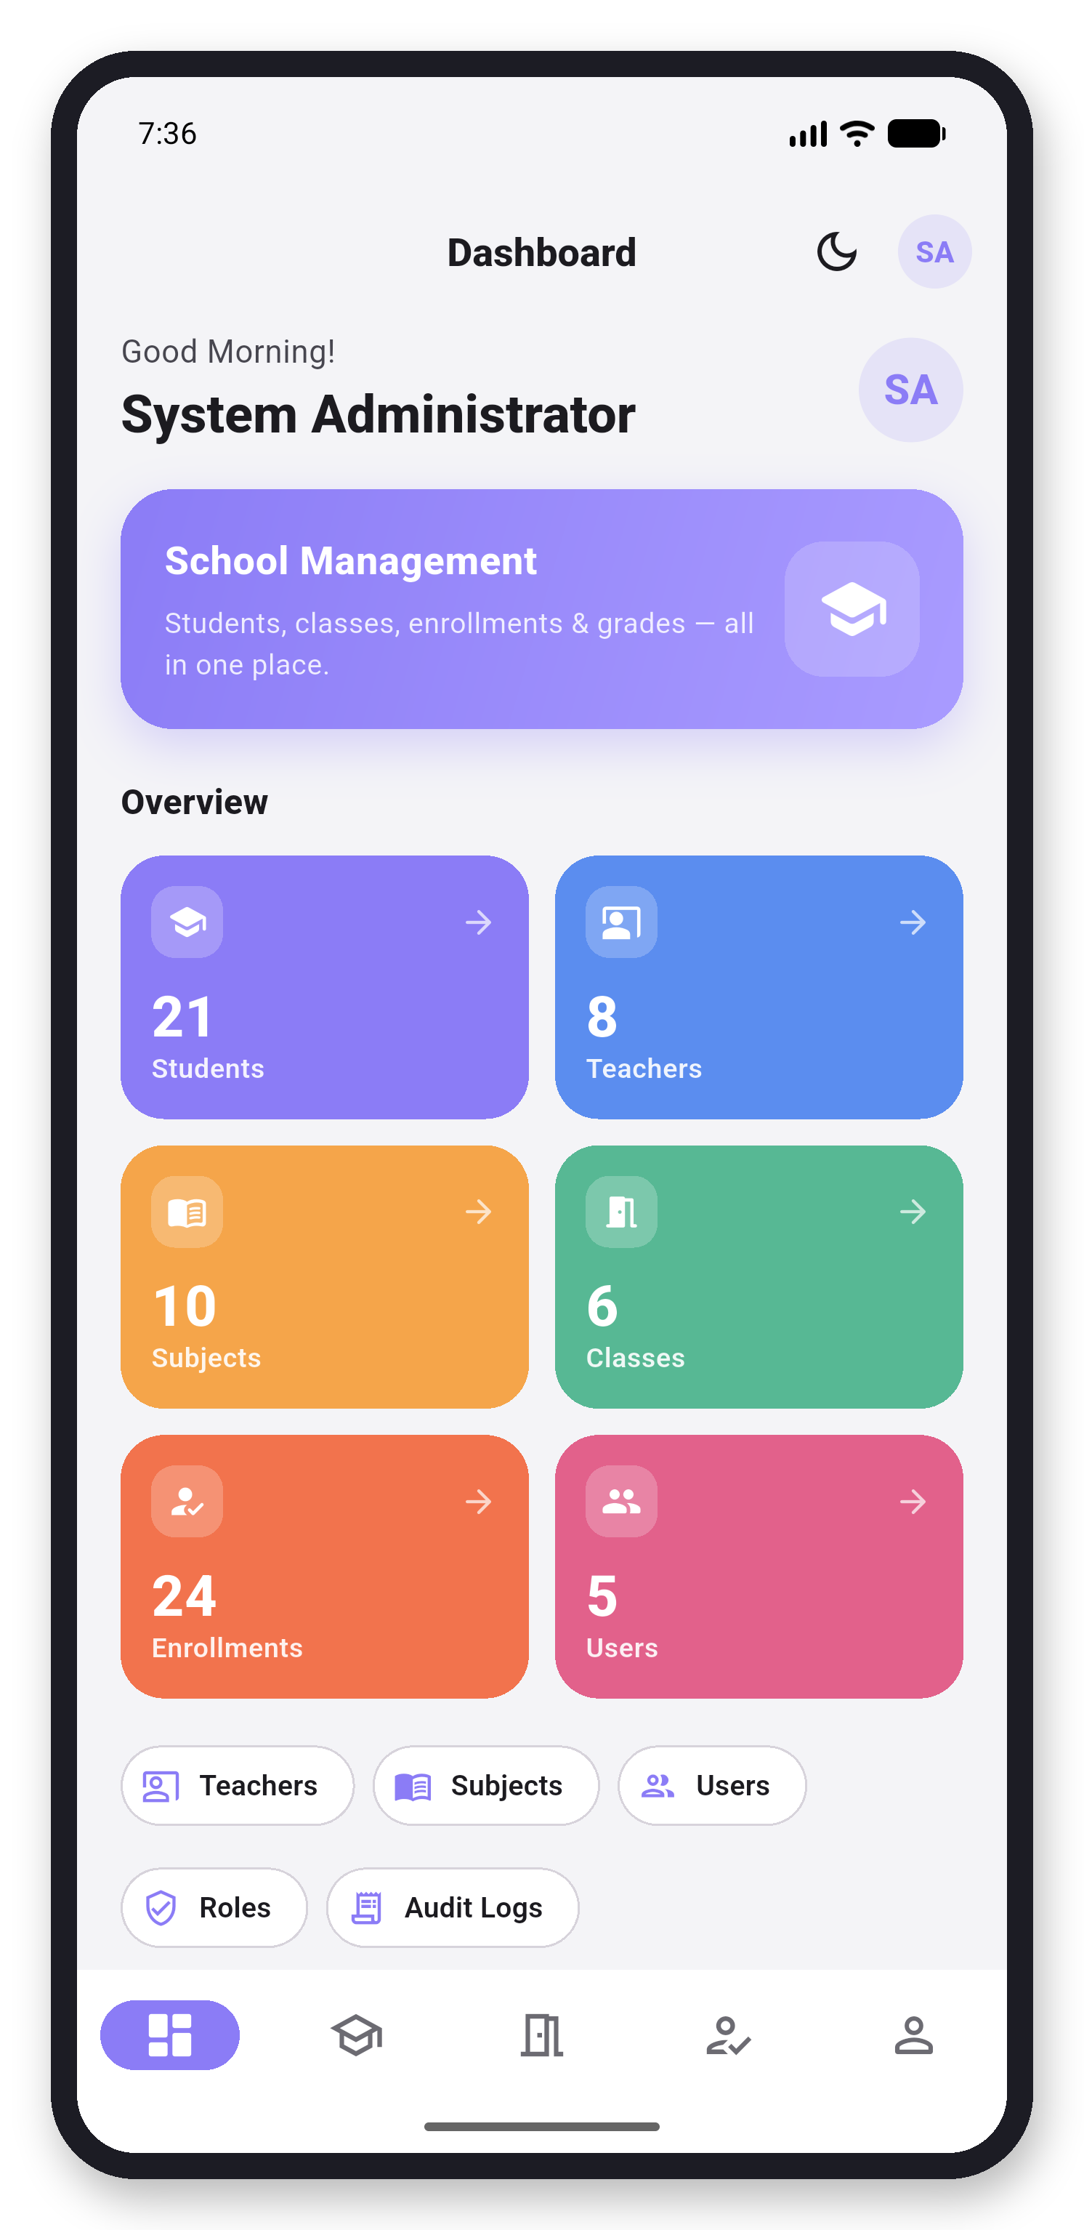  Screen 2: Dashboard
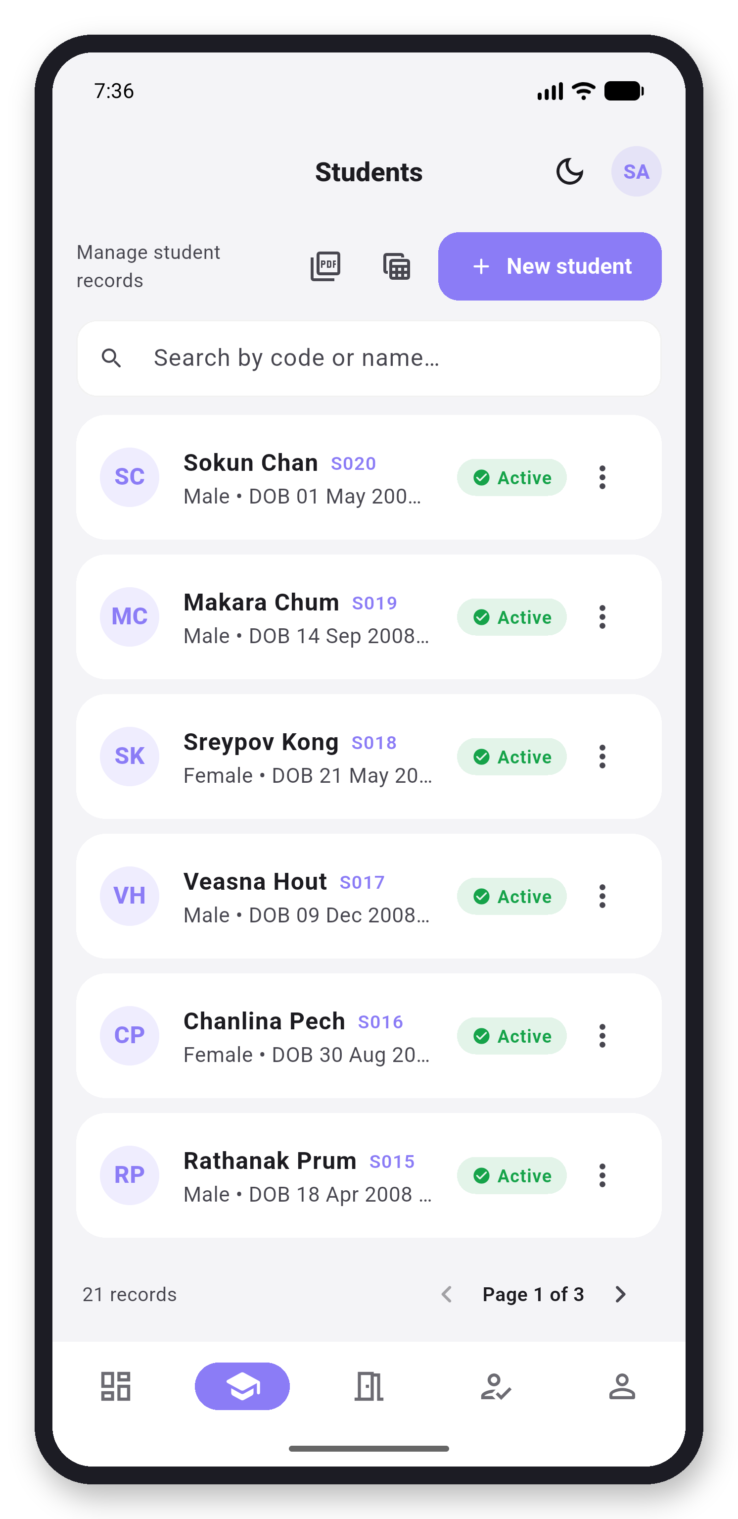  Screen 3: Students | 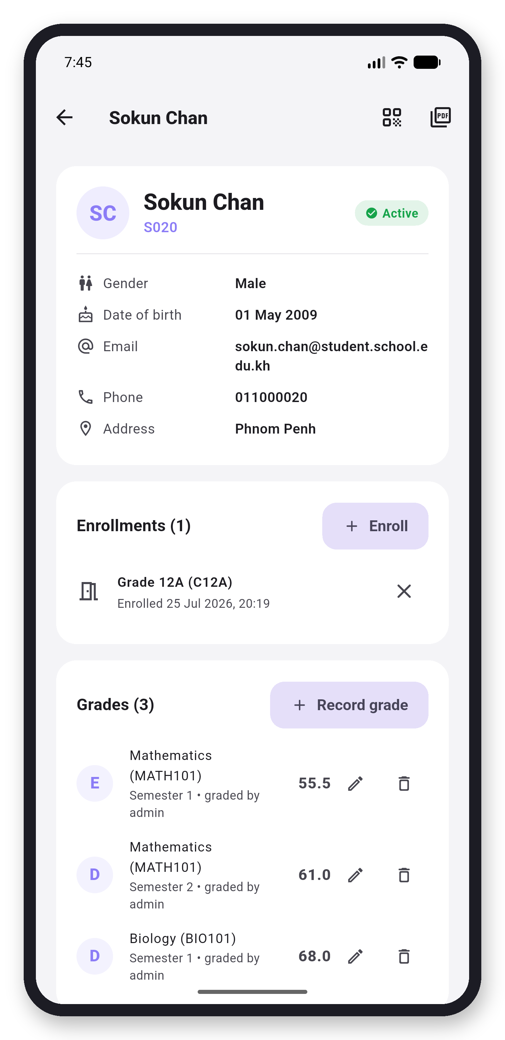  Screen 4: Student Detail
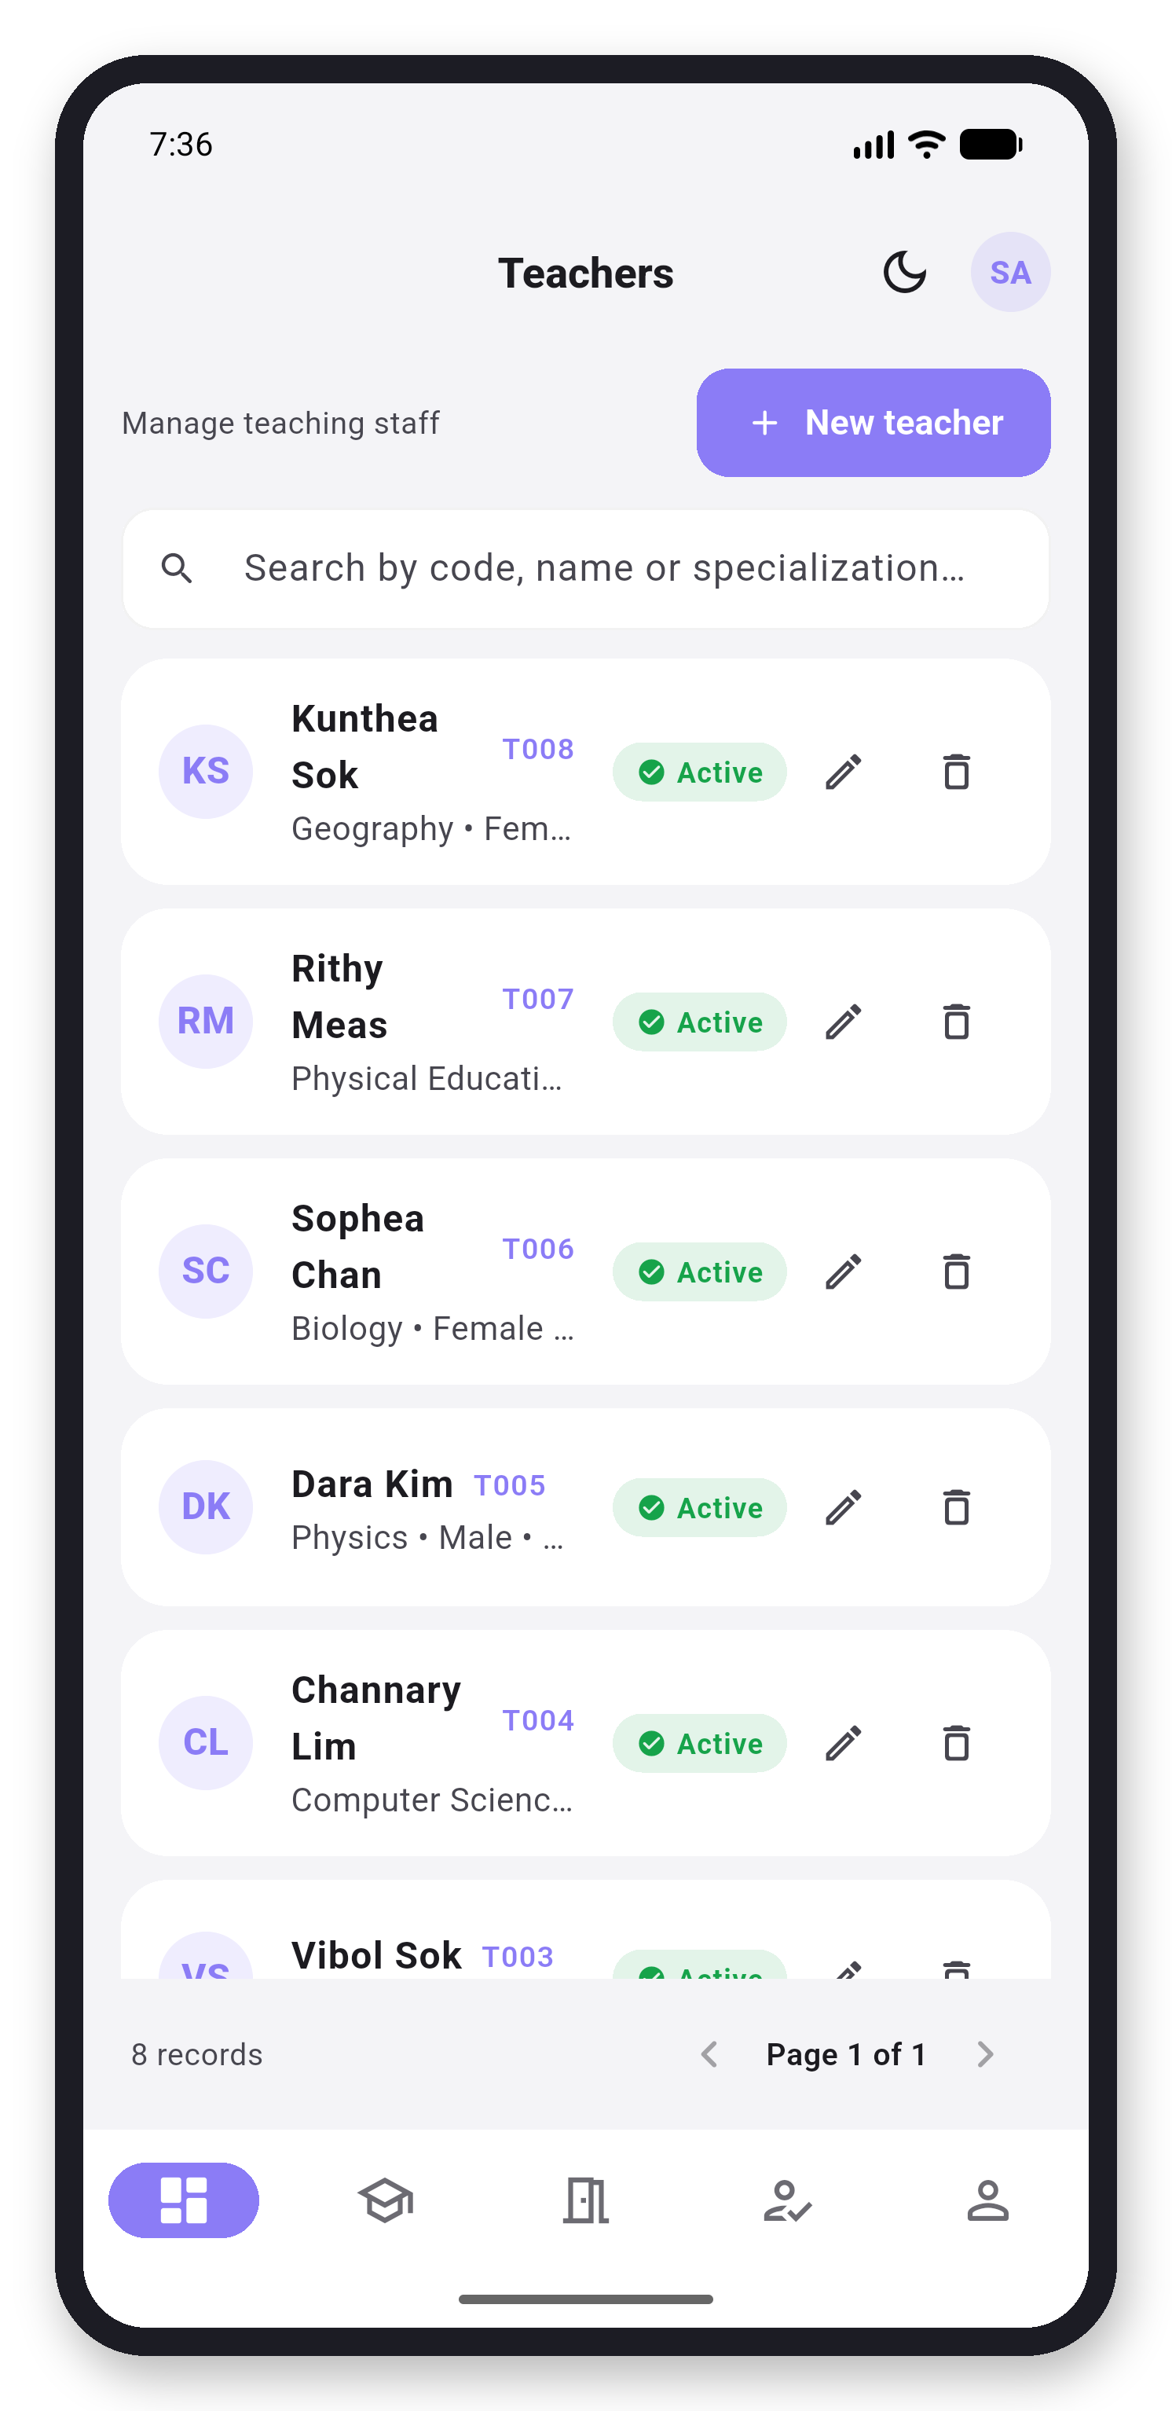  Screen 5: Teachers | 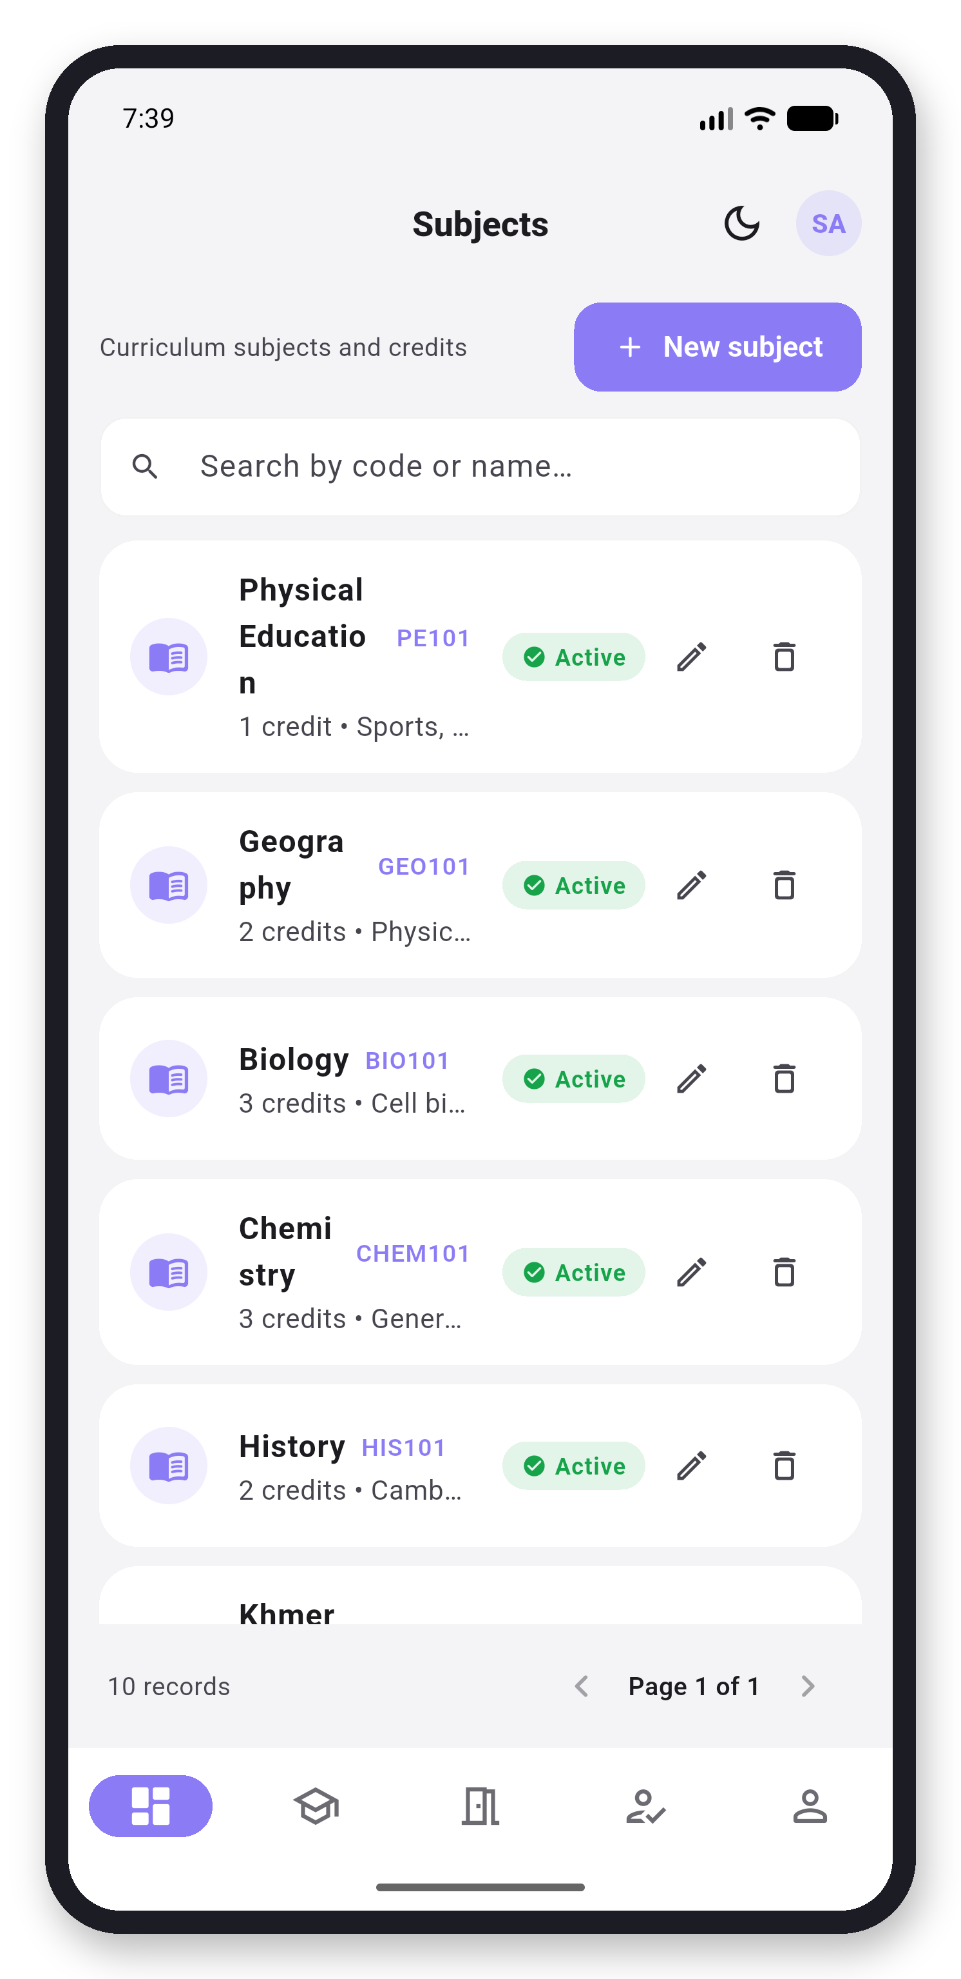  Screen 6: Subjects
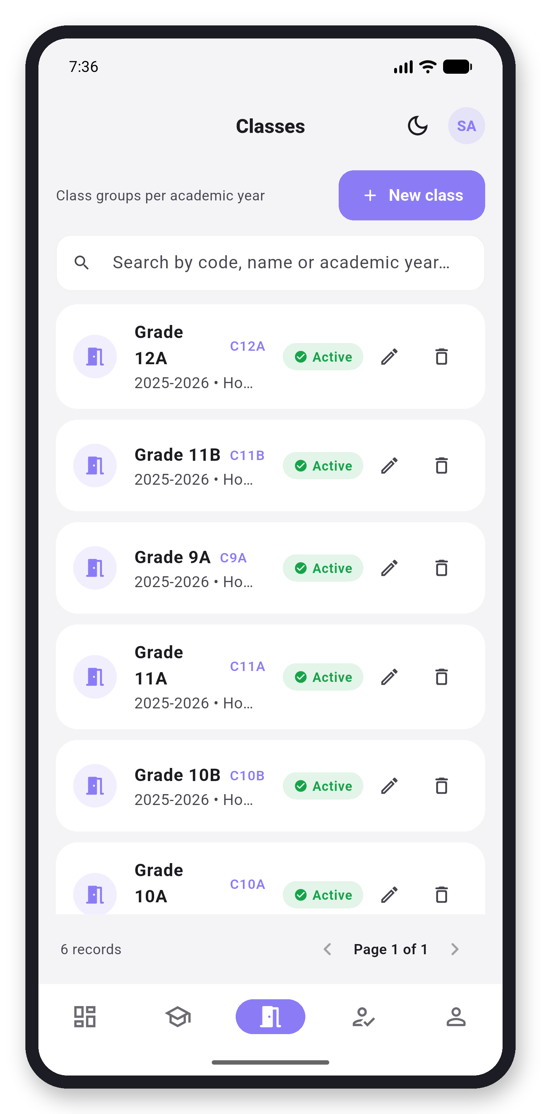  Screen 7: Classes | 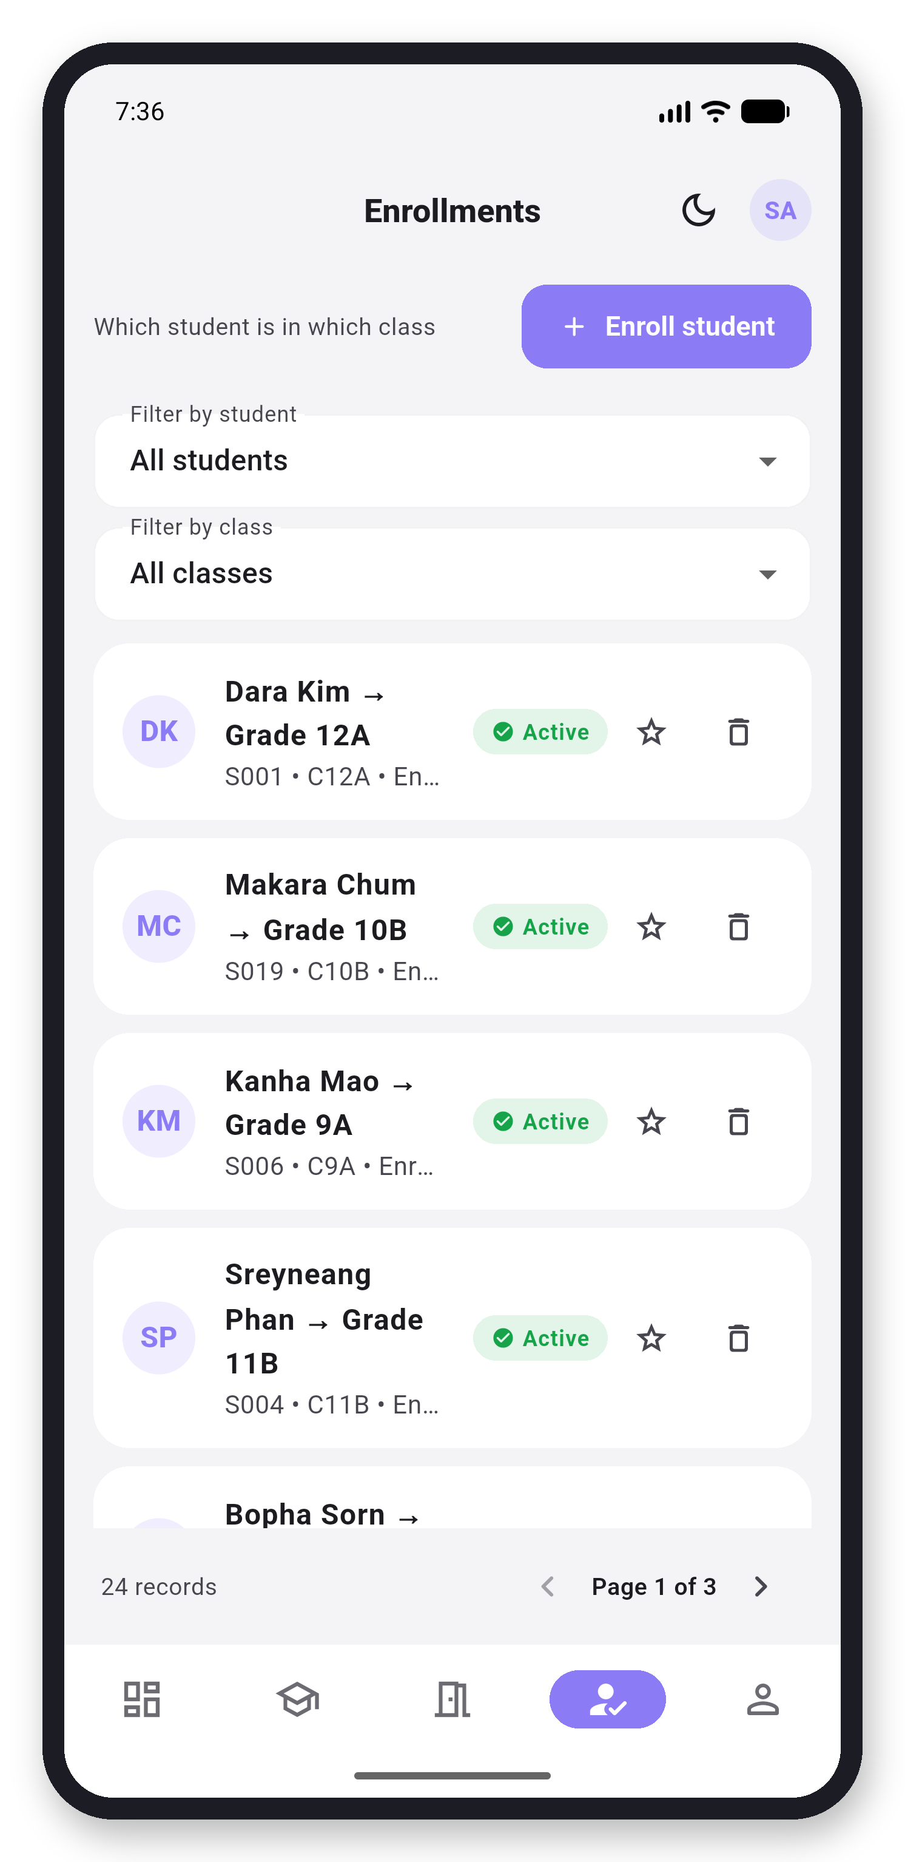  Screen 8: Enrollments
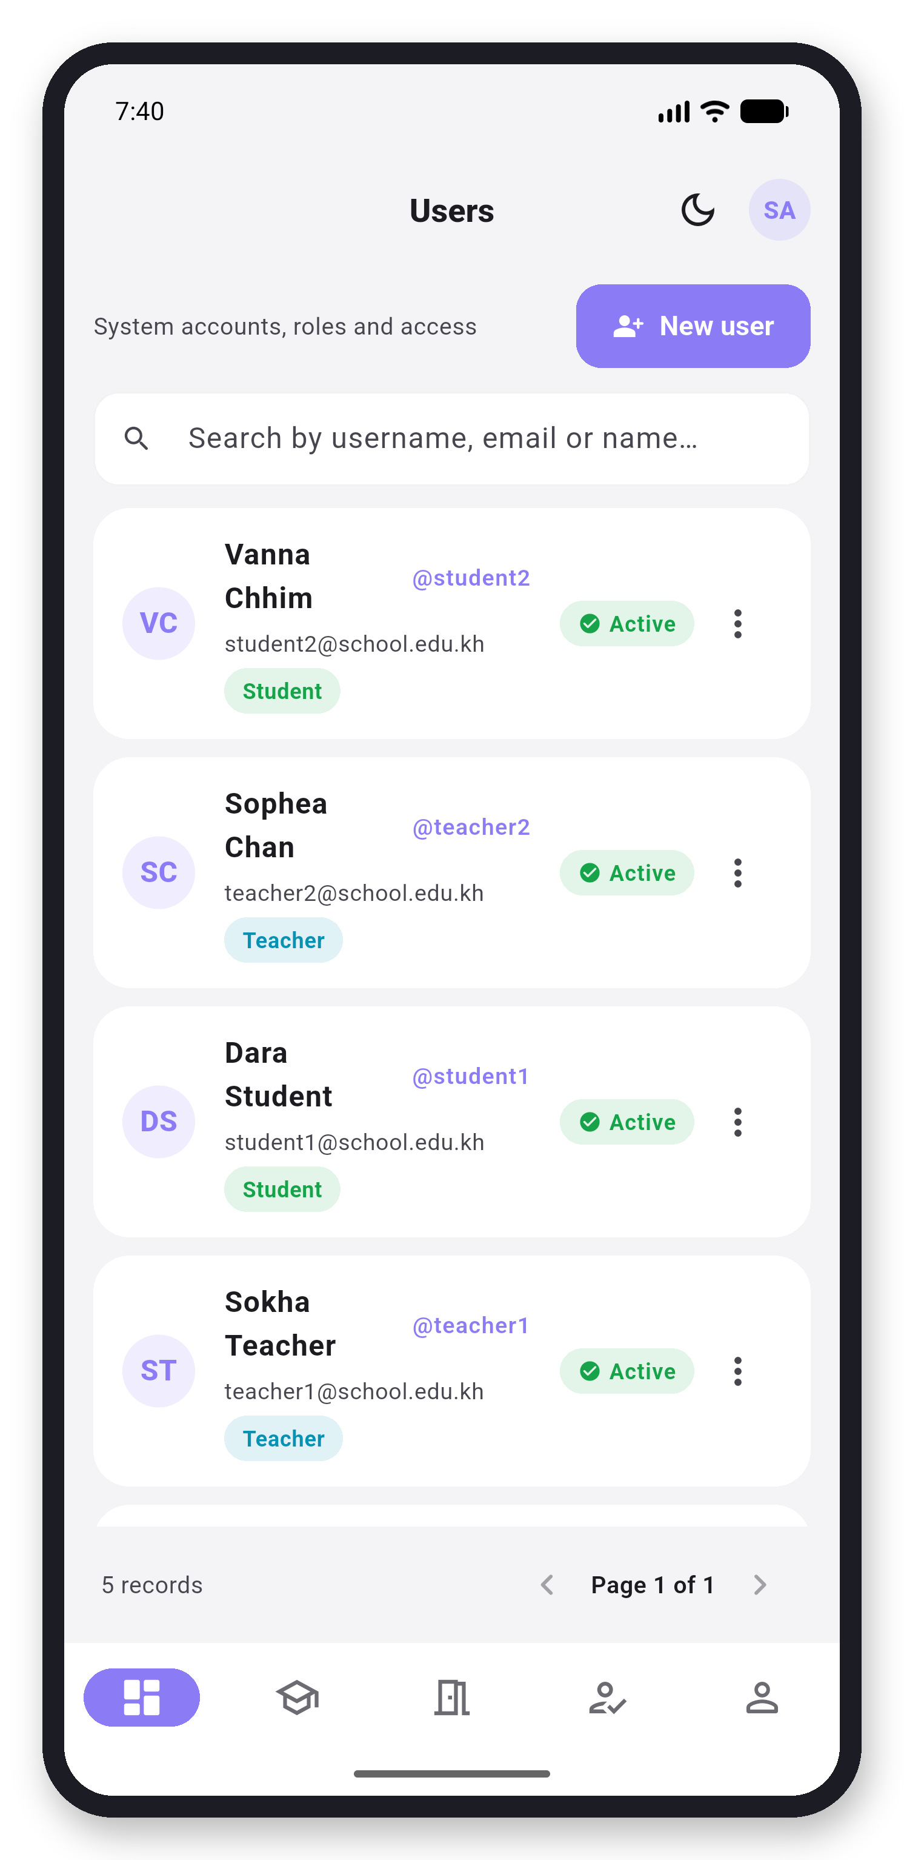  Screen 9: Users | 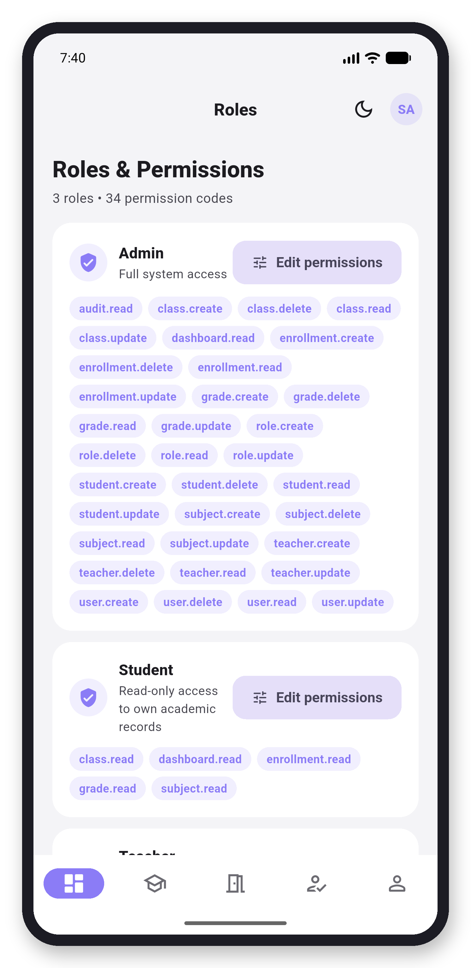  Screen 10: Roles
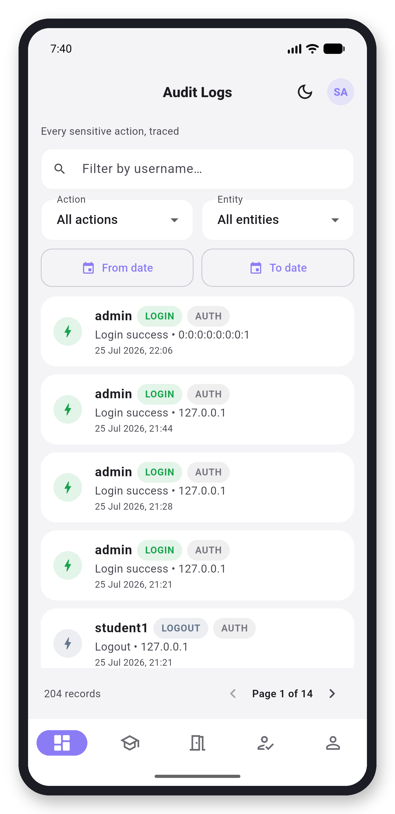  Screen 11: Audit Logs | 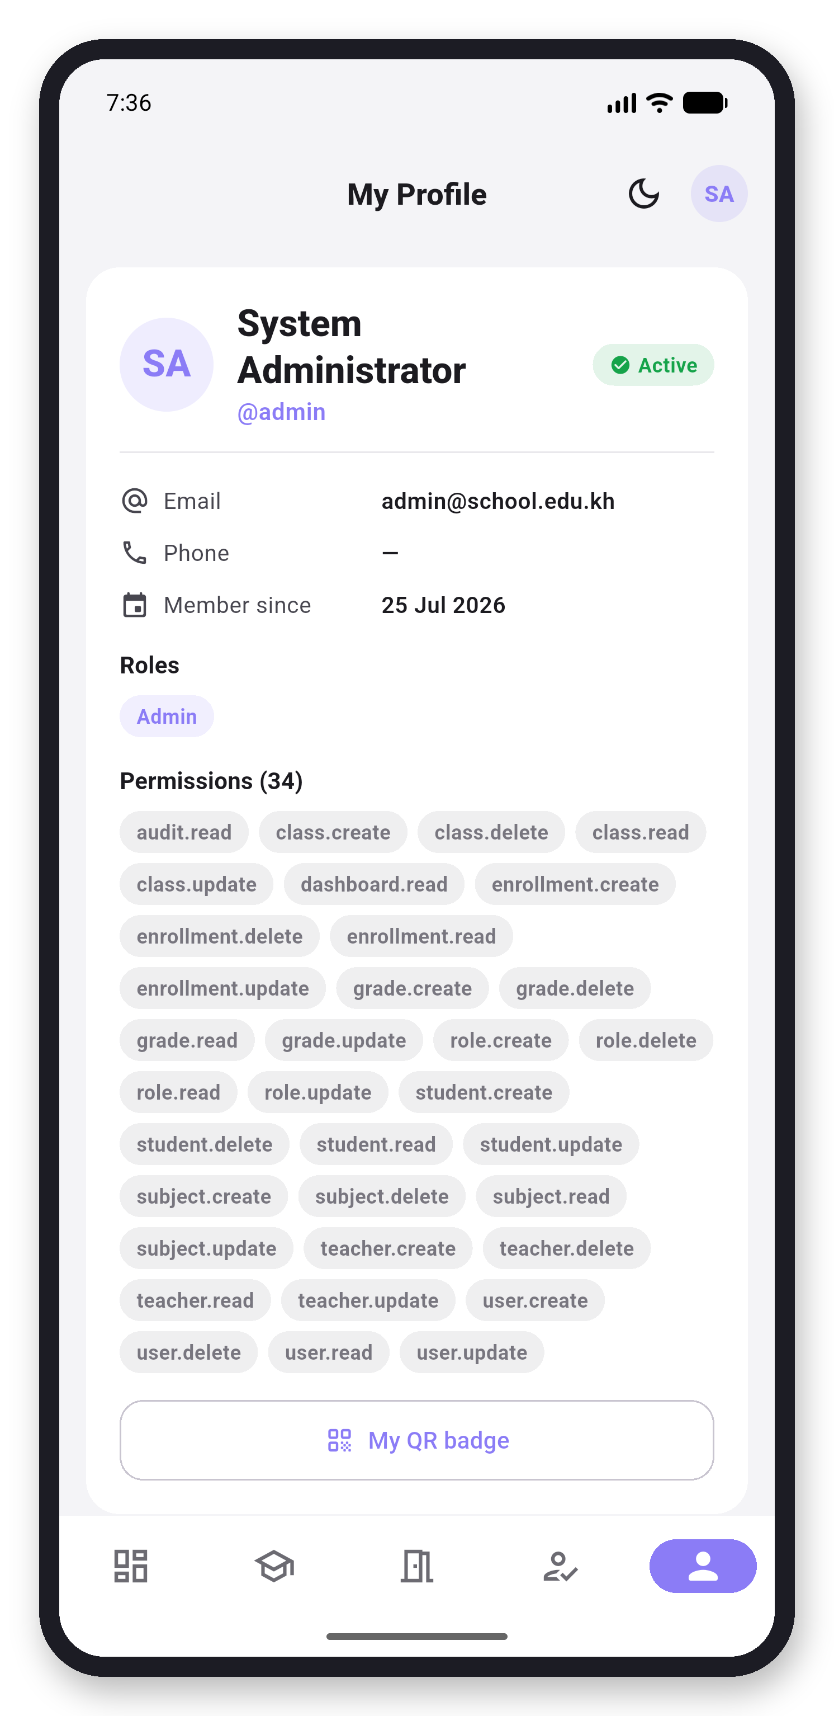  Screen 12: Profile

