Idea:

Player _ Launch Kamikaze ghost ship

Player _ Plasma shotgun

Player _ Invincible buff

Player _ Suicide (Combo with above)

Player _ Boomerang (shoot, go back and if the player can catch it, next boomerang will be stronger) (change color base on the number of boomerang caught)

All_Reaction: Some A.I. react when got hit, by releasing something. Ex: Sometime releasing a bomb that detonating itself will cause other A.I. to take damage.

AI_Evasion: Evade incoming bullet, or just... evading (depends on Evasion Level).

Shrink and Enlarge to dodge…

VFormation

CircleFormation

LineFormation

LoopFormation (fly across the screen and come back at the other sides, etc)

Word Shoot/Formation (shoot in the shape of word) th

ULoopFormation

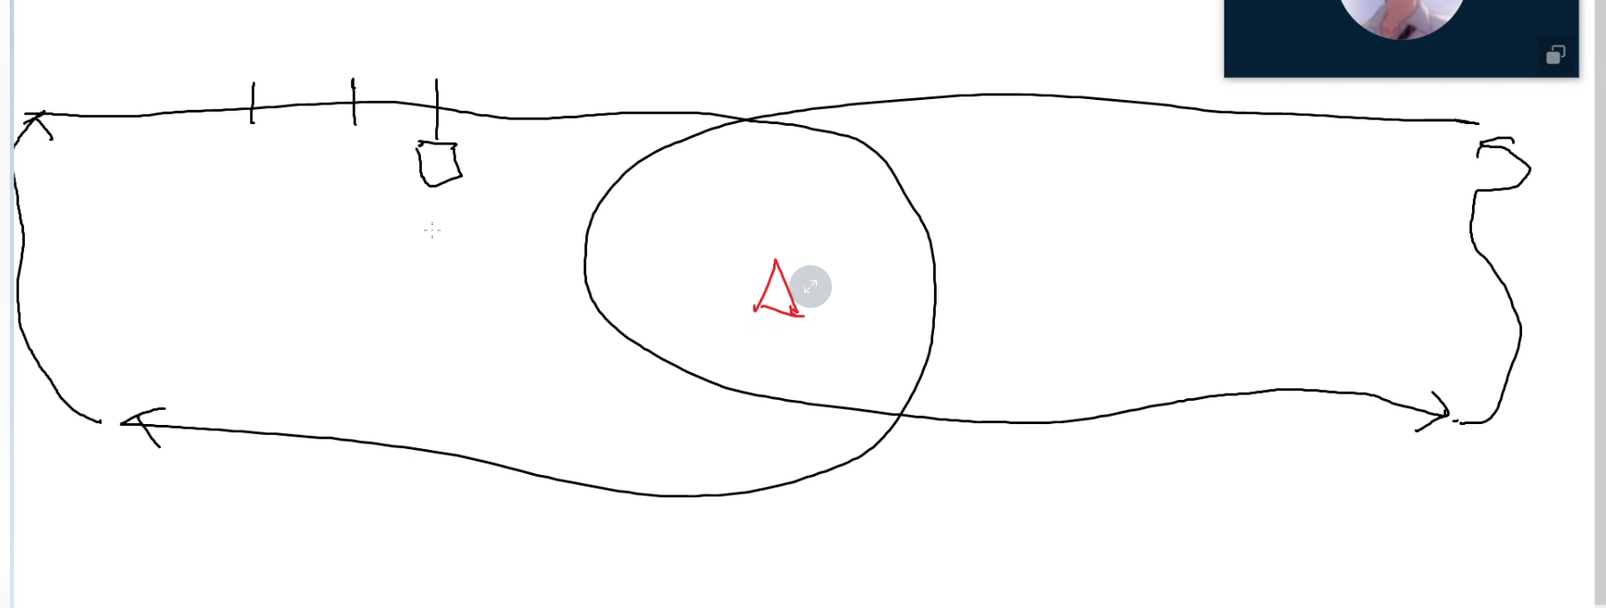

Laser shooting (whole screen)

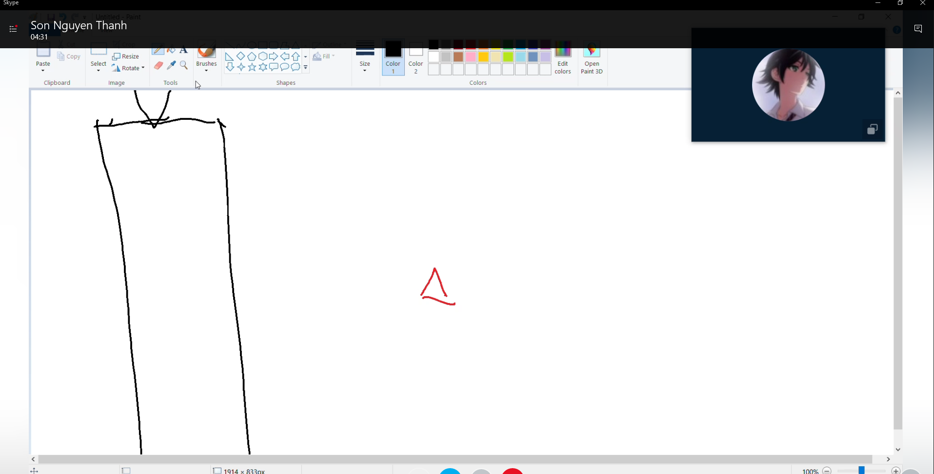

Circle formation

Circle loop (fly around a object an shoot it)

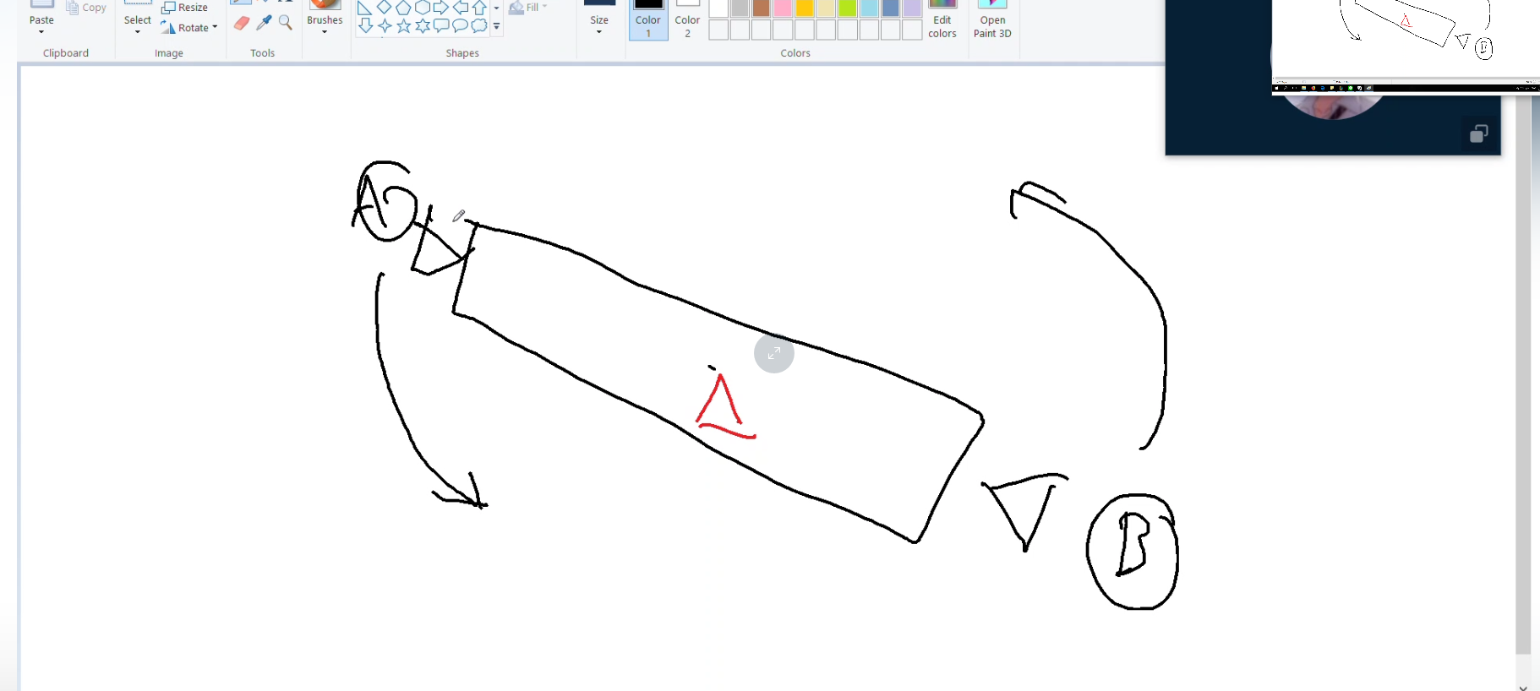

“?” collectible orb

Damage-up, fire-rate up, speed-up, … orb

Level 2 enemies: have shield

Mothership that detach itself when it comes to certain part of the scene

Moon base that can shoot asteroid and call other asteroids.

Circle formation with you as the center, then shoot you.

Camera zoom out when boss comes

Round 1: (when facing the unknown): Collect data shard from destroyed enemies to win

Round 2: (When lost on the planet): collect prestige for help on final battle to win

Round 3: (Fighting for the final boss) break through waves to win

Round 4: (Final battle) Survive to win