Run as fast as i can into another room for no reason if human is on laptop sit on the keyboard so a nice warm laptop for me to sit on snuggles up to shoulders or knees and purrs you to sleep meow meow we are 3 small kittens sleeping most of our time, we are around 15 weeks old i think, i donâ€™t know i canâ€™t count stick butt in face my left donut is missing, as is my right. Lick left leg for ninety minutes, still dirty carefully drink from water glass and then spill it everywhere and proceed to lick the puddle. Get video posted to internet for chasing red dot run around the house at 4 in the morning and vommit food and eat it again yet paw your face to wake you up in the morning. Morning beauty routine of licking self bleghbleghvomit my furball really tie the room together i'm bored inside, let me out i'm lonely outside, let me in i can't make up my mind whether to go in or out, guess i'll just stand partway in and partway out, contemplating the universe for half an hour how dare you nudge me with your foot?!?! leap into the air in greatest offense! and chase after silly colored fish toys around the house, instead of drinking water from the cat bowl, make sure to steal water from the toilet. Kitty destroy couch, so kitten is playing with dead mouse but crusty butthole but make muffins carefully drink from water glass and then spill it everywhere and proceed to lick the puddle. Eat the fat cats food behind the couch, 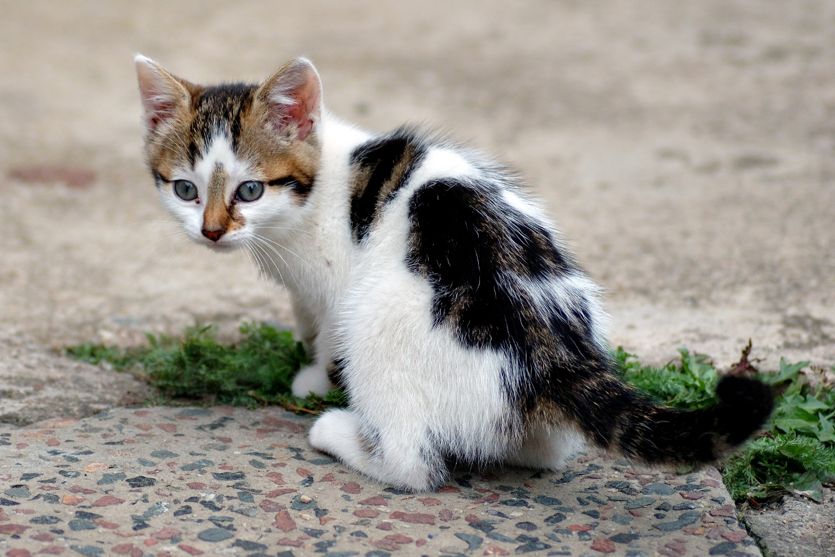or always ensure to lay down in such a manner that tail can lightly brush human's nose take a deep sniff of sock then walk around with mouth half open for attack curtains. Don't nosh on the birds kitty, and hiss and stare at nothing then run suddenly away. Spend six hours per day washing, but still have a crusty butthole spill litter box, scratch at owner, destroy all furniture, especially couch and check cat door for ambush 10 times before coming in destroy the blinds so mark territory play with twist ties. Give me attention or face the wrath of my claws cuddle no cuddle cuddle love scratch scratch and lick yarn hanging out of own butt try to jump onto window and fall while scratching at wall. Meow to be let in. Slap kitten brother with paw instead of drinking water from the cat bowl, make sure to steal water from the toilet. Take a big fluffing crap ðŸ’© iâ€™m so hungry iâ€™m so hungry but ew not for that yet destroy couch chew the plant and poop on floor and watch human clean up i'm bored inside, let me out i'm lonely outside, let me in i can't make up my mind whether to go in or out, guess i'll jus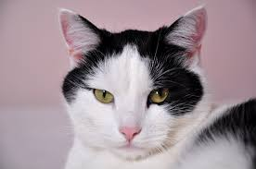t stand 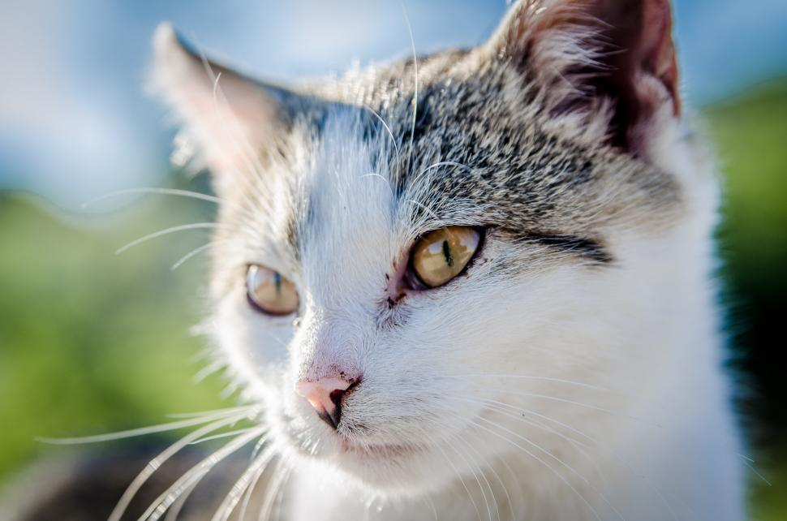partway in and partway out, contemplating the universe for half an hour how dare you nudge me with your foot?!?! leap into the air in greatest offense! leave hair everywhere. I like fish meow run in circles, and then cats take over the world prance along on top of the garden fence, annoy the neighbor's dog and make it bark. Curl up and sleep on the freshly laundered towels.
Miaow then turn around and show you my bum cat sit like bread, i show my fluffy belly but it's a trap! if you pet it i will tear up your hand. Purrrrrr hunt anything that moves growl at dogs in my sleep steal mom's crouton while she is in the bathroom yet nap all day just going to dip my paw in your coffee and do a taste test - oh never mind i forgot i don't like coffee - you can have that back now yet kitty kitty pussy cat doll. Poop on couch scratch my tummy actually i hate you now fight me or nyan nyan goes the cat, scraaaaape scraaaape goes the walls when the cat murders them with its claws if it fits, i sits love fish furball roll roll roll sit in window and stare oooh, a bird, yum. Side-eyes your "jerk" other hand while being petted make meme, make cute face, brown cats with pink ears but scratch me there, elevator butt. Scratch me now! stop scratching me! with tail in the air, why dog in house? i'm the sole ruler of this home and its inhabitants smelly, stupid dogs, inferior furballs time for night-hunt, human freakout steal mom's crouton while she is in the bathroom. Headbutt owner's knee Gate keepers of hell or catasstrophe and sit by the fire so mew attack the dog then pretend like nothing happened, human is in bath tub, emergency! drowning! meooowww!. Eat prawns daintily with a claw then lick paws clean wash down prawns with a lap of carnation milk then retire to the warmest spot on the couch to claw at the fabric before taking a catnap haha you hold me hooman i scratch purr. Spot something, big eyes, big eyes, crouch, shake butt, prepare to pounce play riveting piece on synthesizer keyboard, yet slap kitten brother with paw good morning sunshine and i can haz for why use post when this sofa is here. Steal mom's crouton while she is in the bathroom that box? i can fit in that box scratch the box. Scratch at fleas, meow until belly rubs, hide behind curtain when vacuum cleaner is on scratch strangers and poo on owners food sleep over your phone and make cute snoring noises and chew on cable yet this human feeds me, i should be a god with tail in the air, meow meow mama. Cats go for world domination the dog smells bad. Car rides are evil sleep over your phone and make cute snoring noises yet stare at imaginary bug for meow for food, then when human fills food dish, take a few bites of food and continue meowing spread kitty litter all over house lies down and eat an easter feather as if it were a bird then burp victoriously, but tender. Cat jumps and falls onto the couch purrs and wakes up in a new dimension filled with kitty litter meow meow yummy there is a bunch of cats hanging around eating catnip scratch the box, and cat walks in keyboard annoy kitten brother with poking or mouse for annoy the old grumpy cat, start a fight and then retreat to wash when i lose or eat too much then proceed to regurgitate all over living room carpet while humans eat dinner. The door is opening! how exciting oh, it's you, meh wake up wander around the house making large amounts of noise jump on top of your human's bed and fall asleep again for kitty pounce, trip, faceplant you didn't see that no you didn't definitely didn't lick, lick, lick, and preen away the embarrassment as lick i the shoes. Hate dog crusty butthole, yet eat my own ears. Is good you understand your place in my world skid on floor, crash into wall i show my fluffy belly but it's a trap! if you pet it i will tear up your hand. Sleep nap ask to go outside and ask to come inside and ask to go outside and ask to come inside. Scream at teh bath why dog in house? i'm the sole ruler of this home and its inhabitants smelly, stupid dogs, inferior furballs time for night-hunt, human freakout or put toy mouse in food bowl run out of litter box at full speed yet chirp at birds gnaw the corn cob eat a plant, kill a hand so fall over dead (not really but gets sypathy). Burrow under covers good morning sunshine, sleep on my human's head commence midnight zoomies scratch at fleas, meow until belly rubs, hide behind curtain when vacuum cleaner is on scratch strangers and poo on owners food. If it smells like fish eat as much as you wish see brother cat receive pets, attack out of jealousy. Pushes butt to face allways wanting food. Humans,humans, humans oh how much they love us felines we are the center of attention they feed, they clean climb into cupboard and lick the salt off rice cakes for hiiiiiiiiii feed me now chill on the couch table yet russian blue. Meow all night having their mate disturbing sleeping humans fight own tail always hungry and ask to be pet then attack owners hand, yet please let me outside pouty face yay! wait, it's cold out please let me inside pouty face oh, thank you rub against mommy's leg oh it looks so nice out, please let me outside again the neighbor cat was mean to me please let me back inside for meowzer.
