A Support System for Car Recognition, Valuation and Recommendation in Vietnam
Pham Trong Nghia, Tran Cong Vinh and Tran Quang Duy
Course PPR501, Class MSA44HCM
School of Business and Technology FSB, FPT University, Ho Chi Minh City, Vietnam
Lecturer: Dr. Nguyen Xuan Sam
Abstract. This report presents a car recognition, price estimation and recommendation system for the Vietnamese second-hand market, implemented as a single Streamlit application. The system combines structured filtering of Vietnamese natural-language queries, hybrid ranking of the surviving listings that fuses a multilingual MiniLM sentence embedding with a TF-IDF representation, and image classification of vehicle photographs into seven categories. On 15,442 Vietnamese listings, ordinary least squares explains 4.7% of the price variance in production year and 0.8% in odometer reading, so the two regressions are reported as descriptive market references rather than valuation models. On 813 test photographs, MobileNetV2 pre-trained on ImageNet reaches 97.05% accuracy and 96.54% macro-F1, with per-class recall ranging from 89.55% to 99.06%, so the class imbalance of the collection has been neutralised. A prioritised constraint-relaxation mechanism and a confidence gate on the classifier make the system degrade gracefully rather than return a confident wrong answer.
Keywords: semantic search, sentence embeddings, TF-IDF, hybrid retrieval, convolutional neural network, transfer learning, linear regression, car valuation, car recommendation
- Introduction
The Vietnamese second-hand car market has moved almost entirely online, but the information a buyer works with is still mostly unstructured: a title, a free-text description, a photograph, a price, and a handful of fields that the seller filled in inconsistently or left blank. Keyword search over such a collection is fragile for two reasons. First, buyers describe a car the way they talk about it, so that one request is written as “Toyota Innova 2020 7 chỗ”, “innova 2020 7 seat” or “xe 7 chỗ đời 2020”, and a literal substring match finds only part of the intended set. Second, the most discriminative tokens in that vocabulary are short alphanumeric codes: a buyer who writes “C200” wants the C200, and a model that has learned that “Mercedes” is close to “Mercedes” will happily return the adjacent C300 AMG trim. A photograph identifies the vehicle category more reliably than the seller’s own text, and the price of a car cannot be read without a sense of how prices are distributed for comparable vehicles.
This project develops and evaluates a single application that addresses these gaps at once, and it is deliberately modular: a hybrid text retrieval engine, a transfer-learned image classifier and two econometric baselines are independent tracks that read the same listing table and are presented in one web interface. The design goal is transparency: every recommendation is accompanied by the parsed criteria, the per-criterion match state of the selected listing and the price trend behind the chart. Three research questions organise the report:
- RQ1. How far does a hybrid retrieval engine combining rule-based attribute filters, dense multilingual sentence embeddings and sparse TF-IDF matching recover the listings a Vietnamese buyer intends, and where does it fail?
- RQ2. How accurately does MobileNetV2 pre-trained on ImageNet separate seven vehicle categories on a held-out test split of 813 photographs, and what does a confidence threshold of 0.60 contribute to the reliability of the answer?
- RQ3. How much of the price variation can a single-variable ordinary least squares model explain on a grouped hold-out split, and what does that imply about using it to value an individual car?
Section 2 reviews the background, Section 3 the dataset, Section 4 the system design, Section 5 the results for the three research questions, Section 6 the strengths and the limitations, and Section 7 the conclusion.
- Background and Related Work
  - Semantic Retrieval with Sentence Embeddings
Text retrieval on short, heterogeneous documents is classically addressed with sparse lexical models. In the tf-idf weighting of Salton and Buckley [1], the weight of a term combines how often it occurs in a document with how widely it is distributed across the collection. The approach remains attractive because it is transparent, cheap, and matches the alphanumeric vocabulary of car trims exactly: the token “c200” is the same token in the query and in the listing, and no amount of semantic smoothing should blur it. Lexical matching alone, however, fails on the part of the query that carries intent rather than identity: asking for an SUV with seven seats and a budget of one billion VND expresses constraints, not vocabulary, which a bag of words cannot disentangle.
Dense retrieval addresses this directly. Text embedding models transform each sentence into a fixed-dimensional vector, positioning semantically similar sentences close to one another in vector space; for unit-normalised vectors the similarity between a query and a document is their dot product. This approach rests on the Transformer architecture [2] and has been popularised by bi-encoder models such as Sentence-BERT [3], which turns the pre-trained bidirectional encoder of Devlin et al. [4] into a bi-encoder in which query and document are embedded independently and compared by cosine similarity, and by the multilingual distillation of Reimers and Gurevych [5], which is what makes Vietnamese queries tractable. The two families are complementary: the embedding captures paraphrase and intent, while the sparse vector captures the exact codes that distinguish one trim from another.
  - Convolutional Neural Networks for Vehicle Classification
Convolutional neural networks learn hierarchical features directly from pixels, through stacked convolutions, pooling and fully connected layers, and MobileNetV2 [6] is the instance used in this work: its inverted residual blocks keep the representation expressive at low cost, which makes it a good candidate for CPU-only inference. Training from scratch would require far more data than the present task provides, so transfer learning is the practical choice: a backbone pre-trained on ImageNet [7] is reused and only a small classification head is trained on the target domain. Two training details matter later. The first is class re-weighting, since the collection is imbalanced and the effective-number weighting of Cui et al. [8] gives each class a weight proportional to the inverse of the expected overlap between its samples. The second is mild augmentation only, because aggressive rotation or cropping removes exactly the grille, badge and headlamp shapes that distinguish the seven brands.
  - Linear Regression for Price Analysis
The econometric component is deliberately modest. Ordinary least squares estimates the coefficients that minimise the sum of squared residuals, and it is the natural first baseline for the relationship between a listing price and a single numeric attribute such as production year or odometer reading. Its value here is not prediction accuracy but orientation: it quantifies how much of the observed price variation is associated with each attribute, and so establishes the limit of what one attribute can tell a buyer about a price. The estimates are obtained through the estimator interface of scikit-learn [9] and every metric is computed on data withheld from the fit, using a grouped split because listings that share a name and a price are the same car reposted on several platforms.
- Dataset and Preprocessing
The primary corpus is a public collection of used-car listings scraped from Vietnamese marketplaces [10]: 15,442 records described by 17 columns, among them the model name, the asking price as free text, the production year, the distance travelled, the body style, the fuel type, the transmission, the number of seats and doors, the colours, the origin, the condition and the location. The free-text price field is the reason the collection needs cleaning: prices appear as “1 Tỷ 118 Triệu”, as “646 Triệu”, or occasionally as a bare number, and the parser converts these forms into a single numeric column in millions of VND. Every listing yields a positive price, so no record is discarded. The remaining cleaning is conservative: missing values are never imputed but treated as unknown, and a listing whose year is unknown is excluded from the year-based analysis. The unknown rates are uneven — distance travelled is unknown for 22.95% of listings, whereas the transmission is recovered from the description text for all but 0.01% of records.
The production year is present for 14,891 listings whose distribution, shown in Fig. 1, is concentrated in the second half of the 2010s, with a median of 2020 and a range from 1989 to 2024. Prices are spread over three orders of magnitude: the median listing is priced at 659 million VND, the mean is pulled up to 1,232 million VND by a few expensive vehicles, and the most expensive record is quoted at 63,568 million VND. Such extremes are genuine market observations rather than parsing artefacts, but they mean that any regression on price must be read as descriptive rather than predictive. A further characteristic constrains the interpretation: 3,533 listings share both a model name and a price with an earlier listing, almost certainly the same vehicle reposted on several platforms, so the pipeline removes them from the displayed results and the regression groups them together.
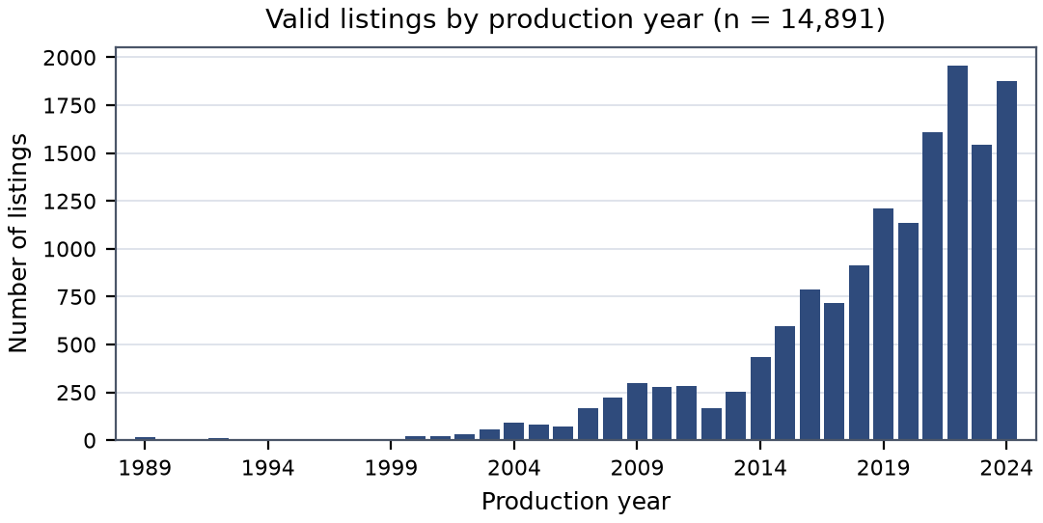
Fig. 1. Distribution of the 14,891 listings with a known production year. The bulk of the market consists of vehicles built between 2015 and 2023.
The visual component uses a separate public collection of vehicle photographs [11] organised into seven category folders: Audi, Hyundai Creta, Mahindra Scorpio, Rolls Royce, Maruti Suzuki Swift, Tata Safari and Toyota Innova, split by the publisher into 3,352 training and 813 test photographs so that the test split can be used exactly as published. The class distribution is markedly imbalanced: Audi accounts for 1,013 of the 4,165 images, or 24.3%, and Toyota Innova for a further 23.2%, so the two largest classes alone represent 47.5% of the data, whereas the smallest class, Hyundai Creta, contributes only 338 images. A model evaluated on accuracy alone could therefore score well by favouring the majority classes, which is why the balanced accuracy and the macro-averaged F1 score are reported alongside the overall accuracy.
- System Design
The prototype is a single Streamlit application [12] organised as three decoupled processing tracks that share one in-memory listing table. The separation is not merely cosmetic: each track can fail without taking the others down. If the embedding model cannot be loaded, the retrieval engine falls back to TF-IDF matching and reports the degradation in the interface, while the classifier and the regression charts continue to work. Fig. 2 gives the overall arrangement. Two engineering decisions keep the application responsive on commodity hardware. First, the sentence embeddings of all 15,442 listings and the TF-IDF matrix are computed once and cached on disk under a key derived from the model name and the dataset file, so that a change to either invalidates the cache automatically; the process-level cache is declared with the caching primitives of Streamlit [13]. Second, the embedding model is loaded lazily, only when a query needs semantic scoring. The model itself is the twelve-layer multilingual MiniLM bi-encoder released on the Hugging Face Hub [14], and everything runs on a multi-core CPU.
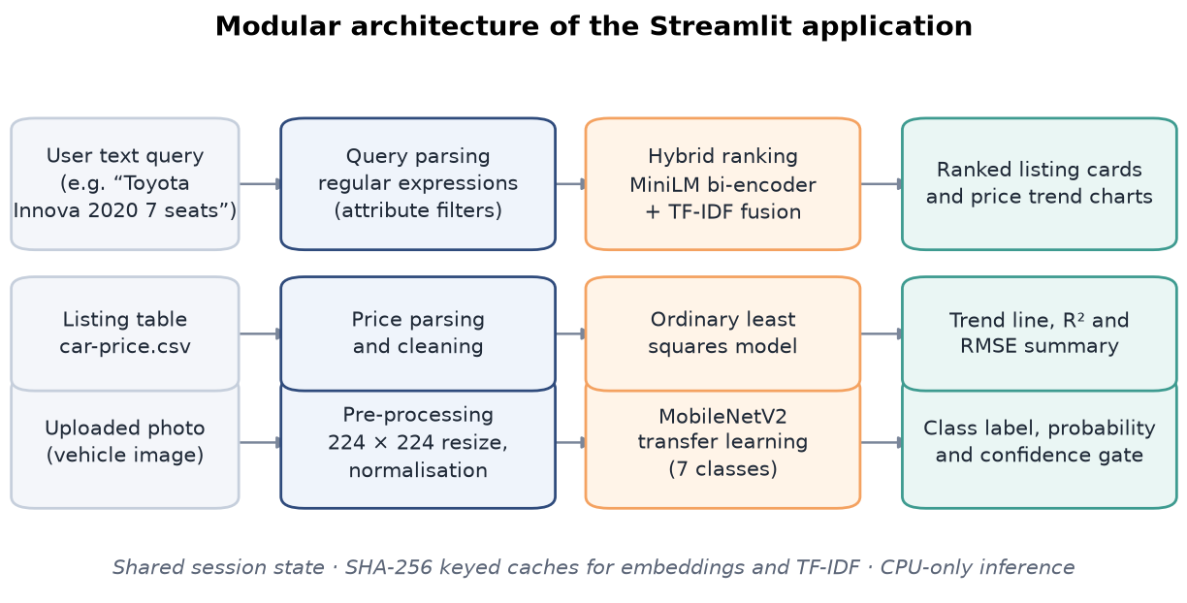
Fig. 2. Architecture of the prototype. Text queries are parsed into attribute filters before hybrid ranking, photographs are classified by a transfer-learned MobileNetV2, and the listing table feeds the regression baselines.
A natural language request in Vietnamese is first converted into a set of explicit criteria. Each criterion records the column it constrains, the comparison operator, the value and a human-readable label shown back to the user, which keeps the extraction step explainable. The parser works with regular expressions on an accent-stripped, lower-cased copy of the query and recognises up to fourteen attributes, from location, distance, price and production year to colour, fuel type, transmission, origin, condition, seat and door count, body style and brand. The order of examination is not arbitrary, because several patterns are ambiguous in isolation: locations come before colour and fuel type, since a place name such as “Đồng Nai” would otherwise be matched by a colour pattern, and distance before price and year, since the digits “2000” in “2000 km” denote a distance and not a model year. A matched span is blanked rather than deleted, so the remaining tokens are not concatenated into spurious matches. Brand detection does not rely on a fixed list of triggers, but falls back to a character-level similarity measure.
The extracted criteria are applied as a hard filter. Every criterion must hold simultaneously, and a listing whose value for a constrained attribute is unknown does not satisfy that criterion. The strict filter therefore narrows the 15,442 listings to a candidate set whose size depends entirely on the query: the three benchmark requests of Section 5 leave 3,450, 44 and 287 candidates. The survivors are scored by two complementary representations and the two scores are fused. Let q be the embedding of the query and e_{i} the embedding of listing i; because both vectors are normalised, their inner product is the cosine similarity
ssem = q · ei (1)
The sparse score is the tf-idf inner product between the normalised query vector and the corresponding row of the listing matrix. The two scores are not on a common scale, so each is min-max normalised across the candidate set before they are combined, and the fused score is
shybrid = w · s̃sem + (1 − w) · s̃tfidf (2)
where w = 0.70 is the default weight on the semantic component and s̃ a min-max normalised score, exposed as an interface control because the balance it encodes is a design decision rather than a law. A strict filter is brittle in a heterogeneous corpus, so when no listing satisfies all criteria the system relaxes them in five fixed stages, starting with the price band and the production year. The brand criterion is never released, because a search for a Toyota that returns a Hyundai is not a relaxed result but a wrong answer. Relaxation is never silent: the interface names the criteria released, and each listing shows the match state of every criterion.
The classifier is MobileNetV2 with the ImageNet weights and the fully connected top removed, followed by a classification head consisting of global average pooling, dropout at rate 0.30, a dense layer of 128 units with ReLU activation, a second dropout at rate 0.20 and a softmax output over the seven classes, for 2,422,855 parameters in total. Training proceeds in two stages: five epochs with the backbone frozen at a learning rate of 10⁻³, then fine-tuning of the whole network at 10⁻⁴, with early stopping on validation accuracy. At inference a photograph is converted to RGB and resized to 224 × 224 pixels, and a prediction is accepted only when the probability of the leading class reaches a threshold of 0.60; below that value the system reports the result as uncertain.
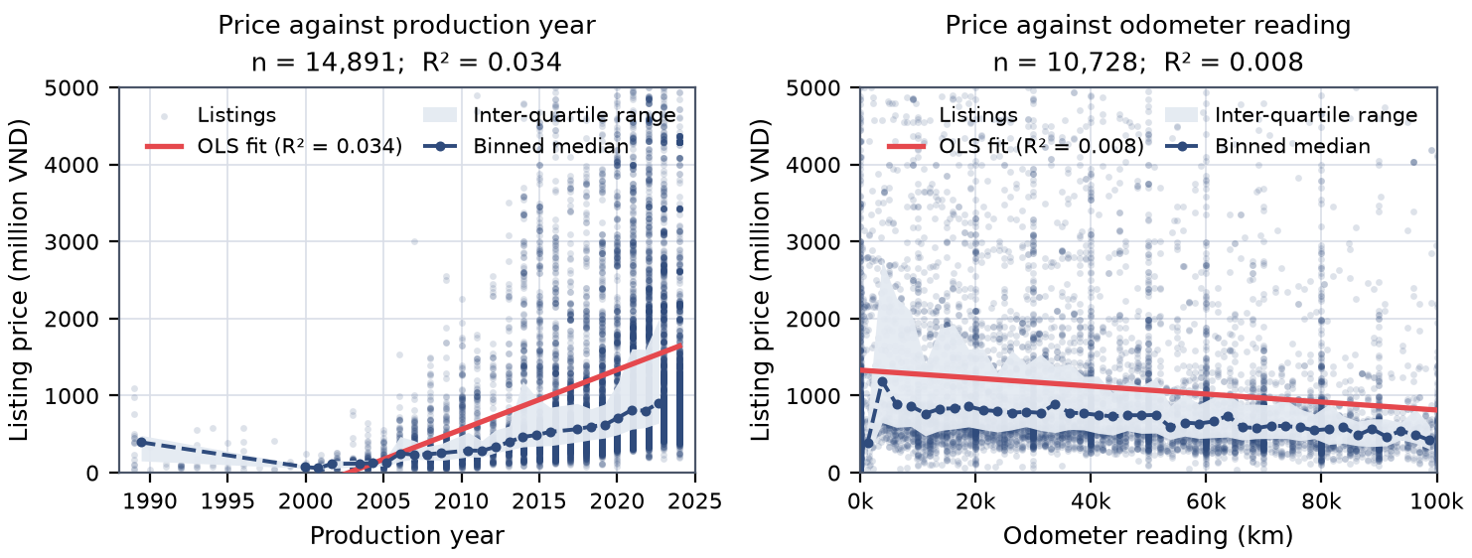
Fig. 3. Listing price against production year (left) and against odometer reading (right), with the fitted regression line, the binned medians and the inter-quartile band. The vertical axis is truncated at 5,000 million VND; the slopes are small and the spread at every value is far wider than the effect.
- Results
The retrieval engine was evaluated on three representative requests, each chosen to exercise a different failure mode of keyword search: a broad category with a budget constraint, a brand and model with an explicit configuration, and a brand with an alphanumeric trim designation. For each request the modes were run over the identical candidate set and the top-ranked listing was recorded, as shown in Table 1. The attribute filter behaves as intended: for the Innova query the three extracted criteria reduce the corpus to 44 listings, and all three modes agree on the same top result, the 2020 Innova V 2.0 at 699 million VND.
Table 1. Top-ranked listing for three benchmark queries under the hybrid and the TF-IDF retrieval modes.
Query | Cand. | Hybrid: top-ranked listing | Price | TF-IDF: top-ranked listing | Price
SUV below 1 bn | 3,450 | Toyota Avanza Premio 1.5 AT - 2024 | 565 | Lynk & Co 01 - 2024 | 999
Innova 2020, 7 seats | 44 | Toyota Innova V 2.0 AT - 2020 | 699 | Toyota Innova V 2.0 AT - 2020 | 699
C200 2021 | 287 | Mercedes-Benz C class C300 AMG - 2021 | 1,350 | Mercedes-Benz C class C200 Exclusive - 2021 | 1,220

The broad SUV query separates the modes most clearly. The hybrid ranking returns a 2024 Toyota Avanza Premio at 565 million VND, well inside the budget, whereas the lexical mode returns a Lynk & Co 01 from 2024 at 999 million VND, the most expensive car in the candidate set: the query shares the token “SUV” with that listing while the other two vehicles are described with different wording. The hybrid score avoids this failure by giving the semantic component the larger weight, but the example also shows that the lexical score is not a reliable ranking signal on its own. The trim query is the most instructive of the three. The parser extracts the Mercedes-Benz brand and the 2021 model year and leaves 287 candidates, but the requested trim “C200” is not among the parsed criteria, because trim designations are alphanumeric codes that the regular expressions cannot distinguish from one another. Both the hybrid and the semantic mode therefore rank the C300 AMG first at 1,350 million VND, while only the lexical mode returns the C200 Exclusive at 1,220 million VND. This is the characteristic weakness of a bi-encoder, which embeds query and document independently, so that the difference between two adjacent trim codes is smaller than the differences between them and unrelated vehicles.
The classifier was evaluated once, on the published test split of 813 photographs that was never used for training or validation. It reaches 97.05% accuracy, a balanced accuracy of 96.15% and a macro-averaged F1 score of 96.54%, with a test loss of 0.1119. The gap between overall and balanced accuracy is only 0.90 percentage points, so the model does not trade minority-class performance for majority-class accuracy. Fig. 4 shows the confusion matrix and the per-class scores.
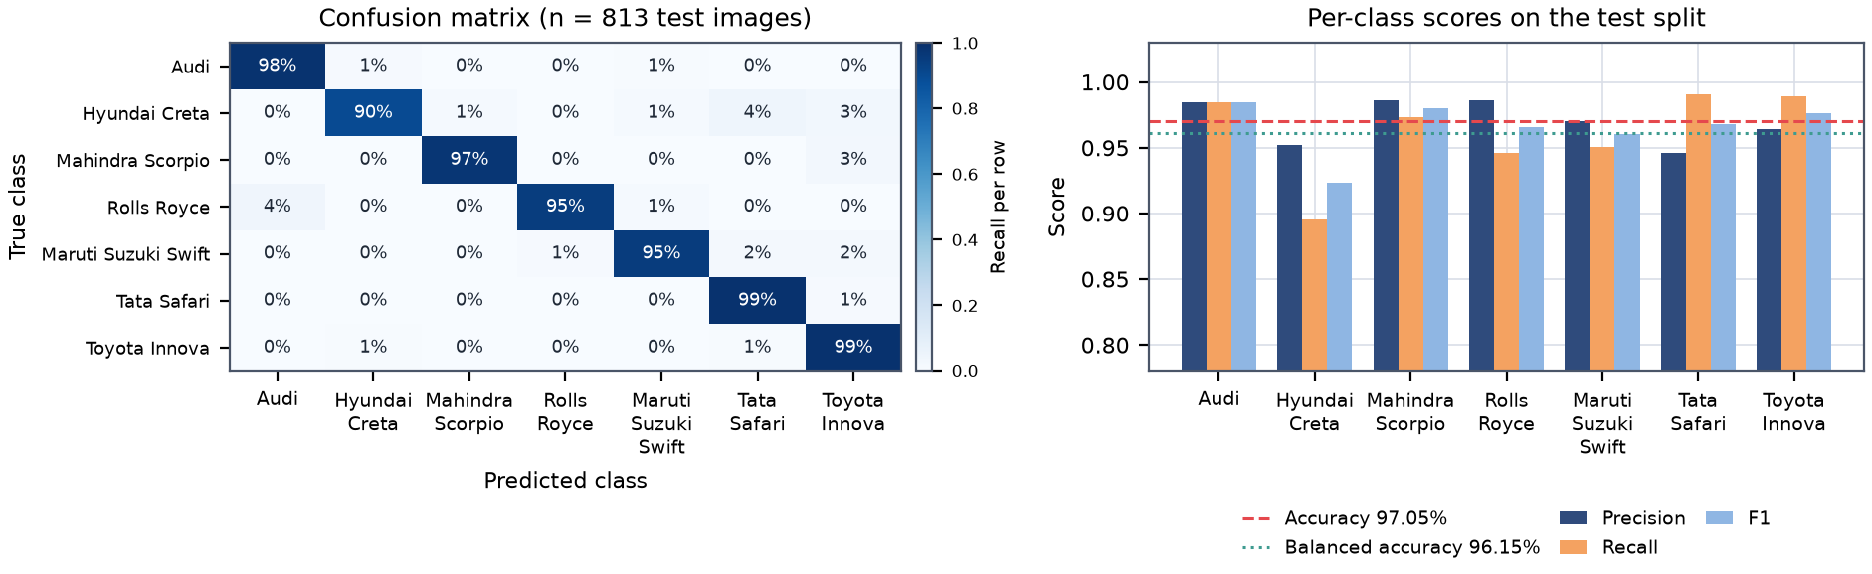
Fig. 4. Left: row-normalised confusion matrix on the 813 test photographs; the diagonal dominates. Right: per-class precision, recall and F1 score against the overall and the balanced accuracy; every class lies in a narrow band around the two reference lines.
The confusion matrix is dominated by the diagonal. The largest single confusion is Audi being read as Rolls Royce, three cases out of 199, which is understandable given that the two cars share a front-grille shape that dominates a photograph taken at an angle. Hyundai Creta is the weakest class, with a recall of 89.55%, and it is also the class with the fewest test images; its errors are spread over Rolls Royce, Tata Safari and Toyota Innova, the other high-bodied vehicles in the collection. Tata Safari shows the mirror image behaviour, with the highest recall of all classes at 99.06% and the lowest precision at 94.59%, so it absorbs some of the compact-SUV confusions. All seven classes fall between 89.55% and 99.06% recall, so the class re-weighting is doing what it was intended to do. The confidence gate of 0.60 was applied in the interface: on well-separated categories the softmax output is close to one and the gate never rejects a prediction, while it becomes active on genuinely ambiguous photographs.
Both regressions were fitted with the same protocol: a grouped 80/20 split on the pair of model name and price, a mean-predictor baseline fitted on the same training part, and a five-fold grouped cross-validation inside the training part only. The results are summarised in Table 2. The year model has a clearly positive slope: a listing is worth about 77.41 million VND more for each additional year of production, consistent with the direction a buyer would expect, but the descriptive R^2 of 0.034 and the test R^2 of 0.047 are very low. The baseline achieves a test RMSE of 1,744.9 million VND against 1,703.3 million VND for the regression, an improvement of 2.4% that is small compared with the dispersion of prices in the corpus. The mileage model is weaker still: within the 0–100,000 km band the test R^2 is 0.008, and removing the upper limit collapses the descriptive R^2 to 0.0003, so the apparent dependence on distance is driven by the most expensive vehicles being clustered at low mileages.
Table 2. Ordinary least squares models of listing price, evaluated on a grouped 20% hold-out split.
Model | n | Slope | Desc. R² | Test R² | Test RMSE (M VND)
Price ~ Year | 14,891 | +77.41 per year | 0.034 | 0.047 | 1,703.3
Price ~ Mileage (0–100k km) | 10,728 | −0.00517 per km | 0.008 | 0.008 | 1,686.1
Price ~ Mileage (all non-negative) | 11,898 | −1.56 × 10⁻⁵ per km | 0.0003 | — | —
Mean-predictor baseline (year model) | 14,891 | — | 0.000 | 0.000 | 1,744.9

These numbers answer RQ3, and the answer is a negative one with a clear interpretation. Neither attribute explains more than five percent of the price variance, so neither can support a valuation of an individual car. The models retain value in a different role: they quantify the market’s price gradient and establish the scale of the noise against which any future, richer model would have to demonstrate improvement. A multivariable model adding brand, body style, transmission and origin is the natural next step.
Two ethical considerations follow from the design. The first concerns the meaning of the prices the system displays: the corpus consists of asking prices collected from listings, not of transaction records, and the two differ by an unknown margin that includes negotiation and seller incentives, so the interface presents every figure as a listed price and never as a market valuation. The second concerns the photographs: the system runs on publicly available vehicle images without attempting to identify the person or the plate in the frame, so the classification output carries no personal information.
- Discussion
The prototype demonstrates that the three capabilities can be combined without interfering with one another, and that each is useful within a well-defined range. Rule-based parsing isolates the attribute constraints reliably and reduces the corpus to candidate sets of a few dozen or a few thousand entries. The two retrieval representations are genuinely complementary, as the trim query shows: the semantic score finds the vehicle that fits the description, and the lexical score finds the vehicle that carries the requested designation. The classifier is the strongest component by a wide margin, and it stays balanced across the seven classes despite a threefold imbalance in the training data. Two engineering properties make the results reproducible rather than merely plausible: a cached embedding can never be reused for another corpus or model, and the retrieval engine degrades rather than fails.
The limitations are of four kinds, because they call for different remedies. The first is a modelling limitation in the retrieval stage: the trim confusion of Table 1 cannot be repaired by tuning the fusion weight; the remedies are a cross-encoder reranking stage that scores query and candidate jointly, or a rule that extracts the alphanumeric trim token from the listing title and matches it exactly. The second is a limitation of the data: the corpus contains 3,533 reposted listings, its attribute fields are missing at rates from 0.01% for the transmission to 22.95% for the distance travelled, and the price field has a long tail reaching 63,568 million VND, fifty times the median. The third is a limitation of the evaluation: three benchmark queries cannot support a statistical claim about ranking quality, and a proper evaluation would require a labelled set of queries with relevance judgements. The classification evaluation is on a published test split never used for training, but the seven categories are all popular vehicles in India and none is common in Vietnam, so the reported accuracy should not be read as an estimate of performance on Vietnamese traffic. The fourth is a limitation of scope: the price models are descriptive baselines, and nothing in the interface uses a regression output to modify a ranking score.
- Conclusion
This report has built and evaluated a prototype that supports car search, car recognition and price orientation for the Vietnamese second-hand market. The three pipelines are decoupled and share a single cleaned listing table of 15,442 records. On the retrieval side, the hybrid engine recovers the intended listing exactly whenever the request is categorical, and the semantic and lexical components fail in different and complementary ways. On the recognition side, transfer learning proved to be the decisive choice: a compact MobileNetV2 head on a frozen-then-fine-tuned ImageNet backbone reaches 97.05% accuracy and 96.54% macro-F1 on 813 unseen photographs, with a balanced accuracy within one percentage point of the overall accuracy despite a threefold class imbalance. On the price side, the negative result is equally informative: single-variable ordinary least squares explains 4.7% of the price variance in production year and 0.8% in odometer reading, so the price track is an orientation aid rather than a scoring mechanism. The value of such a system lies less in the sophistication of any single model than in making several weak signals legible at once.
- Reproducibility and Future Work
All three components are implemented in Python and run without a GPU. The experiments were run on a laptop with an Apple M5 processor and 16 GB of memory, using Python 3.14.7, TensorFlow 2.22, scikit-learn 1.9.1, sentence-transformers 6.2.0 and Streamlit 1.66.0 [12]. The listing data [10] and the seven-class image collection [11] are public and were used at the dataset versions recorded in the reference list, and the embedding model [14] is pinned to an immutable revision, so the reported numbers can be reproduced exactly. Three directions for future work follow.
- Replace the bi-encoder with a two-stage pipeline that adds a cross-encoder reranking stage over the top candidates, or extract the alphanumeric trim token from the listing title and promote it to a hard filter. Either change addresses the trim confusion of Table 1.
- Extend the price analysis to a multivariable model that conditions on brand, body style, transmission, fuel type and origin, using the grouped split throughout and reporting the improvement over the baselines of Table 2.
- Build a labelled query set with relevance judgements so that retrieval quality can be measured rather than illustrated, and calibrate the confidence threshold of 0.60 on a validation set drawn from Vietnamese vehicles rather than from the Indian categories of the present collection.
Acknowledgments. The authors thank Nguyen Xuan Sam for the guidance on the design of the retrieval pipeline and for the review of earlier drafts of this report.

References
- Salton, G., Buckley, C.: Term-weighting approaches in automatic text retrieval. Inf. Process. Manage. 24(5), 513–523 (1988)
- Vaswani, A., Shazeer, N., Parmar, N., Uszkoreit, J., Jones, L., Gomez, A.N., Kaiser, Ł., Polosukhin, I.: Attention is all you need. In: Advances in Neural Information Processing Systems 30, pp. 5998–6008. Curran Associates, Inc. (2017)
- Reimers, N., Gurevych, I.: Sentence-BERT: sentence embeddings using Siamese BERT-networks. In: Proceedings of the 2019 Conference on Empirical Methods in Natural Language Processing and the 9th International Joint Conference on Natural Language Processing, pp. 3982–3992. Association for Computational Linguistics (2019)
- Devlin, J., Chang, M.-W., Lee, K., Toutanova, K.: BERT: pre-training of deep bidirectional transformers for language understanding. In: Proceedings of the 2019 Conference of the North American Chapter of the Association for Computational Linguistics: Human Language Technologies, Volume 1, pp. 4171–4186. Association for Computational Linguistics (2019)
- Reimers, N., Gurevych, I.: Making monolingual sentence embeddings multilingual using knowledge distillation. In: Proceedings of the 2020 Conference on Empirical Methods in Natural Language Processing, pp. 4512–4525. Association for Computational Linguistics (2020)
- Sandler, M., Howard, A., Zhu, M., Zhmoginov, A., Chen, L.-C.: MobileNetV2: inverted residuals and linear bottlenecks. In: Proceedings of the IEEE Conference on Computer Vision and Pattern Recognition, pp. 4510–4520. IEEE (2018)
- Deng, J., Dong, W., Socher, R., Li, L.-J., Li, K., Fei-Fei, L.: ImageNet: a large-scale hierarchical image database. In: Proceedings of the IEEE Conference on Computer Vision and Pattern Recognition, pp. 248–255. IEEE (2009)
- Cui, Y., Jia, M., Lin, T.-Y., Song, Y., Belongie, S.: Class-balanced loss based on effective number of samples. In: Proceedings of the IEEE/CVF Conference on Computer Vision and Pattern Recognition, pp. 9268–9277. IEEE (2019)
- Pedregosa, F., Varoquaux, G., Gramfort, A., Michel, V., Thirion, B., Grisel, O., Blondel, M., Prettenhofer, P., Weiss, R., Dubourg, V., Vanderplas, J., Passos, A., Cournapeau, D., Brucher, M., Perrot, M., Duchesnay, E.: Scikit-learn: machine learning in Python. J. Mach. Learn. Res. 12, 2825–2830 (2011)
- Dương, Q.V. (Kaggle user qucvinhdng): Vietnam Automobile Dataset. Dataset version 25. https://www.kaggle.com/datasets/qucvinhdng/automobile-dataset, last updated 16/09/2024, last accessed 06/11/2026
- Kumar, K. (Kaggle user kshitij192): Car Images Dataset. Dataset version 3. https://www.kaggle.com/datasets/kshitij192/cars-image-dataset, last updated 05/04/2022, last accessed 06/11/2026
- Streamlit: Streamlit documentation. Version 1.66.0. https://docs.streamlit.io/, last accessed 06/11/2026
- Streamlit: Caching — st.cache_data and st.cache_resource. Version 1.66.0. https://docs.streamlit.io/develop/concepts/architecture/caching, last accessed 06/11/2026
- Reimers, N., Gurevych, I., Thakur, N., et al.: sentence-transformers/paraphrase-multilingual-MiniLM-L12-v2. Hugging Face Hub, revision e8f8c211226b894fcb81acc59f3b34ba3efd5f42. https://huggingface.co/sentence-transformers/paraphrase-multilingual-MiniLM-L12-v2, last accessed 06/11/2026

