

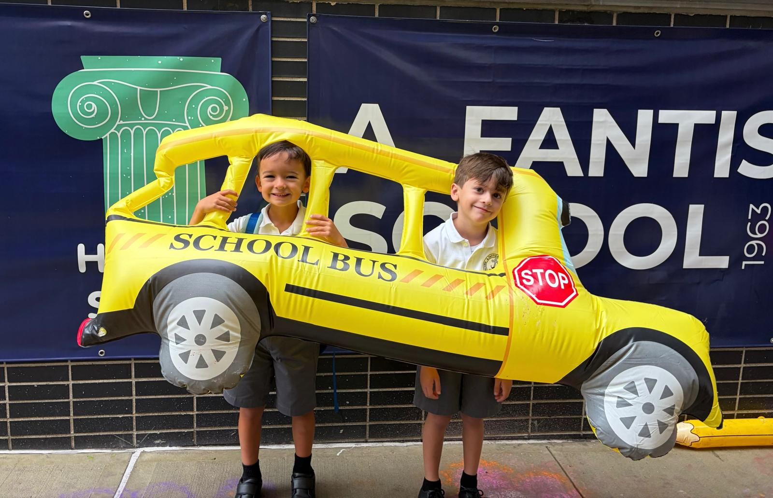

Dear A. Fantis Families,
The school year is officially underway!
After the excitement of the first day (above) and the joy of reconnecting with friends, we’re settling into new routines with homework, Beyond the Bell, and Afterschool clubs. Last Thursday, we had the chance to meet our children’s teachers and learn more about the year ahead during Curriculum Night. We hope you enjoyed the wine & cheese hosted by the PTO. The beginning of the year is an exciting time and perhaps a little overwhelming as we find our rhythm. But remember: We are all in this together!
Whether you're a new family finding your way around or a returning family ready for another year of Fantis traditions, please know that you are part of the PTO and you can reach out to the PTO Board anytime at pto@afantis.org ! Our next opportunities to meet in person are the Back to School Happy Hour, on Fri, Oct 2nd, and the first PTO Meeting of the year on Tue, Oct 13, in person right after Pastries with the Principals. Save the dates and see more details below.
Stay up to date through the School Calendar and the PTO Linktree.
Warmly,
Your PTO Board

🗓️ Save the Dates 🗓️

- Fri, Sept 25: Dress Down Day Fundraiser: Covenant House New York
Sat, Sept 26: Community Picnic in Prospect Park
Wed, Sept 30: School closed for PK3 & K-8; Break Camp available (Full day for UPK)
Wed-Fri, Sept 30-Oct 2: G5-8 Frost Valley Trip
- Fri, Oct 2: Back to School Happy Hour, 4-7pm, Church Courtyard
Mon, Oct 5: World Teachers' Day - see how to participate below
Thu, Oct 8: PTO K-3 Virtual Author Visit: Matt de la Pena & Loren Long, 1:30pm
Mon, Oct 12: School Closed: Columbus Day
Tue, Oct 13: Pastries with the Principals, 8am, Church Hall
Tue, Oct 13: PTO Meeting + Uniform Sale - 8:30, Church Hall
- Tue, Oct 20: Early Dismissal; Beyond the Bell available (no afterschool clubs)



Last Call For Discounted Spirit Gear
There are only a few days left to snag your A. Fantis spirit gear with 35% off! Sales end this Fri, Sept 25. Cute styles include T-shirts, hoodies, and sweatshirts, and they fit kids and adults, so the whole family can show their community pride. And the best of all - school spirit gear is approved for gym!
Shop the New Spirit Gear Here

Welcome Back Happy Hour: Oct 2nd
Join us for a relaxed afternoon of food, conversation, and connection in the Cathedral courtyard (64 Schermerhorn St) on Friday, Oct 2, at 4-7pm. We're switching things up this year to make our annual welcome-back gathering easier for faculty and staff to join, as well as for parents of students heading to Frost Valley, since our campers return that evening.
Childcare & dinner for students will still be offered, with some updates:
- In order to offer childcare this year, we have had to implement a max of 50 students from grades PreK3-G4 and a $5/child fee. The fee will help offset the cost of childcare & dinner for the students.
- You need to RSVP for yourself and for your child by Tue, Sep 29 if you plan to use childcare for any of the 4-7pm time slot, and are not signed up for BtB.
  - If your child already attends BtB & you still plan to leave at your designated time slot, you do not need to RSVP for your child (just RSVP for yourself)
  - Please RSVP if your child attends BtB & you would like them to stay for dinner at 6pm and anytime after that until 7pm.
- Spots are available on a first-come, first-served basis. We cannot accommodate additional students once we reach max occupancy.
- Cash payment/entry at the door for childcare will not be accepted.
- Childcare is open to A. Fantis students in grades PreK3-G4 only. We cannot accommodate children who are not current students or students in grades 5-8 who will not attend the Frost Valley trip.
- Dinner for students will be after 6pm.

50/50 Raffle: Your Chance to Win!
Our successful 50/50 raffle is back to our Welcome Back event this year, and tickets are now on sale through Fri, Oct 2. We'll draw the winner during the Welcome Back Happy Hour, and you don't need to be present to win. All proceeds support our 2026–27 PTO initiatives.
RSVP for the Welcome Back Happy Hour & Childcare
Want to lend a hand? We’d love you for it! Sign up to volunteer here

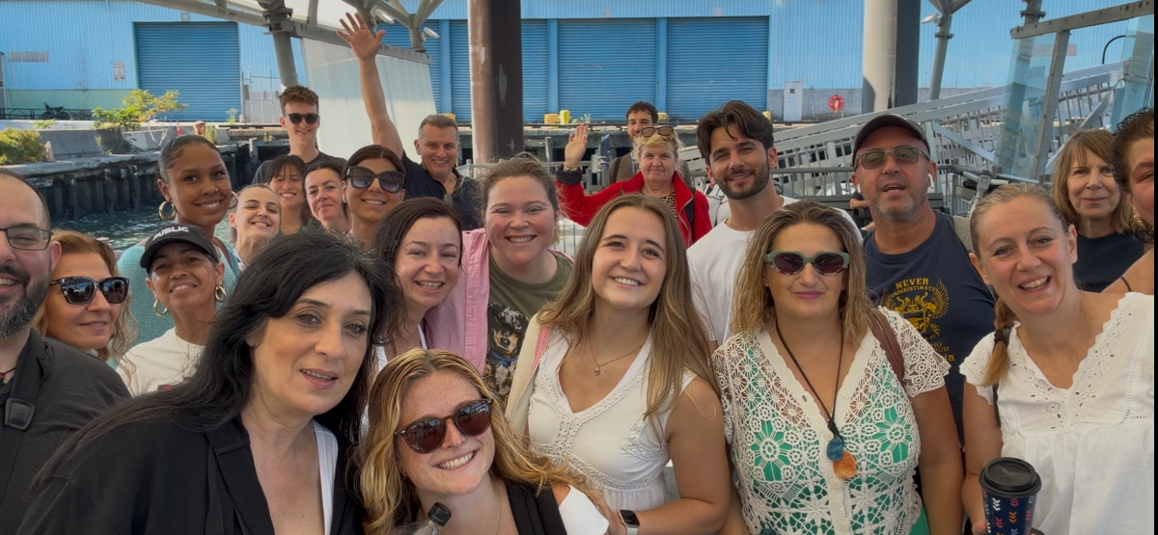

Let’s Celebrate Our Teachers
World Teachers’ Day is Mon, Oct 5, and we're getting ready to show our amazing faculty some love!
Every year, our A. Fantis community comes together to thank our teachers for everything they do for our children. From stocking the teachers' pantry to fulfilling classroom wish lists, there are many ways to show your appreciation. This year's collection runs from now through Sun, Oct 4.
Here are a few ways you can participate:
- Remind your child to make a card: A heartfelt note from a student can mean the world to a teacher!
- Shop a Teacher Wishlist: Help provide classroom supplies and items requested directly by our teachers.
  - K Wishlist
  - G1 Wishlist
  - G2 Wishlist
  - G3 Wishlist
* More wishlists to come as teachers provide them!
- Stock the Teachers' Pantry: Help keep our faculty lounge stocked with snacks and treats. We'll provide a link soon!
- Contribute to the Teacher Fund: Donations help cover faculty lunches and appreciation activities throughout the school year.
Let's make our teachers feel as appreciated as they truly are!

PTO Meeting & Uniform Sale: Oct 13
Thanks to the wonderful turnout at our in-person meetings last year, we're bringing more PTO meetings back to the school this year. We're kicking things off with our first official meeting of 2026-27 on Tuesday, Oct 13, beginning at 8:30 in the Church hall, right after Pastries with the Principals. And yes, we’ll host a Uniform Sale.
8-8:30am: Pastries with the Principals
Start your morning with a light breakfast, good conversation, and a chance to meet and mingle with our Principal, Ms. Panagiota Lilikaki, and Assistant Principal, Ms. Kathy Noufrios, and connect with fellow parents. All grades welcome!
8:30-9am: First PTO Meeting of the Year
Join us for our first PTO meeting of 2026-27! We'll share updates, discuss what's ahead, and hear your ideas as we work together to make this another fantastic year for our community. All grades welcome, including pre-school!
8-9am: Used Uniform Sale
Did your child mysteriously outgrow half their uniform over the summer? You're definitely not alone! Our Used Uniform Sale is back, just in time to prepare for the winter uniform season, which begins November 1. Donate your gently used uniform (no stains, no holes, no socks; Lands End and spirit gear items only) on Fri, Oct 9, or at drop-off on Tue, Oct 13. Please do not bring your donation outside of these dates.

Attention 8th Graders: Lands’ End Scholarship
The official uniform vendor for A. Fantis, Lands’ End is offering its 9th Annual School Starboard Scholarship to recognize and support the next generation of young leaders. Current Fantis 8th graders can apply for one of five $5,000 scholarships toward high school tuition or a 529 plan. Applications are open through January 15, 2027, but only the first 1,000 applications will be considered. If your child is interested, it’s worth getting started early. More Info here.

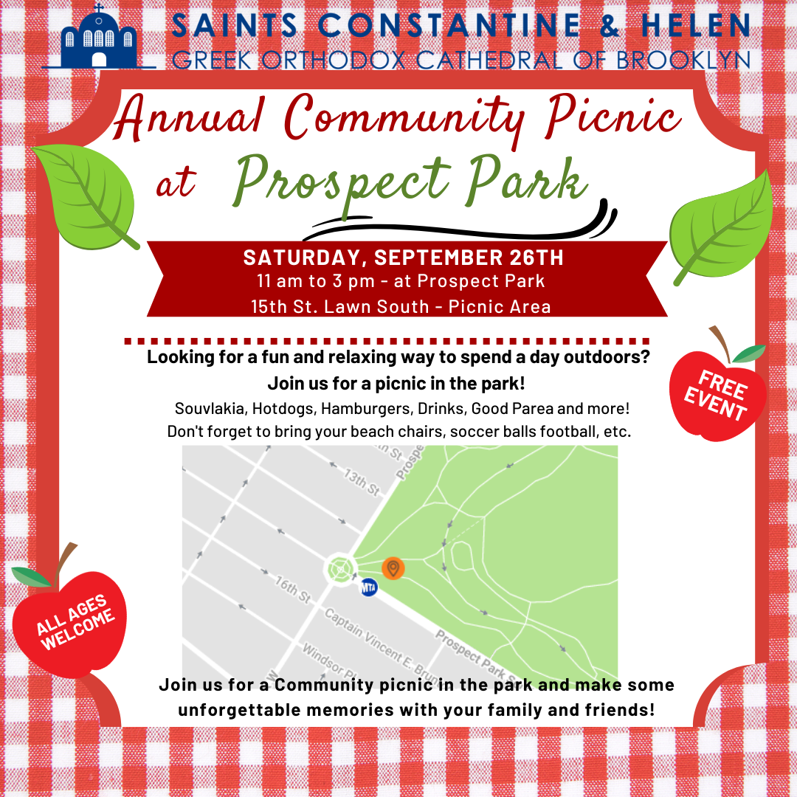

PTO Dues: Why They Matter
As part of PreK3 & K-8 tuition, PTO dues are already covered, and they make a big difference! These funds help offset the cost of gifts, community events, and supplies that make the school year fun and memorable for students, faculty, staff, and families alike. Thanks to your support, we’re able to kick off the year with beloved events like First Day of School Fun, the Welcome Back Happy Hour, and Pastries with the Principals. None of this would be possible without PTO dues - thank you!
As parents, your PTO dues automatically make you members of the PTO. We warmly invite you to get involved, attend events, and join our meetings throughout the year - the first PTO meeting is on Tue, Oct 13, in person right after Pastries with the Principals. We’re excited to host more in-person gatherings, and we invite every family to share ideas and suggestions, volunteer for an event or project, and help us create new traditions and keep our existing ones thriving.
PTO dues are an optional donation for families enrolled in the Universal Pre-K Program. If your child is in UPK and you are interested in donating, please click here. Thank you!

How to Shop, Save & Support Fantis
Did you know you can save money AND support A. Fantis at the same time? Our year long fundraisers make it easy: shop for exclusive discounts, and a portion of every purchase goes right back to our school programs.
- 1st Place Spirit Gear: Show off your school pride. Our 1st Place Spirit Gear is now always available, and every order helps fund PTO initiatives. Enjoy 35% off until this Fri, Sept 25!
- RaiseRight: Buy gift cards for everyday purchases (e.g. gas, groceries, coffee, dining, etc.) and a portion comes back to A. Fantis. It’s simple to set up: create an account at RaiseRight.com/Enroll, enter the enrollment code 6KPJTVYVYN9X to connect your account to A.Fantis, and download the RaiseRight app.
- Mabel's Labels: Durable name labels for gear and clothes. Search our school at www.mabelslabels.com and save on replacing lost items. 20% of all purchases support the PTO. Enjoy 25% off Ultimate Back to School Combo with code ULT25 until this Thu, Sept 24!
- Minted: Get 20% off cards, gifts & more with code FUNDRAISEAFANTIS while Fantis earns 10% back! Go to www.minted.com .
- Squadlocker: Show off your school pride. Our Squadlocker Spirit gear is always available, and every order helps fund PTO initiatives.
- Shoott: Use our special link to book your photo session, and a portion of the proceeds will come back to A. Fantis.
- Box Top$: Buy the brands you already love and earn $5 for A. Fantis. Learn how to earn using this link and browse all participating brands here.

In Case You Missed It

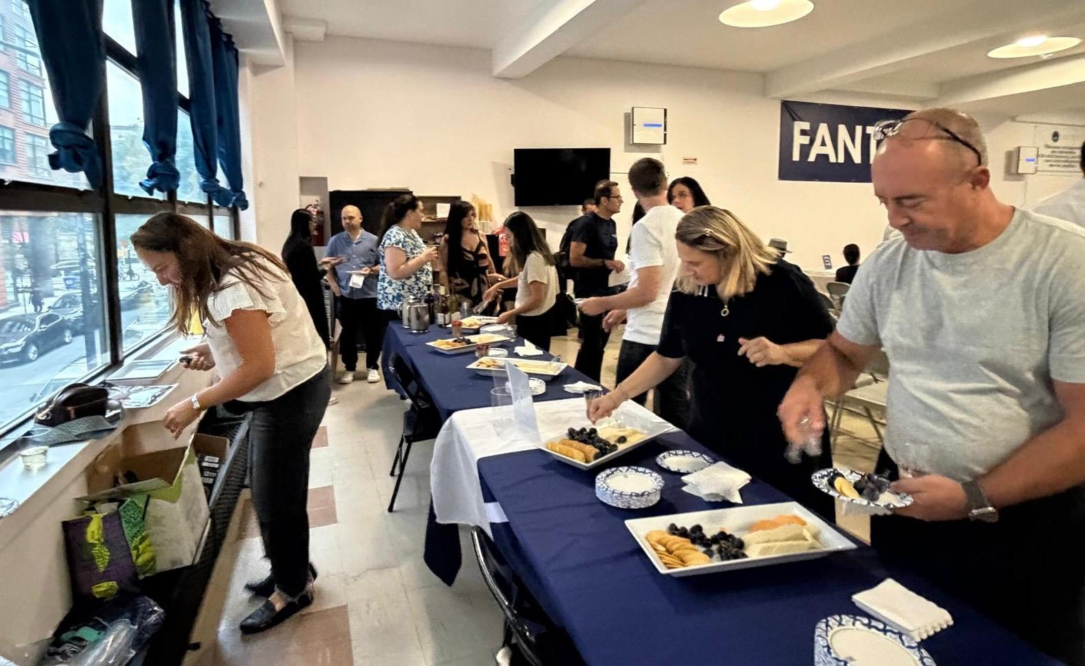
Curriculum Night - Last Thursday (Sept 17), a packed auditorium buzzed with energy as parents mingled and connected with each other, and with teachers and staff, while enjoying wine & cheese provided by PTO. So good to see the enthusiasm for the year ahead.

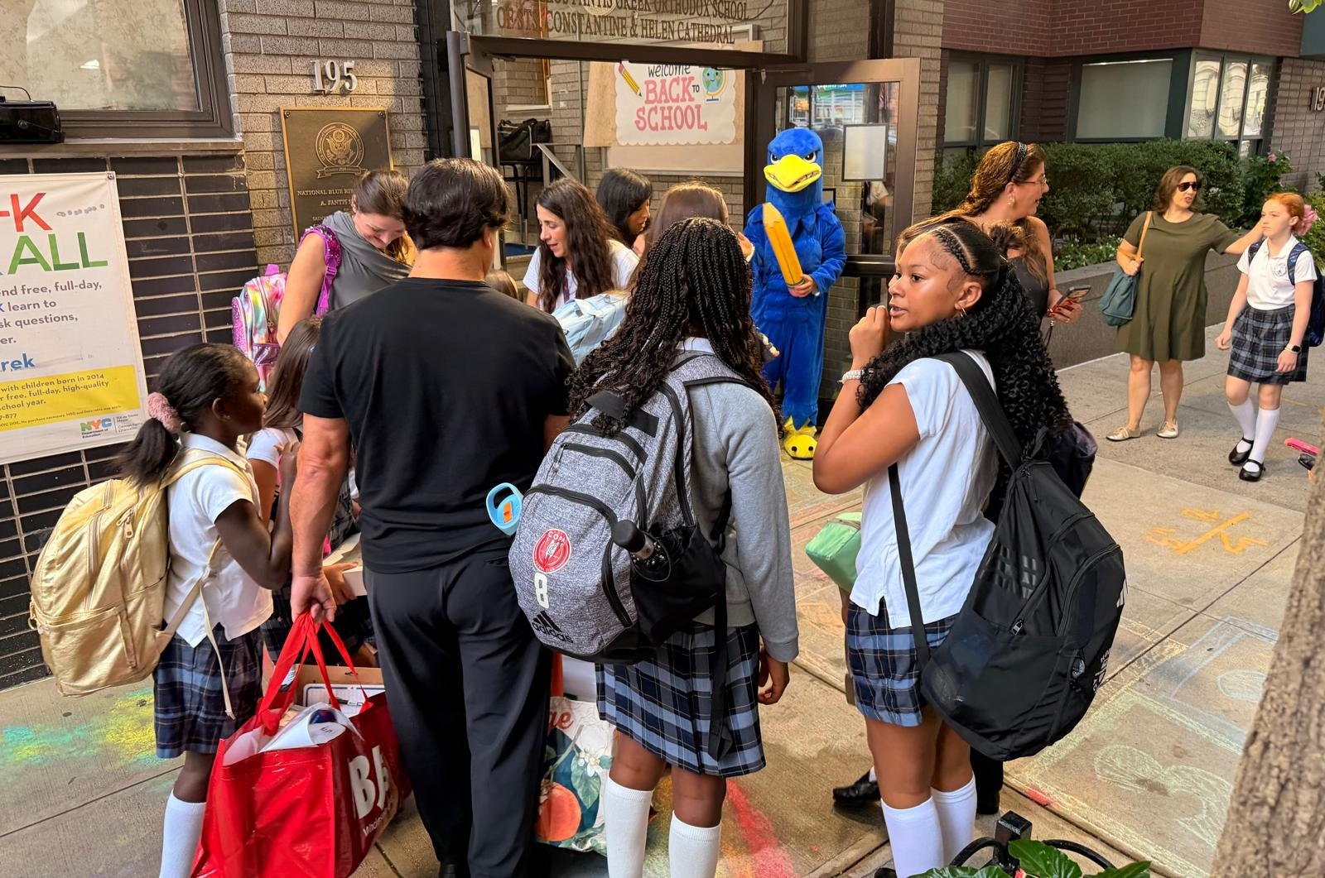
1st Day of School Fun - The first morning of school (Sept 10) was filled with smiles, hugs, and excitement. While the light rain attempted to ruin the chalk drawings on the sidewalk, the PTO welcomed students and families with bubbles, hopscotch, giant bus & pencils, music, and our Falcon mascot. It was wonderful to see everyone back together.

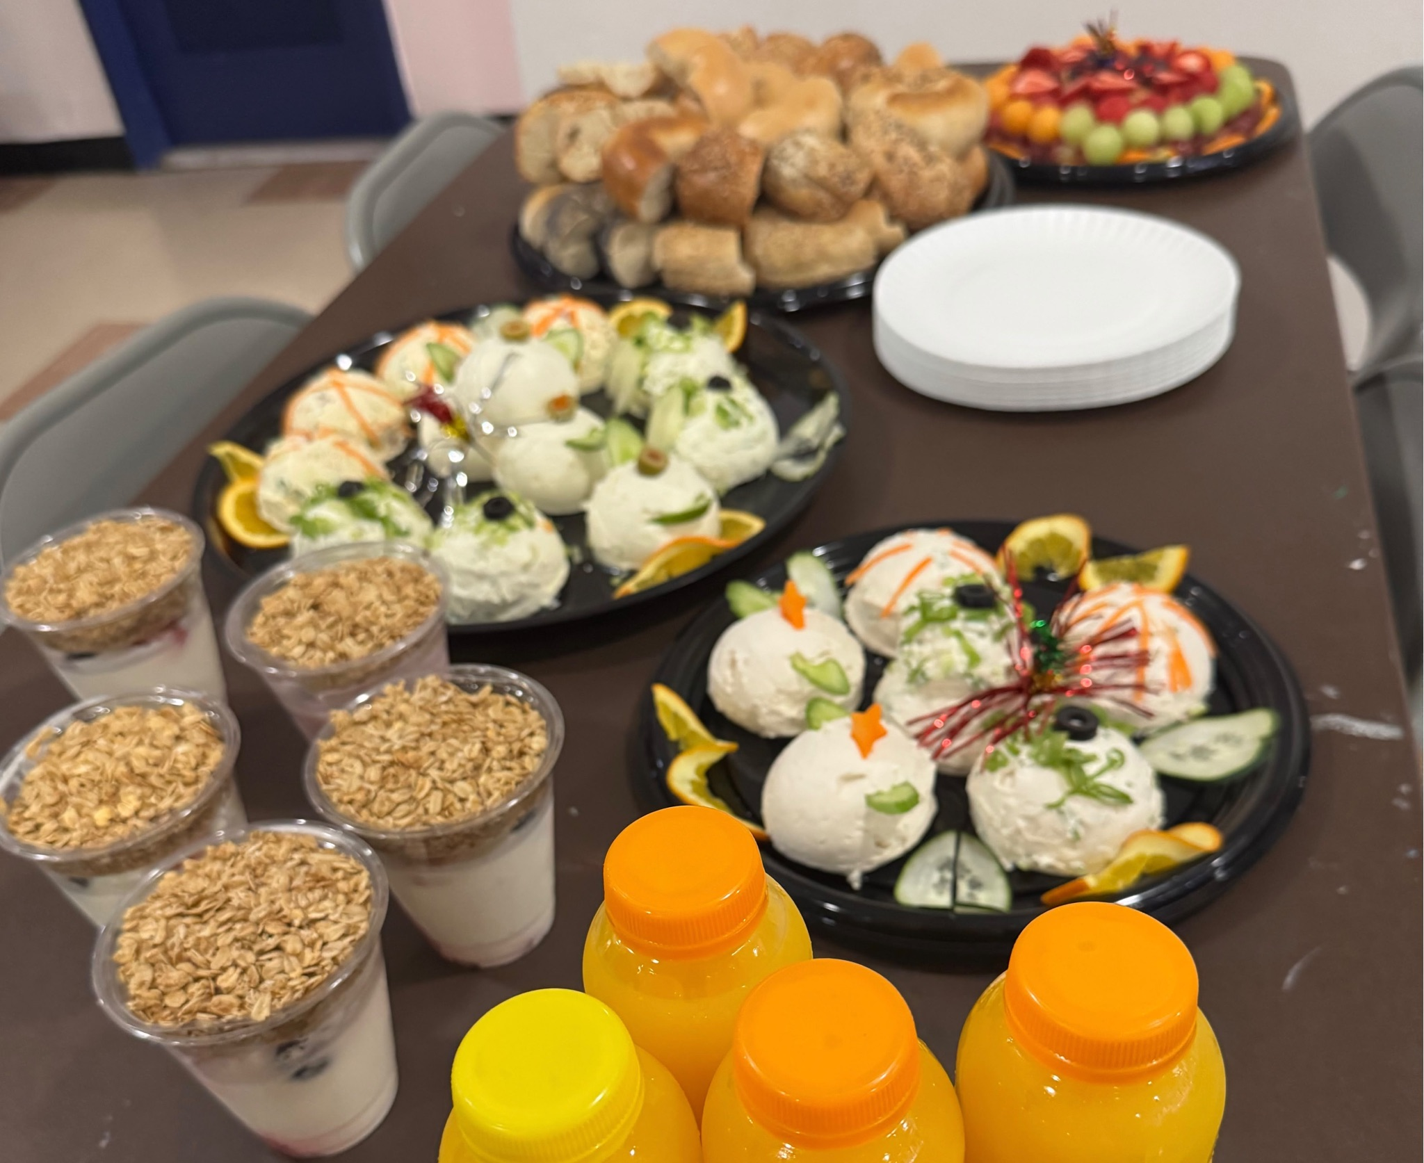
Welcome Back Staff - Our staff worked hard preparing for the 2026–27 school year long before the first student walked through the doors. To welcome them back, the PTO treated our teachers and staff to a hearty breakfast, complete with an assortment of bagels and spreads, pastries, fresh fruit, parfaits, and juice. It was a small way for all of us parents to say thank you for all the time and care they put into getting the school ready for a new year.

