Mark Dagraca

Alex Dang

Pierre Tobgui

Project 1

Instructions:

To run the project all the user needs to do is run the Main.java file. In this file part 1, 2, and 3 are all tested. The answers are printed out into the console.

Answers/Screenshots:

Part 1)

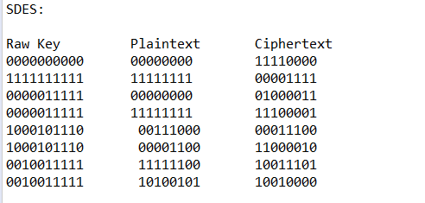

Part 2)

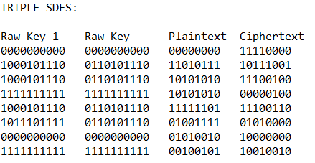

Part 3)

