P-release kinetics as a predictor for P-availability in Swiss cropping systems
Marc Jerónimo Pérez y Ropero
Frank Liebisch
2026-09-21
Abstract
Current empirical Soil Test Phosphorus (STP) methods ($P_{CO_{2}}$, $P_{AAE10}$) use static pools and arbitrary supply classes that ignore the physics of how soils release P over time. In this study, we evaluate… [Insert full abstract here]

1. Introduction

1.1 The Agronomic Dilemma of Phosphorus
Phosphorus (P) is an essential macronutrient for all life, yet its management in agricultural systems presents a significant challenge. In the soil solution, P exists predominantly as highly reactive orthophosphate anions ($HPO_{4}^{2−}$ or $H_{2}PO_{4}^{−}$). These dissolved species are rapidly immobilized—either adsorbed onto the surfaces of clays and metal oxides or precipitated with cations like calcium, iron, and aluminum to form minerals of low solubility (Brady & Weil, 2016; Sposito, 2008). Consequently, the total soil P stock is vast, but the minute fraction dissolved in the soil solution—the only form directly available to plant roots—is highly transient.
To manage this complex nutrient, European agricultural systems rely heavily on empirical soil tests to generate fertilizer recommendations. As detailed by Jordan-Meille et al. (2012) and later expanded by Steinfurth et al. (2022), these systems generally follow a three-step procedure: soil testing, calibration, and recommendation. Central to this process is the “Class Concept” (Klassenkonzept), where raw soil test values are calibrated into discrete P-fertility categories (e.g., Very Low, Target, Excessive). In many European countries, including Switzerland and France, these empirical thresholds are further modified by secondary soil parameters such as clay content and pH.
However, despite these sophisticated calibration matrices, inter-laboratory comparisons reveal massive contradictions, with recommended fertilizer doses for the exact same soil varying by up to 300% across Europe (Jordan-Meille et al., 2012). This fundamental instability arises because standard chemical extractants largely ignore the mechanistic processes governing plant P uptake.

1.2 Conceptual Frameworks vs. Operational Definitions
To conceptualize plant P availability, soil science relies on three fundamental thermodynamic and mass-balance parameters (Frossard et al., 2000): 1. P-Intensity ($I$): The thermodynamic energy state, or chemical activity, of P in the soil solution at any given moment. 2. P-Quantity or Capacity ($Q$): The physical mass of solid-phase P that is readily desorbable and can replenish the soil solution. 3. Phosphorus Buffering Capacity (PBC): The resistance of the soil to changes in P-Intensity, mathematically represented as the derivative of Quantity with respect to Intensity ($dQ/dI$).
While these concepts are theoretically robust, measuring them in natural soils is methodologically challenging. Isotopic Exchange Kinetics (IEK) perfectly capture these dynamics by tracing the true exchangeable pool without altering the chemical equilibrium (Fardeau, 1996; Gallet et al., 2003). However, the requirement for radioisotopes renders IEK unsuitable for routine agronomic testing. In practice, standard agronomic soil tests do not measure absolute thermodynamic states; rather, they rely on operational definitions that often misrepresent the true pool of available P (Demaria et al., 2005). A soil test value is strictly defined by the specific chemical extractant used, the extraction time, and the soil-to-solution ratio.
Different standard methods target different physicochemical pools of P by employing distinct extraction mechanisms: - Olsen P ($NaHCO_{3}$, pH 8.5): Measures desorbable P. The high concentration of bicarbonate ions outcompetes orthophosphate for adsorption sites on soil surfaces (Olsen et al., 1954). - P-AAE10 (Ammonium Acetate EDTA, pH 4.65): A strong extractant that attacks both sorbed and precipitated P forms. EDTA chelates background cations, actively dissolving apatites, while the acetate buffer facilitates desorption (Forschungsanstalt für Agrarökologie und Landbau (FAL), 1996). - Water Extractions ($P_{H_{2}O}$ and $P_{ext{CO}_{2}}$): While lacking aggressive chelators, distilled or $CO_{2}$-saturated water acts as an incredibly strong thermodynamic sink. By plunging the soil into a massively dilute environment, it forcefully drives dissolution and desorption to re-establish equilibrium. Consequently, the actual extracting power of these methods is fiercely modulated by the physical extraction time and, crucially, the soil-to-extractant ratio.

1.3 The Asymmetry of Measurement: Thermodynamics vs. Biology
Relying on operational definitions introduces severe analytical limitations, but a profound epistemological asymmetry exists between the chemical measurements of the soil and the biological measurements of the plant.
On the soil side, thermodynamic measurements can be mechanistically clarified. While empirical tests like $P_{AAE10}$ suffer from clear artifacts (such as the physical saturation of the EDTA chelator in heavy clays), we can rationally address these limitations. We can convert stoichiometric concentrations to corrected chemical activities ($γ$) using Davies or Pitzer equations, isolate kinetic bottlenecks, and model fundamental isotherms. We have rational, physical control over the soil matrix.
Conversely, biological response variables are inherently messy, abstract, and riddled with physiological ambiguity. Agronomic models attempt to use plant tissue concentrations ($C_{P}$) or total Phosphorus Uptake ($P_{extup}$) as response variables, but these are not absolute physical truths. They are abstractions derived from indirect measurements of mass and concentration.
Furthermore, these biological metrics routinely collapse in the field due to physiological phenomena like the Piper-Steenbjerg effect (carbon dilution) (Hirte et al., 2021). When a severely P-starved plant finally receives Phosphorus, it rapidly generates new biomass. This burst of growth paradoxically dilutes the tissue $C_{P}$ concentration, causing the measured concentration to drop even though the total Phosphorus mass in the plant increased. This immediately forces an arbitrary decision: which specific plant tissue should we optimize to represent the whole organism?
Finally, even if a perfect thermodynamic soil model is constructed, its predictive power in field trials remains constantly threatened by overarching pedoclimatic noise. Much like the Athenians praying to Zeus for rain in the Meditations of Marcus Aurelius, agronomic field trials are ultimately subservient to variables beyond human control. Temperature, precipitation, and soil moisture exert effect estimates that vastly overpower subtle chemical variations. Therefore, while we can mathematically anchor our thermodynamic extractions, predicting biological field outcomes requires accepting a fundamentally chaotic and uncertain reality.

1.4 Grounding Agronomy in Thermodynamic Principles
Standard agronomic models frequently rely on empirical curve-fitting, utilizing polynomials or arbitrary linear regressions to maximize $R^{2}$ values across calibration datasets. While these models may perfectly describe a specific field trial, their parameters are often “dead”—lacking physical meaning and failing spectacularly when extrapolated beyond the calibration environment.
To overcome this, we adopt a more fundamental approach grounded in Thermodynamic Perturbation Theory. By translating empirical extractions into thermodynamic state functions, our models inherit several critical virtues from established physical chemistry frameworks:
- Method-Agnosticism and Harmonization: Standard extractions (e.g., Olsen-P at pH 8.5 vs. water extractions at pH ~6) violently alter the chemical equilibrium, making raw extract concentrations across national borders fundamentally incomparable. However, by abstracting these operational extracts into fundamental Quantity ($Q$) and Intensity ($I$) metrics—and utilizing models like the Davies or Pitzer equations to isolate true thermodynamic activities—we strip away the artifacts of the extractant’s ionic strength. This thermodynamic translation is the only mathematically rigorous path to harmonizing disparate regional soil tests.
- Interpretability via Surface Complexation: Our parameters are not meaningless regression weights; they are macroscopic reflections of underlying physical phenomena. For example, predicting a kinetic rate constant ($k$) using the ratio of amorphous aluminum to iron oxides ($Al_{\text{ox}}/Fe_{\text{ox}}$) directly maps to the distinct electrostatic and lateral repulsion perturbations operating on independent mineral sub-lattices. This mirrors advanced surface complexation frameworks, such as the CD-MUSIC model implemented in Visual MINTEQ by Gustafsson and colleagues (Gustafsson, 2001, 2014), which definitively prove that P adsorption non-linearity is governed by spatial charge distribution on specific Fe/Al (hydr)oxide surfaces rather than empirical constants.
- Modularity and Expansion: This approach imports the success of these advanced geochemical models into agronomy. Grounding our agronomic variables in the Gibbs Free Energy expansion provides a rigid mathematical scaffolding that is physically defensible at the thermodynamic boundaries.
This theoretical foundation ensures that the model coefficients are physically defensible. Furthermore, it paves the way for advanced statistical updating (e.g., Bayesian inference), allowing future research to introduce meaningful, mechanistic parameterizations rather than blindly chasing variance with higher-order polynomials. We intentionally accept that biological pedoclimatic noise will inevitably lower apparent $R^{2}$ values in field trials; our objective is structural truth, not mathematical overfitting.

1.5 Unifying Quantity, Intensity, and the Kinetic Bottleneck
By pairing an Intensity measurement with a mass extraction ($Q$, such as $P_{\text{AAE10}}$), we can construct a generalized $Q(I)$ framework. We parameterize this relationship using a Freundlich isotherm ($Q=K_{f}⋅I^{1/n}$) not because it yields a “true” universal constant, but because its log-log linearization elegantly isolates the baseline capacity ($K_{f}$) and the saturation breakdown ($n$). This thermodynamic abstraction liberates the analysis from the arbitrary, method-specific bounds of operational extractants (e.g., AAE10 vs. CAL vs. Olsen). It translates disparate empirical measurements into a common, transparent language where the Phosphorus Buffering Capacity (PBC) can be derived as the continuous first derivative ($\frac{dQ}{dI}$) and meaningfully compared across borders.
While the Freundlich model ($Q=K_{f}⋅I^{1/n}$) is mathematically invalid at absolute thermodynamic extremes—failing Henry’s Law near infinite dilution and predicting infinite adsorption rather than a strict saturation limit—it is the correct analytical approximation for operational agricultural soils. Comprehensive heterogeneous models, such as the Langmuir-Freundlich (Sips) or Toth equations, incorporate a saturation denominator ($1+(aI)^{n}$) to enforce a physical maximum. However, agricultural soils operate strictly within the mid-range of the affinity distribution, far below total surface saturation. In this localized “Goldilocks” zone, the saturation term becomes negligible, and the complex Sips and Toth equations collapse mathematically into the classical Freundlich isotherm. Thus, we utilize the Freundlich exponent ($1/n$) not as a universal law, but as the mathematically exact, localized variance of binding energies across the heterogeneous $Al_{\text{ox}}$ and $Fe_{\text{ox}}$ sub-lattices.
However, even with a correct thermodynamic understanding of $Q$ and $I$, plant uptake remains fundamentally limited by time. Standard conceptual models assume instantaneous solid-solution equilibrium. In reality, desorption is a rate-limiting kinetic bottleneck (Flossmann & Richter, 1982; Nye & Tinker, 2000). When a root depletes the rhizosphere, the soil cannot always resupply phosphate fast enough.
To address this, we define a dynamic predictor: the Initial Activity Flux ($J_{0}$). This flux shifts the focus from static mass to supply rate by multiplying the first-order desorption rate constant ($k$) by the maximum thermodynamic activity ($a_{max}$):
$$J_{0}=k⋅a_{max}$$
Table 1 maps this transition from classic, operationally defined static tests to the proposed thermodynamic and kinetic parameters.
Table 1: Conceptual mapping of fundamental phosphorus availability factors to their analytical proxies.
Approach / Framework | Intensity Factor | Quantity (Capacity) Factor | Kinetic Factor
Theoretical Concept (Frossard et al. (2000)) | Concentration of P in the soil solution | Pool of solid-phase P that can replenish the solution | Rate of P transfer from the solid to the liquid phase
Traditional / Static Proxy (GRUD) | $P_{ext{CO}_{2}}$ (Raw Water-soluble Concentration) | $P_{AAE10}$ (Chelate-extractable Mass) | Not Measured
Dynamic / Kinetic Proxy (This Study) | Raw Intensity ($P_{ext{CO}_{2}}$) | $P_{AAE10}$​ | Dynamic Desorption Velocity ($v_{0}=k⋅P_{CO_{2}}$)

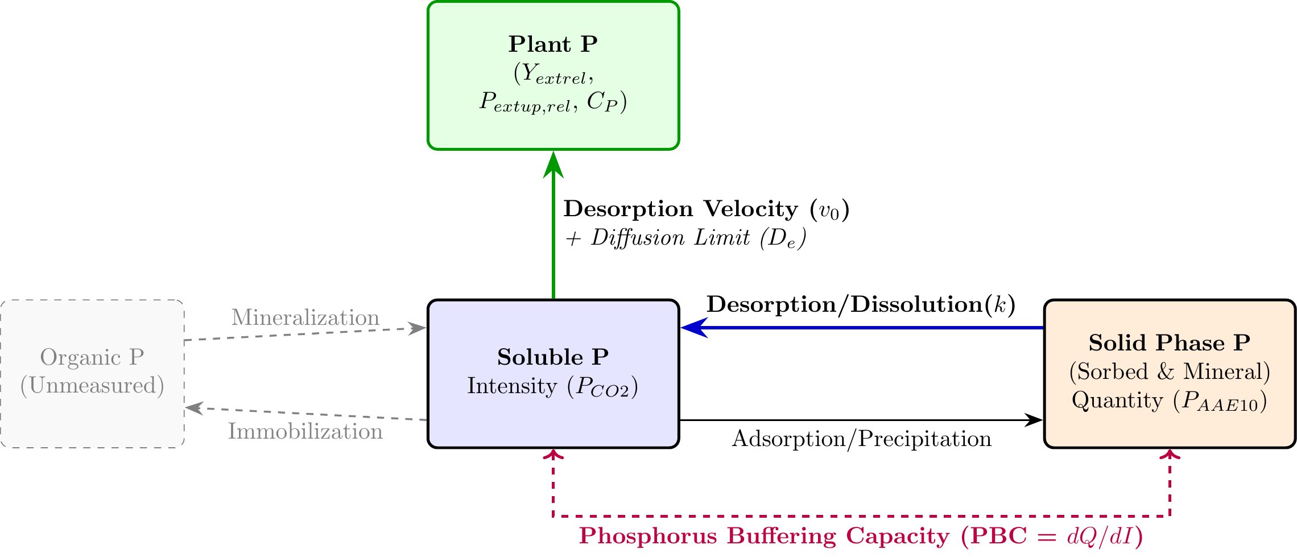
Conceptual model of the rhizosphere phosphorus cycle.

1.6 Thesis Objectives and Analytical Strategy
This thesis hypothesizes that integrating thermodynamic activity and desorption kinetics provides a more comprehensive mechanistic framework for P-management compared to standard empirical testing. Specifically, it directly answers the call by Jordan-Meille et al. (2012) to replace empirical extraction classes with mechanistic sorption-desorption models.
Using soils from the long-term Swiss agricultural experiment STYCS, this study aims to validate this framework through the following core objectives and research questions:
- Thermodynamic Framework Formulation: Establish generalized $Q(I)$ isotherms across highly diverse pedoclimatic sites to abstract the buffering capacity into universally comparable parameters ($K_{f}$ and $n$). Research Question: Is the Swiss GRUD framework and its analytical proxies ($P_{ext{CO}_{2}}$, $P_{AAE10}$) compliant with the broader European class concept presented by Jordan-Meille et al. (2012), and do these empirical classes map meaningfully onto the underlying thermodynamic abstractions of physical desorption kinetics?
- Agronomic Prediction: Statistically evaluate the predictive power of the kinetic Activity Flux ($J_{0}$) against relative crop yield and P-uptake. To isolate the chemical P-limitation from overarching climatic noise, agronomic outcomes will be normalized against a historical biological baseline (the historical maximum yield of non-limiting P treatments for specific site-crop combinations). Hypothesis: The thermodynamically corrected $J_{0}$ will significantly outperform standard static extractions.
- Mechanistic Validation: Propose a modified conceptual framework for radial transport to mathematically illustrate that the desorption rate acts as the primary limiting bottleneck restricting P-availability in the rhizosphere.

2. Materials and Methods

2.1 The Long-Term Phosphorus Fertilization Experiment
The soil samples for this thesis originate from a set of six long-term field trials in Switzerland, established by Agroscope between 1989 and 1992. The primary objective of these experiments was to validate and re-evaluate Swiss phosphorus (P) fertilization guidelines by assessing long-term crop yield responses to varying P inputs across different pedoclimatic conditions. A detailed description of the experimental design and site characteristics can be found in Hirte et al. (2021).
The experiment was set up as a completely randomized block design with four field replications at each site. The core of the experiment consists of six fixed-plot treatments representing different P fertilization levels. These treatments were applied annually as triple superphosphate (TSP) before tillage and sowing. The application rates were strictly calibrated as percentages of the site- and crop-specific officially recommended P inputs (the Swiss GRUD norm): 0% (Zero), 33% (Deficit), 67% (Reduced), 100% (Norm), 133% (Elevated), and 167% (Surplus). This rigorous gradient ensures a massive divergence in cumulative P-balances across the 30-year timeframe, forcing distinct pedological responses.
Crucially, all other macronutrients—including Nitrogen (N), Potassium (K), and Magnesium (Mg)—were applied uniformly across all plots to prevent secondary yield limitations. However, it must be noted that these “non-limiting” applications were structurally calibrated to exactly 100% of their respective empirical Swiss GRUD recommendations, derived from the same matrix of operational soil tests and crop removal estimates criticized in this study. Consequently, the assumption that secondary nutrients were strictly non-limiting throughout the 30-year trial relies entirely on the epistemological validity of the empirical GRUD framework itself—a paradox that underscores the urgent need to transition toward mechanistic, site-specific nutrient modeling.

2.1.1 Crop Yield, Phosphorus Uptake, and Balances
While the fundamental experimental design and baseline data collection follow the protocols described in Hirte et al. (2021), the specific processing of the agronomic variables for this study diverges to explicitly isolate the chemical P-limitation.
Crop yields were measured annually at harvest. Total fresh biomass was recorded, and representative subsamples were oven-dried to determine the absolute dry mass yield. Plant tissue phosphorus concentration ($C_{P}$) was subsequently quantified from these dried subsamples. The total phosphorus uptake ($P_{\text{uptake}}$) for each plot was calculated stoichiometrically as the product of the dry mass yield and the measured $C_{P}$.
To accurately quantify the historical legacy of the different fertilization treatments, the Cumulative P Balance ($Cum_P_\text{bal}$) was calculated for each individual plot. $Cum_P_\text{bal}$ is defined as the net sum of all P inputs (from the annual TSP fertilization) minus all P outputs (specifically, the P removed from the field via the harvested crop biomass) accumulated over the entire 30-year duration of the trial. This provides a direct, continuous metric of the anthropogenic P surplus or deficit, which drives the underlying thermodynamic buffering systems.

2.2 Analytical Workflow and Data Integration
To answer the research questions, the methodology is structured into three highly synchronized, modular steps mapping the raw data to the final agronomic predictions:
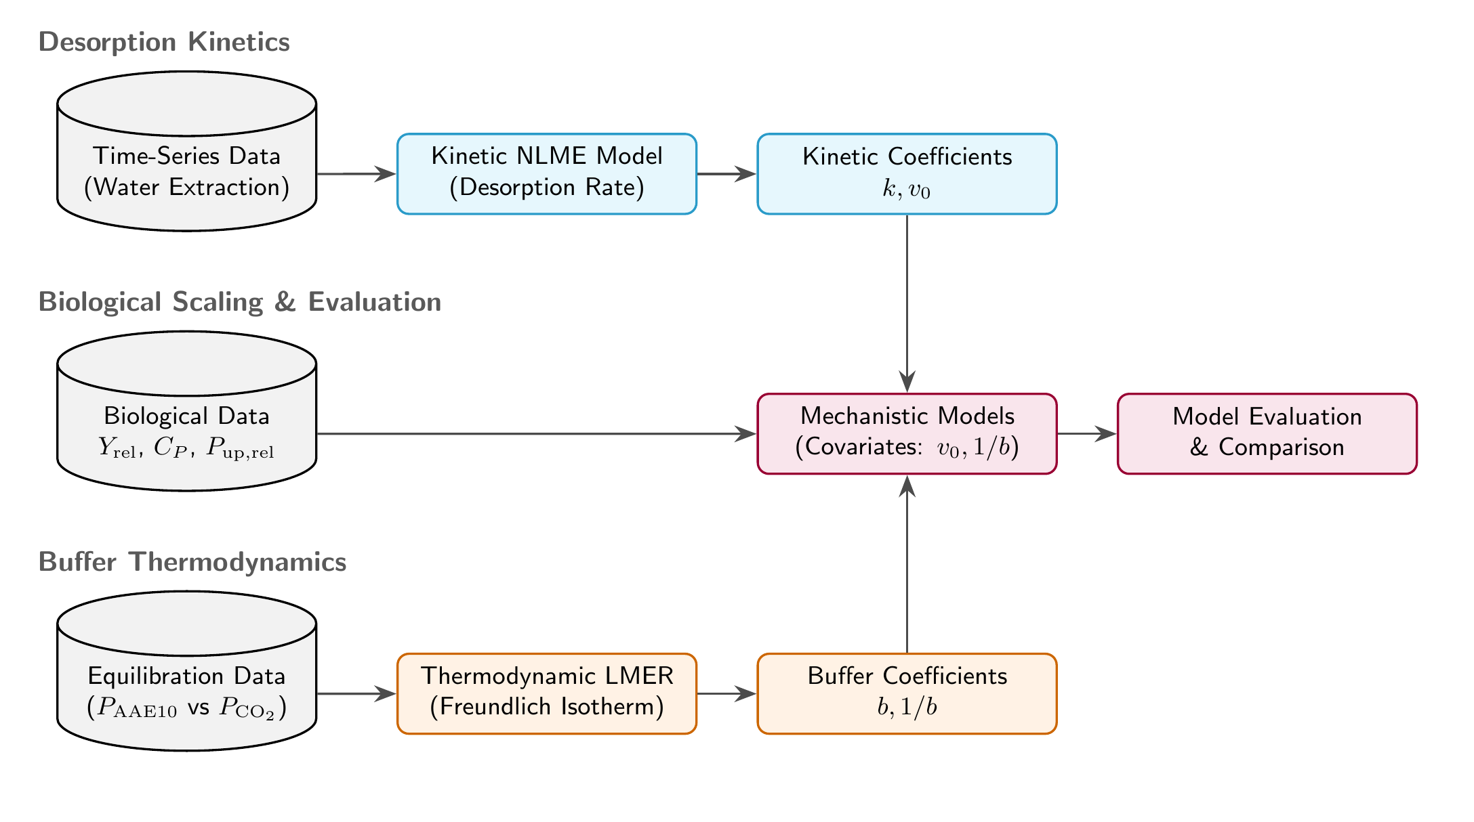
Modular workflow synchronizing data sources, extraction methods, and mathematical models.

2.3 Experimental Sites
The six experimental sites are located in the main crop-growing regions of Switzerland: Rümlang-Altwi (ALT), Cadenazzo (CAD), Ellighausen (ELL), Grabs (GRA), Oensingen (OEN), and Zurich-Reckenholz (REC). The key soil properties are summarized below.
Table 2: Soil characteristics of the six long-term experimental sites. Data adapted from Hirte et al. (2021).
Site | Soil Type (WRB) | Clay (%) | Silt (%) | Sand (%) | Organic C (g/kg) | pH (H2O)
ALT | Calcaric Cambisol | 22 | 30 | 48 | 21 | 7.9
CAD | Eutric Fluvisol | 8 | 52 | 40 | 14 | 6.3
ELL | Eutric Cambisol | 33 | 36 | 31 | 23 | 6.6
GRA | Calcaric Fluvisol | 17 | 49 | 34 | 16 | 8.3
OEN | Gleyic-calc. Cambisol | 37 | 31 | 32 | 24 | 7.1
REC | Eutric Gleysol | 39 | 36 | 25 | 27 | 7.4

Soil samples for this thesis were collected in the year 2022 from the topsoil layer (0-20 cm).

2.4 Phosphorus Desorption Kinetics and Thermodynamics
The laboratory extraction of phosphorus was based on the sequential kinetic principles established by Flossmann & Richter (1982), subsequently modified to capture high-resolution temporal kinetics and corrected to reflect thermodynamic activity.

2.4.1 Adapted Kinetic Protocol for This Study
To capture the desorption process with high temporal resolution while preserving the native soil matrix, a modified water-extraction protocol was employed:
- Pre-washing to Remove Initial Soluble P: 10 g of air-dried soil (sieved to < 2 mm) was suspended in 200 ml of deionized water and horizontally shaken for 60 minutes at 120 rpm. The suspension was centrifuged for 15 minutes at 4000 rpm, and the supernatant containing the readily soluble P was completely decanted. The P concentration of this discarded fraction was not quantified in this study, as the primary objective was to reset the soil solution to $P≈0$ to isolate the subsequent solid-phase desorption kinetics. No soil was lost during decantation due to the highly compact nature of the pellet.
- Kinetic Extraction: Because the remaining saturated soil pellet was highly compacted from centrifugation, achieving full resuspension required rigorous shaking, meaning the reactive surface area was not perfectly constant at the exact onset of the experiment. The pellet was rapidly resuspended in 200 ml of fresh deionized water to initiate the desorption process. The suspension was shaken continuously. To capture the nonlinear initial release phase, 2 ml subsamples were drawn at precisely eight time points: 2, 4, 10, 15, 20, 30, 45, and 60 minutes.
- Analysis: Each subsample was immediately filtered through a 0.2 $μ$m membrane filter to halt desorption, and the stoichiometric concentration of orthophosphate ($c(t)$) was determined colorimetrically using the malachite green method (Van Veldhoven & Mannaerts, 1987).

2.4.2 Temporal Stability of Amorphous Metal Oxides
Although the kinetic parameters ($k$) and geochemical structural variables ($Fe_{\text{ox}}$, $Al_{\text{ox}}$) were measured comprehensively in the year 2023, they were applied to the entire 26-year historical dataset. This is justified because oxalate-extractable iron and aluminum represent native, poorly-crystalline structural minerals rather than highly dynamic labile nutrient pools. Under constant arable management, these amorphous phases are widely recognized as pedologically stable over decadal timescales (Lookman et al., 1995; Schwertmann, 1964). Thus, the 2023 measurements serve as robust, invariant site-means to characterize the fundamental sorption capacity of each experimental field.

2.5 Statistical Analysis and Modeling
All data processing, mathematical modeling, and visualization were conducted using the R programming language (v. 4.3.1) (R Core Team, 2026). Primary packages included nlme (Pinheiro et al., 2026) for non-linear kinetic modeling, lme4 (Bates et al., 2026) for linear mixed-effects modeling, and deSolve and ReacTran for partial differential equation solving.

2.5.1 1. Modeling of Desorption Kinetics and the Desorption Velocity ($v_{0}$)
To establish the foundational kinetic parameters, physical desorption curves were generated using a modified sequential extraction protocol based on Flossmann & Richter (1982). Soil samples were first pre-washed to discard readily soluble P, then resuspended in deionized water and continuously shaken. Subsamples were extracted across a high-resolution time series (2, 4, 10, 15, 20, 30, 45, and 60 minutes), and the orthophosphate concentration was determined colorimetrically using the malachite green method.
Deriving the Desorption Rate Constant ($k$): A non-linear mixed-effects model (nlme) was fitted to these high-resolution extraction curves. The desorption process was modeled as a hyperbolic, asymptotic saturation curve derived from the exact solution of the first-order rate equation:
$$c(t)=c_{\text{max}}×(1−e^{−k×t^{′}})$$
Where $c(t)$ is the desorbed P concentration at time $t$, $c_{\text{max}}$ is the maximum size of the desorbable P pool (the asymptote), $k$ is the first-order desorption rate constant, and $t^{′}$ is an adjusted time ($t_{\text{min}}+3\text{ min}$) representing the empirically determined handling and resuspension time delay required to break apart the centrifuged pellet before true, uniform first-order desorption commenced. Sample-specific deviations were managed with the nested random effect structure c_max + k ~ 1 | site / plot, allowing both parameters to vary freely across sites and individual field plots.
Upscaling via Pedotransfer Function (PTF): Because this labor-intensive 60-minute kinetic extraction cannot be retroactively applied to the entire 30-year historical STYCS archive, a fundamental Pedotransfer Function (PTF) was constructed to predict the rate constant for missing soils and treatments. To ensure the upscaling process remained rigorously grounded in established mechanistic physics rather than arbitrary empirical correlations, the PTF was structured upon the Arrhenius equation—where reaction rates are driven by the competing activation energies of dominant sorption surfaces. Accordingly, a linear model (lm) was trained to predict $ln(k)$ using explicitly pedogenetic predictor variables: the natural log of the ratio of amorphous aluminum to iron oxides ($ln(Al_{\text{ox}}/Fe_{\text{ox}})$) and soil pH.
By anchoring the PTF to these inherently pedogenetic (treatment-independent) geochemical traits, we successfully extrapolated a predicted rate constant ($k_{pred}$) for every spatial and temporal plot in the dataset.
From these predicted parameters, a novel proxy for agronomic availability, the Dynamic Desorption Velocity ($v_{0}$), was defined mathematically as the product of the predicted rate constant and the historically measured static concentration pool:
$$v_{0}=k_{pred}⋅P_{{\text{CO}}_{2}}$$

2.5.2 2. Thermodynamic $Q(I)$ Isotherms and Buffering Capacity
To deduce the Phosphorus Buffering Capacity (PBC), a thermodynamic Quantity-Intensity ($Q/I$) framework was constructed. The $P_{\text{AAE10}}$ extraction was utilized as the standard mass Quantity ($Q$, ${\text{mg P kg}}^{−1}$), while the Davies-corrected $a_{\text{max}}$ was utilized as the native Intensity ($I$, $μ\text{M}$). It must be acknowledged that relying on $P_{\text{AAE10}}$ as a proxy for absolute thermodynamic Quantity carries inherent mechanistic limitations. As demonstrated by isotopic exchange kinetics (IEK) studies, the extraction fluid’s EDTA chelator actively dissolves non-exchangeable calcium phosphates—particularly in high-pH or high-CEC clays—leading to isotopic recovery rates as low as 25% (Demaria et al., 2005). Furthermore, in heavily buffered clay soils, the chelator physically saturates when overwhelmed by exchangeable background cations. Once saturated, the test becomes entirely “blind” to any further thermodynamic $Q$, artificially collapsing the measured $ΔQ$ parameter.
The relationship between these variables across the varying fertilizer treatments at each site was parameterized using a log-linearized Freundlich Isotherm (Freundlich, 1906), which is universally recognized for describing ion sorption on heterogeneous soil surfaces:
$$Q=K_{f}⋅I^{\frac{1}{n}}$$
The apparent Phosphorus Buffering Capacity (PBC) for each specific site and state was then calculated analytically as the first derivative of the fitted Freundlich isotherm with respect to Intensity:
$$\text{PBC}=\frac{dQ}{dI}=K_{f}⋅\frac{1}{n}⋅I^{\left(\frac{1}{n}−1\right)}$$
Predicting Quantity via Pedotransfer Functions (PTF) To evaluate the practical scalability of these thermodynamic concepts, empirical Quantity ($P_{\text{AAE10}}$) was modeled directly from Intensity using a log-linear mixed-effects model (lme):
$$ln(Q)=β_{0}+β_{I}⋅ln(I)+∑(β_{j}⋅Z_{j})+ln(I)∑(β_{int,j}⋅Z_{j})+u_{site}+u_{plot|site}$$
- The Covariates ($Z_{j}$): Geochemical pedotransfer variables including soil fine texture (clay + silt), pH, $C_{\text{org}}$, and exchangeable background cations (Ca, Mg, K). These are mechanistically justified as they structurally determine the density and binding energy of the soil’s sorption complexes (e.g., amorphous metal oxides and calcium carbonates).
- Interaction Terms: The covariates directly interact with Intensity because the slope of the Q/I isotherm (the buffer power) is fundamentally altered by these intrinsic geochemical properties.
- Random Effects ($u_{year|site}$): Nested temporal and spatial intercepts designed to rigorously absorb unmeasured macro-climatic shifts and temporal biological chaos (e.g. frost timing, pest pressure, radiation) across the different experimental years, preventing pseudo-replication.

2.5.3 3. Agronomic Normalization: Controlling Pedoclimatic Noise
To rigorously separate underlying P-limitation from the immense baseline yield variance caused by pedoclimatic shifts and crop genetics, all raw yield and P-uptake metrics were normalized to a biologically strict empirical ceiling. For every combination of site, year, and crop, the absolute maximum value observed across all fertilization treatments was assigned as $100\%$ capacity.
$$Y_{\text{rel}}=\frac{Y_{plot}}{\max_{treatment}(Y)_{site,year,crop}}$$
Unlike using a specific fertilization label (e.g., the P166 treatment average), this method guarantees that the empirical Mitscherlich asymptote of $1.0$ is strictly bounded. It ensures that the unconstrained biological ceiling for that specific environment is defined by the actual absolute maximum biomass it produced, structurally eliminating random negative constraints (e.g., localized compaction or pest damage) that might artificially depress a specific treatment average. This mathematical operation removes the variance in the absolute biological ceiling, strictly isolating the chemical P-limitation from the overarching temporal pedoclimatic noise.

2.5.4 4. Bayesian Modeling of Agronomic Outcomes
To test the core hypothesis and rigorously handle the structural heteroskedasticity inherent in agronomic field data, the biological response variables were modeled using Bayesian non-linear mixed-effects models via the brms package (bürknerBrmsPackageBayesian2017?). Unlike frequentist approaches that often suffer from algorithmic convergence failures (singularities) when fitting complex asymptotes near biological boundaries, the Bayesian framework allows us to define mathematically rigorous, biologically grounded priors to constrain the parameter space.
Due to the extreme non-linearity of the models—which multiply asymptotic kinetics by exponential environmental covariates across hundreds of random intercepts—the computational load was massive. The models were compiled and executed using the highly optimized cmdstanr backend (gabry2023cmdstanr?), enabling within-chain multi-threading to parallelize the Hamiltonian trajectories. All models utilized the No-U-Turn Sampler (NUTS) with four Markov Chain Monte Carlo (MCMC) chains, each running for 2000 iterations (1000 warmup), ensuring robust exploration of the posterior distributions.

2.5.5 The Bayesian Fragility of the Mitscherlich Equation
While the Mitscherlich equation ($Y=A−(A−Y_{0})e^{−cP}$) is the historical standard for modeling diminishing agronomic returns, it proved mathematically fragile within a Bayesian Hierarchical framework. When attempting to decompose the rate constant into pedoclimatic covariates ($c_{\text{eff}}=c_{\text{base}}+βX$), the parameter space became algebraically unbounded. Random-walk sampling of extreme negative $β$ values instantly flipped the exponent from exponential decay to explosive exponential growth, generating mathematical singularities that shattered Hamiltonian Monte Carlo (HMC) convergence. Therefore, the Mitscherlich formulation was explicitly abandoned in favor of the Michaelis-Menten fractional geometry. The rational hyperbolic shape provides the exact same diminishing returns (a monotonically decreasing first derivative) but safely sequesters exponential covariates in the denominator, rigidly bounding the probability space and guaranteeing HMC convergence.
To aid clarity across the manuscript, the core model architectures are explicitly labeled. Alongside the mechanistic formulations, a heavily parameterized Heuristic Model was constructed as an empirical baseline. This heuristic model armed the Michaelis-Menten equations with a full suite of standard soil chemical metrics (pH, Clay fraction, Organic Carbon, and Exchangeable Calcium) alongside the pedoclimatic noise variables. This established a rigorous, highly-informed baseline against which the predictive power of the kinetic physics could be independently tested.
1. The Yield Model ($B_{Yield}$) The agronomic yield response was modeled using the Michaelis-Menten equation, bounding the unidentifiability of the intercept and asymptote by applying strict, crop-specific empirical limits ($Y_{0}$ and $A$) extracted from the bounds of the actual data. The effective half-saturation constant ($K_{\text{eff}}$) was dynamically modulated by pedoclimatic covariates:
$$Yield=Y_{0}+(A−Y_{0})\frac{STP}{K_{\text{base}}⋅exp\left(∑β_{i}⋅Z_{i}\right)+STP}$$
- The Diffusion Bottleneck ($β_{\text{invb}}$): The inverse physical buffer power ($1/b$) acts as the primary transport penalty. Soils with high buffer power cannot replenish the root depletion zone fast enough via diffusion.
- The Kinetics ($β_{k}$): The dynamic desorption rate ($k$) directly decreases the half-saturation threshold by accelerating the physical resupply of P into the root depletion zone.
- Stoichiometric Co-Limitation ($β_{N}$): Nitrogen fertilization fundamentally shifts the metabolic capacity of the crop.
- Pedoclimatic Noise ($β_{Temp},β_{Prec}$): Temperature and precipitation anomalies dictate physical soil moisture (governing diffusion transport) and the basic biological metabolic rate.
2. The Plant Uptake Model ($B_{Uptake}$) Actual mass-flux of P into the plant was modeled using the same Michaelis-Menten biological limit, anchored at the origin ($U_{0}=0$):
$$Uptake=\frac{V_{max}⋅\text{STP}}{K_{\text{base}}⋅exp\left(∑β_{i}⋅Z_{i}\right)+\text{STP}}$$
Where the maximum uptake capacity ($V_{max}$) acts as the biological asymptote, and the effective affinity is driven by the same critical covariates ($β_{\text{invb}},β_{k},β_{\text{Temp}},β_{\text{Prec}}$).
3. The Tissue Concentration Model ($B_{C_{P}}$) To expose the physiological dynamics of tissue concentrations, the apparent $C_{P}$ was modeled empirically using a Mitscherlich saturation curve. Because true Piper-Steenbjerg carbon dilution penalties (a drop in concentration at initial growth stages) were statistically undetectable across the pedoclimatic noise, the phenomena clearly dictate a simpler biological reality: A crop-specific baseline tissue concentration ($C_{\text{min}}$), followed by an asymptotic Luxury Accumulation phase bounded by $ΔC$:
$$C_{P}=C_{\text{min}}+ΔC⋅\left(1−exp\left(−c_{\text{eff}}⋅\text{STP}\right)\right)$$
- Crop-Specific Baseline ($C_{\text{min}}$): The fundamental, minimum tissue concentration required for the plant to physically exist, modeled as a fixed effect grouped by crop species (~ crop - 1 + (1 | site/year)).
- Luxury Accumulation ($ΔC$): Once basic metabolic needs are met, plants accumulate “luxury” P in their tissues up to a theoretical maximum.
- Accumulation Rate ($c_{\text{eff}}$): This rate is significantly driven by pedoclimatic covariates and transport penalties, dictating how rapidly the soil can push excess phosphorus into the plant.
Bayesian Prior Elicitation and Biological Bounds To prevent mathematical singularities and ensure the parameter space remained strictly within physical reality, informative bounds were placed on the fundamental biological constants: - Baseline and Maximum Yield ($Y_{0},A$): Bounded strictly $>0$. To resolve parameter unidentifiability in the flat plateaus of the data, highly informative empirical bounds were dynamically extracted from the dataset. For each crop, $Y_{0}$ was constrained around the absolute minimum observed yield, and $A$ around the absolute maximum, rigidly anchoring the vertical geometry of the curve. - Maximum Uptake Velocity ($V_{\text{max}}$): Bounded $>0$ with normal(30, 15), reflecting standard crop physiological limits (typically 15–45 kg P/ha). - Tissue Concentration Minimum ($C_{\text{min}}$): Bounded $>0$ with normal(1.5, 1.0), as a baseline tissue concentration of $≈1.5\text{ g/kg DM}$ is universally required for basic cellular function in these crops. - Environmental Covariates ($β$): Even with strict structural bounds, the simultaneous estimation of five exponential environmental covariates on the kinetic rate constant created a flat probability valley, preventing HMC convergence. To resolve this unidentifiability, an Empirical Bayes algebraic linearization technique was deployed. The Michaelis-Menten equation was algebraically rearranged into an affine linear model: $Z=ln((A−Y)/(Y−Y_{0}))+ln(\text{STP})$. By passing this linearized response into a frequentist linear mixed-effects model (lmer), exact empirical point estimates for the $β$ modifiers were calculated. These empirically derived coordinates were then injected into the Bayesian model as highly informative priors (e.g., normal(0.776, 0.10) for $β_{N}$), dropping the Markov chains directly onto the global minimum and guaranteeing robust HMC convergence.
Table 3: Comprehensive description of all response variables and covariates used in the thermodynamic and agronomic models, including their explicit preprocessing pipelines.
Abbreviation | Variable | Description | Processing and Filtering
$Y$​ | Absolute Yield | Crop dry matter yield (dt/ha). | Raw measured absolute yield. Handled via log-link function in the Bayesian models.
$P_{\text{up}}$​ | Absolute P Uptake | Total phosphorus uptake in above-ground biomass (kg P/ha). | Calculated as absolute yield multiplied by tissue P concentration ($C_{P}$). Handled via log-link function.
$ln(P_{\text{AAE10}})$​ | Log Quantity Pool | Standard mass of extractable P (AAE10 method). | Natural log transformed to ensure strictly positive predictions and stabilize variance in mixed models.
$P_{{\text{CO}}_{2}}$​ | Empirical Intensity | Water-extractable P ($CO_{2}$ saturated). | Raw measured values. Log-transformed for PTF training.
$a_{{\text{CO}}_{2}}$​ | Thermodynamic Intensity | Thermodynamic activity of the water pool. | Calculated via Davies equation accounting for ionic strength. Log-transformed.
$k_{\text{des}}$​ | Desorption Rate Constant | First-order rate constant of P desorption. | Missing historical plots were imputed using a pedogenetic PTF trained on log(Al/Fe) + pH. Standardized (z-score).
$v_{\text{des}}$​ | Initial Desorption Velocity | Initial dynamic supply rate. | Calculated as product of predicted $k$ and empirical $P_{{\text{CO}}_{2}}$. Standardized (z-score).
${\text{PBC}}^{−1}$​ | Inverse Buffer Power | Inverse of the dynamic $Q/I$ slope ($dI/dQ$). | Analytically derived from predicted Freundlich isotherms. Standardized (z-score).
$Fe_{\text{ox}},Al_{\text{ox}}$​ | Amorphous Oxides | Amorphous Iron and Aluminum oxides. | Averaged into invariant site-means to remove management artifacts, log-transformed, and standardized.
$\text{Clay}$​ | Clay Content | Clay mass fraction. | Standardized directly. Missing values imputed with site-means.
${\text{pH}}_{{\text{H}}_{2}\text{O}}$​ | Soil pH | Soil pH measured in water. | Standardized directly.
$C_{\text{org}}$​ | Organic Carbon | Total organic carbon. | Log-transformed and standardized. Missing values imputed with site-means.
$Ca_{\text{ex}}$​ | Exchangeable Calcium | AAE10-extractable background calcium. | Missing values imputed using site medians. Log-transformed and standardized.
$T_{\text{anom}},Pr_{\text{anom}}$​ | Climate Anomalies | Juvenile phase temp/prec deviations. | Calculated as absolute deviation from the site’s long-term historical mean. Standardized.
$N_{\text{fert}}$​ | Nitrogen Fertilizer | Total applied nitrogen fertilizer. | Standardized directly.

2.5.6 5. Mechanistic Modeling of the Rhizosphere (Barber-Cushman Modification)
To mechanistically validate the field-scale statistical findings and visualize the limitations of static buffering capacity, a modified radial transport model based on Barber-Cushman principles (Barber & Cushman, 1981) was constructed. Standard iterations of the Barber-Cushman model calculate radial diffusion using stoichiometric concentration ($C_{l}$) and a static buffer power ($b=ΔQ/ΔI$), effectively assuming instantaneous soil-solution equilibrium.
To reflect the kinetic bottlenecks identified in this study, the partial differential equation (PDE) for radial transport in cylindrical coordinates was modified. The driving gradient was kept as empirical concentration ($c_{l}$), and the static buffer power was replaced with a dynamic, first-order kinetic source term ($R_{\text{desorption}}$):
$$\frac{∂c_{l}}{∂t}=D_{e}\left(\frac{∂^{2}c_{l}}{∂r^{2}}+\frac{1}{r}\frac{∂c_{l}}{∂r}\right)+\frac{r_{0}v_{0}}{r}\frac{∂c_{l}}{∂r}+R_{\text{desorption}}$$
Where $D_{e}$ is the effective diffusion coefficient, $r$ is the radial distance, $r_{0}$ is the root radius, and $v_{0}$ is the water flux at the root surface. The kinetic source term resupplying the solution was defined using the experimentally derived parameters:
$$R_{\text{desorption}}=k⋅(c_{\text{max}}−c_{l})$$
Furthermore, the inner boundary condition at the root surface ($r=r_{0}$) was upgraded to reflect a dual-affinity Michaelis-Menten uptake system (Michaelis & Menten, 1913), accounting for both high-affinity (PHT1) and low-affinity (LATS) transporter kinetics. The binding kinetics of these transporters are governed by the fundamental thermodynamic driving force of the substrate: its chemical activity ($a$), not its total stoichiometric concentration ($c$) (Atkins & Paula, 2011; Minton, 2001). The boundary condition was defined as:
$$J_{r}=\frac{V_{max1}⋅(c_{l}−c_{\text{min}})}{K_{m1}+(c_{l}−c_{\text{min}})}+\frac{V_{max2}⋅(c_{l}−c_{\text{min}})}{K_{m2}+(c_{l}−c_{\text{min}})}$$
The modified PDEs were solved numerically in R utilizing the ReacTran and deSolve packages to generate dynamic spatial profiles of the P-depletion zone over time.

2.5.7 6. Derivation of Critical Thresholds ($P_{\text{crit}}$)
To translate the mechanistic models into actionable agronomic metrics, the critical Soil Test Phosphorus ($P_{\text{crit}}$) threshold was analytically derived from all three modeling frameworks. Rather than relying on arbitrary inflection points, each derivation represents a distinct physiological or agronomic paradigm:
1. The Relative Yield Paradigm (The Production Target) Agronomically, $P_{\text{crit}}$ is classically defined as the STP required to achieve a specific operational threshold, commonly set as an $x\%$ relative yield target ($q_{Y}$, e.g., 0.95). By setting the relative yield target to $q_{Y}$ in the full Mitscherlich equation ($Y_{\text{rel}}=1−exp(−c_{\text{eff}}⋅(\text{STP}+E_{\text{base}}))$), the required soil concentration is extracted:
$$P_{crit_Y}=\frac{−ln(1−q_{Y})}{c_{\text{eff}}}−E_{\text{base}}$$
Where the effective rate constant incorporates the pedoclimatic penalties: $c_{\text{eff}}=c_{\text{base}}⋅exp(β_{kin}⋅\text{Kinetics}+…)$.
2. The Tissue Concentration Paradigm (The Physiological Buffer) Because true Piper-Steenbjerg minima were statistically absent, the tissue concentration critical limit was redefined as the threshold necessary to guarantee the plant’s fundamental metabolic baseline ($C_{\text{base}}$) plus a luxury reserve ($γ$, representing an $x\%$ safety buffer). Solving the linear mixed-effects model ($C_{P}=C_{\text{base}}+S_{\text{acc}}⋅\text{STP}$) for the target $C_{\text{base}}(1+γ)$ yields:
$$P_{crit_C}=\frac{γ⋅C_{\text{base}}}{S_{\text{base}}+β_{v0}⋅v_{0}+β_{\text{invb}}⋅\frac{1}{b}}$$
This derivation explicitly demonstrates that soils with a faster desorption velocity ($v_{0}$) or stronger buffer power ($1/b$) create a steeper accumulation slope ($S_{\text{acc}}$), inherently reducing the $P_{\text{crit}}$ required in the soil to safely buffer the crop against stress.
3. The Relative Uptake Paradigm (The Mass-Transfer Limit) While yield integrates the entire season, instantaneous phosphorus uptake is strictly governed by Michaelis-Menten kinetics at the root surface. Defining a critical threshold as the STP required to reach an $x\%$ relative uptake target ($q_{\text{up}}$) yields a direct relationship with the effective half-saturation constant ($K_{\text{eff}}$):
$$q_{\text{up}}=\frac{P_{crit_up}}{K_{\text{eff}}+P_{crit_up}}⟹P_{crit_up}=\left(\frac{q_{\text{up}}}{1−q_{\text{up}}}\right)K_{\text{eff}}$$
Where $K_{\text{eff}}$ structurally expands upon the base crop affinity ($K_{m}$) via the same physical kinetic bottlenecks identified in the field data.

2.5.8 7. The Management of Covariate Data: Two Distinct Approaches
As established by Hirte et al. (2021), incorporating pedoclimatic covariates is strictly necessary for obtaining robust, site- and crop-specific plant response models. However, the mathematical architecture used to integrate these covariates fundamentally impacts model stability and generalizability.
Across all models, the experimental structure was formalized using hierarchical random intercepts, (1 | site/year), to absorb time-invariant site fertility and broader climatic potential. Consequently, the main effects of our chosen covariates act exclusively as deviations modulating the base phosphorus affinity ($K_{\text{base}}$). To benchmark model generalization and test the risk of overparameterization, we evaluated two fundamentally different architectures for incorporating these soil constraints:
1. The Heuristic Approach We first established a “Null” baseline using a Michaelis-Menten geometry, explicitly abandoning the classical Mitscherlich asymptote which systematically failed Hamiltonian convergence due to the algebraically unbounded nature of its exponential parameterization. The Heuristic approach then expanded this baseline by directly injecting six raw pedoclimatic variables (soil pH, clay content, organic carbon, calcium, and site-normalized temperature and precipitation anomalies) as simultaneous exponential modifiers on $K_{\text{base}}$.
2. The Mechanistic Approach Rather than directly feeding raw soil chemistry into the agronomic model, the Mechanistic approach first condensed this pedoclimatic complexity through non-linear desorption kinetics (following the fundamental principles of Flossmann & Richter, 1982). This yielded exactly two fundamental thermodynamic parameters—the diffusion bottleneck ($1/b$) and the desorption rate ($k$)—which were then deployed alongside management variables (temperature, precipitation, and nitrogen fertilization) to predict crop response.
Model Evaluation By condensing raw covariates into physical constraints ($b$ and $k$), we sought to determine if the Mechanistic approach generalizes more robustly to unseen data, or if the direct inclusion of all raw soil variables in the Heuristic model provides superior predictive power. Models were rigorously evaluated and compared based on their Hamiltonian stability ($\hat{R}$), root-mean-square error (RMSE), pseudo-$R^{2}$ (marginal and conditional), and out-of-sample expected log predictive density utilizing Leave-One-Out Cross-Validation (LOOIC).
For an agronomic and environmental science context, it is crucial to distinguish between a model’s ability to “fit” the data it was trained on (RMSE, $R^{2}$) versus its ability to safely predict entirely new, unseen field sites (LOOIC). LOOIC operates by iteratively hiding one observation at a time, forcing the model to predict the missing data point; models with a lower (more negative) LOOIC generalize better to the real world. During this cross-validation process, we also calculate the effective number of parameters ($p_{loo}$). In complex agronomic models with multiple interacting pedoclimatic covariates, an inflated $p_{loo}$ metric acts as a direct diagnostic warning for “overfitting”—indicating that the model is hallucinating relationships and memorizing random micro-climate noise rather than capturing universally applicable physical mechanisms.

3. Results

3.1 The Blind Spot of Empirical Soil Tests
Standard empirical soil tests (STP) rely on chemical extraction to quantify a static “stock” of available phosphorus. However, these extractions are inherently blind to the dynamic physical constraints that govern how quickly that phosphorus can actually move through the soil matrix to the root surface.
As demonstrated in Figure 1, soils that are classified identically by empirical extractions ($P_{CO_{2}}$, $P_{AAE10}$) can exhibit drastically different physical properties. A soil with a theoretically “adequate” $P_{CO_{2}}$ extraction value of 1.0 mg/kg can possess a diffusion restriction proxy ($1/b$) ranging anywhere from 0.05 to 0.45, and a desorption rate ($k$) that varies just as wildly.
Ultimately, there appears to be no distinct connection between empirical STP measurements and fundamental kinetic variables. For any given STP value, a soil can exhibit a wide range of differing kinetic and diffusive properties, meaning these standard extractions do not inherently reflect the physical supply mechanisms of the soil matrix.
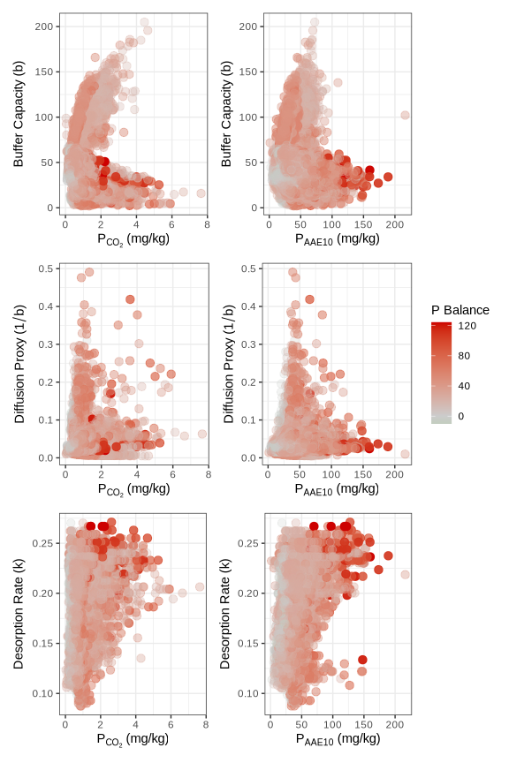
Figure 1: Distribution of long-term P balance across standard empirical tests ($P_{CO_{2}}$, $P_{AAE10}$) versus physical desorption kinetics (Buffer capacity $b$, Diffusion proxy $1/b$, and Desorption rate $k$). Red indicates a positive P balance (surplus), while green indicates a negative P balance (deficit). Note the lack of correlation between the empirical ‘stock’ and the physical ‘flow’ properties.

3.2 Plant Response Variables
When evaluating predictive performance, it is important to strictly distinguish between crop yield and actual P uptake. While both serve as agronomic response variables, yield inherently exhibits greater variance and environmental noise. This instability occurs because the internal phosphorus concentration of the crop tissue ($C_{P}$) can fluctuate significantly—driven by luxury consumption in P-rich environments or physiological dilution during rapid biomass accumulation. Consequently, P uptake provides a more direct, mechanistically linked reflection of soil P availability than raw yield, which acts as a heavily buffered secondary response.
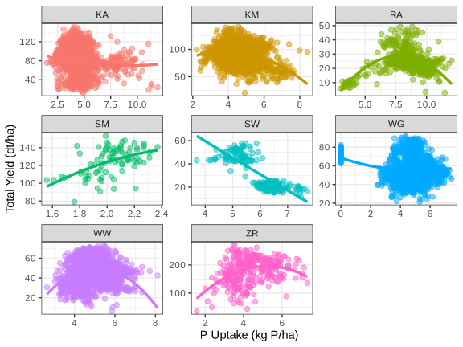
Figure 2: Total Yield versus Annual P Uptake grouped by crop type. The polynomial trend lines highlight the non-linear decoupling of yield from uptake at higher availability levels, driven by fluctuating internal plant P concentrations ($C_{P}$).

3.3 Yield model comparison
To evaluate whether thermodynamic kinetic parameters offer an advantage over empirical supply classes, we compared the predictive power of five non-linear mixed-effects models against a null model. All models accounted for site-specific and crop-specific yield ceilings via hierarchical random effects ($1|\text{site/year}$). They differed in how the base availability ($K_{base}$) of the STP ($P_{CO_{2}}$ or $P_{AAE10}$) was modulated.
While the Heuristic $CO_{2}$ model achieved the lowest root mean square error (RMSE = 10.56) on the training data, the Bayesian leave-one-out cross-validation ($LOOIC$) indicated that this performance was associated with severe overfitting to the six pedoclimatic covariates ($p_{loo}=1104.8$).
In contrast, the Mechanistic model, which constrained $K_{base}$ strictly to the physical limits of the desorption rate ($k$) and buffer capacity ($1/b$), generalized better ($ΔLOOIC=−1086$ vs. Heuristic $CO_{2}$; $p_{loo}=247.2$).
However, neither the empirical STPs nor the kinetic parameters demonstrated strong predictive power for absolute crop yield when compared to the Null model ($ΔLOOIC=−1364$ vs. Mechanistic). This confirms that short-term agronomic yield is overwhelmingly dominated by local micro-climates and crop biology, rendering the specific physical P-supply mechanism secondary for short-term predictions.
Table 4: Comparison of cross-validated predictive performance for yield models.
Model | Pedoclimatic Covariates | RMSE | $R_{Marg}^{2}$​ | $R_{Cond}^{2}$​ | LOOIC | $p_{loo}$​
Base Model CO2 | (None) | 12.36 | - | - | 79256 | 130.7
Base Model AAE10 | (None) | - | - | - | - | -
Null Model | (None) | 11.50 | - | - | 77999 | 231.5
Heuristic CO2 | pH, Clay, Corg, Ca, Temp, Prec | 10.56 | 0.702 | 0.929 | 77721 | 1104.8
Heuristic AAE10 | pH, Clay, Corg, Ca, Temp, Prec | - | - | - | - | -
Mechanistic | 1/b, k, N, Temp, Prec | 10.73 | 0.701 | 0.931 | 76636 | 247.2

To evaluate true predictive power, we relied on the Expected Log Predictive Density (ELPD) calculated via Bayesian leave-one-out cross-validation (LOO-CV). Unlike in-sample error metrics such as RMSE, which invariably reward overly complex models, ELPD rigorously penalizes models that overfit to local noise. The difference in ELPD ($Δ$ELPD) serves as a relative measure of out-of-sample performance. This metric fundamentally exposes models that achieve low training error merely by hallucinating relationships with non-causal covariates.
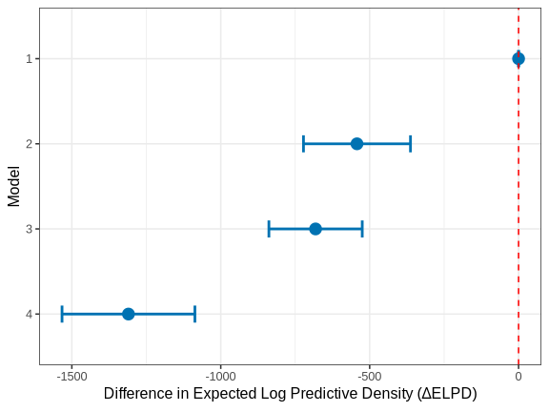
Figure 3: Out-of-Sample Predictive Performance (LOO) of yield models relative to the best model. Error bars represent $±2$ standard errors of the ELPD difference.
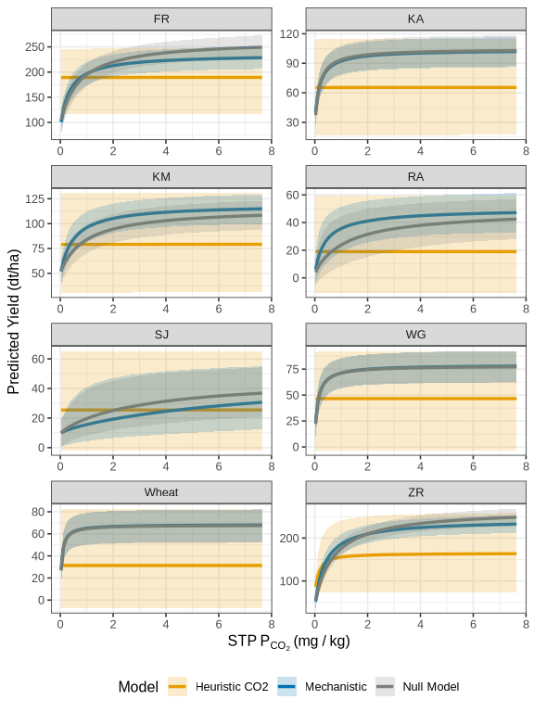
Figure 4: Conditional effects of $P_{CO_{2}}$ STP on predicted yield across crops. The Mechanistic model (blue) produces constrained asymptotic responses bounded by physical desorption parameters. The Heuristic model (orange) demonstrates massive uncertainty and flat average responses, indicating that its predictive power was inappropriately shifted to pedoclimatic covariates.
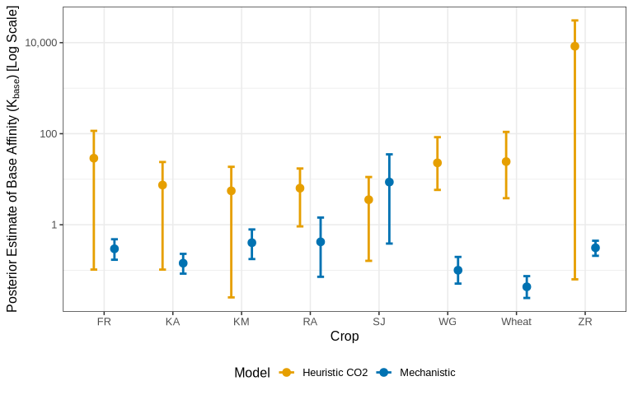
Figure 5: Posterior uncertainty (shrinkage) of the crop-specific base affinity ($K_{base}$) for the Mechanistic and Heuristic yield models. The massive 95% credible intervals for the Heuristic model indicate severe overfitting and an inability to constrain the fundamental agronomic relationship, whereas the Mechanistic model is tightly constrained by physical desorption kinetics.

3.4 Phosphorus Uptake ($C_{P}$) model comparison
We repeated the identical model hierarchy to predict total plant phosphorus uptake rather than dry matter yield.
Table 5: Comparison of cross-validated predictive performance for total phosphorus uptake models.
Model | Pedoclimatic Covariates | RMSE | $R_{Marg}^{2}$​ | $R_{Cond}^{2}$​ | LOOIC | $p_{loo}$​
Base Model CO2 | (None) | 0.70 | - | - | 21539 | 118.9
Base Model AAE10 | (None) | - | - | - | - | -
Null Model | (None) | 0.65 | - | - | 20053 | 144.4
Heuristic CO2 | pH, Clay, Corg, Ca, Temp, Prec | 0.63 | 0.540 | 0.791 | 19374 | 163.2
Heuristic AAE10 | pH, Clay, Corg, Ca, Temp, Prec | - | - | - | - | -
Mechanistic | 1/b, k, N, Temp, Prec | 0.64 | 0.534 | 0.782 | 19820 | 160.8

In a stark divergence from the yield models, the Heuristic $CO_{2}$ model demonstrated the highest predictive power both in-sample (RMSE = 0.62) and out-of-sample (LOOIC = 19374).
Crucially, the Heuristic uptake model did not suffer from the severe overfitting observed in the yield predictions; its effective number of parameters ($p_{loo}=163.2$) was nearly identical to the strictly constrained Mechanistic model ($p_{loo}=160.7$). This indicates that the pedoclimatic covariates (pH, Clay, Temperature, Precipitation) were capturing true, generalizable physical signals rather than memorizing local noise.
This phenomenological divergence is biologically consistent. While absolute dry matter yield is a highly confounded metric capped by dozens of non-phosphorus environmental factors, luxury plant P-uptake ($C_{P}$) is tightly coupled to the physical diffusion of P to the roots and active root metabolism. Therefore, allowing local soil properties and climate variables to flexibly modulate the apparent availability of the empirical STP ($P_{CO_{2}}$) legitimately improves the prediction of biological P-acquisition over purely thermodynamic bounds.
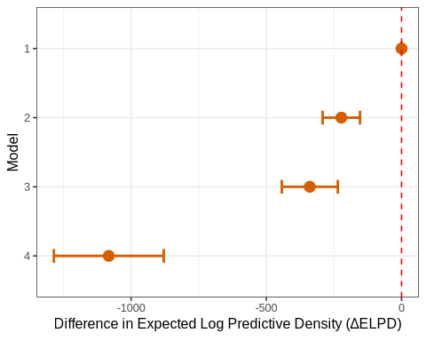
Figure 6: Out-of-Sample Predictive Performance (LOO) of P-Uptake models. In stark contrast to dry matter yield, the Heuristic model genuinely outperforms the Mechanistic constraints out-of-sample.
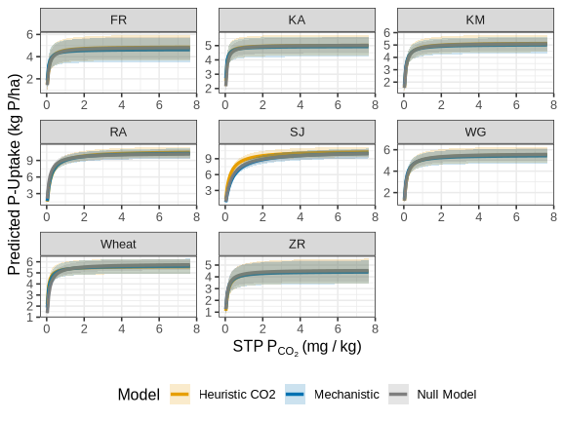
Figure 7: Conditional effects of STP on P-Uptake. Because the pedoclimatic covariates capture true signal for P-acquisition, the Heuristic model produces stable, physically meaningful response curves without hallucinating.
To fully understand why the pedoclimatic covariates induce severe overfitting in the yield models but provide genuine predictive power for P-uptake, we can examine the estimated effect sizes (and their uncertainties) across both agronomic responses (Figure 8).
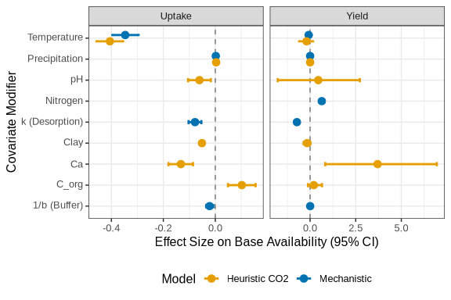
Figure 8: Forest plot of estimated covariate modifiers on base P availability ($K_{base}$) for both Yield and P-Uptake. The Heuristic model’s reliance on soil pH, clay, and organic carbon to predict yield exhibits massive uncertainty (wide 95% CIs) and instability, characteristic of overfitting. In contrast, the effects on P-Uptake are tightly constrained and biologically meaningful.

4. Discussion

5. Conclusion

6. Acknowledgments
Without my wife I could not have again and again found the energy and time to work on my deeply personally motivated thesis. While she gave me the space to work, she tended to our little son, who in return with his intruiging way of demanding and negotiating play-time, attention and proximity, constantly earthed and reminded me of our dependence on others. The idea for this thesis came from many lengthy discussions with Frank Liebisch, where he, although being so busy, invested so much time in my development to an agronomist during my internship. He endured over and over my harsh critique on the nature and issues of agronomic research, and understood my drustration on the limitations posed on agronomic researchers, while still giving me hope in the possibility of progress and knowledge gain. It is not common, that a master student can choose his own topic and methodology for his master thesis, Emmanuel Frossard agreed immediately upon hearing from my idea. He knew that the task I set myself was difficult and extensive, but he not only showed confidence in my ability to grow on the pitfalls and issues, he would always remind me with his charactersitic words. “Il faut avoir le courage”, that acknowloding one’s own limitation and ignorance and simultaneously making falsifiable claims and to stand for them, is a cardinal attitude I can grow into. The support of Frank and Emmanuel went beyond their responsibility as specialists, I will never forget the kindness and patience shown to me, knowing that I behaved often spiky and frustrated, when my abstract and often idealistic considerations met the hard reality of soil-chemisty-measurements. Gratiously Emmanuel Frossard provided me access to the group’s laboratory, where Laurie Schönholzer supported me heavily, developing the protocol for my experiments. She not only shared her professional knowledge, but would also educate me on the code how to properly prepare and clean a lab. My wife reports, that I behave differently since then when it comes to our household. I benefited increadibly from this thesis. Lukas Graz introduced me to Quarto and helped me setting up a workflow, that is both safe in terms of data-loss and reproducible. He relentlessly explained me the pitfalls when using hierarchical models, aided in the selection of the effect-structure and taught me both as a friend and specialist invaluable lessons, how to structure and effiently write R-code, approaching complex real data. He encouraged me over and over, this thesis would not have been possible without him. I would also like to acknowledge the use of Google’s Gemini language model in the preparation of this thesis. It served as a valuable programming assistant for debugging R and LaTeX code, and as an editorial tool for improving language, formatting, and the overall structure of the manuscript, particularly in the discussion and conclusion sections.

7. References
Atkins, P., & Paula, J. de. (2011). Physical chemistry for the life sciences (2nd ed.). Oxford University Press.
Barber, S. A., & Cushman, J. H. (1981). Nitrogen uptake model for agronomic crops. In I. K. Iskandar (Ed.), Modeling wastewater renovation land treatment (pp. 382–409). Wiley.
Bates, D., Maechler, M., Bolker, B., Walker, S., Jagan, M., & Ly, A. (2026). lme4: Linear mixed-effects models using eigen and S4. https://github.com/lme4/lme4/
Brady, N. C., & Weil, R. R. (2016). The nature and properties of soils (15th ed.). Pearson.
Demaria, P., Flisch, R., Frossard, E., & Sinaj, S. (2005). Exchangeability of phosphate extracted by four chemical methods. Z. Pflanzenernähr. Bodenk., 168(1), 89–93. https://doi.org/10.1002/jpln.200421463
Fardeau, J.-C. (1996). Dynamics of phosphate in soils. An isotopic outlook. Fertilizer Research, 45, 91–100.
Flossmann, R., & Richter, D. (1982). Extraction method for characterizing the kinetics of phosphorus release from solid soil to soil solution.
Forschungsanstalt für Agrarökologie und Landbau (FAL). (1996). Methodenbuch für boden-, pflanzen- und nährstoffanalysen. FAL.
Freundlich, H. (1906). Über die Adsorption in Lösungen. Zeitschrift für Physikalische Chemie, 57(1), 385–470.
Frossard, E., Condron, L. M., Oberson, A., Sinaj, S., & Fardeau, J. C. (2000). Processes governing phosphorus availability in temperate soils. Journal of Environmental Quality, 29(1), 15–23. https://doi.org/10.2134/jeq2000.00472425002900010003x
Gallet, A., Flisch, R., Ryser, J.-P., Frossard, E., & Sinaj, S. (2003). Effect of phosphate fertilization on crop yield and soil phosphorus status. Z. Pflanzenernähr. Bodenk., 166(5), 568–578. https://doi.org/10.1002/jpln.200321081
Gustafsson, J. P. (2001). Modeling competitive anion adsorption on oxide minerals and an allophane-containing soil. European Journal of Soil Science, 52(4), 639–653. https://doi.org/10.1046/j.1365-2389.2001.00407.x
Gustafsson, J. P. (2014). Visual MINTEQ 3.1 [Computer software]. https://vminteq.lwr.kth.se/
Hirte, J., Richner, W., Orth, B., Liebisch, F., & Flisch, R. (2021). Yield response to soil test phosphorus in Switzerland: Pedoclimatic drivers of critical concentrations for optimal crop yields using multilevel modelling. Science of The Total Environment, 755, 143453. https://doi.org/10.1016/j.scitotenv.2020.143453
Jordan-Meille, L., Rubæk, G. H., Ehlert, P. A. I., Genot, V., Hofman, G., Goulding, K., Recknagel, J., Provolo, G., & Barraclough, P. (2012). An overview of fertilizer-P recommendations in Europe: Soil testing, calibration and fertilizer recommendations. Soil Use and Management, 28(4), 419–435. https://doi.org/10.1111/j.1475-2743.2012.00453.x
Lookman, R., Desmet, J., Grobet, P., Merckx, R., & Vlassak, K. (1995). A geostatistical assessment of the regional distribution of phosphate sorption capacity parameters (feox and alox) in northern belgium. Geoderma, 66(3-4), 285–296.
Michaelis, L., & Menten, M. L. (1913). Die Kinetik der Invertinwirkung. Biochemische Zeitschrift, 49, 333–369.
Minton, A. P. (2001). The influence of macromolecular crowding and macromolecular confinement on biochemical reactions in physiological media. Journal of Biological Chemistry, 276(14), 10577–10580.
Nye, P. H., & Tinker, P. B. (2000). Solute movement in the rhizosphere. Oxford University Press.
Olsen, S. R., Cole, C. V., Watanabe, F. S., & Dean, L. A. (1954). Estimation of available phosphorus in soils by extraction with sodium bicarbonate (Circular No. 939). United States Department of Agriculture.
Pinheiro, J., Bates, D., & R Core Team. (2026). Nlme: Linear and nonlinear mixed effects models. https://svn.r-project.org/R-packages/trunk/nlme/
R Core Team. (2026). R: A language and environment for statistical computing. R Foundation for Statistical Computing. https://doi.org/10.32614/R.manuals
Schwertmann, U. (1964). Differenzierung der Eisenoxide des Bodens durch Extraktion mit Ammoniumoxalat-lösung. Zeitschrift für Pflanzenernährung, Düngung, Bodenkunde, 105(3), 194–202.
Sposito, G. (2008). The chemistry of soils (2nd ed.). Oxford University Press.
Steinfurth, K., Börjesson, G., Denoroy, P., Eichler-Löbermann, B., Gans, W., Heyn, J., Hirte, J., Huyghebaert, B., Jouany, C., Koch, D., Merbach, I., Mokry, M., Mollier, A., Morel, C., Panten, K., Peiter, E., Poulton, P. R., Reitz, T., Rubæk, G. H., … Buczko, U. (2022). Thresholds of target phosphorus fertility classes in European fertilizer recommendations in relation to critical soil test phosphorus values derived from the analysis of 55 European long-term field experiments. Agriculture, Ecosystems & Environment, 332, 107926. https://doi.org/10.1016/j.agee.2022.107926
Van Veldhoven, P. P., & Mannaerts, G. P. (1987). Inorganic and organic phosphorus in the scheldt estuary. Estuarine, Coastal and Shelf Science, 25(6), 755–765.

8. Appendix: Thermodynamic Correction of $P_{ext{CO}_{2}}$ Extractions

8.1 A.1. Intrinsic Ionic Strength of the $P_{ext{CO}_{2}}$ Extractant
Standard static soil test methods rely on the operational extraction of phosphorus. Strong extractants (e.g., Olsen P, P-AAE10) possess inherently high ionic strengths that dominate the soil matrix, complicating absolute thermodynamic comparisons without complex modeling. In contrast, the $P_{ext{CO}_{2}}$ method utilizes a very weak extractant: water saturated with carbon dioxide at atmospheric pressure (1 atm) and 25 °C.
To demonstrate that the $P_{ext{CO}_{2}}$ extractant adopts the native ionic strength of the soil, we calculate the intrinsic ionic strength ($I$) of the pure extractant.
According to Henry’s Law, the concentration of dissolved $CO_{2}$ (denoted as $H_{2}CO_{3}^{*}$) is:
$$[H_{2}CO_{3}^{*}]=K_{H}×P_{CO_{2}}$$
Given Henry’s constant ($K_{H}≈0.034{\text{ M atm}}^{−1}$) and $P_{CO_{2}}=1\text{ atm}$, the molarity of dissolved $CO_{2}$ is approximately $0.034\text{ M}$.
The primary ionic species generated arise from the first dissociation of carbonic acid:
$$H_{2}CO_{3}^{*}⇌H^{+}+HCO_{3}^{−}$$
Using the acid dissociation constant ($K_{a1}=4.46×{10}^{−7}$ at 25 °C):
$$K_{a1}=\frac{[H^{+}][HCO_{3}^{−}]}{[H_{2}CO_{3}^{*}]}$$
Because $[H^{+}]≈[HCO_{3}^{−}]$, we can solve for the bicarbonate concentration:
$$[HCO_{3}^{−}]=\sqrt{4.46×{10}^{−7}×0.034}≈1.23×{10}^{−4}\text{ M}$$
The intrinsic ionic strength ($I$) of the extractant is defined as:
$$I=\frac{1}{2}∑(C_{i}z_{i}^{2})$$
$$I=\frac{1}{2}\left((1.23×{10}^{−4}×(+1)^{2})+(1.23×{10}^{−4}×(−1)^{2})\right)≈0.00012\text{ M}$$
This intrinsic ionic strength ($≈0.12\text{ mM}$) is negligible compared to native agricultural soil solutions (which typically range from $10$ to $50\text{ mM}$). Therefore, the final ionic strength of the $P_{ext{CO}_{2}}$ extract is primarily dictated by the dissolved soluble salts of the specific soil being analyzed.

8.2 A.2. Justification for the Davies Equation
Because the $P_{ext{CO}_{2}}$ extract adopts the native ionic composition of the soil, reading the orthophosphate concentrations against an $I=0$ (distilled water) calibration curve introduces systematic error. The fundamental thermodynamic driving force for P-availability is the chemical activity, not the stoichiometric concentration.
To correct for this, an activity coefficient ($γ$) must be applied. While the Pitzer equations are the standard method for high-ionic-strength solutions ($I>0.5\text{ M}$, such as the P-AAE10 extractant), the ionic strength of native agricultural soil solutions is typically much lower ($I<0.1\text{ M}$).
In this low-to-moderate ionic strength regime, the Davies equation (an empirical extension of the Debye-Hückel theory) is highly accurate and does not require complex, ion-specific interaction parameters.
The Davies equation calculates the activity coefficient ($γ$) as follows:
$$\log_{10}(γ)=−Az^{2}\left(\frac{\sqrt{I}}{1+\sqrt{I}}−0.3I\right)$$
Where: * $A$ is a temperature-dependent constant ($≈0.509{\text{ L}}^{0.5}{\text{mol}}^{−0.5}$ for water at 25 °C). * $z$ is the charge of the ion in question (for orthophosphate, $z$ depends on pH, predominantly $−1$ for $H_{2}PO_{4}^{−}$ and $−2$ for $HPO_{4}^{2−}$). * $I$ is the total ionic strength of the extracted solution, calculated from the measured concentrations of major cations ($Ca^{2+},Mg^{2+},K^{+}$).

8.3 A.3. Implementation of Thermodynamic Correction
To assess the theoretical P-Intensity ($I$) and formulate the Phosphorus Buffering Capacity (PBC), the operationally defined $P_{ext{CO}_{2}}$ concentrations are converted to thermodynamic activities using the following sequential steps:
- Determine Total Ionic Strength ($I$): Using the measured cation concentrations from the extracts.
$$I=\frac{1}{2}\left([K^{+}]+4[Ca^{2+}]+4[Mg^{2+}]+…\right)$$
- Calculate the Activity Coefficient ($γ$): Applying the Davies equation based on the sample’s specific $I$.
- Compute Chemical Activity:
$$\text{Activity}(P)=[P_{CO_{2}}]×γ$$
By standardizing the measurements to their corrected thermodynamic activity, we remove the analytical bias introduced by varying soil salinity and pedoclimatic history, allowing for an absolute comparison of P-Intensity across all STYCS experimental sites. ## A.4 Supplementary Materials and Reproducibility
This Master’s thesis was produced using a fully reproducible workflow with the Quarto publishing system. All data, R scripts, and analytical notebooks used to generate the figures, tables, and results presented in this work are openly available.
The complete project can be cloned from the author’s GitHub repository, which contains the raw data, the R code for the kinetic and statistical models, and the Quarto source files.
GitHub Repository URL: [https://github.com/ptochosgeorgos/Article-P-desorption-kinetics]
A rendered version of the full project, including the analytical notebooks that document the development process, is also available as a GitHub Pages website at the following URL:
GitHub Pages Site URL: [https://ptochosgeorgos.github.io/Article-P-desorption-kinetics/]
This approach ensures full transparency and allows for the complete replication of the findings presented in this thesis.

