PROJECT2 REPORT

- TITLE
Shortest Job First Task Scheduler
TOLOUDIS PANAGIOTIS, AEM: 02995
NTEMKAS CHRISTOS, AEM: 02984
GAROUFALI MARIA NEFELI, AEM: 03129

- SUMMARY
In this project, we are asked to implement a process scheduler based on the Shortest Job First policy. This will be implemented in a virtual machine that simulates a single-processor system and is provided to us. The virtual machine does not require extensive memory and interrupt management while providing all the interfaces used by the Linux scheduler and performing the various functions just like the Linux kernel.

- INTRODUCTION
In this project, we will implement the Shortest Job First preemptive scheduling algorithm. Our policy should also consider the time that has been mediated since the last execution of each process, favoring the processes that have not been executed for a long time while in the ready queue. It is recalled that the SJF algorithm always selects for execution from the ready processes, the one with the shortest remaining execution time. The preemptive version of SJF allows a running process to be terminated if one appears with a smaller remaining run time. The main weakness of the SJF algorithm, which makes its use problematic, is that it is unrealistic to require prior knowledge of the remaining execution time of a process. One method of circumventing this weakness is the historical monitoring of application behavior. More specifically, the operating system records the previous bursts of each application. As a burst, we define the time from the moment when a process takes control of the processor until the moment it relinquishes (voluntarily) the processor. Based on this information the scheduler can estimate the expected future breakout time of each process, applying a simple mathematical formula that takes care of their "aging". of past observations (and thus reduce their effect on the expected future burst time). The formula that will be used in the work is:

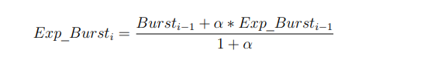

For the project, we considered α = 0.5.

Based on the estimated future burst time of some process and the time by which the process is inactive (since the last time it entered the ready queue), we can calculate a "priority" for the process as follows:

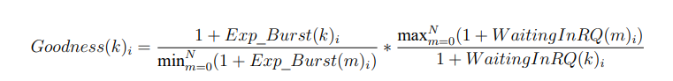

where Goodness(k)i is the “priority” of process k at the time i, WaitingInRQ(k)i is the time that process k has passed since it entered the ready queue of processes, up to the time i and N is the number of processes in the ready queue. The process with the lowest Goodness is preferred.

- ANALYSIS
Here we will analyze the three policies (RR, SJF-EB, SJF-G) firstly from a theoretical point of view and secondly from a practical one by reviewing and analyzing the results of our experiments.
Theoretical Analysis
- Round Robin (RR):

Round Robin is a preemptive scheduling algorithm in which processes are assigned in CPU time slices, also known as time quanta or time intervals, for execution. The CPU is allocated to each process for a fixed time quantum, typically ranging from 10 to 100 milliseconds. When the time quantum expires, the process is preempted, and the CPU is given to the next process in the queue. If a process finishes execution before its time quantum expires, it is removed from the queue, and the CPU is given to the next process.

- Shortest Job First with Expected Burst (SJF-EB):

SJF-EB is a non-preemptive scheduling algorithm in which the CPU is assigned to the process that has the smallest expected CPU burst time. The expected CPU burst time is the average time taken by the process to complete its execution in the past. The algorithm predicts the future behavior of the process based on its past behavior. SJF-EB is not suitable for interactive systems because it favors long-running processes, which can lead to the starvation of short processes. This policy is good for systems with a high proportion of short processes. That is because the average waiting time is reduced, and the turnaround time is improved. Another disadvantage of this policy is the starvation of long processes if there are many short processes in the queue.

- Shortest Job First with Goodness (SJF-G)

SJF-G is a preemptive scheduling algorithm in which the CPU is assigned to the process that has the smallest goodness value. The goodness value is calculated as the ratio of the waiting time of the process to its expected CPU burst time. The algorithm favors short processes that have been waiting for a long time. SJF-G improves the response time of interactive systems compared to SJF-EB, but it may cause starvation of long-running processes.

Experimental Analysis
To assess the scheduler with these policies we created 3 test profiles. Each profile expresses a different condition. There are three conditions that we checked:

- Only interactive processes enter the scheduler.
- Only non-interactive processes enter the scheduler.
- Both interactive and non-interactive processes enter the scheduler.

- Interactive processes
  - Round Robin (RR):
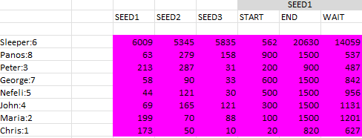

  - Shortest Job First with Expected Burst (SJF-EB)
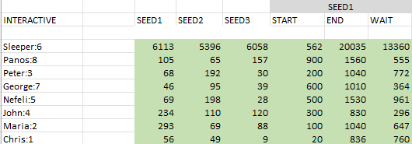

  - Shortest Job First with Goodness (SJF-G)
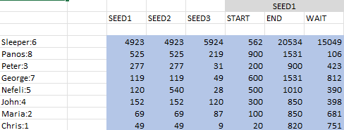

We observed that for interactive processes the best policy is the SJF-G. We can see that because the total running time is more fairly distributed among the processes. We also confirm the theory that SJF-EB is problematic for interactive processes because it can cause the processes to wait for a long time before receiving CPU. The same happens with the RR policy because the continuous changes force the processes to wait a long time before receiving the CPU.

- Non- interactive processes
  - Round Robin (RR):
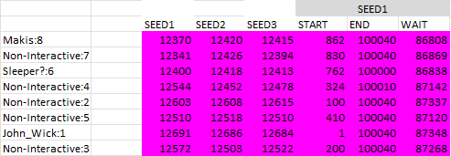

  - Expected Burst (SJF-EB)
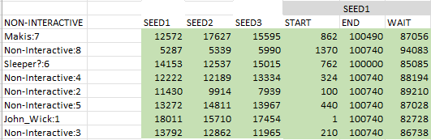

  - Goodness (SJF-G)

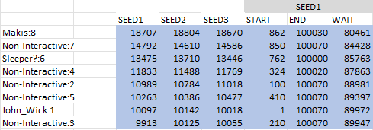

For the non-interactive processes, it seems that the best policies are the RR and SJF-G. We observe that because the average running time for each process is smaller for RR and SJF-G than SJF-EB. More specifically, the results from the smaller average running time to the larger running time is RR <= SJF-G < SJF-EB.

- Both interactive and non-interactive processes
  - Round Robin (RR):
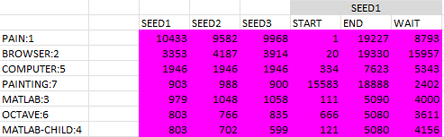

  - Expected Burst (SJF-EB)
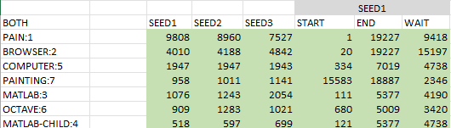

  - Goodness (SJF-G)
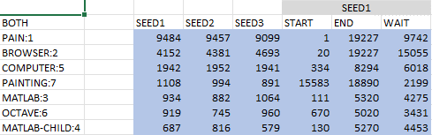

For complex systems that include both interactive and non-interactive processes, ideally we would observe that SJF-G is performing better than the others. As for the RR and SJF-EB, the SJF-EB should be more efficient. However, in our test, all the policies behave the same way. This happens because we created a .conf file that contains both interactive and non-interactive in the same proportion.

We finally checked the results for different SEED values. We observed slightly different results. This is quite logical, because different SEEDs mean randomness in the I/Os.

- CONCLUSION
In conclusion, the choice of scheduling algorithm depends on the nature of the system and the goals of the system. RR is suitable for systems where interactive applications and batch jobs coexist, and fairness is essential. SJF-EB and SJF-G are suitable for systems where short processes are prevalent, and response time is critical. SJF-G provides a better response time than SJF-EB but may cause starvation of long-running processes.

- RESULT
The result of the SJF-EB: https://github.com/ptoloudis/Operating-System/tree/main/Scheduler_VM/best

The result of the SJF-G:
https://github.com/ptoloudis/Operating-System/tree/main/Scheduler_VM/good

The result of the RR:
https://github.com/ptoloudis/Operating-System/tree/main/Scheduler_VM/round

The results:
https://github.com/ptoloudis/Operating-System/blob/main/Scheduler_VM/analysis.xlsx

