**LIGHTNING INSTALLATION MANUAL**

Lightning 0.8.6

11/09/2018

This user manual will explain the installation procedure of **Lightning** (<https://github.com/ptoribi/lightning>), the network simulator based on Docker containers. This document is intended to be a guide for the system administrator of your organization.

For information about how to use this program, please refer to the *“User Manual”*. For creating and configuring your own containers or scenarios repository, please take a look to the *“Professor manual”*.

**Compatibility**

Debian 9 x86_64 (compatibility with more OS will be checked in the nearly future).

**Before the installation**

Before installing Lightning please check that your OS counts with the following **dependencies**:

* **docker-ce** (Docker Community Edition) A complete guide for installing Docker can be found in the official documentation of the project: <https://docs.docker.com/>

On the left panel: **Get Docker** -> **Docker CE** -> **Linux** -> Select your Linux distro and follow the instructions.

* **utilities**: brctl (command line tool for ethernet bridges manipulation), xmllint (XML parser), evince (PDF viewer), git (version control software)

# **apt-get install bridge-utils libxml2-utils evince git**

* **other utilities** that may probably be already installed in your OS:

# **apt-get install sudo bash x11-utils libc-bin coreutils iproute2 iptables mawk sed**

**Install the program**

* **Get the last version of the project**

$ **git clone https://github.com/ptoribi/lightning.git**

* **Change default locations** (Optional)

In order to set the location where the application folder and the symbolic link to the main program will be installed, you can change inside the **install** file the following variables:

* **LIGHTNING_INSTALLATION_DIRECTORY**
* **SYMLINK_INSTALLATION_DIRECTORY**

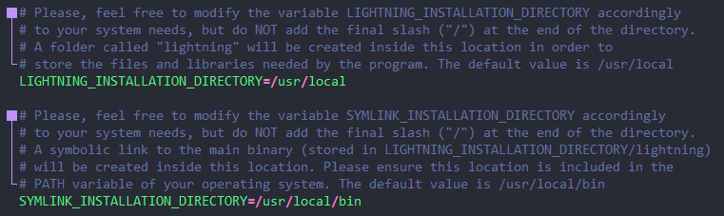

Please ensure before installing that those paths are included in your system's PATH variable. If you have no special needs the default values just work well.

* **Change default repositories** (Optional)

You can specify your own code, scenarios and Docker image repositories to be used by Lightning. This can be done by modifying the **variables.conf** file:

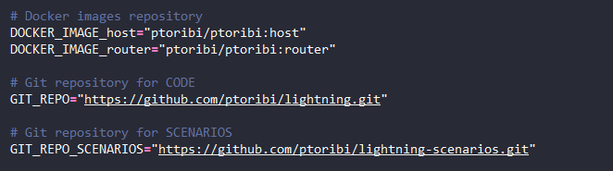

Please agree these values with the professor that will use Lightning.

Alternatively, the file **variables.conf** can also be modified after the installation.

* **Install Lightning**

The installation script will copy all the necessary files to the operating system, and, in addition, will install the scenarios and Docker images indicated in the variables.conf file.

$ **cd lightning**

$ **sudo ./install**

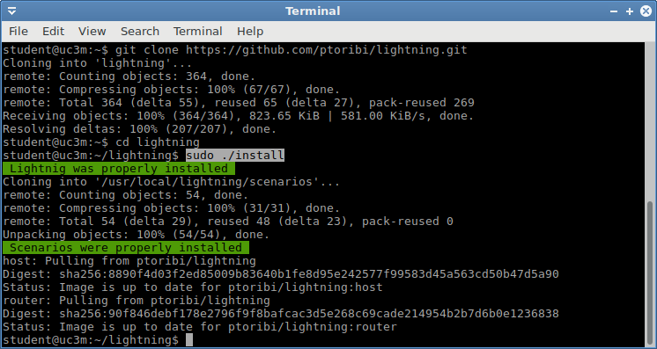

**After the installation**

The user "root" should not execute Lightning directly, only regular users should. Regular users must execute Lightning with root privileges, this can be done by using **one** of these four different ways:

* **Adding the specific user to the sudo group (warning!, that user will be allowed to execute all the programs in the system as root):**

$ **sudo usermod -a -G sudo** *USER_NAME*

* **Allowing that specific user to execute Lightning:**

$ **sudo bash -c "echo '***USER_NAME* **ALL=(ALL) NOPASSWD: $(dirname $(readlink -f $(which lightning)))/lightning' >> /etc/sudoers"**

* **Creating a new group and allowing all its members to execute Lightning, then adding the specific user to that group:**

$ **sudo groupadd** *GROUP_NAME*

$ **sudo bash -c "echo '%***GROUP_NAME* **ALL=NOPASSWD: $(dirname $(readlink -f $(which lightning)))/lightning' >> /etc/sudoers"**

$ **sudo usermod -a -G** *GROUP_NAME USER_NAME*

* **Allowing all the users in the system to execute Lightning:**

$ **sudo bash -c "echo 'ALL ALL=(ALL) NOPASSWD: $(dirname $(readlink -f $(which lightning)))/lightning' >> /etc/sudoers"**

**Add new scenarios**

There are two folders related to scenarios storage:

* **scenarios →** will be populated with the scenarios stored in the configured online repository (GIT_REPO_SCENARIOS variable in the variables.conf file).
* **scenarios-local →** this folder is intended for storing scenarios locally to the computer.

Both folders allow to create other one-level-depth folders inside them to classify the scenarios (for example, with the names of the academic courses).

**Add new functions**

Apart from using use the default functions (stored in the **functions** file), new functions can be defined in the **personalized_functions** file.

For the time being, when using a *XML document* for defining the network scenario Lightning only allows to use the default functions, for using functions created by the professors, they should define the scenario as a *direct execution file*.

**Security**

The **security/container_capabilities.conf** file indicates the capabilities given to the Docker containers. It is important not to add unnecessary capabilities in order to keep a good level of security (hardening) if it is required by your organization:

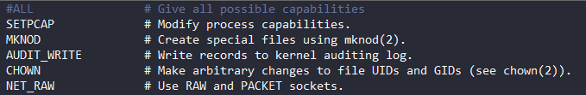

The **security/sudo_commands.conf** file indicates the commands that the user will be able to execute with administrative privileges using **sudo** (and without entering a password) inside the container:

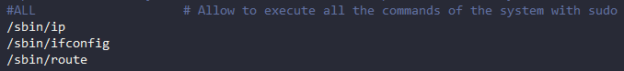

**Uninstall the program**

You will be able to uninstall the program by executing:

$ **sudo $(dirname $(readlink -f $(which lightning)))/uninstall**

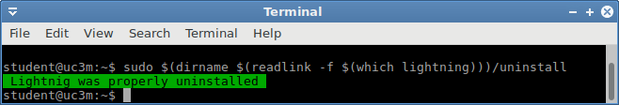

Please note that all the files related to Lightning will be removed from the system, including the **scenarios-local** folder and the **personalized_functions** file.

