**LIGHTNING USER MANUAL**

Lightning 0.8.5

11/07/2018

This user manual will explain the usage of **Lightning** (<https://github.com/ptoribi/lightning>), the network simulator based on Docker containers.

For installing the software please refer to the *“Installation Manual”*. For creating and configuring your own containers or scenarios repository, please take a look to the *“Professor manual”*.

**Main screen → “lightning”**

By typing “lightning” in your Linux console you will be able to see all the commands offered by the program: **start**, **stop**, **purge** and **update**. We’ll explore them in detail in the following sections.

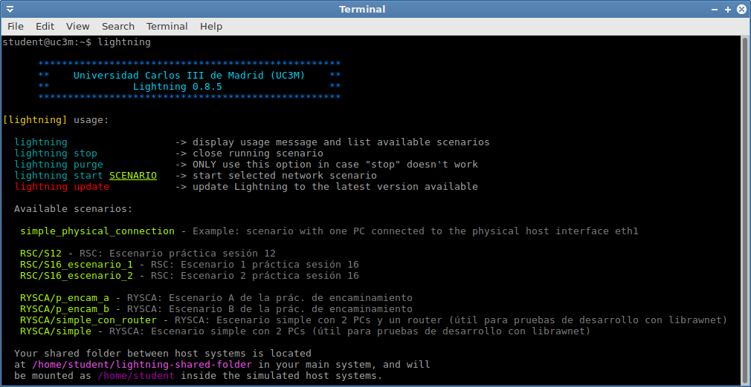

After the command list, the available scenarios in your system are displayed, showing also their respective descriptions.

**Start → “lightning start SCENARIO”**

Launches the specified scenario. In case a PDF file related to that scenario exists, it will be displayed, the Docker containers of the “host” and “router” machines will be started and connected, after that, one command line screen per machine will be shown to you.

Once you have started one network scenario, a folder called “lightning-shared-folder” will be created inside your **home** directory, this folder will be shared between your main operating system and the machines of the running scenario.

Please note this folder and its content will remain even after your scenario is closed, you will not lose any data that you will store there.

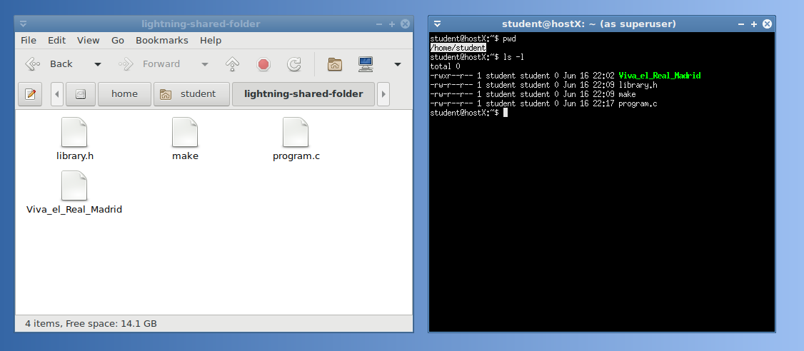

“lightning-shared-folder” will be mounted as /home/your_username inside the Docker container

You will also be able to execute applications with graphical interface inside the containers in real time, as Wireshark.

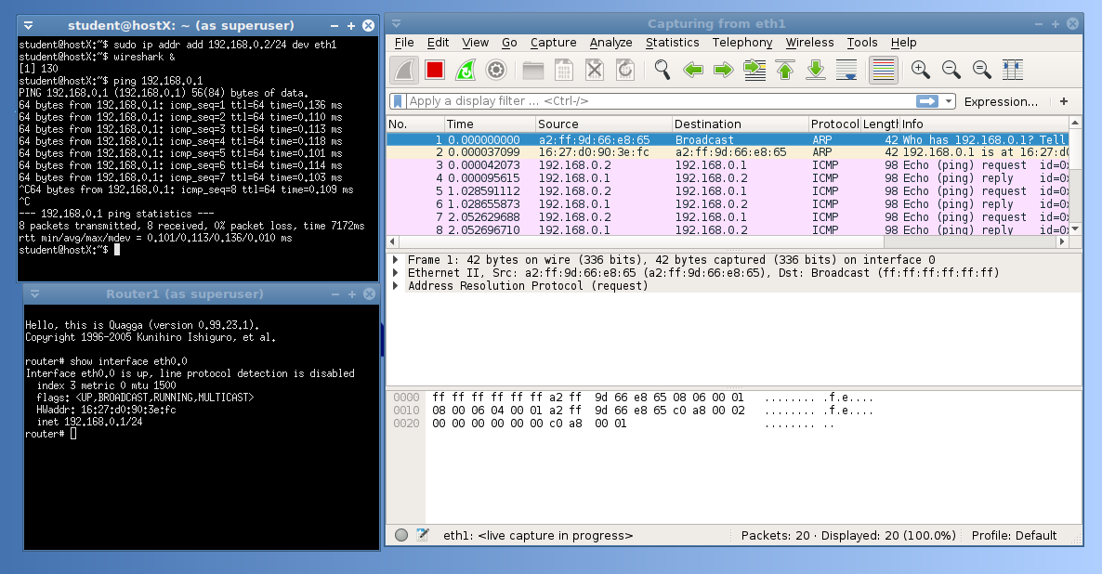

Graphical application being executed inside the container

**Stop → “lightning stop”**

Closes the currently running scenario. All the containers will be stopped and removed, and the networks destroyed. Please note that by stopping the scenario you will lose any configuration performed to the machines, but not the files and folders stored in the shared folder.

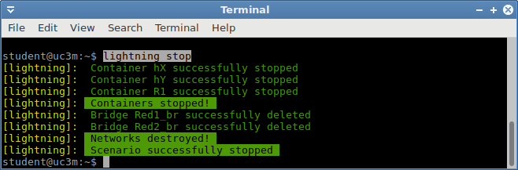

**Purge → “lightning purge”**

This command is intended to be used when the last time it was executed, Lightning was not properly closed by using “lightning stop”. After purging the application, you will be able to start again scenarios as usual.

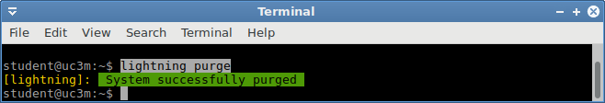

**Update → “lightning update”**

Updates the application, the Docker containers and the scenarios to the latest version. You don´t have to perform an update every time you run Lightning, just pay attention when your professor asks you to do so.

