**UC3M VIRTUAL MACHINE**

**INSTALLATION MANUAL**

11/07/2018

This manual will explain how to install Oracle VirtualBox, import into VirtualBox the OVA file that contains the UC3M virtual machine, share a folder between the VM and your host operating system and exchange files between the VM and your Telematics Department user account.

1. **Download and install VirtualBox**

Access <https://www.virtualbox.org/wiki/Downloads> and download the **latest** version of VirtualBox by choosing from the platform packages list the operating system that you are using:

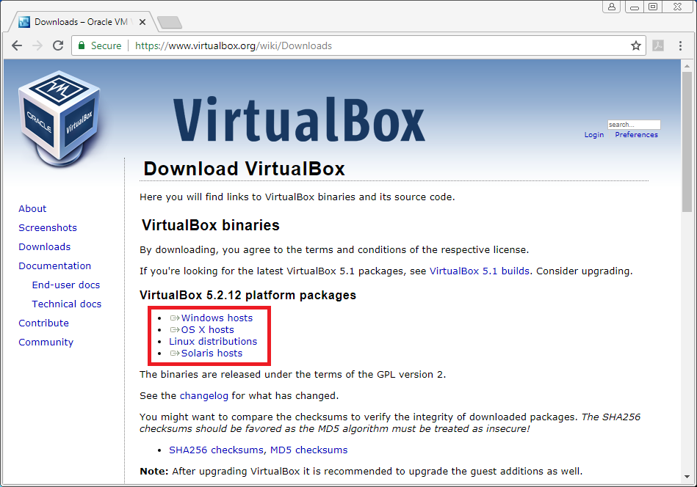

In this guide we will follow installation instructions for a Microsoft Windows operating system.

Execute the package that you downloaded and follow the usual installation steps:

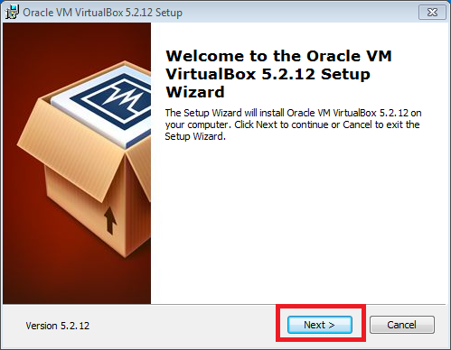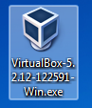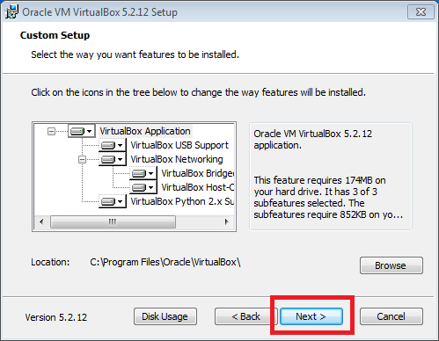

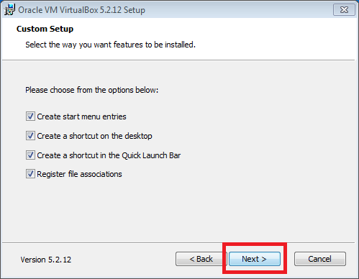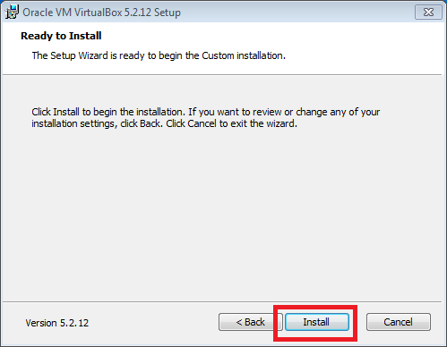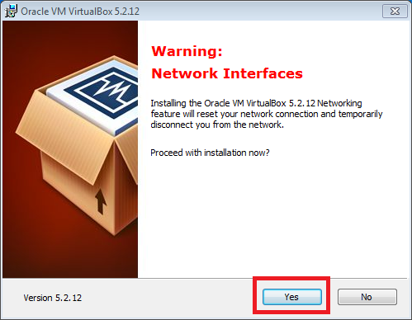

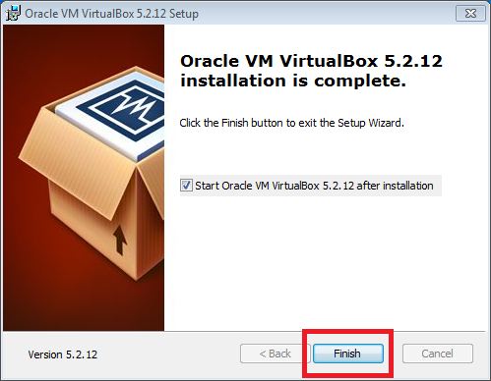

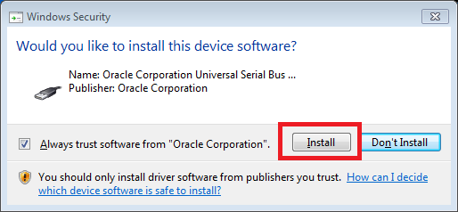

1. **Import the .ova VM file into VirtualBox**

Open Oracle VM VirtualBox, go to **File** → **Import Appliance…** → Select the OVA file distributed by your professor → **Open** → **Next** → **Import**.

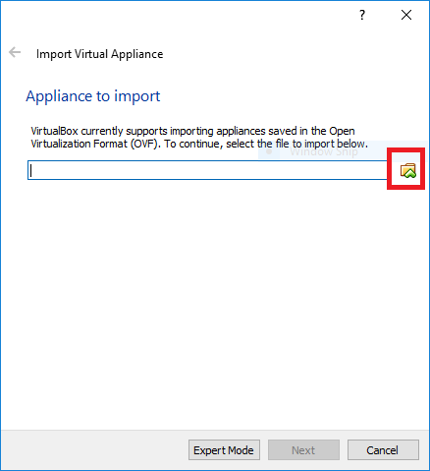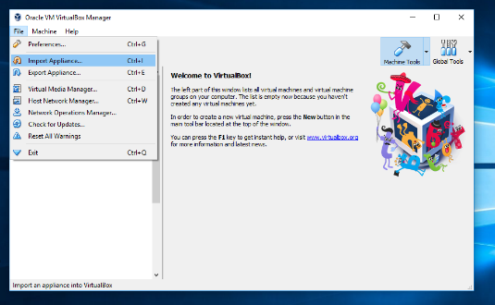

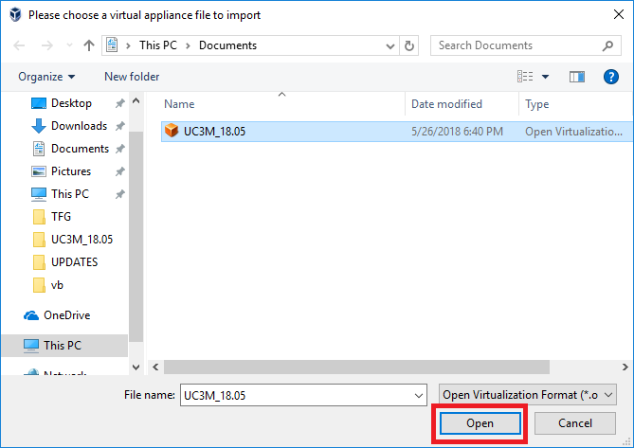

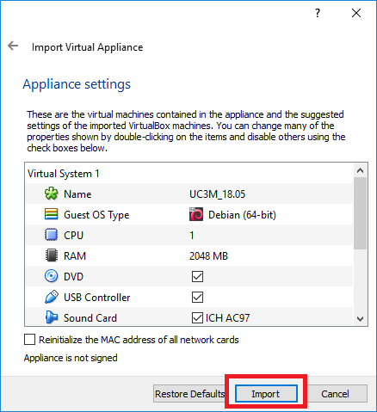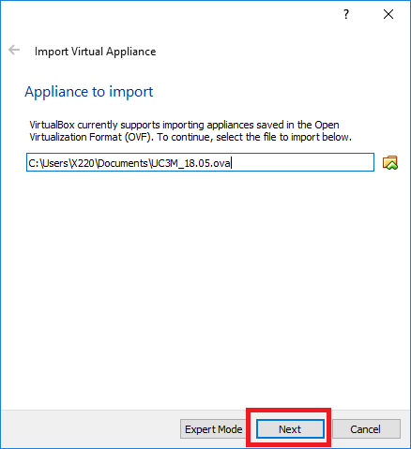

Now wait until the VM is completely imported, after this process it will be ready to be used.

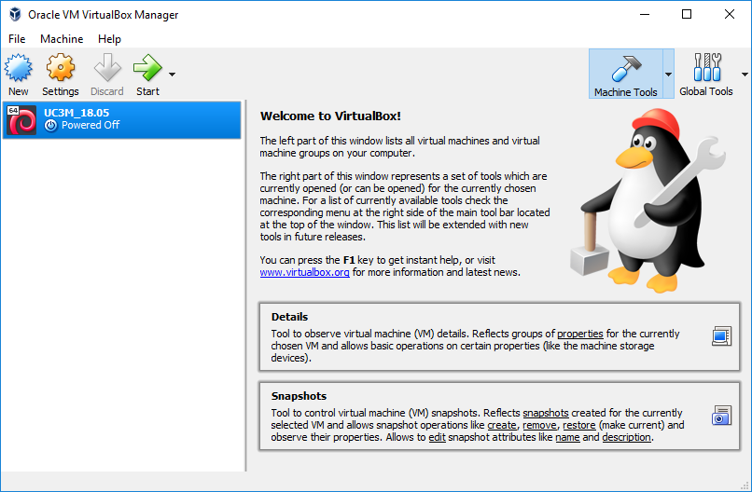

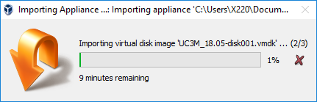

1. **Share a folder between your OS and the virtual machine (optional)**

Do **right-click** over the virtual machine, select **Settings…** → **Shared Folders** → **+**

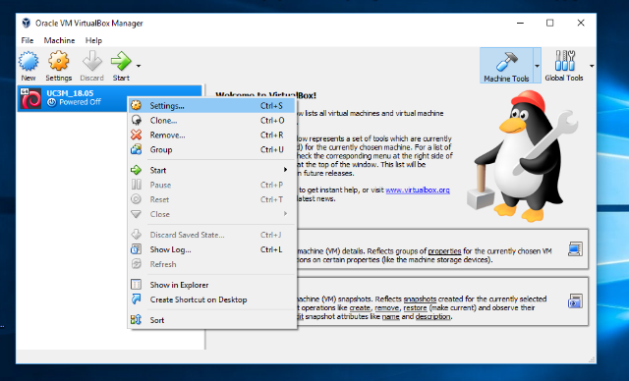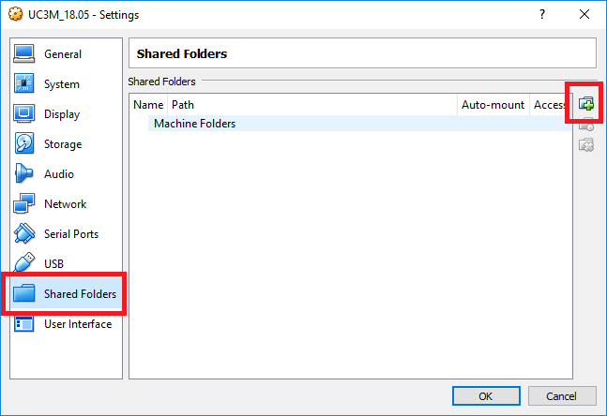

Choose a folder in your operating system to be shared with the virtual machine by clicking Other… inside the pull-down menu → Select Folder:

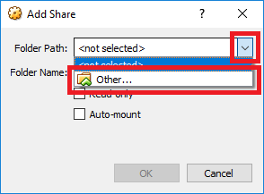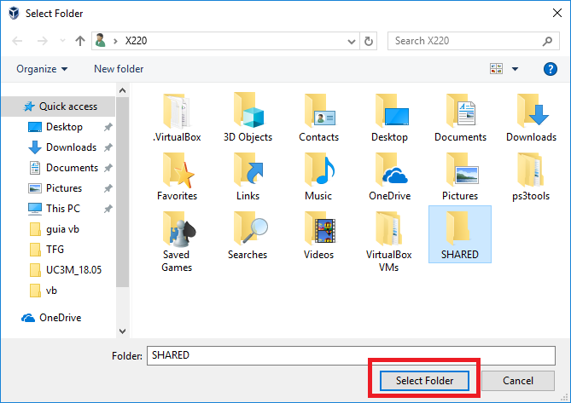

Mark the Auto-mount option → OK → OK

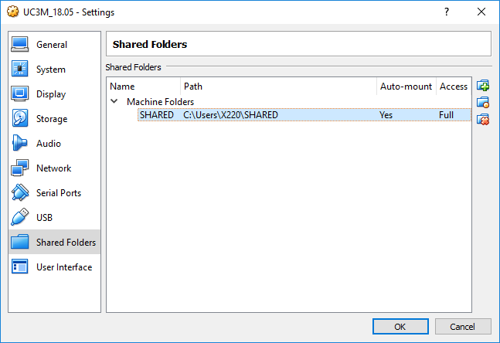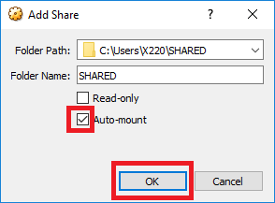

Select and start the virtual machine and launch a file browser. If everything worked properly now you should be able to access the shared folder by clicking on the drive icon located in the left panel (it should be mounted inside the folder /media of the VM).

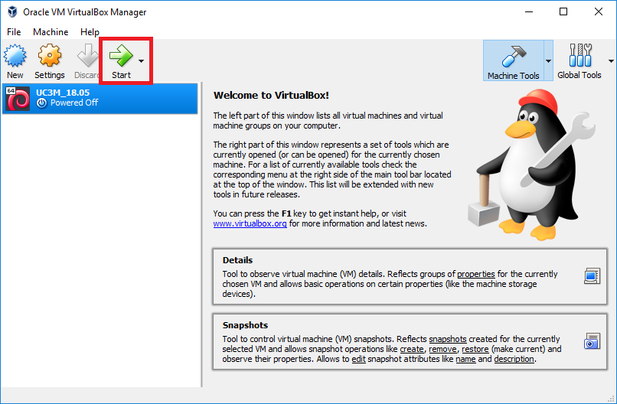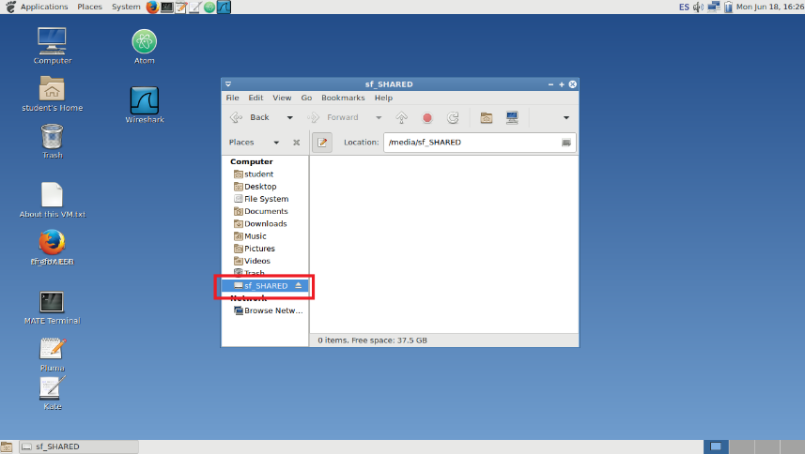

1. **Exchange files between the VM and your Telematics Department user account**

For this purpose, we will make use of the SFTP protocol. As in the machines of the Telematics Department the user’s home folder is mounted using a Network File System when a user logs in, it doesn’t matter which machine we chose for connecting to, the easiest way is to stablish a direct connection with the monitors (monitor01 – monitor04.lab.it.uc3m.es).

In the virtual machine, open the FTP/SFTP client software Filezilla by going to Aplications → Internet → Filezilla.

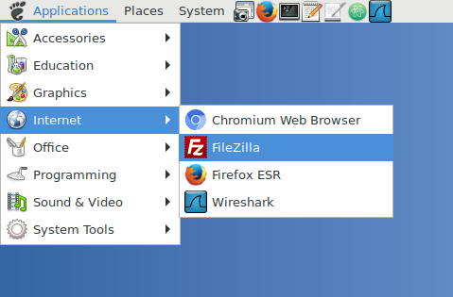

For configuring a connection, make use of the following information:

* **Host:** monitor01 – monitor04.lab.it.uc3m.es
* **Username:** your NIA number without the “10” initial digits
* **Password:** your Telematics Department account password
* **Port:** 22 (yeah, the same as SSH, you guessed it!)

And click on Quickconnect:

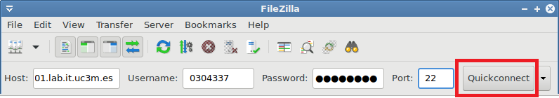

Now you will be accessing your user account folder via the SFTP protocol, for transferring files between the VM and your Telematics account just drag and drop from the left panel to the right one and vice versa:

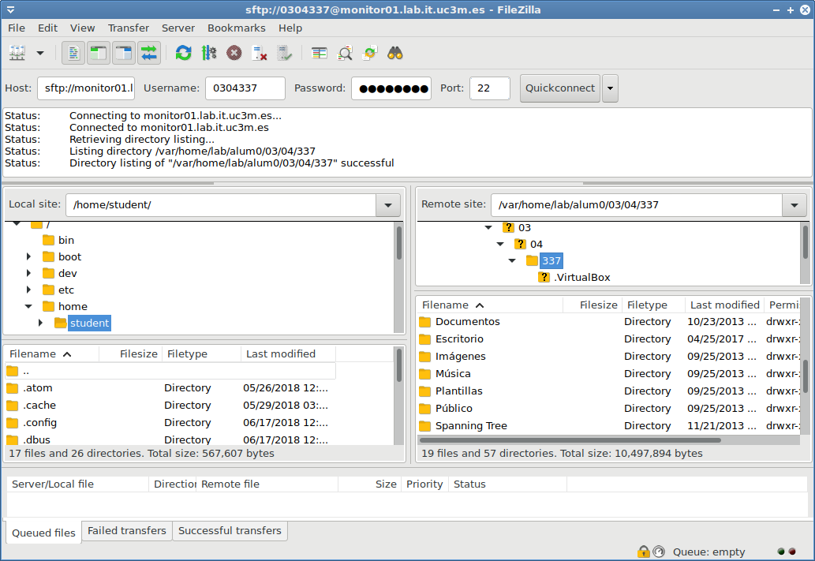

The next time you want to stablish a connection, just click on the pull-down menu near Quickconnect, you will notice your connection data has been saved from the last time:

