InterviewIQ – Prototype and Agile Project Breakdown
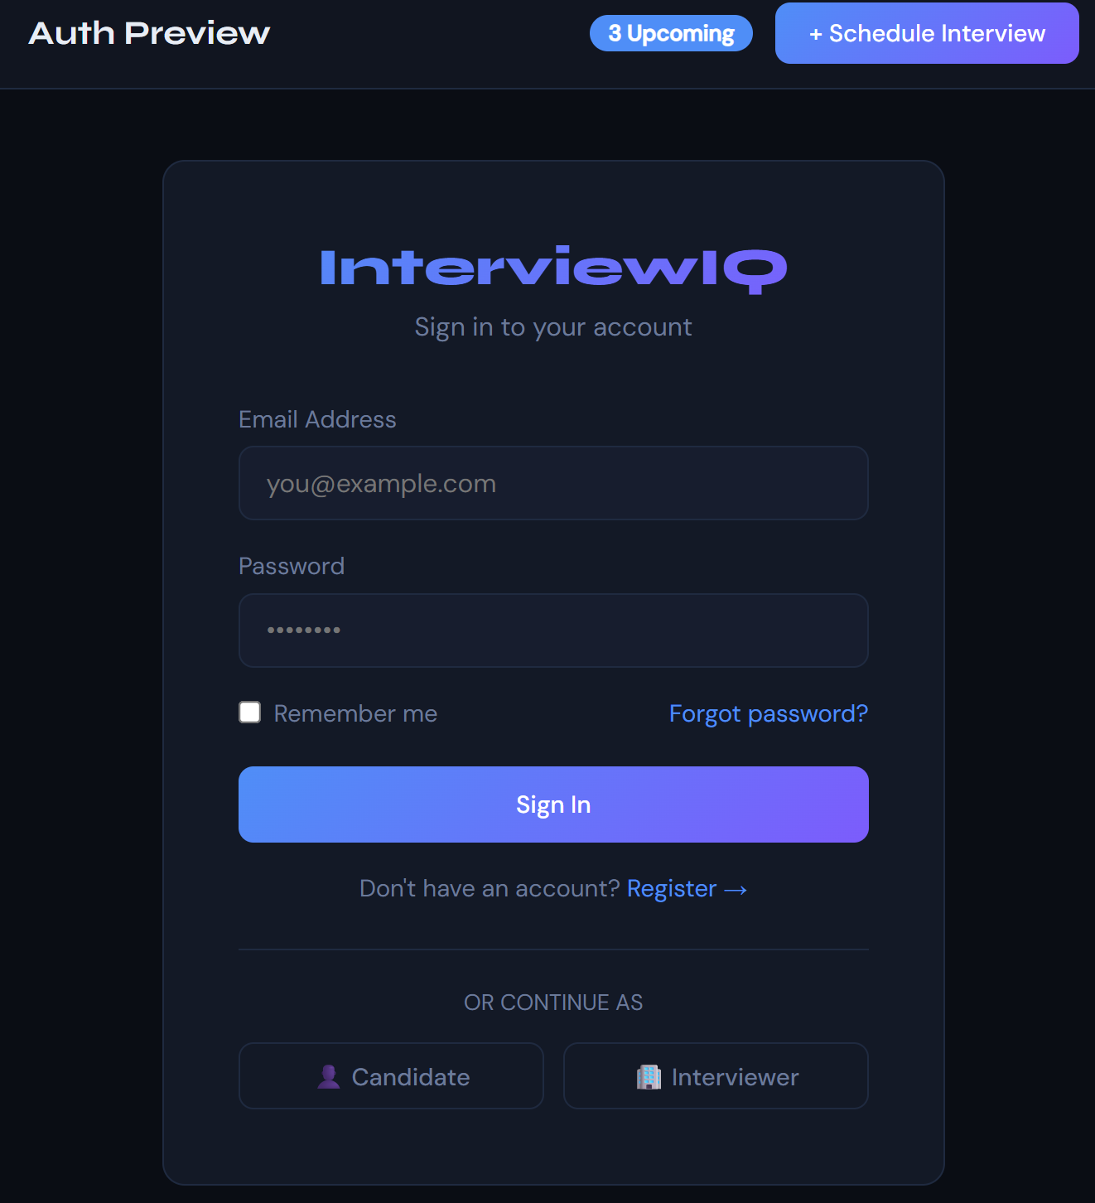
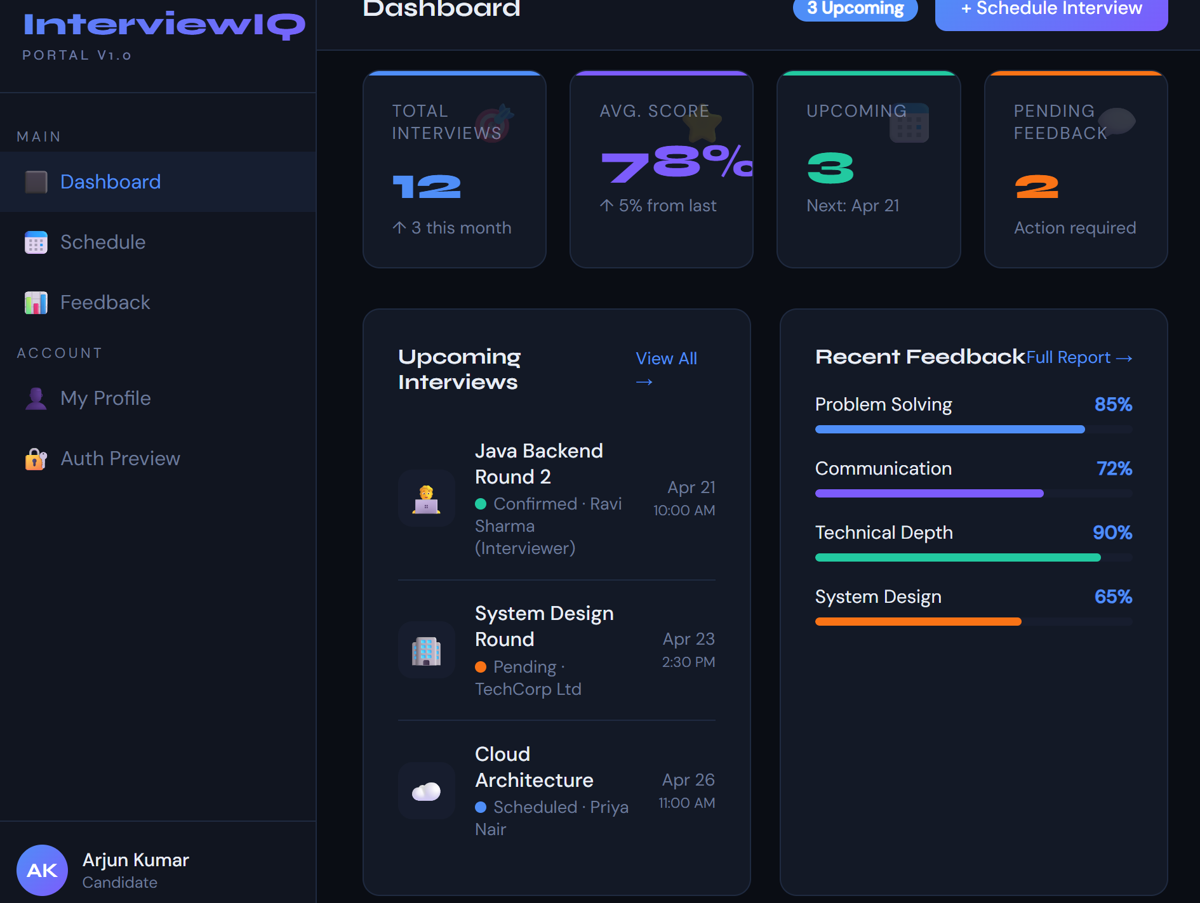
Naming Conventions for User Stories:
Format: [IIQ-<FeatureCode>-<Number>] As a <role>, I want to <goal>, so that <benefit>.
Code | Feature
AUTH | User Authentication & Profiles
APPL | Application Tracking System
SCHD | Interview Scheduling
FBCK | Feedback & Scoring
DASH | Dashboard & Analytics
RECC | Smart Recommendations
ADMN | Admin Management Panel
-------------------------------------------------------------------------------------------------------------------------------
FEATURE 1: Project Setup & DevOps Foundation
Feature Code: SETUP
Goal: Set up the full project skeleton and deployment pipeline before feature development begins.
Sprint 1 (Week 1)
User Story: [IIQ-SETUP-01]
As a developer, I want to set up the Spring Boot backend project with all required dependencies and layered architecture, so that feature development can start on a solid, consistent foundation.
Estimation: 2 Days
Tasks:
# | Task | Type | Est.
T1 | Create Spring Boot project via Spring Initializr (Spring Web, JPA, Security, Mail, Validation, Lombok) | Backend | 1h
T2 | Set up package structure: controller / service / repository / entity / dto / config / exception | Backend | 1h
T3 | Configure application.yml for dev/prod profiles | Backend | 1h
T4 | Set up PostgreSQL locally + configure Datasource | Backend | 1h
T5 | Integrate Flyway for DB migrations | Backend | 2h
T6 | Set up global exception handler (@RestControllerAdvice) | Backend | 1h
T7 | Set up global API response wrapper (ApiResponse DTO) | Backend | 1h

User Story: [IIQ-SETUP-02]
As a developer, I want to set up the React frontend with routing, state management, and component structure, So that all frontend features are built consistently and maintainably.
Estimation: 2 Days
Tasks:
# | Task | Type | Est.
T1 | Create React app using Vite + configure folder structure (pages/components/services/hooks/context) | Frontend | 1h
T2 | Install and configure React Router v6 (public + protected + role-based routes) | Frontend | 2h
T3 | Set up Axios instance with base URL and JWT interceptor | Frontend | 1h
T4 | Set up AuthContext with useContext + useReducer for auth state (with role) | Frontend | 2h
T5 | Install Tailwind CSS and define design tokens | Frontend | 1h
T6 | Create reusable components: Button, Input, Card, Modal, Sidebar, TopBar, Table | Frontend | 3h
User Story: [IIQ-SETUP-03]
As a developer, I want to containerize the application using Docker and set up a basic CI/CD pipeline, So that the app can be built, tested, and deployed consistently.
Estimation: 2 Days
Tasks:
# | Task | Type | Est.
T1 | Write Dockerfile for Spring Boot app | DevOps | 1h
T2 | Write Dockerfile for React app with Nginx | DevOps | 1h
T3 | Create docker-compose.yml with services: backend, frontend, postgres | DevOps | 2h
T4 | Set up GitHub repository with branch strategy (main / develop / feature/*) | DevOps | 1h
T5 | Set up GitHub Actions workflow: build → test → docker build on push to develop | DevOps | 3h
-------------------------------------------------------------------------------------------------------------------------------
FEATURE 2: User Authentication & Profile Management
Feature Code: AUTH
Goal: Allow Candidates, Interviewers, and Admins to register, login, and manage their profiles securely.
Sprint1
UserStory: [IIQ-AUTH-01]
As a new user (Candidate, Interviewer, or Admin), I want to register an account with my email and role, so that I can access the InterviewIQ portal with the right permissions.
Estimation: 3 days
Tasks:
# | Task | Type | Est. | Time took
T1 | Create User entity with fields: id, name, email, password, role (CANDIDATE/INTERVIEWER/ADMIN), createdAt | Backend | 2h
T2 | Create UserRepository (Spring Data JPA) | Backend | 1h
T3 | Build POST /api/auth/register endpoint with request validation | Backend | 2h
T4 | Implement BCrypt password encoding via Spring Security | Backend | 1h
T5 | Create Register page UI in React with form validation | Frontend | 3h
T6 | Axios API integration for registration | Frontend | 1h
T7 | Write unit tests for registration service for both backend, frontend | Testing | 2h
User Story: [IIQ-AUTH-02]
As a registered user, I want to log in using my email and password, So that I can securely access my dashboard and features.
Estimation: 3 Days
Tasks:
# | Task | Type | Est. | Time took
T1 | Set up Spring Security configuration (SecurityFilterChain) with role based access | Backend | 2h
T2 | Implement JWT token generation with role claims | Backend | 3h
T3 | Build POST /api/auth/login endpoint returning JWT token | Backend | 2h
T4 | Create Login page UI in React | Frontend | 2h
T5 | Store JWT token in localStorage and set Axios auth headers | Frontend | 1h
T6 | Implement protected routes using React Router (Candidate→Dashboard, Admin→Admin Panel) | Frontend | 2h
T7 | Write integration test for login flow with different roles | Testing | 2h
User Story: [IIQ-AUTH-03]
As a logged-in user, I want to view and edit my profile (name, skills, experience, notification preferences), So that my information is accurate and up-to-date.
Estimation: 2 Days
Tasks:
# | Task | Type | Est. | Time took
T1 | Create UserProfile entity and one-to-one relation with User | Backend | 2h
T2 | Build GET /api/users/me and PUT /api/users/me endpoints | Backend | 2h
T3 | Build Profile page UI (view + edit form) in React | Frontend | 3h
T4 | Role-based conditional rendering (Candidate vs Interviewer view vs Admin view) | Frontend | 2h
T5 | Write unit tests for profile service | Testing | 1h
-------------------------------------------------------------------------------------------------------------------------------
FEATURE 3: Application Tracking System
Feature Code: APPL
Goal: Allow Candidates to track job applications with company, role, status, and timeline across multiple stages.
Sprint 2
User Story: [IIQ-APPL-01]
As a Candidate, I want to add a new job application with company name, role, and initial status, So that I can start tracking my application journey from the beginning.
Estimation: 3 Days
Tasks:
# | Task | Type | Est. | Time took
T1 | Create Application entity: id, candidateId, companyName, roleName, status (APPLIED/INTERVIEWING/REJECTED/OFFER), appliedDate, createdAt | Backend | 2h
T2 | Create ApplicationRepository with custom queries (by candidate, by status, by date range) | Backend | 2h
T3 | Build POST /api/applications endpoint with validation | Backend | 2h
T4 | Build GET /api/applications?candidateId=X endpoint (candidate's own applications) | Backend | 1h
T5 | Create "Add Application" form UI in React (company, role, status, date) | Frontend | 3h
T6 | Applications list view with status filters and search | Frontend | 3h
T7 | Write unit + integration tests for application service | Testing | 2h

User Story: [IIQ-APPL-02]
As a Candidate, I want to update the status of my application (Applied → Interviewing → Rejected/Offer), So that I can track the progression through different stages.
Estimation: 2 Days
Tasks:
# | Task | Type | Est. | Time took
T1 | Build PUT /api/applications/{id} endpoint for status update | Backend | 2h
T2 | Create status change validation (e.g., can't go from REJECTED back to APPLIED) | Backend | 2h
T3 | Build status update dropdown/modal in React | Frontend | 2h
T4 | Show status change history/timeline visually | Frontend | 2h
T5 | Write tests for status update validation | Testing | 1h
User Story: [IIQ-APPL-03]
As a Candidate, I want to view a timeline of all status changes for each application, So that I can see the complete journey from application to final outcome.
Estimation: 3 Days
Tasks:
# | Task | Type | Est.
T1 | Create ApplicationTimeline entity: id, applicationId, fromStatus, toStatus, changedAt, notes | Backend | 2h
T2 | Auto-create timeline entry when application status changes (trigger in service layer) | Backend | 2h
T3 | Build GET /api/applications/{id}/timeline endpoint | Backend | 1h
T4 | Create timeline visualization component in React (vertical timeline with dates) | Frontend | 4h
T5 | Add notes/comments to each timeline entry | Frontend | 2h
T6 | Write tests for timeline creation | Testing | 1h

User Story: [IIQ-APPL-04]
As a Candidate, I want to view all my applications grouped by status (Applied, Interviewing, Rejected, Offer), So that I can quickly see where each application stands.
Estimation: 2 Days
Tasks:
# | Task | Type | Est.
T1 | Build GET /api/applications/grouped endpoint returning count by status | Backend | 2h
T2 | Create Kanban-style board UI with 4 columns (Applied, Interviewing, Rejected, Offer) | Frontend | 4h
T3 | Drag-and-drop to change status (optional enhancement) | Frontend | 2h
T4 | Add filtering and sorting within each column | Frontend | 2h

FEATURE 4: Interview Scheduling
Feature Code: SCHD
Goal: Allow Interviewers to create interview slots and Candidates to view/accept scheduled interviews.
Sprint 2
User Story: [IIQ-SCHD-01]
As an Interviewer, I want to schedule an interview by selecting a candidate, application, date, time, and round type, So that the interview is registered and the candidate is notified.
Estimation: 4 Days
Tasks:
# | Task | Type | Est.
T1 | Create Interview entity: id, applicationId, candidateId, interviewerId, roundType (TECHNICAL/BEHAVIORAL/SYSTEM_DESIGN), dateTime, mode, status | Backend | 2h
T2 | Create InterviewRepository with custom queries (by candidate, by interviewer, by application, by date) | Backend | 2h
T3 | Build POST /api/interviews endpoint with validation (check candidate availability) | Backend | 3h
T4 | Build GET /api/interviews?role=INTERVIEWER endpoint (interviewer's scheduled interviews) | Backend | 1h
T5 | Create Schedule Interview form UI in React (select application, round type, date-time picker) | Frontend | 3h
T6 | Interviewer: list all scheduled interviews with filters (date, status, round type) | Frontend | 2h
T7 | Integrate date-time picker component in React | Frontend | 1h
T8 | Write unit + integration tests for scheduling service | Testing | 2h

User Story: [IIQ-SCHD-02]
As a Candidate, I want to view all my upcoming and past interviews in a calendar view, So that I can prepare accordingly and track my interview history.
Estimation: 3 Days
Tasks:
# | Task | Type | Est.
T1 | Build GET /api/interviews?candidateId=X endpoint (candidate's interviews) | Backend | 1h
T2 | Implement calendar component in React (month view with event markers) | Frontend | 4h
T3 | Build interview detail side panel (click on event → show details) | Frontend | 2h
T4 | Display interview status tags (Confirmed / Pending / Completed / Cancelled) | Frontend | 1h
T5 | Write unit tests for candidate interview fetch | Testing | 1h
User Story: [IIQ-SCHD-03]
As an Interviewer, I want to edit or cancel a scheduled interview, So that I can manage changes in availability or interview requirements.
Estimation: 2 Days
Tasks:
# | Task | Type | Est.
T1 | Build PUT /api/interviews/{id} endpoint for update | Backend | 2h
T2 | Build DELETE /api/interviews/{id} endpoint (soft delete / status = CANCELLED) | Backend | 1h
T3 | Add Edit Interview modal in React with pre-filled form | Frontend | 2h
T4 | Add Cancel button with confirmation dialog | Frontend | 1h
T5 | Write tests for update and cancel flows | Testing | 1h

User Story: [IIQ-SCHD-04]
As a user (Candidate or Interviewer), I want to receive email notifications when an interview is scheduled, updated, or cancelled, so that I stay informed without checking the portal constantly.
Estimation: 2 Days
Tasks:
# | Task | Type | Est.
T1 | Configure Spring Boot Mail (JavaMailSender) with SMTP | Backend | 2h
T2 | Create email templates (HTML) for Schedule / Update / Cancel events | Backend | 2h
T3 | Trigger email async using @Async on interview create/update/delete | Backend | 2h
T4 | Test email delivery in staging with MailHog or similar | Testing | 1h
-------------------------------------------------------------------------------------------------------------------------------
FEATURE 5: Interview Feedback Engine
Feature Code: FBCK
Goal: Allow Interviewers to submit structured feedback per round; Candidates can view their feedback.
Sprint: Sprint 3
User Story: [IIQ-FBCK-01]
As an Interviewer, I want to submit feedback after conducting an interview with scores per skill category (Technical, Behavioral, System Design), so that the candidate receives structured, actionable evaluation.
Estimation: 4 Days

Tasks:
# | Task | Type | Est.
T1 | Create Feedback entity: id, interviewId, roundType, technicalScore, behavioralScore, systemDesignScore, questionsAsked (JSON), difficultyLevel, confidenceRating, comments, overallScore, submittedAt | Backend | 3h
T2 | Build POST /api/feedback endpoint | Backend | 2h
T3 | Build GET /api/feedback/{interviewId} endpoint | Backend | 1h
T4 | Add authorization check (only assigned interviewer can submit feedback) | Backend | 1h
T5 | Create Feedback submission form UI with skill sliders, difficulty dropdown, confidence rating, and questions asked textarea | Frontend | 5h
T6 | Calculate overall score automatically (avg of skill scores) | Frontend | 1h
T7 | Write unit and integration tests | Testing | 2h
User Story: [IIQ-FBCK-02]
As a Candidate, I want to view detailed feedback and scores from each interview round, So that I can identify my strengths and areas for improvement.
Estimation: 3 Days
Tasks:
# | Task | Type | Est.
T1 | Build GET /api/feedback/candidate/{candidateId} (all feedback for candidate across all applications) | Backend | 2h
T2 | Create Feedback detail page with skill progress bars per round (Technical, Behavioral, System Design) | Frontend | 4h
T3 | Show per-interview feedback breakdown (expandable rows grouped by application) | Frontend | 2h
T4 | Display questions asked, difficulty level, and confidence rating | Frontend | 2h
T5 | Write tests for candidate feedback fetch | Testing | 1h
-------------------------------------------------------------------------------------------------------------------------------
FEATURE 6: Insights Dashboard & Analytics
Feature Code: DASH
Goal: Provide Candidates with insights into weak areas, success rate, common rejection stages, and performance trends.
Sprint 3–4
User Story: [IIQ-DASH-01]
As a Candidate, I want to see a dashboard showing my weak areas (e.g., DSA, System Design) based on feedback scores, So that I can focus my preparation on areas that need improvement.
Estimation: 4 Days
Tasks:
# | Task | Type | Est.
T1 | Build GET /api/analytics/weak-areas?candidateId=X endpoint (avg scores per skill category) | Backend | 3h
T2 | Calculate weak areas: skill with avg score < 70% | Backend | 2h
T3 | Candidate dashboard UI: stat cards (Total Applications, Interviews Completed, Avg Score) | Frontend | 3h
T4 | Create "Weak Areas" widget with color-coded skill bars (red < 60%, yellow 60-75%, green > 75%) | Frontend | 3h
T5 | Write tests for weak areas calculation | Testing | 1h
User Story: [IIQ-DASH-02]
As a Candidate, I want to see my interview success rate (offers/total applications),
So that I can measure my overall performance.
Estimation: 2 Days
Tasks:
# | Task | Type | Est.
T1 | Build GET /api/analytics/success-rate?candidateId=X endpoint (count OFFER vs total applications) | Backend | 2h
T2 | Create success rate ring/gauge component in React | Frontend | 2h
T3 | Show breakdown: Offers, Rejections, In-Progress | Frontend | 2h
T4 | Write tests for success rate calculation | Testing | 1h
User Story: [IIQ-DASH-03]
As a Candidate, I want to see the most common rejection stage (e.g., Technical Round, System Design), So that I can understand where I'm struggling most.
Estimation: 2 Days
Tasks:
# | Task | Type | Est.
T1 | Build GET /api/analytics/rejection-stage?candidateId=X endpoint (group rejections by round type) | Backend | 2h
T2 | Create bar chart component showing rejection count per stage | Frontend | 3h
T3 | Highlight the most common stage | Frontend | 1h
T4 | Write tests for rejection stage analysis | Testing | 1h
User Story: [IIQ-DASH-04]
As a Candidate, I want to see my performance trends over time (last 6 months), So that I can track whether I'm improving.
Estimation: 3 Days
Tasks:
# | Task | Type | Est.
T1 | Build GET /api/analytics/trends?candidateId=X&months=6 endpoint (monthly avg scores) | Backend | 3h
T2 | Create line chart component showing score trends over time | Frontend | 4h
T3 | Add trend indicator (↑ Improving, ↓ Declining, → Stable) | Frontend | 1h
T4 | Write tests for trend calculation | Testing | 1h
FEATURE 7: Smart Recommendations (Rule-Based)
Feature Code: RECC
Goal: Provide actionable recommendations based on feedback scores (e.g., "Practice DSA" if multiple rejections).
Sprint 4
User Story: [IIQ-RECC-01]
As a Candidate, I want to receive smart recommendations (e.g., "Practice System Design") when I have weak areas, So that I get actionable guidance on what to study next.
Estimation: 3 Days
Tasks:
# | Task | Type | Est.
T1 | Create Recommendation entity: id, candidateId, category (DSA/SYSTEM_DESIGN/BEHAVIORAL), message, priority, createdAt | Backend | 2h
T2 | Build recommendation engine service with rules:  - If Technical score < 60% in 3+ interviews → "Practice DSA"  - If System Design score < 60% in 2+ interviews → "Study System Design"  - If Behavioral score < 65% → "Improve Communication" | Backend | 4h
T3 | Build GET /api/recommendations?candidateId=X endpoint | Backend | 1h
T4 | Trigger recommendation generation after each feedback submission | Backend | 2h
T5 | Create "Recommendations" banner/widget on dashboard | Frontend | 2h
T6 | Show priority-based color coding (High: Red, Medium: Yellow, Low: Blue) | Frontend | 1h
T7 | Write tests for recommendation rules | Testing | 2h
User Story: [IIQ-RECC-02]
As a Candidate, I want to dismiss recommendations once I've addressed them, So that my dashboard only shows relevant, actionable items.
Estimation: 1 Day
Tasks:
# | Task | Type | Est.
T1 | Add dismissed boolean field to Recommendation entity | Backend | 1h
T2 | Build PUT /api/recommendations/{id}/dismiss endpoint | Backend | 1h
T3 | Add dismiss button (X icon) on each recommendation | Frontend | 1h
T4 | Filter out dismissed recommendations from dashboard | Frontend | 1h
T5 | Write tests for dismiss functionality | Testing | 1h
FEATURE 8: Admin Management Panel
Feature Code: ADMN
Goal: Allow Admins to manage users, view all applications, and access platform-wide analytics.
Sprint 4
User Story: [IIQ-ADMN-01]
As an Admin, I want to view a list of all users (Candidates and Interviewers) with their basic info, So that I can manage user accounts and monitor platform usage.
Estimaton: 3 Days
Tasks:
# | Task | Type | Est.
T1 | Build GET /api/admin/users endpoint with pagination and role filter | Backend | 2h
T2 | Add admin authorization check (only ADMIN role can access) | Backend | 1h
T3 | Create Admin User Management page UI (table with search, filter by role) | Frontend | 3h
T4 | Add "Deactivate User" and "Reset Password" buttons | Frontend | 2h
T5 | Build PUT /api/admin/users/{id}/deactivate endpoint | Backend | 1h
T6 | Write tests for admin user management | Testing | 2h
User Story: [IIQ-ADMN-02]
As an Admin, I want to view all applications across all candidates with their current status, So that I can monitor platform-wide application activity.
Estimation: 2 Days
Tasks:
# | Task | Type | Est.
T1 | Build GET /api/admin/applications endpoint (all applications with candidate info) | Backend | 2h
T2 | Create Admin Applications page UI (table with filters: status, company, date range) | Frontend | 3h
T3 | Add export to CSV functionality | Frontend | 2h
T4 | Write tests for admin applications fetch | Testing | 1h
User Story: [IIQ-ADMN-03]
As an Admin, I want to view platform-wide analytics (total applications, success rate, avg scores, top rejection reasons), So that I can generate insights and reports for stakeholders.
Estimation: 3 Days
Tasks:
# | Task | Type | Est.
T1 | Build GET /api/admin/analytics/overview endpoint (total users, applications, interviews, avg success rate) | Backend | 3h
T2 | Build GET /api/admin/analytics/top-rejections endpoint (group by round type and count) | Backend | 2h
T3 | Create Admin Analytics Dashboard with stat cards and charts | Frontend | 4h
T4 | Add date range filter for analytics | Frontend | 2h
T5 | Write tests for admin analytics | Testing | 1h
-------------------------------------------------------------------------------------------------------------------------------
Total Estimation Overview
Feature | User Stories | Estimated Days | Sprint
Project Setup | IIQ-SETUP-01, 02, 03 | 6 days | Sprint 1 – Week 1
User Auth & Roles | IIQ-AUTH-01, 02, 03 | 8 days | Sprint 1 – Week 2
Application Tracking | IIQ-APPL-01, 02, 03, 04 | 10 days | Sprint 2
Interview Scheduling | IIQ-SCHD-01, 02, 03, 04 | 11 days | Sprint 2
Feedback Engine | IIQ-FBCK-01, 02 | 7 days | Sprint 3
Insights Dashboard | IIQ-DASH-01, 02, 03, 04 | 11 days | Sprint 3
Smart Recommendations | IIQ-RECC-01, 02 | 4 days | Sprint 4
Admin Panel | IIQ-ADMN-01, 02, 03 | 8 days | Sprint 4
TOTAL | 28 User Stories | ~65 Dev Days | ~5 Sprints / 10 Weeks

