Nerding Out on Nerdle:

An Optimal Algorithm
A comprehensive analysis of the game “Nerdle”

Patrick Tousignant

Abstract

Nerdle is a constraint-based numerical puzzle in which the objective is to infer a hidden valid equation through successive queries and structured feedback. Unlike lexical analogues such as Wordle, Nerdle imposes syntactic and semantic constraints rooted in arithmetic logic, rendering its solution space both discrete and highly structured. This paper attempts to discover the optimal strategy for Nerdle.

We introduce an entropy-minimizing selection heuristic that balances digit and operator uncertainty with equation structure, and we formalize pruning techniques that exploit algebraic invariants and positional constraints. Comparative analysis with brute-force enumeration and stochastic sampling methods demonstrates that our algorithm achieves near-optimal performance in terms of expected guess count and computational efficiency. The framework offers broader implications for symbolic reasoning under feedback constraints and contributes to the study of algorithmic play in mathematically governed games.

-----------------------------------------------------------------

Table of Contents
- Rules of the game
- Defining what it means to "win"
- Sizing up the problem space
- The goal we try to achieve
- The general algorithm
- The optimizations

Rules of the game
Nerdle is a logic-based arithmetic puzzle in which the player must deduce a hidden equation composed of digits, arithmetic operators, and an equal sign. Each puzzle consists of a fixed-length string—typically eight characters—that represents a valid mathematical equation. The equation must be both syntactically correct, adhering to standard arithmetic grammar, and semantically valid, meaning the left-hand side must evaluate numerically to the right-hand side. Permissible symbols include the digits 0 through 9, the operators addition (+), subtraction (−), multiplication (×), and division (÷), as well as the equal sign (=), which must appear exactly once in every guess.
Players are allowed six attempts to identify the correct equation. After each guess, the game provides structured feedback for each character in the guess. A character that is both present in the solution and correctly positioned is marked as correct by changing its background color to green; a character that is present but misplaced is marked using a purple color; and a character that does not appear in the solution is marked with a black background. This feedback mechanism is positional and symbol-specific, allowing players to iteratively refine their guesses by eliminating invalid symbols and repositioning valid ones.
Importantly, all guesses must themselves be valid equations. That is, the player cannot submit arbitrary strings of symbols; each guess must evaluate correctly according to arithmetic rules. For example, a guess such as “4+3+5=12” is valid, whereas “3+*5-1=7” or “4+3+5=17” would be rejected. The game also treats commutative equations as equivalent, so “10+20=30” and “20+10=30” are both accepted as correct if they match the answer. But note that feedback colours are provided by comparing against only one of the equivalent answers.
Some equations are allowed as guesses without being valid answers. For example, the equation "3++5=8+0" is a valid guess since it evaluates correctly using arithmetic rules, but the valid answer will never have an operand with an explicit sign (the second + in that example); also, it would never have an operator on the right-hand side of the equal sign.
This constraint-based feedback system transforms Nerdle into a structured search problem over the space of valid equations, where each guess serves to partition the solution space and reduce uncertainty. The challenge lies in balancing exploratory guesses that maximize information gain with targeted guesses that exploit known constraints.

What is “winning” anyway?
The game seems to imply that to “win” the game, you simply need to guess the equation within six guesses. But to compare one’s nerdhood against another, we must have something quantifiable. The percentage of successful games would be quite inadequate since even a novice player can easily achieve a success rate of 100%.
The somewhat unofficial measurement of skill is the percentage of games solved within three guesses. This is reasonable for human players, but when a computer plays this game, the number of guesses to solve is almost always 3.
A more suitable measurement is the average number of guesses to solve for all possible answers.

Sizing up the problem space
In this section we will define the set of equations that are valid as answers, as well as valid guesses.
Given that there are 8 positions to fill and 15 possible symbols to fill them with, an obvious upper bound for the set of guesses would be . But the vast majority of those would not be valid arithmetic equations. For example, an equation cannot start with an equal sign '='.
Let us define the rules for what constitutes a valid guess and answer.

Valid guesses…
- ... must contain eight symbols from the set: + - * / = 0 1 2 3 4 5 6 7 8 9
- ... must contain an equal sign
- ... must form a valid arithmetic equation
- ... must evaluate (using standard precedence rules) to the same integer on both sides of the equal sign

Valid answers…
- ... must be a valid guess, as defined above
- ... must not have any operator on the right-hand side of the equal sign
- ... must not have numbers with leading zeros
- ... must not have numbers with + or - sign prefixes

The regular expression for a valid guess looks like:
^(?=.{8}$)[+-]?[0-9]+(?:[-+/*][+-]?[0-9]+){0,2}=[+-]?[0-9]+(?:[-+/*][+-]?[0-9]+){0,2}$
In this expression, we start with a look-ahead assertion to verify that the whole string has 8 symbols. Then each side of the equal sign is an alternating sequence of operands and operators.
We still need to validate that the values on either side of the equal sign are the same integer. This is something a regular expression cannot do; we must rely on another programming language.
This gives us a total of 499,668 possible guesses.
We can then narrow down this set to valid answers by matching the following regular expression:
^(?=.{8}$)([1-9][0-9]*(?:[-+/*][1-9][0-9]*){0,2})=((?:0|[1-9][0-9]*))$

The distribution of symbols in each position looks like this:
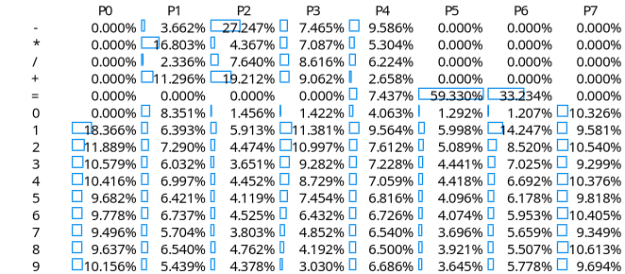
We can see, for example, that the equal sign is most frequently placed at position 5.
To get an accurate count of the possible answers, we must first restrict the above set to only those sequences that form a valid mathematical equation. We can achieve this using a regular expression.
All possible answers must match the following regular expression:
^([1-9][0-9]*(?:[-+/*][1-9][0-9]*){0,2})=((?:0|[1-9][0-9]*))$
The expression starts with a number and is optionally followed by up to two operations with another number, then an equal sign and finally another number. The numbers cannot start with a zero, except for the last number which can be a single zero.
Applying this regular expression to all possible permutations gives us a count of 84,504,960 possible answers.
But even that set includes invalid answers, such as 12+34=99. We need to remove any equation where both sides of the equal sign are not, in fact, equal.
After applying this final restriction, we get an answer count of 17,723.

Answers are not guesses
While there are 17,723 valid answers, the game allows the player to enter equations that are not valid answers. In other words, the rules for what is a valid guess are different than the rules for a valid answer.
For example, one can enter a guess of: 9+4*-2=1. A negative operand is not allowed as an answer, but it is allowed as a guess.
The regular expression for a valid guess looks like:
^[+-]?[0-9]+(?:[-+/*][+-]?[0-9]+){0,2}=[+-]?[0-9]+(?:[-+/*][+-]?[0-9]+){0,2}$
In this expression, numbers are allowed to start with a zero and are also allowed a + or - sign prefix. Also, operators are allowed on either side of the equal sign. Both sides of the equal sign must still be equal. This gives us a total of 499,668 possible guesses.

Hints are not unique
Both answers 1/1+9=10 and 2/1+8=10, when given a guess of +0/+01=0 give a hint of +0/+01=0.

The "average guess count" concept
We'll start with the trivial scenarios and build up from there.
If we are given an answer set consisting of a single equation and we recruit a thousand players to guess which equation is the correct answer. The result would be 100% of the players would pick the one and only possible answer. The average number of guesses to solve this game would be exactly 1.
If we are given an answer set of two answers and ask the thousand players to play the game, then half the players would pick the right answer on the first guess, and the other half would pick the wrong answer on the first guess and then pick the right answer on the second guess. That means the average guess count to solve is .
If we are given an answer set of three and ask the thousand players to play the game, then one third of the players would pick the right answer on the first guess, the other two thirds would pick one of the wrong answers on the first guess but then the resulting hint would allow them to pick the right answer on the second guess. That means the average guess count to solve is . This assumes that the hint received in the first incorrect guess does provide enough information to pick the correct answer. This is a safe assumption with a set of three, but does not hold up as we increase the size of the set.
If we are given an answer set of 10, things get more complicated. For example, let's say we give our players the following set:
10-6-4=0
11-6-1=4
11-6-4=1
14-6-1=7
14-6-4=4
14-6-7=1
17-6-4=7
17-6-7=4
19-6-4=9
19-6-9=4

The selection of the first guess starts being a bit more strategic. Especially since that first guess can be any of the 499,668 valid guesses. In theory, that was true for the smaller answer sets above, but there was no strategic reason for players to pick anything outside the answer set given.
Guess: 10-6-4=0
Buckets:
10-6-4=0
11-6-1=4
14-6-1=7
14-6-7=1
17-6-7=4
19-6-9=4
10-6-4=0
11-6-4=1
14-6-4=4
17-6-4=7
19-6-4=9
10-6-4=0
10-6-4=0

ds

An answer set of a single answer is obvious. The average guess count is 1. A single guess will match the answer, and we are done.
For an answer set of two, the strategy in this scenario is to try one of the two answers first. Half the time, that will be the answer, the other half of the time, you'll need to try the other answer as a second guess. We need one guess half the time, two guesses the other half of the time. This gives an average of 1.5.

How to evaluate a guess
We start with the full set 0f 17,723 answers. We evaluate each of the 499,668 guesses against this answer list and choose the guess that produces the best set of buckets.

The guess is used to split the answer list into smaller lists grouped by the hint produced by comparing the guess with the answer.

For example, the first guess would be 52-34=18 and the first answer would be 1-10+9=0, this results in a hint of 52-34=18. The answer 1-10+9=0 is therefore grouped under 52-34=18

To evaluate the quality of a guess, we examine every possible answer against that guess and group them by the hint they produce. For example, my favourite opener has been 9+4*-2=1. If we run all 17,723 answers against it, we get a total of 879 unique hints.
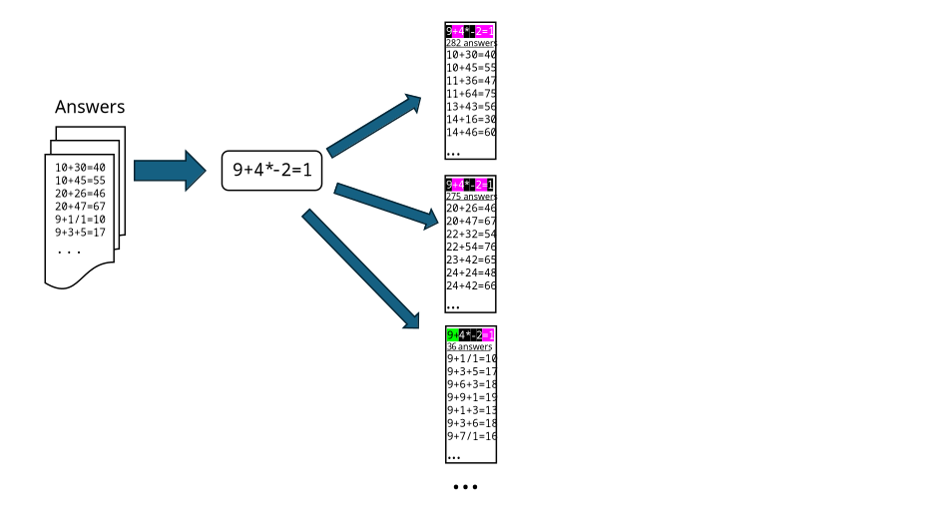

The theory is that a guess that results in a larger number of unique hints is better than one with fewer. Under that theory, the most effective opening guess would be 52-34=18 with 1,703 unique hints.
Now let us put that theory to the test. We can take the answer list produced for each hint and recursively run them through the same process for every possible second guess. For each 499,668 guesses, we group the list of 282 answers from the first hint above

Guess 52-34=18 has 1703 hints.
Guess 48-32=16 has 1689 hints.
Guess 62-43=19 has 1687 hints.
Guess 72-14=58 has 1687 hints.
Guess 52-38=14 has 1687 hints.
Guess 54-36=18 has 1685 hints.
Guess 56-37=19 has 1684 hints.
Guess 68-21=47 has 1683 hints.
Guess 62-13=49 has 1681 hints.
Guess 54-38=16 has 1680 hints.

Looking for my opener

Glossary
Answer | The mathematical formula that we are trying to discover
Guess | The mathematical formula that we entered as guess
Hint | The coloured boxes that tell us which symbols are correct/incorrect/misplaced

To Do
- Operation-less equations are allowed as guesses. Such as “0123=123”. But there doesn’t seem to be a way to make one of those without a leading zero, there probably isn’t a valid operation-less answer.
- Is 10-2-3=5 a commutation of 10-3-2=5 ?
- Is 14/7/1=2 a commutation of 14/1/7=2 ?

Sometimes we get lucky and solve it in 1.
For now, we will ignore commutative variations of answers. More on that later.

