Practical Exam
Mathematics & Advanced Statistics
Loan Default Risk: Statistical & Probability Analysis
Dataset: loan_applications.csv (5,000 records)
Fields: Customer_ID, Age, Income, Loan_Amount, Credit_Score, Loan_Term (months), Default_Status (Yes/No)
Tools: Python 3, pandas, NumPy, SciPy, Matplotlib
Deliverables: loan_analysis.ipynb / loan_analysis.py (all calculations) and this report
Student name / ID: ______________________________
Note on data: the original loan_applications.csv was not available, so a synthetic dataset of 5,000 records was generated (generate_data.py, seed 42). All numbers below come from that file. Replace it with the real CSV and re-run the notebook to get your actual values; the code does not change.

Part A – Theory (Short Questions)

1. Mean, Median and Mode in the context of customer income
Mean is the arithmetic average: total income divided by the number of customers. It uses every value, so a few very rich customers pull it upward.
Median is the middle value when incomes are sorted; half of customers earn less and half earn more. It is robust to outliers, so it is the better "typical income" when income is right-skewed.
Mode is the most frequent income value (or band). It shows the most common income level among applicants.
Example: incomes of 30k, 35k, 40k, 45k, 250k give mean = 80k, median = 40k. The mean is distorted by one high earner while the median still describes the typical customer.

2. Standard Deviation vs Variance using loan amounts
Variance (σ²) is the average of squared deviations of loan amounts from their mean. Its unit is squared (rupees² or dollars²), so it is hard to interpret directly.
Standard deviation (σ) is the square root of variance. It is in the same unit as the loan amount, so "σ = 42,600" means a typical loan lies about 42,600 above or below the average loan.
Both measure spread; variance is convenient for algebra (variances of independent variables add) and standard deviation is convenient for interpretation.

3. Random Variable (with an example from the dataset)
A random variable is a function that assigns a numerical value to each outcome of a random experiment (here, picking a customer at random).
Discrete example: X = 1 if Default_Status = Yes, 0 if No (a Bernoulli variable). Loan_Term (12, 24, 36, 48, 60) is also discrete.
Continuous example: Income, Loan_Amount and Credit_Score can take any value in a range.

4. Conditional Probability in terms of loan defaults
Conditional probability is the probability of an event given that another event has already occurred:
P(A | B) = P(A ∩ B) / P(B), with P(B) > 0.
For loans, P(Default | Credit_Score < 600) is the share of low-score customers who default. It differs from the overall P(Default), which shows that credit score carries information about risk.

5. Bayes’ Theorem and how banks can apply it
P(A | B) = P(B | A) · P(A) / P(B) reverses a conditional probability and updates a prior belief using new evidence.
Bank application: the bank knows historical P(Default) (prior) and P(Credit < 600 | Default) from past loans. When a new applicant has a score below 600, Bayes’ theorem gives P(Default | Credit < 600), the updated risk, which feeds approval, pricing and credit limits. It is also the basis of Naive Bayes risk classifiers and of updating risk as new information (late payments, job loss) arrives.

6. Empirical vs Theoretical Probability
Theoretical probability is derived from reasoning about equally likely outcomes, without collecting data: P(heads) = 1/2; P(a fair die shows 6) = 1/6.
Empirical probability is computed from observed data: (number of times the event occurred) / (total trials). Example: P(Default) = 1,322 / 5,000 = 0.2644 in our dataset.
By the Law of Large Numbers, empirical probability approaches the true (theoretical) probability as the sample size grows. Loan default has no known theoretical probability, so banks rely on empirical estimates.

7. Poisson Distribution and a business example
The Poisson distribution models the number of events in a fixed interval of time or space when events occur independently at a constant average rate λ:
P(X = k) = e^(−λ) λ^k / k!, with mean = variance = λ.
Business example: if a bank branch receives on average 4 loan applications per hour, the probability of exactly 6 applications in an hour is e^(−4)·4^6/6! ≈ 0.104. Other uses: customer calls per minute, defaults per month in a portfolio, insurance claims per day.

8. Eigenvalues and Eigenvectors in data analysis
For a square matrix A, a non-zero vector v is an eigenvector if A v = λ v. The scalar λ is the eigenvalue: the factor by which A stretches v without changing its direction. They are found from det(A − λI) = 0.
Use in data analysis: the eigenvectors of the covariance (or correlation) matrix are the principal components, i.e. the directions of maximum variance, and each eigenvalue is the variance captured along that direction. Dividing an eigenvalue by the sum of all eigenvalues gives the explained-variance ratio, which guides dimensionality reduction (PCA), noise removal and handling of correlated features (multicollinearity).
Applied to this dataset (see Bonus in Part B): Income and Loan_Amount load almost equally on PC1, which explains 41.66% of total variance.

Part B – Practical (Python Output)

Step 1: Central Tendency & Dispersion
Statistic | Value
Income – Mean | 54,382.36
Income – Median | 48,600.00
Income – Mode | 15,000.00
Loan_Amount – Range (max − min) | 382,400.00
Loan_Amount – Variance (sample) | 1,814,634,131.38
Loan_Amount – Standard Deviation | 42,598.52

df["Income"].mean(), df["Income"].median(), df["Income"].mode()[0]
la.max()-la.min(), la.var(ddof=1), la.std(ddof=1)
Interpretation: mean (54,382) is larger than median (48,600), indicating right-skewed income. The mode (15,000) is the minimum-income floor where 31 applicants are bunched, so it is a weak measure of the typical income here.

Step 2: Probability & Events
Probability of default: P(Default) = 1322 / 5000 = 0.2644 (26.44%).
Contingency table: Default_Status × Credit_Score range
Credit Score Range | No | Yes | Total | Default Rate
<550 | 19 | 119 | 138 | 86.23%
550-599 | 145 | 327 | 472 | 69.28%
600-649 | 596 | 492 | 1088 | 45.22%
650-699 | 1136 | 282 | 1418 | 19.89%
700-749 | 972 | 87 | 1059 | 8.22%
750+ | 810 | 15 | 825 | 1.82%
All | 3678 | 1322 | 5000 | 26.44%

Conditional probability:
- P(Credit_Score < 600) = 0.1220 (610 customers)
- P(Default ∩ Credit_Score < 600) = 0.0892
- P(Default | Credit_Score < 600) = 0.0892 / 0.1220 = 0.7311 (73.11%)
- For comparison, P(Default | Credit_Score ≥ 600) = 0.1995 (19.95%)

Step 3: Distributions & Visualization
(a) Histogram of Credit_Score with Gaussian curve. Mean = 679.21, SD = 69.49. The histogram follows the fitted bell curve closely, so Credit_Score is approximately normal.
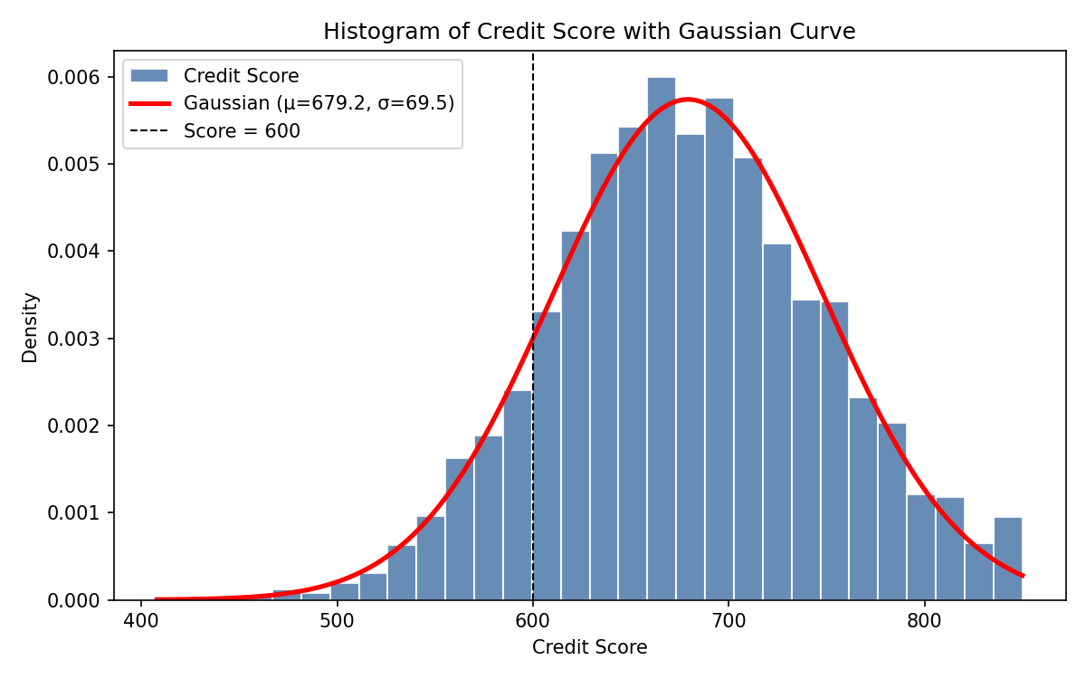
Figure 1: Credit Score histogram with fitted Gaussian curve
(b) Skewness and Kurtosis of Loan_Amount.
Measure | Value
Skewness | 1.6069
Excess kurtosis (Fisher; normal = 0) | 4.6006
Kurtosis (Pearson; normal = 3) | 7.6006
Interpretation: skewness > 1 means a strongly right-skewed distribution (long tail of large loans). Positive excess kurtosis means heavy tails (leptokurtic), so extreme loans are more frequent than under a normal distribution.
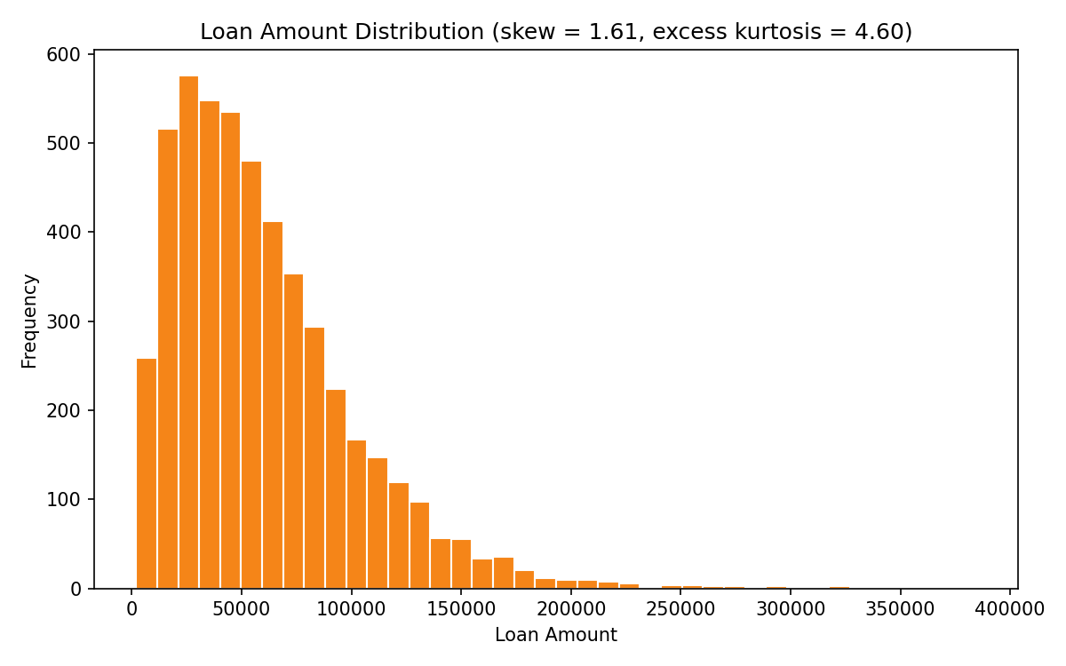
Figure 2: Loan Amount distribution

(c) Q-Q Plot for Income. Points bend away from the red line at both ends, with an upward curve in the upper tail. Income is therefore not normal (skewness = 1.60, Q-Q correlation = 0.9463). After a log transform the points fall on the line (correlation = 0.9995), so Income is approximately log-normal.
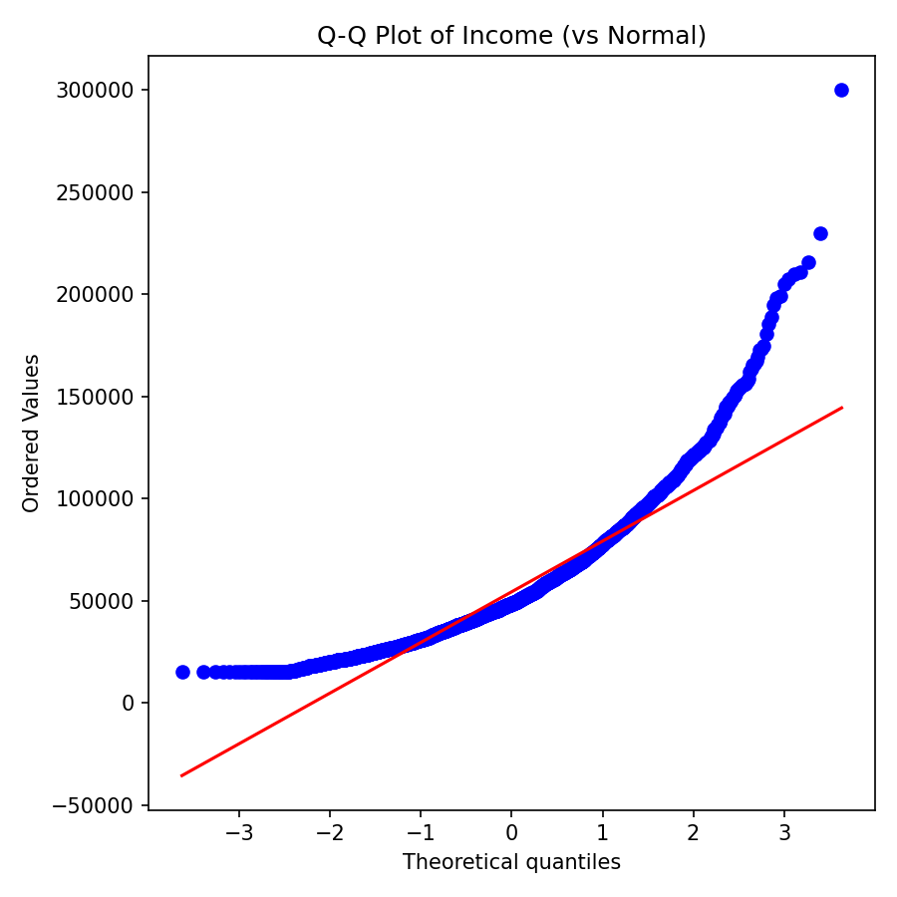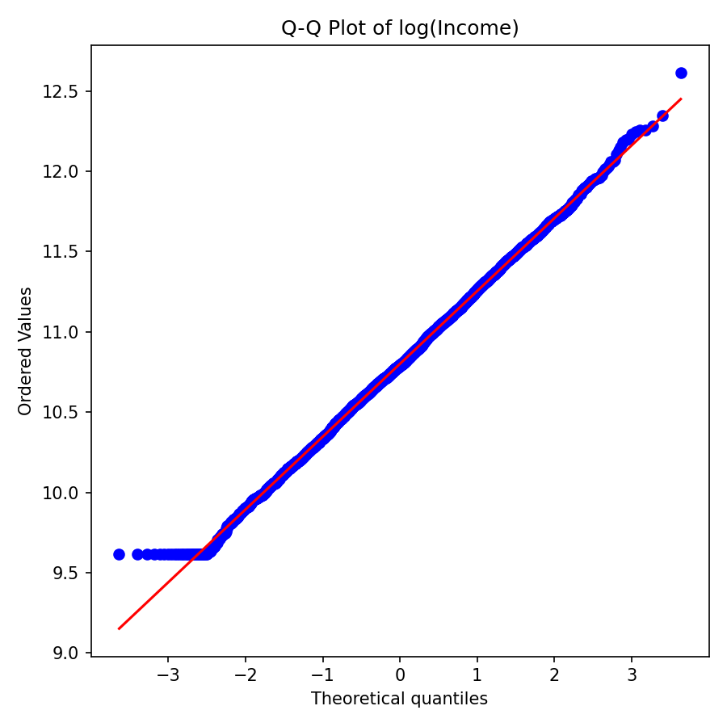
Figure 3: Q-Q plot of Income (left) and of log(Income) (right)

Step 4: Linear Algebra Application
First five customers as vectors [Income, Loan_Amount]:
Customer | Income | Loan_Amount
C1 | 43,600 | 63,200
C2 | 42,800 | 36,100
C3 | 35,800 | 68,000
C4 | 59,400 | 18,600
C5 | 54,500 | 42,500

Using Customer 1 = [43,600, 63,200] and Customer 2 = [42,800, 36,100]:
Operation | Result
Dot product C1 · C2 | 4,147,600,000
Norm-2 of C1 ‖C1‖₂ = √(43600² + 63200²) | 76,780.21
Norm-2 of C2 ‖C2‖₂ | 55,991.52
cos θ = (C1·C2) / (‖C1‖‖C2‖) | 0.964773
Angle θ = arccos(cos θ) | 15.25°
a, b = V[0], V[1]; np.dot(a,b); np.linalg.norm(a,2)
np.degrees(np.arccos(np.dot(a,b)/(np.linalg.norm(a)*np.linalg.norm(b))))
Interpretation: the norm is the overall "financial size" of a customer. An angle of 15.3° (cos θ ≈ 0.96) means the two customers have a very similar income-to-loan proportion (direction), even though their magnitudes differ.

Bonus: Eigen-analysis of the standardized covariance matrix
Component | Eigenvalue | Explained variance
PC1 | 1.6666 | 41.66%
PC2 | 1.0139 | 25.35%
PC3 | 0.9830 | 24.58%
PC4 | 0.3365 | 8.41%
PC1 loadings: Age -0.067, Income 0.706, Loan_Amount 0.705, Credit_Score 0.021. PC1 is essentially "Income + Loan_Amount" together (customers who earn more borrow more).

Key Insights
- Overall default risk is about one in four. P(Default) = 26.44% (1322 of 5000 customers).
- Customers with Credit Score < 600 have a 73.11% chance of default, versus 19.95% for scores ≥ 600, roughly 3.7 times higher risk.
- Default risk falls steadily as credit score rises: 86.23% in the <550 band, 45.22% at 600-649, and just 1.82% for 750+. A tiered cut-off or risk-based pricing is justified.
- Loan amounts and income are right-skewed with heavy tails. Loan_Amount skewness = 1.61, excess kurtosis = 4.60. Use median and log transforms for reporting and modelling, and review large loans separately.
- Credit scores are approximately normal (mean 679, SD 69), with only 12.20% of applicants below 600. Income and loan size move together (PC1 explains 41.66% of variance), so loan-to-income ratio is a useful extra risk feature.

Conclusion
Descriptive statistics, conditional probability, distribution diagnostics and vector methods all point to the same finding: credit score is the strongest single indicator of default in this dataset. Credit-score-based screening, combined with loan-to-income checks, would reduce default exposure.

