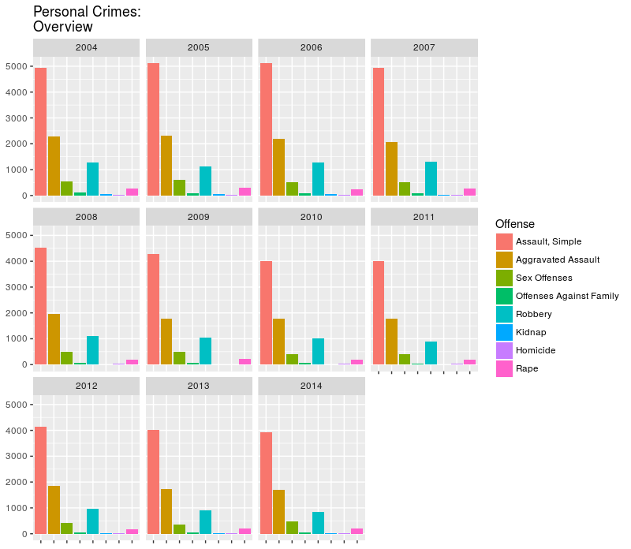

Figure 1: Relative frequency of personal crimes by year.

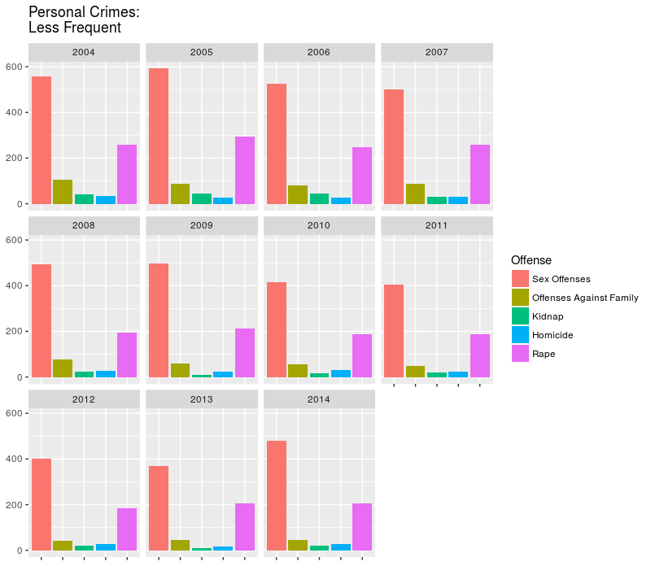

Figure 2: Relative frequency of personal crimes by year, with three offenses removed for better visibility.

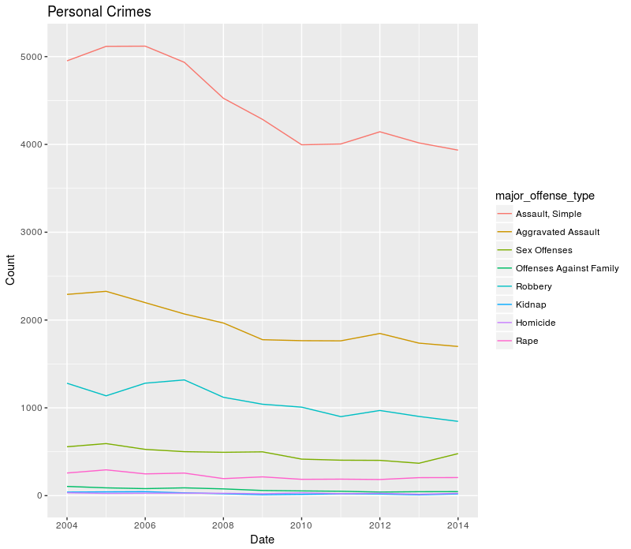

Figure 3: Trends in personal crime from 2004 – 2014. The three most frequent crimes dominate the chart.

Figure 4: Robbery offenses with linear regression line included.

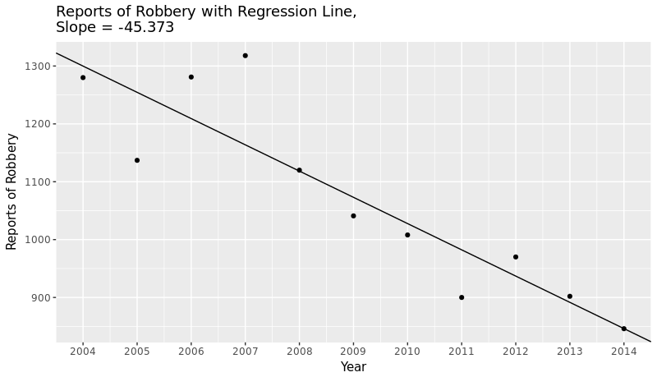

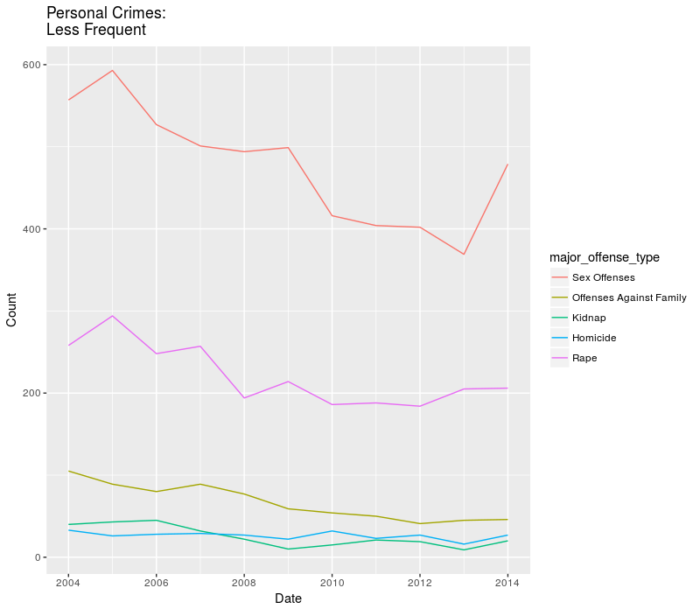

Figure 4: Trends in personal crime, with the three dominating offenses removed for clarity.

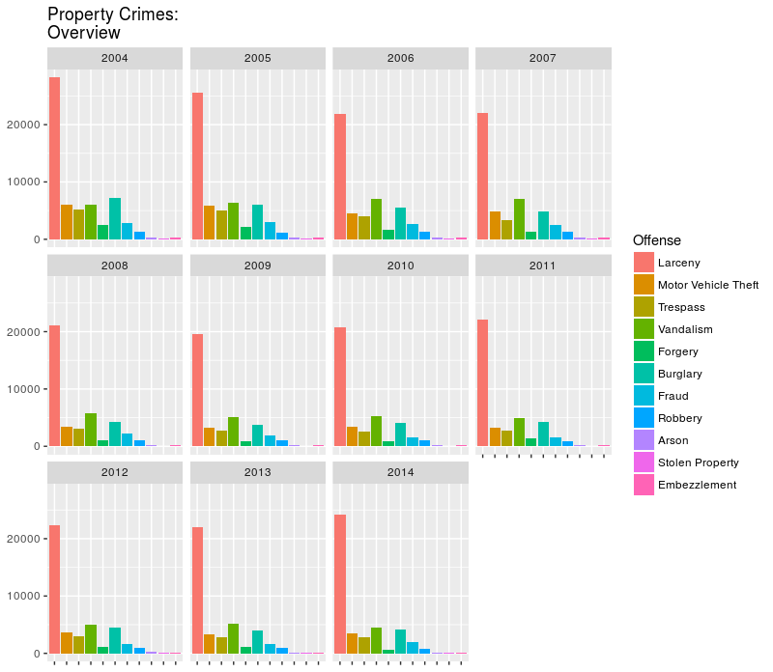

Figure 5: Relative frequency chart for property crimes. Larceny dominates the chart.

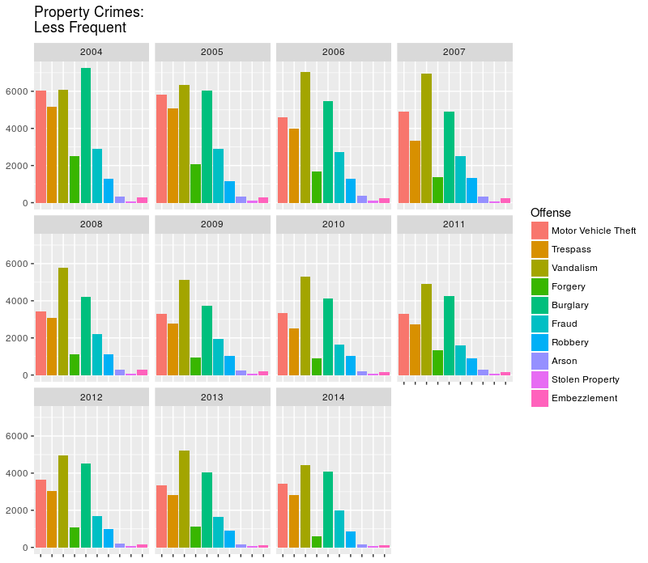

Figure 6: Relative frequency chart for property crimes with Larceny removed for clarity.

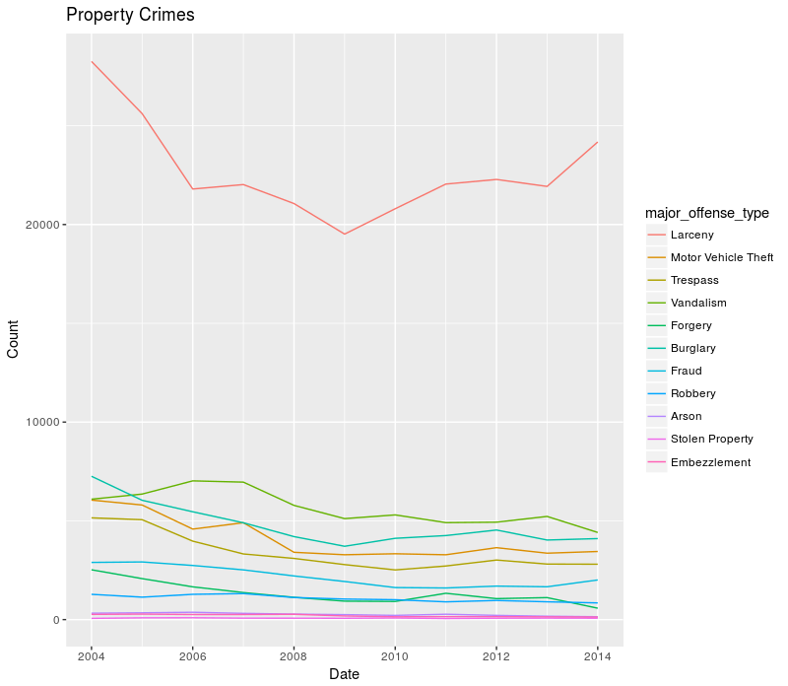

Figure 7: Trends in property crime from 2004 – 2014.

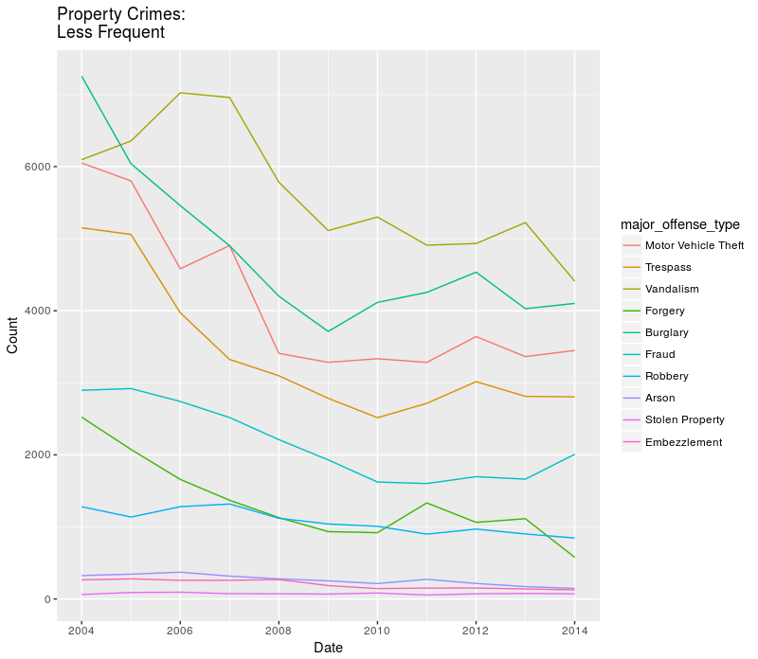

Figure 8: Trends in property crimes, with Larceny removed for clarity.

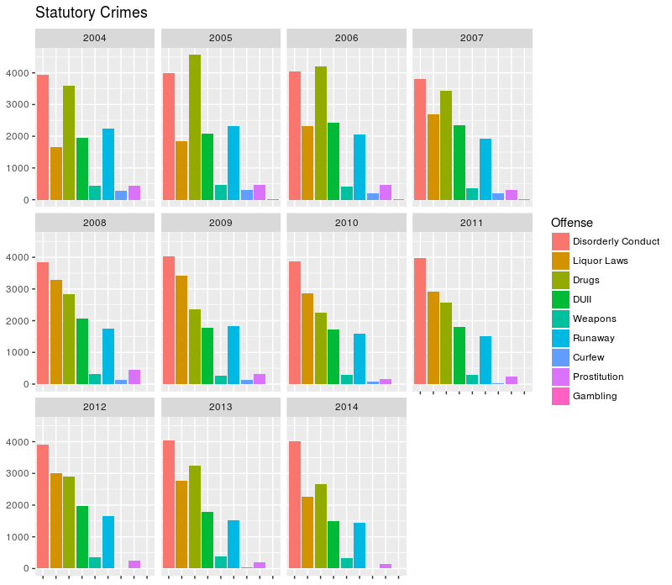

Figure 9: Relative frequency of statutory crimes.

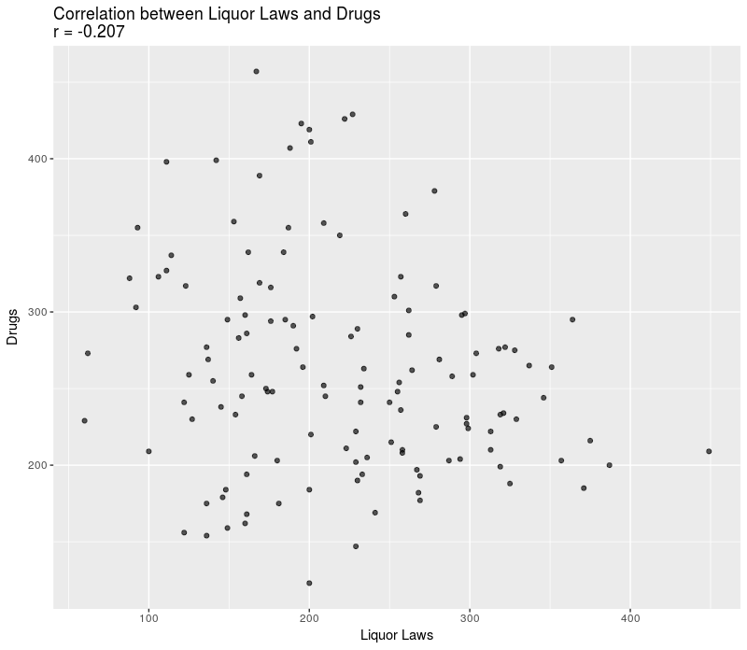

Figure 10: Relationship between liquor law offenses and drug-related offenses, 2004 – 2014.

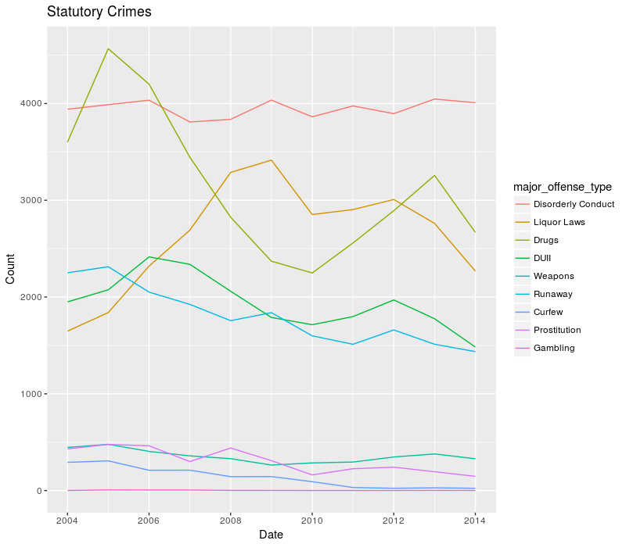

Figure 11: Trends in statutory crimes, 2004 – 2014.

Figure 12: Correlation plot for Population vs. Total Crime Incidents, 2004-2014.

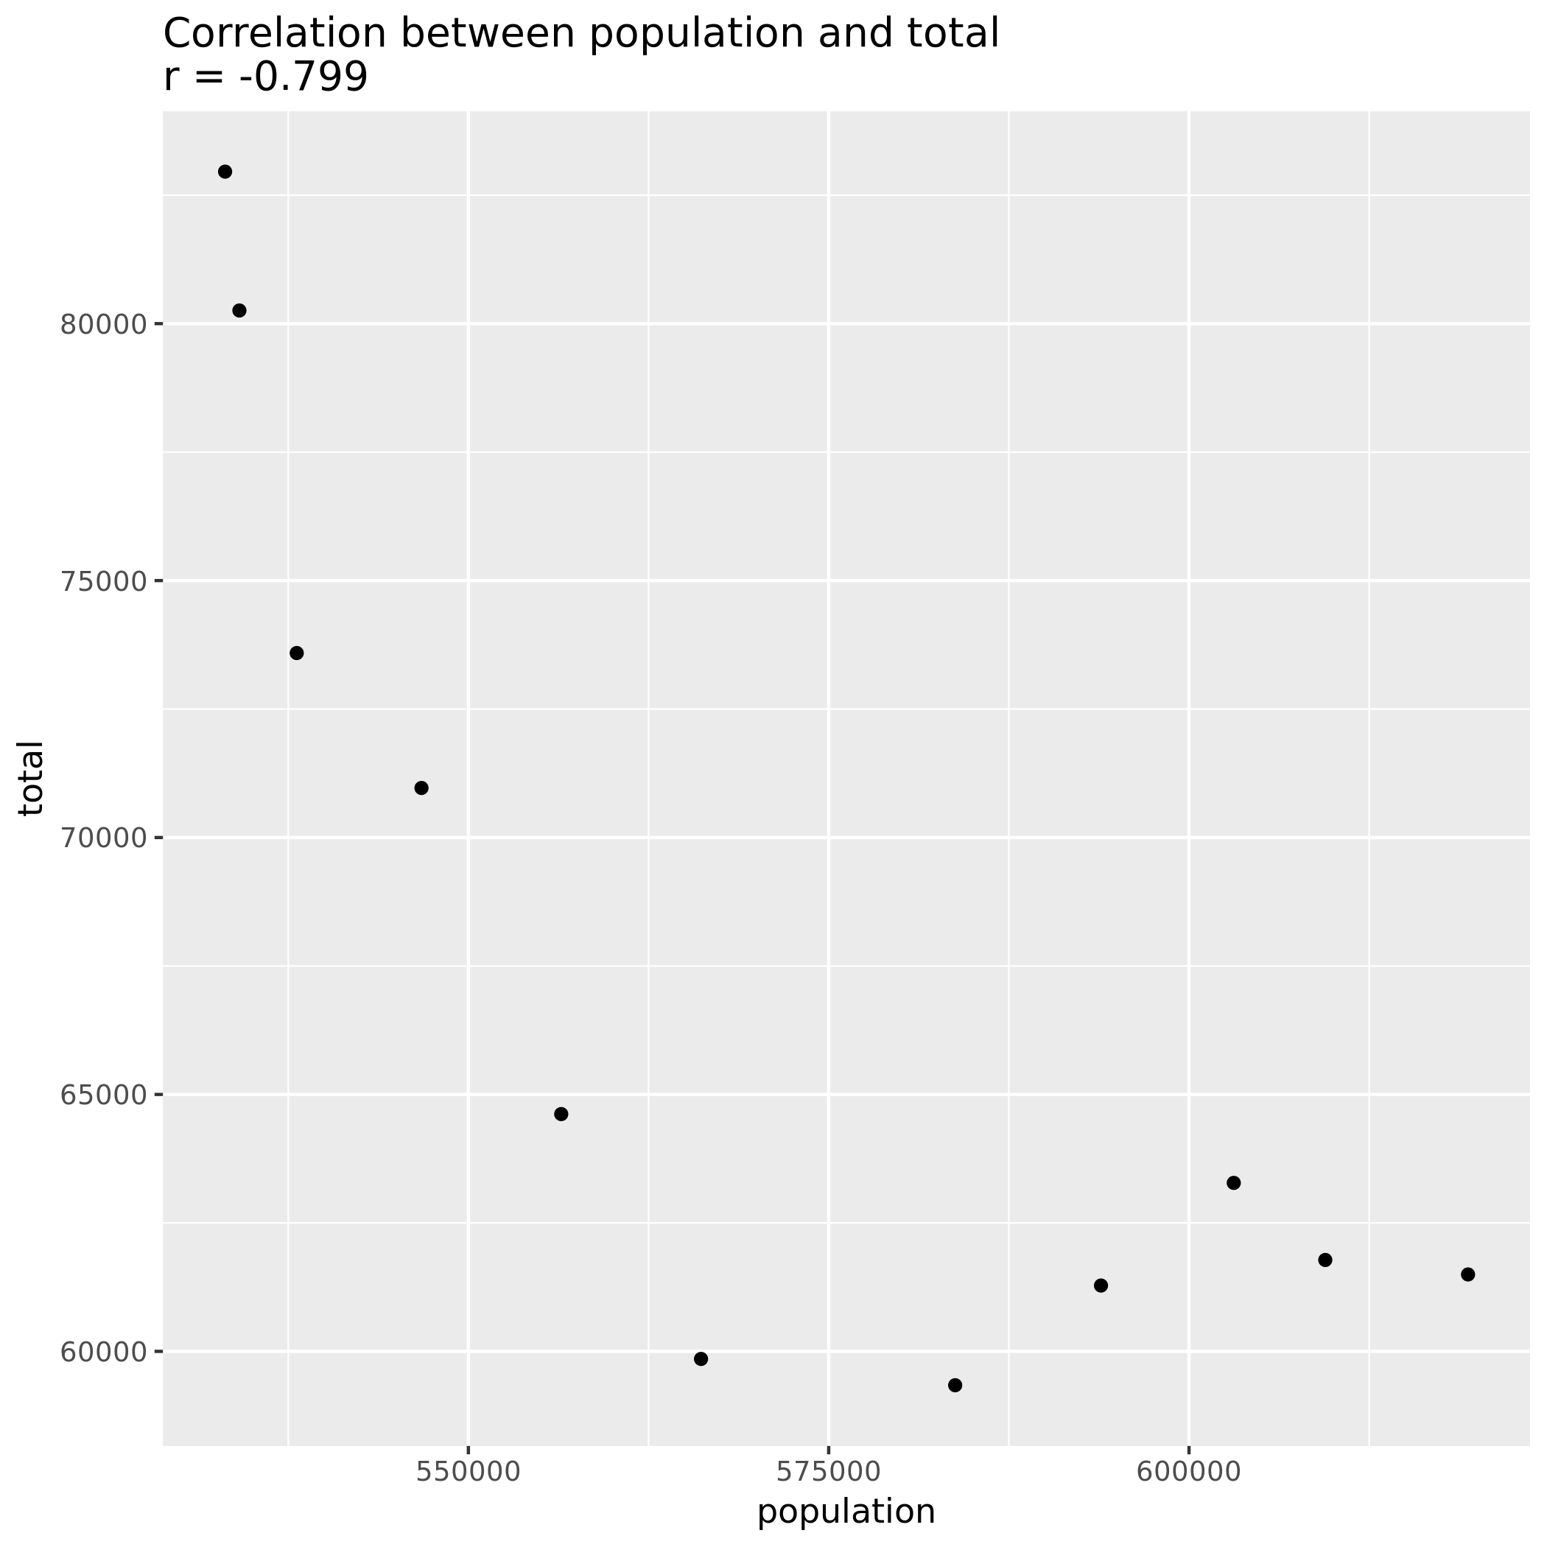

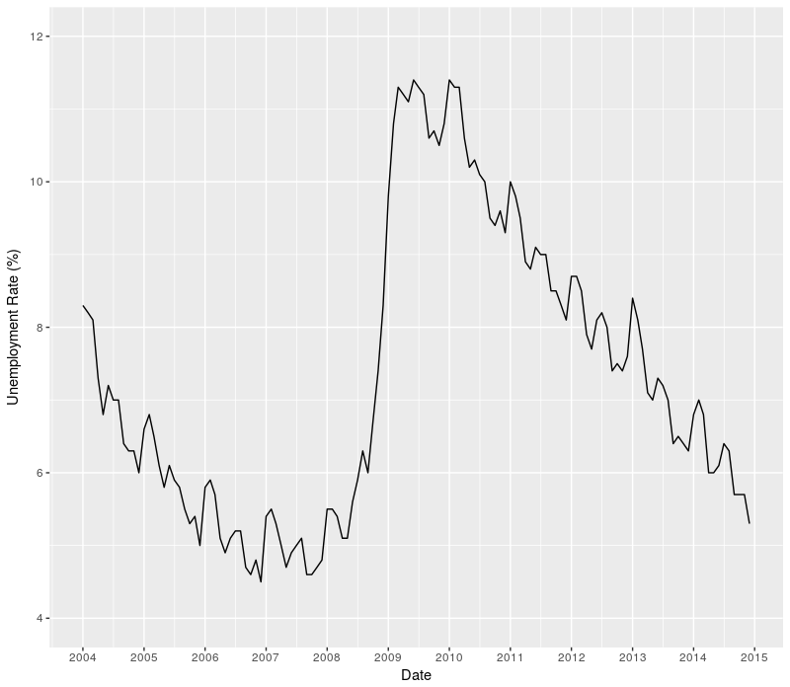

Figure 12: Portland’s unemployment rate for 2004 – 2014.

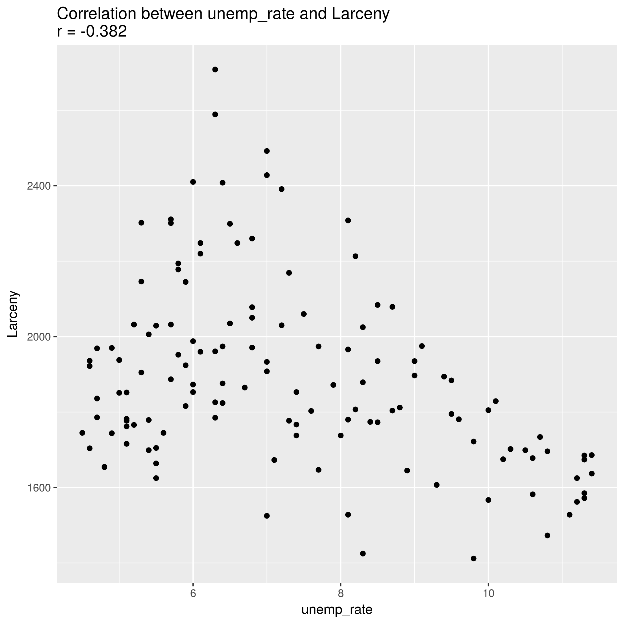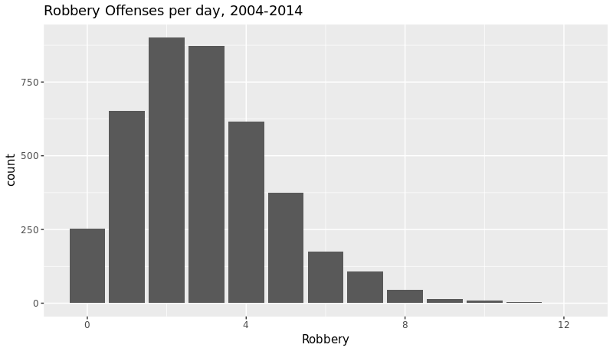

Figure 13: Scatter plot showing the relationship of the 2004 – 2014 unemployment rate to larceny offenses.

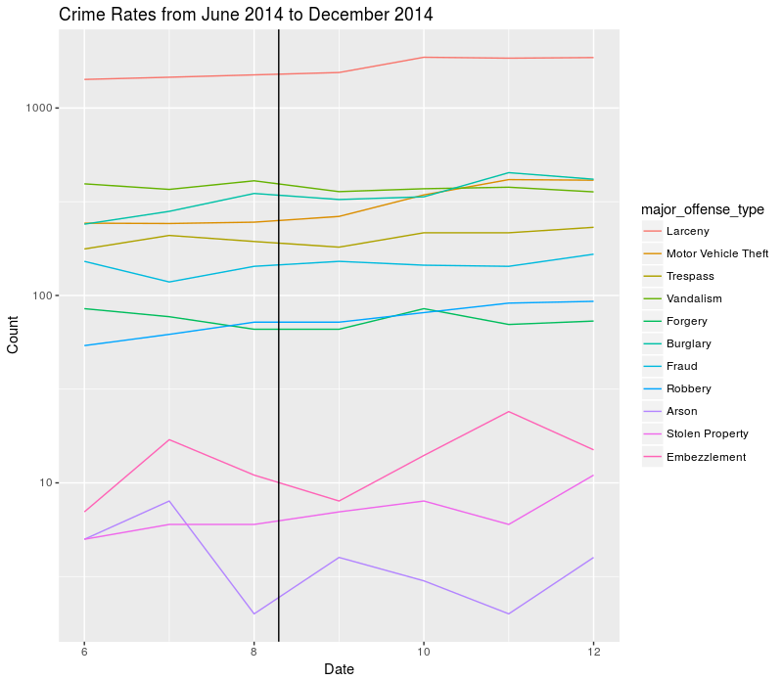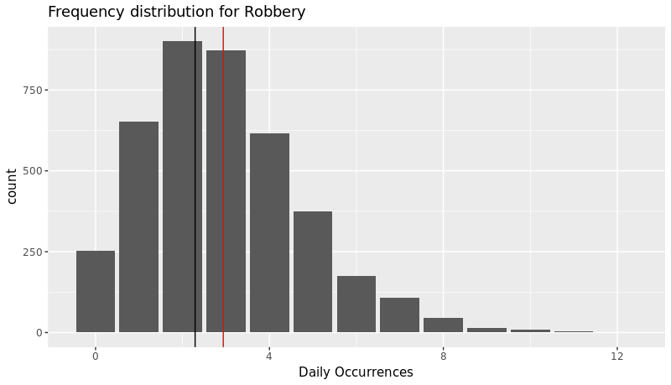

Figure 14: Property crime rates in Portland during the months surrounding events in Ferguson, Missouri (June to December 2014). The event itself is marked with a vertical black line.

Figure 15: Distribution for Robbery.

Figure 16: Robbery distribution, with the mean for 2004-2014 drawn in red, and the mean for the time period after the events in Ferguson, Missouri depicted in black. Student’s t-test revealed a potentially significant effect.

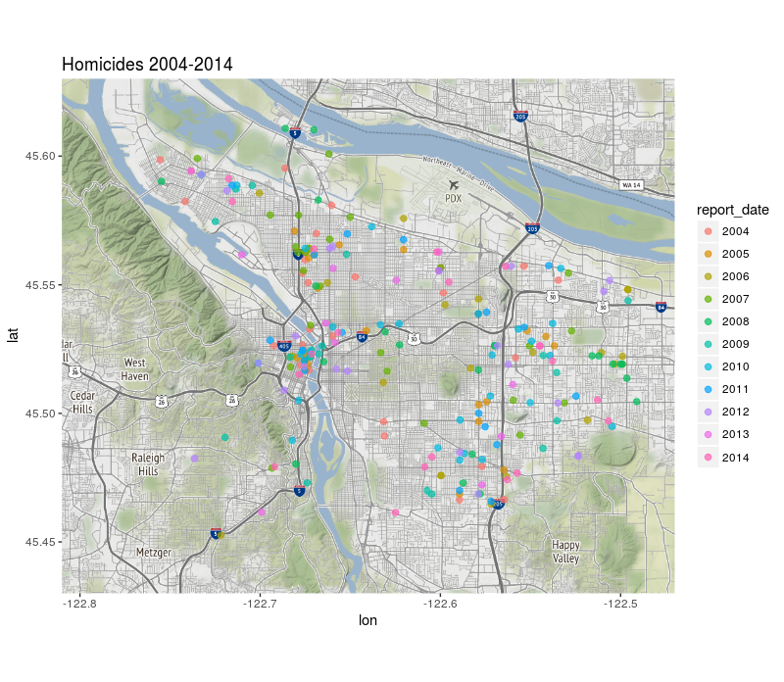

Figure 15: Location of homicides in Portland, 2004 – 2014, colored by year.

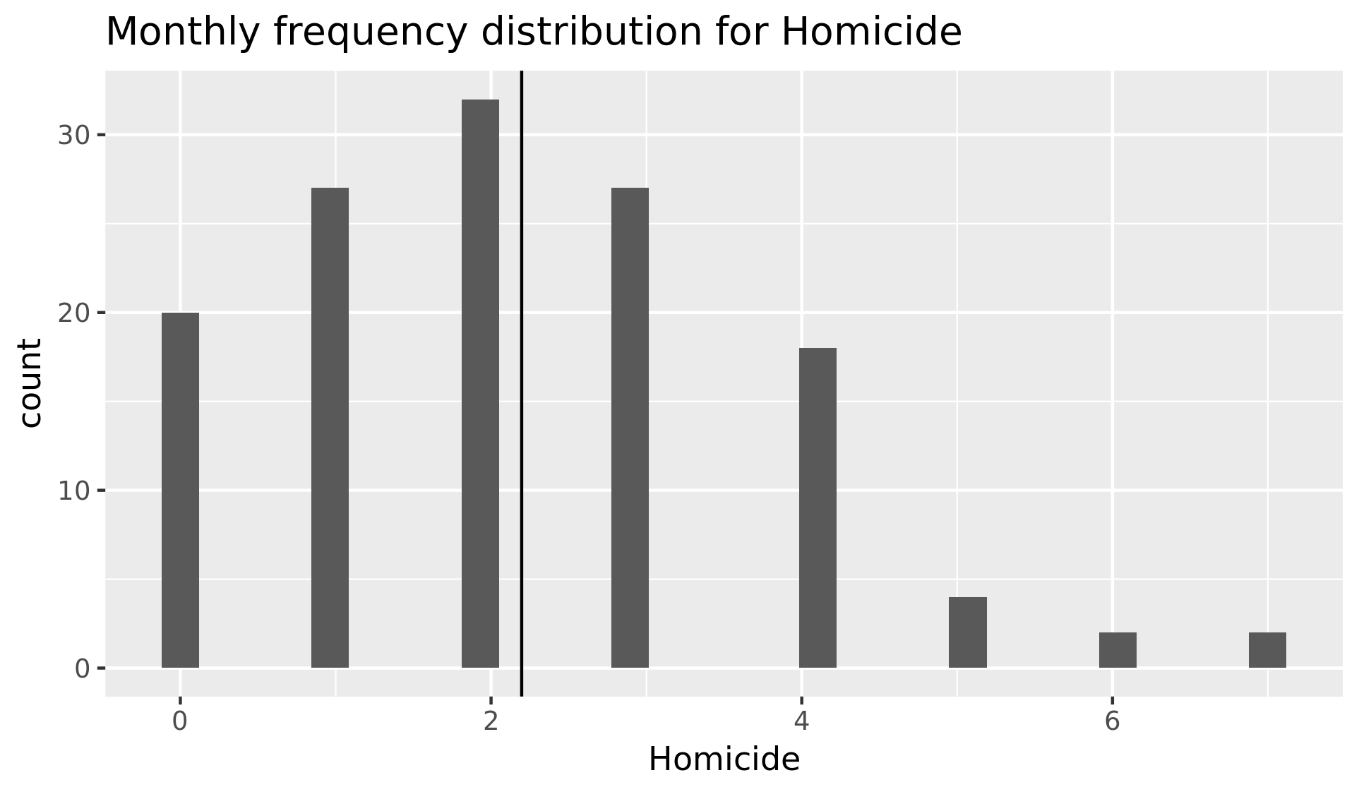

Figure 16: Histogram of homicides per month from 2004 – 2014. Portland enjoys a relatively low homicide rate, with a mean value of 2.20.

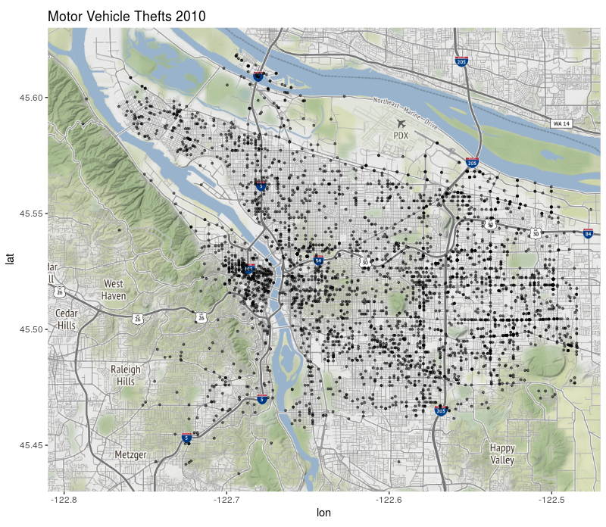

Figure 17: Location of motor vehicle thefts in Portland, 2010.

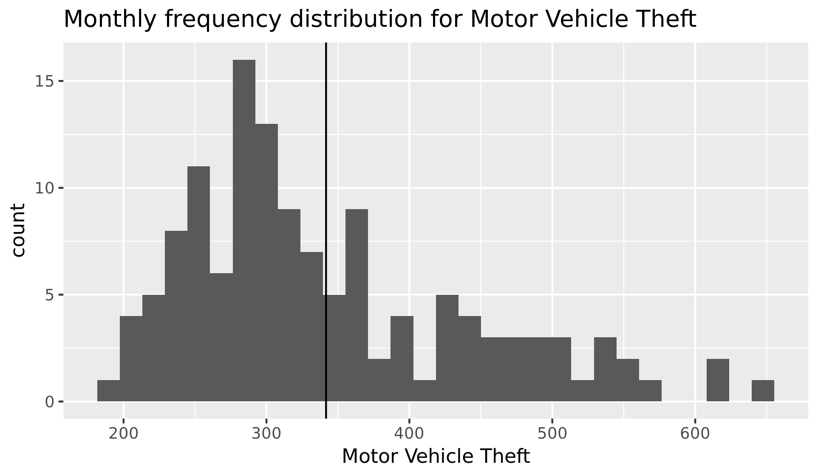

Figure 18: Histogram of motor vehicle thefts per month from 2004 – 2014. The mean value is 2.20.

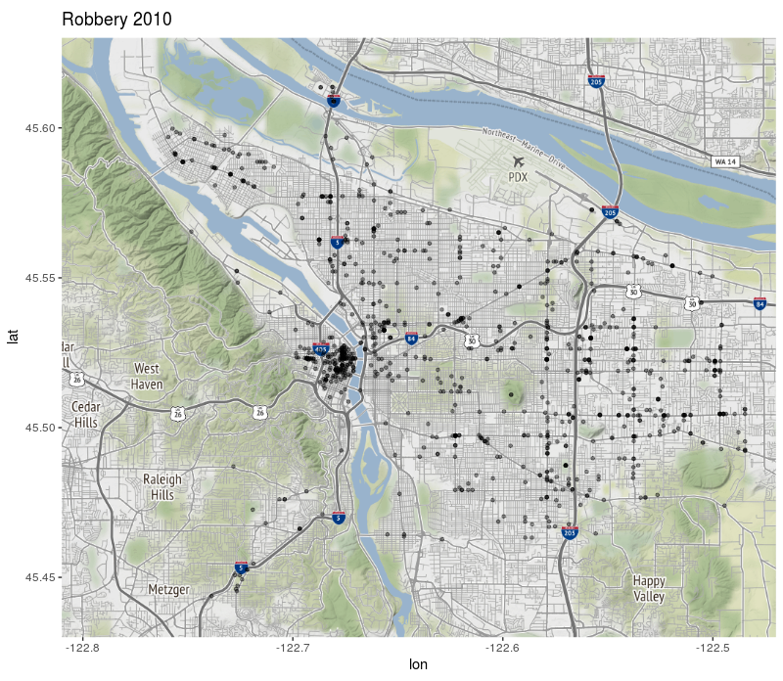

Figure 19: Robberies, 2010.

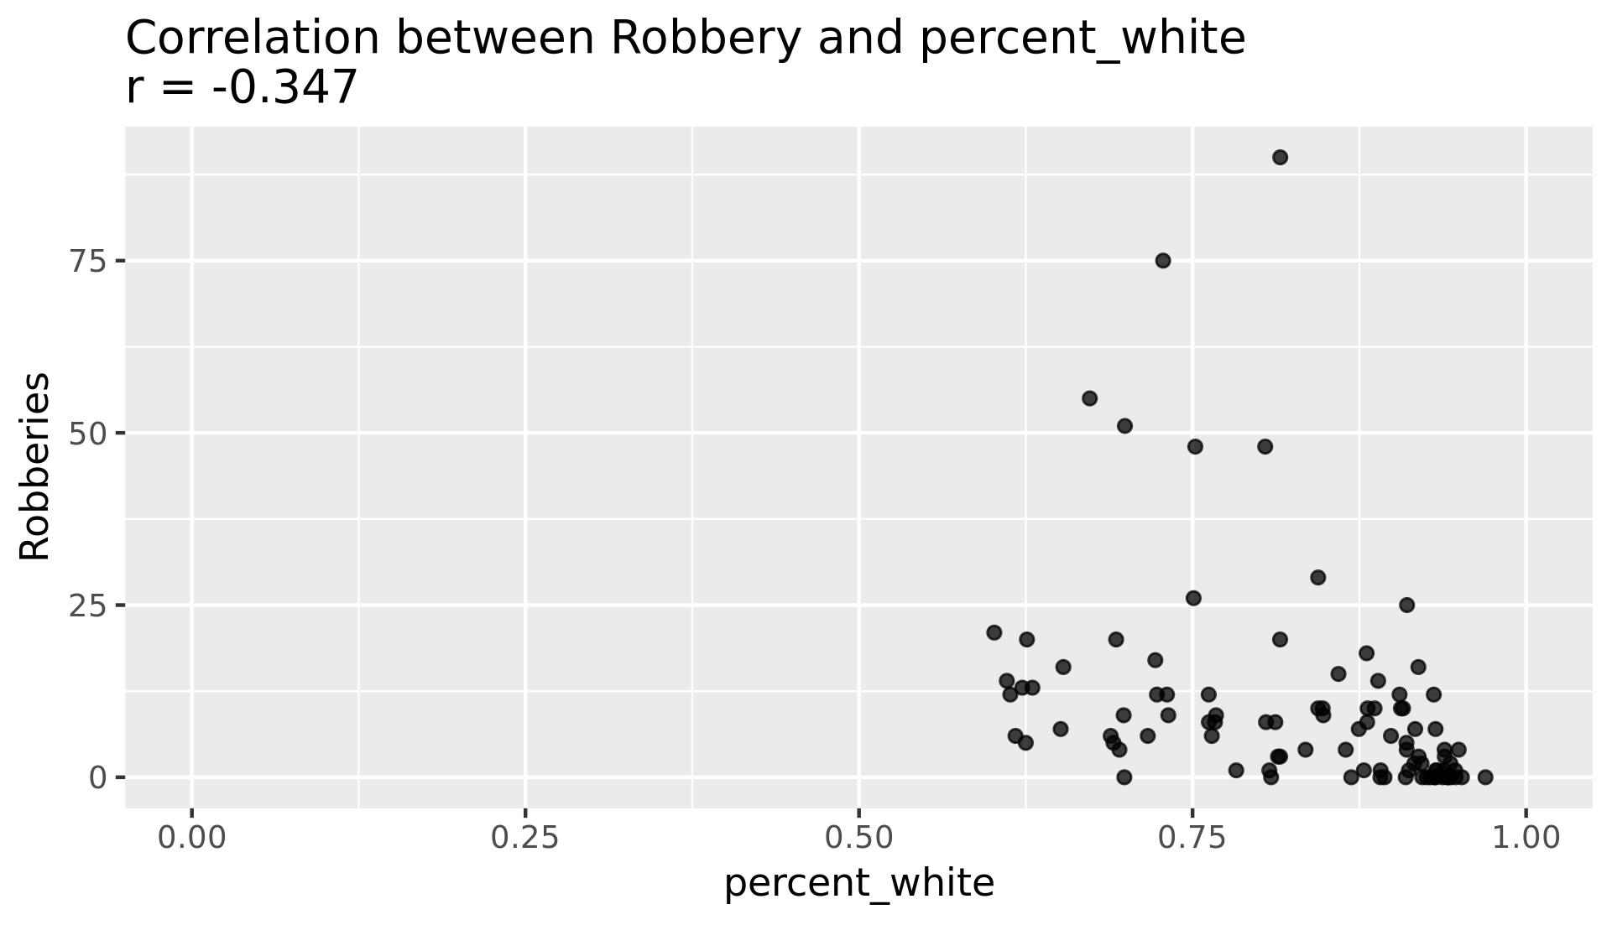

Figure 22: Relationship between percentage of people identifying as white in a particular neighborhood and the incidence of robbery in that neighborhood in 2010.

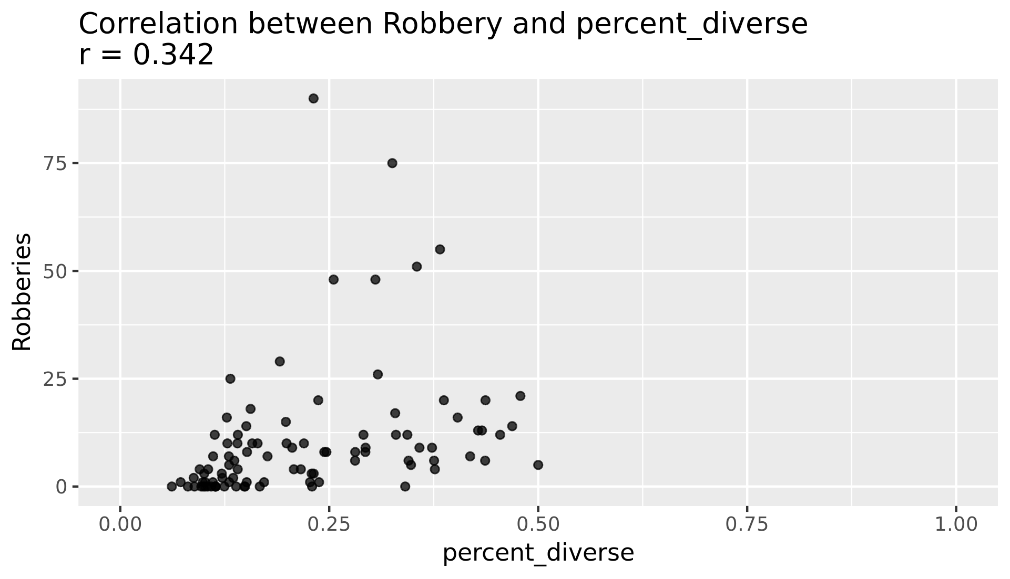

Figure 23: Relationship between percentage of people identifying as not white in a particular neighborhood and the incidence of robbery in that neighborhood in 2010.

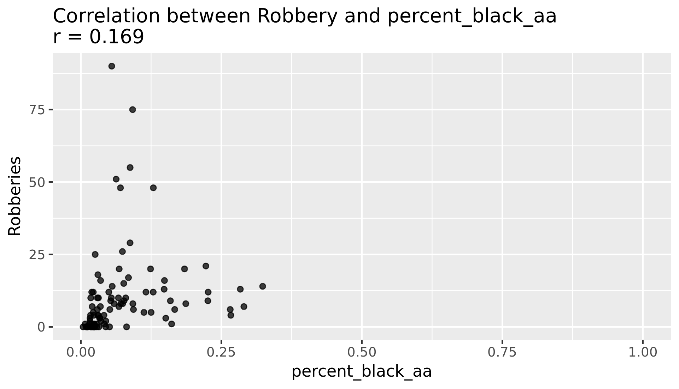

Figure 24: Relationship between percentage of people identifying as black or African American in a particular neighborhood and the incidence of robbery in that neighborhood in 2010.