Crime in Portland, Oregon, 2004-2014: A summary of trends

1. Introduction: Overview of purpose and motivation, summary of findings

Over the past several decades, public awareness of crime has increased significantly. Those who do follow the news are exposed to a constant iteration of story after story about illegal activity, local, national, and global. This growing awareness and concern over crime comes at a time where, in many places in the United States, crime rates are actually falling and law enforcement is more effective than ever before in protecting citizens from criminal activity.

At the same time, the public has been informed for several years now that crime rates are on the decline, and that there is actually less crime now than there has been for many years. Is this true? How does one reconcile declining crime rate statistics with one’s own experience of becoming aware of more and more crime as time goes on? One approach is to let the responsibility rest with the media: if the media reports more crime, then the public will be more and more aware of it, despite general decreases in the crime rate overall. Another approach is to acknowledge that one’s personal experience changes over the course of time, and that perhaps as one’s age increases, one’s awareness of larger societal trends also tends to grow.

This project seeks to explore crime in one US city: Portland, Oregon. Portland is a convenient city to study: crime data gathered by the Portland Police Bureau are shared openly and publicly, after appropriate measures have been taken to anonymize police records. Currently, data from the years 2004-2014 are available. This time span offers the opportunity to examine several possible influences on crime rate, including:

1. Portland’s population grew from 533,120 in 2004 to 619,360 in 2014[1]. This represents a 16.18% increase over the course of the eleven years under consideration. Has this influx of population had an influence on Portland’s absolute and relative crime rates?
2. The US economy saw a marked decline between December 2007 and June 2009[2]. Studies (discussed below) have suggested that unemployment and low wages can have a statistically significant influence on crime rates. Was an effect of this kind seen in Portland during the time period in question?
3. On August 9, 2014, events in Ferguson, Missouri raised concerns about whether crime rates around the country might increase. Is there any evidence that these events had an influence on crime in Portland?

In order to ensure an understanding of the terms and vocabulary used in this project, a broad categorization of crime follows:

* Personal Crimes are those which involve harm to the physical or mental state of a person. These can include assault, battery, false imprisonment, kidnapping, homicide, and rape. In the data under scrutiny for this project, simple assault, aggravated assault, and robbery account for a large percentage of personal crimes (robbery, it should be noted, is classified under both personal crime and property crime).
* Property Crimes are those which involve actions that prevent another person from using or enjoying their property. These can include larceny, robbery, burglary, arson, embezzlement, forgery, false pretenses, and receipt of stolen goods. Property crimes account for the majority of crimes under scrutiny in this project. In fact, larceny alone accounts for a large percentage of total crime in the city.
* Statutory Crimes are those which violate any federal, state, or local statute. These can include personal and property crimes, and others sometimes called “victim-less crimes.” Examples include disorderly conduct, DUII, gambling, and selling alcohol to a minor.
* Inchoate Crimes are those which are started, but not completed. These can include any attempted crimes, solicitation, and conspiracy. Portland Police Bureau data obtained for this project does not include inchoate crimes.[3]

Interestingly, these different categories of crimes do not occur with equal frequency among different subpopulations in the United States. For example, young urban minorities are more likely to be arrested for personal and property crimes than other groups. This kind of crime is likely to be reported by local media. Other types of crime, including embezzlement, are committed more frequently by people of high economic standing, and is less likely to be investigated or reported.[4]

In regards to the first statement, several studies have been done around the issues of criminal motivations, and the various factors that influence changing levels of criminal activity over time. In 2002, Gould, Weinberg and Mustard[5] examined data from the 1980s and 1990s to try to identify correlations between broad economic trends and changing crime rates. They found that when economic markers were good (low unemployment, higher relative wages), certain criminal activity rates did decrease. In particular, the authors argued that young unskilled men (who commit most higher-visibility crime), were more likely to commit property crimes during times of economic difficulty, including difficult job markets. Interestingly, the unemployment rate actually had a less significant effect than low wages in this regard. This points to the possibility that crime is largely motivated by economic forces. This point is further strengthened by the fact that changes in the economic climate did not have a statistically significant effect on rates for personal crimes such as murder and rape, which are seldom committed with an economic motive.

1. Summary of available literature and journal articles, as well as various media contributions to the public understanding of crime in Portland. Items from bibliography follow:
   1. Methods for calculating crime indices: Cahill, M. E., & Mulligan, G. F. (2003).
   2. Nationwide crime trends: Johnson, C. (2016, September 19).
   3. Examining crime rates vs. economic opportunities: Gould, E. D., Weinberg, B. A., & Mustard, D. B. (2002).
   4. Robbery rates and racial segregation: O’Flaherty, B., & Sethi, R. (2007). Also Akins, S. (2003).
   5. The “Ferguson Effect”: Pyrooz, D. C., Decker, S. H., Wolfe, S. E., & Shjarback, J. A. (2016).
   6. Importance of locality in predicting crime trends: Cahill, M. E. (2004).
   7. FBI Releases Crime Statistics for Oregon and Washington.
   8. Violent crime in Portland, including geographic information: Cahill, M., & Mulligan, G. (2007).
   9. Korn, P. (2013, October 31). The Rose City's homicide drought.
2. Report of findings from data sources, highlighting major trends over time and by location.

Analysis for this project was completed using the R statistical programming language. Several libraries and packages were utilized as well, including readr, plyr, purrr, sp, dplyr, lubridate, ggplot2, ggmap, and mapproj. A brief description of the data acquisition and cleaning process follows.

Data for this project was collected from the following sources:

* + 1. http://www.civicapps.org/datasets: This data is that recorded by the Portland Police Bureau, cleaned, and made available to the public with identifying information removed from each record. Variables such as data and time of report, major offense type, and location information for each incident are provided. For this project, the time of each incident was ignored. Location information was converted from State Plane coordinates to Latitude/Longitude coordinates using the sp library.
    2. https://data.bls.gov/pdq: This data includes unemployment information for Portland from January 2004 to December 2014. Only the date and unemployment rate columns were utilized.
    3. https://www.portlandoregon.gov/bps/62635
    4. <https://www.pdx.edu/crime-data/>
    5. https://www.biggestuscities.com/city/portland-oregon: This data includes population (estimates) for Portland for January 1 of each year of interest.

An overview of crime in Portland can be seen in the following charts. Crime is of necessity broken up into the categories described above (Personal, Property, Statutory). This breakdown makes the crime data more visible and easy to understand.

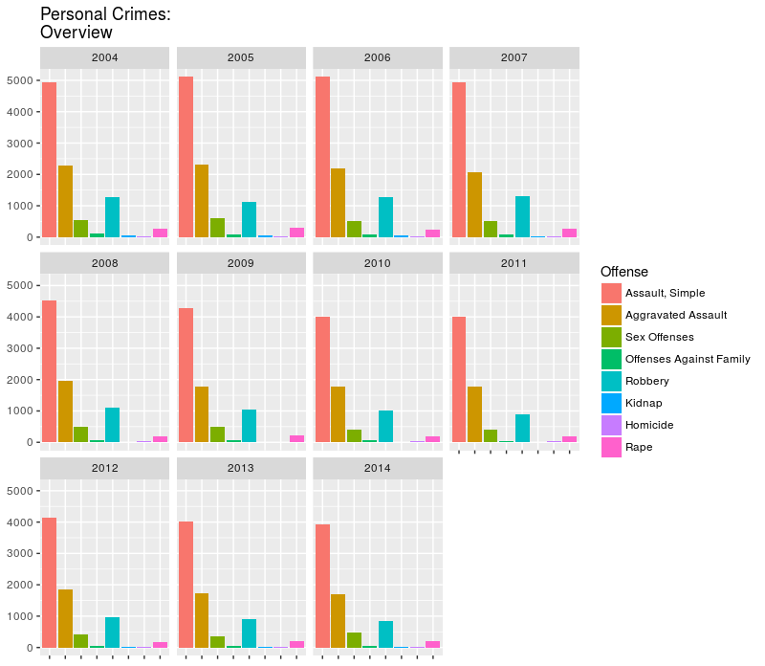 First, we will examine person crimes. The most frequent crimes in this category are simple assault, aggravated assault, and robbery. The data is faceted into bar charts depicting each year in the data set. Each of the three most frequent crimes in this category appear to be on a downward trend; the other crimes are more difficult to see due to their lower levels. A second bar chart, with the three most frequent crimes removed, follows. Again, it appears that personal crimes on this chart are either declining over time, or remaining at a fairly constant level. Of particular interest is the very low number of homicides across the timespan in question: Portland’s relatively low homicide rate has sparked interesting speculation[6]..

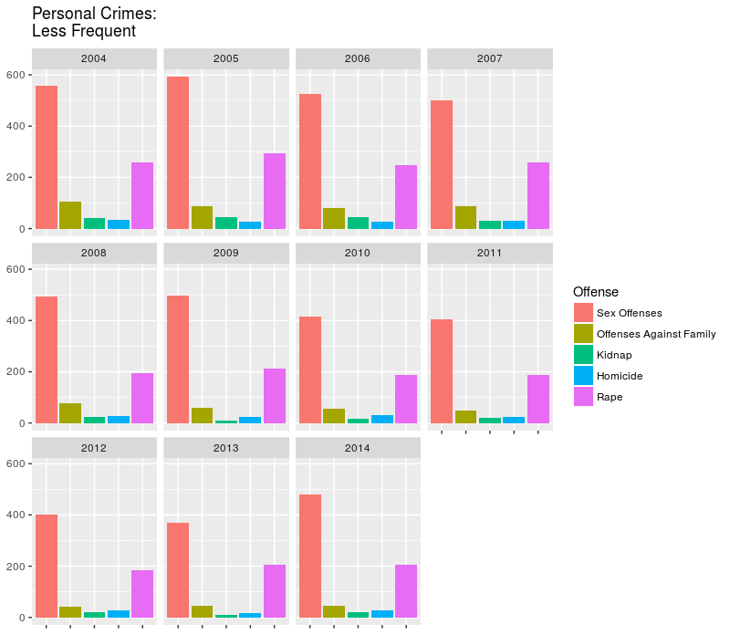

The major trends among these personal offenses are made more clear in the following time-series plots.

* 1. Crime in total, then broken into broad categories: property crime vs. violent crime
     1. Scatter plots:
        1. Total reported Portland crime 2004-2014
        2. Reported property crime 2004-2014
        3. Reported violent crime 2004-2014
  2. Further scrutiny of specific types of crime in question: robbery, burglary, etc. versus assault, homicide, etc. Is it possible to determine how much of this crime was committed by repeat offenders?
     1. Bar charts, stacked bar charts:
        1. Property and violent crime 2004-2014
        2. Property crime alone, including subcategories: Shoener, N. (2017, March 21).
        3. Violent crime alone, including subcategories: Shoener, N. (2017, March 21).
     2. Possibility of identifying repeat offenders? How would this be done given the data available?
  3. Trends in various types of crime over time: has there been an increase or decrease in residential burglary, for example? Can these trends be correlated to any economic markers? Was there any particular spike after the events in Ferguson, Missouri?
     1. Scatter plots:
        1. Trends in various types of crime, 2004-2014. It may be possible to do this with a single graphic, however, using several might improve readability.
        2. Look for a relationship between any economic markers and crime rates: how are crime rates related to major economic trends? Where could data on these economic trends be located?
        3. Look for any unusual activity immediately after Ferguson (after August 9, 2014): this is toward the end of the available data, any change may not be apparent.
  4. Trends in various types of crime over geographic location.
     1. At first this may be limited to which precinct was involved in the various crimes, but depending on availability of information it may be possible to actually represent crime data on a city map and look for general patterns and areas of interest.
     2. Sub-maps may be an option here as well. Can these trends by location be correlated to any economic markers? For example, average house sale price in the neighborhood?

1. Comparison of Portland data to that reported in the summary of the literature above. Does the data from Portland agree with the findings from the studies done by those authors, for example? Is the local media in Portland giving an accurate picture of crime in the city?
2. Conclusion and summary of major results or findings. Possible avenues for further investigation, or other data that might inform future research.

1. Portland Population History, 2017.
2. BLS, 2012.
3. Shoener, 2017.
4. Crossman, 2017.
5. Gould, et. al. 2002.
6. Korn, 2013.