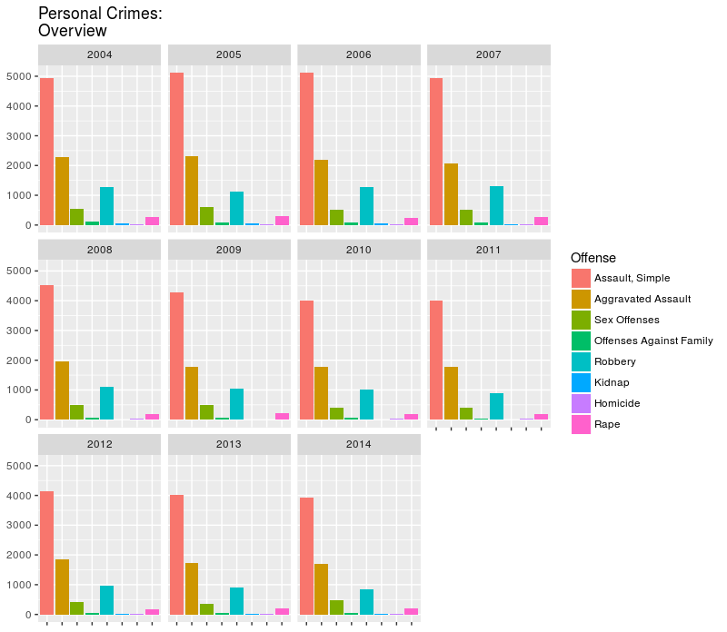

Figure 1: Relative frequency of personal crimes by year.

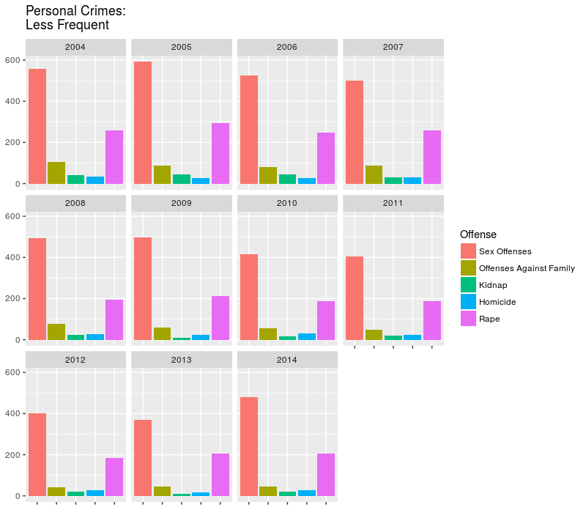

Figure 2: Relative frequency of personal crimes by year, with three offenses removed for better visibility.

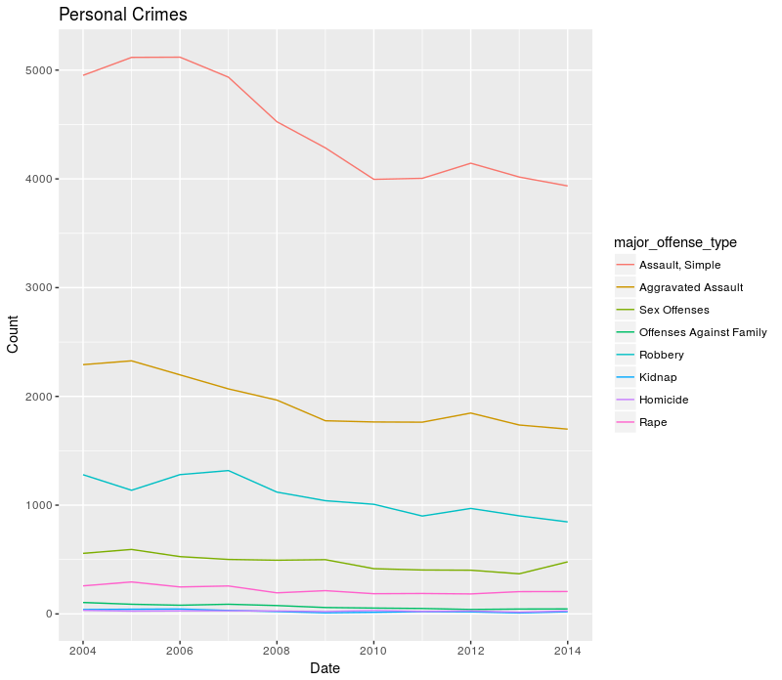

Figure 3: Trends in personal crime from 2004 – 2014. The three most frequent crimes dominate the chart.

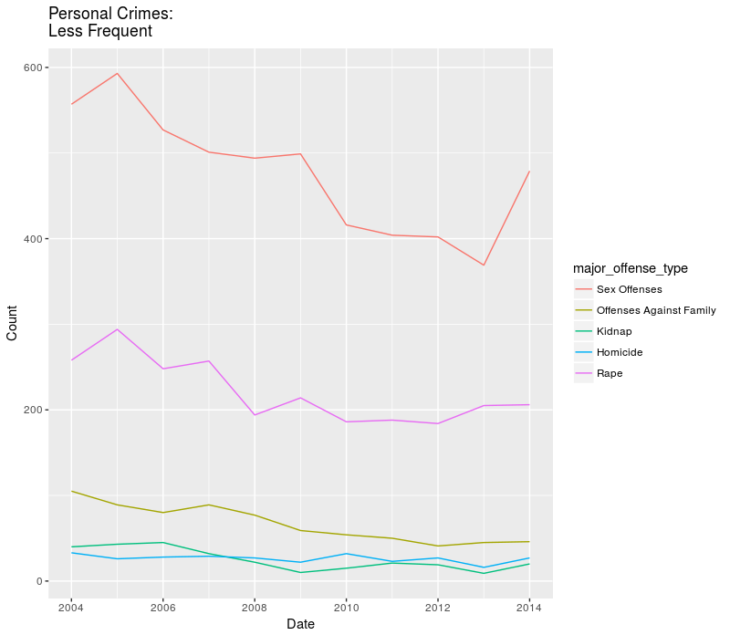

Figure 4: Trends in personal crime, with the three dominating offenses removed for clarity.

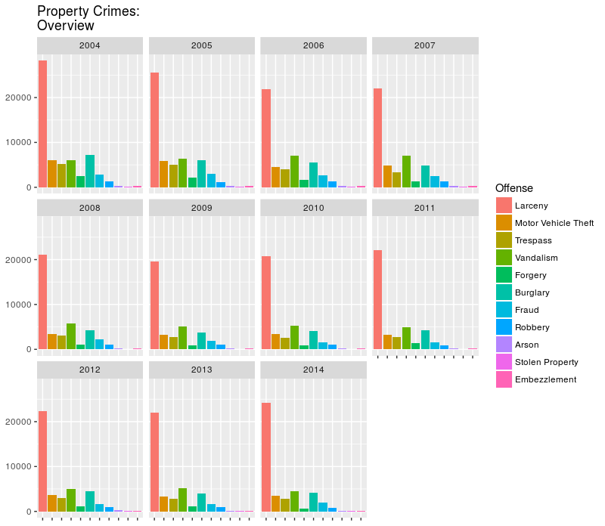

Figure 5: Relative frequency chart for property crimes. Larceny dominates the chart.

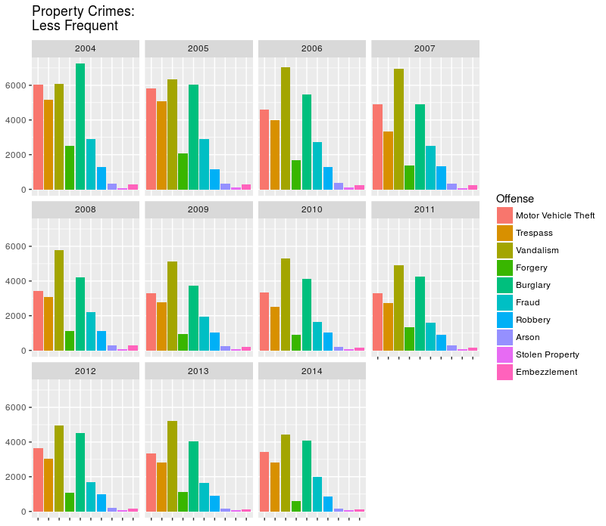

Figure 6: Relative frequency chart for property crimes with Larceny removed for clarity.

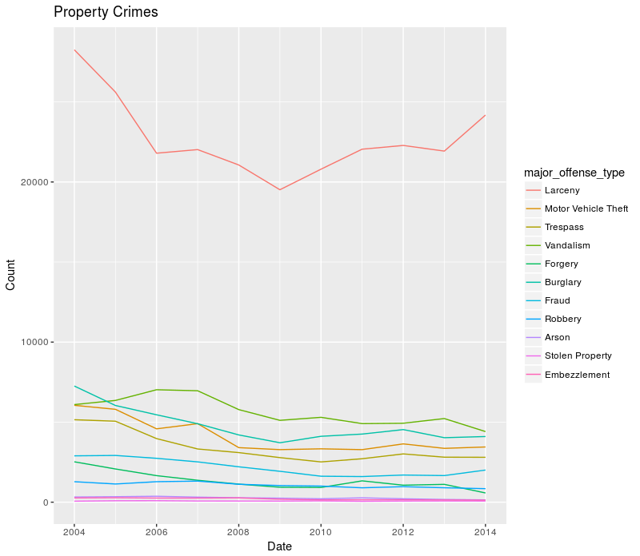

Figure 7: Trends in property crime from 2004 – 2014.

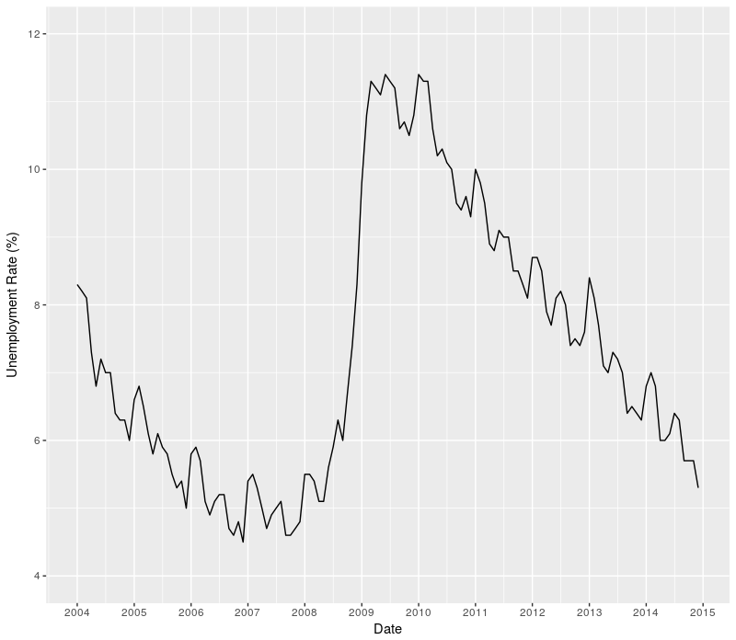

Figure 8: Portland’s unemployment rate for 2004 – 2014.

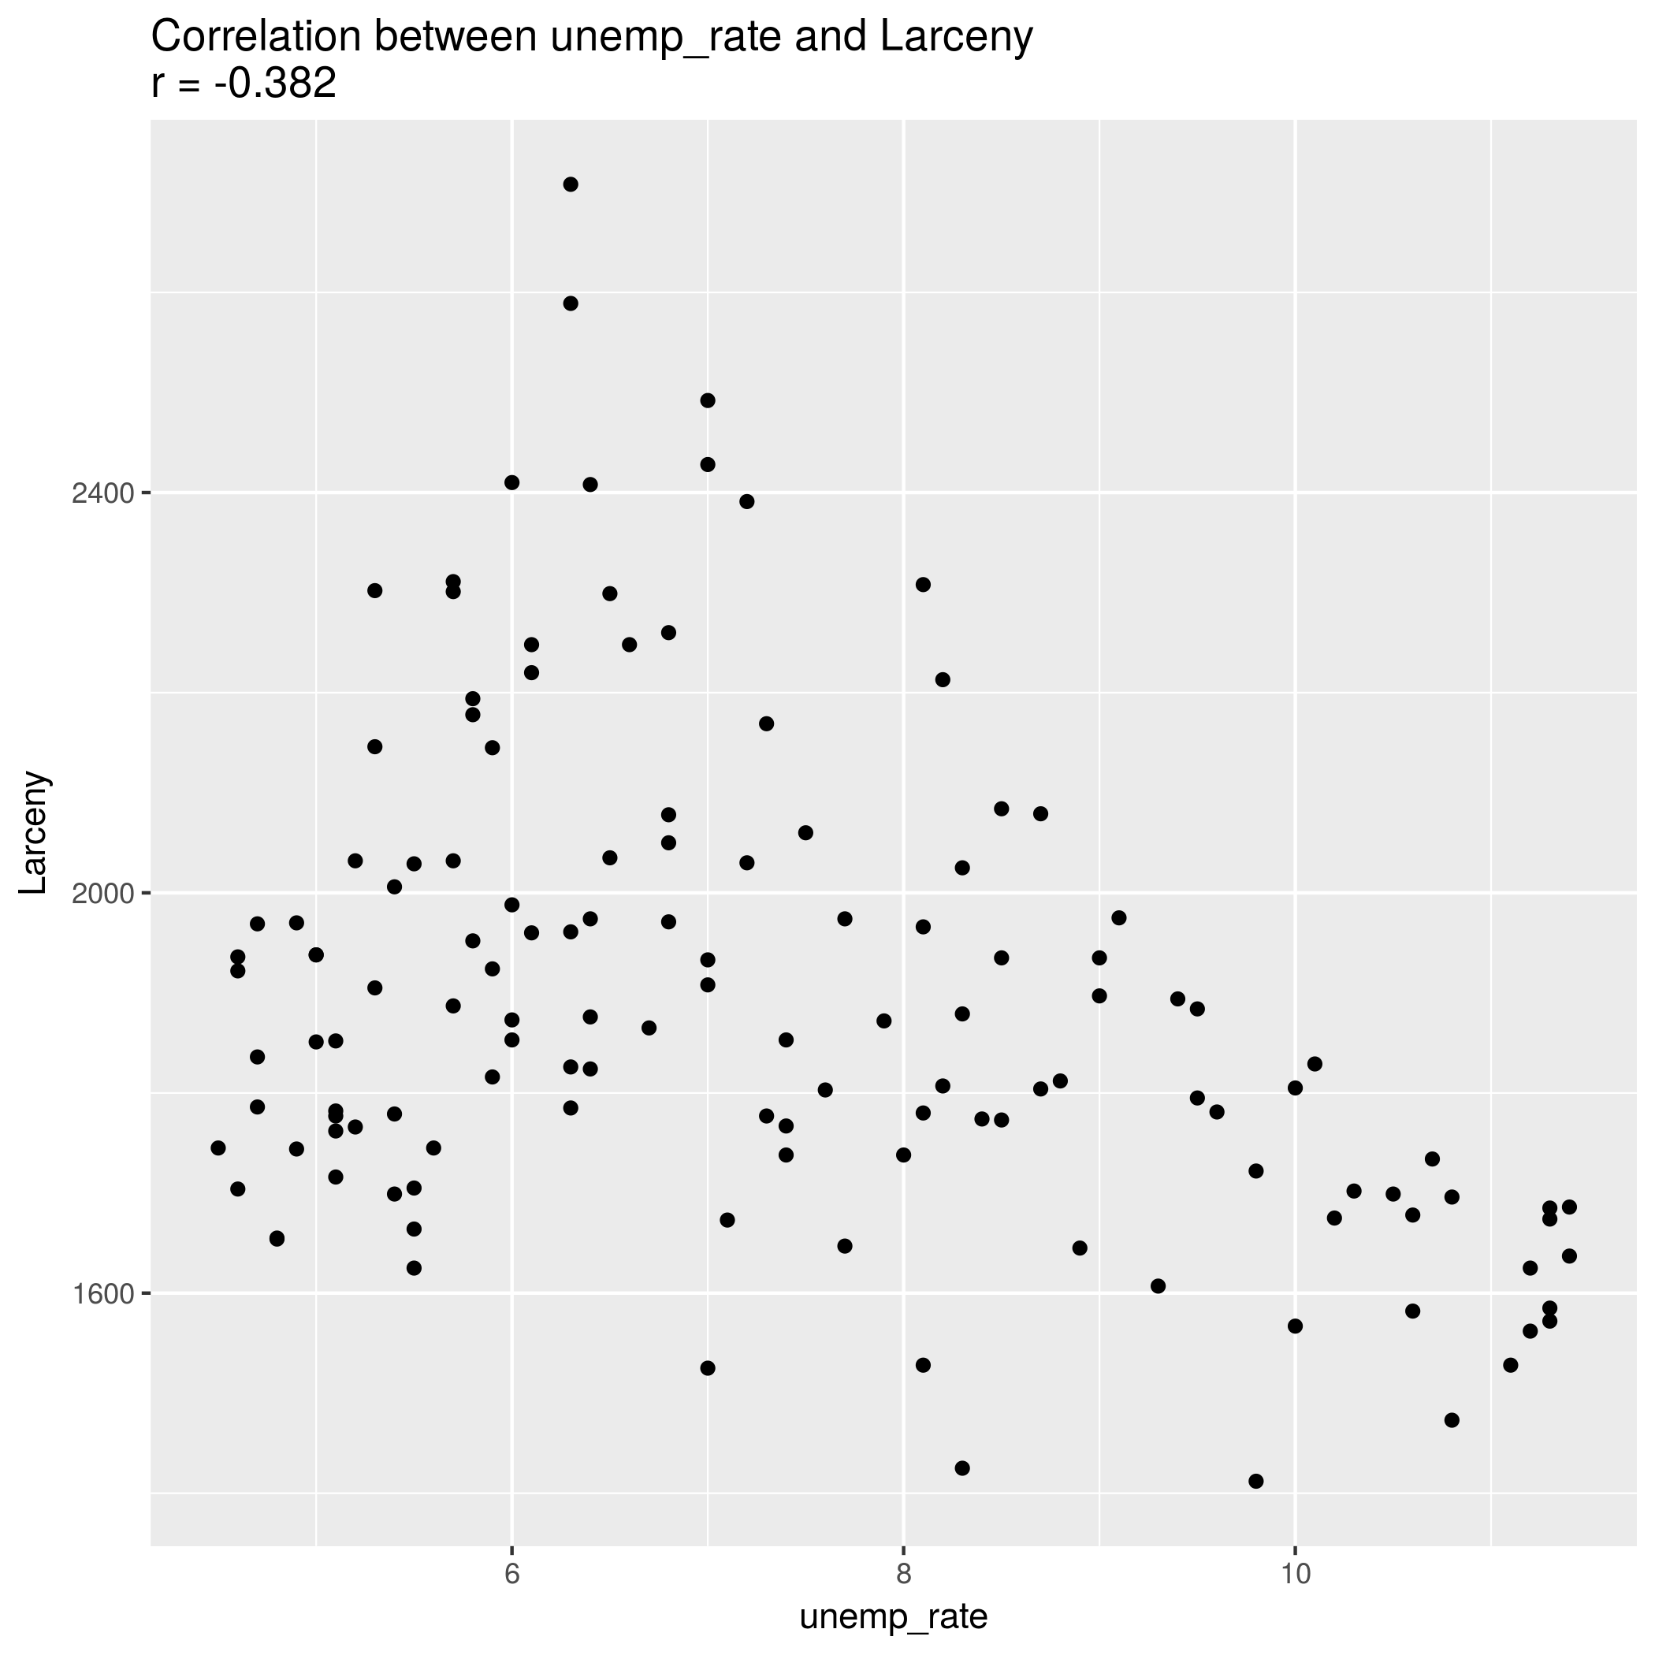

Figure 9: Scatter plot showing the relationship between the 2004 – 2014 unemployment rate to larceny offenses.

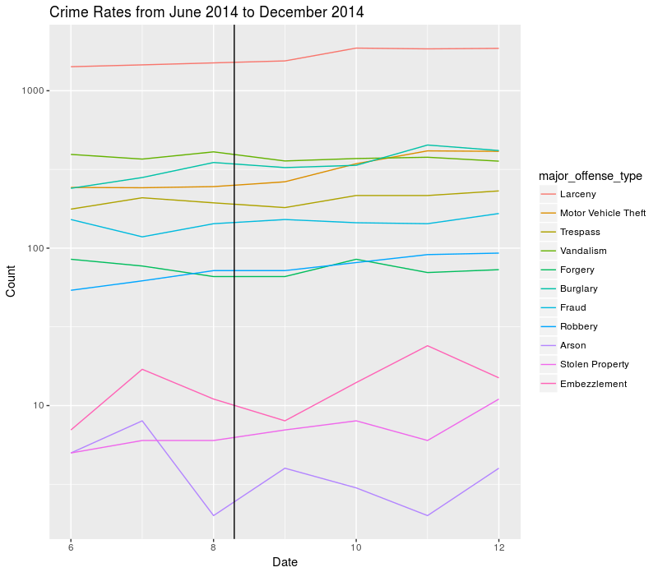

Figure 10: Crime rates in Portland during the months surrounding events in Ferguson, Missouri (June to December 2014). The event itself is marked with a vertical black line.

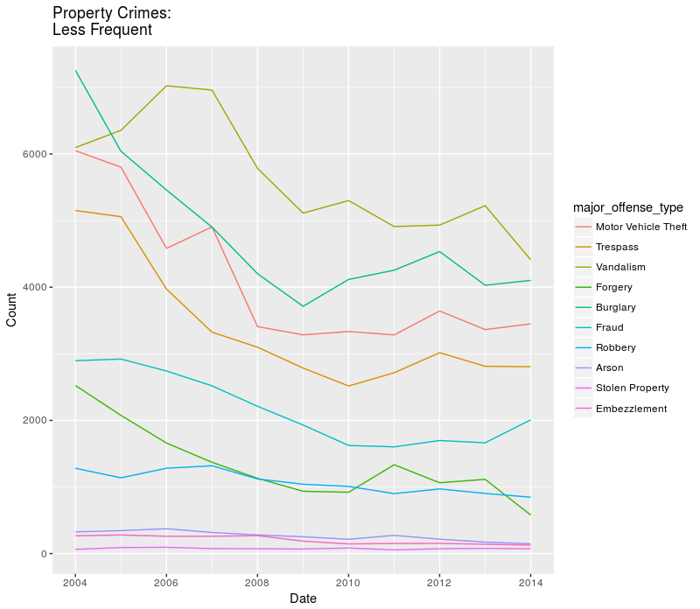

Figure 11: Trends in property crimes, with Larceny removed for clarity.

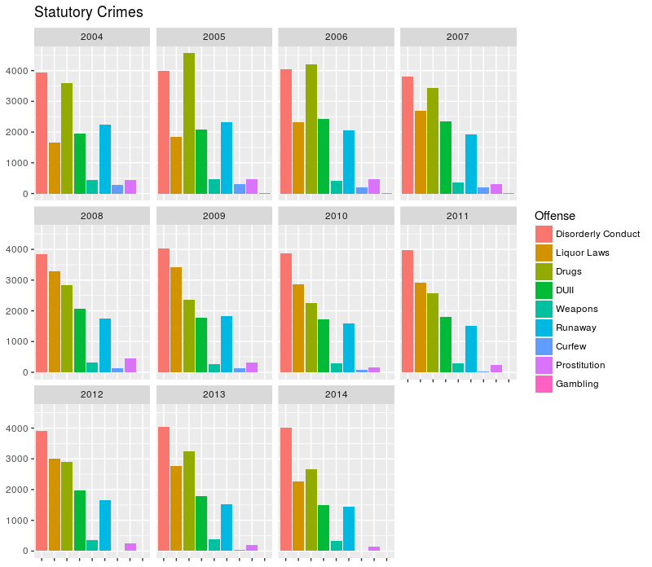

Figure 12: Relative frequency of statutory crimes.

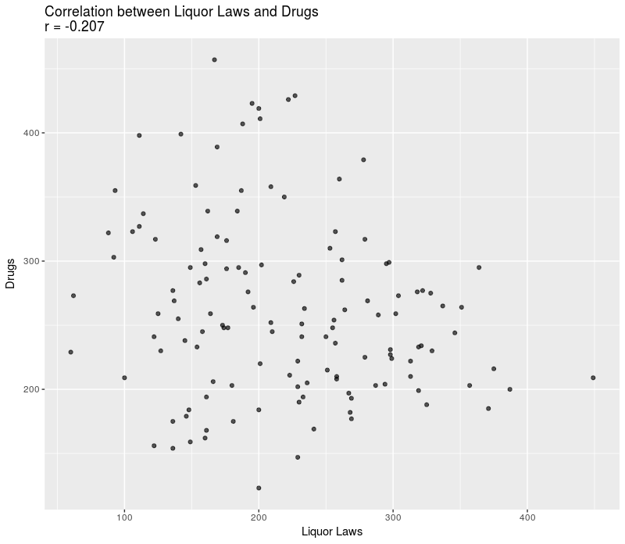

Figure 13: Relationship between liquor law offenses and drug-related offenses, 2004 – 2014.

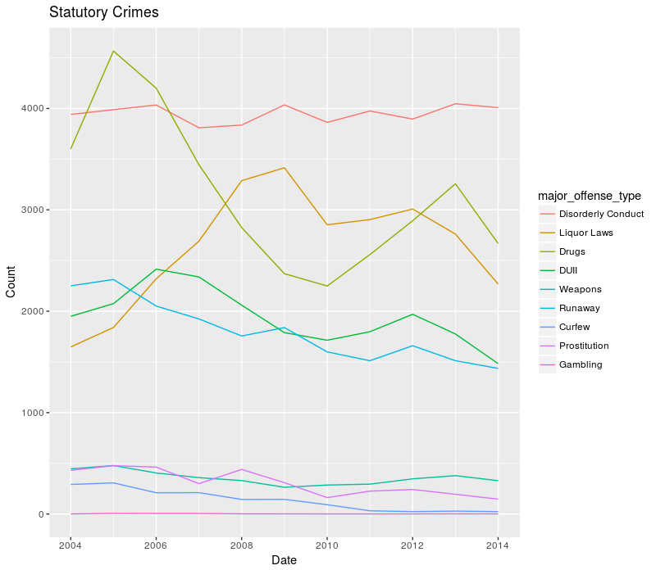Figure 14: Trends in statutory crimes, 2004 – 2014.