Crime in Portland, Oregon, 2004-2014: A Summary of Trends

Over the past several decades, public awareness of crime has increased significantly. Those who do follow the news are exposed to a constant iteration of story after story about illegal activity, local, national, and global. This growing awareness and concern over crime comes at a time where, in many places in the United States, crime rates are actually falling and law enforcement is more effective than ever before in protecting citizens from criminal activity.

At the same time, the public has been informed for several years now that crime rates are on the decline, and that in most major cities in the United States there is actually less crime now than there has been for many years.[1] Is this true? How does one reconcile declining crime rate statistics with one’s own experience of becoming aware of more and more crime as time goes on? One approach is to let the responsibility rest with the media: if the media reports more crime, then the public will be more and more aware of it, despite general decreases in the crime rate overall. Another approach is to acknowledge that one’s personal experience changes over the course of time, and that perhaps as one’s age increases, one’s awareness of larger societal issues also tends to grow.

This project seeks to explore crime in one US city: Portland, Oregon. Of necessity, because of the length of this paper and the time allotted for its completion, the exploration will be an initial one, intended mainly to raise questions for further investigation. For example, there are several places in the project that the desire for more information, especially in regards to statistical investigation, is desired. While it may have been possible to calculate, for example, a simple linear regression to model a particular situation, it is not clear that a particular model would have been appropriate for a given situation. To avoid making unwarranted conclusions, or biasing one’s view of the data presented, no such models were attempted. It is hoped that the exploration below will serve as a catalyst for further investigation, rather than as an answer to every question that may arise.

Portland

Portland is a convenient city to study: crime data gathered by the Portland Police Bureau are shared openly and publicly, after appropriate measures have been taken to anonymize police records. Currently, data from the years 2004-2014 are easily available. This time span offers the opportunity to examine several possible influences on crime rate, including:

1. Portland’s population grew from about 533,120 in 2004 to about 619,360 in 2014.[2] This represents a 16.18% increase over the course of the eleven years under consideration. Has this influx of population had an influence on Portland’s absolute and relative crime rates?
2. The US economy saw a marked decline between December 2007 and June 2009.[3] Studies (discussed below) have suggested that unemployment and low wages can have a statistically significant influence on crime rates. Was an effect of this kind seen in Portland during the time period in question?
3. People become concerned that certain events that occur on the national or global scale have a direct influence on local crime rates. This project will examine one such concerning event, namely, the events in Ferguson, Missouri on August 9, 2014. Is there any evidence that these events had an influence on crime in Portland?

Definitions

In order to ensure an understanding of the terms and vocabulary used in this project, a broad categorization of crime follows.

* Personal Crimes are those which involve harm to the physical or mental state of a person. These can include assault, battery, false imprisonment, kidnapping, homicide, and rape. In the data under scrutiny for this project, simple assault, aggravated assault, and robbery account for a large percentage of personal crimes (robbery, it should be noted, is classified under both personal crime and property crime).
* Property Crimes are those which involve actions that prevent another person from using or enjoying their property. These can include larceny, robbery, burglary, arson, embezzlement, forgery, false pretenses, and receipt of stolen goods. Property crimes account for the majority (68%) of crimes under scrutiny in this project. In fact, larceny (common theft) alone accounts for more than a third (33.7%) of *total* crime in the city.
* Statutory Crimes are those which violate any federal, state, or local statute. These can include personal and property crimes, and other actions sometimes called “victimless crimes.” Examples include disorderly conduct, DUII, gambling, and selling alcohol to a minor.
* Inchoate Crimes are those which are started, but not completed. These can include any attempted crimes, solicitation, and conspiracy.[4] Portland Police Bureau data obtained for this project does not include inchoate crimes.

Crime and City Demographics

Interestingly, the several broad categories of crimes do not occur with equal frequency among different subpopulations in the United States. For example, young urban minorities are more likely to be arrested for personal and property crimes than other groups. This kind of crime is likely to be reported by local media. Other types of crime, including embezzlement, are committed more frequently by people of high economic standing, and are less likely to be investigated or reported.[5]

In regards to the first statement, several studies have been done around the issues of criminal motivations, and the various factors that influence changing levels of criminal activity over time. In 2002, Gould, Weinberg and Mustard[6] examined data from the 1980s and 1990s to try to identify correlations between broad economic trends and changing crime rates. They found that when economic markers were good (low unemployment, higher relative wages), certain criminal activity rates did decrease. In particular, the authors argued that young unskilled men (who commit most higher-visibility crime), were more likely to commit property crimes during times of economic difficulty, including difficult job markets. In particular, the unemployment rate and low wages both had a statistically significant effect on the crime rate, with unemployment having the less significant effect of the two. This points to the possibility that some crime is largely motivated by economic forces. This possibility is further strengthened by the fact that changes in the economic climate did not have a statistically significant effect on rates for personal crimes such as murder and rape, which are seldom committed with an economic motive.

While there are several methods for calculating a crime index, this paper will focus on examination of the most basic: strict frequency of occurrence. Crime rate per capita will also be included on a limited basis, and with equivocation, due to the author’s lack of confidence in data supplying Portland’s actual population levels for the time period in question. While a US Census did take place in 2010, other sources that give estimates for each of the years in question are only estimates, and the margin of error for these numbers is unknown.

For similar reasons, examination of crimes occurring in particular areas of the city will take place, but it will be difficult to state with any certainty whether a particular neighborhood has a higher proportion of a specific demographic. Data from the 2010 census is available, but again, no trends can be identified from this single data point. The relationship between areas of varying demographic heterogeneity and the 2010 crime reports will be examined.

Methods

Analysis for this project was completed using the R statistical programming language. Several libraries and packages were utilized as well, including readr, plyr, purrr, sp, dplyr, lubridate, ggplot2, ggmap, mapproj, and several others. A brief description of the data acquisition and cleaning process follows.

Data for this project was collected from the following sources:

* + - http://www.civicapps.org/datasets: This data is that recorded by the Portland Police Bureau, cleaned, and made available to the public with identifying information removed from each record. Variables such as data and time of report, major offense type, and location information for each incident are provided. For this project, the time of each incident was ignored. Location information was converted from State Plane coordinates to Latitude/Longitude coordinates using the sp library.
    - https://data.bls.gov/pdq: This data includes unemployment information for Portland from January 2004 to December 2014. Only the date and unemployment rate columns were utilized.
    - https://www.portlandoregon.gov/bps/62635
    - <https://www.pdx.edu/crime-data/>
    - https://www.biggestuscities.com/city/portland-oregon: This data includes population (estimates) for Portland for January 1 of each year of interest.

It should be noted that the data under consideration do not contain all crimes committed in Portland during the time period in question. Some crimes, of course, are never reported. Other crimes may be reported to agencies different from the Portland Police Bureau, including the Multnomah County Sheriff’s Office, for example. Other crimes may be reported to state or federal law enforcement. For this reason and others, reports compiled by various agencies on crime statistics in Portland may or may not agree exactly with the figures provided in this report. The FBI release of violent crime statistics in September 2013,[7] for example, includes statistics that vary from those reported here. Additional reasons that statistics may vary include the severity of the offense. For example, in this data, “Homicide” is reported as a flat statistic, whereas the FBI has the ability to tease out which homicides were “Murder and non-negligent manslaughter,” as opposed to justifiable homicides or homicides motivated by self-defense.

An overview of crime in Portland can be seen in graphics and charts included after the References section at the end of this paper. Crime is of necessity broken up into the categories described above (Personal, Property, Statutory). This breakdown makes the crime data more visible and easy to understand. The bar charts serve to show the relative frequency of the different crimes relative to each other, while the line charts show trends over the time period in question.

First, we will examine personal crimes (Figure 1). The data is faceted into bar charts depicting each year in the data set. The most frequent crimes in this category are simple assault, aggravated assault, and robbery. Each of the three most frequent crimes in this category appear to be decreasing; this will be more visible in the line charts below. The relative levels of other crimes are more difficult to see due to their lower frequency.

A second bar chart (Figure 2), with the three most frequent crimes removed, is shown next. Again, it appears that personal crimes on this chart are either declining over time, or remaining at a fairly constant level. Of particular interest is the very low number of homicides across the timespan in question: Portland’s relatively low homicide rate has sparked interesting speculation.[8] More discussion on this topic will come later in the paper.

The major trends among these personal offenses are made more clear in several time-series plots. In Figure 3 each offense is plotted on the same graph, with the trends discussed above illustrated. In particular, Simple Assault, Aggravated Assault, and Robbery have decreased by 20.5%, 25.9%, and 33.9%, respectively. It would be interesting to construct a linear regression model on each of these offense types and to note the slope of the line thus generated. This would be more revealing than a simple percentage decrease, as is done here in a simple exploratory way.

When we remove the three most frequently committed offenses from the line graph, we can see trends in the remaining offenses more clearly (Figure 4). In particular, using the same elementary method of finding the percentage change from 2004 to 2014, we see that several offenses have seen marked decreases: Offenses Against Family and Kidnapping have decreased 56.2% and 50%, respectively, while Homicide and Rape have decreased 18.2% and 20%. Sex Offenses have also decreased 14%, despite the upward spike visible in 2014. Again, a linear regression model would reveal more about the general trends in each case (especially Sex Offenses).

A series of charts and graphs similar to those discussed above follows, this time examining property crimes. One observation that can be made at the outset (Figure 5) is that Larceny accounts for a large percentage of crimes in this category. This isn’t too surprising, since larceny includes such minor offenses as shoplifting and pickpocketing, and the value of such items can be relatively small. In fact, larceny accounts for about 33.7% of all crime, total, in Portland for the time period, and 49.6% of property crime.

Inspecting the property crimes without Larceny included in the bar graph (Figure 6) reveals the relative frequency of the remaining offenses. It is interesting to note that so-called “white-collar crimes” such as Fraud, Forgery and Embezzlement have low levels relative to “street crimes” such as Motor Vehicle Theft, Trespass, and Vandalism. Although trends for each offense type are somewhat apparent in the charts above, line charts are again provided to make these trends more visible.

Larceny here seen in Figure 7 to be on a general downward trend until 2009, then the rates tend to increase again, though at a lower rate than they had been decreasing previously. Despite this increase, from 2004 to 2014 the total percentage decrease was 14.4%.

It is interesting to note that this increase coincides with a spike in Portland’s unemployment rate following the 2007-2009 recession (see Figure 8). Nationally, the unemployment rate hit a high point at 10.0% in October 2009.[9] Portland’s unemployment rate was above 10% from February 2009 through August 2010. This appears to coincide with an increase in monthly Larceny offenses in the city. Note that no such increase in personal crimes was obvious during this time frame; it would seem that Gould’s 2002 results indicating an increase in property crime, but not in crimes without economic motive, may hold for Portland during this time period.

When a correlation analysis was done between Portland’s unemployment rate and larceny offenses for the time period, the coefficient obtained is -0.382, indicating at best a low-moderate relationship (and a negative relationship at that). Figure 9 shows a scatter plot of unemployment rate vs. larceny reports for 2004 – 2014. As can be seen, a linear relationship is not very apparent between these two variables; thus the low correlation coefficient found above. It would appear that any relationship that is present is actually a negative one: there were actually fewer reports of larceny when the unemployment rate was high.

Another question of interest in this report is the effect of certain headline news incidents on crime rates in Portland. In 2016 Pyrooz, Decker, Wolfe and Shjarback conducted an investigation into the so-called “Ferguson Effect,” wherein national crime rates had supposedly increased in the months following the August 9, 2014 “shooting death of an unarmed young black man by a white police officer in Ferguson, Missouri.”[10] The authors of this study concluded that no systematic increase in crime rates had occurred in the months following the death, but indicated that individual cities may have seen some increases in particular crimes, including robbery. Portland did see some increase in certain property crime incidents, though no causal link is implied here: the month-over-month changes are not unusual, and could have been a part of the normal fluctuation in crime rates in the city (see Figure 10).

Further investigation is required here if the increases are to be labeled as statistically significant. Perform t-test

Let us return to the larger data set (2004-2014). With Larceny removed from the line graph, the downward trend of each of the remaining offenses is quite apparent (Figure 11). In particular, reports of the “white-collar crimes” Forgery, Fraud, and Embezzlement, have decreased 77.1%, 30.7%, and 52.5%, respectively, while other crimes have decreased a comparable amount. The exception to this is the “(Possession of) Stolen Property” category, which is the only one in this category that actually saw an increase over the time period, from 63 incidents in 2004 to 72 in 2014, a change of +14.3%.

The statutory crimes under examination are shown in Figure 12. For this data set, the crimes of lower frequency include Weapons, Curfew, Prostitution, and Gambling. Among these data are those that do not necessarily involve damage to a person or their property; the levels relative to each other appear to have remained fairly constant over the course of this time period, except for Liquor Laws and Drugs. These two offenses appear to vary more drastically than the other offenses under examination. It appears that Liquor Laws and Drugs may have a negative correlation: when one is high, the other is low, and vice-versa. However, when a correlation analysis was done on the two variables, the correlation coefficient was found to be -0.207, indicating a weak correlation at best. This lack of correlation is depicted in Figure 13. One consideration that may come into play for data after 2014 is Oregon’s legalization of recreational marijuana; it is possible that drug-related offenses may see a change in response to this new statute. However, this question lies outside the scope of data available for this project.

Again, the trends made visible in the line chart shown in Figure 14 seem to indicate that most of the offenses in this category have either decreased slightly or maintained a fairly regular level during 2004-2014. The exception, again, are Liquor Laws and Drugs offenses. Overall, Liquor Laws saw a 37.6% increase during this time period, while Drugs saw a net 25.9% decrease. Disorderly conduct remained fairly constant at a slight raise of 1.7%, while Gambling had a net change of 0. DUII, Weapons, and Prostitution saw decreases of 23.9%, 26.2%, and 65.9%, respectively. Runaway and Curfew saw decreases of 36.2% and 91.8%, respectively. The actual Curfew numbers (the most drastic reduction in the dataset) were 292 in 2004 and 24 in 2014.

It was originally hoped that there might be a way to identify repeat offenders in this data set; however, identifying information has been intentionally removed from the data in the interests of protecting the privacy of individuals. One method that might shed some light on this question, however, is to examine the address of each offense recorded.

The dataset used to create the “Property Crimes” summaries has a total of 502,845 entries over the time period in question, but only 53,605 unique addresses are included in the data. However, it must be noted that several addresses are of the form “12301-12499 block of NE GLISAN ST,” which could include a number of buildings, especially if there are apartments included in the block. Therefore, this method of determining repeat offenders will probably not be fruitful.

It may be interesting, however, to examine the geographic distribution of the offenses recorded in the data. While identifying information about individual repeat offenders may not be obvious, it may be possible to note patterns in particular areas of the city. Since State Plane coordinates were included for each offense, it was possible to convert these coordinates to Latitude and Longitude, and thus include them on a map of the city. Detailed analysis of these incidents and how they relate to the demographics of the city, including economic and other indicators, is beyond the scope of this project. Fascinating reading (of interest to residents of Portland, and to those with an interest in conducting this sort of analysis in general) can be had in the several studies conducted by Meagan Cahill and her associates.[11]

In lieu of this, several maps with crime incidents plotted are included below. Due to the sheer volume of the data involved, there is a significant issue with overplotting involved with this attempt. After all, over the span in question, PPB recorded nearly 750,000 incidents. Trying to put these on a map, even when broken into various categories as above, does not lend itself to a clear understanding of the issues involved. For this reason, the author has chosen to include a few illustrative plots, in hopes that a general feeling for the prevalence and distribution of several types of crime in the city can be obtained.

First, we will examine homicide. As mentioned earlier in this paper, Portland has an unusually low homicide rate, compared to other cities in the United State of a comparable size. Peter Korn has written an in-depth article[12] that attempts to illuminate some possible reasons for this low rate. Possible factors that are investigated are poverty, gentrification, problem-oriented policing, and high levels of good medical care (people can be rushed to a good hospital before death). Korn concludes that none of these explanations is quite enough to explain the low homicide rate for the past several years. Following is a map showing the distribution of homicide in Portland, grouped by years.

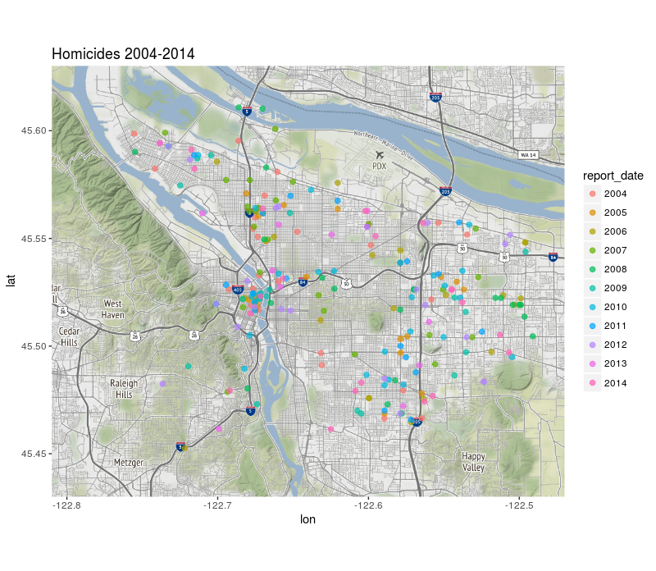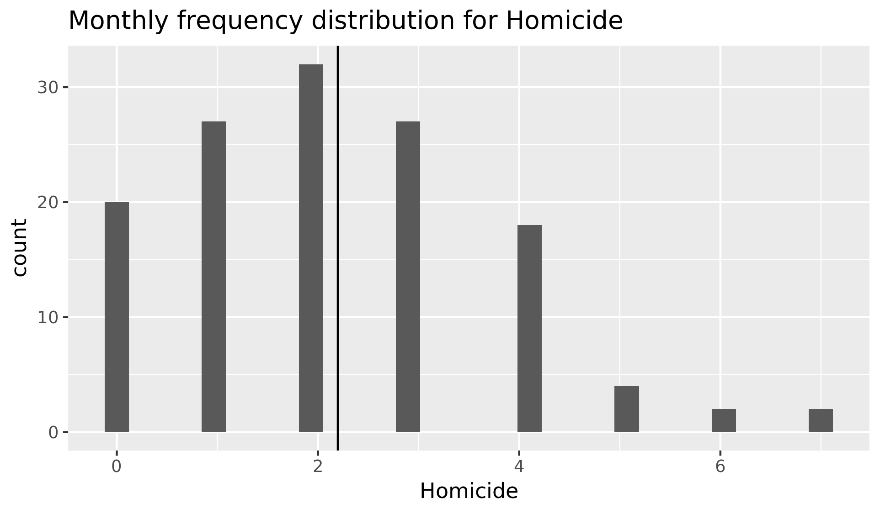

O’Flaherty and Sethi conducted interesting research in 2007, examining the relationship between racial segregation and robbery rates.[13] Their fascinating paper postulates that, given a robbery attempt, since whites are perceived as less likely than blacks to resist robbery, whites are also more likely to be targeted by robbers. Because whites are more likely to be targeted, they are also more likely to move to a safer neighborhood if their economic circumstances allow it. Since whites are also, on average, better off economically than blacks, these safer neighborhoods tend to become predominantly white, while the more dangerous neighborhoods tend to become more and more black. “Hence, *conditional on income,* blacks live in more dangerous neighborhoods than whites.”[14]

Do neighborhoods with more blacks in Portland also tend to have higher robbery rates? Following is a map of robberies that occurred in 2010.

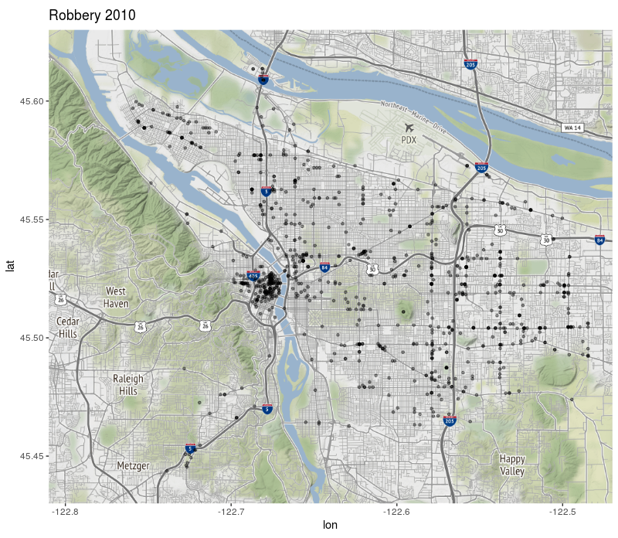 How are these incidents related to the demographic distribution of the various neighborhoods in Portland?

(Return to this topic in the coming week)

* 1. Trends in various types of crime over geographic location.
     + At first this may be limited to which precinct was involved in the various crimes, but depending on availability of information it may be possible to actually represent crime data on a city map and look for general patterns and areas of interest.
     + Sub-maps may be an option here as well. Can these trends by location be correlated to any economic markers? For example, average house sale price in the neighborhood?

1. Conclusion and summary of major results or findings. Possible avenues for further investigation, or other data that might inform future research.

1. Johnson, 2016.
2. Portland Population History, 2017.
3. BLS, 2012.
4. Shoener, 2017.
5. Crossman, 2017.
6. Gould, et. al. 2002.
7. FBI, 2013.
8. Korn, 2013.
9. BLS, 2012.
10. Pyrooz, 2016.
11. Cahill, 2004, Cahill and Mulligan, 2003, Cahill and Mulligan 2007.
12. Korn, 2013.
13. O’Flaherty and Sethi, 2007.
14. O’Flaherty and Sethi, 2007, p. 392.