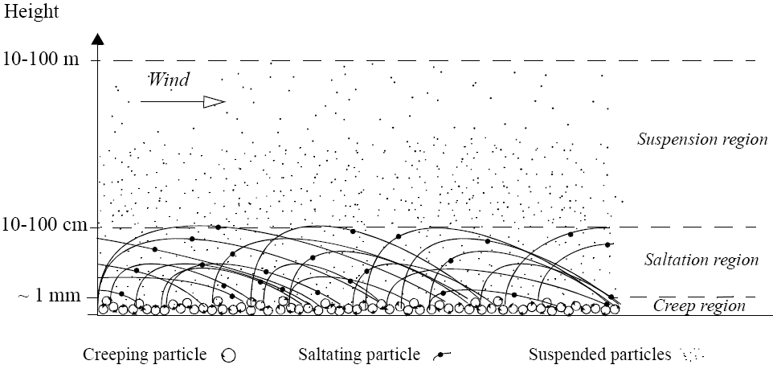

Fluid Mechanics Visualization
SMN6200 & STE6234

Pål Solberg Trefall

ª Narvik University College, Lodve Langesgt. 2, P.O. Box 385, N-8505 Narvik, Norway.

11 January 2011

Abstract
This document is a report of the task, the work, insight and the results from the SMN6200 project in Fluid mechanics visualization at the University College of Narvik, Norway, 2010/2011. Through the project an application was made that would load STL Mesh data and Flow3D simulation data. Using a heavily data-driven approach to the application, most features of the application can be changed and new features can be added, without touching C++ code and without recompiling the software. The scripting interface is based on Lua, which is used for scene initialization and application behaviour. The markup language, XML, has been used to provide a customized way to load any Flow3D data into the application, no matter the set of parameters. The gui uses html/css to define the interface, as is easy to extend with new features. Via the gui, the user can interact with the settings of each single entity loaded into the scene of the application, be it an animated flow3d particle field or a stl mesh. Using the application, the user can analyse the behaviour of particle simulations and follow different kinds of data represented graphically however preferred (the particle field is simply sent to the graphics card, where the geometry shader can be used to customize the visualization of the particles). Bundled with the application there's written a smooth particle visualization, which represents each particle as a spherical point, and a line visualization, which is used to visualize velocity direction and magnitude. The end-result is an application that will render out the particle fields of the assignment, along with the stl meshes, but it's been written with great attention to data-driven architecture and extensibility in mind.

1. Introduction
Second half-semester of fall 2010, the project in fluid mechanics visualization was handed out. I immediately envisioned a super-flexible application that would allow a researcher with mild scripting abilities to be able to extend and modify the application to his/her needs. The focus of the application has thus been on a generalized C++ back-end, with a data-driven front-end. This gives the end-user the ability to go through simple text-files to change everything from something as simple to change by which amount you scale an entity when pressing a button, but write entirely new user-interfaces, how geometry/particles are visualized and how logic flows through the application. The user can modify an XML document that describes the parameters to group and expect from his/her flow3d simulations, or can modify the scene start-up script to shoehorn how the application start up.

2. Material & methods
2.1 Simulation
The assignment involves a simulation of particles falling down a pipe with a bucket in it, meanwhile water is flowing up from the bottom of the pipe. The simulation shows how all of the particles end up in the bucket due to the energy of the water.
2.2 Visualization
The visualization handles first and most particle field rendering. That is, it renders points on the screen based on a three-dimensional particle resource. How this particle data then is visualized can be heavily modified in the application's data-driven front-end.
Vectors, like velocity, can easily be visualized for a particle-field using the geometry shader in glsl 1.50. Based on the input particle position, we can generate a new vertex-point directly on the Gpu. It would be very easy to extend this to support more info as well. It could generate multiple vectors lit with different colours, it's limitless.
We can also visualize stl triangular meshes. In this application, the face-normals for the mesh is also handled, so that we can perform both lighting calculations, as well as reflect the environment. This can also be extended to perform more advanced visualization techniques if required.
2.3 Data-driven application
The data-driven nature of the application allows the end-user to change most anything of how the application behaves, and can extend functionality also. Key features in this application's frontend includes:
- XML defined parameter grouping for Flow3d file loading
- XML defined configuration of application initialization, allowing the end user to set options like application resolution, pixel depth, fullscreen, vsync, etc.
- XML defined entities, allows the user to define entity types that can later be loaded by the application. Bundled in are skybox, flow3d, stl mesh and cube entities.
- Html/Css-based graphical user interface, allowing the end-user to easily modify and extend the user interface.
  - Can send events straight to Lua scripts.
- Lua scripting, allowing the end-user to do advanced application logic and talk with the C++ Engine's exposed features. Add effects via components, change the startup script, tweak behaviour of gui events, and much more!
- GLSL 1.50 scripts, allowing the end-user to alter how particles and other geometry is handled on the graphics-hardware. Visualize points as lines, colour them based on input variables, or whatever the end-user sees fit for the best visual representation to do his/her job.
- Property-system with embedded event system. Allows the end-user to add a property variable of any type to an entity, and add methods that can listen to any existing property when it change state.

3. Results
Following is presented some screenshots from the application. An explanation will follow each screenshot, and closeups of particularly interesting sub-sections of each image will be presented too.
3.1 Visualization of simulation
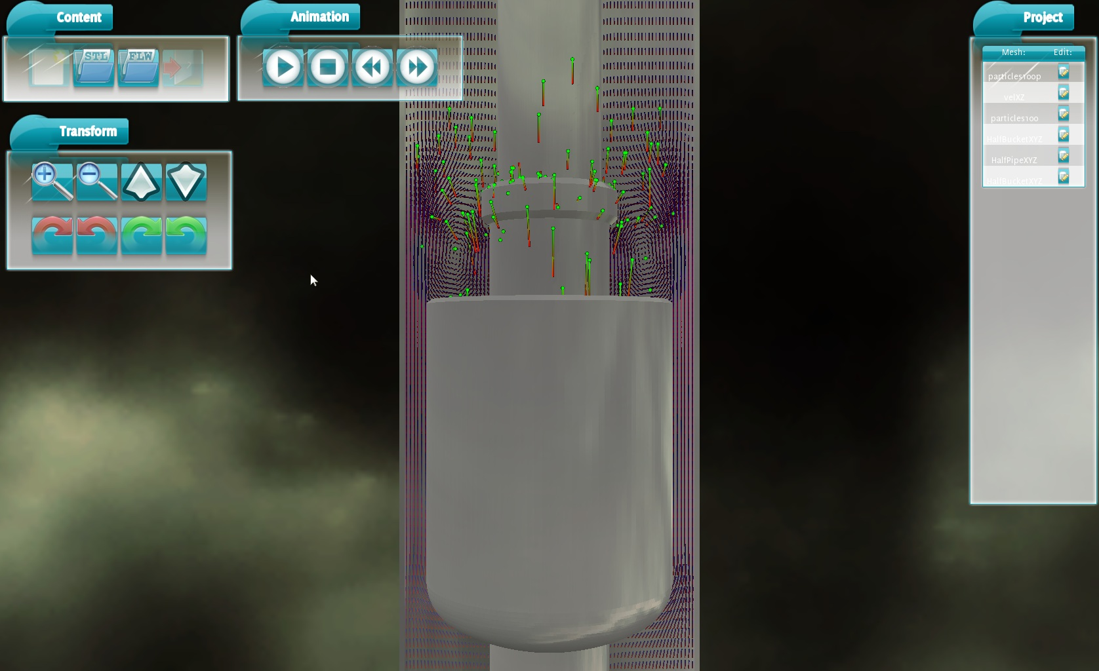
These images shows several feautres of the application's visualization.

First is the VelocityXZ 2d field data-set that is a one-frame simulation snapshot of the water that clearly flows upward. Blue represents the particle position, and the more red end of the vector represents the velocity magnitude and direction.

It's interesting to see how the particles enters a circular path at the mouth of the bucket, and how fast the particles move on the sides of the bucket, where pressure is very high.

Second is the 100-frame Particle field. It's been loaded in with a point visualization and a velocity visualization. The green colour represent the particle's position, while the red indicates velocity direction. The longer the vector is, the greater is the magnitude of the velocity.

We can clearly see how particles are forced into the bucket by the force of the water.

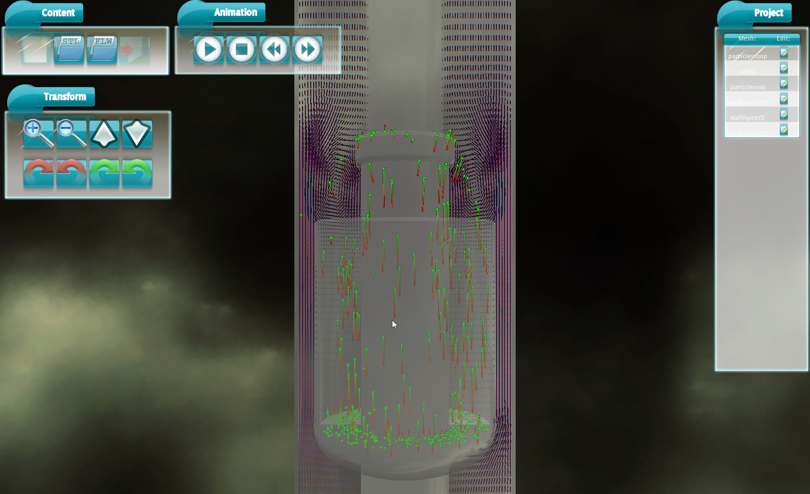
Here the bucket has been set to translucent, effectively allowing us to look inside the bucket. We can see that particles moves towards the bucket floor with high velocity, and bounce against the bucket-floor for a while before they lay to rest.

At the bottom of the bucket, we can also see how the water in the pipe presses into the narrow path between the bucket and the pipe, which results in such a velocity and pressure gain in the water particles.

The flexibility of the data-driven application is evident in that it's so easy to change how the scene entities are visualized. Here, some particles are rendered as spheres, others with broad velocity vectors, and the water cells' red velocity tip and blue particle position comes clearly forward. Though this last screenshot might not really provide a lot of useful information, it serves as an example of how simple it is to change the visualization drastically. No code was touched to produce this, and no specialized C++ code was produced either to provide this specific render-state.

3.2 Data-driven architecture
3.2.1 Geometry shader and GLSL 1.50

An excerpt from the geometry shader of the particles that fall into the bucket. First we position the particle and define it's color as green, we then define a second point, which takes the velocity vector as input with a scale modifier, and gives it a red color. Further up in this script, it's clearly stated that we want to produce a line from the input point. The Gpu will automatically interpolate the color value along the line from the first point to the second.

3.2.2 Flow3d Parameter groups XML definitions

3.2.3 Html/Css-based gui formating and definition
3.2.4 Lua scripted gui event handling and property-system usage
4. Conclusions
The results and discussions forms the basis for the main conclusion(s) and any conclusion must be presented as clear and concise as possible. The conclusions are normally presented in a separate short Conclusions section (as in this description). However, Conclusions may be a subsection of a Discussion or Results and Discussion section.
The conclusions in an average student work/project are normally weak and often the weakest point of the report. Please pay special attention to possible conclusions already from the start of the actual work or analyses. By always keeping an awareness regarding the main objectives for doing the work or making the analysis, the conclusions regarding whether you have achieved your goals or not, becomes clear.

As a student and later working with engineering analysis, research etc, always keep in mind that structuring your reporting also will increase the efficiency of the work itself and thereby improving your results☺

Suggestions and recommendations for further work or analysis should be located in or immediately after the conclusions section. This since reflections about the further work naturally is the ‘final’ words from the author(s) to the reader and that these recommendations are normally founded on the conclusions.
Acknowledgements
The author would like to thank his colleagues at the postgraduate studies at Narvik University College for reading and commenting on this document (Providing language help, writing assistance or proof reading the article, etc.).

References
Flow Science Inc., 2010, 683 Harkle Rd Ste A, Santa Fe, NM 87505, http://www.flow3d.com/apps/index. html (21.10.2010).
SINTEF, 2010, The Centre for Renewable Energy, Published September 24, 2010, http://www.sintef.no/Home/Environment/fornybar-energi (25.10.2010).
Sundsbø, P.A. and Bang, B., 1998, Calculation of snowdrift around roadside safety barriers, Proceedings of the International Snow Science Workshop, Sept, Sunriver, Oregon, USA, 279-283.
Sundsbø, P.A., 1997, Numerical modelling and simulation of snow drift – Application to snow engineering, Doctoral Thesis, ISBN 82-471-0047-9, Norwegian University of Science and Technology, Trondheim.
Tabler, R.D., Pomeroy, J.W., and Santana, B.W, 1990, Drifting snow, In. W.L. Ryan and R.D. Crissman (eds.), Cold Regions Hydrology and Hydraulics, American Society of Sivil Engineers, New York, 95-146.

Appendix A. Example on research paper and consultancy report structure

- An appropriate structure on your reporting will often improve the structure of the actual work/analysis and thereby improving the final results.
- Most students/engineers develop a certain structure on a specific type work even if they think they do not.

The structure chosen for the reporting in this course consists of the following parts: Abstract, Introduction, Material & Methods, Results & Discussion, Conclusion, Acknowledgements, References and Appendices, reflects the basic within various types of scientific and engineering reporting.

A.1 Example on a research paper structure for publication in an international engineering journal:
Beyers, J.H.M., Sundsbø, P.A. and Harms, T.M., 2004, Numerical simulation of threedimensional, transient snow drifting around a cube, Journal of Wind Engineering and Industrial Aerodynamics, Volume 92, 725-747.
- Abstract
- Nomenclature
- 1. Introduction
- 2. Numerical modelling (Material and Methods)
- 3. Experimental results (Results/Discussion)
- 4. Numerical results and discussion (Results/Discussion)
- 5. Conclusion
- Acknowledgements
- References

A.2 Example on a consultancy report structure (large report, several issues):
Sundsbø, P.A., 2004, Wind Chill Index- and snowdrift simulations/analysis on Hammerfest LNG Plant, WSB report 105-03 Rev 1, Commissioned by Tractebel Industry Engineering, Brussels.
- Summary (Abstract)
- 1.0 Introduction
- 2.0 The Wind Chill Index (WCI) (Material and Methods)
- 3.0 Meteorological data – WCI (Material and Methods)
- 4.0 Snow drift conditions (Material and Methods)
- 5.0 Numerical model (Material and Methods)
- 6.0 Numerical simulations of WCI (Results/Discussion)
- 7.0 Numerical simulations of snowdrift (Results/Discussion)
- 8.0 Snow drift control (Results/Discussion)
- 9.0 Emergency escape ladder location (additional separate analysis)
- 10.0 Conclusions
- References
- Appendices (I-III, showing results from WCI & snowdrift analysis)

Comments: Material related to modelling, programming, simulations and data collections may be presented in the Appendices. Do not include unnecessary data/info. Evaluate this carefully.

