Maintenance Command Handler Design Specification

Document Number: ?

Version: 0.1

Date: 6/23/99

Revision History

Version: | Date: | Comments/Remarks | Modified By:
0.1 | 6/23/99 | Initial Release | T. Olson

Contributor List
- Tim Olson

Table of Contents

1. Introduction 4
1.1 Scope of the Document 4
1.2 References 4
1.3 Glossary 4
2. Overview 5
2.1 Maintenance Command Handler Requirements 5
2.2 Maintenance Command Handler Architecture 6
2.2.1 Module Descriptions 6
2.2.2 Interfaces 7
3. SW Design 7
3.1 Information Model 7
3.2 Object Description 7
3.2.1 MCH Command 7
3.2.2 Diagnostic Commands 7
3.2.3 MCH Help Command 8
3.2.4 MCH Task 8
3.2.5 Diagnostic 8
3.2.6 Diagnostic Result 8
3.3 Object Attributes 8
3.3.1 MCH Command 8
3.3.2 Start Diagnostic 8
3.3.3 Stop Diagnostic 8
3.3.4 Get Diagnostic Results 8
3.3.5 Get Diagnostic Help 8
3.3.6 MCH Help Command 8
3.3.7 MCH Task 8
3.3.8 Diagnostic 9
3.3.9 Diagnostic Result 9
3.4 Object Methods 9
3.4.1 MCH Command 9
3.4.2 Start Diagnostic 9
3.4.3 Stop Diagnostic 9
3.4.4 Get Diagnostic Result 9
3.4.5 Get Diagnostic Help 10
3.4.6 MCH Help Command 10
3.4.7 MCH Task 10
3.4.8 Diagnostic 10
3.4.9 Diagnostic Result 10

Introduction

Scope of the Document
This document describes the design and functionality of the ViperCell Maintenance Command Handler.

References
- JetCell, HLD-000003-98, PocketBTS Software Architecture Specification, version 10, Release Candidate
- JetCell, HLD-00000x-99, ViperCell OA&M Architecture Specification, version 0.7

Glossary

Overview
The Maintenance Command Handler is a module within the OA&M plane that provides access to ViperCell maintenance functionality. Commands may be received via the MIB Controller or from a terminal interface such as a Tornado Shell or telnet connection. The Maintenance Command Handler will be a separate task from the MIB Controller so that maintenance functionality may be performed concurrent with the MIB Controller operation.

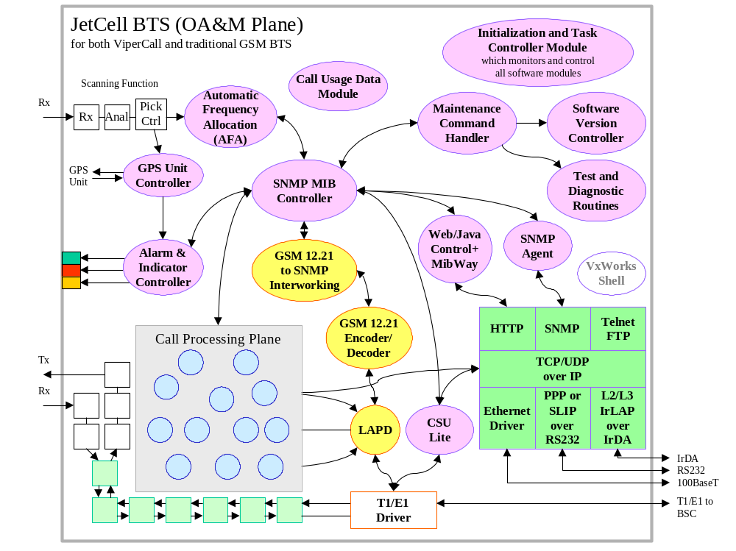
Figure 2-1: JetCell BTS OA&M Software Module Organization
The following is a list of the basic functionality provided by the Maintenance Command Handler:
- Provide an interface for the initiation, termination and results display of diagnostics.
- Start and stop diagnostics.
- Manage diagnostic results.
- Provide Maintenance Command Handler help.
- Provide diagnostic test help.

Maintenance Command Handler Requirements
- Maintenance commands from the SNMP MIB Controller and the Tornado shell must be parsed. Command formats do not have to be the same from each source though. For example, commands from the SNMP MIB Controller may be an ASCII string while commands from the Tornado shell may be already in standard data types.
- The following diagnostic commands will be available from the Maintenance Command Handler interface: StartDiagnostic, StopDiagnostic, GetDiagnosticResult.
- A help command that lists available commands will be implemented.
- Help information about individual diagnostics will be provided. This information will describe the diagnostic and its parameters.
- The Maintenance Command Handler must be able to start and stop each diagnostic in its own task context.
- The Maintenance Command Handler will save diagnostic results into a specified result file on the local file system. Additionally, the latest diagnostic results for each test will be maintained for subsequent retrieval.
- Other maintenance commands????????

Maintenance Command Handler Architecture

Maintenance Command Handler
Test and Diagnostic Routines
Tests
Results

SNMP MIB Controller
Tornado Shell

SNMP Agent
Web/Java Control+

Figure 2-2: Maintenance Command Handler Architecture

Module Descriptions
- Maintenance Command Handler – The Maintenance Command Handler module provides the interface for managing all diagnostic tests.
- Test and Diagnostic Routines – The Test and Diagnostic Routines module provides the basic infrastructure to develop and execute diagnostic tests. Additionally this module is the database of all available diagnostic tests.
- SNMP MIB Controller - This module is responsible for maintaining the SNMP MIB (a logical view, from maintenance perspective, for all the resources) for the ViperCell. SNMP stands for Simple Network Management Protocol. The remote OA&M commands from the OMC-R (via BSC) are all carried out via changes to the MIB. This module also contains the internal representation of the MIB (C-structure) as well as the “glue code” to access the data in the internal MIB data structure.
- Tornado Shell - The target shell provides command line interface to invoke any program function in the system.
- SNMP Agent - The SNMP Agent takes the SNMP PDU from the remove manager and performs the requested action accordingly. It performs the action for the manager, so it is called the “agent.” The agent comes as part of the SNMP Agent tool kit and will interface to the SNMP stack directly. The SNMP Agent will based on the MIB and invoke the appropriate “glue code” in the SNMP MIB Controller module to perform the action.
- Web/Java Control+ - – The “WebControl” and “JavaControl” are two products from Rapid Logic Inc to enable web-based management interface through standard HTML pages using a standard web browser, such as Microsoft’s Internet Explorer or Netscape’s Communicator. This middleware can interface the existing MIB through internal communication to SNMP MIB agent without massive development rework on the SNMP agent glue code. Even though the Web-module is used to provide web-base management tool over IP-connection, it is not limited in the IP-based deployment only. Even in the traditional GSM deployment, the local maintenance port (IrDA and RS232) can all be used to provide IP connection for running the HTTP between the browser in the local maintenance laptop/PDA and the Web server embedded in the ViperCell.

Interfaces
- SNMP MIB Controller <-> Maintenance Command Handler: The Maintenance Command Handler will accept requests from the SNMP MIB Controller for the execution of diagnostics. The format of the request is TBD, but one possibility is an ASCII string. The Maintenance Command Handler will access any data needed to execute a test via the SNMP MIB Controller.
- Tornado Shelll <-> Maintenance Command Handler: The Maintenance Command Handler will accept requests from the Tornado shell for the execution of diagnostics. The Maintenance Command Handler will display diagnostic results on the Tornado shell.
- Maintenance Command Handler <-> Test and Diagnostic Routines: The Maintenance Command Handler will access diagnostics via the collection of Test and Diagnostic Routines. Commands such as start and stop will be given the Test and Diagnostic Routines. The results from diagnostic tests will be sent from the Test and Diagnostic Routines to the Maintenance Command Handler.

SW Design

Information Model
Figure 3-1 shows all the objects that make up the information model.

MCH Command
MCH Task

Diagnostic
Diagnostic Commands
MCH Help Command

Diagnostic Result

Figure 3-3: Information Model

Object Description

MCH Command
The MCH Command object is the base class for maintenance commands. The purpose of this object is to provide common handling for all maintenance commands. It also provides the template functions that all maintenance commands must provide. This object will be designed a pure virtual object so that no MCH Command object may ever be created on its own.

Diagnostic Commands
The Diagnostic Command objects are the objects that implement all of the diagnostic functionality. The following are the available diagnostic commands:
- Start Diagnostic
- Stop Diagnostic
- Get Diagnostic Results
- Get Diagnostic Help
- List Available Diagnostics

MCH Help Command
The MCH Help Command provides a display all available maintenance commands. Help information may be directed to the Tornado shell or to the network component.

MCH Task
The MCH Task object provides the task context for all execution with the Maintenance Command Handler. All maintenance requests will arrive via a predetermined queue and be process by the MCH Task object.

Diagnostic
The Diagnostic Command is the base class for all diagnostics under the control of the Maintenance Command Handler. The Diagnostic Command class provides the basic template for all derived diagnostics. The Diagnostic Command object will provide some basic functionality such as task creation, queue creation and processing, timed diagnostic capability, and display of help information. The Diagnostic Command object allows the diagnostic developer to simply add the body of the testing code. This object will be designed a pure virtual object so that no Diagnostic Command object may ever be created on its own.

Diagnostic Result
The Diagnostic Result object is the base class for all diagnostic results. This object provides common functionality for result storage and retrieval, result formatting, and result forwarding. This object will be designed a pure virtual object so that no Diagnostic Command object may ever be created on its own.

Object Attributes

MCH Command
- longName – Long hand version of the ASCII name used to invoke the command.
- shortName – Short hand version of the ASCII name used to invoke the command.

Start Diagnostic
- None

Stop Diagnostic
- None

Get Diagnostic Results
- None

Get Diagnostic Help
- None

MCH Help Command
- None

MCH Task
- msgQId – VxWorks message queue ID used to receive all maintenance commands.
- activeDiags – Linked list of the current diagnostics in execution.
- diagResults – Linked list of last diagnostic results for any given diagnostic.
- mchCommands – Linked list of MCHCommands.

Diagnostic
- msgQId – VxWorks message queue ID used by the diagnostic to receive stop test, test result, and diagnostic defined messages.
- diagName – ASCII name used to identify the diagnostic.
- diagDescription – ASCII string describing diagnostic. (NOTE: at some point we may want to get this info from a file instead of hard coding it.)
- diagUsage – ASCII string describing diagnostic parameters and their usage. (NOTE: at some point we may want to get this info from a file instead of hard coding it.)
- durationTimer – A VxWorks timer for diagnostics that could run for a timed duration.
- instanceNum – A unique number used to identify the particular instance of a given diagnostic test.

Diagnostic Result
- resultInfo – A void pointer to the test results.
- resultLen – Number of bytes pointed to by resultInfo.

Object Methods

MCH Command
- isCommand(command name) – Compares a given ASCII string to the predetermined long and short name. It it is a match then true is returned, otherwise the function returns false.
- ExecuteCommand(parameter string) – This function will be defined as a pure virtual function. Each individual derived object will determine the action for this function.
- ExecuteCommand(parameter struct) – This function will be defined as a virtual function. The default action will be to call the ExecutCommand function that takes an ASCII string with a NULL string. This way commands that take no parameters do not need to implement this function as the behavior of the other version is fine. For commands that have parameters, this function must be implemented.

Start Diagnostic
- EcecuteCommand(parameter string) – This function creates the specified diagnostic object from the data base of diagnostics and tests and initiates its execution. This version of ExecuteCommand must parse the parameters from an ASCII string.
- EcecuteCommand(parameter struct) - This function creates the specified diagnostic object from the data base of diagnostics and tests and initiates its execution.

Stop Diagnostic
- EcecuteCommand(parameter string) – This function sends a stop diagnostic message to the specified diagnostic. This version of ExecuteCommand must parse the parameters from an ASCII string.
- EcecuteCommand(parameter struct) - This function sends a stop diagnostic message to the specified diagnostic.

Get Diagnostic Result
- EcecuteCommand(parameter string) – This function retrieves the most current test results for a given diagnostic. If the test is currently running then an intermediate result is returned. If a test is not running then the latest result from the last time the diagnostic was executed is returned. This version of ExecuteCommand must parse the parameters from an ASCII string.
- EcecuteCommand(parameter struct) - This function retrieves the most current test results for a given diagnostic. If the test is currently running then an intermediate result is returned. If a test is not running then the latest result from the last time the diagnostic was executed is returned.

Get Diagnostic Help
- EcecuteCommand(parameter string) – This function will extract help information from the specified diagnostic object and return it to the requester. This version of ExecuteCommand must parse the parameters from an ASCII string.
- EcecuteCommand(parameter struct) - This function will extract help information from the specified diagnostic object and return it to the requester.

MCH Help Command
- EcecuteCommand(parameter string) – This function will display a list of all the available maintenance commands available.

MCH Task
- InitMCH – Called to created the maintenance command handler task object. This is the main initialization function where queues are created, lists are constructed, etc.
- MCHLoop – This is the maintenance command handler message processing loop. This is where all diagnostic and other maintenance request will come. The individual command objects will actually do the work though.

Diagnostic
- DiagnosticMsgLoop – This method provides a message handler for any messages that might be received by the diagnostic. Handling for common messages such as stop test will be handled here. A hook to handle specific diagnostic messages will be provided.
- RunDiagnostic – This function coordinates the execution of the diagnostic. A queue and a task is created to execute the diagnostic. The initiate and terminate diagnostic functions are called to execute the test.
- SetTimer – Function used to set the timer for diagnostics that run for a given duration.
- TimerExpired – Function to hand a timer expiration.
- InitiateDiagnostic – This is a pure virtual function that must be implemented by the derived object. This function will be the code that starts the diagnostic running.
- TerminateDiagnostic - This is a pure virtual function that must be implemented by the derived object. This function will be the code that stops the diagnostic from running. This function should also save any final diagnostic results.
- ProcessMessage – This is a virtual function whose default action is to print out and error if it is called. A derived object that expects to receive any special messages should overload this function.

Diagnostic Result
- SetTestReport – Function which provides generic storing of diagnostic results.
- GetTestReport – Get the value of a given test report.
- TerminalDisplay – Display a diagnostic result to a terminal device such as the Tornado shell or telnet screen.
- NetworkDisplay – Send diagnostic result back to the network (OMC-R, SNMP agent, etc.).

