Local User Database

Document Number: ?

Version: 0.3

Revision Date: June 15, 1999

Revision History

Version: | Date: | Comments/Remarks | Modified By:
0.1 | March 18, 1999 | First Draft | Kevin S. Lim
0.2 | April 2, 1999 | Incorporate comments from Bhava, Ian, JoAnn, Oleg, Sheausong | Kevin S. Lim
0.3 | June 15, 1999 | Update on Supplementary Services Support and Messages | Kevin S. Lim

Contributor List
- Bhava Nelakanti
- Ian Sayers
- Jo Anne Miller
- Oleg Turovski
- Sheausong Yang

Table of Contents

1 Introduction 5
1.1 Introduction 5
1.1.1 Mobility Management Related Operations 5
1.1.2 Supplementary Services Related Opeartions 6
1.2 Document Structure 6
1.3 References 6
1.4 Glossary 6
2 Information Elements 7
2.1 Permanent Subscriber Data 7
2.1.1 International Mobile Subscriber Identity (IMSI) 7
2.1.2 Mobile Station International ISDN Number (MSISDN) 7
2.1.3 International Mobile Station Equipment Identification (IMEI) 7
2.1.4 International Mobile Station Equipment Identification and Software Version Number (IMEISV) 8
2.1.5 Provision of services 8
2.1.5.1 Provision of bearer service 8
2.1.5.2 Provision of teleservice 8
2.1.5.3 Provision of supplementary service 9
2.1.6 Subscriber status flag 9
2.1.7 Operator determined barring(ODB) Data 9
2.1.7.1 ODB General Data 9
2.1.7.2 ODB HPLMN Data 10
2.1.8 Foreign Subscriber Flag 10
2.2 Temporary Subscriber Data 10
2.2.1 Random Number (RAND), Signed Response (SRES) and Ciphering Key (Kc) 10
2.2.2 Ciphering Key Sequence Number (CKSN) 10
2.2.3 Selected Ciphering Algorithm 11
2.2.4 Current Kc 11
2.2.5 VoIPHandle 11
2.2.6 Mobile station status data 11
2.2.6.1 IMSI detached 11
3 Data Structure 11
3.1 LUDB Table Entry 11
3.2 LUDB Table 12
3.2.1 Structures 12
3.2.2 Allocation 12
3.2.3 Deallocation 12
3.2.4 Access Methods 12
3.2.5 Changes and Updates 13
3.2.6 Retrieving Information 13
4 LUDB and MM 13
4.1 MM Procedures with LUDB 13
4.1.1 Location Update 13
4.1.1.1 Location Update w/ entry not found 13
4.1.1.2 Location Update w/ entry found 14
4.1.1.3 Location Update reject by Gatekeeper 14
4.1.1.4 IMSI Detach 14
4.1.1.5 Identity Request 14
4.1.1.6 Authentication 14
4.1.1.7 Ciphering 14
4.2 Messages between LUDB and MM 14
5 LUDB and CC 15
5.1 CC Procedures with LUDB 15
5.1.1 Authorisation 15
5.2 Messages between LUDB and CC 15
6 LUDB and GUDB 15
6.1 Procedures with LUDB 15
6.1.1 Unregister Request from GUDB 15
6.1.2 Subscriber Information from GUDB 15
7 Subscriber Information Message 15
7.1 Message Structure 15
7.1.1 Mobile ID (IMSI) 15
7.1.2 Provision of Bearer Service List 16
7.1.3 Provision of Teleservice List 16
Provision of Supplementary Service List 16
7.1.5 Barring Information 17
7.1.6 Supplementary Service Profile 17
7.1.7 Security Information 17
8 Implementation Consideration 18
9 Future Modification 18

Introduction

Introduction
This document illustrates on the design and implementation aspects of Local User Database (LUDB) which resides in each of the ViperCell. It mainly focuses on the data elements that are stored in the database and the information parameters that are exchanged with other tasks or other layers of the network via messages or API function calls. The most important role of the LUDB is that it retrieves a copy of the subscriber’s information from the Global User Database (GUDB) which resides in the ViperBase and provides it to the tasks in ViperCell. The current design of LUDB is aimed to meet the minimal functionality with less over-head costs. For that reason, we will have LUDB as “passive” database rather than “active” database. However, we will need a designated task to do some maintenance on the database such as “purging entry”. Following minimal functionality is provided by the current design of the LUDB.
- Upon request from the internal task such as MM, a new entry in the database can be created and the index of the entry is returned.
- With a given user identification, looking up in the database can take place and the index of the table is returned to the internal tasks such as MM and CC.
- With a given index of the entry in the database and other information elements, updating on the entry will take place by the request from the internal tasks such as MM.
- LUDB shall have a maintenance task for the purpose of deallocating an entry from the table. Other task like H323 task should send a message to this task for the entry deletion.
The current design of the task interaction is shown as below. The thin arrow line denotes API function calls and the wide arrow line denotes message transactions.
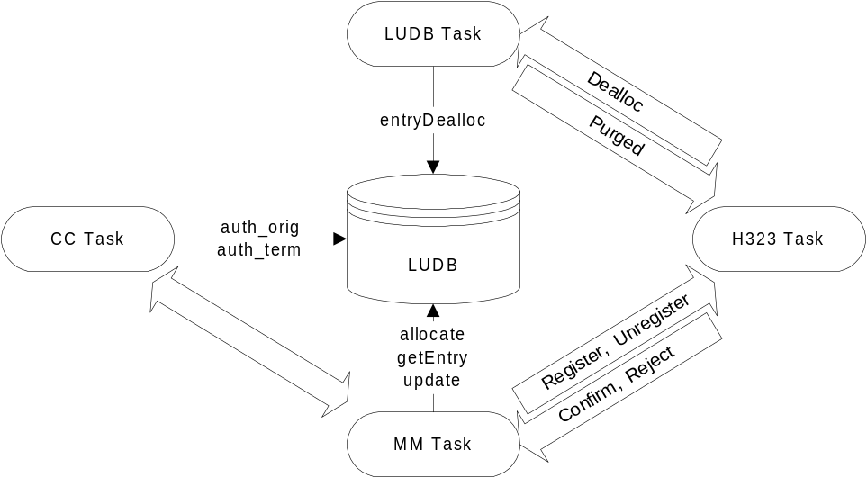

Figure 1. LUDB interaction with other tasks

In this document, the expansion on the subscriber information parameters that are transferred with the GUDB, is also focused. For ease of adaptation of GUDB subscriber information which will have similar coding scheme as GSM Mobile Application Part (MAP) specification, the information elements between LUDB and GUDB are derived from GSM VLR, HLR information parameters.
For the supporting ability of our system, we also have to consider the ViperCell as being the Serving GPRS Node (SGSN). For that matter, the consideration of parameters for GPRS is initiated here as well.

Mobility Management Related Operations
For Mobility Management functionality, it is desired to implement LUDB to provide following user information retrieved from GUDB.
- Authentication information
- Ciphering information
- Authorisation information on incoming/outgoing calls

Supplementary Services Related Opeartions
For Supplementary Services, it is desired to add information to the user information to support the services.
- Calling Line features
- Connected Line features
- Call Forwarding
- Call Waiting
- Call Hold
- Call Transfer
- Multiparty calls
- Call Barring Services
- Short Message Services

Document Structure
- The section 2 elaborates on the user information elements that are to be stored in LUDB. These information elements would be brought down from GUDB. These include non-GPRS specific data elements as well as GPRS specific data elements.
- The section 3 illustrates the design issue of the data structure of the database and the access methods.
- The section 4 illustrates the procedures done by Mobility Management Task related to the access of LUDB.
- The section 5 illustrates the procedures done by Call Control Task related to the access of LUDB.
- The section 6 illustrates transactions between LUDB and GUDB and the procedures done by H323 Task.
- The section 7 shows what to be considered when implementing LUDB.
- The section 8 shows for the future modification, what factors are to be observed for the necessity of changes.

References
GSM TS 03.03: “Digital cellular telecommunications system (Phase 2+); Numbering, addressing and identification”
GSM TS 03.08: “Digital cellular telecommunications system (Phase 2+); Organisation of subscriber data”
GSM TS 03.20: “Digital cellular telecommunications system (Phase 2+); Security related network functions”
GSM TS 04.08: “Digital cellular telecommunications system (Phase 2+); Mobile radio interface layer 3 specification”
GSM TS 09.02: “Digital cellular telecommunications system (Phase 2+); Mobile Application Part(MAP) specification”
JetCell IP PocketBTS: Layer 3 Software Design Document for Call Control, and Mobile Management

Glossary

Information Elements

The subscriber information retrieved from GUDB and stored in LUDB can be separated to two categories. One is the permanent subscriber data that is created for each subscriber at the time of subscription and also can be set or changed by the service provider or the subscriber. The other is the temporary subscriber data that can be set by the network automatically at the registration or call setup time.

Permanent Subscriber Data

International Mobile Subscriber Identity (IMSI)
IMSI is the unique identification of a mobile station in a PLMN network, which consists of:
- 3 digits of Mobile Country Code (MCC)
- 2 digits of Mobile Network Code (MNC)
- Not more than 10 digits of Mobile Subscriber Identification Number (MSIN).
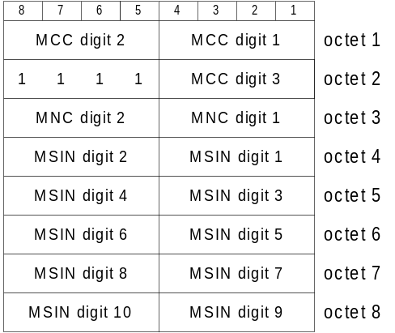

Mobile Station International ISDN Number (MSISDN)
MS International PSTN/ISDN number consists of:
- Up to 3 digits of Country Code (CC)
- Less than 15 digits of National significant mobile number which can be also broken down to National Destination Code (NDC) and Subscriber Number (SN)
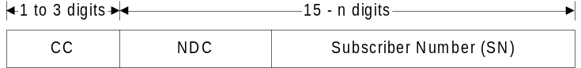

International Mobile Station Equipment Identification (IMEI)
The network can initiate IMEI check to MS for the security.
It consists of 15 digits of:
- 6 digits of Type Approval Code (TAC)
- 2 digits of Final Assembly Code (FAC)
- 6 digits of Serial Number (SNR)
- 1 digit of Spare

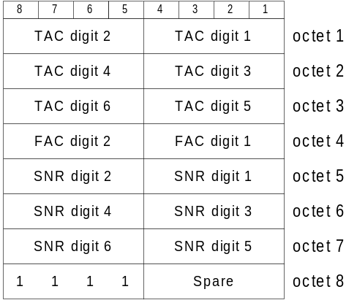

International Mobile Station Equipment Identification and Software Version Number (IMEISV)
IMEI may contain Software Version Number.
It consists of 15 digits of:
- 6 digits of Type Approval Code (TAC)
- 2 digits of Final Assembly Code (FAC)
- 6 digits of Serial Number (SNR)
- 2 digits of Software Version Number (SVN)
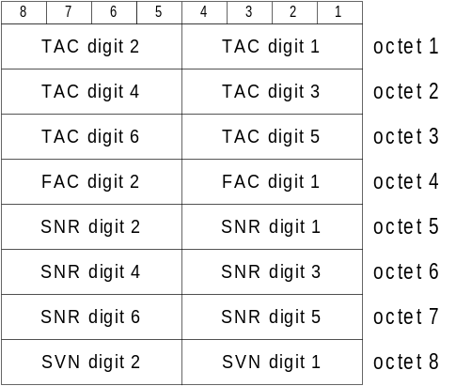

Provision of services
To update subscriber information in LUDB, GUDB sends subscribed service list to LUDB at the time of the location update or the subscription changes. These data are provided as Bearer Service List, Teleservice List, and Supplementary Service List. When LUDB sees that the ViperCell does not support some of the subscribed services, then it will respond back to ViperBase with an unsupported service list.

Provision of bearer service
The current plans for the supporting services are following.
Bearer Service Type | Service Number
9.6K bps, circuit switched, asynchronous, data | 26
14.4K bps?

Provision of teleservice
The current plans for the supporting services are following.
Teleservice Type | Service Number
Speech telephony | 11
Emergency calls | 12
Short message service(SMS) mobile terminated point-to-point (MT/PP) | 21
SMS mobile originated point-to-point (MO/PP) | 22
Alternate speech and facsimile group 3 | 61

Provision of supplementary service
The current plans for the supporting features are following.
Supplementary Service Type | Code
CLIP - Calling line identification presentation | 0x11
CLIR - Calling line identification restriction | 0x12
COLP - Connected line identification presentation | 0x13
COLR - Connected line identification restriction | 0x14
CFU - Call forwarding unconditional | 0x21
CFB - Call forwarding on mobile subscriber busy | 0x29
CFNRY - Call forwarding on no reply | 0x2A
CFNRC - Call forwarding on mobile subscriber not reachable | 0x2B
ECT - Call Transfer | 0x31
CW - Call waiting | 0x41
HOLD - Call hold | 0x42
MPTY - Multiparty | 0x51
BAOC - Barring of outgoing call | 0x92
BOIC - Barring of outgoing international call | 0x93
BOICE - Barring of outgoing international call except to HPLMN | 0x94
BAIC - Barring of incoming call | 0x96

Subscriber status flag
Indicates whether the subscriber is subject to operator determined barring.
Possible values are:
ServiceGranted (0)
OperatorDeterminedBarring (1)

Operator determined barring(ODB) Data
Which barring is subject to be applied to the subscriber can be corded as below:

ODB General Data
32 Bit Coding Value (high 16 reserved) | Information
0000 0000 0000 0001 | Barring of all outgoing calls.
0000 0000 0000 0010 | Barring of all outgoing international calls.
0000 0000 0000 0100 | Barring of all outgoing international calls except those directed to the home PLMN country.
0000 0000 0000 1000 | Barring of premium rate (information) calls.
0000 0000 0001 0000 | Barring of premium rate (entertainment) calls.
0000 0000 0010 0000
0000 0000 0100 0000 | Barring of all outgoing inter-zonal calls.
0000 0000 1000 0000 | Barring of all outgoing inter-zonal calls except those directed to the home PLMN country.
0000 0001 0000 0000 | Barring of all outgoing international calls except those directed to the home PLMN country AND barring of all outgoing inter-zonal calls.
0000 0010 0000 0000 | Barring of invocation of any call transfer.
0000 0100 0000 0000 | Barring of call transfer where at least one of the two calls is a call charged to the served subscriber.
0000 1000 0000 0000 | Barring of call transfer where at least one of the two calls is a call charged to the served subscriber at international rates.
0001 0000 0000 0000 | Barring of call transfer where at least one of the two calls is a call charged to the served subscriber at inter-zonal rates.
0010 0000 0000 0000 | Barring of call transfer where both calls are charged to the served subscriber

ODB HPLMN Data
32 Bit Coding Value (high 16 reserved) | Information
0000 0000 0000 0001 | Operator specific barring (type 1).
0000 0000 0000 0010 | Operator specific barring (type 2).
0000 0000 0000 0100 | Operator specific barring (type 3).
0000 0000 0000 1000 | Operator specific barring (type 4).

Foreign Subscriber Flag
A flag indicating the subscriber is foreign to the PLMN that the LUDB belongs to.

Temporary Subscriber Data

Random Number (RAND), Signed Response (SRES) and Ciphering Key (Kc)
LUDB should be able to retrieve Security Related Information from H.323 side
When these Security Related Information get exchanged between LUDB and the Gatekeeper, an array of Authentication Set of maximum size 5 is being used.
The Authentication Set consists of three following elements.
- RAND
- SRES
- Kc
SRES is generated using RAND and Ki by Algorithm 3.
Kc is generated using RAND and Ki by Algorithm 8.
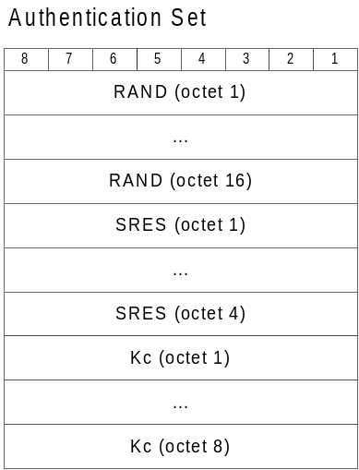

Ciphering Key Sequence Number (CKSN)
If a registered MS passing TMSI as its identification requests the location update, the CKSN with presumed valid Kc is used for verifying identity for the mobile station. It is compared with the CKSN that was sent by MS and if it matches, ciphering can be engaged with the Kc without authentication.
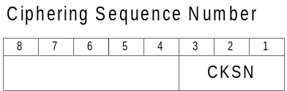
Bits 321
000
through 110 allocated by network
111 CKSN not available

Selected Ciphering Algorithm
Ciphering Algorithm that is selected for current ciphering.
Bits 8765 4321
- 0000 0001 No encryption
- 0000 0010 GSM A5/1
- 0000 0100 GSM A5/2
- 0000 1000 GSM A5/3
- 0001 0000 GSM A5/4
- 0010 0000 GSM A5/5
- 0100 0000 GSM A5/6
- 1000 0000 GSM A5/7

Current Kc
Current Kc is 8 octets value for current active subscriber. It is stored associated with CKSN, LAI, and TMSI.

VoIPHandle
VoIPHandle is the instance allocated by the H323 side when there is a mobile who is registered to the H323 side. LUDB stores this value when the corresponding mobile subscriber entry gets activated. H323 side issues this value upon the success of the registration procedure.

Mobile station status data

IMSI detached
LUDB Entry state will be changed to ‘Inactive’ when the mobile send IMSI detach message and the Unregistration procedure to the ViperBase succeeded. The mobile is noted then as “Unreachable”.

Data Structure

LUDB Table Entry
- Current Version (as of March 15, 1999) has following elements in the entry.
Variable name | Type of variable | Comment/Reference
mobileId | T_CNI_RIL3_IE_MOBILE_ID | 2.1.1 IMSI/TMSI/IMEISV
ClassmarkType | short
ClassmarkData | classmarkData_t
State | LUDBState
mobileHandler | VoIPMOBILE | 2.2.5 VoIPHandle
- Elements to be added
Variable name | Type of variable | Comment/Reference
msisdn |  | 2.1.2. MSISDN
BearerList |  | 2.1.5.1. Provision of bearer
TeleList |  | 2.1.5.2. Provision of teleservice
SsList |  | 2.1.5.3. Provision of supplementary services
SubsStatus  BarringList |  | 2.1.6. Subscriber Status Flag  2.1.7. Barring Flags
ForeignFlag |  | 2.1.8. Foreign Subscriber Flag
authSetList |  | 2.2.1. Authentication Set List
cksn |  | 2.2.2. CKSN
cipherCode |  | 2.2.3. Selected Ciphering
currKc |  | 2.2.4. Current Kc
mobileStatus |  | 2.2.6. Status Flags

LUDB Table

Structures
LUDB Table has an array of LUDB entries.
Maximum number of entries in the LUDB table is to be defined by a constant variable MaxNumLUDBEntry.

void LUDB::init()

Functionality Initializes all entries of the LUDB table by invoking LUDBEntry::init().

Allocation
LUDB entries are allocated when MM module tries to do Update Procedures and finds out that LUDB has no information regarding on the corresponding mobile station. MM initiates the LUDB entry allocation and gets subscriber information from the Gatekeeper side and updates database with it.

short LUDB::entryAlloc()

Functionality Searches for the free entry available for new allocation and marks it as “not free”.
Return Value ludbId: Returns the newly allocated entry index number in the LUDB table.
-1: No free entry available for the allocation.

Deallocation
Deallocation can be initiated from the Gatekeeper side by the Unregister Procedures. Also, old entries can be purged and reported to the Gatekeeper. In either case, we will have a LUDB maintenance task that calls actual entryDealloc function call.
An active entry becomes a candidate to be an inactive entry, after the entry has been marked as “active” for a certain amount of time. The time is to be defined as a constant variable ActiveToInactiveTime.
An inactive entry becomes a candidate to be purged, after the entry has been marked as “inactive” for a certain amount of time. The time is to be defined as a constant variable InactiveToPurgeTime.

void LUDB::entryDealloc(short i)

Functionality Initializes the LUDB entry by invoking LUDBEntry::init().

Access Methods
The LUDB entry index associated with a registered (active) subscriber can be retrieved by using two types of key values. One is mobile station identification type of IMSI, TMSI with LAI. The other is MSISDN.

short LUDB::getEntry(const T_CNI_RIL3_IE_MOBILE_ID& mobileID)

Functionality Searches through the LUDB table entries and find an entry which is marked as “not-free”, with a key of IMSI or TMSI with LAI.
Return Value ludbId: The index of the found entry from the LUDB Table
-1: Entry found but in inaccessible state
-10: Entry found with given TMSI doesn’t match LAI
-20: Entry not found with given IMSI
-21: Entry not found with given TMSI

short LUDB::getEntry(const T_MSISDN ???)

Functionality Searches through the LUDB table entries and find an entry which is marked as “not-free”, with a key of MSISDN.
Return Value ludbId: The index of the found entry from the LUDB Table
-22: Entry not found with given MSISDN

Changes and Updates
Currently, there are only changes on state and VOIPMobileHandler with given index.

void LUDB::update(const short index, const LUDBEntry::LUDBState state)

Functionality Changes state of the LUDB entry to the state given.

void LUDB::update(const short index, const VOIPMOBILE mobileHandler)

Functionality Stores the H.323 Mobile Handle in the LUDB entry.

void LUDB::update(const short index, const T_LUDB_SUBSC_INFO& subscInfo)

Functionality Stores the information regarding the subscription of the mobile station. This information presumably has been brought from the GUDB.

Retrieving Information
The related information about the subscriber can be retrieved from the LUDB directly.

LUDBEntry::LUDBState LUDB::getState(const short index)

Return Value state: The state of the LUDB entry with given index.

VOIPMOBILE LUDB::getMobileHandler(const short index)

Return Value VOIPmobile: The instance of the VOIP mobile handler with given index.

T_CNI_RIL3_IE_MOBILE_ID getMobileId(const short index)

Return Value mobileId: The mobileId type of IMSI or TMSI with given index.

LUDB and MM

MM Procedures with LUDB

Location Update

Location Update w/ entry not found
MM entry upon reception of Location Update Request from MS invokes LUDB::getEntry() with IMSI or TMSI as a key. If the corresponding LUDB entry is not found in LUDB table, the key value is sent to H323 side with allocated MM entry Id.
LUDB entry is also allocated by LUDB::entryAlloc() with status of waiting for Registration.
If the user information is valid in Gatekeeper database, H323 registration confirm is returned to MM.
Then MM updates the subscriber information on the entry by LUDB::update().

Location Update w/ entry found
MM entry upon reception of Location Update Request from MM invokes LUDB::getEntry() with IMSI or TMSI as a key. If the corresponding LUDB entry is found in LUDB table, LUDB::getEntry() function returns the index to the entry within LUDB table.
If the corresponding LUDB entry is found in LUDB table, and if marked as active, it doesn’t need to be registered in H323 side.
If the corresponding LUDB entry is found in LUDB table, and if not marked as active, the key value is also sent to H323 side for registration.

Location Update reject by Gatekeeper
If H323 side issues Reject on H323 registration request, the corresponding LUDB entry would not be created but the Location Update Reject message is sent to MS.

IMSI Detach
MM invokes LUDB::getEntry() upon reception of IMSI Detach requested by Mobile.
If the mobile id is not found in LUDB table, the message is ignored.
If the corresponding LUDB entry is found, H323 Unregister Request is sent to H.323 side.
If the H.323 side response with Unregistration Confirm, the LUDB entry is marked as Inactive.
If the H.323 side reject w/ reason of invalid mobile id, the LUDB entry should be cleared.

Identity Request
Upon call of LUDB::getEntry(), returned value indicates “IMSI wanted”, MM shall proceed Identity Request procedure and invokes LUDB::getEntry() with IMSI again.
IMSI will be wanted when LUDB::getEntry() is called with other key then IMSI type or mobile identification.

Authentication
MM will initiate Authentication procedure after it retrieved the user profile from LUDB or from H.323.
The user profile information should contain following elements for this purpose.
- Authentication Set List
- Current Kc.
- CKSN corresponding to an IMSI.

Ciphering
Upon Authentication Response, MM will initiate Ciphering Mode engagement.
The user profile information should also contain following elements for this purpose.
Selected Ciphering Algorithm

Messages between LUDB and MM
For current design of “passive” database of LUDB access, MM will invoke functions directly to issue inquiry to the database elements with keys or manipulation of the elements in the database entries.

LUDB and CC

CC Procedures with LUDB

Authorisation
Upon call origination or call termination, CC initiates LUDB to grant the call proceeding based upon the user information against the calling party number or called party number.
This can be done with similar methods as described in GSM 09.02 sub-clause 8.

Messages between LUDB and CC
For current design of “passive” database of LUDB access, CC will invoke functions directly to issue inquiry to the database elements with keys or manipulation of the elements in the database entries.

LUDB and GUDB

Procedures with LUDB

Unregister Request from GUDB
ViperBase may initiate the procedure that deallocates LUDB entry directly, by sending Unregister Request message to LUDB Task, then LUDB Task will call LUDB::Dealloc().

Subscriber Information from GUDB
A copy of Subscriber Information is sent from GUDB to LUDB Task directly when
- Mobile does the location update and consequently MM Task issues registration to ViperBase.
- The subscription data is changed and need to refresh the copy in the LUDB.

Subscriber Information Message

Message Structure
Subscriber Information will have following structure.

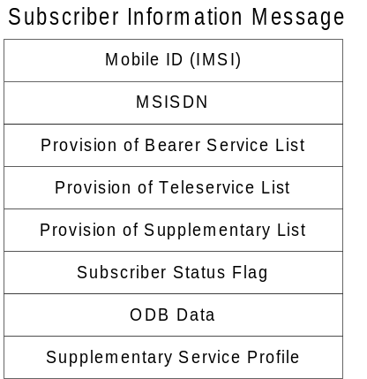
Each element of Information will have following contents.

Mobile ID (IMSI)
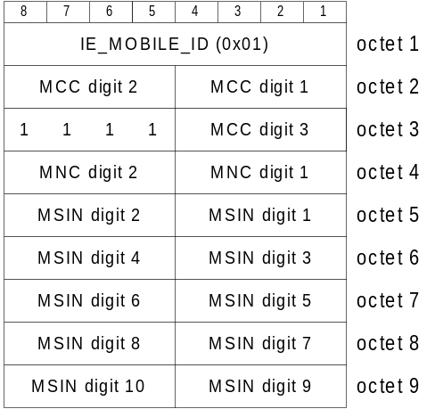

MSISDN
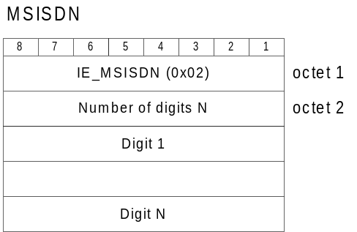
See 2.1.2 for detailed information.

Provision of Bearer Service List
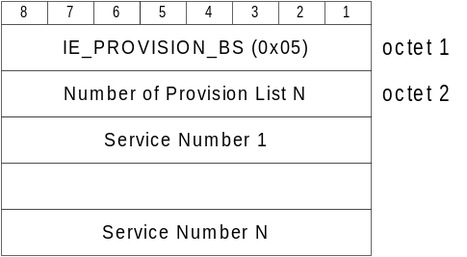
See 2.1.5.1 for detailed Service Number.

Provision of Teleservice List
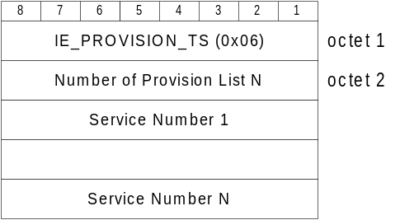
See 2.1.5.2 for detailed Service Number.

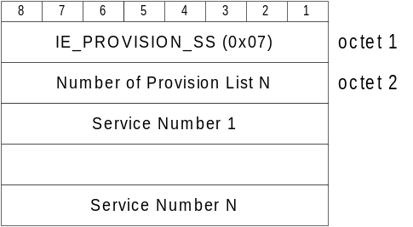Provision of Supplementary Service List

See 2.1.5.3 for detailed Service Number.

Subscriber Status

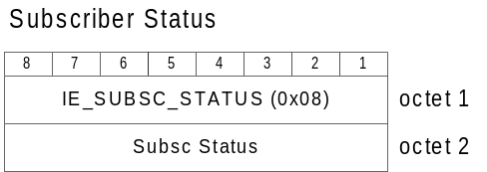
See 2.1.6 for detailed value.

ODB Data
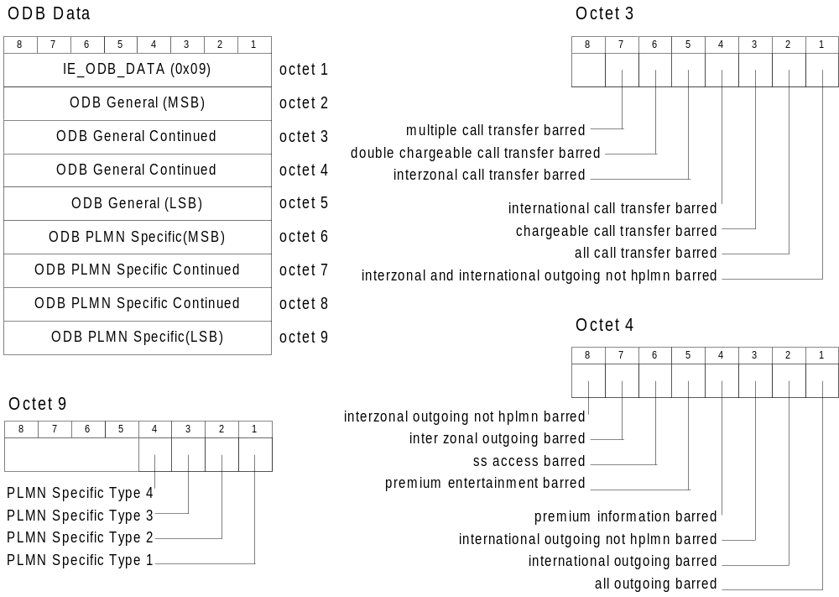
See also 2.1.7.1 and 2.1.7.2 for detailed values

Supplementary Service Profile
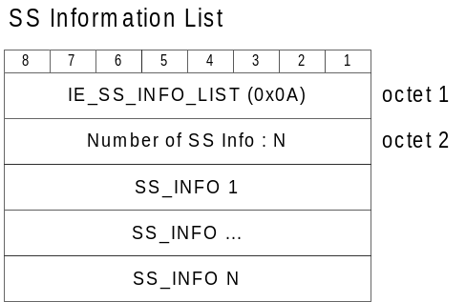
Each SS_INFO element can be
- Call forwarding information
- Call barring information

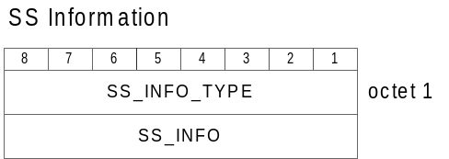
Call forwarding information is one of SS_INFO element as follows.

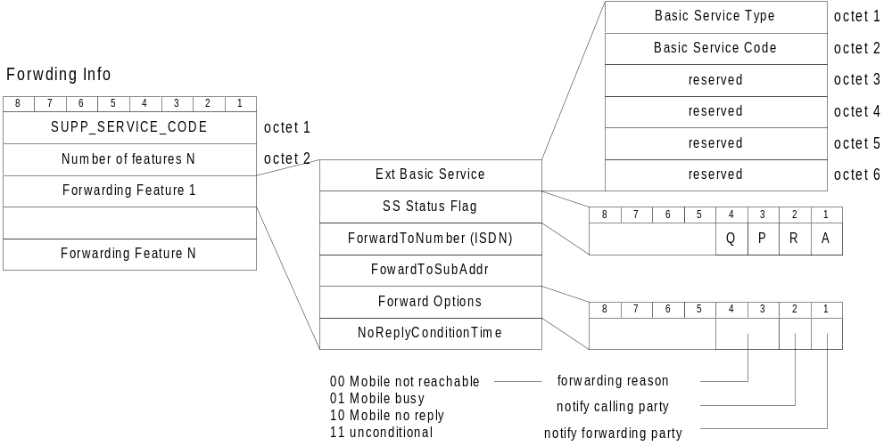
Call barring information is other SS_INFO element as follows.
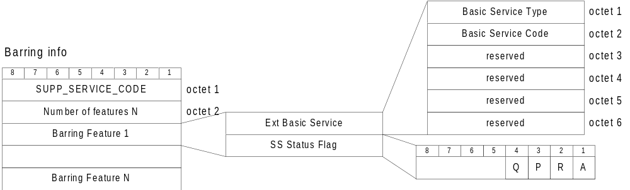

Security Information

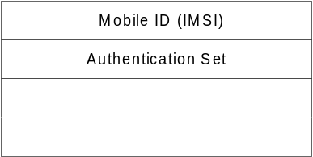
See also 2.2.1 for detailed values.

Implementation Consideration

The GUDB on ViperBase need to be incorporated with Public PLMN network, which means the GUDB will communicate with outer network HLR. For that, GUDB will utilise MAP in this communication. We may be able to implement altered form of the information elements for the internal operation between LUDB and GUDB. However it is desirable to implement the same coding scheme as MAP elements so the conversion effort can be minimal.
The subscriber information can be modified through ViperBase configuration program or interface. However it is desired to have subscriber management package separated from configuring ViperBase itself.

Future Modification

