QAD (Quantum Aided Design)

Introduction
The idea of QAD is to add QGIS of all CAD commands for editing geometries in an professional way.

Work philosophy
QAD has a different logic by QGIS and closer to popular CAD software.
To reduce learning time, QAD is inspired to the most popular CAD. This manual assumes that you have already the knowledge of the most popular CAD environment and commands. Otherwise use the appropriate documentation (there is a large amount of manuals) or search the command on internet.
QAD commands haven’t the same options as those of the most popular CAD since QGIS context is different (usually graphical options), some commands have more options. This manual describes only the options not present in the corresponding most popular CAD commands.
The current reference system of the project must be a projected coordinate system and not a geographic system.

Layer
QAD supports all types of vector layers of QGIS with a distinction regarding the point layer. In fact, QAD manage layers of QGIS distinguishing between symbols layers and text layers. The first displays symbols while the second displays texts.
The text layer is a layer that displays labels only. It is a QGIS point layer with the following characteristics:
- the symbol must have a minimum of 90% transparency
- must have a label
Layers that are not textual will be considered as symbol layers.

Text layer model:
The text layer must have the following fields:
- a character field to store text
Optional fields:
- a real number field to store the text height (map unit)
- a real number field to store text rotation (degree counterclockwise where zero = horizontal to the right)
The textual layer must be defined with labels set as follows:
- the size can be read from a real number field that stores the text height (in map units, tab <Labels>-<Text>, if set than the TEXT command will ask for it)
- the rotation can be read from a real number field that stores text rotation (degree counterclockwise where zero = horizontal to the right), <Preserve data rotation values> option enabled (tab <Labels>-<Placement>, if set than the TEXT command will ask for it)

Symbol layer model:
The symbol layers may have the following optional fields:
- a real number field to store the symbol rotation (degree counterclockwise where zero = horizontal to the right)
- a real number field to store the symbol scale
The symbol layer can be defined with a style set as follows:
- If you decide to handle the rotation or scale of symbols then the <Symbology>-<Single Symbol> option and <Symbology>-<Size>-<map units> option must be enabled
- The rotation could be read by a real number field that stores the symbol rotation through the formula "360-<field that stores the rotation>" (degree counterclockwise where zero = horizontal to the right, <Symbology>-<Rotation>-<Expression>, if set than the INSERT command will ask for it)
- The scale can be read by a real number field that stores the scale of the symbol (<Symbology>-<Size>-“ field that stores the scale”, if set than the INSERT command will ask for it)

Arcs and circles
QAD supports approximating arcs and circles in small segments.
- For arcs the number of these segments depends on TOLERANCE2APPROXCURVE and ARCMINSEGMENTQTY variables (minimum number of segments to be used for the approximation)
- For circles the number of these segments depends on TOLERANCE2APPROXCURVE and CIRCLEMINSEGMENTQTY variables (minimum number of segments to be used for the approximation)

Maximum approximation error

OSNAP
The F3 key activates/deactivates the osnap mode.
Since QAD version 3.0.4 osnap will be run on the snap layers enabled by QGIS (current layer, all layers, only snap selected layer).
To change the osnap mode:
- When a command ask for a point press CTRL + right mouse button to choose a different snap mode.
- When a command ask for a point type in the text window:
"NONE" = no snap
"END" = endpoints of each segment
"END_PL" = endpoint of the entire polyline
"MID" = midpoint
"CEN" = center (centroid)
"NOD" = point object
"QUA" = quadrant point
"INT" = intersection
"INS" = insertion point
"PER" = perpendicular point
"TAN" = tangent
"NEA" = closest point
"APP" = apparent intersection
"EXT" = Extension
"PAR" = Parallel
"INT_EXT" = intersection on extension
"PR" = progressive distance (may be followed by a number to set a progressive distance different from default)
- Using the setvar command to set the OSMODE variable with a combination a bit using the following schema:
0 = None
1 = endpoint
2 = midpoint
4 = center (centroid)
8 = point object
16 = quadrant point
32 = intersection
64 = insertion point
128 = perpendicular point
256 = tangent
512 = closest point
1024 = clear all object snaps
2048 = apparent intersection
4096 = extension
8192 = parallel
16384 = osnap disabled
65536 = progressive distance
131072 = intersection on extension
2097152 = endpoints of the entire polyline
- Run DSETTING command

How to specify a point
The coordinates of a point can be expressed using the following syntax:
- x,y
- @length<angle (from the previous point you move to a distance using an angle)
- @ x,y (from the previous point you move to a distance in the X axis and to another distance in the Y axis)
- @ (previous point)
- length (from the previous point you move to a distance using the current mouse position)
- Coordinate specified in a coordinate reference system different from the current one

Coordinate specified in a coordinate reference system different from the current one
If the coordinate reference system is projected:
enter x,y (SRID). For example 1491621.64817, 4915622.63154 (EPSG:3003) is a point with coordinate X=1491621.64817 and Y=4915622.63154 in the projected coordinate reference system EPSG:3003
If the coordinate reference system is geographic:
enter latitude, longitude (SRID). For example 44º 24' 48N/ 08º 50' 15E (EPSG:4326) is a point with latitude 44 degrees 24 minutes 48 seconds and longitude 6 degrees 50 minutes 15 seconds in the geographic coordinate reference system EPSG:4326.
Latitude and Longitude values can be set using the following notations:
- Decimal Degrees (DDD) - In this notation, decimal precision is set in the 'degree' coordinate. For example, 49.11675953666N
- Degrees, Minutes, and Seconds (DMS) - In this notation, decimal precision is set in the 'seconds' coordinate. For example, 49 7'20.06"N
- Degrees, Minutes with Decimal Seconds (DMM) - In this notation, decimal precision is set in the 'minutes' coordinate. For example, 49 7. 3343333"N. (Here, 20.06 seconds above is divided by 60 to get the decimal minute value for 20.06 seconds.)
Latitude and Longitude syntax is specified as follows:
- Numeric Values - Simply separate each coordinate notation with a white space and the entry will be recognized correctly. For example, you can indicate a DMS notation as: 37 24 23.3. You could indicate a DMM notation as 49 7.0055722.
You can also use the character (°) for degrees, the single quote mark (') for minutes and the double quote mark (") for seconds, as follows: 49°7'20.06"
- Direction Notation (North/South, East/West)
Use 'N', 'S', 'E', or 'W' to indicate direction. The letter can be entered either upper or lower case and it can be placed before or after the coordinate value. For example: N 37 24 23.3 is the same as 37 24 23.3 N
You can also use the minus sign (-) to indicate a westerly or southerly position. When you use this kind of notation, do not specify a letter symbol. Additionally, you do not need to use a plus sign (+) to indicate northerly/easterly directions. So, for example this is a valid entry: 37 25 19.07, -122 05 08.40
- Entering Latitude, Longitude Pairs
When entering latitudinal or longitudinal pairs, the first coordinate is interpreted as latitude unless you use a direction letter to clarify (E or W). For example, you can enter longitude first as: 122 05 08.40 W 37 25 19.07 N
However, you cannot use the minus sign to enter longitude first:-122 05 08.40 37 25 19.07
You can separate pair entries with a space, a comma, or a slash: 37.7 N 122.2 W or 37.7 N,122.2 W or 37.7 N/122.2 W

DYNAMIC INPUT
You can turn off dynamic input temporarily by holding down the F12 key. Dynamic input provides a command interface near the cursor in the drawing area.
Run DSETTINGS command to set dynamic input properties.

Selecting objects
When a command ask to select the objects (usually with the message "select objects") you can type the letter "H" for Help to show all options.
The <WCircle> and <CCircle> options select respectively objects that are Inside/intersecting a circle and objects only inside a circle.
The <WObjects> and <Cobjects> options select respectively objects that are Inside/intersecting existing objects and objects only inside existing objects.
The <FBuffer> and <IBuffer> options select respectively objects that are Inside/intersecting a buffer and objects only inside a buffer.

Dimensioning
Dimension style is a set of properties that determine the appearance of dimensions. These properties are stored in files with the extension .dim and are loaded on QAD startup or on loading a project. Dimension files must be saved in the current project folder or in the QAD installation folder (i.e. For QGIS 3 in windows "C:\Users\current use\AppData\Roaming\QGIS\QGIS3\profiles\default\python\plugins\qad").
QAD stores the elements constituting a dimension in 3 different layers:
- Text layer for storing dimension text
- Symbol layers to store punctual dimension objects (dimension points, arrow symbols ...)
- Linear layers to store linear dimension objects (dimension line, extension lines ...)

Text layer model for dimensioning:
The main element of a dimension is the text. Its textual layer must have the following fields:
- a character field to store the dimension text
- a character field to store the font Of the dimension text
- a real number field to store the dimension text height (in map unit)
- a real number field to store text rotation (degree counterclockwise where zero = horizontal to the right)
Optional fields:
- an integer number field to store the unique ID of the dimension
This field is required if you want to group the objects of the same dimension and implement the erasing and editing features of an existing dimension. Because it must be a unique value field, actually, it is supported for PostGIS table only where you have to create a serial type not null field which is the primary key of the table. (i.e. “id”). In addition to this you have to create another bigint type field which will be managed by QAD to store the dimension ID (i.e. “dim_id”). Shape files don’t let QAD group objects of the same dimension so, after drawing a dimension, every objects will be independent each one from the other.
- a character field to store the color of the dimension text
- a character field to store the dimension style name (required if you want to use the editing features of an existing dimension)
- a character field (2 characters) to store the dimension style (linear, aligned ...) according to the following scheme:
"AL" = linear aligned dimension
"AN" = angular dimension
"BL" = baseline and continued dimension
"DI" = diameters of arcs and circles dimension
"LD" = creates a line that connects annotation to a feature
"LI" = dimensions using only the horizontal or vertical components of the locations
"RA" = radial dimension
"AR" = measure the length along a circle or arc
(required if you want to use the editing features of an existing dimension)
An SQL example to create a PostGIS table and indexes for dimension text:
CREATE TABLE qad_dimension.dim_text
(
id serial NOT NULL,
text character varying(50) NOT NULL,
font character varying(50) NOT NULL,
h_text double precision NOT NULL,
rot double precision NOT NULL,
color character varying(10) NOT NULL,
dim_style character varying(50) NOT NULL,
dim_type character varying(2) NOT NULL,
geom geometry(Point,3003),
dim_id bigint NOT NULL,
CONSTRAINT dim_text_pkey PRIMARY KEY (id)
)
WITH (
OIDS=FALSE
);

CREATE INDEX dim_text_dim_id
ON qad_dimension.dim_text
USING btree
(dim_id);

CREATE INDEX sidx_dim_text_geom
ON qad_dimension.dim_text
USING gist
(geom);

The textual layer must be defined with labels as follows:
- The font must be read from a field that stores the font character of the dimension text (tab <Labels>-<Text>)
- The size must be read by a real number field that stores the dimension text height (in map units, tab <Labels>-<Text>)
- The rotation must be read by a real number field that stores the dimension text rotation (degree counterclockwise where zero = horizontal to the right), option <Preserve data rotation values> activated, (tab <Labels>-<Placement>)
- Placement <Around point> with distance = 0 (tab <Labels>-<Placement>)
- <Show all label for this layer> option enabled (tab <Labels>-<Rendering>)
- <Show upside-down labels> option with value <always> (tab <Labels>-<Rendering>)
- <Features act as obstacles> option disabled (tab <Labels>-<Placement>)
Optional settings:
- The color can be read from a character field that stores the dimension text color (tab <Labels>-<Text>)

Symbol layer model for dimensioning:
The dimension symbols (arrows, etc.) should be stored in a layer with the following fields:
- a real number field to store dimension text rotation (degree counterclockwise where zero = horizontal to the right, use expression “360-rotation_field”)
Optional fields:
- a character field to store the symbol name
- a real number field to store the symbol scale
- a character field (2 characters) field to store the punctual object type according to the following scheme:
"B1" = first arrow block ("Block 1")
"B2" = second arrow block ("Block 2")
"LB" = leader arrow block ("Leader Block")
"AB" = arc symbol ("Arc Block")
"D1" = dimension point 1
"D2" = dimension point 2
(required if you want to use the editing features of an existing dimension)
- an integer number field to store the unique ID of the dimension (necessary if you want to group the objects of a dimension, and implement the erasing and editing features of an existing dimension)
An SQL example to create a PostGIS table and indexes for dimension symbol:
CREATE TABLE qad_dimension.dim_symbol
(
name character varying(50),
scale double precision,
rot double precision,
color character varying(10),
type character varying(2) NOT NULL,
id_parent bigint NOT NULL,
geom geometry(Point,3003),
id serial NOT NULL,
CONSTRAINT dim_symbol_pkey PRIMARY KEY (id)
)
WITH (
OIDS=FALSE
);

CREATE INDEX dim_symbol_id_parent
ON qad_dimension.dim_symbol
USING btree
(id_parent);

CREATE INDEX sidx_dim_symbol_geom
ON qad_dimension.dim_symbol
USING gist
(geom);

The symbol layer must be defined with a style set as follows:
- <Simbology>--<Single Symbol> option enabled
- <Simbology>-<Size>-<map units> option enabled
- Set the size of the symbol so that the width of the arrow is 1 map unit (tab <Simbology><Size>).
To get the proper size value, try to insert a symbol and measure its width. Change the size until the width is 1.
In the following example the layer simbology uses the symbol “filled_arrowhead” with size = 2.
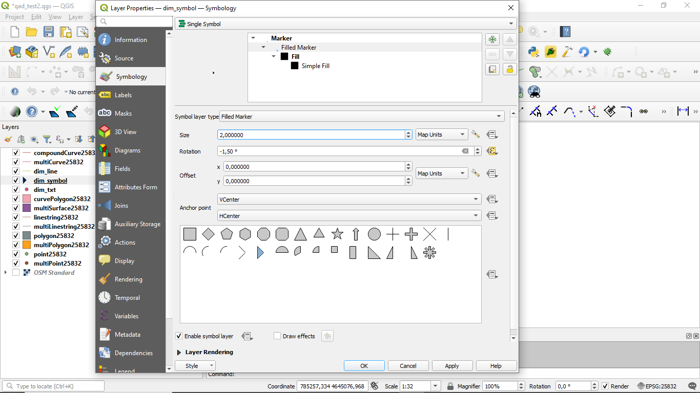
Inserting that symbol using size = 2 the width results in 1 map unit (using “measure line” tool)
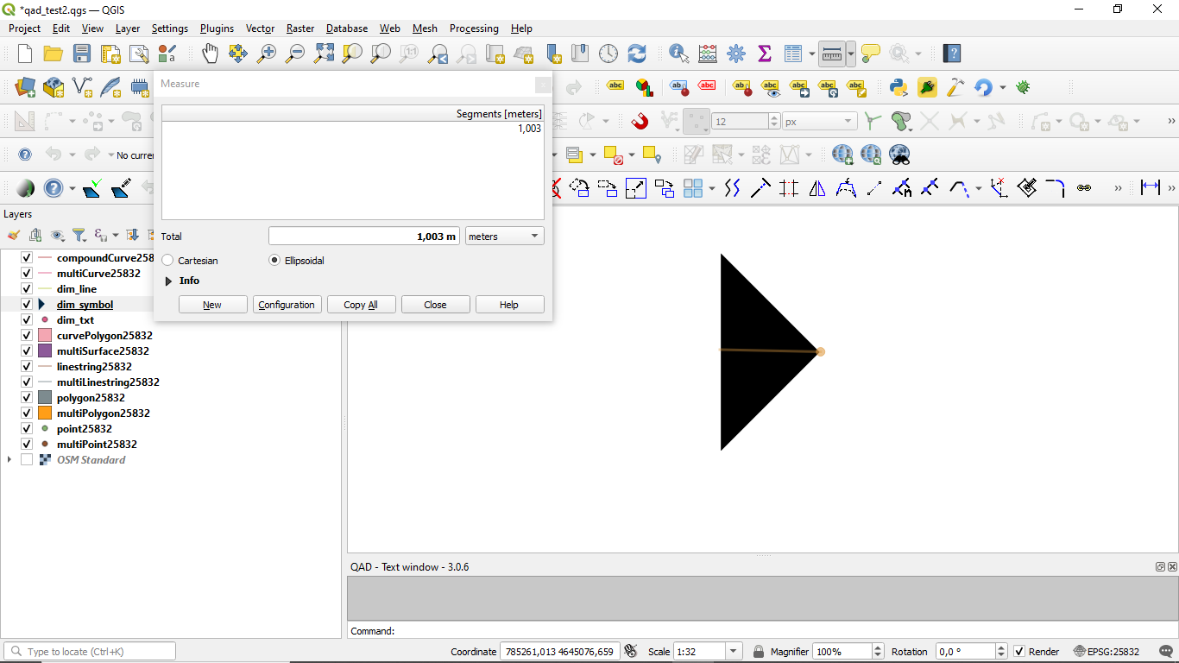

- The rotation must be read by a real number field that stores the symbol rotation through the formula "360-<field that stores the rotation>" (degree counterclockwise where zero = horizontal to the right, <Simbology>- <rotation>-<Expression>)
- The scale can be read by a real number field that stores the scale of the symbol (<Symbology>-option <Size>-<Expression>:
coalesce(“the size of the symbol so that the width of the arrow is 1 map unit“ * “field that stores the scale”,0)
The arrow symbol when inserted with rotation = 0 must be horizontal with the arrow pointing to the right and its insertion point should be on the tip of the arrow.

Linear layer model for dimensioning:
Linear elements of a dimension (dimension line, extension lines ...) must be stored in a linear layer with the following fields:
- No mandatory fields
Optional fields:
- a character field to store the color of the dimension lines
- a character field to store the linetype of the dimension lines
- a character field (2 characters) field to store the linear object type according to the following scheme:
"D1" = Dimension line 1
"D2" = Dimension line 2
“X1” = Extension of dimension line 1
“X2” = Extension of dimension line 2
"E1" = Extension line 1"
"E2" = Extension line 2
"L" = leader line when the text is outside the dimension
“CL” = Center line for center marker of an arc or circle
(required if you want to use the editing features of an existing dimension)
- an integer number field to store the unique ID of the dimension (necessary if you want to group the objects of a dimension, and implement the erasing and editing features of an existing dimension)

An SQL example to create a PostGIS table and indexes for dimension lines:
CREATE TABLE qad_dimension.dim_line
(
line_type character varying(50),
color character varying(10),
type character varying(2) NOT NULL,
id_parent bigint NOT NULL,
geom geometry(LineString,3003),
id serial NOT NULL,
CONSTRAINT dim_line_pkey PRIMARY KEY (id)
)
WITH (
OIDS=FALSE
);

CREATE INDEX dim_line_id_parent
ON qad_dimension.dim_line
USING btree
(id_parent);

CREATE INDEX sidx_dim_line_geom
ON qad_dimension.dim_line
USING gist
(geom);

The linear layer must be defined with the style set as follows:
Optional settings:
- The color can be read from a character field that stores the dimension line color
- The linetype can be read from a character field that stores the linetype of dimension lines

Dimension commands refer to the current dimension style. To set the current dimension style run DIMSTYLE command.

Commands customization
It is possible customize the commands (shortcuts) by a file named qad_<language>_<region>.pgp (utf-8).
<language> is the current QGIS language (mandatory) and <region> is the current linguistic region (optional). For example qad_pt_br.pgp is the file in portuguese language of region Brazil, qad_en.pgp is the English version of the pgp file. The file is searched by QAD following the paths in the system variable SUPPORTPATH.

Commands
The commands are activated by menu VECTOR->QAD or toolbar or command line. The commands and their options can be specified in English by prefixing the character "_" to the name (e.g. _ LINE) regardless of the language used in QGIS.
QAD command can be interrupted at any moment by the activation of another tool. To resume the paused command and make active the QAD environment use the QAD item in the QAD menu or press the button  in the toolbar.
As you type the name of a command QAD will display a list of commands that begin with what has been written Typing "*" the list of all QAD commands will appear.
To choose an option, type the capital letters for this option or click on the option that you want.

ARC
Draw an arc.

ARRAY
Creates copies of objects arranged in a pattern.

ARRAYPATH
Evenly distributes object copies along a path or a portion of a path.

ARRAYPOLAR
Evenly distributes object copies in a circular pattern around a center point.

ARRAYRECT
Distributes object copies into any combination of rows and columns.

BREAK
Breaks the selected object.

CIRCLE
Draws a circle.

COPY
Copies one or more objects.

DIMALIGNED
Draws an aligned dimension.

DIMARC
Draws a length arc dimension.

DIMLINEAR
Draws a linear dimension.

DIMRADIUS
Draws a radial dimension.

DIMSTYLE
Creates, modifies, compare dimensioning styles. It sets the current dimensioning style.

DIVIDE
Creates evenly spaced punctual objects along the length or perimeter of an object.

DSETTINGS
Set some properties to draw.

ERASE
Erases one or more objects.

EXTEND
Extends one or more objects.

FILLET
Rounds and fillets the edges of existing object.

HELP
Displays the QAD manual.

ID
It shows the coordinate of the specified position.

INSERT
Inserts a symbol. If the symbol scale is derived from a field then the command will ask the factor scale. If the symbol rotation is derived from a field than the command will ask the rotation (degree). Only for symbol layer.

LENGTHEN
Lengthen an object.

LINE
Draws a line.

MAPMPEDIT
It modifies the selected polygon geometry.
- The <Add> option adds an existing geometry to the selected polygon (e.g. a ring).
- The <Delete> option deletes a geometry to the selected polygon (e.g. a ring).
- The <Union> option modifies the geometry of the selected polygon with the result of the union of the same geometry with a group of polygon.
- The <Subtract> option modifies the geometry of the selected polygon with the result of the subtraction of the same geometry with a group of polygon.
- The <Intersect> option modifies the geometry of the selected polygon with the result of the intersection of the same geometry with a group of polygon.
- The <split Objects> option modifies the geometry of the selected polygon by dividing it into 2 or more independent objects using a cutting polyline drawn by the user.
- The <split Parts> option modifies the geometry of the selected polygon by dividing it into 2 or more parts of the same object using a cutting polyline drawn by the user.
- The <include Objs> option modifies the geometry of the selected polygon to include the geometries of a group of objects.
- The <Undo> option undoes the last operation.

MBUFFER
Draws a buffer around the selected objects. Select the objects and specify the buffer width.

MEASURE
Creates punctual objects at measured intervals along the length or perimeter of an object.

MIRROR
Creates a mirrored copy of selected objects.

MOVE
Moves the selected objects.

MPOLYGON
Draws a polygon using the same options of the PLINE command.

OFFSET
Draws concentric circles, parallel lines and arcs.

OPTIONS
Customizes the program settings.

PEDIT
Modifies a polyline. The <Simplify> option asks for a tolerance value used to simplify the geometry.

PLINE
Draws a polyline. The <Trace> option is used to trace an existing object. During the digitizing, point to any point of an existing object to trace, select the <Trace> option and select the same object in the final trace point.

POLYGON
Draws a regular polygon. After specifing the center, the <Area> option calculate the polygon.

RECTANGLE
Draws a rectangle.

REDO
Redo the changes undone by the UNDO command.

ROTATE
Rotate the selected objects.

SCALE
Scale the selected objects.

SETCURRLAYERBYGRAPH
Sets the current layer selecting an object.

SETCURRUPDATEABLELAYERBYGRAPH
Sets edit mode to the layers of the selected objects. If you specify only one layer it becomes the current one.

SETVAR
Lists or modifies the values of QAD variables. Once specified the QAD variable name, a short decription and the type of the variable value (real, integer, character, boolean) is shown.

STRETCH
Stetches the selected objects.

TEXT
Inser a text. If the height text is derived from a field then the command will ask the text height. If the text rotation is derived from a field then the command will ask the rotation (degree). At the end the command will ask the value of the text. Only for textual layer.

TRIM
Trims the selected objects.

UNDO
Undo changes made by QAD.
QAD commands that create, modify or erase objects affect all visible and editable layers, and not only the current layer as QGIS does. That's why QAD uses its undo/redo system that operates on all layers involved into QAD commands
If the user will run the Undo/Redo command of QGIS, QAD will lose alignment with the history of the changes made by its commands and then the undo/redo stack will be cleared.

Grip mode
You can drag grips to perform any stretch, move, rotate, scale, or mirror operations.
The editing operation you choose to perform is called a grip mode.
Grips are small, solid-filled squares that are displayed at strategic points on objects that you have selected with a pointing device. You can drag these grips to stretch, move, rotate, scale, or mirror objects quickly.
When grips are turned on, you can select the objects you want to manipulate before entering a command, and then you can manipulate the objects with the pointing device.
Note: Grips are not displayed on objects that are on locked layers.
To copy the selected object, press and hold the Ctrl key while you’re manipulating it.
To Edit Objects Using Grips:
- Select the object to edit.
- Select and move grips to stretch the object.
Note: In the case of some object grips, for example, symbol or text reference grips, stretch will move the object rather than stretch it.
- Press Enter, Spacebar or right-click to cycle to the move, rotate, scale, or mirror grip modes.
- Hover over a grip to view and access the multifunctional grip menu (if available).

System variables
System variables are settings that control how certain commands work. They can be integer, real, char, bool or RGB color type (i.e. “#FF0000”).
A variable is called “global” when its value doesn’t change when the current project change. These variables are saved and loaded into the QAD.INI file located in the installation folder.
A variable is called “project” when its value change when the current project change. These variables are saved and loaded into <current project name>_QAD.INI file of the current QGIS project folder.

APBOX
The same as the most popular CAD. Global variable.

APERTURE
The same as the most popular CAD. Global variable.

ARCMINSEGMENTQTY
Minimum number of segments to approximate an arc. Valid values from 4 to 999, integer type, default value 12. Project variable.

AUTOSNAP
The same as the most popular CAD. Global variable.

AUTOSNAPCOLOR
Color of the snap markers. Global variable.

AUTOSNAPSIZE
Dimension of the snap markers in pixel. Global variable.

AUTOTRACKINGVECTORCOLOR
Color of the autotrack vector. Global variable.

CIRCLEMINSEGMENTQTY
Minimum number of segments to approximate a circle. Valid values from 6 to 999, integer type, default value 12. Project variable.

CMDHISTORYBACKCOLOR
Command history background color. Global variable.

CMDHISTORYFORECOLOR
Command history text color. Global variable.

CMDINPUTHISTORYMAX
The same as the most popular CAD. Global variable.

CMDLINEBACKCOLOR
Active prompt background color. Global variable.

CMDLINEFORECOLOR
Active prompt color. Global variable.

CMDLINEOPTBACKCOLOR
Command option keyword background color. Global variable.

CMDLINEOPTCOLOR
Command option keyword color. Global variable.

CMDLINEOPTHIGHLIGHTEDCOLOR
Command option highlighted color. Global variable.

COPYMODE
The same as the most popular CAD. Global variable.

CROSSINGAREACOLOR
The same as the most popular CAD. Global variable.

CURSORCOLOR
Cross pointer color. Valid values are valid RGB colors, color type, default value red =“#FF0000”. Global variable.

CURSORSIZE
The same as the most popular CAD. Global variable.

DELOBJ
It controls whether the original geometry is retained or removed. Global variable.
0 = All defining geometry is retained.
1 = Deletes all defining geometry.
-1 = Displays prompts to delete all defining geometry.

DIMSTYLE
The same as the most popular CAD. Project variable.

DYNDIGRIP
Turns Dynamic Input features on and off. Global variable.
0 = None.
1 = Resulting dimension.
2 = Length change dimension.
4 = Absolute angle dimension .
8 Angle change dimension.

DYNDIVIS
The same as the most popular CAD. Global variable.

DYNEDITFORECOLOR
Set the dynamic input text color (RGB). Global variable.

DYNEDITBACKCOLOR
Set the dynamic input background text color (RGB). Global variable.

DYNEDITBORDERCOLOR
Set the dynamic input border color (RGB). Global variable.

DYNMODE
The same as the most popular CAD. Global variable.

DYNPICOORDS
The same as the most popular CAD. Global variable.

DYNPIFORMAT
The same as the most popular CAD. Global variable.

DYNPIVIS
Controls when pointer input is displayed. Global variable.
1 = Automatically at a prompt for a point
2 = Always

DYNPROMPT
The same as the most popular CAD. Global variable.

DYNTOOLTIPS
The same as the most popular CAD. Global variable.

DYNTRECKINGVECTORCOLOR
Set the Autotreck vector color (RGB). Global variable.

EDGEMODE
The same as the most popular CAD. Global variable.

FILLETRAD
The same as the most popular CAD. Project variable.

GRIPCOLOR
The same as the most popular CAD. Global variable.

GRIPCONTOUR
The same as the most popular CAD. Global variable.

GRIPHOT
The same as the most popular CAD. Global variable.

GRIPHOVER
The same as the most popular CAD. Global variable.

GRIPMULTIFUNCTIONAL
Specifies the access methods to multi-functional grips. Global variable.
0 = Access to multi-functional grips is disabled.
2 = Access multi-functional grips with the dynamic menu and the Hot Grip shortcut menu.

GRIPOBJLIMIT
The same as the most popular CAD. Global variable.

GRIPS
The same as the most popular CAD. Global variable.

GRIPSIZE
The same as the most popular CAD. Global variable.

INPUTSEARCHDELAY
The same as the most popular CAD. Global variable.

INPUTSEARCHOPTIONS
The same as AUTOCOMPLETEMODE system variable of the most popular CAD. Global variable.

MAXARRAY
The same as the most popular CAD. Global variable.

OFFSETDIST
The same as the most popular CAD. Project variable.

OFFSETGAPTYPE
The same as the most popular CAD. Project variable.

ORTHOMODE
The same as the most popular CAD. Project variable.

OSMODE
The same as the most popular CAD. Global variable.

OSPROGRDISTANCE
Progressive distance for <Progressive distance> snap mode. Real type, default value 0. Project variable.

PICKADD
The same as the most popular CAD. Global variable.

PICKBOX
The same as the most popular CAD. Global variable.

PICKBOXCOLOR
Sets the object selection target color. Global variable.

PICKFIRST
The same as the most popular CAD. Global variable.

POLARANG
The same as the most popular CAD. Global variable.

POLARMODE
The same as the most popular CAD. The value 4 is not supported (use additional polar tracking angles). Global variable.

SELECTIONAREA
The same as the most popular CAD. Global variable.

SELECTIONAREAOPACITY
The same as the most popular CAD. Global variable.

SUPPORTPATH
Searching path for support files. Character type. Global variable.

SHOWTEXTWINDOW
Show the text window at startup. Bool type, default value true. Global variable.

TOLERANCE2APPROXCURVE
Maximum error approximating a curve to segments. Valid values from 0.000001, real type, default value 0.1. Project variable.

TOOLTIPTRANSPARENCY
Sets the transparency for drafting tooltips. Valid values from 0 to 100. Global variable.

TOOLTIPSIZE
Sets the display size for drafting tooltips, and dynamic input text. Valid values from -3 to 6. Global variable.

WINDOWAREACOLOR
The same as the most popular CAD. Global variable.

