Plots

To download R: <https://www.rstudio.com/products/rstudio/download/>

If that does not work, some people found that this link was working instead:

<http://archive.linux.duke.edu/cran/>

Please graph the 3 plots in either R or Matlab. Remember that there will be a latitude, a longitude and a count value. Please graph and comment on the 3 graphs.

R Studio:

Code:

dataset_example = read.csv("dataset_example.csv");

install.packages("scatterplot3d")

require("scatterplot3d")

scatterplot3d(dataset_example[3:5])

Notes:

If you are having trouble reading the dataset and it is having trouble use the import dataset button to import the dataset manually.

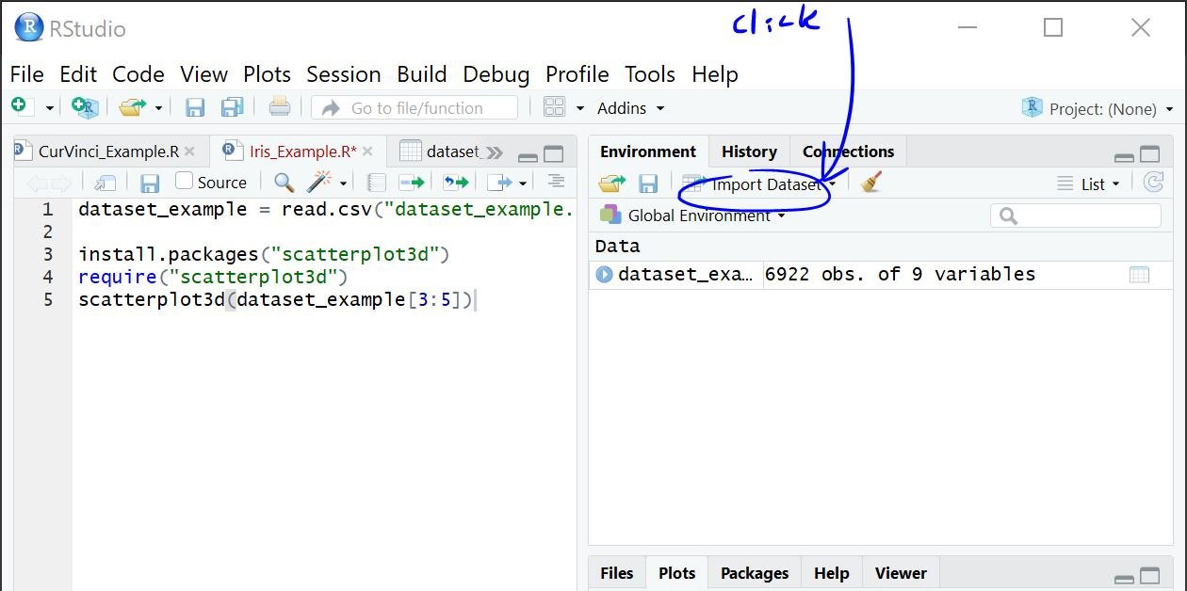

Press => from Text (base)

Go and download scatterplot3d library from internet and download on desktop.

Link: <https://cran.r-project.org/web/packages/scatterplot3d/index.html>

Chose the Windows or OSX downloads on the page and unzip file.

Then run code

Plots should look like:

(This is what the dataset_example_3 looks like)

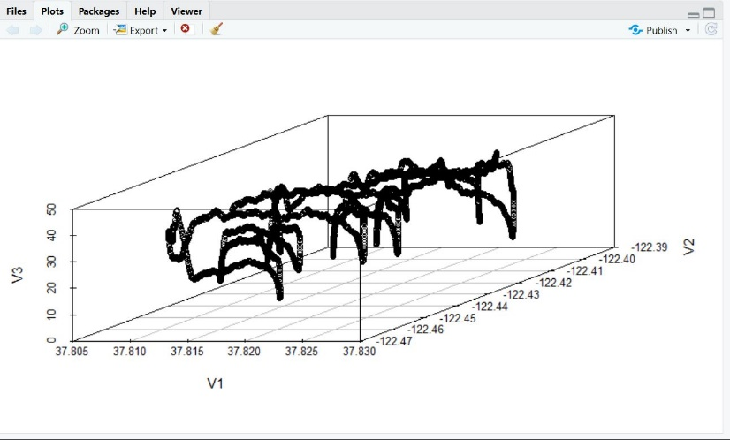

Matlab

Either sign up for the free trial or use R if you don’t already have Matlab

Code:

A=load('dataset_example.csv');

B=A(:,3);

C=A(:,4);

D=A(:,5);

E=A(:,7);

F=A(:,8);

G=A(:,9);

figure

plot3(B,C,D);

hold on;

plot3(E,F,G);

hold on;

grid on;

Notes:

This will create a 3d plot of specific values from the dataset.

If you have Matlab, simply save the csv file in your Matlab’s directory and proceed with the code.

When plotting dataset_example you should come up with a graph like this:

(This is plotting two of the paths with values on the same graph to look at the differences in the paths.

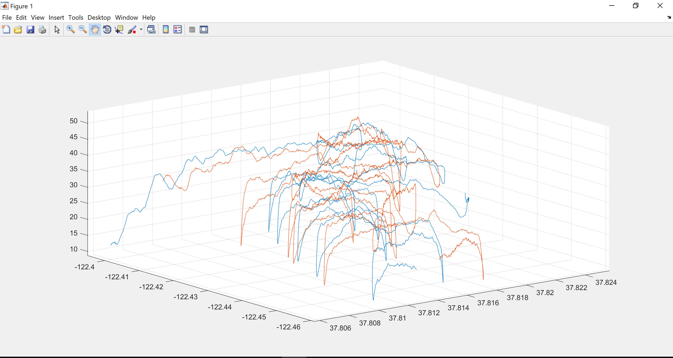

*Don’t forget to provide the picture of the graph you plotted and the analysis beneath.

Research Component

Please research and take note of what alpha, beta, and gamma radiation are. Answer the Following questions:

Gamma Rays

What is a gamma ray?

What are their energy range?

Example of radioactive isotopes that emit gamma rays?

What can it penetrate?

Beta Particles

What is a beta particle?

What are their energies?

Example of radioactive isotopes that emit beta particles?

What can it penetrate?

Alpha Particles

What is an alpha particle (include components and masses)?

What are their energies?

Example of radioactive isotopes that emit alpha particles?

What can it penetrate?

Charge?

*Make sure to site your sources.

Planning

Write up a plan in which you will collect your data and learn more about the Geiger counters to enhance your data collection and allow you an easy way to format and record the data.