**CHAPTER 1**

**INTRODUCTION**

* 1. **Background**

Computers have brought up a revolutionary change in the past couple of decades. They are everywhere now and are being used by everyone. Most of our day-to-day jobs are being influenced by the use of computers. They play vital role in our daily life owing to facilities it provides which are beyond our imagination. The new generation computer technology is expanding and surrounding humans and computers communicating as naturally as a human with other human. The technology in user-interfaces (UI) has changed to gesture interface, capturing the motion of our hands and controlling the devices is more natural and realistic. Human Computer Interfaces (HCIs) support users to interact or simply control any kind of devices founded on machinery basis. This Human-Computer Interaction (HCI) is a field in which the developer makes a user friendly system. Very simple and common interfaces are represented by mouse and keyboard by which a user interacts with the personal computer machine. Computer and software manufacturers have noticed the importance of making computers “user-friendly”: easy to use, save people time, etc.

**1.2 Motivation**

Many of us suffer from backache and some of us RSI (Repetitive Strain Injury) as we relentlessly pound the keys and squeeze the mouse for hours on end. Remarkably, most of us put up with these problems. Researchers have known for years that pointing, clicking and dragging are not ideal forms of interaction for many tasks.

**1.3 Objectives**

The objective of this project is to design the wearable, real time and user friendly device for human computer interaction. The details of objective are

1. To read the data from flex sensors and accelerometer.

2. To process the data on ARM processor.

3. To display action taken out by the hand glove on LCD

4. To send the action signals wirelessly to computer.

5. To perform respective operation at computer

**CHAPTER 2**

**LITERATURE SURVEY**

The conventional interfaces for human computer interaction are mouse and keyboard by which a user interacts with the personal computer machine. But user relentlessly pounds the keys and squeezes the mouse for hours on end. Due to such continuous use of mouse and keyboards user may suffers from pain in forearm due to repeated pressure on the wrist and/or elbow. Also user may suffer from Repetitive Strain Injury (RSI) affecting the right shoulder and back.

Traditional computer mouse were wired. Now in days wireless mouse is available. But even though it is wireless it will cause aches and pains. Many types of human computer interaction systems have been developed in the last few years such as tablet computers that use stylus-based interaction on a screen, multi touch sensitive touch screen tablets. But they do not provide wireless interactions. Also speech recognition systems are better but make errors due to background noise and therefore are less efficient.

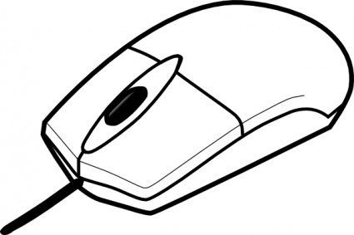 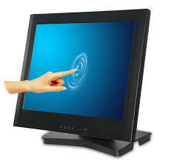

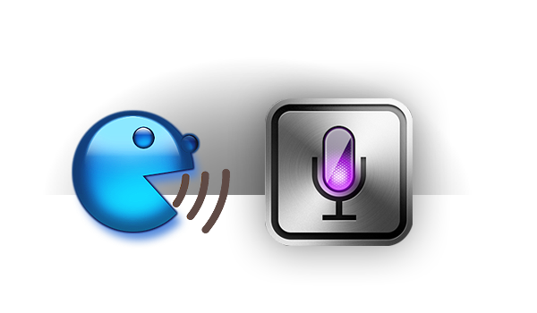

Fig. 2.1 Traditional ways of interacting with computers[Reference internet]

[1]Researchers have been trying to break away from traditional modes of interaction. A history of studies over the past 30 years suggests that Gesture Controlled User Interfaces (GCUI) now provide realistic and affordable opportunities, which may be appropriate for older and disabled people. The worst affected class of physically challenged are those who have become paralyzed over a significant percentage of their bodies, i.e. quadriplegics. These people find it extremely difficult to perform any task that require even small amount of force.

[2]Joshua R. New Knowledge systems Laboratory Jacksonville State University Jacksonville proposed a method of temporal hand gesture recognition. Ongoing efforts at his laboratory have been aimed at developing techniques that reduce the complexity of interaction between humans and computers. In particular, he have investigated the use of a gesture recognition system to support natural user interaction while providing rich information content. He present additions to a platform independent, gesture recognition system which previously tracked hand movement, defined orientation, and determined the number of fingers being held up in order to control an underlying application. The additions provide the functionality to determine a temporal gesture, such as movement of the hand in a circle or square. This technique have proven to replace the common “clickfest” of many applications with a more powerful, context-size, and natural interface.

[3]Hand gesture recognition systems Research on hand gestures can be classified into three categories. The first category, glove based analysis, employs sensors (mechanical or optical) attached to a glove that transduces finger flexions into electrical signals for determining the hand posture. The relative position of the hand is determined by an additional sensor. This sensor is normally a magnetic or an acoustic sensor attached to the glove. For some data glove applications, look-up table software toolkits are provided with the glove to be used for hand posture recognition. The second category, vision based analysis, is based on the way human beings perceive information about their surroundings, yet it is probably the most difficult to implement in a satisfactory way. Several different approaches have been tested so far. One is to build a three-dimensional model of the human hand. The model is matched to images of the hand by one or more cameras, and parameters corresponding to palm orientation and joint angles are estimated. These parameters are then used to perform gesture classification. A hand gesture analysis system based on a three-dimensional hand skeleton model with 27 degrees of freedom was developed by Lee and Kunii. They incorporated five major constraints based on the human hand kinematics to reduce the model parameter space search. To simplify the model matching, specially marked gloves were used. The third category, analysis of drawing gestures, usually involves the use of a stylus as an input device. Analysis of drawing gestures can also lead to recognition of written text.

The proposed device is wearable hand glove unit due to which user will not require keeping or putting a hand over a mouse and wrist on a mouse pad. Therefore this wearable hand glove unit will avoid aches and pains.

The proposed device will provide wireless interaction with computer and due to simple gestures it will achieve user friendliness.

**CHAPTER 3**

**SYSTEM ARCHITECTURE**

**3.1 Block Diagram**

LCD

FLEX SENSORS INPUT

ARM7

XBEE

MAX232

ACCELEROMETER

POWER SUPPLY

XBEE

PERSONAL COMPUTER

Fig. 3.1 Block diagram of proposed system

**CHAPTER 4**

**PROPOSED SPECIFICATIONS**

**4.1 Component Specifications**

**1.Flex Sensor**

**Features and Technical Specifications**

|  |  |
| --- | --- |
| **Parameter** | **Specifications** |
| Flat Resistance | 10KΩ |
| Resistance Tolerance | ±30% |
| Bent Resistance Range | 60KΩ to 110KΩ |
| Power Rating | 0.5W continuous , 1W peak |
| Temperature Range | -35º to +80º C |

Table no.5.1: Flex sensor specifications

We have used flex sensor to measure the bending of finger. There are two types of sensors depending on the application to be performed.

a) Flex sensor 2.2 ̋

b) Flex sensor 4.5 ̋

The sensor which we are using is flex sensor 2.2 ̋

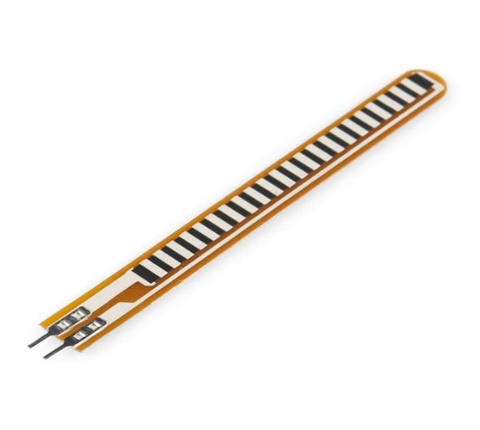

Fig. 3.2(a) Flex Sensor[Internet]

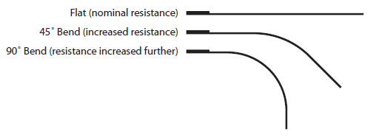

Fig.3.2(b) Change in resistance of flex sensor depending on the bend[Internet]

**2. Zigbee Module**

**Features and Technical Specifications**

* True single-chip 2.4 GHz IEEE 802.15.4 compliant RF transceiver with baseband modem and MAC support
* DSSS baseband modem with 2 MChips/s and 250 kbps effective data rate.
* Suitable for both RFD and FFD operation
* Low current consumption (RX: 18.8 mA, TX: 17.4 mA)
* 5.Low supply voltage (2.1 – 3.6 V) with integrated voltage regulator
* Low supply voltage (1.6 – 2.0 V) with external voltage regulator
* Programmable output power
* No external RF switch / filter needed
* I/Q low-IF receiver
* 10.I/Q direct upconversion transmitter
* 11.Hardware MAC encryption (AES-128)
* 12.Battery monitor
* 13. QLP-48 package, 7x7 mm

Bluetooth and Zigbee is very similar having low power consumption, low cost. But the range of zigbee is greater than that of bluetooth.

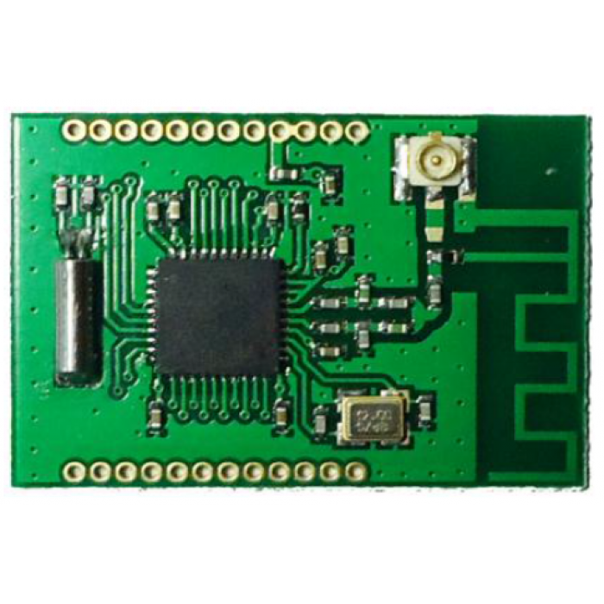

Fig. 3.4 Zigbee Module [Interent]

**3. Accelerometer**

**Features and Technical Specifications**

|  |  |
| --- | --- |
| **Parameter** | **Specifications** |
| Measurement Range | ±3g |
| Power | 350µA typical |
| Operating Voltage Range | 1.8V to 3.6V |
| Temperature Range | -40º to +85º C |

Table no.5.2: Accelerometer sensor specifications

The two modules of accelerometer we considered were

a) ADXL335

b) ADXL345

Both are 3-axis accelerometer. The ADXL335 is preferred by us because the maximum gravity measured by it is ±3g which is more than sufficient for our application, rather than going for ADXL345 which is having maximum gravity measured till ±16g.

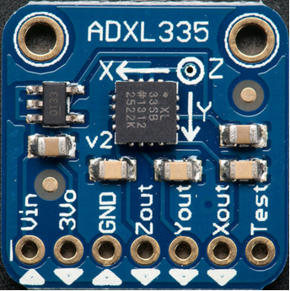

Fig. 3.6(a) Accelerometer Sensor[Internet]

**4. Processor used: ARM 7 LPC2148FBD64**

**Features and Technical Specifications**

|  |  |
| --- | --- |
| **Parameter** | **Specifications** |
| Flash Program Memory | 512 KB |
| SRAM Data Memory | 32 KB |
| I/O Pins | 45 |
| Timers | Two 32-bit |

Table 5.3 LPC 2148 Specifications

* 64-pin High-Performance ARM Microcontroller.
* A/D Converter: 10-bit Fourteen Channels.
* DAC: 10-bit.
* Real-Time Clock (RTC): Independent Power and Dedicated 32kHz Input.
* I²C: Two Modules with Master or Slave Operation.
* SPI: Full Duplex Serial Operation.
* UART: Two Modules.
* USB: 2.0B Fully Compliant Controller with RAM.
* External Oscillator: Upto 25 MHz with integrated PLL for 60MHz operation.

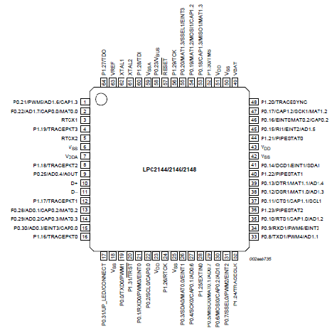

Fig. 3.5 Pin diagram of LPC 2148[5]

**5.LCD Display**

LCD display will display the actions taken out by hand glove unit.

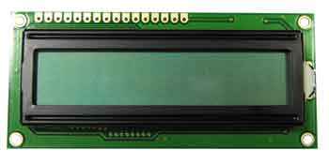

Fig. 3.7 LCD 16 X 2[Internet]

**Interface Pin Connection**

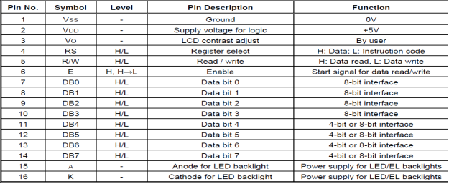

Table no. 3.1 LCD Pin Configuration [Internet]

**4.2 Project Specifications**

1. Device will work up to the range of 40m i.e. distance between glove and computer.
2. It can perform various operations of mouse like right click, left click, dragging the objects.
3. If the object is selected it can also increase or decrease the size of the object
4. Weight of the glove is also limited up to 200 gram.
5. Flexibility will also be very large as compared to other mouse like devices.

**CHAPTER 5**

**Design Details**

To read the data from flex sensors and accelerometer.

To process the data on ARM processor.

To display action taken out by the hand glove on LCD

To send the action signals wirelessly to computer directly from ARM Processor via Zigbee Module

v via Zigbee Module

To perform respective operation at computer

**Flowchart**

**Test Results**

**Conclusion**

**CONCLUSION**

This project will give us a more sophisticated method for human computer interaction. In this we have completed coding as well as the hardware implementation, in step by step manner ,the results were verified by our technical guide -------------.

Various project specification i.e. the weight ,distance as well as other component specification has been according to the company requirement of product .The designing as well as implementation is done in the manner so that it can challenge the similar working devices like mouse,speech recognition etc.

Now a days devices like wireless mouse and speech recognition is mostly used but it has various drawback like in mouse it needs plain surface for its working also it causes acne and paining after long use and in case of speech recognition there is large amount of errors also it has limited area of accessibility.

Thus this project provide a device which can be used by the person with certain disability of eye as well a handicap person as well as a normal person with ease ,with less number of drawbacks with real time human computer interaction.

**CHAPTER 6**

**PROJECT PLAN**

|  |  |
| --- | --- |
| AUGUST 2015 | Literature survey and finalizing the project |
| SEPTEMBER 2015 | Block diagram and component specification**.** |
| OCTOBER 2015 | Component Purchase and Testing of Components |
| NOVEMBER 2015 | PCB Layout designing |
| DECEMBER 2015 | Software assembly and Mounting of component |
| JANUARY 2016 | Circuit Testing along with result generation |
| FEBRUARY 2016 | Report writing and Conclusion |

Table no. 6.1 :Project Plan

**CHAPTER 7**

**FUTURE SCOPE**

* GESTURE ADDITION

More gestures recognition can be added in the system to improve the efficiency and practicality of the system.

* HELPFUL FOR DISABLED PERSON

Can be very helpful for disabled persons, as we can incorporate all the signs of the sign language by using same gesture or similar gesture.

* USE OF CAMERA

A camera module can be added to increase the accuracy of the project, which will use DIP (Digital Image Processing).

* USE OF INERTIAL MEASUREMENT UNIT(IMU)

Using IMU to get directions more accurately for all the motions of the hand.

* USING PLUG & PLAY

Implementing plug and play, by making the driver for the hardware.

**REFERENCES**

1. Moniruzzaman Bhuiyan, “Gesture Recognition and Control”. International Journal on Recent and Innovation trends in Computing and Communication.
2. Joshua R., New Knowledge Systems and Laboratory Jacksonville State University. International Journal on Recent and Innovation trends in Computing and Communication.
3. Prashant Chaudhary, G. R. Phulay, Ravindra Patil, “A Review on Hand Gesture Recognition System”. International Journal of Advanced Research in Computer Engineering and Technology (IJARCET), January 2013.

### Kumar P; Rautaray S.S; Agrawal A. “Hand data glove: A new generation real-time mouse for Human-Computer Interaction.” International Conference on Recent Advances in Information Technology (RAIT), 15-17 March 2012.

### Wan, Silas; Nguyen, Hung T. “[Human computer interaction using hand gesture](http://ieeexplore.ieee.org/xpl/articleDetails.jsp?tp=&arnumber=4649672&queryText%3DHuman+Computer+Interaction+using+Hand+Gesture).” 30th Annual International Conference of the IEEE Engineering in Medicine and Biology Society, 20-25 Aug. 2008

### Jonathan Grudin,“Three faces of human-computer interaction.” Annals of the History of Computing, IEEE Volume: 27, 5 December 2005