- Arithmetic techniques
Overview
The study of arithmetic techniques is fundamental to understanding how microprocessors manipulate numbers. This can be seen in the following concept map.
Microcomputer operation (concept map)
Objectives
At the completion of this module you will be able to:
- demonstrate the arithmetic for binary addition and subtraction
- describe the complements system and its use in both decimal and binary arithmetic
- show how the complements system is used with positive and negative numbers; and
  - Binary arithmetic
Let’s take a closer look at the binary system and the rules governing mathematical operations. From previous work we recall for addition, the rules are:
 |  | 0 | + | 0 | = | 0
 |  | 0 | + | 1 | = | 1
 |  | 1 | + | 1 | = | 0 | plus a carry of 1 to the next highest column
1 | + | 1 | + | 1 | = | 1 | Plus a carry of 1 to the next highest column

Consider now an example showing binary addition.
    - Example 1, addition
Add the following numbers in both binary and decimal form: 13₁₀ + 10₁₀.
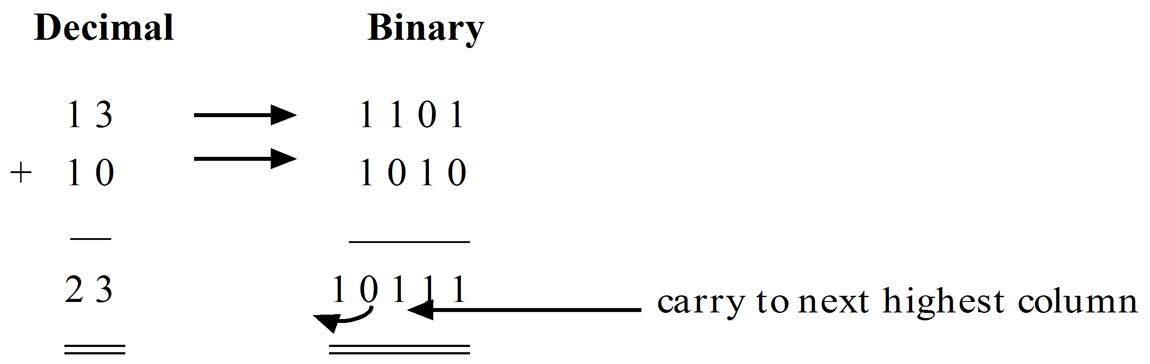
For subtraction the rules are:
0 | – | 0 | = | 0
1 | – | 0 | = | 1
1 | – | 1 | = | 0
0 | – | 1 | = | 1 | With a borrow of 1 from the next highest column

Consider an example showing binary subtraction.
    - Example 2, subtraction
Subtract the following numbers in both binary and decimal form: 14₁₀ – 11₁₀.
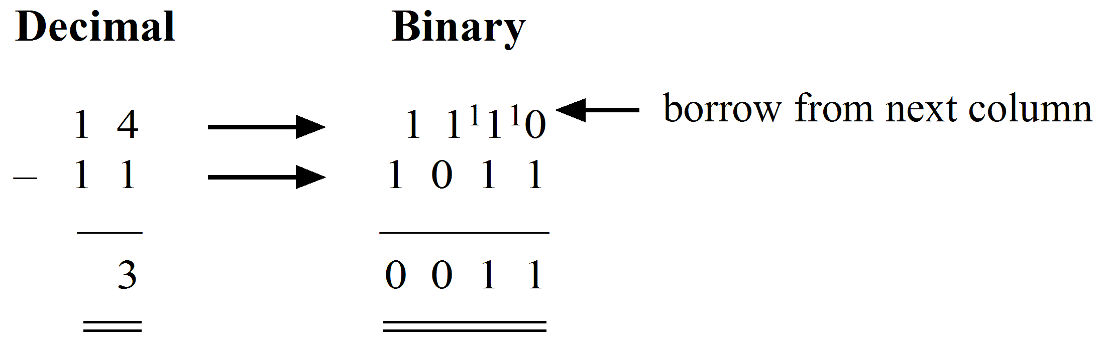
  - Complements arithmetic
The complements system of arithmetic is used in most computer systems as it permits logic manipulation easily. The true complement of a number is obtained by subtracting successively each digit of the number from another number which is the (appropriate base –1) and then adding a 1 to the least significant digit, (LSD).
- The true complement of a decimal number is called the ten’s complement.
- The true complement of a binary number is called the two’s complement.
    - Example 1, decimal complements
Find the true complement of 57₁₀.
Using the previous definition we have:
(appropriate base for decimal numbers – 1) = 10₁₀ – 1 = 9₁₀
 | 99
– | 57
 | ---
 | 42
 | +1 | add 1 to the LSD
 | ---
 | 43

Therefore 43₁₀ is the true complement of 57₁₀
We note this result could be obtained directly by subtracting 57 from 100, however as you will see later it is more convenient to use this method when using digital logic to perform these functions.
    - Example 2, binary complements
Find the true complement of 10101₂.
(appropriate base for binary numbers - 1) = 10₂ - 1 = 1₂
 | 11111
– | 10101
 | -------
 | 01010 | Note: this is the inverse of the number to be complemented
 | + 1 | add 1 to the LSD
 | -------
 | 01011

Therefore 01011₂ is the true complement of 10101₂
To simplify the above process, for binary numbers, the true complement is found by inverting the each binary digit and adding 1 to the LSD.
Inverting the digits we have, | 01010
Adding 1 to the LSD we have, | 00001
The true complement is:

Note if we do not add the 1 to the LSD we obtain: |  | - the nines complement for decimal numbers
 | and | - the ones complement for binary numbers

  - Subtraction by addition using true complements
The most important use of complemented numbers is that they can be used to perform subtraction by addition. This technique is used in all computers as it is more convenient to use a logic adder than a subtractor.
    - Modular number systems
To perform subtraction by addition, using true complements, it is helpful to understand modular number systems. That is, a number system that consists of a finite number of elements. The modulus of a function was first introduced in module 5 where it was used to describe binary counters. The modulus of a counter was defined as the number of input pulses for one complete count cycle. Similarly, a modular number system counts to a maximum number then returns to zero, repeatedly.
For example, the odometer in a car may count to 99 999 kilometres then return to 00 000, in a similar way a clock counts to 12 then returns to 1. Both are modular number systems; the odometer having a modulus of 100 000; and the clock a modulus of 12.
If, in the examples 6.2.1 and 6.2.2 you add the complement to the original number the result will be the modulus.
The subtraction by addition process can be illustrated graphically by assuming we have two numbers A and B on which the operation A – B is to be performed.
Let the two numbers be represented by two arc segments of appropriate length around a circle. The circumference of the inner circle represents the modulus of the particular number system. The right-hand diagram shows that B plus the complement of B is equal to the modulus.
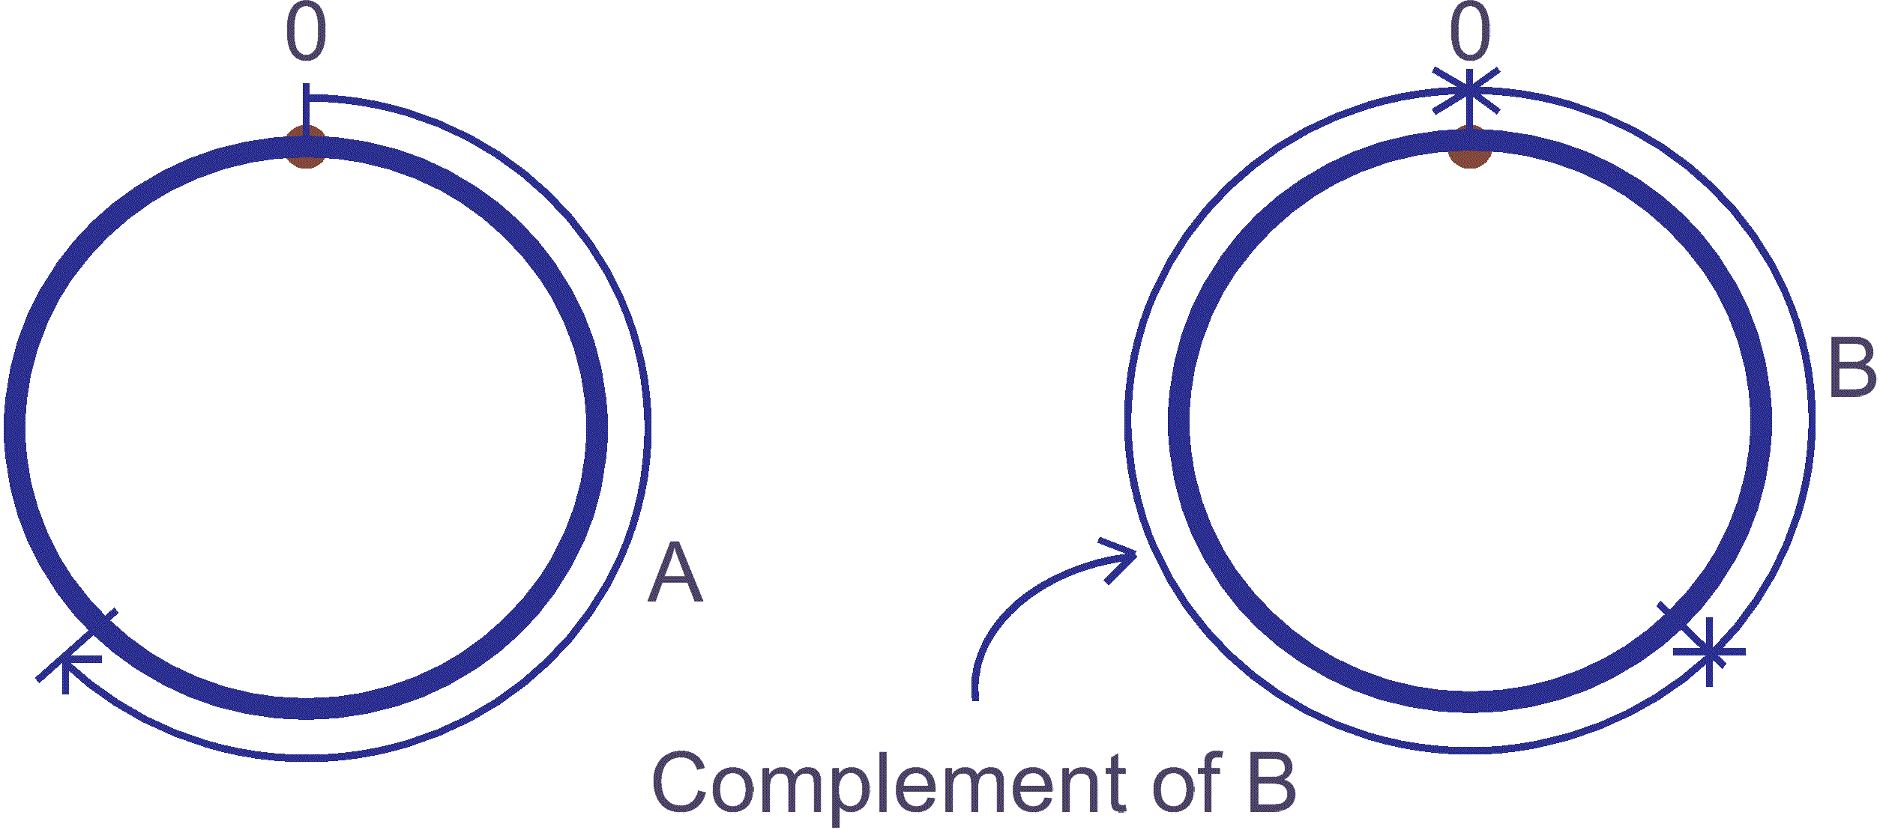
The next two diagrams depict A-B using normal arithmetic on the left, and A-B where the true complement of B is added to A, i.e. A+(-B) on the right. To obtain the correct result the modulus (one complete circle) is ignored, so the outer arc represents the result of A-B.
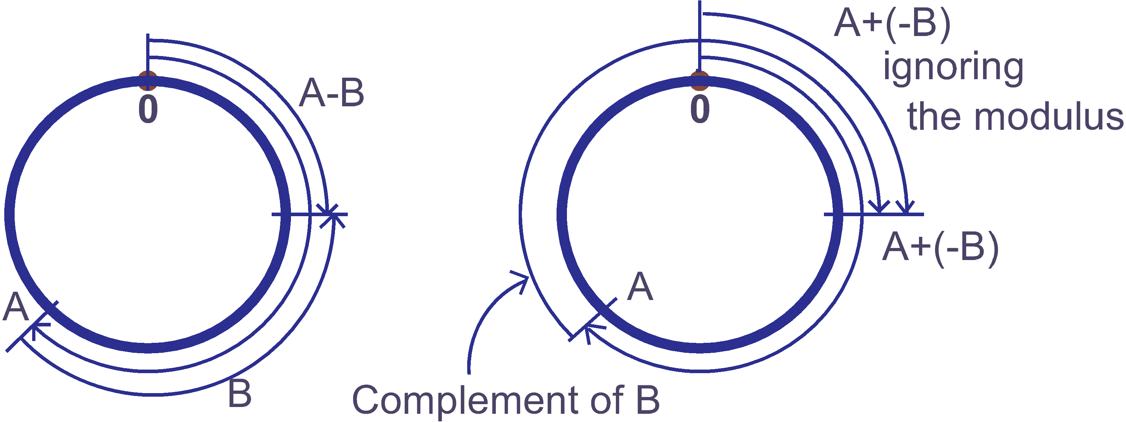
The technique to perform subtraction by addition is now stated as three basic steps:
- The number to be subtracted (subtrahend) is complemented.
- The complemented subtrahend is added to the other number (minuend).
- If the modulus is now ignored then the result is a subtraction.
This technique is best illustrated by examples in both the decimal and binary systems.
    - Example 1, decimal complements arithmetic
Execute 60₁₀ - 49₁₀ using the true complements method.
Using the three basic steps:
- The subtrahend (49) is complemented thus:
(10 - 1) | = | 9
99 - 49 | = | 50
50 + 1 | = | 51₁₀

The modulus is 49 + 51 = 100
- The complemented subtrahend (51) is added to the minuend. Thus:
51 + 60 = 111₁₀
- The modulus (100) is now ignored and the result (11) is the required subtraction.
Try this using the circular representation. Note: once around the circumference is the modulus of this number system, i.e. 100, so 51 is a little over half way around the circle.
    - Example 2, binary complements arithmetic
Execute 10111₂ - 10001₂ using the true complements method.
- True complement of 10001 is 01111₂.
The modulus is 10001 + 01111 = 100000₂.
- Add to minuend: | 10111
 | 01111

- Ignore the modulus and the result (110₂) is the required subtraction.
Try this using the circular representation. You may find it difficult to determine the arc lengths in binary, so convert each binary number to decimal as you proceed.
  - Subtraction using NINES and ONES complements
    - Example 1, nines complements
Execute 75 – 52 using nines complements.
- Nines complement of 52 is 47.
- Add to minuend  - This time add the carry bit to the result | 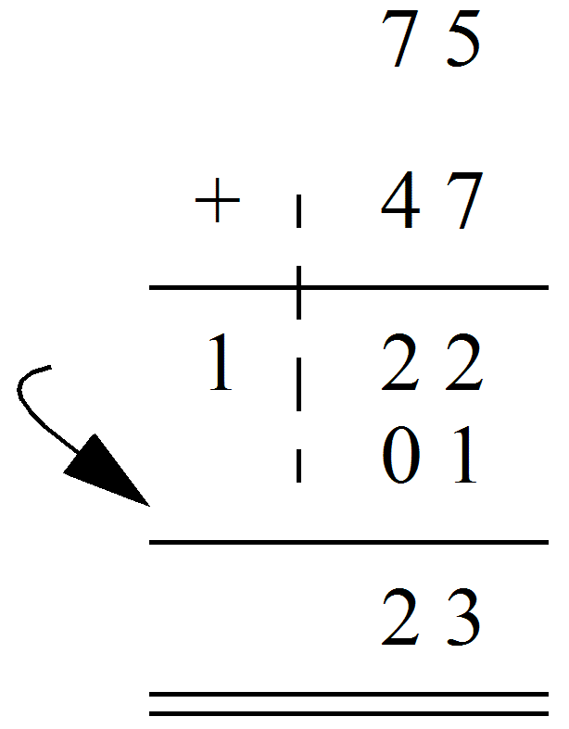

23 is the required subtraction
    - Example 2, ones complements
Execute 11011 – 1010 using ones complements.
Note: The subtrahend must have the same number of binary digits as the minuend prior to finding the complement, i.e. 1010 becomes 01010 prior to complementing.
- Ones complement of 01010 is 10101
- Add to minuend | 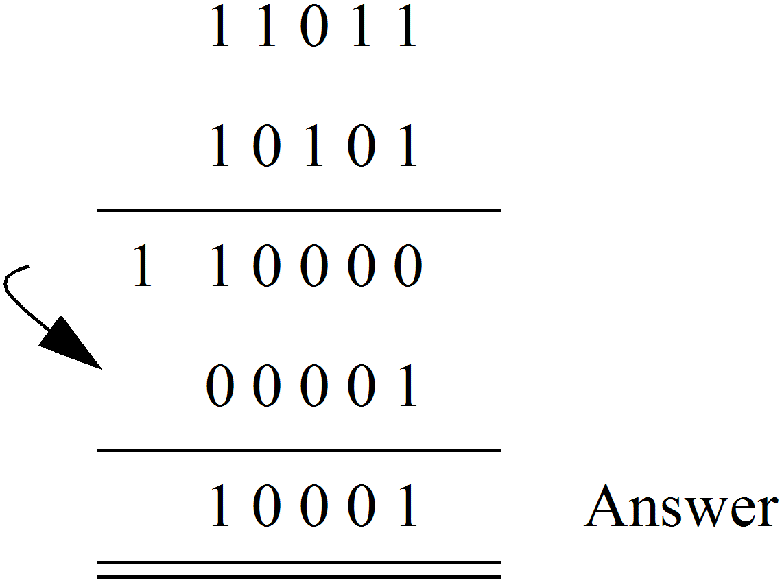

Note: The extra digit which appears in the next highest column is added to the result and is called the ‘end around carry’.
The basic difference between using the tens or true complement and the nines or ones complement methods, is where and how the extra 1 is added.
It is easier for some computers to use the ones complement rather than true complements, so the ‘end around carry’ method is sometimes used.
  - Signed binary arithmetic
So far we have assumed that the subtrahend is smaller than the minuend which means that the result of a subtraction is always positive, but this is not always the case. For two numbers A and B we have four possibilities:
Case 1 | A + B | (both numbers positive)
Case 2 | A - B | (B negative) ==> A + (-B)
Case 3 | -A + B | (A negative) ==> (-A) + B
Case 4 | -A - B | (both negative) ==> (-A) + (-B)

Again let us consider numerical examples to illustrate these situations.
For the two numbers A and B,
Let | A = +13₁₀ and B = +11₁₀ in decimal
then | A = 00110₂ and B = 00101₂ in binary.

Why add the leading zeros in binary?
- The binary number is increased to 5 bits to ensure the magnitude of the result in each case falls within the modulus of the number system.
e.g. 13 + 11 = 24, this result is too large to be represented by 4 bits, so increasing the number of bits by one gives us a range of 0 to 31₁₀, i.e. a modulus of 32₁₀.
- Another bit is added to represent the sign of the number, i.e. the MSB is the sign bit.
- For positive numbers simply add a leading ‘0’ as the MSB.
- For negative numbers 2’s complement the 5-bit number (magnitude bits) to make it negative, then add a leading ‘1’ as the MSB.
MSB |  |  |  |  | LSB
5 | 4 | 3 | 2 | 1 | 0
Sign bit | Magnitude bits
0 = +
1 = – | 2’s complemented if negative

    - Case 1
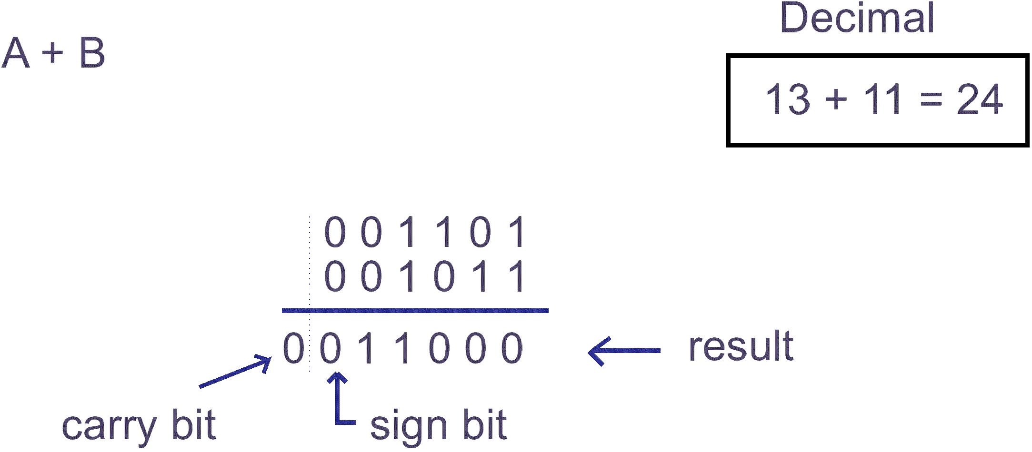
Note: Complements were not used in this case so there was no requirement for the number system to be modular. However, if the number system was modular the carry bit would be ignored; the sign bit indicates a positive result; and the magnitude is 11000₂ (24₁₀).
In circular representation:
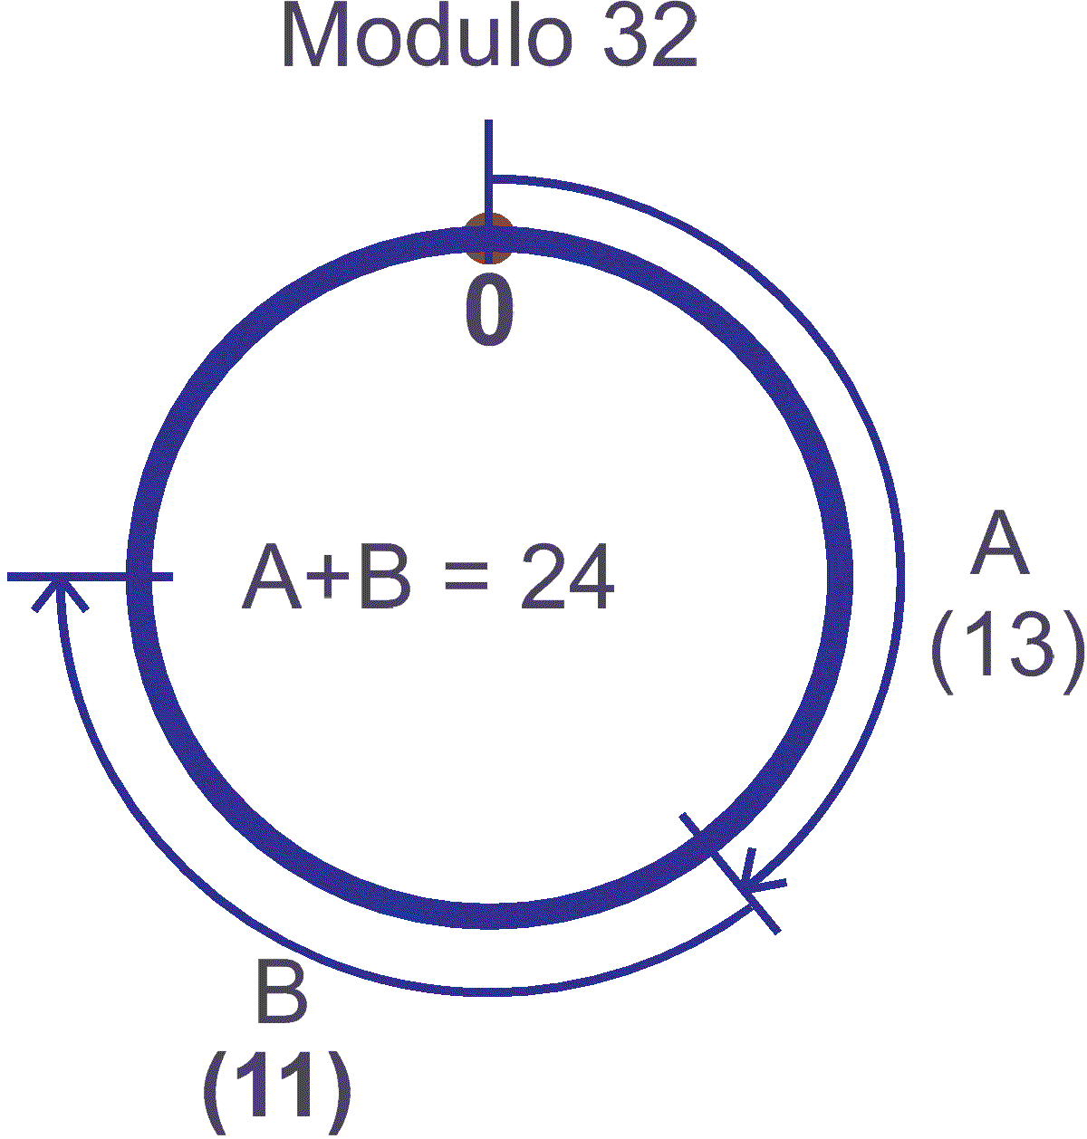
    - Case 2
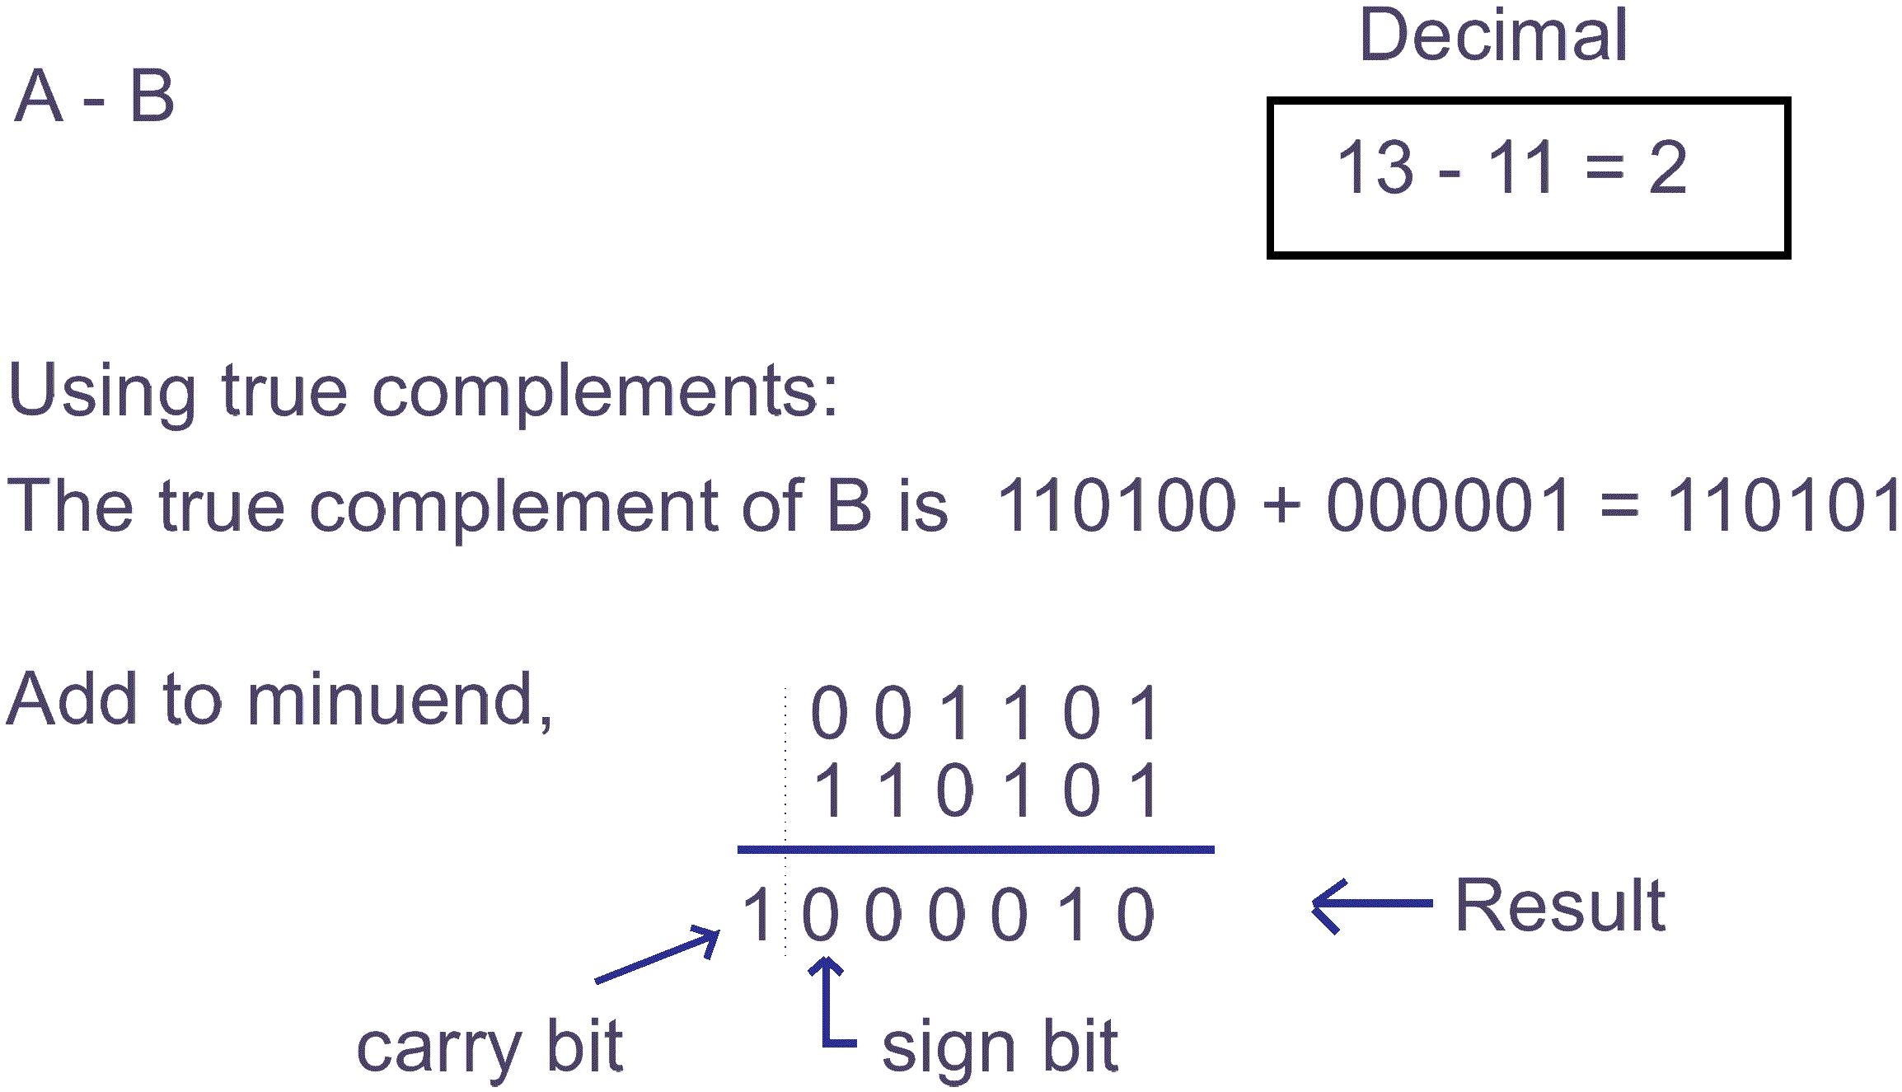
Notes:
- The true complement of B is used in this case so the number system must be modular, and the modulus is 32₁₀.
- When using true complements we ignore the carry bit in the result and the remainder is the magnitude, i.e. 00010₂ (2₁₀).
- Since the sign bit is positive the magnitude is in the correct form.
In circular representation:
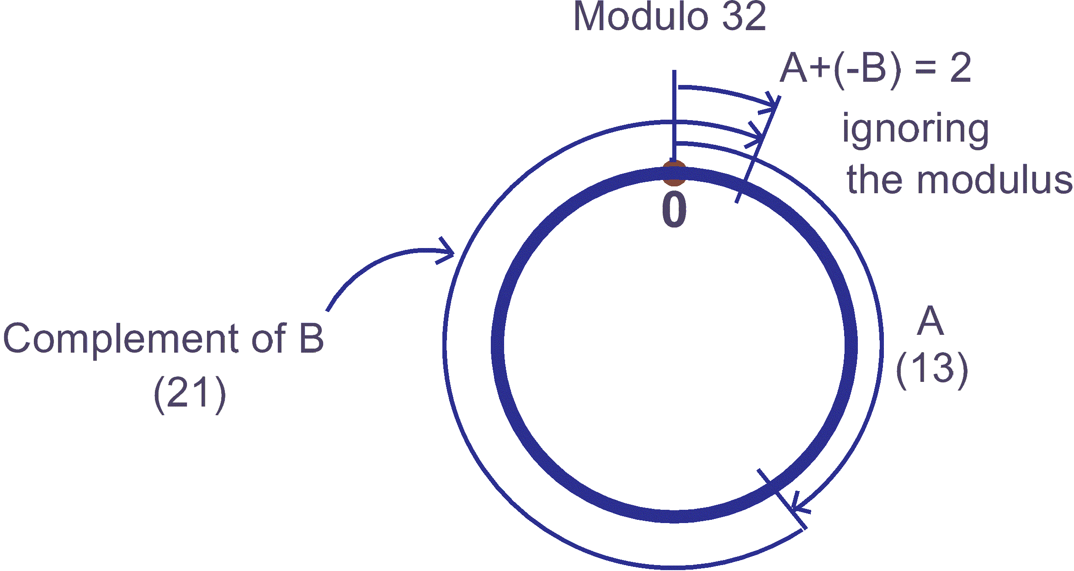
    - Case 3
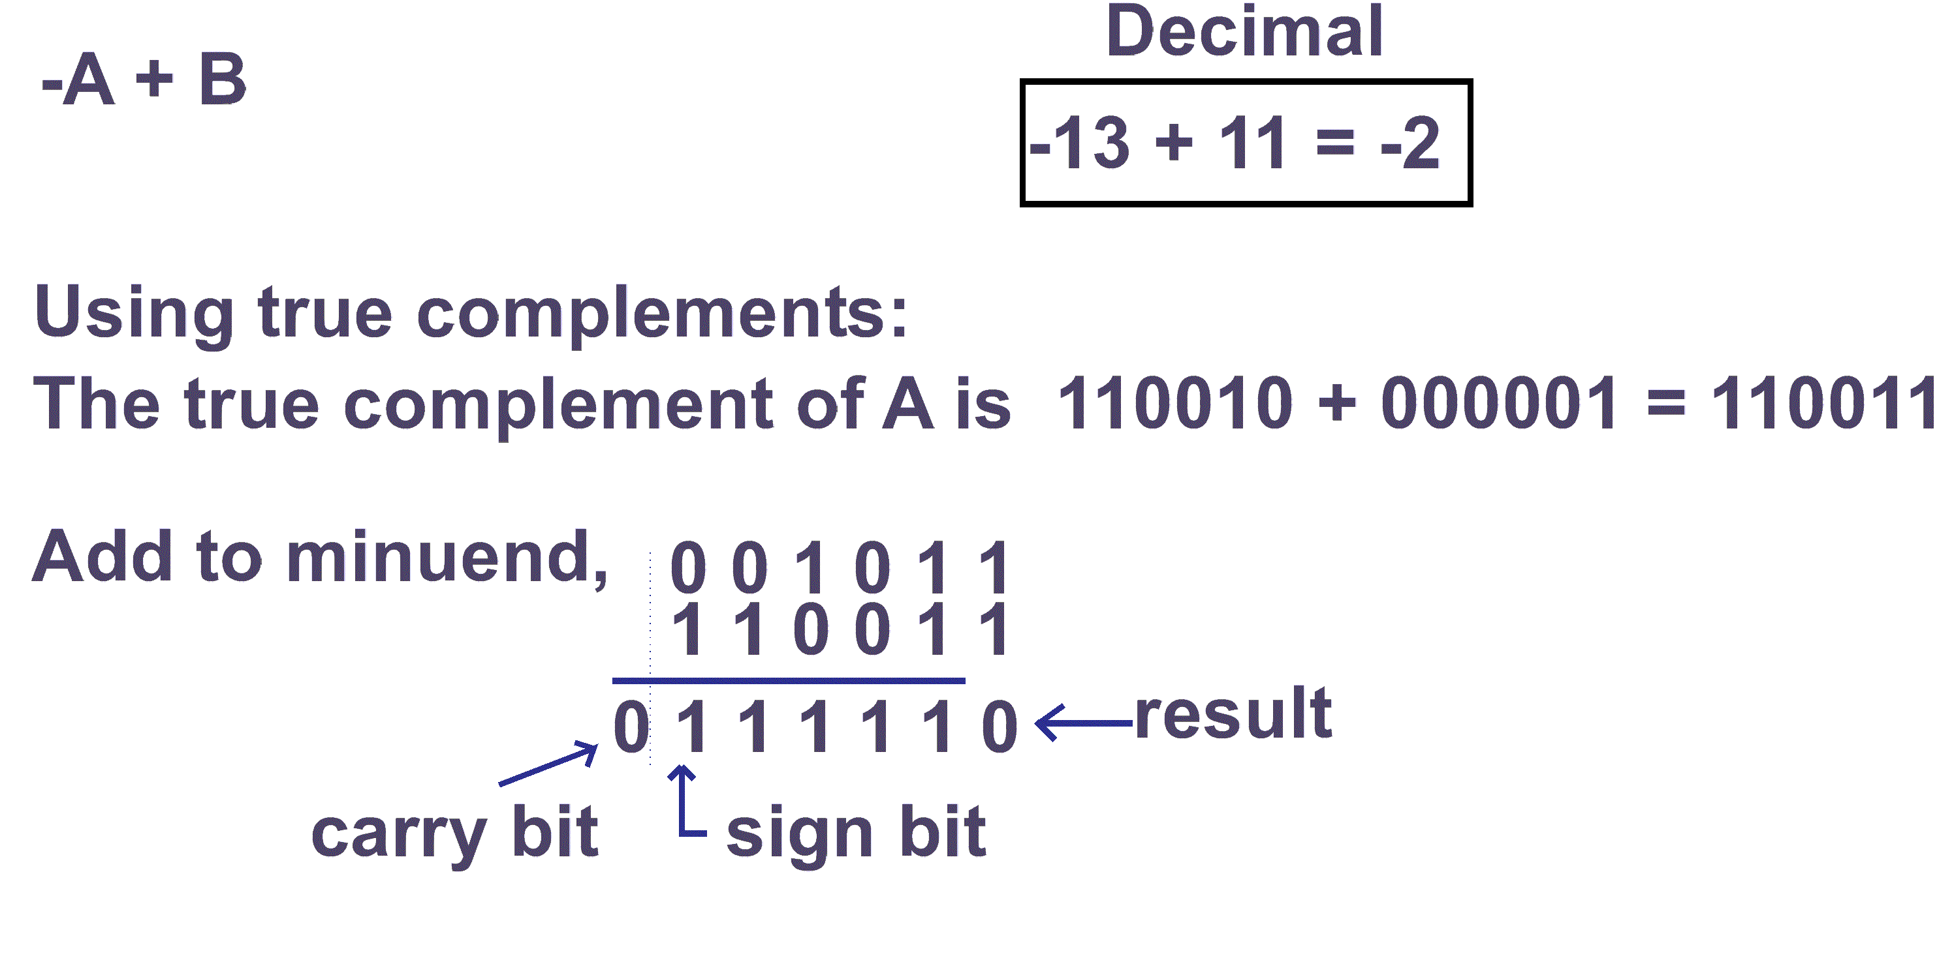
Notes:
- The true complement of A is used in this case so the number system must be modular, and the modulus is again 32₁₀.
- When using true complements we ignore the carry bit in the result and the remainder is the answer, i.e. 11110₂ (30₁₀).
- However, the result is negative so the magnitude is in 2’s complement form. Taking the 2’s complement of 11110₂, we get 00010₂ (2₁₀).
In circular representation:
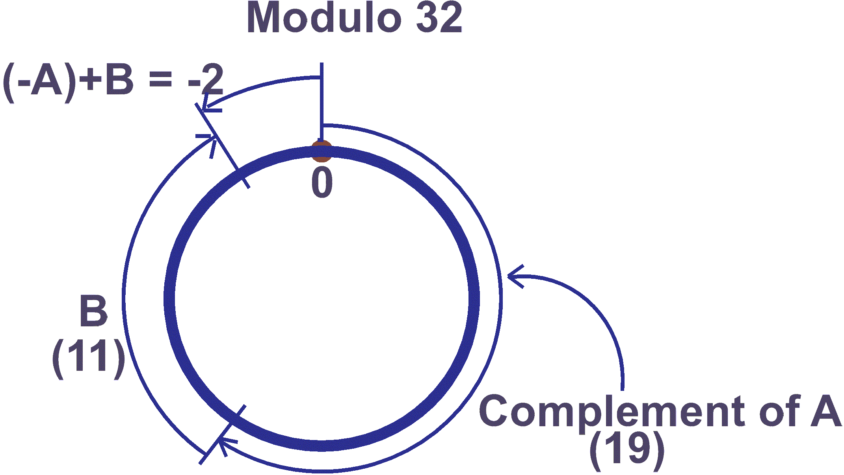
    - Case 4
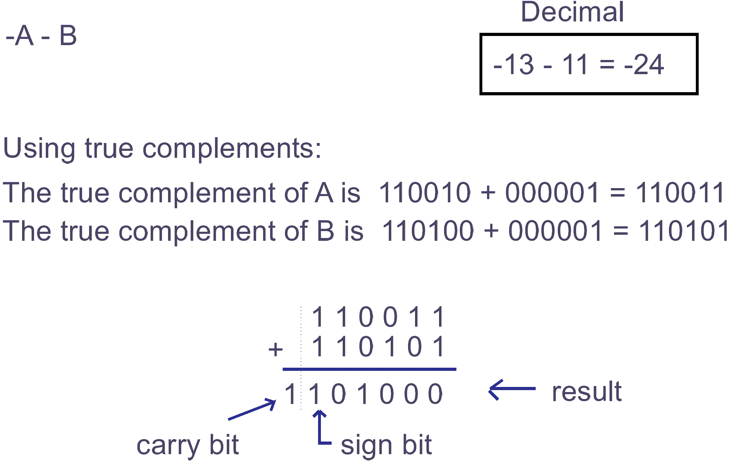
Notes:
- The true complements of A and B are used in this case so the number system must be modular, and the modulus is again 32₁₀.
- When using true complements we ignore the carry bit in the result and the remainder is the answer, i.e. 01000₂ (8₁₀).
- However, the result is negative so the magnitude is in 2’s complement form. Taking the 2’s complement of 01000₂ we get 11000₂ (24₁₀).
In circular representation:

 | Activity 6.1  - Find the NINES complement and also the TENS complement of the decimal number 477.  - Find the ONES complement and also the TWO’s complement of the binary number 10001100.  - Subtract the decimal number 21 from the decimal number 35 by converting both into binary format and using TWO’s complement signed arithmetic.  Subtract the decimal number 25 from the decimal number 19 by converting both into binary format and using TWO’s complement signed arithmetic.

 | Solutions to activity 6.1  - The nines complement of 477 is 522, and the tens complement is 523.  - The ones complement of 10001100 is 01110011, and the twos complement is 01110100.  - Convert your answer back into decimal to check that it is correct.  - Convert your answer back into decimal to check that it is correct.

