- What is Paquete?
Paquete is a packaging plugin.
Paquete is a simple package viewer javascript plugin which supports packages like IMS and others where a package is a collection of related pages and content. Paquete describes the relationships within the package using a JSON manifest file.
Paquete uses one page to host all of the pages of a package which reduces overall page loading time and allows users to navigate easily. Once an individual sub-page is loaded, it is cached in the host page making browsing much quicker.
Specific pages are denoted individually so bookmarking of an individual page is possible.
What does Paquete consist of?
Paquete arranges the files within the package so there is a table of contents (TOC) on the left-hand side and html pages on the right. User navigation can utilise the TOC or the arrowed navigation buttons which can direct navigation through the package page by page in a linear fashion.
How can Paquete be used?
Paquete can be used:
- on its own to group files and display them in a browser for viewing.
- in a Learning Management System (LMS) like Moodle for viewing course content.
- in other web applications where navigating through grouped content is important.
An example of Paquete grouping a simple file structure in web-view
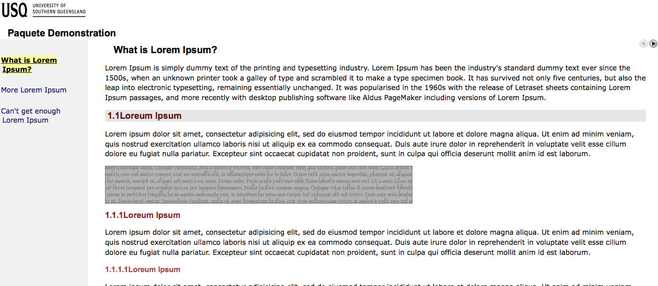Illustration 1: What does Paquete look like?
An example of the Paquete file structure
The Paquete file structure as it would appear on a server, complete with skin and related files.
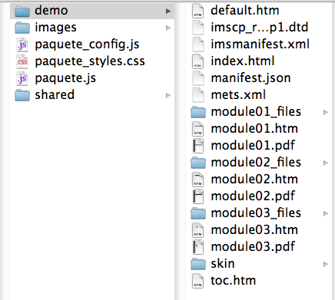Illustration 2: What does the Paquete file structure look like?

