- Test One
Testing
- Xml parser test
Test – <Alt> test.
- Testing images in a list.
- A icon.
- Another icon.
A icon in a paragraph.


This link to a document outside test packages
This link to a folder outside test packages
A png:

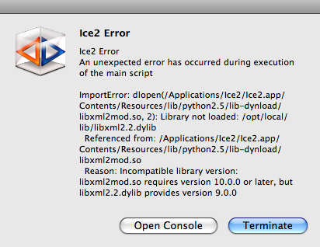

A jpg:

A bmp:
