USQ News No. 1 May 2009

Story Ideas 2
Top Stories 2
Other News 3
In Brief 5
Staff Profile 5
USQ Experts 6
Calendar of Events 6
Photo Gallery 6
Support USQ tenancies 7
About this Newsletter 7

Story Ideas
If you have any story ideas please email them to Corporate Communications for consideration for the Newsletter.
Top Stories
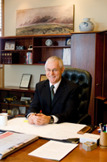 | USQ out in front in national graduate survey  A nation-wide survey of university graduates has placed University of Southern Queensland (USQ) graduates among the top performers for salaries, career destinations and student satisfaction with their studies. Read More>>>>> Discuss
……………………………………………
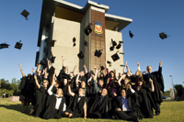 | USQ Springfield celebrates ‘coming of age’  USQ valedictorian Iain Puxty was one of 37 students to participate in the Springfield campus’ inaugural Autumn Graduation Ceremonies earlier this month. Like many of his fellow graduates, the Ipswich local was the first in his family to have undertaken a university degree. Read More>>>>> Discuss
……………………………………………
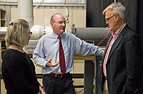 | USQ Impresses Queensland Chief Scientist  Travelling from Australia to Britain by plane in under two hours is still be some years away but work being done at the University of Southern Queensland (USQ) might make the trip happen just that bit sooner. Read More>>>>> Discuss

Other News
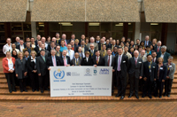 | USQ hosts major United Nations’ farming and climate workshop  Climate variability, farming education programs and advances in meteorological services is at the forefront of discussions this week with some of the world’s finest meteorological and agricultural science minds converging on the University of Southern Queensland (USQ) for a series of United Nations’ (UN) Agricultural Meteorology workshops and meetings. Read More>>>>> Discuss
……………………………………………
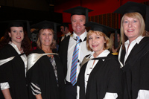 | USQ Fraser Coast Graduation 2009  The Fraser Coast Chronicle described it as ‘125 degrees in the right direction’ – and that’s exactly what it was for the students who received their academic qualifications at the USQ Fraser Coast graduation ceremony on Saturday. Read More>>>>> Discuss
……………………………………………
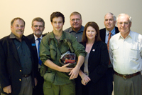 | Documentary to shed light on ‘forgotten’ Vietnam battle  For Vietnam veteran Rob Costello the Battle of Fire Support Base Coral in 1968 is still strong in his memory, despite the event being seen by many as the Vietnam War’s ‘forgotten’ battle. Read More>>>>> Discuss
……………………………………………
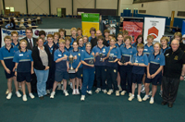 | Concordia named winner of Challenge  Concordia Lutheran College’s finest young scientists won USQ’s 2009 Regional Science and Engineering Challenge. Read More>>>>> Discuss
……………………………………………
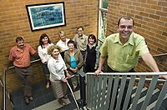 | Initiative gives USQ students opportunity to teach in Bangkok  University of Southern Queensland (USQ) Education students will once again be given the opportunity to undertake professional experience in Thailand through an agreement between the University’s Faculty of Education and the Sarasas Ektra Schools in Bangkok. Read More>>>>> Discuss
……………………………………………
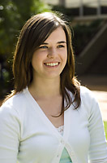 | Competition winner starts university on high note  Talented young singer Marina Paroz is a good example of how the University of Southern Queensland (USQ) is helping young people fulfil their life ambitions. Read More>>>>> Discuss
……………………………………………
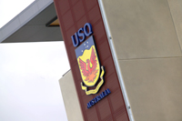 | Fledgling legal eagles meet at USQ  Senior school students from around the region converged on USQ Springfield last week for the 2009 Legal Studies Conference. Read More>>>>> Discuss
……………………………………………
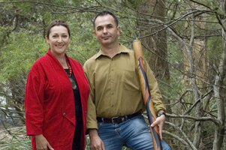  + | Festival embraces local Indigenous history  Local indigenous history will be the focus of the University of Southern Queensland’s (USQ) 2009 Breez Finance Children’s Festival. Read More>>>>> Discuss
……………………………………………
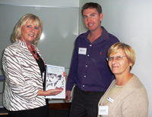 | Bullying researcher addresses local school guidance officers  A local researcher on bullying and violence in schools has spoken to school guidance officers at an annual seminar conducted by the University of Southern Queensland Fraser Coast. Read More>>>>> Discuss
……………………………………………
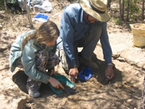 | Toowoomba archaeologists uncovered  Audiences will have an opportunity to meet Toowoomba’s very own ‘Time Team’ at the University of Southern Queensland’s (USQ) first Twilight Archaeology Seminar next week (27 May). Read More>>>>> Discuss

In Brief
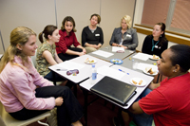 | Good turnout for Go WEST project  The Go Women in Engineering, Science and Technology (Go WEST) project commenced 2009 with activities involving USQ staff and students, with online access for external students, and Engineers from Toowoomba Regional Council. Read More >>>>> Discuss
……………………………………………
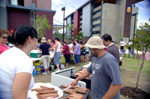 | Springfield residents get a taste of university life  More than 30 residents sampled university life at USQ Springfield earlier this month. USQ Communications lecturer Nick Todd said the 8th Student for a Day event had been the campus' most successful yet. Read More>>>>> Discuss
……………………………………………
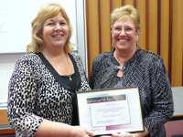 | Academic gives inaugural oration at Nursing Awards  Associate Director of Sciences and head of USQ Fraser Coast Nursing Associate Professor Trudy Yugonvich gave the oration at the Inaugural Regional International Nurses’ Day celebrations and Nursing Awards presentation on Friday May 8. Read More>>>>> Discuss

Staff Profile
 | USQ welcomes new Journalism lecturer  Teaching students how to create quality online journalism will be a primary focus for USQ’s new Senior Journalism lecturer. Dr Usha Rodrigues, who last month took up her new position in the Faculty of Arts, said she strongly believed newspapers would soon be superseded by online news. Read More>>>>> Discuss

USQ Experts
USQ continually gets request for expert comments from around Australia and the globe on a range of topical issues. One way in which the media contact the University is through USQ experts. If you are someone at the University who can provide expert comment on almost any issue and you are looking to build your own profile within the local, national and international community make sure that you register on the USQ experts page. You never know when the media might come looking for your expert opinion or comment!
Calendar of Events
Do you have an upcoming event at the University? Make sure that you register it on the University’s Calendar of Events. For more information on the Calendar contact Judy Halter.
Photo Gallery
2009 Regional Science and Engineering Challenge
Concordia Lutheran College finest young scientists won USQ’s 2009 Regional Science and Engineering Challenge. The Toowoomba school, along with fellow 2009 Challenge winner’s Toowoomba State High School (Mount Lofty), Downlands College and Toowoomba Grammar School will go on to compete in the Super Challenge against teams from New South Wales and Brisbane in August. View photos>>>>> Discuss

Outstanding individuals recognised with Australia Day honours
Three individuals who have a close association with USQ have been congratulated by Governor of Queensland Ms Penelope Wensley AO for being honoured in the 2009 Australia Day Awards. USQ Council member Greg Claydon received an Australia Day Public Service medal for his water reform achievements, Professor Jim Taylor was awarded a Member in the General Division of the Order of Australia for his service to tertiary education, while Harry Spencer was recognised with a Member of the Order of Australia (OAM) for his service to basketball and the community of Toowoomba. View Photos>>>>> Discuss

Support USQ tenancies
USQ staff are encouraged to support the following on-campus businesses.
USQ Toowoomba
- Heritage Building Society - +61 7 4636 1183
- USQ Hair and Beauty Salon - +61 7 4631 2907
- MECU - +61 7 4636 1629
- Darling Heights Post Office - +61 7 4631 2973 or +61 7 4636 5171
- USQ Student Guild +61 7 46 31 1588
- The Refectory - +61 7 4631 2475
- Coffee Club - +61 7 4631 2819

USQ Fraser Coast
- Bella Café
About this Newsletter
Edition: USQ News No 1. May 2009
Audience: All USQ
Created by: Josh Ada

