Images
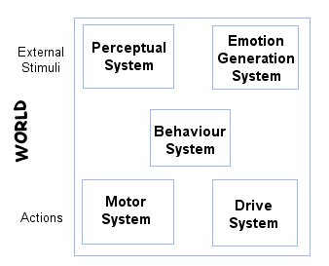
Figure 2.4 EBC Framework for Autonomous Agents
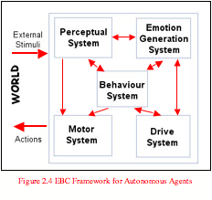
Figure 2.4 provided with permission From Dr Penny de Byl for testing only.

