- HRD issues
Module 4 overview
 | Audio  Please listen to the audio overview for this module.  Module 4 audio overview

This module considers some significant people development influences that have an effect on enhanced performance in the contemporary business environment. The focus is on three broad issues, viz. coaching, mentoring and career development, although some brief coverage of diversity is included at the end of the module.
Edwards (2003) asks the question ‘Coaching – the latest buzzword or a truly effective management tool?’ The terms coaching and mentoring are frequently used inclusively with the inference that they have a similar meaning and this module starts off by considering what coaching actually means and some possibilities for it to be used as a strategic intervention.
It will also be demonstrated that there is no single definition of mentorship and there are many established and emerging practical applications of the main constructs of mentorship that need to be considered in the greatly altered work conditions. Although it is intuitively attractive to assume that mentorship can lead to the acquisition of collaborative and self-development competencies for individuals and enhance organisational capacity, it is hard to find research evidence supporting these claims. However, despite the limited research on mentorship it remains an attractive action strategy for self-development.
Consideration is also given to how changes in the world of work have created a turbulent environment in which today’s managers and leaders are executing their careers. The module will consider what a career is, the changing nature of work, specific change influences related to careers, and personal career planning. Career development is an activity that all managers and HR practitioners need to be aware of. They have their own careers to develop, but more importantly, are concerned with the development of their employees. This development is necessary to ensure that employees have the skills needed to perform and meet organisational goals, as well as meeting the individuals’ needs for growth. The development of employees will be of even greater significance in this new world of work.
Objectives
By the end of this module you should be able to:
- understand the concept of coaching
- explain how coaching might be used to develop people and their performances
- define mentoring and some of its key constructs
- articulate how mentoring can be used to achieve people development outcomes at individual and organisational levels
- assess your own and your organisation’s readiness for mentorship
- understand and describe the changing nature of work and its impact on individuals and their careers
- explain the key elements of careers theory
- identify career management strategies that could be used to develop people within organisations
- discuss the relationship between career management and effective organisational performance
- apply some principles of personal career planning to investigate and reflect on your current and projected future work life
- to understand the relevance of diversity to HRD.
Learning resources
Selected readings
Selected reading 4.1: Rock, D 2003, ‘Managers to coaches’.
Selected reading 4.2: Rider, L 2002, ‘Coaching as a strategic intervention’.
Selected reading 4.3: Friday, E & Friday, S 2002, ‘Formal mentoring: is there a strategic fit’.
Selected reading 4.4: Australian Centre for Industrial Research and Training 1999, Australia at work.
Selected reading 4.5: Marchant, T 1998, ‘New conceptualisations of careers’.
Selected reading 4.6: DeSimone, R & Harris, D 1998, Human resource development.
Selected reading 4.7: Nankervis, A, Compton, R & Baird, M 2002, Strategic human resource management.
Selected reading 4.8: Marchant, T 1998, ‘The changing nature of work’.
Selected reading 4.9: Marchant, T 1999, ‘Managers’ careers in the context of organisational turbulence’.
Web sites
<http://www.coachingnetwork.org.uk/>.
The International Association of Career Management Professionals–provides reports on career trends and support, , <http://www.iacmp.org>.
Career Training and Development site, , <http://ohr.gsfc.nasa.gov/DevGuide/Career/home.htm>.
Mentoring works, http://mentoring-works.com/about_Ann_Rolfe.html

  - What is coaching?
 | Presentation  Please view the Module 4 presentation. Click here to view.  You will find an icon on the first screen that links to a ‘notes’ file for you to print out and use if you prefer.

Whilst it is simple to locate and offer specific definitions for coaching, it is not until we consider both coaching and mentoring that the boundaries and subtle distinctions between the two become most evident. Rylatt (2000, p. 248) suggests that ‘the difference between coaching and mentoring is often more pedantic than actual…however, the term ‘coach’…describes someone who performs the role of training, inspiring and motivating others.’ Edwards (2003, p. 298) expands on this and proposes that ‘coaching is a highly personalized one-to-one personal development programme’ and distinguishes between coaching and mentoring as ‘…mentoring gives advice and teaches, whereas coaching facilitates learning’ (p. 299).
Rock (2003) proposes pragmatic and functional applications for coaching to achieve enhanced performance outcomes from managers becoming employee coaches. He goes on to suggest that ‘the most common reasons why organizations establish a coaching initiative are to improve individual performance or to help managers with their people skills (p. 38).
 | Reading activity 4.1  Selected reading 4.1: Rock, D 2003, ‘Managers to coaches’, HRMonthly, June, pp. 38–9.

Rider (2002, p. 233) suggests that rather than focusing on coaching as an individual development intervention, that a second generation of coaching emerges when organizations take a strategic perspective and evaluate the effectiveness of coaching interventions. This becomes even more powerful and a maximum optimization of the benefits of the coaching investment when organizations ‘also harness and disseminate the learning the coach gains about the organization, to the benefit of the business and its people’.
Reading activity 4.2
Selected reading 4.2: Rider, L 2002, ‘Coaching as a strategic intervention’, Industrial and Commercial Training, vol. 34, no. 6, pp. 233–6.

  - What is mentoring?
There is no single inclusive theory or model of mentoring that fully captures this process and experience (Hale 1995) or the diversity of mentoring arrangements now possible. Rather, mentorship has gone through significant changes in its conception since the middle of the last century.
Under the classical or primary construct, ‘mentoring is seen as a relatively long term, intense developmental relationship in which protégés receive a broad range of career assistance and personal support from one senior manager.’ (Whitely & Coetsier 1993, p. 333). By way of contrast the secondary construct of mentorship (Whitely & Coetsier 1993) focuses mainly on ‘external’ career outcomes that are more transient and involve multiple mentors. Whitely and Coetsier regard secondary mentors as coming from senior ranks to the protégé, and implicitly, from inside the protégé’s organisation. They also consider secondary mentorships to be more narrowly focused on ‘external’ career outcomes and are of shorter duration and rely on the combined efforts of a number of persons, e.g. Career mentoring, peer mentoring, peer reviews, spot mentoring, board of advisors mentoring, and group mentoring (Whitely & Coetsier 1993).
These primary and secondary constructs locate mentoring firmly in the arena of human resource management (Applebaum, Ritchie & Shapiro 1994) or more specifically professional development. That means these constructs view mentorship as a means of professional development for individuals.
More recently, mentorship has been seen to have wider organisational outcomes and significance. An emerging tertiary construct of mentorship is located in the larger arena of organisational behaviour and management (OBM) (Applebaum, Ritchie & Shapiro 1994). ‘Organisational behaviour and management is a field of study that investigates the impact that individuals, groups and structure have on behaviour within organisations, for the purpose of applying such knowledge toward improving an organisation’s effectiveness.’ (Robbins, Millett, Cacioppe, & Waters-Marsh 2006, p. 10). Within the OBM construct mentorship is presented as a phenomenon that impact on the overall operation of the organisation via individuals, groups and organisational structures.
    - Mentorship and the individual – career advancement
Mentorship has acquired something of a reputation as a cure all remedy for any skill deficit and or career difficulty that may confront a worker. This reputation is not, however, fully supported by hard research evidence. Limitations of current research include:
- The contribution of mentorship to managers’ and professionals’ careers specifically has been relatively unresearched for some time (Kram & Scott 1985; Zey 1984). This observation still stands, particularly given emerging trends in professionals’ and managers’ careers. That is, the small amount of research that exists about the contribution of mentorship to managers’ and professionals’ careers is in dramatic need of updating given the altered nature of managers’ and professionals’ careers in recent times.
- The tendency to focus on middle to senior level managers’ retrospective recollections of their early career mentoring experiences (Whitely & Coetsier 1993) has led to potentially biased results about the effectiveness and processes of mentoring. The findings are skewed by the selection of managers who already have achieved a level of advancement and by the bias effect of recollection itself.
- Further, there is little research into the risks, outcomes and mechanisms of poor or dysfunctional mentorship experiences to balance the overwhelmingly positive press received by mentorship (Hale 1995).
- Finally, factors other than mentorship (refer to the table below) can contribute to career advancement (Whitely & Coetsier 1993). These factors can confound the findings of mentorship studies that do not acknowledge them, and many mentorship studies do not.
    - Mentorship and the individual – competency acquisition
Self-development and collaborative competencies have been identified as enhancing one’s employability in the present and foreseeable future. These are defined in table 4.1. The question remains can they be developed through mentorship?
Table 4.1: Self-management and collaborative competencies defined
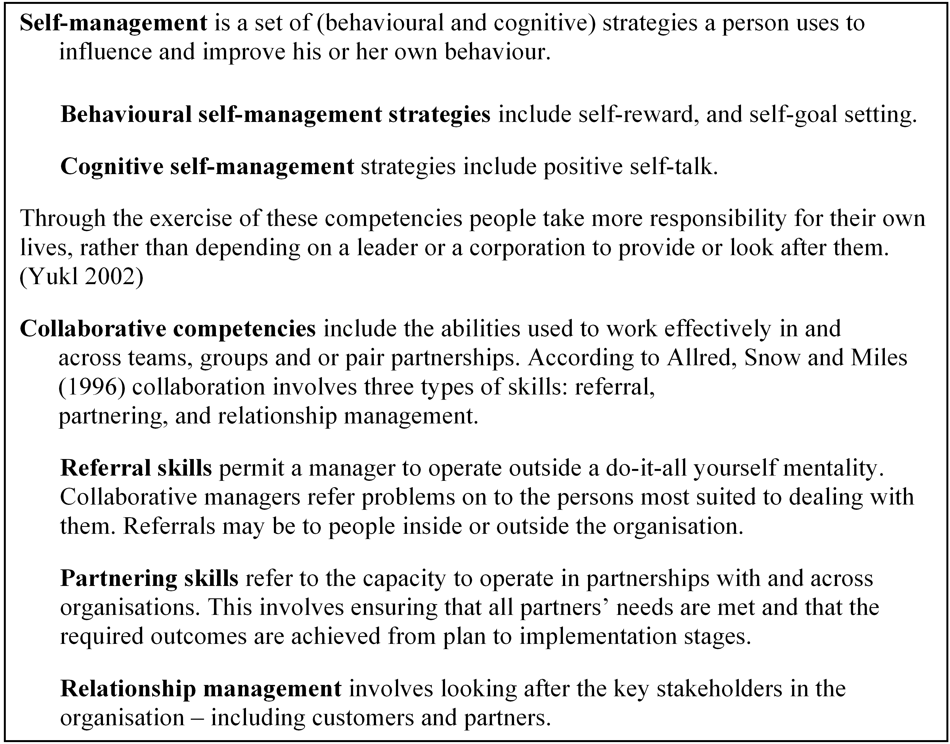
It is intuitively attractive to think of mentorship as an appropriate means for acquiring self-development competencies. According to Yukl (2002) the process of developing self-leadership in others has been labelled ‘super leadership’ and is the legitimate province of leaders. Given Yukl’s notion of mentorship as a leadership behaviour it is reasonable to assume that mentorship could be one mechanism through which leaders could exercise super leadership.
Similarly, collaborative competencies and mentorship have significant face value connections. Collaboration can be regarded as the capacity to work co-operatively with others. Mentorship is therefore a collaborative process. Mentorship can be a means of acquiring collaborative competencies as well as a collaborative process in itself. Formal mentorship programs particularly, include training and accountability measures that actively cultivate collaboration skills.
In short it is legitimate to desire to cultivate and enact collaborative and self leadership competencies through mentorship. It is also easy to believe mentorship is an excellent means of developing these competencies. However as Yukl (2002, p. 389) writes ‘Little is known about the skills, values and behaviours most likely to be acquired or enhanced in a mentoring relationship’. In short, again the jury is still out on the efficacy of mentoring in cultivating these specific competencies.
    - Mentoring and the organisation
The trend is the same in relation to the contribution of mentorship to organisational effectiveness. There is more enthusiasm for mentorship than there is hard research evidence supporting claims of its effectiveness. At the same time formal mentorship programs are an increasing trend in the current climate. (McKenzie 1995).
Particular gaps in the research knowledge base include:
- While it is assumed that the newer boundary less organisations may be particularly well suited to mentorship (Clawson 1996) there is no research testing the compatibility and hospitality of these or any other organisational structures to mentoring (Hale 1995).
- Existing mentorship research is largely descriptive and a theoretical (Hale 1995).
- Mentorship research has tended to focus on issues within an HRM construct. Foci issues have included the mentor’s development of the relationship and protégé outcomes from the relationship (Ragins 1997). The research has generally not focused on questions that would advance knowledge of and perception of mentorship as an OBM construct such as:
- What exactly is the relationship between mentoring and organisational values and processes?
- What are the precise circumstances and processes required for organisational capability to be transferred from more experienced staff members to newer staff members through mentorship?
- How exactly does mentorship impact protégé motivation and consequent performance? (Hale 1995)
In addition you need to consider the level of influence you have within the organisation and the organisation’s readiness to host such a program.
  - Is your organisation ready for mentorship?
You may wish to evaluate the readiness of an organisation for mentorship for a number of reasons. You can do this as an individual wishing to evaluate the likely success of mentorships that you set up for your personal use within the context of your organisation. Alternately you can do this from the perspective of a leader wishing to introduce, or improve mentorships within your organisation.
Evaluating the readiness of your organisation for mentoring involves consideration of the following questions:
- What needs of the organisation and or its employees are you hoping to meet through mentoring?
- How compatible is your organisation’s current culture and life cycle stage with the mentoring ethos?
- How willing or able is your organisation to supply the necessary infrastructure for mentoring and how soon would the program need to show results to survive?
- What type of mentorship arrangements would best suit your organisation and its members?
Whatever the rationale for your evaluation it is suggested that you be strategic in your information gathering about your organisation. Even information gathering can be a political process. You need to avoid accidentally putting any key players in the organisation offside by, for example omitting them from the process or by engaging them too late in the process. Similarly you need to consider how you will lobby and or present your findings if they indicate a formal mentorship program would be viable.
The strategic fit of mentoring programs is discussed by Friday and Friday (2002, p. 152) and they propose a framework for creating a corporate level mentoring strategy.
Reading activity 4.3
Selected reading 4.3: Friday, E & Friday, S 2002, ‘Formal mentoring: is there a strategic fit’, Management Decision, vol. 40, no. 2, pp. 152–7.

It is suggested that you develop a list of the organisational members whose support would be essential to the success of the program. You need to consider for example people whose job titles or duty statements are likely to link them to the program. You may for example have a Human Resource Section or Manager who definitely needs to be involved. You also need to consider organisational members who have influence in relation to resources required supporting the program.
Finally, you need to consider if and when your information gathering is to become formal whose authority you will need at that stage. You need to consider how exactly you intend to gather this information. The instrument that follows could be used either for one on one interviews or be turned into a tick and flick survey tool for circulation more widely throughout the organisation.
The following checklist in table 4.2 is an adaptation of one developed by McKenzie (1995). In response to each question the organisation is rated as follows:
1 = ready, 2 = willing but not ready, 3 = not ready and unwilling.
According to McKenzie (1995) results of your information gathering need to be clumped into one of three overall categories.
- The organisation is ready for a mentorship program. No organisation will score a 100% readiness rating. An organisation can however, on balance be ready for a mentorship program.
- The organisation is willing but not ready. This means there is potential for a mentorship program but that the timing is not quite right at the moment.
- The organisation is not ready and unwilling. This means that the program is not an option for the foreseeable future. Given this result you need to consider other ways to stimulate mentorship options for yourself and or how to bring the organisation into a state of readiness.

 | Interactive activity  See and interact with this table. This link takes you to an Interactive table 4.2. Fill in the blanks and print this out for your records.

Table 4.2: Organisational readiness diagnostic tool
 | ready | willing but not ready | not ready and unwilling
How compatible is your organisation's current culture and life cycle stage with the mentoring ethos?
Is your organisation supportive of developmental relationships between different levels in the organisation?
Is there good communication across organisational boundaries (for example, between departments or divisions)?
Will job designs and job rotations allow sufficient contact between protégés and mentors for relationships to develop?
Is there a commitment to relationship building between different levels in the organisation?
Is the organisation in a stage of consolidation – the optimum life stage for introducing mentorships?
Is there a willingness to develop strategies for reducing the impact that organisational change may have on mentoring relationships?
What needs of the organisation and or its employees are you hoping to meet through mentoring?
Is there evidence in your organisation of a medium and longer-term focus for staff development?
Is mentoring seen as a major process for growing future leaders and managers?
Is there an acceptance that mentoring may help attract desirable employees?
Is there an acceptance that mentoring may help retain valuable employees – both managerial and non-managerial?
Is there a concern to improve the status of and opportunities for women, people with disabilities and minorities?
Is there willingness to regard managerial and mentorship functions as separate rather than competing?
What type of mentorship arrangements would best suit your organisation and its members?
Is there willingness to trial a number of mentorship options?
Is there support for a particular type of mentorship relationship e.g. peers, hierarchical?
How willing or able is your organisation to supply the necessary infrastructure for mentoring and how soon would the program need to show results to survive?
Is there a willingness to develop monitoring and evaluation aspects of the process?
Is your organisation willing to devote the necessary resources (for example, mentor and protégé time, and dedication of staff) to establish and co-ordinate a mentoring program?
Is there a commitment to investing the time and effort required to develop the critical interpersonal skills necessary for mentoring?
Is there willingness to reward managers and protégés for engaging in mentoring experiences (for example, incentives plus appraisal measurements for mentoring)?
Is there a commitment to careful matching of mentors and protégés?
Is there a commitment to training in the mentoring process?
How much time and effort are you willing personally to invest in this program and for how long?
Is there sufficient leadership support to sustain the program?

  - How to develop a mentorship program
Having considered your own and your organisation’s readiness for a mentorship program it is now appropriate to consider what is involved in setting up a mentorship program.
It should be noted that Australian mentorships have historically tended to be informal with formal mentorship programs being a fairly recent development (McKenzie 1995). Carruthers’ (1991) research revealed formal Australian mentorship programs tend to share the following characteristics:
- Mentors are untrained. This is despite claims that training is essential for all participants within mentorship programs (Tabbron, Macaulay & Cook 1997).
- They tend to focus on cadet and new graduate protégés.
- They target improved job satisfaction and decreased turnover.
- They tend to have a low visibility within organisations. This is consistent with Ragins’ (1997) observation that participants in mentorships may not even be aware of their relationship till it is brought to their attention.
- They match mentors and protégés without much say by participants in the process. (This is despite claims that participants should input into the selection process (Tabbron, Macaulay & Cook 1997).
- They are perceived to be voluntary for mentors but obligatory for protégés.
On balance, these programs do not seem to be following a particularly successful formula.
Well-managed formal mentorship programs tended to be highly integrated into the culture and operation of the organisation. They tend to have the following qualities:
- Executive commitment and champions: the backing of all levels of management and people with influence who promote the program
- Rationale: a clear focus with measurable goals and outcomes with organisational benefits
- Accountability: outcomes must be monitored and measured with mentors evaluated on their efforts.
(Mattis 1992, cited in McKenzie 1995, p. 57)
Developing a mentoring program involves avoiding pitfalls as well as planning for positive outcomes. A list of harmful scenarios for mentoring and compensatory strategies is included below (Hale 1995).
Table 4.3: Harmful scenarios and compensatory strategies for mentoring
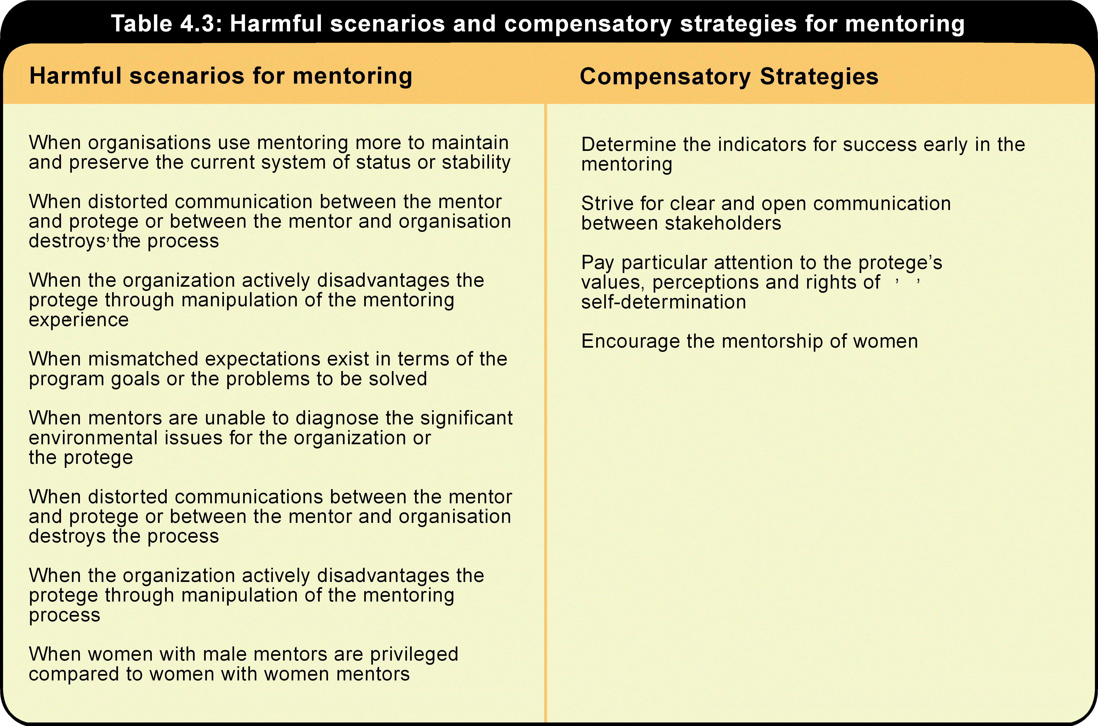
(Source: Hale 1995, p. 337, colour enhanced by USQ.)
It should not be assumed that the following guidelines implicitly suggest that designing and implementing a mentorship program will and can take place in a neat, linear, logical sequence. In reality, organisations are dynamic rather than stable entities (Mintzberg 1998). Implementing any program or strategy involves what Mintzberg (1998) refers to as ‘crafting’ rather than simple recipe following. Figure 4.1 depicts program development as an interactive process in which the same steps are re-visited in a circular mutually informing sequence rather than in a simple beginning, middle and end sequence.
Presentation
See and hear this illustration explained by clicking on the play button.

Figure 4.1: Developing a mentorship program
Play
The first clump of steps involves information gathering about the organisation’s readiness for the program and lobbying for the program at a big picture level. Information gathering and marketing continues throughout the life of the program as staff come and go and as the organisation faces new challenges from the external environment.
The purpose of information gathering is not simply to establish the degree of support within the organisation for a well-run mentorship program. Such support is often forthcoming (Tabbron, Macaulay & Cook 1997). The real question is ‘Is this organisation willing and able to invest the time and effort required to make the program successful?’ A well run mentorship program will gather support as it goes.
A variety of information gathering processes can be used. Tabbron, Macaulay and Cook (1997) used a combination of structured format interviews of senior and middle managers and focus groups of team coaches when investigating the feasibility of an extended mentorship program within a blue chip American company.
These tasks are followed by a more closely collaborative, more focused cluster of tasks. These are the tasks associated with the initial set up and on-going maintenance of the program. The program needs someone to co-ordinate it and to problem solve on an on-going basis. Specific goals and evaluation procedures need to be developed. Specific types of mentorships need to be selected, mentors and protégés need training and matching. Administrative infrastructures need to be developed as well as human resource management strategies that actively support the program (McKenzie 1995). All of these decisions need to be taken with a clear understanding of the strategic variables actively being manipulated through mentorship (Hale 1995).
The third cluster of tasks is associated with the monitoring and on-going adaptation of the program. These involve gathering information from stakeholders, comparing accomplishments against goals and comparing the applied program with the planned version of the program (McKenzie 1995).
By way of contrast, the following table outlines some of the advantages and disadvantages of formal mentorships.
Presentation
See and hear this table explained by clicking on the play button.

Table 4.4: Advantages and disadvantages of formal mentorships
Play
(Source: Adapted from McKenzie 1995, p. 56, animation and audio added by USQ.)
There is no single optimum degree of structure for a mentorship. It is a matter of identifying and evaluating the impact of structure on specific mentorships.
While there are preferred status arrangements for mentorships, these are not always possible to achieve. Sometimes one must, for example accept one’s line manager as a mentor. This is generally not regarded as desirable although it may be preferable to having no mentor at all. It is preferable to think about status constituency in terms of its effectiveness in meeting stakeholder needs rather than in terms of intrinsically good or bad configurations.
There is evidence to support the claim that it is best to have a mentor from outside the protégé’s reporting structure (McKenzie 1992; Burke & McKeen 1989). Loeb (1995) suggests avoiding having your supervisor or your supervisor’s supervisor as your mentor. Asking your boss to be your mentor can be perceived as a phoney attempt at ingratiation. Having your boss’s boss as your mentor can make your boss anxious about what you say to your mentor. Mentors are preferably at least two levels above the protégé if they are in the same reporting structure (McKenzie 1992; Burke & McKeen 1989).
However, pragmatic factors such as availability may make it necessary to accept one’s supervisor as one’s mentor. Supervisor-mentors are prevalent in Australia for this reason (McKenzie 1995). Unfortunately, these two competing roles – as your boss to make sure the job gets done and, as your mentor, to offer objective developmental advice – are not always compatible (McKenzie 1995).
Hierarchical mentorships can also include people you supervise. In this situation the titles of mentor and protégé are difficult to assign. The intention of these mentoring relationships is to understand how you are perceived by those you supervise and what needs improvement (Loeb 1995).
The intended advantage of peer mentorships is that they can have a collaborative, mutual tone not always possible within hierarchical relationships (Bartunek & Kram 1997). Although it must be noted that even in such peer or group mentorships the constituency can involve participants who are generally acknowledged as more and less experienced than each other. Bartunek and Kram’s (1997) peer mentorship involved three ‘less experienced’ participants and three ‘veterans’.
Summary
There is no simple answer to the question ‘What is mentorship? and why there is no single ‘best’ form of mentorship. What works for one individual, group or organisation may not work for another. There are many established and emerging practical applications of the main constructs of mentorship that need to be considered in the greatly altered work conditions. Although it is intuitively attractive to assume that mentorship can lead to the acquisition of collaborative and self-development competencies for individuals and enhance organisational capacity, it is hard to find research evidence supporting these claims.
However, despite the limited research on mentorship it remains an attractive action strategy for self-development. Substantial opportunities exist to forge some of the newer more transient forms of mentorship particularly.
  - Career development for enhanced performance
A lot has been written about the changing nature of work, and how careers will be different in future, as illustrated by the material in this module. It is more difficult to find new material that suggests how organisational career management and HRD in general will work in the new employment era. To succeed, today’s organisations need to be flexible, ‘close to the customer’, flatter and innovative. How can career development contribute to this?
If organisations need flexible employees, they need employees who have a range of skills, or who are prepared and able to develop new skills. Flatter organisations have fewer management levels, and fewer management jobs. Therefore the organisation is less able to offer the promotions that constituted career progress and provided rewards for employees in terms of increased status and salary. Now career progress has to be measured in terms of increased competency, capability and measurable contributions to achieving organisational outcomes.
There are two key implications for HRD here. One is that of skill development – or ongoing training for, and learning by, employees. The answer to the key question ‘who is responsible for training and development?’ is that now employees must assume a much larger share of the responsibility. Both they and organisations must ensure that the investment they make is directed towards skills, abilities and experiences that will make them more productive in any employment setting, not just the current employing organisation. The second is a greater emphasis on performance management, which was addressed earlier in this course.
There has been a strong trend towards more flexible employment arrangements in Australia with a substantial increase in part-time, casual, temporary and contract employment, as well as self-employment. Many organisational functions, including HRM in some instances, have been outsourced. This is in contrast to the traditional stereotype of the ‘secure job’ often held for life with one organisation. With the increase in contingent, or contract work, one big issue that is raised is who is responsible for training and development. This issue will be explored in this module.
Reading activity 4.4
Selected reading 4.4: Australian Centre for Industrial Research and Training 1999, Australia at work, Prentice Hall, Sydney, pp. 1–9.
Although this reading comes from an Australian source which is now a few years old, there are a number of generalisations about trends that can be drawn from it and which relate to the global context.

  - What is a career?
Is it appropriate to talk of the career of a ditch digger or is ditch digging just a job (Wilensky 1960)? This module will answer the question by indicating that careers involve learning and development, and therefore ditch digging is probably just a job.
Formerly, careers were conceived of as an orderly progression through logically connected functions by early sociologists who emphasised the importance of careers as stabilising influences on individuals, families, organisations, and wider society (Glaser 1968; Defillippi & Arthur 1994; Inkson 1995). That is, individual career paths were executed in organisational career structures.
    - Conventional versus contemporary views
Old definition
Conventionally, definitions of organisational career paths centred on upward movement through one organisation, e.g. ‘the status passage of a person through a social structure commonly called an organisation’ (Glaser 1968, p. 13).
New definition
Contemporary definitions of a career emphasises change and learning, and this implies that work activity may occur within many different organisations or contexts. For example, ‘the unfolding sequence of a person’s work experience over time, which involves a lifelong series of identity changes and continuous learning, that is subject to frequent self-evaluation’ (Marchant 1998, developed from Arthur, Hall & Lawrence 1989, p. 8; Hall 1996, p. 9; & Analoui 1997).
As you work through this module you will encounter change influences that have resulted in this new definition of careers.
Reading activity 4.5
Selected reading 4.5: Marchant 1998, ‘New conceptualisations of careers’, PhD thesis, University of Southern Queensland, pp. 1–11.
This reading synthesises a lot of the current literature on new careers. It is important that you note the differences between traditional career theory in the DeSimone & Harris reading and what Marchant proposes.

 | Learning activity 4.1  - When you think about the term ‘career’, what comes to your mind?  - What are the differences between the conventional and contemporary definitions of career?  - Which definition does your career more closely match?  - What is meant by the idea of a ‘new’ employment relationship?  - Does it make sense to speak of careers and career planning in today’s business environment?

    - Career stages – the underpinning for career development
Career development for individuals is a process of successively refining the occupational self-concept over a series of life stages (Super 1957; 1994). Career development can also be set in the wider context of whole-of-life development and adjustment (Levinson 1986). Super’s five-stage theory concentrates on career stages. Levinson’s whole-of-life approach covers both career stages and other developments in adult life such as those associated with establishing a family. In table 4.5 these two main theories are summarised and compared.
Levinson’s theory is similar to Super’s in that it posits periods of pre-, early-, middle- and late-adulthood. It also specifically addresses several periods of transition within these major stages, and importantly, gives a wider context in which careers can be understood.
The other main difference, apart from the inclusion of broader life considerations by Levinson, is that Levinson breaks the life cycle down into four longer stages, compared to Super’s five.
Table 4.5: Comparison of super and Levinson’s career stage theories
Super |  | Levinson
Stage | Key features | Stage | Key features
Growth Age 0–14 | Beginning of self concept development | Pre-adulthood  Age 0–22 | Growth from a dependent, undifferentiated infant to an independent responsible adult.
Exploration  Age 15–25 | Experimenting and testing leads to emergence of self concept | Early adulthood  Age 17–45 | Forming and advancing in an occupation.
Establishment  Age 25–45 | Implementation of self- concept | – | –
Maintenance  Age 45–65 | Preserving or being nagged by self-concept (that is prompting to change career if the one chosen earlier does not match self-concept). Holding a place that has been made, demonstrating stability | Middle adulthood Age 40–65 | May be a senior member of the work world, responsible for the development of others
Decline  Age 65+ | Valuing other non-work roles | Late adulthood  Age 60 +
(Source: Marchant, T 1998, 'The effect of organisational restructuring on managers' careers in Australia', Doctoral dissertation, University of Southern Queensland, Toowoomba.)
In Super’s theory the five stages of career development start with growth, during which time the self-concept begins to develop through identification with keys. Next is exploration which represents the first transition from school to work, and is characterised by the emergence of the occupational self-concept through experimentation and testing.
The third stage is establishment when the person makes early attempts to implement their self-concept. This period involves the individual putting forth effort in the field of endeavour identified as appropriate in the earlier stage. During this stage, the life work is usually found. Maintenance is the fourth stage, during which the main aim is to hold a place that has already been made. Continuity is the key theme, and it is a period of preserving (or being nagged by) the self-concept. The final stage, decline, is the lead-in to death and is concerned with developing and valuing other non-work roles (Dalton 1989; Super 1957; Super 1994).
One stage that attracts particular attention is the mid-life transition (Sheey 1974). Mid-career is defined as the period from about age thirty-five to fifty (that is, late establishment to maintenance) for individuals with a typical career starting at age twenty-one and progressing through to retirement at sixty-five (Hall 1986). Mid-career is a phase of career development that has been singled out for some attention, because of its relationship to the critical mid-life phase, where there are often significant changes, including the mid-life crisis.
Mid-career is a period where individuals have become established and achieved a degree of mastery, and precedes the disengagement process. It is a period that may involve a slowing down of career advancement, a perception of fewer future career opportunities, and a questioning of career identity, future career directions, and the role of the career compared to other aspects of life (Hall 1986).
Reading activity 4.6
Selected reading 4.6: DeSimone, R & Harris, D 1998, Human resource development.
The reading does not highlight this point, but current thinking and research suggests that careers may no longer proceed through such an orderly progression of stages, as depicted by the three theorists above. For example Super (1994) now says that career stages may be repeated in a lifetime. Marchant’s (1998) research in Australia shows that managers’ career paths nowadays are less likely to conform to Super’s career stage theory than they were in earlier times. Now, organisational restructuring and the type of changes to the nature of work discussed in the next section, have changed career paths, so that they are no longer well described by the career stages discussed above.

Learning activity 4.2
- Draw up a table comparing the career development stages discussed by the different theorists in this section. (i.e. Erikson, Levinson, & Greenhaus).
- How would you describe your current career stage?
- Which one of these views does your career match most closely? (or the career of one of your family members or friends, if you are just starting out)

    - Career planning & development in a changing context
Organisations have been urged to ameliorate the effects of the new organisational environment on their employees by introducing or improving existing career management systems in order to help employees find other developmental opportunities. Many writers have addressed this topic. See for example Brett (1990); Clark & Koonce (1995); Feldman (1996); Hiltrop (1995); James & Wark (1995); Manganelli & Raspa (1995); Morrissey & Compton (1996); Richman (1994); Stevens (1993); Turpin & Deville (1995) and Vaughn & Wilson (1994).
The relationship of career planning and development to broader HR strategy is illustrated in figure 4.2.
Presentation
See and hear this illustration explained by clicking on the play button.

Figure 4.2: Relationship of career management
Play
Reading activity 4.7
Selected reading 4.7: Nankervis, A, Compton, R & Baird, M 2002, Strategic human resource management, 4th edn, Nelson, Australia, pp. 357–88.
This chapter provides a broad discussion of some of the many elements involved in career development in organisations, particularly those that are still operating on a fairly traditional basis. The authors in their introduction also acknowledge some of the factors that are influencing careers today, and address some of the important issues such as career development for women. In this reading:
- Career planning is carried out by, and is the responsibility of the individual.
- Career development is carried out by, and is the responsibility of the organisation.
The key points in an organisation’s career development program are as follows:
- determining organisational and individual needs
- creating favourable conditions in so far as, a management attitude that values employees, is required
- analysing work opportunities, present and future
- assisting employees to gauge their potential and do their own career planning, with accurate and realistic information about future possibilities both inside and outside the organisation.

The difficulty with the material written by Nankervis et al. 2002 and DeSimone, Werner & Harris 1998 is that it does not really take into account the contemporary career concepts discussed by Marchant. Research has shown that managers are changing jobs more frequently (Marchant, Critchley & Littler 1997b) and that their job moves are more likely to be sideways, or even downwards, than in earlier times (Marchant 1998, unpublished). Therefore, the challenge for organisations is to find ways to motivate employees in a situation where promotion – the conventional reward for loyalty and good performance – may no longer be available. The challenge for individuals is to carry out their own career planning in an environment where there is so much change that it is difficult to set career goals.
Some advice can be found in the following illustration. DBM Asia Pacific is a large outplacement firm who have worked with a lot of individuals who have been retrenched by their former employers, to help them find new career options. Increasingly, these options include alternatives other than another job in an organisation.
Figure 4.3: Career myths and realities

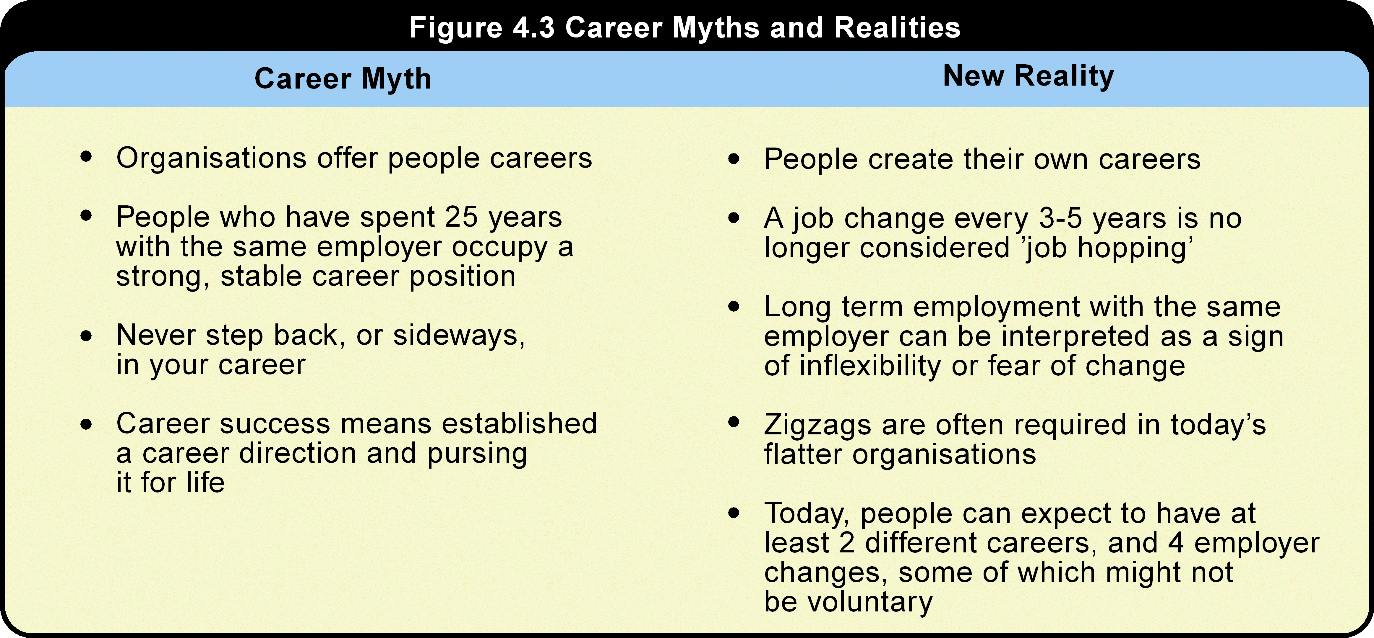
Career management or planning for individuals involves taking charge of your own career. Organisations should encourage employees to take charge of their own careers. Organisations may no longer be able to offer job security, or the traditional ‘job for life’, however, they should offer individuals the opportunity to develop and maintain marketable skills, by providing employees with a range of learning experiences. These skills, and the associated experience and flexibility that multi-skilling offers, should be of benefit to the organisation. They should also benefit the individual, who would be better prepared to find new employment should their current job, project, or contract end.
  - Theory of organisational careers
There is a very large body of literature relating to careers. This section starts with the structure of organisations and how they contribute to different types of careers, including traditional, current, and future options. Then the section focuses on theory underpinning hierarchical career structures, and how these structures contribute to motivation. Finally individual factors are addressed including individual differences, career stages, and career transition strategies.
    - The structure of organisations provides for different career types
The main point here is that organisational structure provides avenues for different types of careers. Kanter, (1989a; 1989b; 1991) identified three dimensions on which career opportunity types can be distinguished, and to these three dimensions a fourth dimension – limitations on achievement – may also be added.
Table 4.6 shows how the four dimensions relate to bureaucratic, professional, and entrepreneurial career opportunities. The bureaucratic type has been the traditional model for managers’ careers in organisations.
Table 4.6: Three career opportunity types on a four dimensional typology

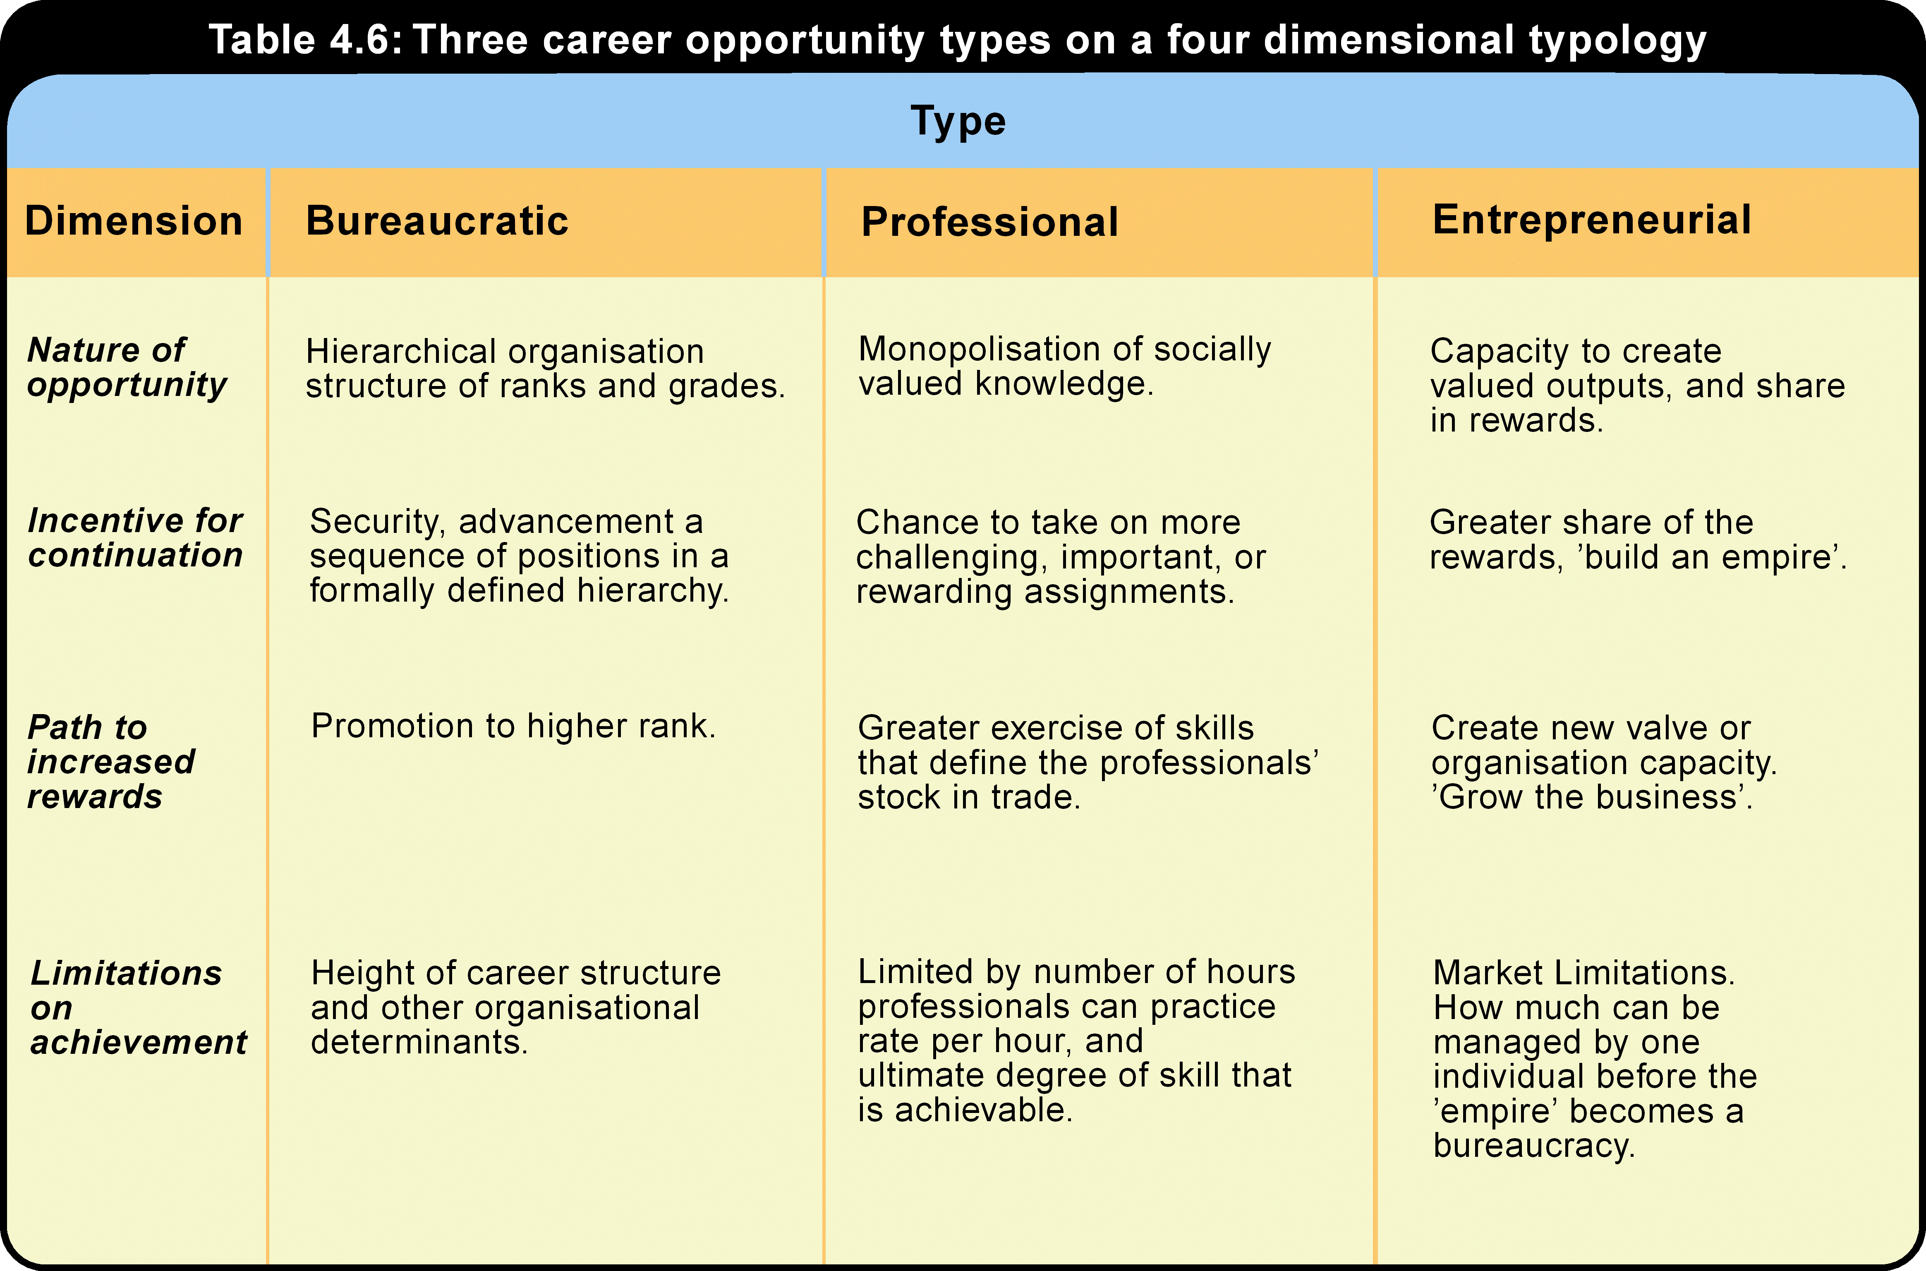
There have, however, been recent shifts in the nature of organisations in western society and these have had implications for career opportunities (Kanter 1991). Organisation theory supports the view that changes in the structure of organisations have driven changes in managerial career structures. Existing hierarchical firms are tending towards flatter structures through downsizing and delayering, and new organisations exhibit structures that are different from the traditional hierarchical pyramid. Predictions that there will be a move away from bureaucratic career types (associated predominantly with the industrial revolution) (Kanter 1989a; 1989b) have to some extent been confirmed by the literature on downsizing in large organisations, which suggests that the move away from bureaucratic career structures is occurring in some contexts (Littler, Bramble & McDonald 1996; Littler, Dunford, Bramble & Hede 1997).
Learning activity 4.3
Reflect on the structure of your organisation. A discussion forum has been set up in the course website on USQConnect. Please contribute to this discussion while considering the following three points.
- Has it changed over recent years?
- Have there been implications for careers as a consequence?
- Has this had any effect on you personally and your career satisfaction?

    - Career structures in hierarchical organisations
The bureaucratic career that takes place within organisational hierarchies is the perspective from which managers’ careers have traditionally been studied (Stewart 1963; Kanter 1991; Inkson 1995). Bureaucratic career structures are prime determinants of employee behaviour (Glaser 1968), and therefore are a significant field of study because they have implications for productivity and performance. This section will examine this career type in more detail, using the concept of career structures.
Hierarchical career structures are separate organisational entities which are independent of the individual. They are defined following Wilensky (1960) with the emphasis on jobs in organisations, not individuals in jobs. That is:
a career, viewed structurally, is a succession of related jobs arranged in a hierarchy of prestige, through which persons move in an ordered, predictable sequence.
(Source: Wilensky 1960, p. 127)
In other words, organisational career structures are a series of jobs that exist independently of the person holding the job at any given moment.
The theory that vertical career structures provide the motivation that binds employees to bureaucratic organisations and gives them incentive to perform has been the basic underpinning of much research into careers in organisations. Early writers defined career structures as organisational strategies for eliciting output from employees. For example, career structures in organisations.
is a system for motivating white-collar workers to put forth effort and maintain membership in bureaucratic organisations, based on the employees’ subjective perception of future rewards awaiting them upon promotion to positions of higher rank.
(Source: Stinchcombe 1974, p. 124)
This definition encompasses notions of loyalty and career expectations. These are significant HR and career variables that are influenced by organisational strategy and will be referred to at several points in the module.
In theory, bureaucratic structures will work better as motivational systems when they are perceived by employees to be growing. A growth rate of three percent per annum should double the promotion rate (Stinchcombe 1974). That is, organisations do not have to be growing rapidly to ensure that promotion is a realistic expectation. Recent research has demonstrated that periods of growth do lead to higher promotion rates (Hurley & Sonnenfeld 1995). However, hierarchical organisations are not currently growing, resulting in limitations on career structures (Marchant 1998).
Managerial careers have typically been analysed in the context of internal or organisation-based labour markets (Osterman 1984; Kramar 1990). Internal labour market theory argues that labour markets are constructed within organisations to manipulate employees’ consciousness (using rewards and security) in order to extract labour power (King 1990). Internal labour markets have several administrative rules and procedures that govern entry to, progression within, and access to training provided by, organisations (Doeringer & Piore 1971).
  - Individual careers theory
This section will review theory on individual differences, individual-organisation fit, and the career transition cycle.
    - Individual differences
The notion of individual differences can be found in both career psychology and sociology, even though the concept is normally attributed only to psychology. In psychology, trait-factor theories dominate.
Trait-factor theories are based on Parsons’ (1909, in Betz, Fitzgerald & Hill 1989) concept of ‘matching men and jobs’. Traits are stable characteristics of individuals that can be matched to characteristics of jobs to provide fit or congruence between the two. Factor analysis reduces the number of traits to the smallest number of underlying dimensions. Traits consist of abilities (specific or general cognitive abilities), and vocational interests, needs and values. Matching or congruence is based on the connection between abilities and job performance; between interests and values; and between job satisfaction and motivation (Savickas & Lent 1996).
The most enduring trait-factor approach is Holland’s (1985) theory of vocational types, which still forms the basis of much careers research and practice (Savickas & Lent 1994). Holland describes six vocational types that can be used to classify both individuals and occupations on two dimensions; people oriented versus non-people oriented, and intellectual versus practical. The six types are realistic, investigative, artistic, social, enterprising and conventional, and are typically represented as each forming one side of a hexagon. In this context, it would be expected that the conventional, social, and to a lesser extent, enterprising, types would characterise managers’ career preferences and traits.
    - Individual – organization fit
Organisational variables also need to be considered along with individual differences. In contrast to the trait-factor theories exemplified here by Holland, other individual difference approaches take account of a range of organisational variables that extend beyond the characteristics of the job or occupation. Schein’s work is a good example of this organisational emphasis and will be discussed next.
Career anchors
The theory of career anchors (Schein 1978) is unusual in that it represents an attempt to integrate ideas on individual difference, with ideas of career development over time (Dalton 1989). There is a degree of consistency in individuals’ orientation to their work that explains their career patterns, even when there is no apparent consistency in their externally observed career paths. The patterns are called career anchors (Schein 1978), developed as a result of individuals having had some work experience, and taking into account individual preferences for different organisational settings (Schein 1978; 1996). The career anchors are as follows:
- Technical-functional competence: individuals in this group are not oriented to managerial careers as such, but want to develop and be challenged within their particular area of know-how or competence.
- Managerial competence: individuals with this anchor want to climb corporate ladders, exercise large amounts of responsibility, and link their own achievement to organisational achievements. This anchor matches the bureaucratic career type above.
- Security/stability: this group is interested in stability; that is, settling down in one organisation or within one geographic location. Again, this anchor would be expected to be found among individuals in bureaucratic career systems.
- Creativity: this anchor describes the entrepreneurs, those who want to create a company, product or service by themselves.
- Autonomy and independence: these individuals want to work for themselves, rather than in large organisations, and establish autonomous roles such as professor or consultant. This anchor might be observed among individuals in the professional or entrepreneurial career types.
- Service, challenge and lifestyle: these three new career anchors were added to the typology in the 1980s to account for increased diversity in the workforce (Schein 1996). Service could be associated with the professional career type, but is probably better associated with other types of careers that are not addressed by Kanter’s typology. Challenge could be associated with any of the career types described above, but may also be separate. Lifestyle is an issue that will be addressed below.
Career concepts
An alternative typology of individual characteristics, in combination with organisational features, produces career patterns called career concepts (Driver 1982, in Dalton 1989). There are four ‘career concepts’ that underlie a person’s thinking about their career, but which also relate to organisational properties. In contrast to career anchors, these concepts specifically address career mobility. The four career mobility concepts are:
- Transitory: no set job or field is permanently chosen and the pattern consists of job and occupation-hopping. In early conceptions of careers, this pattern would not be recognised as a career; however, it is recognised today in terms of flexibility and will be discussed below.
- Steady state: a field is selected early in life and the person stays in this field. This pattern might characterise individuals in professional career opportunity types.
- Linear: a field is chosen early in life and a plan for upward progress through the field is developed. This pattern resonates with the bureaucratic career type.
- Spiral development: pursuing a career in one field for a certain period and then moving to a different job or even a completely new field, where further development occurs.
Career transition strategies
Both the career anchors and the career concepts described above have some implications for the trajectory and mobility aspects of managerial career paths. There are different types of mobility, including three career transition strategies (Gunz 1989). They are:
- Building: operating in one dominant career model within one organisation. This strategy has been elaborated as developing either a traditional generalist career into management, or a specialised career within one of the organisations’ functions. Again this strategy would be equated with the bureaucratic career opportunity type (Fish & Wood 1993).
- Searching: abandoning one climbing frame for another (that is changing organisations) in pursuit of a better occupational outcome, which could be aligned with a spiral career concept.
- Subsisting: abandoning the climb, or being abandoned, being plateaued, or viewing a job as just a means to other ends. This would not constitute a career under the definition adopted in this module.
    - The transition cycle
It has been typical for managers to change jobs approximately every two years in Australia in the 1980s and 1990s (Marchant 1998). These changes or transitions are often within the same organisation. Nicholson and West (1998) proposed a transition cycle as a model for this job change process.
There are four stages in the transition cycle model, labelled preparation, encounter, adjustment and stabilisation. Preparation or anticipation is about arriving at a state of readiness for change. The encounter phase is concerned with the shocks and surprises of the first contact with the new situation, and with the emotional coping that is required. Adjustment involves evaluating and then minimising any degree of misfit by the person between themselves and the job, either through role innovation or personal change. Stabilisation involves a period of settling in and embodies preparation for the next round of transitions. The fourth stage leads directly into another round of preparation. Stabilisation is short lived, as it flows relatively quickly into preparation for the next job change. These cycles of change repeat themselves in managers’ careers, for example within three years on average in the United Kingdom (Nicholson & West 1988), and two years in Australia (Marchant 1998).
In times of transition, managers are able to call on their fundamental social and intellectual skills to survive and perform. Such skills have been developed through a range of experiences and transitions, and enable them to successfully negotiate subsequent transitions (Nicholson & West 1988). This observation is important in considering the future of careers for managers, since it provides some evidence that managers may be able to cope in times of organisational turbulence despite the question raised above about the intractability of individual traits. Turbulence will be considered in the next section.
Learning activity 4.4
Think also about career concepts and career transition strategies. How relevant are these ideas to you, given the patterns in your career?

  - The changing nature of work
This section introduces you to the broader context in which change to organisations, and particularly to careers, is taking place. At the end of this section, you should have a good overview of the main macro elements affecting careers, and have some ideas on how these elements are operating in your particular situation. The purpose of providing this overview is that an appreciation of the wider change forces that are affecting societies and economies can give a better insight into changes that are happening at a local level – that is in your organisation or in your career. In addition, this material is relevant to understanding the particular context in which leaders and managers are required to operate and, therefore, there are implications for the practice of leadership and management.
Reading activity 4.8
Selected reading 4.8: Marchant, T 1998, ‘The changing nature of work’, pp. 41–56.

Learning activity 4.5
Using the seven change influences shown in figure 4.4, make a list of all the more detailed change influences discussed in Marchant’s reading.
Looking again at each of the many change influences, consider whether or not each one applies in your particular situation. If yes, in what way? If not, do you have any comments on why not?

Figure 4.4: A simple framework for categorising change influences
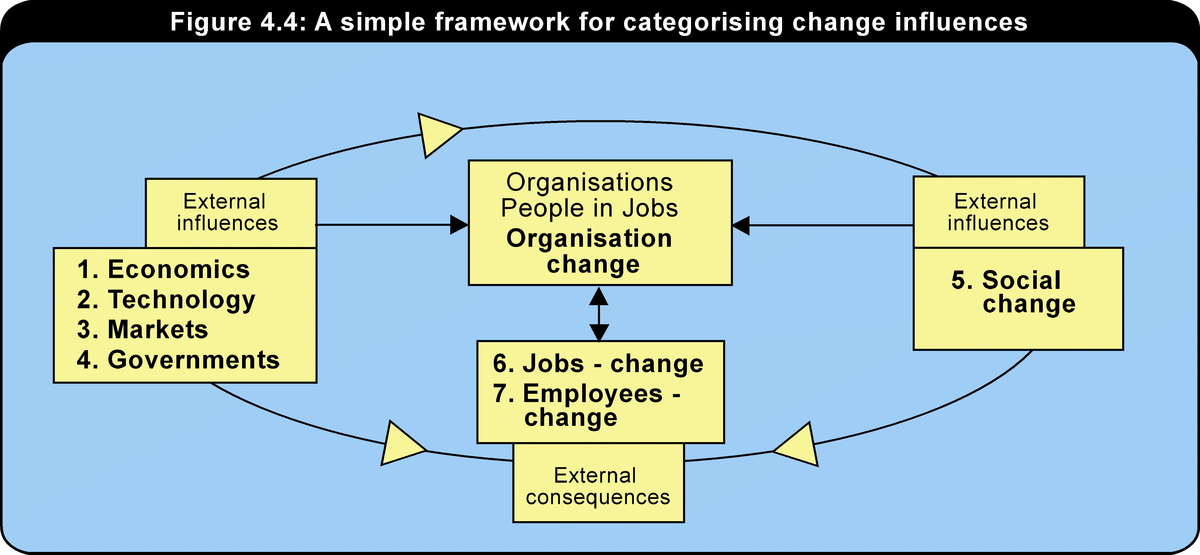
(Source: Marchant 1998,‘The changing nature of work’.)
Having reviewed the context in which changes are taking place, this module will now move on to examine how this turbulent environment is affecting careers.
    - Organisational turbulence and trauma that affects careers
This section will look specifically at the career effects of current organisational turbulence.
Reading activity 4.9
Selected reading 4.9: Marchant, T 1999, ‘Managers’ careers in the context of organisational turbulence’.
The main implications for managers’ careers, as highlighted in the reading by Marchant, can be summarised as follows:
- New trends are affecting managerial positions, and now managers are no longer protected from redundancy.
- The shifts from manufacturing, to services, and ultimately to the knowledge economy demand new skills of managers.
- The shift from large to smaller organisations also demands different skills, and presents different types of careers.
- Job security, training, and upward promotion are all fewer in both restructured large organisations, and smaller organisations.
- Although downsizing may not achieve organisations’ objectives, it still has a significant, negative impact on managers’ careers.
- There is an accompanying loss of organisational commitment and career satisfaction.
- Managers have demonstrated increased career mobility, changing jobs (but not necessarily employers) every two years on average.
- There has been an increase in the incidence of managers being retrenched, and career moves are more likely to be sideways, compared to the frequency of upward moves in earlier times.

Learning activity 4.6
- What has been your experience of redundancy? It may not have happened to you, but it has occurred in about half of larger Australian organisations.
- What are your observations of the process, how it was carried out, and the effect it had on people?

Two possible factors that have contributed to the demise of managers who have been retrenched were a lack of previous career mobility – that is, not changing jobs, and secondly, a lack of learning – that is, a failure to carry out sufficient developmental activities. Are you ‘guilty’ of either of these two? If you are, it does not necessarily mean your head is on the chopping block! However it may be advisable to consider what you can do to boost your employability. This issue will be discussed in more detail shortly. At present, look at the following checklist of activities taken from Marchant’s (1998) survey, and indicate which ones you have completed last year, or are planning for next year.
Learning activity 4.7
For the following activities, indicate whether you are involved in them this year and whether you are planning them for next year.
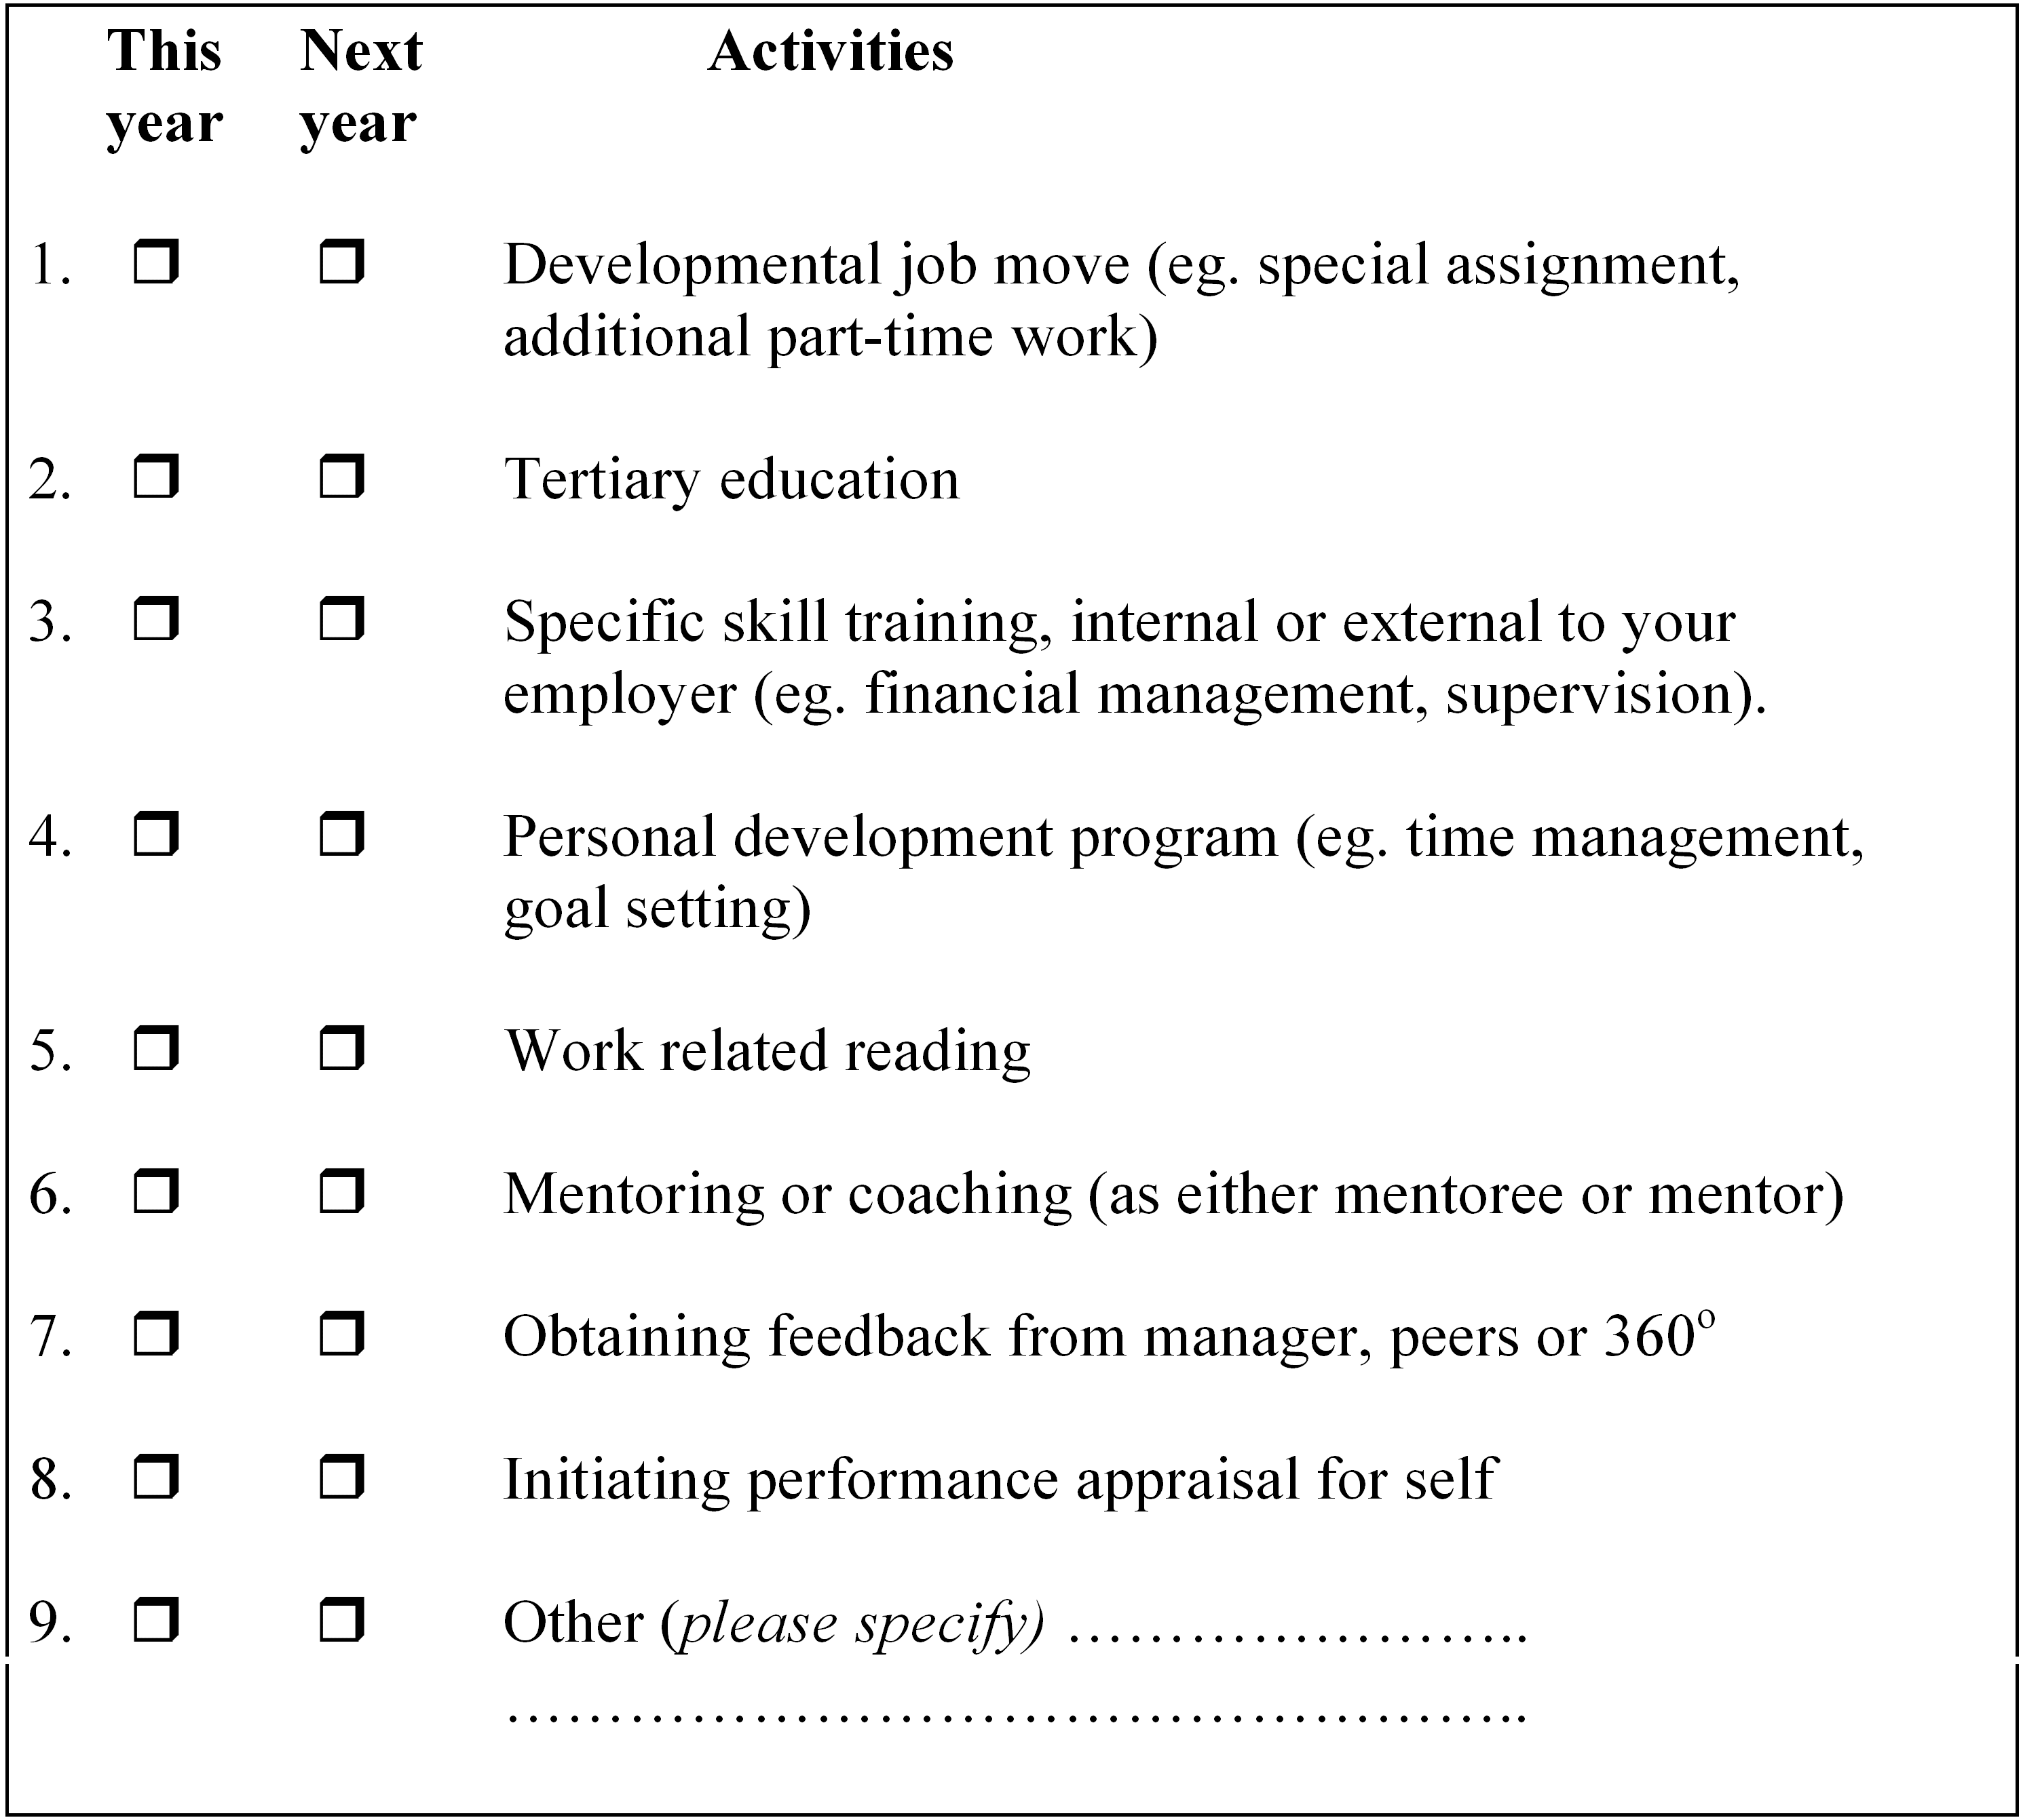

(Source: Marchant 1998, ‘The effect of organisational restructuring on managers’ careers in Australia’.)
Marchant’s work showed that on average Australian manager’s ticked seven activities, when asked what they had done in 1996 and or were planning in 1997. Are you therefore average, above average, or below average? Consider the items which you ticked – how these items relate to your career play? Then consider the items which you did not tick – should these activities be part of your plans for the next year and how might they positively influence your career plan?
  - Personal and career competencies
This section will involve you reviewing your own career in more specific detail. First there is a flow chart showing how the career planning process can be carried out on an individual basis. Next, the list of many of the career competencies that are needed in a turbulent environment is provided so you can self-assess your own career competencies. Then an explanation is provided on how these competencies relate to the leadership and team competencies that are also part of other modules in this course.
Ball (1997) describes a career planning cycle based on exploration, planning, acting and review. Figure 4.5 provides an alternative approach that you may find useful. This conception of career planning indicates that initially there are two strands of action in a personal career planning program: an internal or subjective focus, in which you assess yourself, your competencies, your likes and dislikes; and an external or objective focus, where you investigate the external world, the opportunities available, likely obstacles and requirements and so on. At some point these two streams intersect, and this is where you match up yourself with the available and suitable opportunities. Decisions need to be made at this stage and, following this, the usual job search activities take place. We say usual, although this may not be usual, if you have held the same job in the same organisation for many years and have never had to go through the job search process. However, you can do some analysis by benchmarking yourself on the competencies that are required for managers to maintain employability.
Presentation
See and hear this illustration explained.

Figure 4.5: A personal career planning flowchart
Play
Learning activity 4.8
Go through this table now and identify the relevance of these competencies to your situation by answering the following questions:
- How would I currently rate on this element, on a scale from 1 to 5 for my current or future career?
1 = no importance or need, 2 = low importance or need, 3 = some importance or need, 4 = great importance or need 5 = very great importance or need
- What do I need to do to acquire this competency?

Interactive activity
See and interact with this table. This link takes you to Interactive table 4.7. Fill in the blanks and print this out for your records.

Table 4.7: New expectations advise managers to maintain employability – How do you rate in these areas?
Competencies | Importance |  |  |  |  | What needs to be done to acquire this
 | 1 | 2 | 3 | 4 | 5 | competency?
Project Team competencies
Do you have the competencies to be hired for project teams that will be disbanded when the project is finished?
Lateral career move competencies
Are you prepared to move along a horizontal ladder?
Competencies to deal constructively with job instability
Do you accept that you will not have a lifetime career with one employer?
Are you prepared to change jobs often?
Are your job search skills up to date?
Notions of change and flexibility
Are you prepared to cope with change?
Do you thrive on ambiguity?
Are you prepared to be flexible, adaptable, resilient, hardy and agile?
Emphasis on continuous learning
Do you know how to use information?
Do you need to develop skills to move across, and work with people from different functional areas?
Are you prepared to learn on a continuous basis?
Are you prepared to become a change leader?
Do you capitalise on new technology in your work practices?
Are you prepared to learn how to work in teams, and demonstrate better communication and interpersonal skills?
Employability/career orientation
Do you ensure that in your work you make an identifiable, value-added contribution?
Do you have an entrepreneurial, commercial, or marketing approach – think of yourself as a ‘business of one’?
Are you actively building a professional reputation, and committing to a set of professional values?
Are you prepared to accept the accomplishment of a task as the reward, not the achievement of status symbols?
Are you prepared to take charge of your own career, be self-reliant?

    - The future and you – career dreams, goals and strategies
The personal career planning flow chart shown in 4.5 above represents the standard ‘vocational guidance’ process for assisting people to choose, or change careers. The activity you carried out using table 4.7 above represents part of the first step – self assessment, which has an internal focus. Another important part of this process is to consider the future. Different individuals approach this task differently. Some of you will set very definite goals, with time frames attached, and develop a structured logical plan for achieving these goals. Others may approach it in a more holistic fashion, depending on personal preferences and beliefs. In either case, as a manager or leader interested in personal and professional development, it is important to have some view, vision, or goal for your future career, and some time should be invested in developing this vision or goal.
There are many good resources available which provide more detailed guidance in this regard, and some of these can be easily obtained from many libraries. The main purpose of the career development sections in this module is to introduce you to new material about how careers are changing and the impacts on enhanced individual and organisational performance. This material can then be used in conjunction with the more established or conventional career planning represented in currently available sources.
  - Additional issues for career development
The remainder of this module raises several different career development topics and poses questions which are intended to encourage you to think about the issues – in terms both of how they might impact upon your individual career development and how they might impact upon those individuals whom you might supervise as a manager. In particular, there is a focus on the developmental aspects that might be addressed within each of these topics.
    - Career and family – is balance possible?
There are a number of specific career issues relating different situations and needs for men and women and also relating to dual career couples. Employees who face conflict between work and family are three times more likely to think about quitting (US National Study of the Changing Workforce).
Career development of men and women
Key questions
- What are the main differences between the career development of men and women, according to the literature on career development?
- What are the barriers to career progression for women?
- What can organisations and individuals do to overcome these barriers?

Dual career couples
In the contemporary environment, it should not be assumed that ‘dual career couples’ are a ‘male and female’ combination. However, based on data that is available, 58% of Australian married couples are dual earner couples. Dual career couples are also increasingly prevalent and organisations and individuals should not assume that the woman will always be the ‘trailing partner’ if one person in a dual career partnership is transferred or relocated. Problems are also associated with refusing relocations, and an unwilling trailing partner can result in costs to the organisation.
Key questions
- What are ‘dual career couples’?
- How prevalent are they in Australia and overseas?
- What are the HRM issues involved with dual career couples? Consider this question in terms of all of the HR functions – recruitment and selection, promotion, remuneration, relocation, etc.
- How have different organisations and couples dealt with the difficulties associated with their situation?

Balance and lifestyle
One of the theoretical underpinnings for a study of balance and lifestyle is the question of the different work values of individuals. What individuals seek from their careers varies quite widely, and this needs to be taken into consideration in any discussion of balance. The other interesting aspect of this topic is the variation between different generations entering the workforce. Successive cohorts of new younger workers are said to have different values. These are important factors to be considered, both in your own decisions about what balance represents for you, and equally important for those employees or individuals that you are managing or leading.
Key questions
- What are the implications of different work values for a ‘balanced’ lifestyle?
- What does a balanced lifestyle mean? Is this definition affected by contextual factors? (e.g., age, culture, gender).
- How prevalent are individuals who really do enjoy a balanced lifestyle?
- What are the implications for organisations, when employees are committed to a balanced lifestyle?

    - Older workers careers
This is a topic where there is a lot of opinion amongst managers, and not a great deal of fact.
Key questions
- How do older workers differ?
- Do employers discriminate against older workers? If yes, how?
- How can employers capitalise on older workers’ strengths?
- How should the careers of older workers be managed, by themselves, and by organisations?
- Should there be a compulsory retirement age?

    - Retrenchment – carrying it out, avoiding it, coping with it
Key questions
- What are the main issues in executing retrenchments in organisations?
- What areas of potential conflict are there, when this process is carried out, between the organisation’s perspective, and the needs of individuals? Is it possible to reconcile them?
- Given the general lack of success of downsizing in achieving organisation’s objectives, how justifiable is this process?
- How can you ensure that the individuals are able to retreat with ‘dignity and grace’?

    - Establishing or adapting organisational career management systems for turbulent times
Career management systems in organisations have attracted considerable attention in the literature in the face of organisational restructuring. Firms have been urged to ameliorate the effects of the new organisational environment on their employees, by introducing or improving career management systems, in order to help employees find other developmental opportunities.
Key questions
- What are the principles of career management in organisations?
- How relevant are these principles in the current turbulent environment?
- What is the relationship between career management and effective organisational performance?

Summary
The world of work has changed dramatically in the last decade. The conventional notions of career no longer apply. Today’s and tomorrow’s careers are going to be ‘boundary-less’. That is, they will not be constrained to one organisation. To cope with a boundary-less career, employees are going to need to make a continuous investment in their own learning. Organisations are going to need new and faster ways to train and develop groups of employees who may not remain in the organization for extended periods of time.
Careers are generally thought of as attributes of individuals. However this module showed that they are also characteristics of, or determined by, organisational structures, and as these structures change so do the career options open to individuals. The conventional, hierarchical organisational structure has been the standard model for managers’careers, but this is giving way to lateral and other forms.
In terms of individual careers theory, key concepts included individual differences and, more importantly, how these individual differences relate to aspects of organisations, in terms of individual-organisational fit. Concepts of career stages, where individuals’ behaviour is expected to be different, depending on age, and career transitions, which are happening more frequently, were also addressed.
Many elements of organisational turbulence are affecting careers in the contemporary environment, including organisational restructuring, and an increased emphasis on competitiveness and performance as well as flexibility and adaptability at both organisational and individual levels.
The old management functions and capabilities are no longer sufficient for individuals to survive and prosper in this environment. Managers and leaders in the new millennium will need a whole range of new and additional competencies which particularly include taking responsibility for their own careers.
In terms of current issues in careers, the module pointed to the work life versus non work life elements of careers, which encompass as sub-issues career development of women, dual career couples, and balance. Other current issues include the fate of older workers, the expansion of opportunities for international careers with the globalisation of the economy, and the unique career implications of the recent dramatic increase in managerial redundancy. Finally, not only individual leaders and managers, but organisations as a whole, need new career management strategies for turbulent times.
  - International HRD – diversity & culture
The field of international HRD is still immature. However, one of the seminal pieces of writing in this area was by Iles (1995 in Stewart & McGoldrick 1996, pp. 71–97). The following, taken directly from that source, provides a good overview of the key issues involved in international HRD.
…the increasingly global nature of business activities has placed new demands on organizational and managerial performance. International assignments are being increasingly used for not only staffing, control and representational purposes but also as vehicles to develop managers’ skills and knowledge and as ways of enhancing organizational learning and capabilities. Many managers are involved in managing transnational ventures, mergers and acquisitions, and are operating in increasingly diverse environments with multi-cultural teams. Senior managers are often called upon to manage geographically and culturally diverse businesses, balancing the demands of global integration and centralization with those of local sensitivity and responsiveness. HRD strategies therefore have a key role to play in ensuring that:
- organizational structures and systems enhance global effectiveness, enabling both global and local responsiveness
- organizational cultures are fostered which value diversity and difference whilst creating a sense of unified mission and acting as the ‘corporate glue’
- personnel systems attract, place, retain and develop managers with the knowledge, skills and attitudes required to perform effectively in a global business environment.

(Source: Stewart & McGoldrick (eds) 1996)
However, the importance of diversity and culture is not only relevant in the international sense. The following section is based upon e-mail communication with Don Clark (aka ‘Big Dog’).
One of the great challenges facing organizations is getting ALL employees, from the CEO to the casual and part-time workers, to realize that to become 'the best’ they have to embrace diversity.
Why is embracing diversity a challenge? Because our bias and prejudice are deeply rooted within us. Since early childhood, our families, friends, peers, and idols have influenced us on what ‘is right’. Simply teaching a session on diversity will not erase these beliefs. Indeed, even the best training will not erase most of these deeply rooted beliefs, but simply will help us to become aware of them so that hopefully in the future they do not hinder us on our way to becoming the best. Training diversity is more than a two-hour class; it involves workshops, role playing, and plenty of one-on-ones. It involves a heavy commitment by the leaders of the organization.
Why do we need to become the best? If an organization does not take on this challenge, it will become extinct. There are too many competitors who are striving to become the best. Those that are the best must continue to strive to be the best or they will be overtaken, e.g. IBM, Sears, General Motors. At the present, I [Don Clark] work for the best gourmet Coffee Company in the world, Starbucks Coffee Company. But we do not sit around patting ourselves on the back because we know that there are dozens of others who want to take our place. We do, however, at select times celebrate our accomplishments and achievements.
Why embrace diversity? Simply enforcing government regulations will not get you to being the best. You must be willing to use the full potential of every individual to create great work teams in order to obtain a competitive edge. Teams are much more than a group. A group is collection of individuals, where each person is working towards their own goal. While a team is a collection of individuals working towards a common goal or vision. There is a synergy effect with teams, that is, one plus one equals more than one. An individual, acting alone, can accomplish much but a group of people acting together can accomplish great wonders. This is because team members understand each other. By using the synergy effect of teams you create a competitive advantage over organization using people acting alone.
What has all this to do with HRD? Most problems in the workplace are NOT that people cannot do their jobs. It is that people cannot get along with other people. People are hired on the premise that they can perform the job, or with a reasonable amount of training, be coached into performing the job. Except for some basic information about the organization and perhaps a course or two on safety and computer networking, most training given to new employees involves on-the-job (OJT) training. Normally this involves very little effort from the Training and Development department (T&D) as supervisors, leading hands, peers, etc conduct OJT. Actually, T&D should become more involved in the OJT process, e.g. providing coaching classes for the trainers and creating training aids. Otherwise, people spend wasted hours in OJT because their trainers have not received basic training, coaching, and learning skills. Effective training is good for the organization as it creates people who are prepared to carry out the mission of the organization, while bad training simply wastes money that could be better spent on others goals to become the best.
Why is it that people cannot get along with other people? Diversity! Not just black vs. white, female vs. male, homosexual vs. heterosexual, Jew vs. Baptist, young vs. old; but the diversity of every individual, slow learner vs. fast learner, introvert vs. extrovert, controlling type vs. people type, bookworm vs. sport person, left-wing vs. conservative. This is where T&D needs to focus its efforts...helping people to realize that it takes a wide variety of people to become the best and that they need to have some understanding of what human nature is all about.
An organization needs controllers, thinkers, dreamers, doers, organizers, team builder’s etc. to reach the goals that make an organization the best. Having a group of team builders will get you nowhere, as everyone will be out trying to create a team. Likewise, having a group of doers will get you nowhere as everyone will be trying to accomplish something without any clear goal to better the organization. Most organizations picture diversity in very limited terms. The essence of diversity should NOT be to picture diversity as race, religion, sex, age etc. BUT to picture it that every individual is unique.
Culture matters. Organizations have to realize that the many cultures of the world are their potential customers. Not too long ago, many businesses focused on young and/or middle age white classes. This was where the money was. Now, thanks to great efforts towards recognizing the many facets of diversity and the good that it brings us, the money is in the hands of people of all colors, religions, cultures, etc.
In order to attract a wide variety of cultures, organizations MUST truly become multi-culture themselves. They can no longer just talk the talk; they must also walk the walk. Organizations that only employ ‘people of their kind’ in leadership positions will not be tolerated by people of different cultures. These other cultures will spend their money on organizations that truly believe in diversity.
Embracing diversity has several benefits for the organization:
- It is the right thing to do. Organizations must take the moral path in order to attract good people into their ranks.
- It helps to build teams that create synergy
- It broadens their customer base in a very competitive environment.

Goals of HRD. All leaders and movers within an organization must be visibly involved in programs affecting organizational culture change and evaluating and articulating policies that govern diversity. To do so display leadership that eradicates oppression of all forms. The result is enhanced productivity, profitability, and market responsiveness by achieving a dynamic organization and work force. This is the first goal of HRD, to train the leadership.
The work force wants to belong to an organization that believes in them, no matter what kind of background they come from. They, like their leadership, want to be productive, share in the profits, and be a totally dynamic work force. If HRD achieves the above goal, this goal will be relatively easy.
Training Diversity. The training of diversity is considered a soft skill. Unlike hard skills, soft skills are relatively hard to put into measurable learning objectives. For example, ‘Using a calculator, notepad, and pencil, calculate the number of minutes it will take to produce one widget.’ This hard skill is easily measured in the classroom. Now, consider a soft skill, ‘After the training period the group will be able to perform as a team.’ This cannot easily be measured in the classroom. Its true measure must be taken in the workplace. This is because this type of training falls more under development and education. For a quick review of the three terms:
- Training is the acquisition of technology that permits employees to perform their present job to standards. It improves human performance in the job that the employee is presently doing or is being hired to do.
- Education is training people to do a different job. Unlike training, which can be fully evaluated immediately upon the learners returning to work, education can only be completely evaluated when the learners move on to their future jobs. We can test them on what they learned while in training, but we cannot be fully satisfied with the evaluation until we see how well they perform their new jobs.
- Development is training people to acquire new horizons, technologies, or viewpoints. It enables leaders to guide their organizations onto new expectations by being proactive rather than reactive. It enables workers to create better products, faster services, and more competitive organizations. It is learning for growth of the individual, but not related to a specific present or future job. Unlike training and education, that can be completely evaluated, development cannot always be fully evaluated. This does not mean that we should abandon development programs, as helping people to grow and develop is what keeps an organization in the forefront of competitive environments.
HRD practitioners must picture themselves not only as trainers, but also as Educators and Developers.

(Source: Stewart & McGoldrick (eds) 1996)
Presentation
See and hear this illustration explained by clicking on the play button.

Learning activity 4.9
This is a multiple choice quiz based on the materials covered in this module. Please click on ‘start quiz’ to proceed.
Module 4 quiz.
See if you can remember the order of events within the training cycle. Place your cursor on the text holding your finger down, drag and place the text into the appropriate box. If it is not right it will drop back down. If it is correct it will stay in place.
Drag and drop exercise.

Conclusion
Throughout this course we have tried to ensure that you arrive at this stage with a clear view and understanding that Human Resource Development is not just about training. It is about learning and performance development and arguably that incorporates both individual learning and organisational learning.
Performance management will need to adapt to being able to manage the performance of a diverse workforce which incorporates full-time, part-time and casual staff as well as outsourced ‘contractors’. Careers will be redefined and ‘career development’ will become more and more the responsibility of the individual.
Dedicated training roles are disappearing from many organisations although the need for continual learning and development is ongoing. The challenges and roles of HRD will increasingly be carried out by section and line managers, with expert input from key professionals (both internal and external to the organisation). This will see a heightened awareness of the importance of performance management.
Finally, the roles of coaching, mentoring, career development and diversity are important strategic HRD functions.
This course is only a small part of your ongoing learning and development. If the subject areas have captivated your interest and you are considering post-graduate studies, please contact either of the course team members to discuss possibilities for further study in HRD.
If you are particularly interested in the further education and training aspects, the Department of Further Education and Training in the Faculty of Education at USQ have a range of courses (both academic and certifications).
You should now focus your attention on preparing for the examination. The structure of the examination is outlined in the assessment section of your introductory book.
No previous examination papers are available. However, the course leader will post practice questions on the USQStudydesk Discussion Board towards the end of the semester.
Audio
Please listen to the audio conclusion for this course.
Module 4 audio conclusion

Reference list
Allred, BB, Snow, CC & Miles, RE 1996, ‘Characteristics of managerial careers in the 21st century’, Academy of Management Executive, vol. 10, no. 4, pp. 1–27.
Applebaum, Ritchie & Shapiro 1994.
Arthur, MB, Hall, DT & Lawrence, BS 1989, Handbook of career theory, Cambridge University Press, Cambridge.
Ball, B 1997, ‘Career management competencies–The individual perspective’, Career Development International, vol. 2, no. 2, pp. 74–9.
Bartunek, JM & Kram, K 1997, ‘A group mentoring journey into the department head role’, Journal of Management Inquiry, vol. 6, no. 4, December, pp. 270–80.
Betz, NE, Fitzgerald, LF & Hill, RE 1989, ‘Trait-factor theories: traditional cornerstone of career theory’, in MB Arthur, DT Hall & BS Lawrence (eds), Handbook of career theory, Cambridge University Press, Cambridge, pp. 26–40.
Brett, JM 1990, ‘Job transitions and personal role development’, in GR Ferris & KM Rowland (eds), Career and human resource development, JAI Press, Greenwich, pp. 99–129.
Brown, TL 1990, ‘Match up with a mentor’, Industry Week, vol. 239, no. 1.
Burke, R & McKeen, C 1989, ‘Developing formal mentoring programs in organizations’, Business Quarterly, Winter, pp. 76–9.
Carruthers, J 1991, ‘The search for mentoring in business in Australia: a modern odyssey’, Mentoring International Journal, vol. 5, no. 2 and 3, Spring–Summer, pp. 24–9.
Clark, J & Koonce, R 1995, Training and development, pp. 23–30.
Clawson, JG 1996, ‘Mentoring in the information age’, Leadership and Organizational Development Journal, vol. 17, no. 3, pp. 6–15.
Dalton, GW 1989, ‘Developmental views of careers in organisations’, in MB Arthur, DT Hall & BS Lawrence (eds), Handbook of career theory, Cambridge University Press, Cambridge, pp. 89–109.
DBM 1996, ‘Report on Survey of Retrenched Executives 1995’, Sydney.
DBM Asia Pacific 1996, ‘Client Newsletter’.
Doeringer, PB & Piore, MJ 1971, Internal labor markets and manpower analysis, Heath Lexington Books, Lexington.
Edwards, L 2003, ‘Coaching–the latest buzzword or a truly effective management tool?’, Industrial and Commercial Training, vol. 35, no. 7, pp. 298–300.
Feldman, DC 1996, ‘Managing careers in downsizing firms’, Human Resource Management, vol. 35, no. 2, pp. 145–61.
Fish, A & Wood, J 1993, ‘A challenge to career management practice’, International Journal of Career Management, vol. 5, no. 2, pp. 3–10.
Friday, E & Friday, S 2002, ‘Formal mentoring: is there a strategic fit?’, Management Decision, vol. 40, no. 2, pp. 152–7.
Glaser, BG 1968, Organisational careers, Aldine, Chicago.
Hale, M 1995, ‘Mentoring women in organisations: practice in search of theory’, American Review of Public Administration, vol. 25, no. 4, pp. 327–40.
Hall, DT 1996, ‘Protean careers in the 21st century’, Academy of Management Executive, vol. 10, no. 4, pp. 8–16.
Holland, J 1985, Making vocational choices, 2nd edn, Prentice-Hall, Englewood Cliffs.
Hurley, AE & Sonnenfeld, JA 1995, ‘Career development programs in changing organisations’, in M London (ed.), Employees, careers and job creation, Jossey-Bass, San Francisco, pp. 27–48.
Inkson, K 1995, ‘Effects of changing economic conditions on managerial job changes and careers’, British Journal of Management, vol. 6, pp. 183–94.
James, P & Wark, V 1995, ‘Replacing the ladders’, People Management, vol. 11, no. 1, pp. 29–31.
Kanter, RM 1989a, When giants learn to dance, Touchstone, New York.
Kanter, RM 1989b, ‘Careers and the wealth of nations: a macro-perspective on the structure and implications of career forms’, in MB Arthur, DT Hall & BS Lawrence (eds), Handbook of career theory, Cambridge University Press, Cambridge, pp. 506–21.
Kanter, RM 1991, ‘The future of bureaucracy and h ierarchy in organisational theory: a report from the field’, in P Bourdieu & JS Coleman (eds), Social theory for a changing society, Westview Press, New York, pp. 63–93.
King, JE 1990, Labour economics: an Australian perspective, 2nd edn, Macmillan, South Melbourne.
Kram, K & Scott, K 1985, Mentoring at work, Foresman and Co., Glenview, Illinios.
Kramar, R 1990, ‘Managerial and professional employees, trade unions and industrial tribunals in Australia’, Working Paper no. 82, University of NSW, School of Industrial Relations and Organizational Behaviour, Kensington, NSW.
Levinson, DJ 1986, ‘A conception of adult development’, American Psychologist, vol. 41, pp. 3–13.
Littler, CR, Bramble, T & McDonald, J 1994, Organisational restructuring: downsizing, delayering and managing change at work, AGPS, Canberra.
Littler, CR, Dunford, R, Bramble, T & Hede, A 1997a, ‘The dynamics of downsizing in Australia and New Zealand’, Asia Pacific Journal of Human Resources, vol. 35, no. 1, pp. 65–79.
Loeb, M 1995, ‘The new mentoring’, Fortune, vol. 132, no. 11, p. 213.
Management Today 1996, ‘Chequered career path’, pp. 13–16.
Manganelli, R & Raspa, SP 1995, ‘Why reengineering has failed’, Management Review, vol. 84, no. 7, pp. 39–43.
Marchant, T, Critchley, B & Littler, CR 1997b, ‘Managers on the move’, HRMonthly,
pp. 6–8.
Marchant, T 1998, ‘The changing nature of work’, in KW Parry & D Smith (eds), Human resource management: contemporary challenges and future directions, USQ Press, Toowoomba, pp. 41–56.
Marchant, T 1998, ‘The changing nature of work’, in KW Parry & D Smith (eds), Human resource management: contemporary challenges and future directions, USQ Press, Toowoomba, pp. 41–56.
Marchant, T 1998, The effect of organisational restructuring on managers’careers in Australia, Doctoral Dissertation, University of Southern Queensland, Toowoomba.
Mattis, M 1992, ‘Breaking the glass...or just window dressing’, Management Review, March, pp. 16–22.
McKenzie, B 1992, ‘Mentoring guidelines for executive and professional women’, Australian Psychological Association, Adelaide.
McKenzie, BC 1995, Friends in high places.‘How to achieve your ambitions, goal and potential with the help of a mentor.’ The executive woman’s guide, Business and Professional Publishing, Sydney.
Mintzberg, H & Quinn, J 1998, Readings in the strategy process, Prentice International, Inc., London.
Morrissey, B & Compton, R 1996, Management, pp. 11–14.
Nankervis, A, Compton, R & McCarthy, T 1999, Strategic human resource management, 3rd edn, Nelson, Melbourne.
Nicholson, N & West, MA 1988, Managerial job change: men and women in transition, Cambridge University Press, London.
Osterman, P 1984, ‘White-collar internal labour markets’, in P Osterman (ed.), Internal labour markets, MIT Press, Cambridge, pp. 163–89.
Ragins, BR 1989, ‘Barriers to mentoring: the female manager’s dilemma’, Human Relations, vol. 42, pp. 1–22.
Ragins, BR 1997, ‘Diversified mentoring relationship in organizations: a power perspective’, Academy of Management Review, vol. 22, no. 2, April, pp. 482–522.
Ragins, BR & Cotton, JL 1991, ‘Easier said than done: gender differences and perceived barriers to gaining a mentor’, Academy of Management Journal, vol. 34, no. 4, pp. 939–51.
Richman, LS 1994, ‘How to get ahead in America’, Fortune, vol. 129, no. 10, pp. 46–54.
Rider, L 2002, ‘Coaching as a strategic intervention’, Industrial and Commercial Training, vol. 34, no. 6, pp. 233–6.
Robbins, SP, Millett, B, Cacioppe, R & Water-Marsh, T 2001, Organisational behaviour. Leading and managing in Australia and New Zealand, 3rd edn, Pearson education, French’s Forest, NSW.
Rock, D 2003, ‘Managers to coaches’, HRMonthly, June, pp. 38–9.
Rylatt, A 2000, Learning unlimited, 2nd edn, Business + Publishing, Warriewood, Australia, pp. 257–7.
Savickas, ML & Lent, RW 1994, Convergence in career development theories, CPP Books, Palo, Alto.
Schein, EH 1978, Career dynamics: matching individual and organisational needs, Addison-Wesley, Reading.
Schein, EH 1996, ‘Career anchors revisited: implications for career development in the 21st century’, Academy of Management Executive, vol. 10, no. 4, pp. 80–8.
Sheey, G 1974, Passages, Bantam Books, New York.
Stevens, P 1993, Career development support in organisations, The Centre for Worklife Counselling, Mosman.
Stewart, J & McGoldrick, J (eds) 1996, Human resource development: perspectives, strategies and practice, Pitman, London.
Stewart, RS 1963, The reality of management, Pan Books, London.
Stinchcombe, AL 1974, Creating efficient industrial administrations, Academic Press, New York.
Super, DE 1957, The psychology of careers, Harper Row, New York.
Super, DE 1994, ‘A life Span, life space perspective on convergence’, in M Savickas & R Lent (eds), Convergence in career development theories, CPP Books, Palo Alto, pp. 63–74.
Tabbron, A, Macaulay, S & Cook, S 1997, ‘Making mentoring work’, Training for Quality, vol. 5, no. 1, pp. 6–9.
Tepper, BJ 1995, ‘Upward maintenance tactics in supervisory mentoring and nonmentoring relationships’, Academy of Management Journal, vol. 38, no. 4, August, pp. 119–36.
Turpin, T & Deville, A 1995, ‘Occupational roles and expectations of research scientists and research managers in scientific research institutions’, R & D Management, vol. 25, no. 2, pp. 141–57.
Vaughn, RL & Wilson, MC 1994, ‘Career management using job trees: charting a path through the changing organisation’, Human Resource Planning, vol. 17, no. 4, pp. 43–55.
Werner, JM & DeSimone, RL, 2006, Human resource development, 4th edn, Harcourt College Publishers, Fort Worth.
Whitely, WT & Coetsier, P 1993, ‘The relationship of career mentoring to early career outcomes’, Organizational Studies, vol. 14, no. 3, Summer, pp. 419–42.
Wilensky, HL 1960, ‘Work careers and social integration’, International Social Science Journal, vol. 12, no. 4, pp. 553–8.
Yukl, G 2002, Leadersip in organisations, 5th edn, Prentice Hall, New York.
Zey, M 1984, Seizing the future: how the coming revolution in science, technology and industry will expand the frontiers of human potential and reshipe the planet, Simon & Schuster, New York.

