- Floods and flood frequency analysis
At the completion of the module, you should be able to:
- describe the standards used in designing infrastructure works relating to flood and drainage, using terms such as Average Recurrence Interval and Annual Exceedance Probability
- understand the concept of flood risk and make estimates of the risk of failure
- perform a flood frequency analysis using Annual and Partial flood series, so Design Flood discharges can be estimated.
Introduction
When they occur, floods can cause substantial economic and social damage. An understanding on how often floods occur is essential to manage the risk of flood damage and to design flood and drainage works.
  - Basic terms
For the purpose of this course, floods are defined as relatively high water levels within constructed and natural waterway systems (including creeks, rivers, estuaries, lakes etc.) caused by rainfall. Floodwater resulting when the flow discharge exceeds the confines of the waterway channel can cause significant flood damage to adjacent property and assets. Insurance companies often define flooding in these terms as part of their insurance policies.
  - Design Flood
    - Definition of a Design Flood
A Design Flood is an observed or synthetic (a devised or ‘made-up’ event) flood that is assigned a certain frequency and is used for planning or design. Inundation maps showing the extent of flooding associated with events of various magnitudes are often prepared by local authorities to identify land areas that are floodprone. The limit of flooding associated with a Design Flood can be used to define a land corridor adjacent to a creek or river where the building of houses should be restricted.
The peak discharge associated with a Design Flood is also used to design flood control works such as floodways and diversion channels, as well as major hydraulic structures including dam spillways and bridge crossings.
    - AEP and ARI of a Design Flood
A Design Flood is defined by how often (or the number of occurrences) the flood is expected to occur within a certain period of time. A large flood will occur less often than a small flood. The frequency of a Design Flood can be defined in terms of:
- Annual Exceedance Probability (AEP) which is the probability or likelihood of a flood occurring in any one year that is at least the size of the Design Flood
- Average Recurrence Interval (ARI) which is a statistical estimate of the average period of time (in years) between the occurrences of a Design Flood or larger.
A Design Flood that is commonly selected for planning and design is the 100-year ARI flood (or commonly abbreviated to Q100 flood) expected to occur on average once every 100 years. This doesn’t mean that a 100-year ARI flood will happen at regular intervals of every100 years. It is possible to have more than one 100-year ARI flood within a 100-year period, as illustrated by figure 3.1. Ten floods equal or larger than the Q100 are likely to occur during the 1000 year timespan. The recurrence interval between floods will vary, but the average of the recurrence intervals (mean of RI1, RI2, …RI9) is expected to be 100 years.
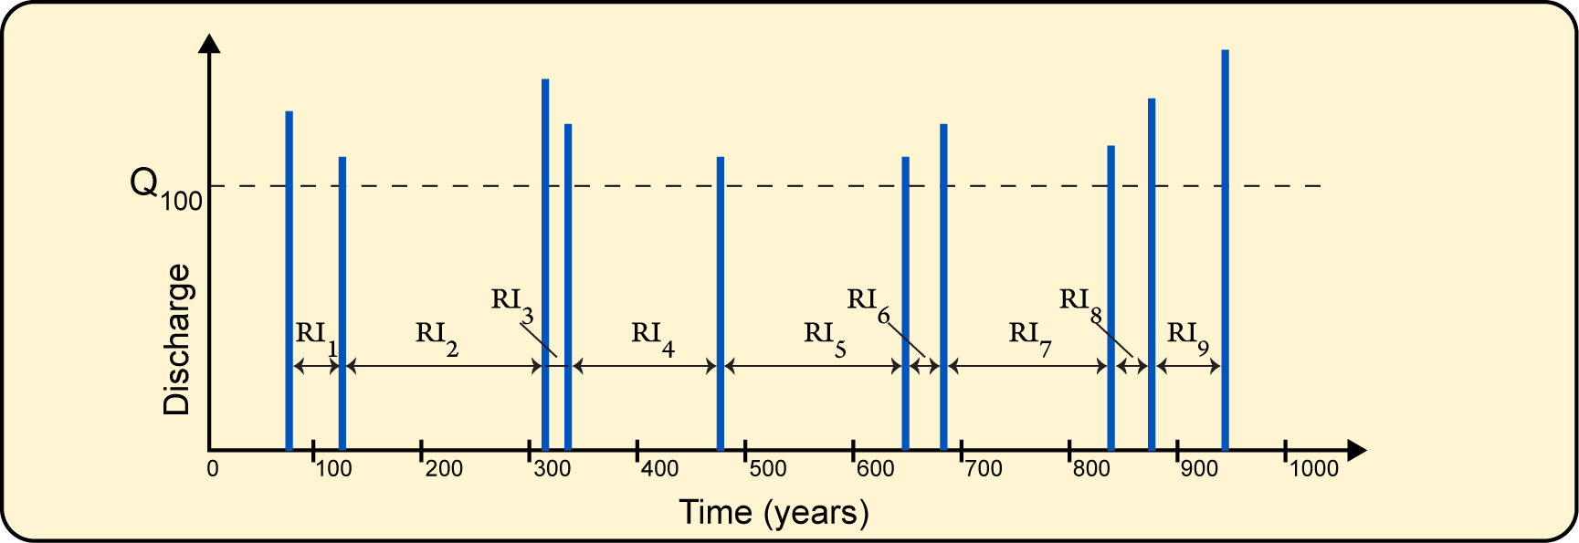
Figure 3.1: Hypothetical series of large flood events over a 1000 year timespan. Only floods larger than Q100 are plotted for clarity
In the example shown in figure 3.1, maximum instantaneous discharge is used to quantify the size or magnitude of the Design Flood. Maximum flood level or another flood property such as the duration of flooding can be sometimes used to quantify the Design Flood.
An alternative way to express the frequency of a Design Flood is the Annual Exceedence Probability (AEP), or probability that the Design Flood will be equalled or exceeded in any one year. A Q100 or 100-year ARI flood has an AEP of 1 in 100, or 0.01. In other words, the AEP is the reciprocal of the ARI:
AEP =
The AEP is conventionally expressed as a percentage, e.g. 1% AEP or as a likelihood e.g. 1 in 100 AEP.
    - AEP and risk of failure
As AEP is a probability, it can be applied to provide answers to problems often encountered in evaluating the risk of flooding. From general probability theory, it can be demonstrated that:
F = 1 – (1 – P) N
Where F is the probability that at least one flood occurring in N years has an AEP of P. In practice, F is often referred to as the risk of failure or flood risk.
Some practical examples involving risk of failure are described below.

 | Worked example 3.1 – assessing the risk of failure  Example 1  A house is for sale in a suburb that is located next to a large river. From Council flood maps of the area, the available information suggests that the floor level of the house is the same elevation as the Q100 flood level. A buyer is interested in purchasing the house as a long-term investment and is interested in determining the risk of flooding over the next 20 years.  From the above statement, we know that as it is the Q100 flood, P=1/100 = 0.01 and also N=20 years. Thus:  Risk of failure F = 1-(1-0.01)20 = 0.18  The risk equates to approximately a 1 in 5 chance that the house will be flooded at least once during the next 20 years. The potential buyer regards this risk as too high as he is unable to obtain flood damage insurance for this property and, in his opinion, flooding of the house will lead to costly repairs and cleanup.  This example highlights the situation that even though the house seems to have a high immunity against flooding, there is a likelihood of flooding if a sufficient length of time is considered.
Example 2
A dam is to be constructed within a river. A temporary diversion channel is planned to divert river flows around the construction site so the foundations can be built. The diversion channel will be costly to install, but if a flood occurs in the river and it is not diverted then extensive damage to the foundations is expected. Foundation construction is scheduled to be completed within a 2-year timeframe. A cost analysis has been completed and it is decided that an acceptable level of flood risk for the project is 1 in 10 (or 10%). To what Design Flood should the diversion channel be able to handle?
From the above statement, we know that F=0.1 and N=2. Thus:
0.1 = 1- (1-P)2 or P = 1-(1-0.1)0.5 = 0.052
The AEP of the Design Flood is 5% (rounded down to the nearest percent), which is equivalent to an ARI = 1/0.05 = 20 years. Thus the diversion channel should be designed to have at least a hydraulic capacity to convey the Q20 or 1 in 20 AEP flood.

    - Selection of an appropriate Design Flood
As demonstrated by the above example 2, selection of an appropriate Design Flood should weigh up the cost of implementing the design and the consequences of failure. Ideally, selection of the Design Flood would maximise the net benefit, i.e. the difference between the benefit (expressed as a dollar value) and the cost of implementing the design. The benefit would include a reduction in flood damage and less social and economic disruption that may also be caused by flooding. It is often difficult to assign a monetary value to these benefits.
A higher Design Flood would typically lead to a higher cost to implement the design. As would be the case for most engineering projects, further increases in the size of the Design Flood would escalate the cost but the increment in benefit may be small (in other words, the ‘law of diminishing return’ would arise). So, the selection of an appropriate Design Flood is often an uncertain process.
Due to this uncertainty, a generic approach is often adopted where the Design Flood is chosen based on the type of infrastructure. A range of standard Design Floods used in Australian practice are given in table 3.1 (adapted from Ladson 2008).
Table 3.1: Standard Design Floods used in Australia
Type of infrastructure | Typical AEP range
Major dam spillways | 1 in 10,000 to 1 in 1,000,000
Minor dam spillways | 1 in 100 to 1 in 1000
Flood mitigation | 1 in 20 to 1 in 100
Major bridges or culverts | 1 in 50 to 1 in 100
Minor bridges or culverts | 1 in 5 to 1 in 50
Minor stormwater works (gutters and pipes) | 1 in 5 to 1 in 10
Major stormwater works (flood channels and floodways) | 1 in 50 to 1 in 100
Road reserves | 1 in 2 to 1 in 10

A historical flood, such as the largest flood on record, may sometimes be selected as being the appropriate Design Flood. This is a convenient design benchmark but the frequency of a historical flood may be unknown, especially if records are sketchy or have not been taken over a long period of time.
    - Methods to determine the Design Flood
Once a design standard has been selected, the next step is generally to determine the hydrologic characteristics of the Design Flood. In many cases, the peak instantaneous discharge only is required for design purposes. The full hydrograph of the Design Flood may be needed where the effect of temporary storage is important as would be the case, for example, in the design of major detention basins.
AR&R provides guidance on various methods that can be applied in Design Flood prediction (commonly referred to as flood estimation):
- Flood frequency analysis based on a probability analysis of recorded floods is typically used for design of flood works of medium to high importance where a significant length of historical records is available and only a peak discharge is required. Flood frequency analysis is described in the remainder of this Module.
- Runoff routing models are suited if the Design Flood hydrograph is required. These models predict the discharge hydrograph produced from a catchment for a rain storm. Details of the physical characteristics of the catchment are needed. Runoff routing models used in Australia include RAFTS, RORB and WBNM as well as many others. Runoff routing modelling is discussed in module 6.
- Rational Method is a simpler method used for the design of minor to medium flood works on small to medium sized catchments where only the peak discharge is needed. Typical structures include culverts, stormwater drainage, soil conservation works and spillways of small dams. The Rational Method is described in module 5.
  - Flood frequency analysis
    - The flood frequency curve
A flood frequency analysis (abbreviated to FFA) produces a relationship between flood magnitude, usually the peak discharge, and its frequency of occurrence. FFA is undertaken using streamflow data measured at a known location. The result is a flood frequency curve; an example is shown in figure 3.2. The horizontal axis indicates how often the flood is expected to occur in terms of ARI, or 1 in Y AEP. Design flood discharge, or another flood characteristic if required, is plotted in the vertical axis. The flood frequency curve is plotted on special probability graph paper.
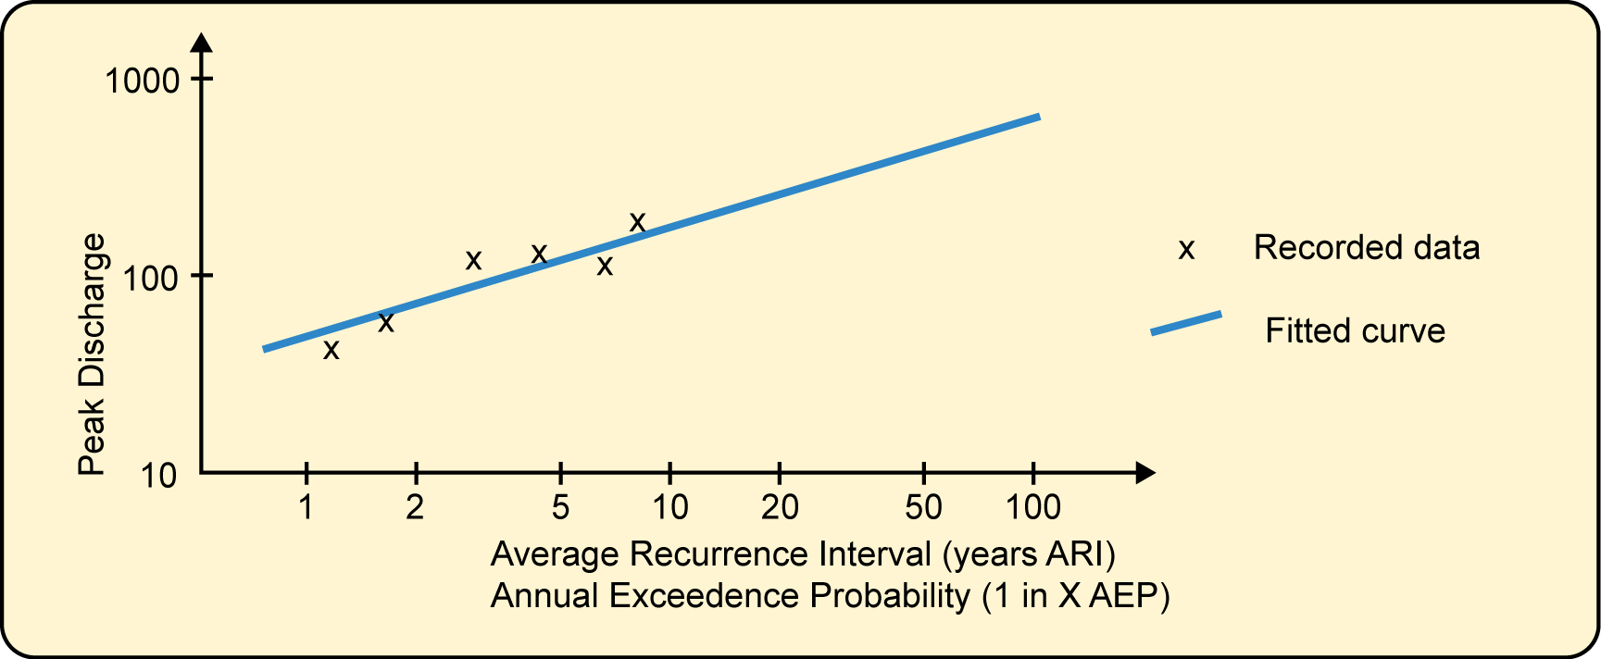
Figure 3.2: A flood frequency curve
The data points that are plotted on figure 3.2 are based on flood data recorded at a streamgauge. A flood frequency curve is a line fitted to the data points that is generally based on a theoretical probability distribution. Alternatively, a line that best fits the visual trend of the data points is sometimes used (this is referred to as ‘best fit by eye’). The design discharge for any AEP can be extracted from the flood frequency curve: 1 in 2 year, 5 year, 10 year, 20 year, 50 year and 1 in 100 year AEP are often used in engineering design (see table 3.1).
The data points used in FFA are based on selecting flood event data from the available streamflow record. Two different approaches are used to obtain a series of datapoints to plot:
- Selecting the highest discharge that occurred in each year of record. This is called the Annual Series.
- Selecting any discharge that exceeds a chosen threshold and is independent of other events. This is called the Partial Series. The difference between Annual and Partial Series is illustrated in figure 3.3.
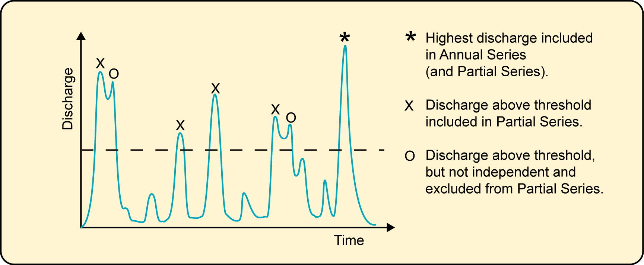
Figure 3.3: Selection of discharges for Annual and Partial Series. This graph shows the recorded discharge at a streamflow gauge for one year only – discharges are selected for all years of available record.
The Annual Series and the Partial Series produce very similar FFA results for design floods larger than 10-year ARI. The Annual Series is the most common method to select floods for FFA and is preferred for design floods greater than 10-year ARI. For floods smaller than 10-year ARI, the Partial Series is generally preferred as it has a greater representation of recorded events in this range. The Annual Series may omit many smaller floods that will be of interest as only one flood for each year (the highest) is selected for the Annual Series.
In FFA, it is preferred to have at least 10 to 15 years of streamflow records as a minimum set of data for analysis.
It is assumed in FFA that the future occurrence of floods will follow the same frequency behaviour as the floods recorded at the streamgauge. In other words, information on past floods is used to predict future floods. Thus, it is inappropriate to use FFA if it is intended to predict flood frequencies that may arise from physical changes in the catchment, such as urban development, and/or climate change. In statistical terms, FFA requires data that is stationary, in which the mean and variance of the discharge data do not change with time.
It is also important that only independent flood peaks are included in the flood frequency analysis. This means that a flood discharge should not be included in the series if it is part of a flood event that already has a selected discharge. Generally this is not a problem for the Annual Series, as only one peak discharge (the highest) is chosen per year.
The use of a water year instead of a calendar year further increases the likelihood of obtaining independent flood peaks. In Queensland, and other locations where summer rainfall dominates and winters are drier, the water year starts in October. As shown in figure 3.4, this reduces a significant flood event being split between two years.
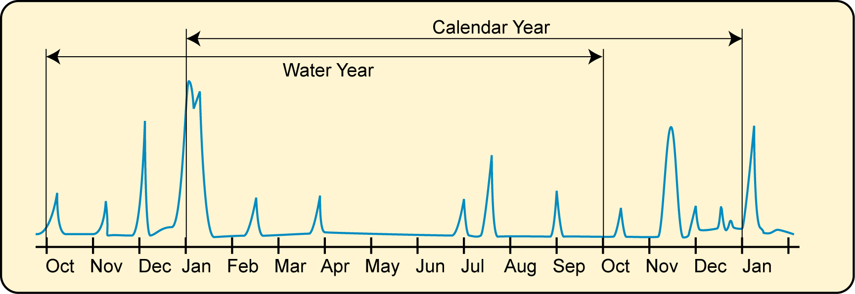
Figure 3.4: Discharge time series showing the difference between a calendar year and a water year
Flood data used in FFA is also required to be homogeneous, or share the same basic types of underlying causes or factors. Non-homogeneity may be introduced in a streamflow record for various reasons. For example, a flood that may have been caused by an unusual circumstance such as a dambreak, would not be homogeneous with the majority of floods caused by heavy rainfall. Changes in data collection methods, such as a transition from manual readings to automatic loggers or modification of the streamgauge rating curve, can also lead to flow records which are not fully homogeneous.
  - FFA using the Annual Series
    - Basic procedures
An example of the results of a FFA based on an Annual flood Series is provided asfigure 3.5. It shows
- the peak discharge for each year of record included in the Annual Series plotted as ♦
- A probability distribution fitted to the Annual Series data – in this case, we have used a log Pearson III distribution,
- Confidence Limit curves that provide an indication of the uncertainty in the Design Flood estimates.
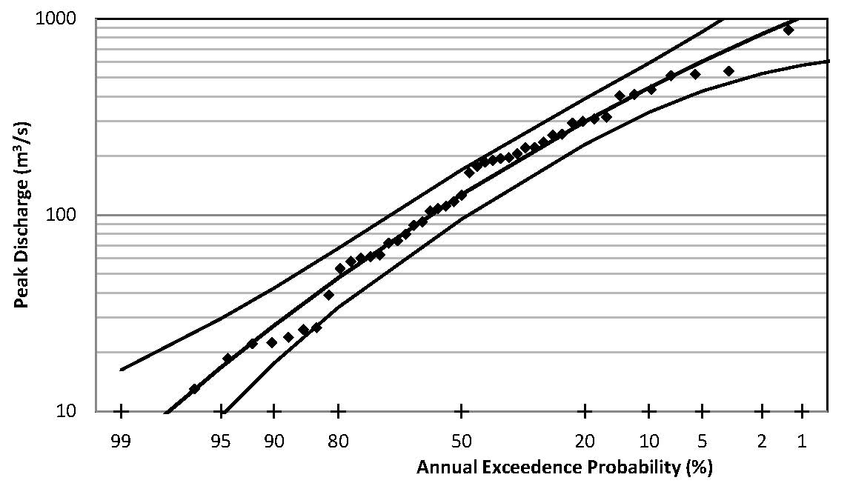
Figure 3.5: Example of FFA chart based on an Annual Series – Styx River at Jeogla, 1939–1985 (adapted from AR&R)
The log Pearson III (or LP3) distribution is the most commonly used theoretical probability distribution used in Australia as it is recommended by AR&R. It will be discussed in more detail in section 3.3.3.
The LP3 curve provides a ‘best estimate’ of the Design Flood discharge for a given AEP. The ‘true’ estimate of the Design Flood is expected to fall within the range between the confidence limits (in this case, they are set at 5% and 95% confidence levels). This range is called the confidence interval. Using figure 3.5 as an example, we should be 90% confident (=95%-5%) that the true Design Flood discharge will fall within the confidence interval shown. If the FFA is based on a short Annual Series, then the confidence interval will be large and hence we should be more uncertain about the accuracy of the Design Flood estimate. Under these circumstances, it may be prudent to adopt a more conservative Design Flood estimate that is above the LP3 estimate.
The basic procedures in preparing a FFA chart using the Annual Series as shown in figure 3.5 are:
- Obtain the streamflow record for the site and undergo data quality checks (e.g. Is the data complete?, Are there any major catchment changes that have occurred during the flow record?, Is the rating curve accurate and gauged up to high flows?).
- Extract the peak instantaneous discharge recorded within each water year to produce the Annual Series. Analyse and plot the Annual Series datapoints. See section 3.3.2 for details.
- Fit a LP3 distribution to the Annual Series datapoints and derive the confidence limits. See section 3.3.3 for details.
- Calculate the Design Flood discharges for the flood frequencies that may be required. See section 3.3.4 for details.
    - Analysing and plotting the Annual Series data
After the quality and completeness of the streamflow data is checked, the peak instantaneous discharge for each water year is extracted. These discharge values, one for every year of record, forms the Annual Series.
The next step is to compute an estimate of the AEP of each of the Annual peak discharges, so it can be plotted. As a result, this AEP estimate is called the plotting position. To determine the plotting position, data in the Annual Series is sorted or ranked from the largest discharge to the smallest discharge. The largest flood on record is the rank 1 event and has the lowest AEP. Small floods will be located down the rank and will have a high AEP of being exceeded.
There are several ways to estimate the plotting position AEP, but it is generally calculated by the following formula:

where PP(m) is the plotting position or AEP estimate of a flood discharge of rank m in a Series of N years of record. ∝ is a constant depending on the type of probability distribution – for LP3, ∝=0.4
As AEP is the reciprocal of ARI (from section 3.2.2), the ARI of the plotting positions can also be derived, if required.
Once the plotting positions are calculated, the Annual Series data points can be plotted. Logarithmic Probability graph paper is used – this presents probability on the x-axis (as % AEP) and discharge on a log-scale on the y-axis. There are various types of probability graph paper available, but it is general practice to use log-Normal paper.
    - Fitting a LP3 distribution with confidence limits
At this point, it is worthwhile revisiting some basic probability distribution theory that you may have encountered before in previous Courses. A commonly used probability distribution is the Normal distribution; this has a classic bell-shaped curve as shown by the example provided in figure 3.6 [A]. This is a plot of the probability of occurrence of a discharge Q, or Pr(Q), against the discharge Q. The Pr(Q) falls with a range between zero and one.

 | Note  The term Normal is just a label for the probability distribution of that name. It does not imply that this is what we would expect as normality. In fact, it is abnormal for a river to have flows that follow a Normal distribution.

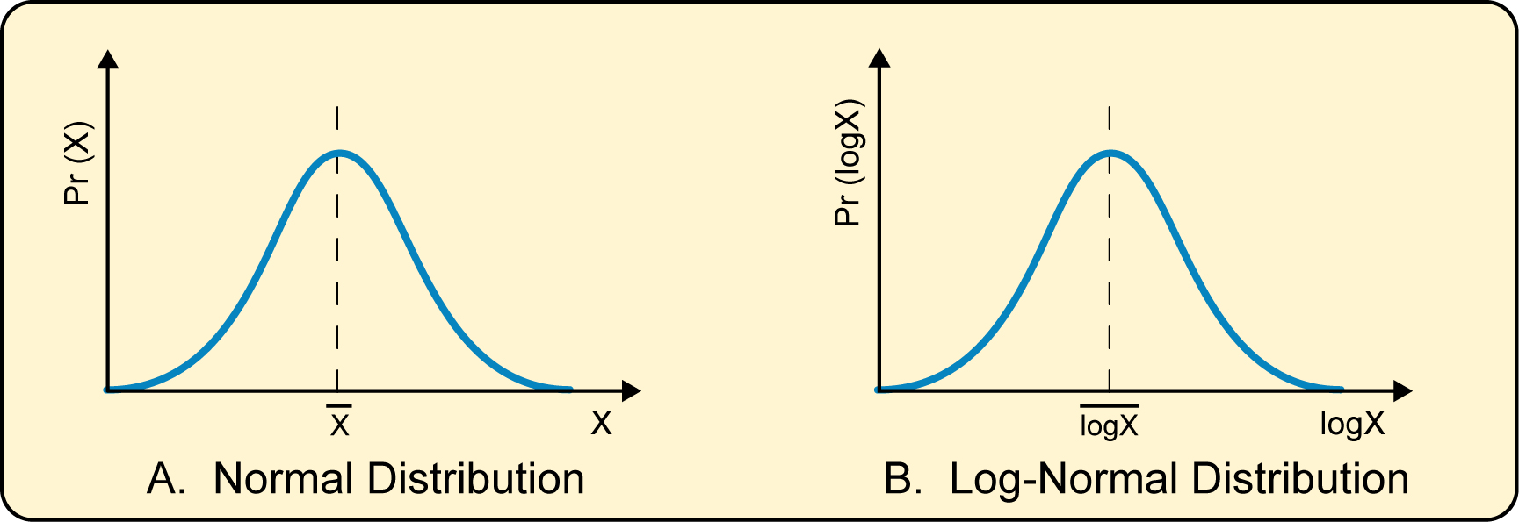
Figure 3.6: The Normal and Log-normal probability distributions
Discharge data is said to have a Normal distribution if the discharge with the highest probability of occurrence coincides with the mean discharge. In other words, the distribution is symmetric around the mean. Two statistical parameters are used to define the Normal distribution; the mean and standard deviation.
The problem in hydrology is that it is rare that discharge data conforms to a classic Normal distribution. Sometimes, a better fit with a Normal distribution may occur if logs (log to the base 10) are taken of the discharge data. This can result in a good fit with the log-Normal distribution as shown in rigure 3.6 [B]. As data has been ‘transformed’ from Q to log Q, this process is termed log transformation.
Even after log transformation, the log Q values may not always plot symmetric around the mean as would be the case for a true log-Normal distribution. The peak probability of occurrence Pr (log Q) may be below the mean log Q as indicated by figure 3.7 [A]. This is referred to as positive skew. Most Australian streamflow data based on the Annual Series are in fact positively skewed. If the peak probability of occurrence Pr (log Q) plots above the mean then it has a negative skew (figure 3.7 [B]). A log-Normal distribution (figure 3.6 [B]) has a zero skew.

Figure 3.7: The Log-Pearson III (LP3) probability distribution with positive and negative skews
The LP3 distribution is based on three statistical parameters: the mean M of the logs of the discharges in the Annual Series, their standard deviation S and a frequency factor (or deviate) KY. If an Annual Series fits a LP3 distribution, then the probability of a flood discharge QY having an AEP of 1 in Y is such that:
log Qy = M + KYS
The frequency factor KY is selected from relevant tables in AR&R (These tables are reproduced at the end of this module). Approximate equations and spreadsheet formulas to estimate KY are also described in Ladson (2008). The value of KY depends on the design flood AEP and the skew coefficient G, where G is another statistic determined from the Annual Series data. The equations for mean M, standard deviation S and skew coefficient G are provided below.

where N is the number of data points in the Annual Series (i.e the number of years of record) and Qi is the peak discharge for each year.
M, S and G are the moments of the LP3 distribution, so fitting a LP3 distribution to an Annual Series by determination of these statistics is called the method of moments. There are standard functions in Excel to perform these calculations: AVERAGE, STDEV and SKEW.
Fundamentally, fitting a LP3 distribution by the method of moments to Annual Series data is relatively straightforward and involves
- Log transformation of the Annual Series data i.e. calculating log Qi for each year of record,
- Computation of the LP3 moments, namely M, S and G, and
- For various design flood AEP, calculate the corresponding QY. Frequency factors KY are available from 1 in 1 year AEP to 1 in 500 year AEP. Typical AEPs that are used are 1 in 1, 2, 5, 10, 20, 50 and 100.
The procedure of fitting a LP3 distribution may be further complicated if, for example, there are known floods that have occurred historically before streamflow records commenced at the site and hence do not appear within the Annual Series. Large historical floods provide valuable information and should be incorporated into the FFA if possible. AR&R provides guidance on how this is done. Another possible complication is the presence of outliers which are individual flood events that plot substantially away from the trend of the other discharges within the Annual Series. These outliers may be present in the data simply as a result of an error or may be the associated with an extreme rainfall event. A method to detect outliers is also provided in AR&R.
The QY estimates are plotted on the flood frequency graph as shown on the Styx River example in figure 3.5. A curve joining the QY values represents the fitted LP3 distribution. As the LP3 is an arbitrarily selected probability distribution, it is not guaranteed that the LP3 curve will closely fit the plotted Annual Series data (but often does).
To complete the Annual Series FFA, confidence limits are calculated and plotted. The QY values are estimates only as they are based on a limited sample size governed by the number of years of available record. We would be more confident in the QY estimates if they were determined from a long streamflow record (more than 50 years) than if a shorter record is available. It is customary to estimate the 5% and 95% confidence limits; there is a 90% probability that the true QY will fall within the band defined by these upper and low bounds.
The 5% confident limit CL5(QY) about a discharge QY is calculated from the equation:
log(CL5(QY)) = log QY +1.645
The 95% confident limit CL95(QY) about a discharge QY has a similar equation:
log(CL95(QY)) = logQY – 1.645
(or the Greek letter ‘delta’) is a parameter for determining the standard error of a LP3 probability distribution Values of depend on the skew coefficient G and the AEP of the discharge QY and can be read off a table in AR&R (reproduced at the end of this Module).
The 5% and 95% confidence limits are calculated for the same AEPs used for the QY values and are plotted on the FFA chart (figure 3.5 illustrates the confidence limits for the Styx River example).

 | Warning about fitting LP3 distributions  The current 2003 version of AR&R recommends the method of moments be used to fit the LP3 distribution to the Annual flood Series. AR&R is in the process of being revised and the method of moments is under review. Although the method can be easily carried out in a spreadsheet such as Excel, there are concerns that a few large flood discharges in the Annual Series may bias the results, especially if the available streamflow record is small. The method of moments may not be recommended as a preferred approach in future editions of AR&R.

    - Calculating Design Flood discharges from Annual Series
The QY estimates from the LP3 distribution can be directly used as Design Flood discharges for various AEPs: for example the Q50 discharge corresponds to the 1 in 50 AEP (or 50 year ARI when expressed as an average recurrence interval). As discussed in Section 3.4, to estimate design discharges equal to and smaller than the Q10 (1 in 10 AEP) it is generally better to use the Partial Series.
  - FFA using the Partial Series
    - Basic procedures
FFA based on the Annual Series uses the maximum flood peak for every year of record, which discards useful data about other reasonably-sized floods that may have also occurred within a given year. For example, the second-largest flood in one year may be bigger than the largest flood in another year, but is not included in the Annual Series.
To address this issue, the Partial Series is based on including all independent floods that are larger than a threshold level. As a consequence, the Partial Series is used to evaluate the probability of smaller floods (≤1 in 10 year ARI) because these floods are more represented within the Partial Series.

Note – ARI is more appropriate that AEP in Partial Series Analysis
ARI is more appropriate that AEP in Partial Series Analysis. In any particular year, there may be no floods (all discharges were below the threshold) or several floods in a Partial Series. The concept of an AEP is based on the probability of a flood magnitude being exceeded in a Series made up of maximum values within each year-long period (i.e. the Annual Series). AEP is not appropriate for the Partial Series as there can be more than one flood a year. Thus, the average time period between floods of a certain magnitude (i.e. the ARI) is the preferred FFA term to use in Partial Series analysis

An example of the results of a FFA based on a Partial flood Series is provided as figure 3.8. It shows
- the peak discharges within the record above a threshold plotted as ♦,
- a probability distribution fitted by regression to the data.
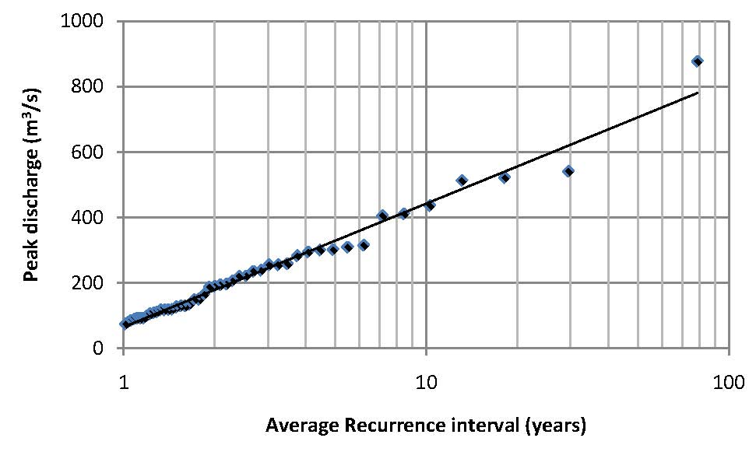
Figure 3.8: Example of FFA chart based on a Partial Series – Styx River at Jeogla, 1939–1985 (adapted from AR&R)
The basic procedures in preparing a FFA chart using the Partial Series are similar to those based on the Annual Series:
- Obtain the streamflow record for the site and undergo data quality checks (e.g. Is the data complete?, Are there any major catchment changes that have occurred during the flow record?, Is the rating curve accurate and gauged up to high flows?).
- Extract the peak discharges of independent floods within the streamflow record above a selected threshold to produce the Partial Series. Analyse and plot the Partial Series datapoints. See section 3.4.2 for details.
- Fit a regression distribution to the Partial Series datapoints and derive the confidence limits. See section 3.4.3 for details.
- Calculate the Design Flood discharges for the flood frequencies that may be required. See section 3.4.4 for details.
    - Analysing and plotting the Partial Series data
Flood peaks that are above a threshold level are included in the Partial Series. The number of floods that are included in the Partial Series for a particular streamflow record is thus determined by the threshold level. Let’s denote the number of floods in the Partial Series as K. If N is the number of years of record (= number of events in the Annual Series), then a threshold should be selected such that K is between N and 3N.
It is important that only independent flood events are included in the Partial Series. Take a streamflow record shown in figure 3.9 as an example. It is reasonably clear that Flood Peaks 1 and 2 are independent, i.e. associated with two separate rainfall events. For Flood Peaks 3 and 4 it is not so clear-cut – they appear to be peaks associated with the same long rainfall event and hence are likely to be dependent. If peak flows are dependent then they should be considered part of the same flood and only the higher peak should be included in the data set for analysis. Thus, Flood Peak 4 should not be included in the Partial Series.
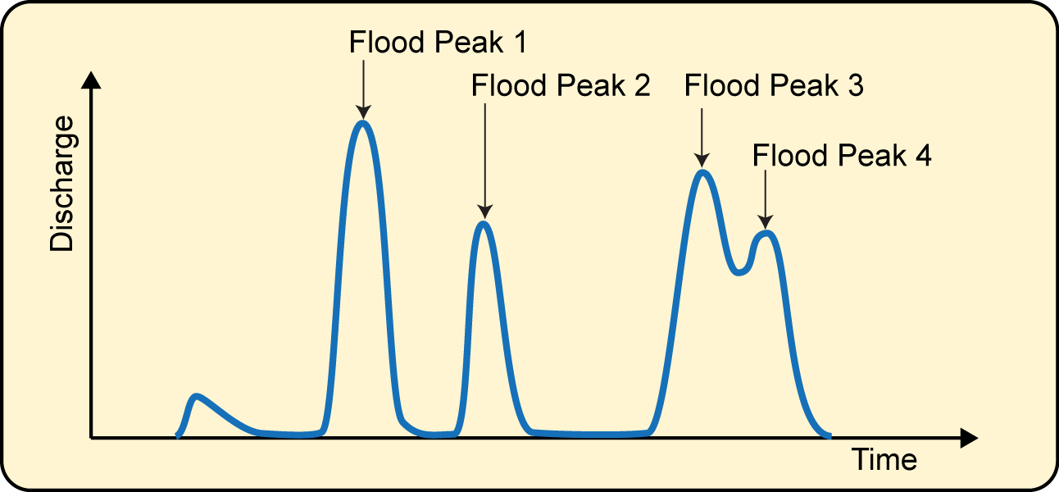
Figure 3.9: Streamflow record showing a sequence of flood peaks. All peaks are above the selected threshold.
Determining whether two consecutive flood peaks are independent can be based on the time interval between the peaks (which is related to catchment size and runoff characteristics). There are many different examples of criteria or rules being used in order to determine flood independence. One example is that floods are independent if “the time period between peaks is at least 5 days and the discharge between the peaks must fall to below 75% of the discharge of the lower peak”. This rule would be applicable for catchments larger than 1000 km2. Determining flood independence is often a subjective process.
After these peak above threshold or POT discharges have been selected from the streamflow record to form the Partial Series, the next step is to compute an estimate of the ARI of each data point. As was done in the Annual Series FFA, the discharges in the Partial Series must be sorted or ranked from the largest discharge to the smallest discharge. As ARI is used instead of AEP, the formula for the plotting position ARI is the reciprocal of that used for the Annual Series data (see section 3.3.2):
PP(m) =
where PP(m) is the plotting position or ARI estimate of a flood discharge of rank m in N years of record. The plotting position assumes a LP3 distribution ( ∝=0.4). Note that K (= number of flood peaks above threshold) is not used in calculating the plotting position.
The probability distribution that is assumed to be suitable for the Partial Series is a special form of the LP3 distribution called the Negative Exponential distribution. This plots as a straight line on semi-log (or log-linear) graph paper, so this type of graph should be used. Discharge is plotted on the linear scale on the y-axis against the calculated plotting position ARI on the log-scale on the x-axis (i.e. log (ARI) values). Refer back to the FFA chart of the Styx River given as figure 3.8 as an example.
    - Fitting a regression distribution
As the Negative Exponential distribution is generally assumed to apply, this makes it easier to fit a curve to the plotted data points. (The Negative Exponential has a skew G=2, so G doesn’t need to be computed as done in the LP3 fit to the Annual Series).
The general practice is to fit a simple regression line to the log ARI discharges. This can be easily done in EXCEL by using the ‘Add a trend line’ function. The fitted probability distribution has the basic form given below– the probability of a flood discharge QY having an ARI of Y years is such that:
QY = a log(ARI) + b
where a and b are regression constants.
It is possible to calculate confidence limits to the fitted Partial Series distribution using regression theory. A method is described in section 6.6.1 of Ladson (2008), but is not covered by this course.
    - Calculating Design Flood discharges from partial Series
The QY estimates from the fitted regression curve can be directly used as Design Floods for various ARIs. As noted previously, it is preferred to express QY estimates from Partial Series FFA in terms of ARI, but in industry practice the use of AEP and ARI is often interchangeable.
As indicated schematically by figure 3.10, the ARI estimates based on the Partial Series tend to converge with the Annual Series ARI estimates at approximately 10 year ARI (or 1 in 10 AEP). For ARIs less than 10 year ARI, the Partial Series discharge estimate is larger than the Annual Series estimate. The difference is due to the extra flow information included in the Partial Series.
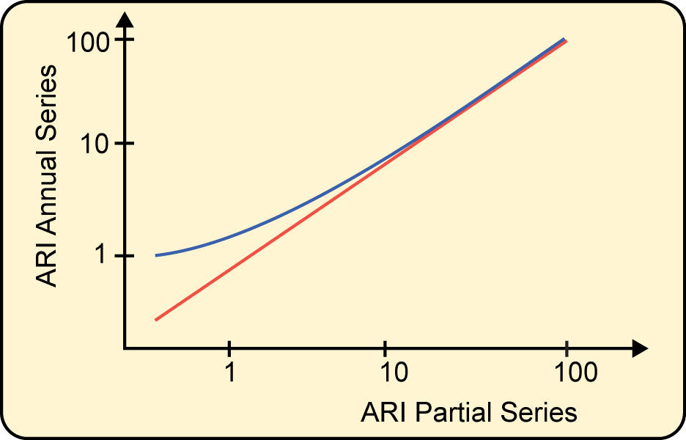
Figure 3.10: Plot of the Annual Series ARI estimate against the Partial Series ARI estimate
  - Extreme floods
As the ARI increases, Design Flood discharges estimated using flood frequency analysis become less accurate. It is recommended that FFA should not be used for Design Floods bigger than 1 in 100 AEP (the absolute limit of extrapolating estimates based on FFA is 1 in 500 AEP).
As indicated by table 3.1, there are some types of major infrastructure such as dam spillways that are designed to handle extreme floods of up to 1 in 1,000,000 AEP. Estimating the Design Flood discharge associated with events of this magnitude is a specialised task and is not covered by this Course. Details can be found in AR&R.
Summary
The flood frequency analysis (FFA) is one method to estimate Design Floods of various AEP. Providing that there is an accurate streamflow record of sufficient length, FFA has several advantages over alternative methods:
- It is a simpler procedure.
- All factors affecting the flood discharge are inherently incorporated in the resulting Design Floods, as it is based on measured streamflows.
- The flood of the required AEP is estimated directly, so no knowledge of the relationship between rainfall and runoff probabilities is needed.
- Confidence limits can be calculated to show the uncertainty of the results.
- The method doesn’t require rainfall data, so raingauge records or estimation of rainfall losses are not required.
However, there are several features of FFA that should be considered when deciding to use this method to estimate Design Flood discharges, especially for large, low AEP events:
- FFA is based on an arbitrarily selected probability distribution (LP3 for the Annual Series) as the true form of the flood probability distribution cannot be established from the comparatively short records of Australian stream gauges (generally less than 100 years)
- Significant uncertainty will exist in estimating Design Floods from a short streamflow record, particularly with the skew that is present.
- It is very difficult to adjust the data to account for any catchment changes that occurred during the streamflow record, or are expected to occur during the future life of the works under design
- Considerable extrapolation of the streamgauge rating curves is generally necessary to convert recorded stage to discharge for the largest recorded flood peaks. Failure of recording equipment often happens during large floods, so these key events may be unrecorded.
When there is insufficient streamflow records to undertake a FFA, the engineering hydrologist must estimate the Design Flood discharge from rainfall data. This is described further in modules 5 and 6.
List of references
Ladson, A 2008, Hydrology – an Australian introduction, Oxford University Press.
Additional resources
Tables 2.2, 2.3 and 2.4 from AR & R.
Table 2.2: Frequency factors KY for use with Log-Pearson Type III distribution (positive skew coefficients).
Table 2.3
Table 2.4

