Appendix A1. Experimental
A1.1 General Experimental Information
All reactions were performed under an atmosphere of argon unless they involved aqueous reagents. Glassware for inert atmosphere reactions was pre-dried in an oven (minimum temperature 180 ºC) and cooled to room temperature under vacuum before introducing argon.
Water used in work-ups was de-ionised and all aqueous solutions were saturated unless otherwise stated. Petrol refers to the fraction of light petroleum ether with boiling point 40 – 60 ºC. This and all other solvents used in chromatography and work-ups was pre-distilled. Dichloromethane, methanol, acetonitrile and toluene used in reaction mixtures were distilled from calcium hydride. Diethyl ether and tetrahydrofuran (along with a triphenylmethane indicator) were distilled from calcium hydride and lithium aluminium hydride. Anhydrous benzene and N,N-dimethylformamide were used as supplied commercially. Triethylamine, N,N-diisopropylethylamine and diisopropylamine were all distilled from calcium hydride and stored over potassium hydroxide. All other reagents and solvents were purified by standard procedures or were used as obtained from commercial sources as appropriate.
Flash chromatography was performed over silica using Breckland Scientific Supplies Silica Gel 60 (230 – 400 mesh) or alumina using Merck Aluminium Oxide 90 (standardised). Compressed air was used to elute the column. Analytical thin layer chromatography was carried out on pre-coated glass-backed plates (Merck Kieselgel 60 F₂₅₄) and visualised by UV fluorescence (λ = 254 nm) and staining by acidic ammonium molybdate (IV) with heating. Where this was not suitable use of alternative staining agents, e.g. acidic ethanolic vanillin or basic aqueous potassium permanganate (VII), are noted in the text.
All data was collected at the Department of Chemistry, University of Cambridge. Melting points were measured on a Reichert hot stage apparatus on borosilicate glass plates (BDH, thickness number 1). Optical rotations were measured using either a Perkin-Elmer Model 343 or Model 241 polarimeter with a sodium lamp and are reported as [α]^{X}_{D} (c, CHCl₃) where X is the temperature in degrees centigrade and c is the concentration in grams / 100 mL CHCl₃. Infra-red spectra were recorded either neat or as thin films from evaporation of a chloroform or diethyl ether solution on a Perkin-Elmer Spectrum One FT-IR, fitted with a Universal ATR Sampling Accessory. Absorbances (ν_{max} / cm⁻¹) are reported as s = strong, m= medium, w = weak, br = broad. Proton magnetic resonance (¹H NMR) spectra were recorded at 400 MHz, 500 MHz and 600 MHz on a Bruker Biospin Avance 400, 500 (cryoprobe) and 600 machine respectively. Measurements were taken at room temperature in either CDCl₃ or C₆D₆ and are reported in the format: chemical shift δ / ppm (number of protons, multiplicity, coupling constant J / Hz, assignment). Coupling constants are quoted to the nearest 0.1 Hz with s = singlet, d = doublet, t = triplet, q = quartet, m = multiplet and br = broad signal. The residual protic solvent CHCl₃ (δ_{H} = 7.26 ppm) or C₆H₆ (δ_{H} = 7.15 ppm) was used as an internal reference. Carbon magnetic resonance (¹³C NMR) spectra were recorded on the same machines in either CDCl₃ or C₆D₆ at room temperature and the residual protic solvent CHCl₃ (δ_{C} = 77 ppm, triplet) or C₆H₆ (δ_{C} = 128.6 ppm) was used as the internal reference. The spectra were assigned as fully as possible using a variety of 2-D and nOe techniques. High resolution mass spectra were obtained on a Waters LCT Premier spectrometer with Micromass MS software using electrospray ionisation (+ESI).
A1.2 Experimental Data for Section 2.1
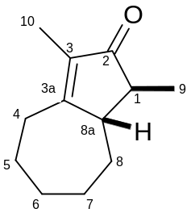
(+/-)
69
rac-(1S*,8aS*)-1,3-dimethyl-4,5,6,7,8,8a-hexahydro-2(1H)-azulenone
Preparation from enamine 68: An oven-dried flask was charged with diironnonacarbonyl (80 mg, 0.221 mmol) and deoxygenated by alternatively applying a vacuum then filling with argon three times. To the flask was added enamine 68 (100 mg, 0.552 mmol) as a solution in benzene (2 mL) followed by 2,4-dibromopentanone (45 mg, 0.184 mmol) in a further 1 mL benzene. The flask was deoxygenated in the same way as previously then stirred at room temperature wrapped in foil for 16 hours. The reaction mixture was quenched with aqueous sodium bicarbonate (10 mL) and extracted with ethyl acetate (4 x 10 mL). The combined organics were washed with brine (10 mL), dried over sodium sulphate, filtered and concentrated in vacuo to a brown oil. This was dissolved in 3 % w/v ethanolic sodium hydroxide (1 mL) and stirred at room temperature for 30 minutes. The mixture was partitioned between water (4 mL) and ethyl acetate (5 mL). The organic layer was washed with water (4 mL), dried over sodium sulphate, filtered and concentrated in vacuo to a clear oil. This was purified by flash chromatography over silica, eluting with a slow gradient from 1 : 100 to 1 : 13 ethyl acetate / petrol to yield the title compound as a clear oil (23 mg, 70 % yield based on 2,4-dibromopentanone).
Preparation from silyl enol ether 73: An oven-dried flask was charged with diironnonacarbonyl (120 mg, 0.329 mmol) and deoxygenated by alternatively applying a vacuum then filling with argon three times. To the flask was added silyl enol ether 73 (62 mg, 0.274 mmol) as a solution in benzene (1 mL) followed by 2,4-dibromopentanone (100 mg, 0.411 mmol) in a further 1 mL benzene. The flask was deoxygenated in the same way as previously then stirred at room temperature wrapped in foil for 16 hours. The reaction mixture was quenched with sodium bicarbonate (10 mL) and extracted with ethyl acetate (4 x 10 mL). The combined organics were washed with brine (10 mL), dried over sodium sulphate, filtered and concentrated in vacuo to a brown oil. This was dissolved in 3 % w/v ethanolic sodium hydroxide (2 mL) and stirred at room temperature for 2.5 days. The mixture was partitioned between water (10 mL) and ethyl acetate (15 mL). The aqueous layer was washed with ethyl acetate (10 mL) then the combined organics were washed with water (10 mL), dried over sodium sulphate, filtered and concentrated in vacuo. The residue was purified by flash chromatography over silica, eluting with a slow gradient from 1 : 100 to 3 : 97 ethyl acetate / petrol to yield the title compound as a clear oil (9 mg, 18 % yield).
R_{f} 0.19 (1 : 10 ethyl acetate / petrol); υ_{max} / cm⁻¹ 2921m, 2853m, 1695s, 1634m, 1450m, 1381m, 1356m, 1323m, 1306m, 1258w, 1179w, 1101m, 1003m, 963m, 923m, 830w, 809w, 732m; ¹H (600 MHz, CDCl₃) δ 2.65 (1H, dd, J 6.3, 17.0, H-4), 2.54 (1H, dd, J 10.5, 16.8, H-4), 2.37 – 2.36 (1H, m, H-8a), 1.98 – 1.95 (1H, m, H-8), 1.90 – 1.85 (2H, m, H-1, H-6), 1.74 – 1.64 (3H, m, 2 x H-5, H-7), 1.66 (3H, s, H-10), 1.49 – 1.44 (1H, m, H-7), 1.42 – 1.36 (2H, m, H-6, H-8), 1.16 (3H, d, J 7.3, H-9); ¹³C (150 MHz, CDCl₃) δ 210.7 (C-2), 176.5 (C-3a), 134.4 (C-3), 51.8 (C-8a), 48.3 (C-1), 33.3 (C-8), 31.1 (C-4), 29.7 (C-6), 28.9 (C-7), 26.3 (C-5), 14.2 (C-9), 8.0 (C-10); m/z (+ESI) Found 179.1428 [M+H]⁺, C₁₂H₁₉O requires 179.1436. All data was consistent with that reported in the literature.⁷²
Selected nOe’s for 69 - Irradiation at H-8a:
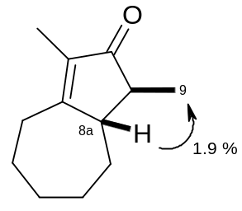
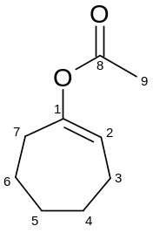
70
1-cyclohepten-1-yl acetate
Isopropenyl acetate (3.92 mL, 35.66 mmol) and p-toluenesulfonic acid monohydrate (75 mg, 0.392 mmol) were added to neat cycloheptanone (2.1 mL, 17.83 mmol) and the mixture refluxed for 24 hours. After this time the brown reaction mixture was diluted with diethyl ether (100 mL) and washed with aqueous sodium bicarbonate (100 mL). The aqueous layer was washed with diethyl ether (2 x 100 mL) then the combined organics were dried over magnesium sulphate, filtered and concentrated in vacuo to a brown oil. This was purified by flash chromatography over silica eluting with 1 : 10 diethyl ether / petrol to yield the title compound as a yellow oil (2.34 g, 85 %).
R_{f} 0.32 (1 : 10 diethyl ether / petrol – vanillin spray); υ_{max} / cm⁻¹ 2922m, 2851m, 1748s, 1686m, 1447m, 1366m, 1231s, 1205s, 1151m, 1117m, 1091s, 1070s, 1023m, 965w, 954w, 917m, 899m, 863w, 840m, 820w, 793w, 738w; ¹H (400 MHz, CDCl₃) δ 5.46 (1H, t, J 6.5, H-2), 2.30 (2H, dd, J 5.5, 5.5, H-7), 2.12 – 2.07 (2H, m, H-3), 2.08 (3H, s, H-9), 1.75 – 1.63 (4H, m, H-5, H-6), 1.62 – 1.56 (2H, m, H-4); ¹³C (100 MHz, CDCl₃) δ 169.8 (C-8), 153.1 (C-1), 118.0 (C-2), 33.1 (C-7), 30.9 (C-5), 27.0 (C-4), 25.3, 25.1 (C-3 / C-6), 21.0 (C-9); m/z (+ESI) No molecular ion found. All data was consistent with that reported in the literature.⁹⁰
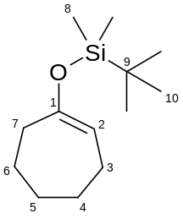
71
(1-cyclohepten-1-yloxy)(1,1-dimethylethyl)dimethylsilane
A solution of diisopropylamine (208 μL, 1.47 mmol) in tetrahydrofuran (1 mL) at -78 ºC was treated dropwise with n-butyllithium (919 μL of 1.6 M solution in hexanes, 1.47 mmol). The mixture was stirred for 5 minutes then warmed to 0 ºC over 15 minutes. After re-cooling to -78 ºC the mixture was treated dropwise with a solution of cycloheptanone (158 μL, 1.34 mmol) in tetrahydrofuran (1 mL). After stirring at this temperature for 1 hour the mixture was treated with t-butyldimethylsilyl trifluoromethanesulfonate (323 μL, 1.41 mmol) and stirred for a further 1 hour at -78 ºC then warmed to room temperature and stirred for 30 minutes. At this point the mixture was quenched with half-saturated aqueous sodium bicarbonate (5 mL) and dichloromethane (10 mL). The aqueous layer was extracted with dichloromethane (3 x 5 mL) then the combined organics were washed with brine (5 mL), dried over sodium sulphate, filtered and concentrated in vacuo. The residue was purified by flash chromatography over silica doped with 1 % triethylamine, eluting with petrol containing 1 % triethylamine to yield the title compound as a clear oil, containing a small amount of silyl-containing impurity (236 mg, 78 %).
R_{f} 0.25 (neat petrol – vanillin spray); υ_{max} / cm⁻¹ 2925m, 2856, 1661m, 1472m, 1463m, 1446m, 1389w, 1364m, 1279w, 1252m, 1228s, 1166s, 1128s, 1075m, 1025m, 1006m, 957m, 939w, 892s, 877s, 854s, 836s, 800s, 773s, 706m, 666m; ¹H (400 MHz, CDCl₃) δ 5.01 (1H, t, J 6.5, H-2), 2.24 – 2.21 (2H, m, H-7), 1.99 (2H, dd (br), J 6.5, 11.1, H-3), 1.71 – 1.65 (2H, m, H-5), 1.60 – 1.50 (4H, m, H-4, H-6), 0.92 (9H, s, H-10), 0.12 (6H, s, H-8); ¹³C (100 MHz, CDCl₃) δ 156.2 (C-1), 108.6 (C-2), 35.5 (C-7), 31.4 (C-5), 27.8 (C-4), 25.7 (C-10), 25.3, 25.2 (C-3 / C-6), 18.0 (C-9), -4.4 (C-8); m/z (+ESI) No molecular ion found. All data was consistent with that reported in the literature.⁹¹
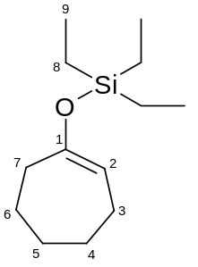
73
(1-cyclohepten-1-yloxy)(triethyl)silane
A solution of diisopropylamine (208 μL, 1.47 mmol) in tetrahydrofuran (1 mL) at -78 ºC was treated dropwise with n-butyllithium (919 μL of 1.6 M solution in hexanes, 1.47 mmol). The mixture was stirred for 5 minutes then warmed to 0 ºC over 15 minutes. After re-cooling to -78 ºC the mixture was treated dropwise with a solution of cycloheptanone (158 μL, 1.34 mmol) in tetrahydrofuran (1 mL). After stirring at this temperature for 1 hour the mixture was treated with triethylsilyl trifluoromethanesulfonate (318 μL, 1.41 mmol) and stirred for a further 1 hour at -78 ºC then warmed to room temperature and stirred for 30 minutes. At this point the mixture was quenched with half-saturated aqueous sodium bicarbonate (5 mL) and dichloromethane (10 mL). The aqueous layer was extracted with dichloromethane (2 x 10 mL) then the combined organics were washed with brine (5 mL), dried over sodium sulphate, filtered and concentrated in vacuo. The residue was purified by flash chromatography over silica doped with 1 % triethylamine, eluting with petrol containing 1 % triethylamine to yield the title compound as a clear oil, containing a small amount of silyl-containing impurity (133 mg, 43 %).
R_{f} 0.71 (1 : 3 diethyl ether / petrol – vanillin spray); υ_{max} / cm⁻¹ 2954m, 2918m, 2877m, 2850w, 1660m, 1457w, 1414w, 1367w, 1279m, 1227m, 1205w, 1168m, 1128m, 1075m, 1004m, 961m, 890m, 875m, 849m, 830m, 797m, 765m, 739s, 721s, 674m; ¹H (400 MHz, CDCl₃) δ 5.01 (1H, t, J 6.6, H-2), 2.26 – 2.23 (2H, m, H-7), 1.98 (2H, ddd, J 4.7, 6.5, 6.5, H-3), 1.71 – 1.64 (2H, m, H-5), 1.60 – 1.49 (4H, m, H-4, H-6), 0.97 (9H, t, J 7.9, H-9), 0.64 (6H, q, J 8.0, H-8); ¹³C (100 MHz, CDCl₃) δ 156.2 (C-1), 108.0 (C-2), 35.5 (C-7), 31.5 (C-5), 27.8 (C-4), 25.4 (C-6), 25.2 (C-3), 6.7 (C-9), 5.0 (C-8); m/z (+ESI) No molecular ion found.
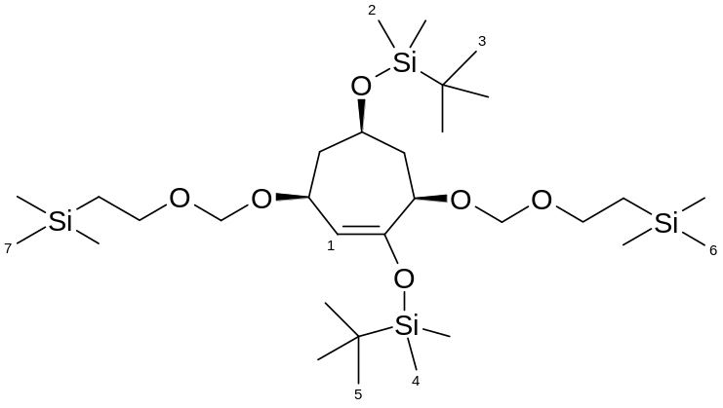
(+/-)
74
rac-[{(1R*,3R*,6S*)-3,6-bis[({[2-(trimethylsilyl)ethyl]oxy}methyl)oxy]-4-cycloheptene-1,4-diyl}bis(oxy)]bis[(1,1-dimethylethyl)(dimethyl)silane]
A 1 M solution of lithium bis(trimethylsilyl)amide in tetrahydrofuran (103 μL, 0.103 mmol) at -78 ºC was treated dropwise over 10 minutes with a solution of ketone 55 (50 mg, 0.093 mmol) in tetrahydrofuran (0.2 mL). The solution was stirred for 1 hour then treated with t-butyldimethylsilyl trifluoromethanesulfonate (23 μL, 0.098 mmol) dropwise over 10 minutes. The resulting reddish mixture was stirred for a further 1 hour then warmed to room temperature and stirred for 30 minutes. The dark brown solution was quenched with aqueous sodium bicarbonate (5 mL) and extracted with diethyl ether (4 x 10 mL). The combined organics were washed with brine (5 mL), dried over sodium sulphate, filtered and concentrated in vacuo to a clear oil. The residue was purified by flash chromatography over silica doped with 1 % triethylamine, eluting with neat petrol containing 1 % triethylamine to yield a clear oil (22 mg, 36 %). This material was immediately used without further purification in the next step.
Characteristic ¹H NMR peaks (tentative assignment): ¹H (400 MHz, CDCl₃) δ 4.89 (1H, d, J 4.0, H-1), 0.93, 0.88 (18H, two s, H-3 / H-5), 0.17, 0.08 (12H, two s, H-2 / H-4), 0.03 (18H, s, H-6, H-7).
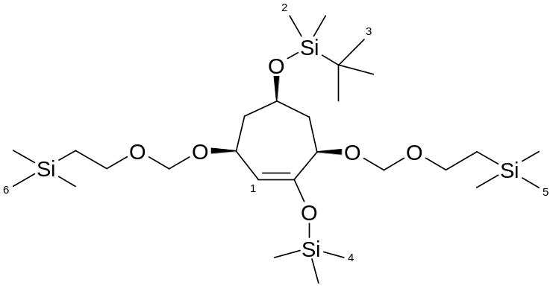
(+/-)
75
rac-[{(1R*,4S*,6R*)-6-{[(1,1-dimethylethyl)(dimethyl)silyl]oxy}-2-[(trimethylsilyl)oxy]-2-cycloheptene-1,4-diyl}bis(oxymethanediyloxy-2,1-ethanediyl)]bis(trimethylsilane)
A 1M solution of lithium bis(trimethylsilyl)amide in tetrahydrofuran (62 μL, 0.062 mmol) at -78 ºC was treated dropwise over 15 minutes with a solution of ketone 55 (30 mg, 0.056 mmol) in tetrahydrofuran (0.15 mL). The solution was stirred for 1 hour then treated with chlorotrimethylsilane (14 μL, 0.112 mmol) as a solution in tetrahydrofuran (0.1 mL) dropwise over 10 minutes. The resulting mixture was stirred for a further 1 hour then warmed to room temperature and stirred for 30 minutes. The slightly yellow solution was quenched with half-saturated aqueous sodium bicarbonate (5 mL) and extracted with dichloromethane (4 x 10 mL). The combined organics were dried over sodium sulphate, filtered and concentrated in vacuo a yellow oil (47 mg, quantitative). This material was immediately used crude in the next step.
Characteristic ¹H NMR peaks (tentative assignment): ¹H (400 MHz, CDCl₃) δ 4.90 (1H, d, J 4.0, H-1), 0.89, 0.22 (18H, two s, H-3 / H-4), 0.07 (6H, s, H-2), 0.03 (18H, s, H-5, H-6).
A1.3 Experimental Data for Section 2.2
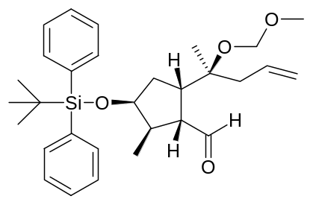
85
(1R,2R,3S,5S)-3-{[(1,1-dimethylethyl)(diphenyl)silyl]oxy}-2-methyl-5-((1S)-1-methyl-1-{[(methyloxy)methyl]oxy}-3-buten-1-yl)cyclopentanecarbaldehyde
To a suspension of alcohol 84 (1.17 g, 2.35 mmol) and sodium bicarbonate (592 mg, 7.05 mmol) in dichloromethane (5 mL) was added Dess-Martin periodinane (1.5 g, 3.53 mmol) portionwise over 10 minutes at room temperature. The resulting mixture was stirred for 1 hour then treated with aqueous sodium thiosulphate (30 mL) and stirred for 20 minutes. The solution was poured into half-saturated aqueous sodium bicarbonate (70 mL) and extracted with diethyl ether (60 mL). The organic layer was washed with water (35 mL) then the aqueous layers were combined and extracted with diethyl ether (60 mL), which was subsequently washed with water (35 mL). The organic layers were combined and washed with half-saturated aqueous sodium thiosulphate (70 mL) followed by aqueous sodium bicarbonate (70 mL). The organics were then dried over magnesium sulphate, filtered and concentrated in vacuo. The residual yellow oil, which contained a cream solid, was taken up in diethyl ether (7 mL) and the solution decanted off from the solid, filtering through a cotton wool plug. The solution was concentrated in vacuo and the decantation procedure repeated to leave a yellow oil containing a small amount of cream solid. This was immediately used crude in the next step.
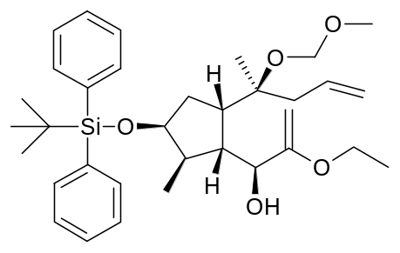
86
(1S)-1-[(1R,2R,3S,5S)-3-{[(1,1-dimethylethyl)(diphenyl)silyl]oxy}-2-methyl-5-((1S)-1-methyl-1-{[(methyloxy)methyl]oxy}-3-buten-1-yl)cyclopentyl]-2-(ethyloxy)-2-propen-1-ol
A solution of ethyl vinyl ether (2.25 mL, 23.50 mmol) in tetrahydrofuran (16 mL) at -78 ºC was treated dropwise with t-butyllithium (6.9 mL of a 1.7 M solution in hexane, 11.75 mmol). After stirring for 5 minutes the solution was allowed to warm to 0 ºC over 15 minutes, at which point the deep yellow solution became pale. The mixture was re-cooled to -78 ºC and treated by cannula with a pre-cooled solution of aldehyde 85 in tetrahydrofuran (14 mL) at -78 ºC. The solution was stirred for 1.5 hours then warmed to 0 ºC and stirred for a further 30 minutes. After warming to room temperature the solution was quenched with aqueous sodium bicarbonate (40 mL) and extracted with diethyl ether (3 x 60 mL). The organics were combined, washed with brine (40 mL), dried over magnesium sulphate, filtered and concentrated in vacuo to a yellow oil which was immediately used crude in the next step.

