



Inline Image:  12mm x 15.99mm

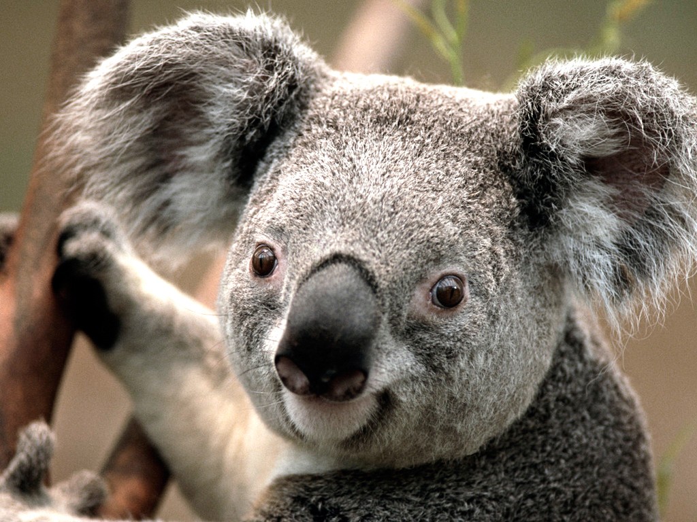

Figure Cropped Koala 31.24 \* 100mm

Bitmap :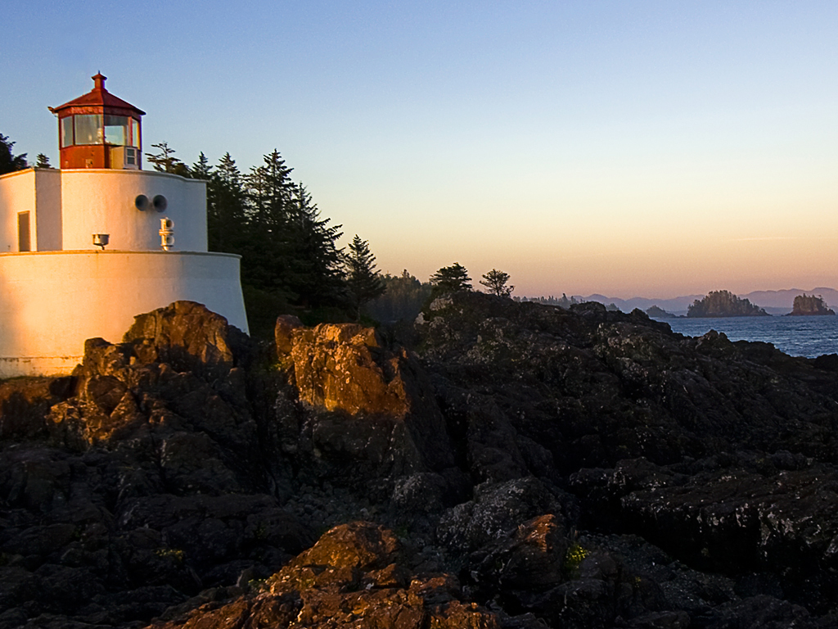 Cropped 130mm Right, 80mm bottom, 50% size, 70mm width

Tiff: Lighthouse.tif 20% size (54.19mm width)