Benzene 1-(4-acetylphenyl)-4-piperidinecarboxylic acid

is a compound and H 2 O 1 is another.

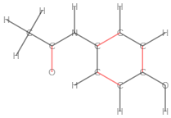

This is **compound 1** in the current document 1-(4-acetylphenyl)-1H-pyrrole-2,5-dione xxx melting point xxx