Svaraa V0 — Frontend Plan & Timeline
Nov 2, 2026 · @Pragati

Overview
Two frontend developers build the Svaraa app for iOS, Android and web. Internal release: Jan 8, 2027.
- Build: all 28 screens from the wireframes, in English and Hindi
- Web: caretaker screens and the setup-link page only
- Pendant: simulator now, real Bluetooth later, with no screen changes
- Not now: music, news, reminders (the app is ready to add them)

Who does what
 | FE-A | FE-B
Focus | App, caretaker, web | Pendant, wearer, voice
Screens | A1–A4, B1, B3, D1–D8, E1, E3–E5 (17) | B2, C1–C8, E2 (11)
Works with | Person 1 (login, circles, links) | Person 2 (simulator), Person 3 (voice)
Each person reviews the other’s code, so both know the whole app.

Tech stack
Need | Tool
App for iOS, Android, web | React Native + Expo (TypeScript), Expo Router
Builds and updates | EAS Build, EAS Update
Data from backend | TanStack Query + client generated from /openapi.json
Fake backend until APIs are ready | MSW mocks
App state | Zustand
English + Hindi | i18next, Noto Sans Devanagari
Pendant | Simulator over WebSocket now; react-native-ble-plx later
Audio | react-native-audio-api
QR scan, push, secure storage | expo-camera, expo-notifications, expo-secure-store
Google sign-in | @react-native-google-signin
Tests | Jest, Maestro
Code quality and CI | ESLint, Prettier, GitHub Actions, Sentry

App structure
svaraa-mobile/
├── app/ screens only (auth, onboarding, j/[token], main)
├── features/ auth, circles, devices, invites, consent, sos
├── services/ api, pendant, voice, push ← all outside calls
├── ui/ design system + caretaker/wearer themes
├── i18n/ en.json, hi.json
└── config/ env, feature flags, simulator/BLE switch
Rules
- Screens never call the backend, Bluetooth or WebSocket directly; only services/ does.
- Pendant uses one interface: SimulatorTransport now, BleTransport later, switched in config.
- Setup progress comes from the server, so users can resume anytime.
- No hard-coded text; every word lives in en.json and hi.json.
- Wearer screens use the large-size theme: bigger text and buttons, same screens.
- New features (music, news) = a new folder + a feature flag.

Working with backend
Backend agrees on each API first, so frontend never waits.
- Frontend lists what each screen needs.
- Backend adds the endpoint to /docs with sample data.
- Frontend generates code from /openapi.json and builds on mock data.
- Backend makes it live; frontend switches from mock to real.
Backend gives us | Who | By
Railway URL + /docs | Person 4 | Week 1
interface_spec.md + simulator | Person 2 | Week 1–2
Login APIs | Person 1 | Week 1 (draft), week 3 (live)
Circles, claim, consent, contacts, setup-link APIs | Person 1 | Week 2 (draft), week 4 (live)
Voice WebSocket format | Person 3 | Week 2
Push + feature-flag APIs | Person 4 | Week 4–5
Daily 10-min standup together; API sync twice a week. Any API change needs a frontend reviewer.

Sharing and merging code
- One GitHub repo svaraa-mobile; main is protected and must always build.
- Branch per ticket: feat/FE-04-caretaker-setup; merge within 1–2 days.
- Every pull request is reviewed by the other person; keep it under 400 lines.
- CI must pass before merge: lint, type check, tests, missing Hindi text check.
- Rebase on main every morning; shared folders (ui/, config/) change in small separate PRs.

AI tool usage
- Both use the same AI coding tool (e.g. Claude Code) with one shared CLAUDE.md holding the rules above.
- Use AI for screens, tests, mock data, first-draft Hindi text and PR notes.
- Write by hand, AI only assists: pendant/Bluetooth, background audio, login, consent and SOS.
- AI code goes through normal review; never paste secrets or user data into the tool.

User stories
- As a wearer, I set up and pair my pendant myself, add emergency contacts and test SOS.
- As a caretaker, I set up the pendant for my parent and send them a link to agree and pair.
- As a wearer, I talk to my pendant and hear Svaraa reply, even when my phone is locked.
- As a caretaker, I see everyone I care for and their status, on phone or web.

Tickets
About 42 working days each. Split each ticket into sub-tasks on the board.
ID | Task | Owner | Week | Days
FE-01 | Project setup, CI, design system, EN/HI, API client | A | 1–2 | 8
FE-02 | Sign in + Home setup card (A1–A4) | A | 2–3 | 7
FE-03 | Role choice + caretaker permission (B1, B3) | A | 3 | 1
FE-04 | Caretaker setup (D1–D5) | A | 3–4 | 6.5
FE-05 | Setup link, deep links, web landing (D6–D8) | A | 5 | 8
FE-06 | Caretaker Home, circle, ownership (E1, E3–E5) | A | 6 | 5.5
FE-07 | Web build + Hindi review | A | 7 | 3
FE-08 | Device testing + release | A | 7–9 | 2.5
FE-10 | Shared components, pendant connection layer, background-audio test | B | 1 | 7
FE-11 | Permissions, about you, claim (B2, C1–C2) | B | 2–3 | 6
FE-12 | Pairing + pendant check (C3–C4) | B | 3–4 | 4.5
FE-13 | Emergency contacts + invite (C5–C7) | B | 4 | 3
FE-14 | Voice relay (pendant ↔ backend) + feature flags | B | 5 | 5
FE-15 | SOS drill (C8) | B | 5 | 2
FE-16 | Background mode, push, pendant status, wearer Home (E2) | B | 6 | 8
FE-17 | Accessibility + automated flow tests | B | 7 | 3.5
FE-18 | Device testing + release | B | 7–9 | 3

Timeline
Both setup paths run end to end on the simulator by Dec 11, features are complete by Dec 18, and the internal release ships Jan 8, 2027.
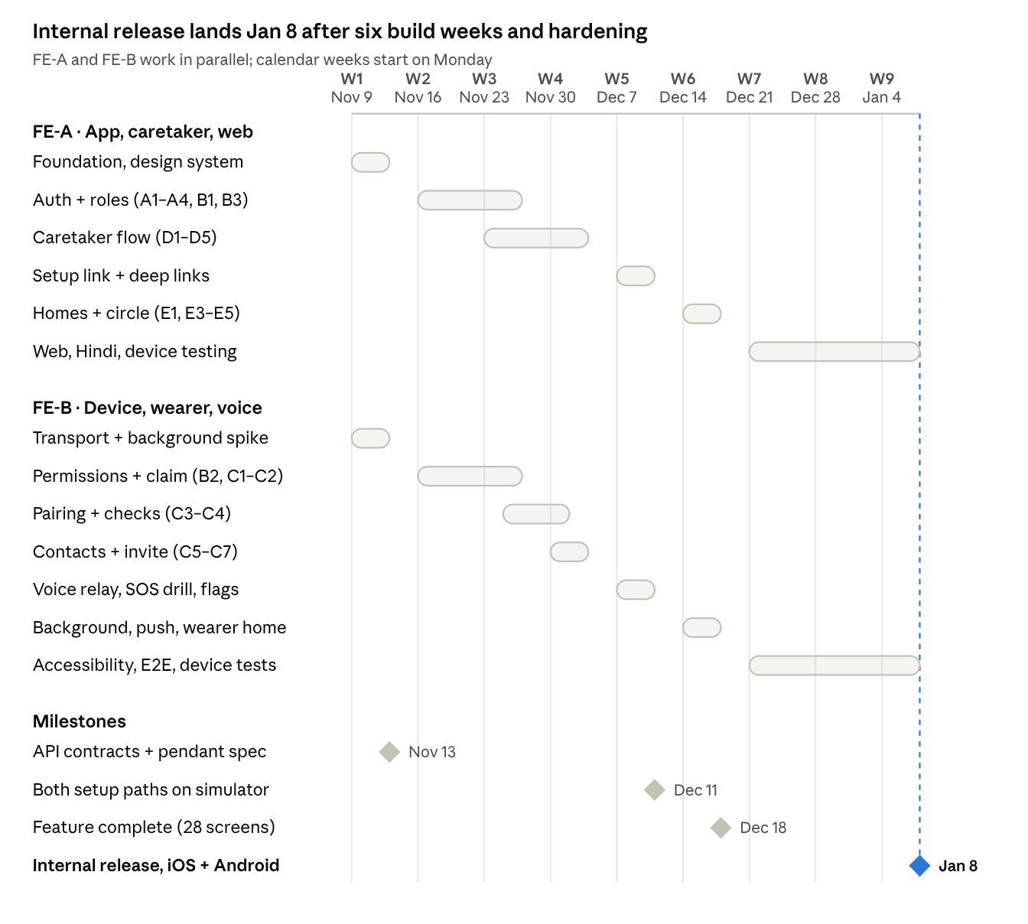
frontend timeline · 2 people, 4 milestones
Weeks 7–9 include the Dec 25 and Jan 1 holidays.
Milestone | Date | Done when
M1 | Nov 13 | API drafts + pendant spec shared; design system merged
M2 | Dec 11 | Both setup paths work end to end on the simulator
M3 | Dec 18 | All 28 screens done in EN + HI; push and background work
M4 | Jan 8 | Tested on devices; TestFlight + Play internal builds live

Saturday demos
Every Saturday, stakeholders see a working build on real phones. Each week ends with something they can tap.
Saturday | What we show
Nov 14 | App on iOS + Android in brand style; switch English ↔ Hindi; app connects to the pendant simulator
Nov 21 | Sign in with phone OTP and Google; wearer permission screens
Nov 28 | Home with setup card; role choice; claim pendant by QR (wearer and caretaker)
Dec 5 | Caretaker setup done and link created; wearer pairs pendant and adds emergency contacts
Dec 12 | Full setup by link (send → open → agree → pair); talk to pendant and hear a reply; SOS drill
Dec 19 | All 28 screens; caretaker and wearer Home; voice works with phone locked; push alerts
Dec 26 | Caretaker screens on web (short demo, holiday week)
Jan 2 | Hindi review done; accessibility fixes; device test results
Jan 9 | Release builds installed from TestFlight + Play on stakeholders’ phones
How we keep it on track
- Friday 4 pm: merge stops; an EAS build from main goes to the demo phones.
- Friday 6 pm: both developers run the demo once; anything broken is hidden behind a feature flag.
- Screens still on mock data are labelled “demo data”.
- Feedback from Saturday becomes tickets on Monday.

Risks
Risk | Plan B
Backend APIs late | Keep building on mock data; raise it at API sync
iOS stops audio when phone locks | Test in week 1; fallback: voice works with app open only
Pendant spec keeps changing | Freeze version 1 by Nov 13
Holidays slow testing | Cut in this order: web build → ownership transfer → automated tests

Done means
- ☐ Works on iOS and Android (and web, if on web)
- ☐ English and Hindi text fit the screen
- ☐ Connected to the real API, or mock linked to a backend ticket
- ☐ Reviewed by the other person; CI green

