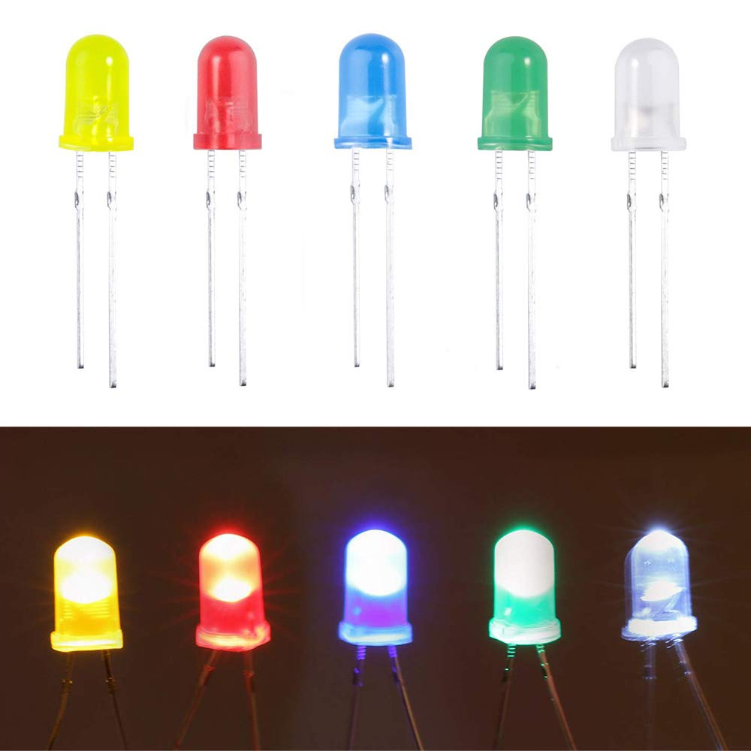
WayinTop 5mm LEDs

Feature
☺It includes Red, Green, Yellow, Blue Diffused Lens LEDs and White Clear Lens LEDs.
☺Wavelength Range: Red, 620-625nm; Yellow, 590-595nm; Green, 520-525nm; Blue, 460-465nm; White, 8000K.
☺Wide Application: DIY LED Projects, School Science Experiments, Car Decorations, Signal Indicator, Electronic and Electrical Experiments, etc.

Specification
Head Type: Round
Head Diameter: 5mm
Pin Length: 18 mm
Max. Current: 20mA
Viewing Angle: 30 Degree
Forward Voltage: R/Y 2.0-2.2V; B/G/W 3.0-3.2V

