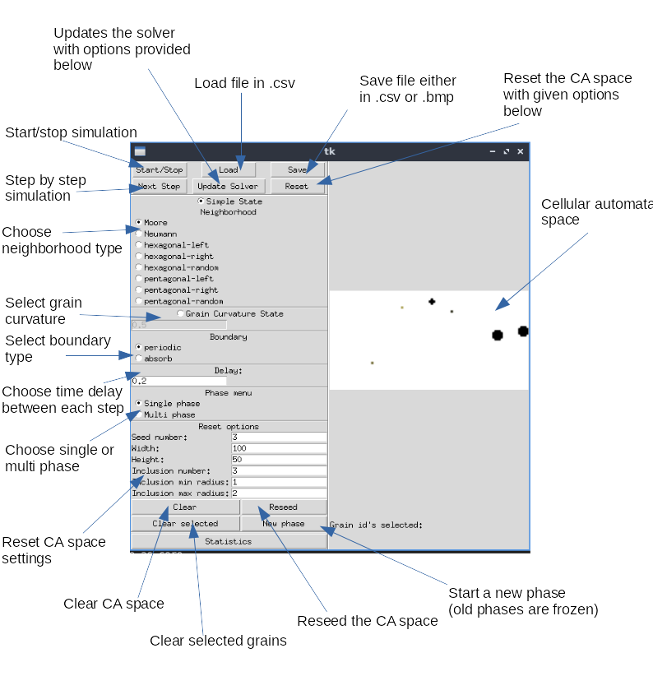
Multiscale Modelling – Report

1. Topic

The topic of the task was to create an application that simulates the behaviour of grain growth, based on the cellular automata algorithm.

2. GUI – Funcionalities and appearance

3. Sample results:
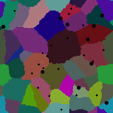
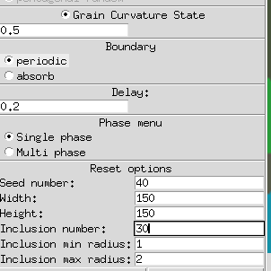
4. Conclusion

The task was very interesting. There were many opportunities to implement good design OOP design patterns.
The biggest obstacles that I have faced was the implementation of a „step-by-step” feature, because of the design of the application it was not as simple as one might thought it would be. The whole application-controller was thought as a simple state-machine and because of that, and because of the lack of a distinction between „running” states (only „on” and „off”), it was quite a tricky task to solve.

5. Links:
https://github.com/ptutak/cellular-automaton

6. Installation - dependencies:

pip install -r requirements.txt

7. Running

python3 cellular_automaton/main.py

