SCS Sitebuilder staging instructions and production progress

Current content production status/site map is here:

https://docs.google.com/spreadsheets/d/1PyFYmMCCI-Tq8t87hOUciAXAHXITJvz6HCLGQWGSMu0/edit#gid=0

Sitebuilder staging is here: https://warwick.ac.uk/services/careers2018

Page layouts(types)

There are basically three page layouts (excluding homepage). They all use the basic template in Sitebuilder.

- Standard content page
- Topic page
- Guide page

In the ‘student-careers-prototype-kit’ Git repository you’ll see a folder with boilerplate HTML for the above pages that you can paste into Sitebuilders RAW editor.

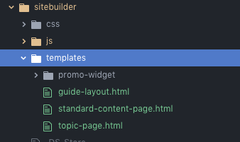

Standard content page

This is the most commonly used page type. Use it if you content can fit onto one page without excessive scrolling. If you page has too much content consider splitting it into two separate pages or use the guide layout.

Tips for main content block:

- Keep bullet point to 5-6 minimum – ideally three or less.
- Use h2 h3 and h4 heading to help users make sense of content importance
- Pull out important content using the emphasis pull (see below)

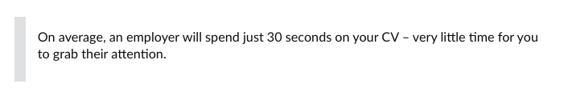

- Put all external links in the right side nav under ‘Elsewhere on the web’
- Put related links in the right side nav under ‘Related content’
- Edit copy so it is not verbose and is relevant to users visiting the page
- Don’t duplicate or repeat content on other pages - be specific
- When linking to an important form use the following style button to do so (replace text with your own of course)



- Use images only if they help the user understand the content. Do not use them to pad the page out.
- Use video to support and extend the page content. Do not use as replacement for content or to pad out pages.

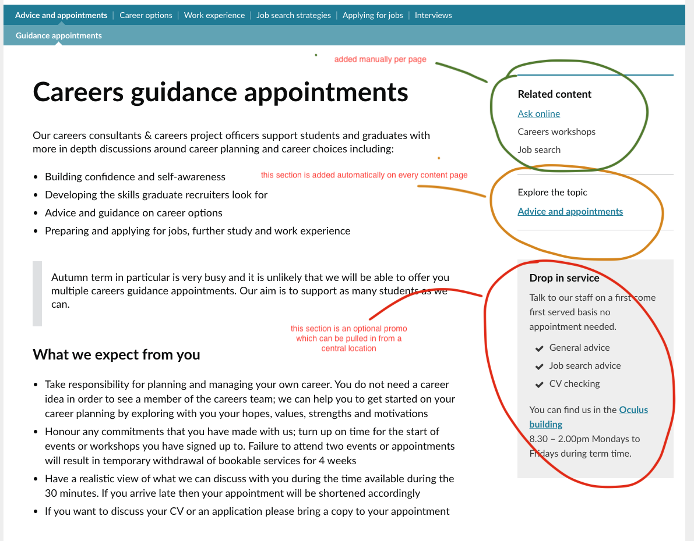

Right menu

- Related content section is added manually on each page( I’m leaving linking each href until most of the site builder page are ready)
- Explore the topic section is added automatically using JavaScript (see below for details)
- Promo section is optional, you can add a one off promo on a page or you can pull in a frequently used promo from /partials (see below for details)

JavaScript helpers

Each page includes careersapp.js. This JavaScript code creates the explore the topic section and allows you to optional pull in a frequently used promo section

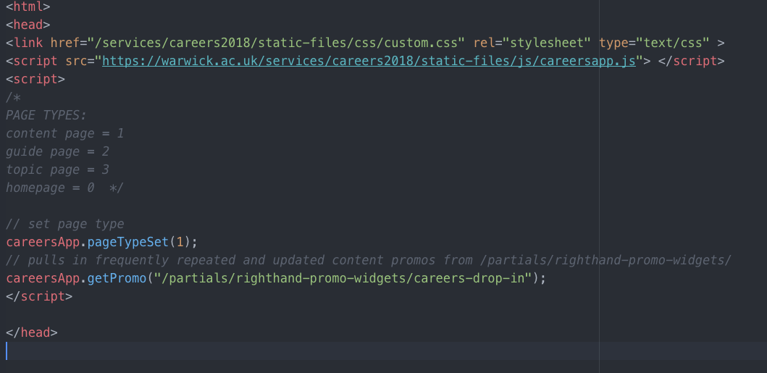

Setting the page type in the script is needed to create the explore the topic section:

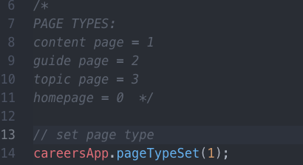

Promos

Promos are option widget boxes that can be included in the right nav. They can pull in frequently used content which can be updated once centrally. This can help site maintenance and help keep the site up-to-date.

The line below is optional and should be used if you wish to pull in frequently used and updated content. Update the path (in green below) to link to another promo.

The directory “/partials/righthand-promo-widgets” (see below) in Sitebuilder staging has a number of common promos that you can pull in - or you can create your own by copying one of them.

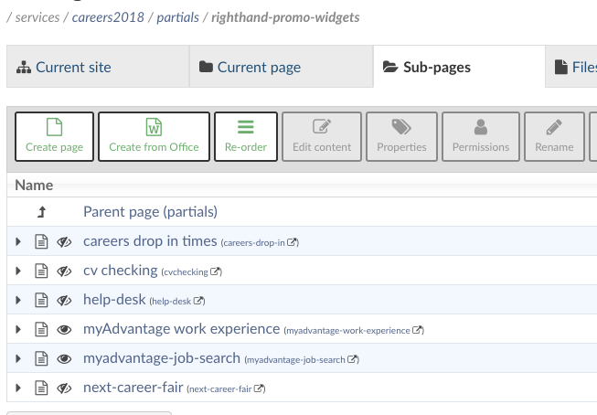

You can comment the line below out if you don’t want to use promos. Optionally you can add promo markup to the page without pulling it in from a central location.

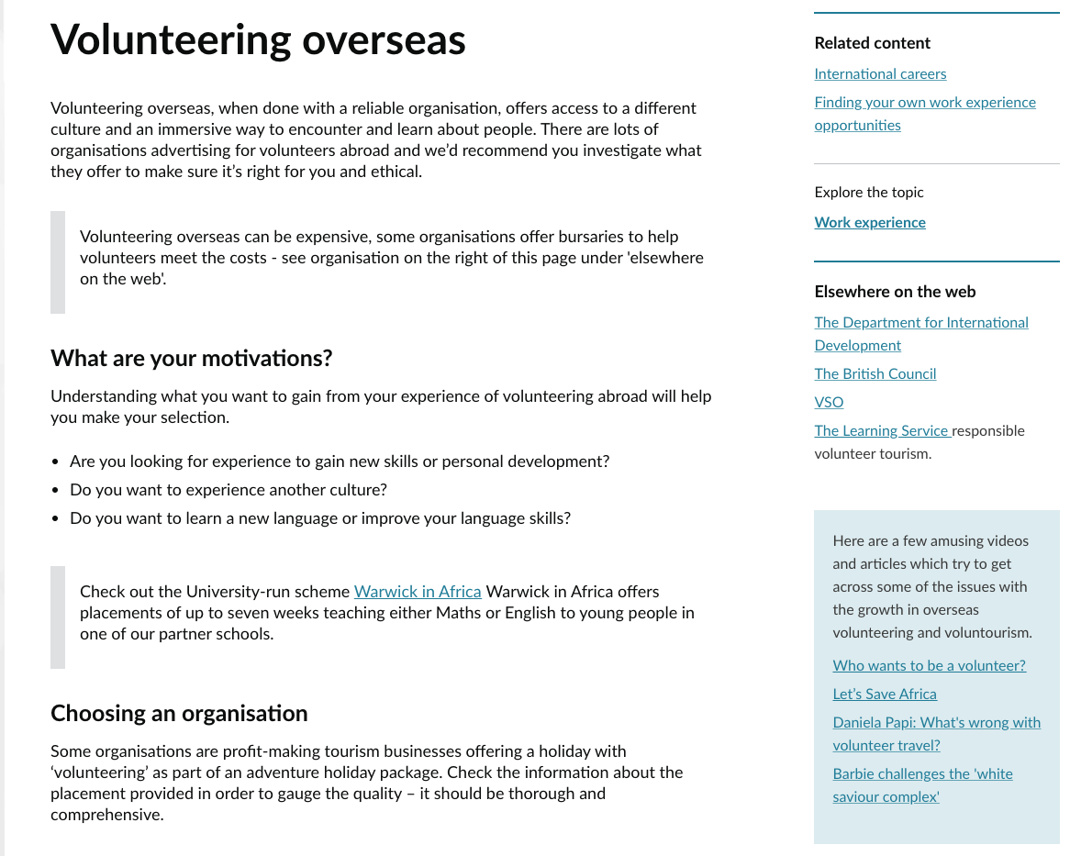

The page above uses the promo space for page specific content.

External Links

Use the ‘Elsewhere on the web’ format shown above for all external links that a page might use.

Guide Pages

Guide pages are a solution for pages with a lot of content. They allow you to split the content up into subpages – think of it as a little guide book.

Example:

https://warwick.ac.uk/services/careers2018/job-applications/how-to-write-a-cv/introduction

Guide pages have a table of content (toc) and pagination both of which the users can use to navigate the content.
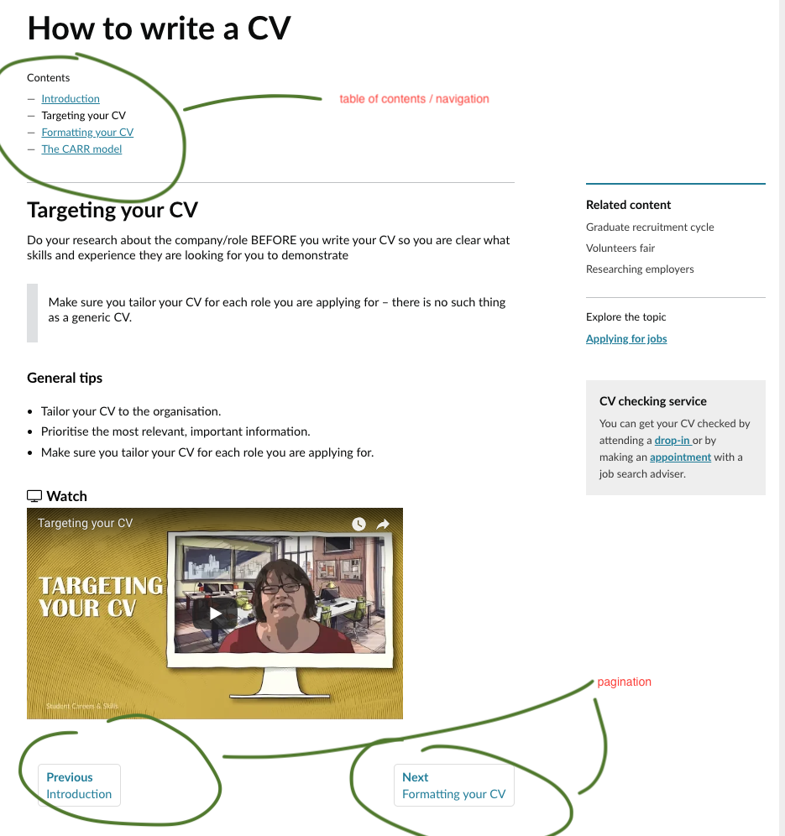

How to setup a guide page

Step 1

In order to use pagination and TOC you must first setup a parent page of the guide pages in sitebuilder

Example parent page:

https://warwick.ac.uk/services/careers2018/job-applications/how-to-write-a-cv/

This page must use the content list page template in Sitebuilder and have ‘show previous links on subpages’ selected.

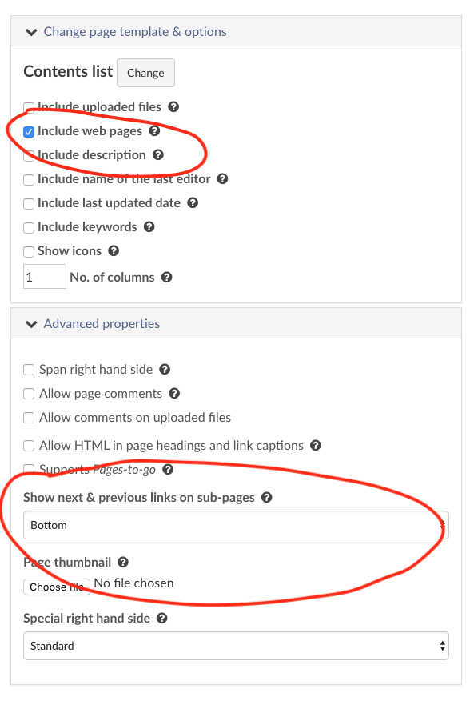

This page is for organising sub-pages only and not meant for user to see, so turn off ‘show in local navigation’ in the pages properties. You don’t need to add any HTML code to this page..

Step 2: add guide pages

Add a subpage(s) below this parent page. The first of these subpages is the landing page for the guide.

- Create a new page under the parent page you just created
- Use the default blank template
- Use the naming convention below:

When creating guide subpages put the title bar caption in the format shown below.

Parent page title: subpage title

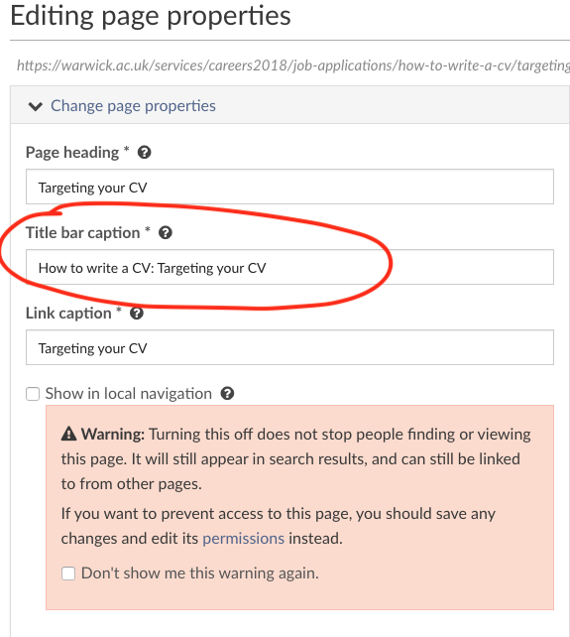

Make sure you include guidepages.js and careersapp.js in the head of the page and set the page type to 2.

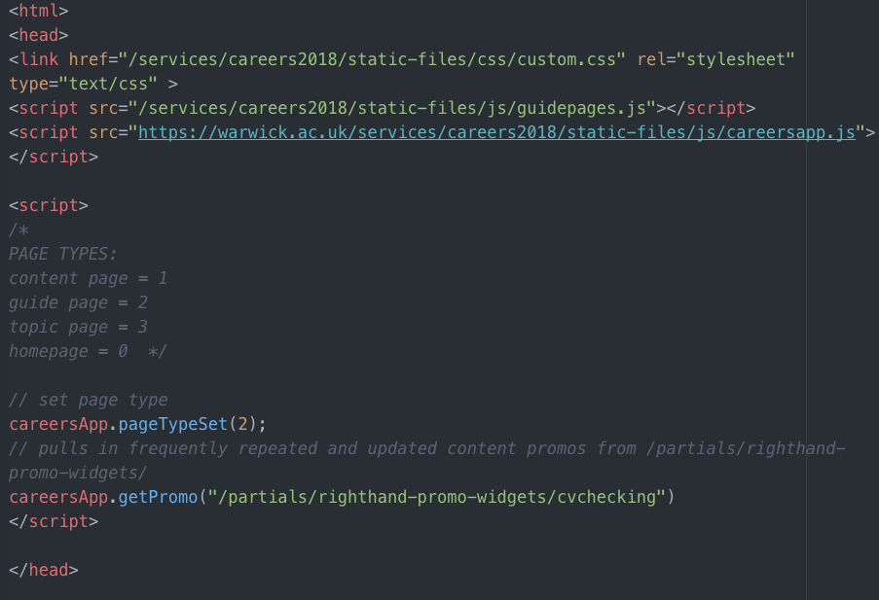

parent title: subpage title

The table of content and navigation will now be setup automatically. You can change the order of pages if necessary using re-order in Sitebuilder.

