

**This document is licensed under the Creative Commons Attribution-NonCommercial-ShareAlike 3.0 Unported (CC BY-NC-SA 3.0) License. To view a copy of this license, visit http://creativecommons.org/licenses/by-nc-sa/3.0/; or, (b) send a letter to Creative Commons, 171 2nd Street, Suite 300, San Francisco, California, 94105, USA.”**

**Copyright (C) 2010 Fraunhofer Institute for Open Communication Systems (FOKUS)  
Fraunhofer FOKUS  
Kaiserin-Augusta-Allee 31  
10589 Berlin  
Tel: +49 30 3463-7000  
*info@fokus.fraunhofer.de***

Security Mechanism of OpenRide

The „Security Pattern“that is used for OpenRide’s Webclient is the following of the J2EE Standard pattern:

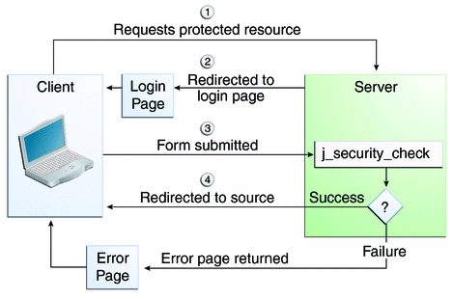

It is called “form-based-authentication”. The “security check“component uses the so called JDBC-Realm to check the sent user information (nickname/password), requesting the database.

Another way to perform this action is to use a direct request to the j2ee security component. The request could look like this e.g.: <https://193.174.152.244:3013/OpenRideServer-RS/j_security_check?j_username=tilo&j_password=test>. This would authenticate a user to the system. Afterwards the user can send requests to all the resources that are deployed, if the specification is considered. More detailed information can be found on oracles java tutorial page: http://download.oracle.com/docs/cd/E17410_01/javaee/6/tutorial/doc/gkbaa.html#bncbq.