HammerDB testing

1. Run HammerDB

* You will see window as below:

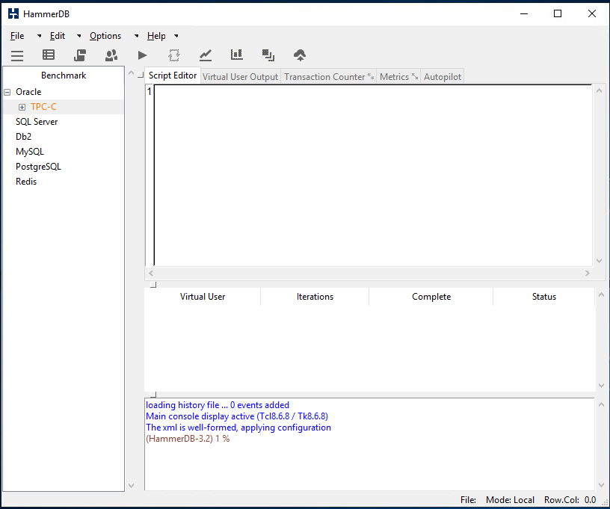

* Double-click SQL Server on the left pane and confirm as per window below:

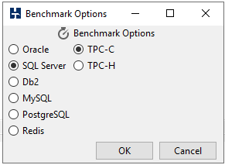

1. Set Build Options and build schema

* Select *Options* in *Schema Build* tree
* Select *SQL Server Authentication* and set IP address, User ID, Password and Database (default: tpcc)
* Set *SQL Server ODBC Driver* to: SQL Server Native Client 11.0
* Set desired number of *Warehouses* and *Virtual Users*
* Make sure selected database has no tables
* Select *Build*, it will take several hours to create

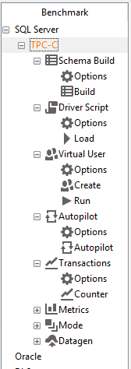 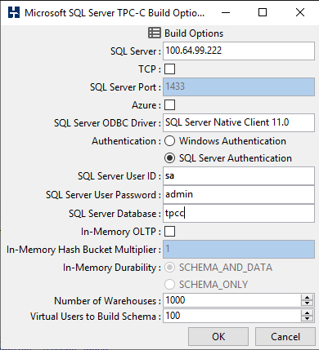

1. Set Driver Script Options and load

* Select *Options* in *Driver Script* tree (if there is no window popping up, click on Stop icon button in upper menu)
* Most of data should be the same as in previous step
* Select *Timed Driver Script*
* Select *Exit on SQL Server Error* and *Use All Warehouses* options
* *Load* script

 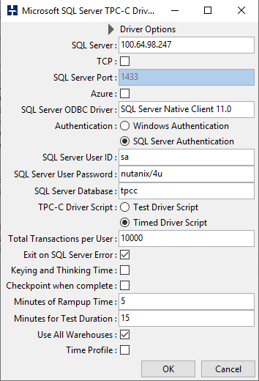

1. Run test
   * Select *Options* in *Virtual User* tree.
   * Enter correct number of *Virtual Users*
   * Select *Log Output to Temp* and *Use Unique Log Name* options
   * Run

 