18 Работа с базами данных. Технологии доступа к данным
Задание 1. CRM для небольшого бизнеса
CRUDоперации: ClientRepository с GetAllClientsAsync(),
AddClientAsync(Client), UpdateClientAsync(Client), DeleteClientAsync(Client)
Привязка: Clients в CRMViewModel как ObservableCollection&lt;Client&gt;, в XAML <ListView ItemsSource=«{ Binding Clients}»/>;
Сохранение: в SaveClientsCommand выполнять await _context.SaveChangesAsync()
Листинг программы:
public class OrderModel
{
public int Id {get; set;}
public string Title { get; set; }
public decimal Price { get; set; }
public ClientModel client { get; set; }
}
public class ClientService
{
private List<ClientModel> _clients = new List<ClientModel>();

public List<ClientModel> GetClients() => _clients;
public void AddClient(ClientModel client) => _clients.Add(client);
public void DeleteClient(ClientModel client) => _clients.Remove(client);

public void UpdateClient(ClientModel oldClient, ClientModel newClient)
{
oldClient.FullName = newClient.FullName;
oldClient.Contact = newClient.Contact;
oldClient.ClientType = newClient.ClientType;
}
}
public class ClientModel : INotifyPropertyChanged
{
private string _fullName;
private string _contact;
private string _clientType;
public string FullName
{
get => _fullName;
set
{
if (_fullName != value)
{
_fullName = value;
OnPropertyChanged(nameof(FullName));
}
}
}
public string Contact
{
get => _contact;
set
{
if (_contact != value)
{
_contact = value;
OnPropertyChanged(nameof(Contact));
}
}
}
public string ClientType
{
get => _clientType;
set
{
if (_clientType != value)
{
_clientType = value;
OnPropertyChanged(nameof(ClientType));
}
}
}
public event PropertyChangedEventHandler PropertyChanged;
protected void OnPropertyChanged(string name)
{
PropertyChanged?.Invoke(this, new PropertyChangedEventArgs(name));
}
}
public class BoolToVisibilityConverter : IValueConverter
{
public object Convert(object value, Type targetType, object parameter, CultureInfo culture)
{
return (bool)value ? Visibility.Visible : Visibility.Collapsed;
}
public object ConvertBack(object value, Type targetType, object parameter, CultureInfo culture)
{
throw new NotImplementedException();
}
}
public class ClientDialogVM
{
public List<string> ClientTypes { get; } = new List<string>
{
"Обычный",
"VIP"
};
public ClientModel Client { get; set; } = new ClientModel();
public bool ClientSaved { get; private set; } = false;

public ICommand SaveCommand { get; }
public ICommand CancelCommand { get; }

public ClientDialogVM()
{
SaveCommand = new RelayCommand(_ => Save());
CancelCommand = new RelayCommand(_ => Cancel());
}
private void Save()
{
if (string.IsNullOrWhiteSpace(Client.FullName))
{
MessageBox.Show("Введите имя клиента");
return;
}
ClientSaved = true;
CloseWindow();
}
private void Cancel()
{
ClientSaved = false; CloseWindow();
}
private void CloseWindow()
{
foreach (Window window in Application.Current.Windows)
{
if (window.DataContext == this)
{
window.Close();
break;
}
}
}
}
public class MainVM : INotifyPropertyChanged
{
public ObservableCollection<ClientModel> Clients { get; set; } = new ObservableCollection<ClientModel>();
public ObservableCollection<OrderModel> Orders { get; set; } = new ObservableCollection<OrderModel>();
private ClientService _clientService = new ClientService();
private ClientModel _selectedClient;
private bool _isLoading;
public event PropertyChangedEventHandler PropertyChanged;
protected void OnPropertyChanged(string name)
{
PropertyChanged?.Invoke(this, new PropertyChangedEventArgs(name));
}
public bool IsLoading
{
get => _isLoading;
set
{
_isLoading = value;
OnPropertyChanged(nameof(IsLoading));
}
}
public async Task LoadClientsAsync()
{
IsLoading = true;
var clients = await Task.Run(() =>
{
Thread.Sleep(2000);
return _clientService.GetClients();
});

Clients.Clear();
foreach (var c in clients)
Clients.Add(c);
IsLoading = false;
}
public ClientModel SelectedClient
{
get => _selectedClient;
set
{
_selectedClient = value;
OnPropertyChanged(nameof(SelectedClient));
CommandManager.InvalidateRequerySuggested();
}
}
public ICommand AddClientCommand { get; }
public ICommand DeleteClientCommand { get; }
public ICommand EditClientCommand { get; }
public MainVM()
{
AddClientCommand = new RelayCommand(_ => AddClient());
DeleteClientCommand = new RelayCommand(_ => DelClient(), _ => SelectedClient != null);
EditClientCommand = new RelayCommand(_ => EditClient(), _ => SelectedClient != null);
_ = LoadClientsAsync();
}
public void AddClient()
{
var vm = new ClientDialogVM();
var window = new ClientDialogWindow
{
DataContext = vm
};
window.ShowDialog();
if (vm.ClientSaved)
{
_clientService.AddClient(vm.Client);
Clients.Add(vm.Client);
}
}
public void DelClient()
{
if (SelectedClient == null) return;
if (MessageBox.Show($"Удалить клиента {SelectedClient.FullName}?", "Подтверждение",
MessageBoxButton.YesNo, MessageBoxImage.Warning) == MessageBoxResult.Yes)
{
_clientService.DeleteClient(SelectedClient);
Clients.Remove(SelectedClient);
}
}
public void EditClient()
{
if (SelectedClient == null) return;
var vm = new ClientDialogVM
{
Client = new ClientModel { FullName = SelectedClient.FullName, Contact = SelectedClient.Contact }
};
var window = new ClientDialogWindow
{
DataContext = vm
};
window.ShowDialog();
if (vm.ClientSaved)
{
_clientService.UpdateClient(SelectedClient, vm.Client);
}
}
}
public class RelayCommand : ICommand
{
private readonly Action<object> execute;
private readonly Predicate<object> canExecute;
public RelayCommand(Action<object> execute, Predicate<object> canExecute = null)
{
this.execute = execute;
this.canExecute = canExecute;
}
public bool CanExecute(object parameter) => canExecute?.Invoke(parameter) ?? true;
public void Execute(object parameter) => execute(parameter);
public event EventHandler CanExecuteChanged
{
add { CommandManager.RequerySuggested += value; }
remove { CommandManager.RequerySuggested -= value; }
}
}
Таблица 18.1 – Входные и выходные данные
Входные данные | Выходные данные
Макарчук Богдан Владимирович, pu2toy1@gmail.com | Макарчук Богдан Владимирович, pu2toy1@gmail.com

Анализ результатов:
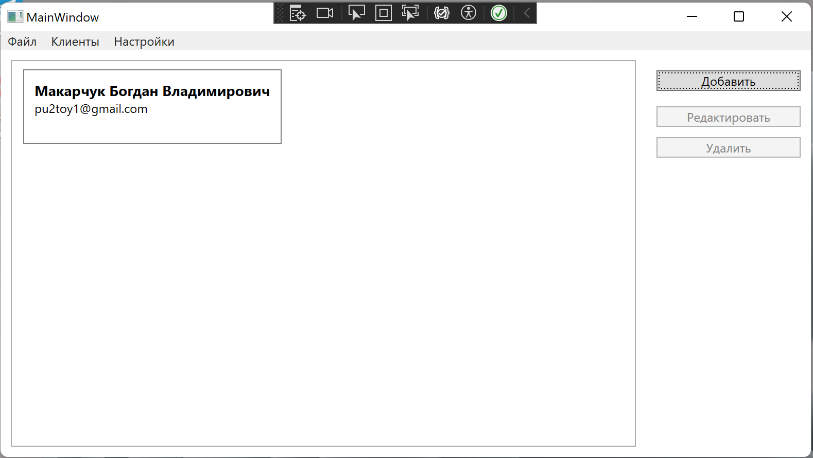
Рисунок 18.1 – Результат работы программы

