CIS430 Web and E-Business Design and Development - **Project**

|  |  |
| --- | --- |
| First Name |  |
| Last Name |  |
| Student ID# |  |

**Table of Contents**

1 Part 1: Designing a website for chocolate shop 1

1.1 Home 1

1.2 About 2

1.3 Products 2

1.4 Contact Us 3

1.4.1 Basic Contact Info 3

1.4.2 Contact Us Form 3

1.4.3 Social Network Pages 3

2 Part 2: Publish your website 4

2.1 Purchase a domain name. 4

2.2 Purchase Website Hosting 4

2.3 Publish a Website 4

3 How to submit your work 4

**Rubric (total points: 100)**

**Part 1: Designing a website for chocolate shop (80 points = 4*20 points)**

1.1 Home **(20 points)**

1.2 About **(20 points)**

1.3 Products **(20 points)**

1.4 Contact Us **(20 points)**

**Part 2: Publish your website (20 points)**

# Part 1: Designing a website for chocolate shop

You are going to design a website for a chocolate shop. The website will have the following pages.

## Home

This page should include following elements.

1. Welcome message.
2. Pictures of selected products.
3. A video about chocolate (embedded from YouTube) – You can search YouTube and embed your favorite video(s).

## About

In this page you will write about **1)** the company and **2)** team (**8 team members**). Following figure shows “a sample” team members layout.



More samples are available in the following link:

<https://speckyboy.com/50-webpage-layouts-showcasing-company-teams-employees/>

**Note:** The content of the above link is available as a pdf file in the final project folder.

50 Web Layouts for Showcasing Company Teams & Employees.pdf

## Products

This page will have a list of 8 sample products. The following figure shows a sample layout for this page.

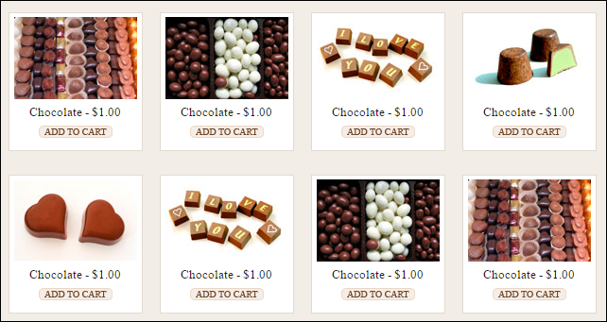

## Contact Us

This page should have following elements.

### Basic Contact Info

Phone:

Fax:

Mob:

Address:

### Contact Us Form

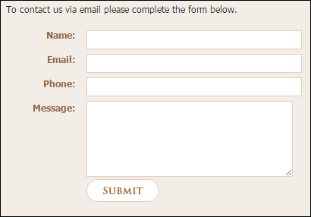

### Social Network Pages

There should be four buttons that link to four different social network pages/channels (Facebook, Twitter, Instagram, Youtube)



**Facebook**

Please create a **Facebook** page and post some sample photos of the products on your page. Then in the “contact us” page, link the **Facebook** icon to the **Facebook** page.

**Twitter**

Please create a **twitter** account for the chocolate company and post some sample photos of the products on your twitter page. Then in the “contact us” page, link the **twitter** icon to the **twitter** page.

**Instagram**

Please create an **Instagram** page and post some sample photos of the products on your page. Then in the “contact us” page, link the **Instagram** icon to the **Instagram** page.

**Youtube**

Please create a **Youtube** channel and post some sample videos about chocolate on your channel. Then in the “contact us” page, link the **Youtube** icon to the **Youtube** page.

Note: All pages should be responsive.

# Part 2: Publish your website

After finishing part 1, you need to bring your website online.

## Purchase a domain name.

You can buy a domain name from Internet domain registrar. Any top-level domain (TLD) name, e.g. .com, .info, .org can be used. You can buy some domain names for as little as $1 for the first year.

Write the url of your website, in the following box.

|  |  |
| --- | --- |
| Website URL | Write here |
| Example: | www.chocolateNUclass.com |

## Purchase Website Hosting

The next step in publishing your website is to ­find a hosting service. One popular option is to use a company that charges for website hosting services. Of the thousands of companies that provide web hosting services, most charge a monthly fee, but some offer free web hosting in exchange for advertising on your website.

**Note:** Some webhosting services can host many websites at one shared hosting. So you and other classmates can share the total cost (about $5-$10 for a month) and pay as little as $1 depending on the number of websites hosted on one share hosting.

## Publish the Website

Once you register a domain name and secure a web hosting strategy, the next step is to publish your website so that it is accessible to the world. When you publish your website, you transfer your website ­les to a web server. After transferring, or uploading, the ­les, users can access the website by typing the domain name into the Address bar on a browser.

# How to submit your work

1. After creating the required pages, compress the final folder (containing all the files, including this word document file) and submit it as a single compressed file (Zip or Rar files).
2. Rename the compressed file as following.

*YourLastName* – *YourFirstName* – *StudentIdNumber*.zip

**Example:**

Smith – John – 234566435.zip

1. Upload the file and submit it (only using Blackboard).  **Note:** Whensubmitting your project using blackboard, in your cover message include the url (address) of the online version of the website.

**The end.**