Christopher Allen Tucker: Academic Genealogy and Research
Christopher Allen Tucker received a Ph.D. from the University of Reading in 2013 for The Transmission of Wireless Power by Magnetic Resonance. The Mathematics Genealogy Project records Kevin Warwick as his advisor. Warwick’s own record leads through two recorded advisor branches: John Hugh Westcott and Panayotis (Panos) John Antsaklis.

Tucker’s recorded genealogy
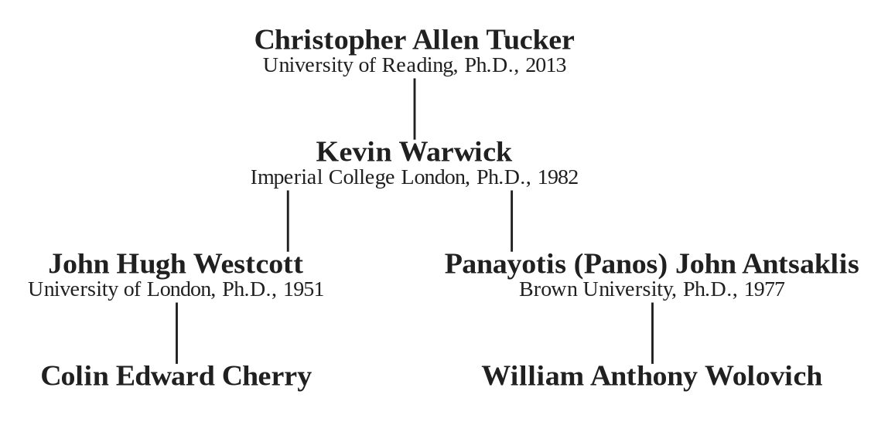
Academic genealogy from Christopher Allen Tucker through the two recorded doctoral-advisor branches.
This is a bounded lineage extract, not a claim to a complete intellectual or institutional genealogy. It identifies the recorded control-systems connections relevant to the subscriber research note.
Source: Mathematics Genealogy Project, “Christopher Allen Tucker,” ID 177516, accessed 10 September 2026; Kevin Warwick, ID 142578; John Hugh Westcott, ID 116874; Panayotis (Panos) John Antsaklis, ID 142577.

