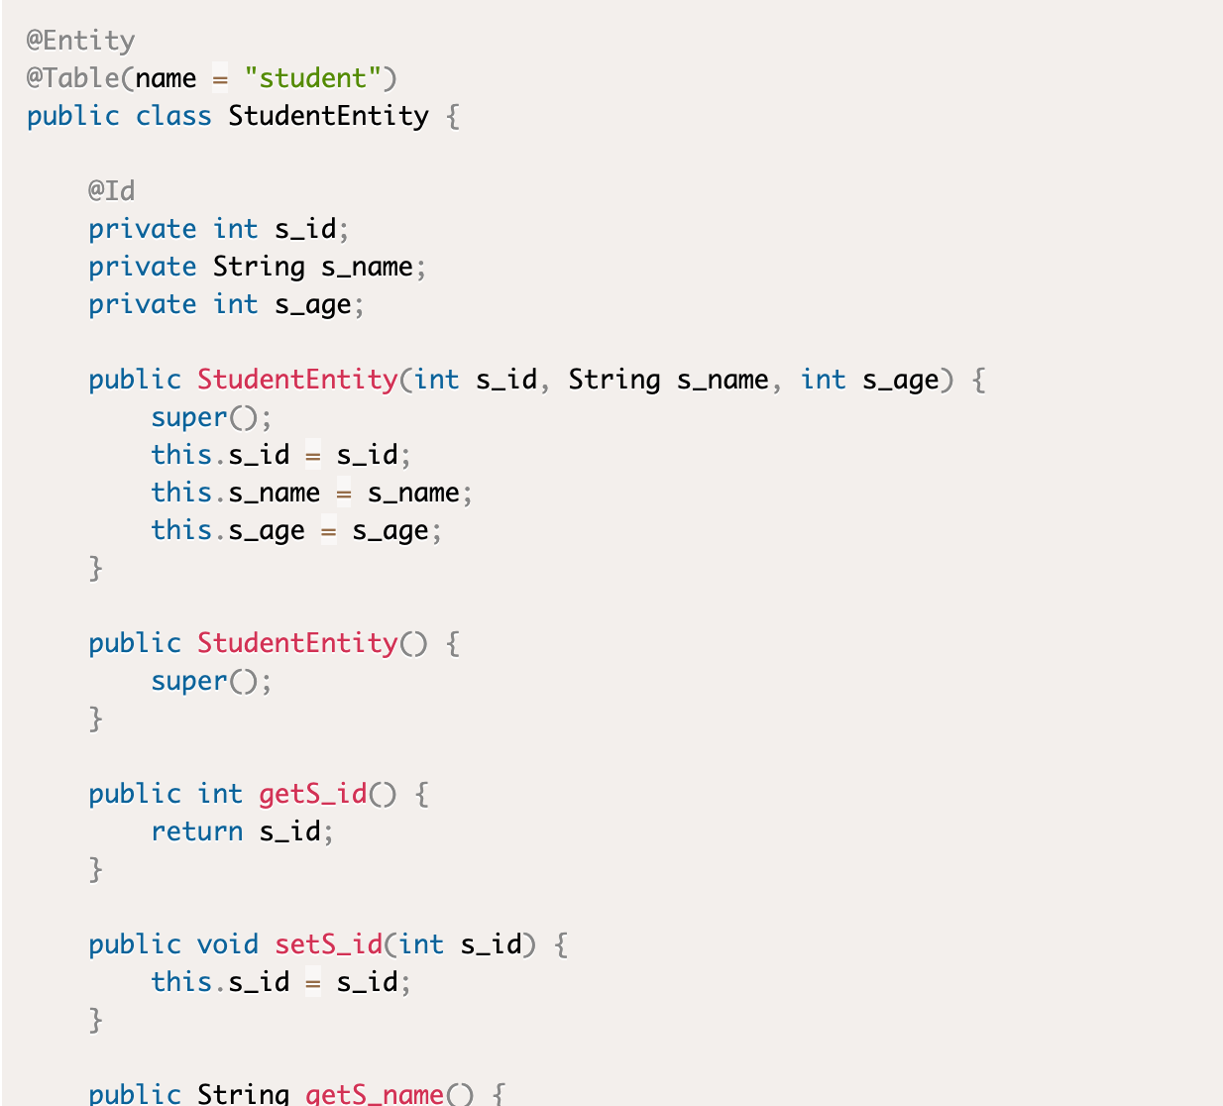

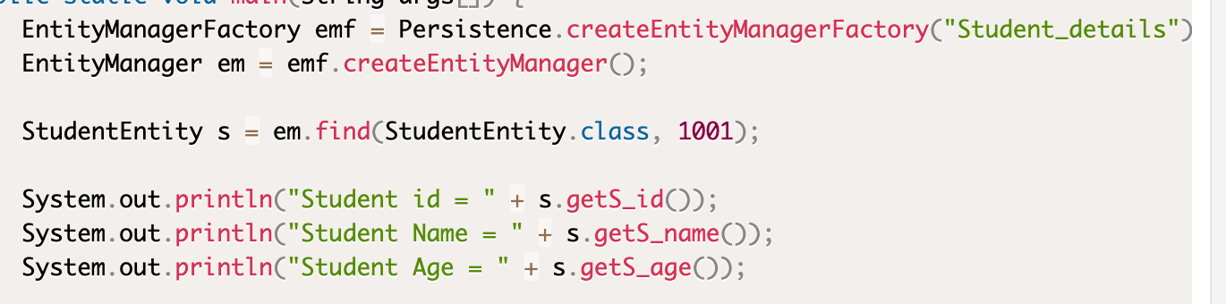





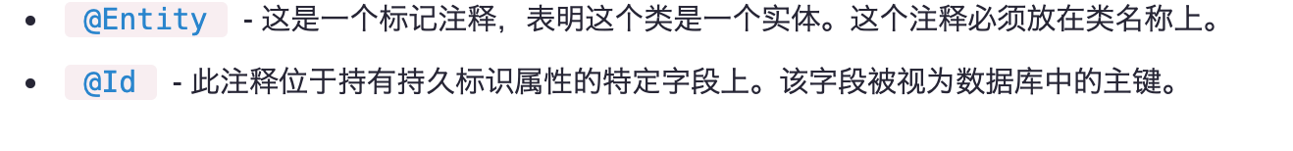

<https://www.yiibai.com/jpa/jpa-creating-an-entity.html>

[http://dudu88.cn/books/querydsl_zh_CN/Tutorials/Querying%20JPA.html](http://dudu88.cn/books/querydsl_zh_CN/Tutorials/Querying JPA.html)