Hdfs

<https://hdfscli.readthedocs.io/en/latest/api.html>

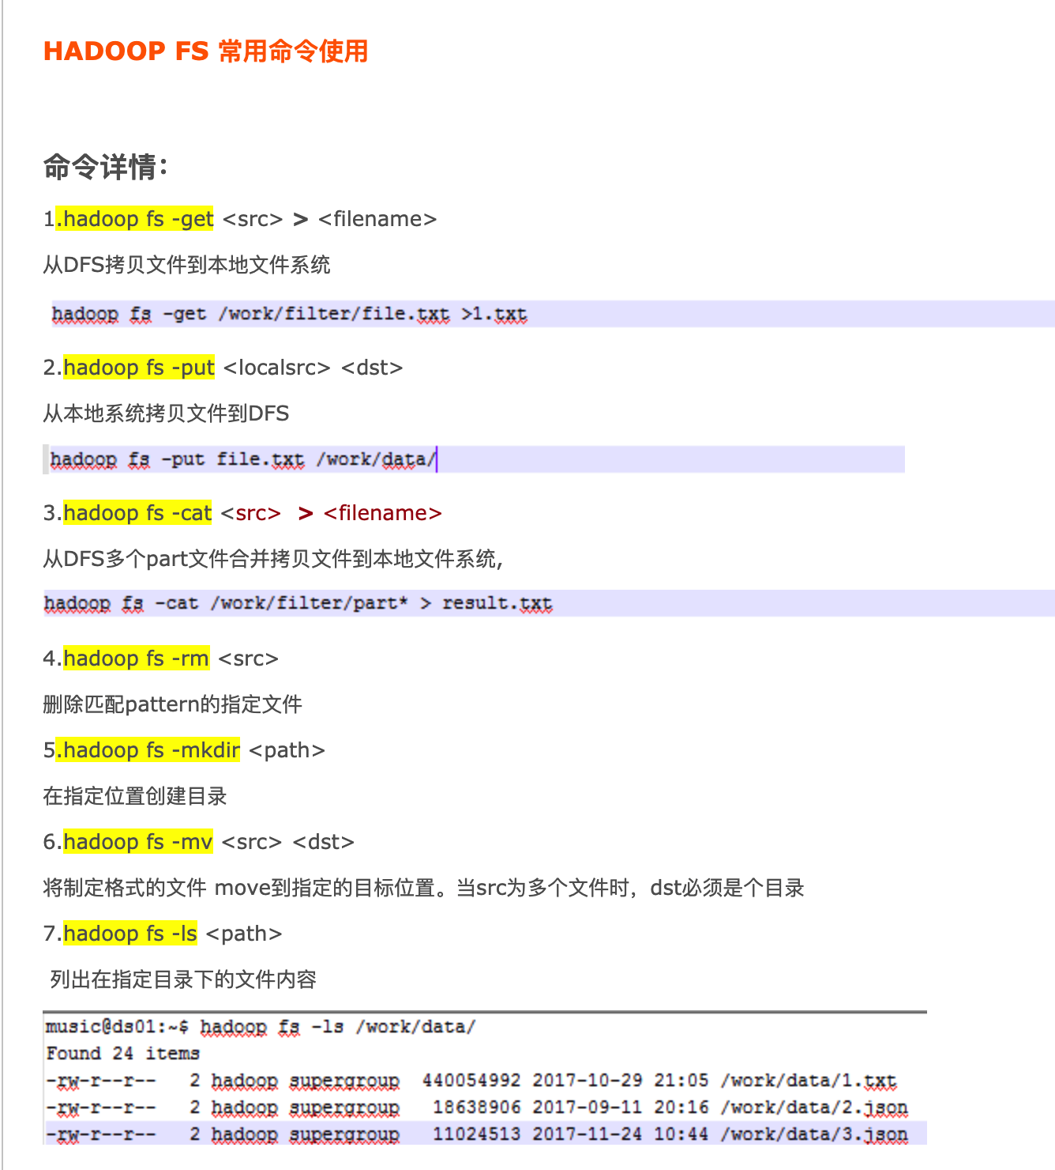

<https://www.iteblog.com/archives/2321.html?from=related>

hadoop fs -rm /user/shiyouguandao/feature_ZSY-69_2019-09-24_17945.csv 删除文件

hadoop fs -ls /user/root/.Trash/Current/user/shiyouguandao 垃圾桶文件展示

hadoop fs -mv /user/root/.Trash/Current/user/shiyouguandao/feature_ZSY-69_2019-09-24_17945.csv /user/shiyouguandao 垃圾桶文件恢复

hadoop fs -ls /user/shiyouguandao 查看hdfs文件

