K8s

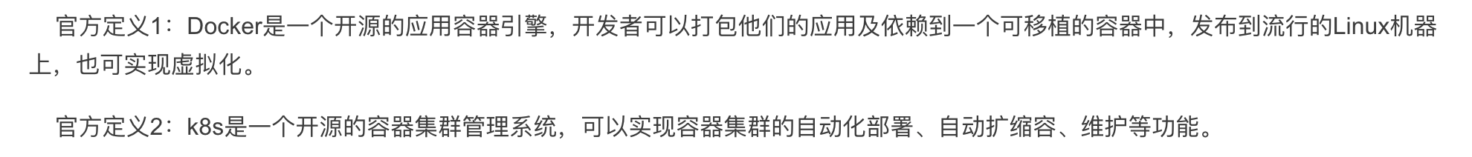

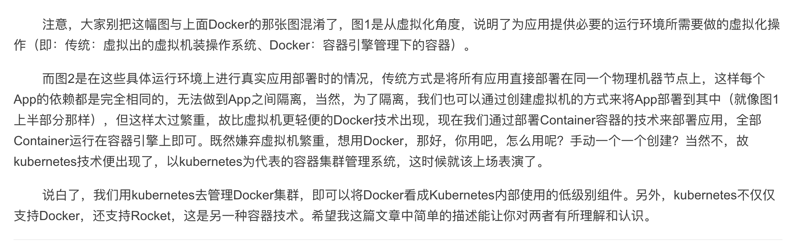

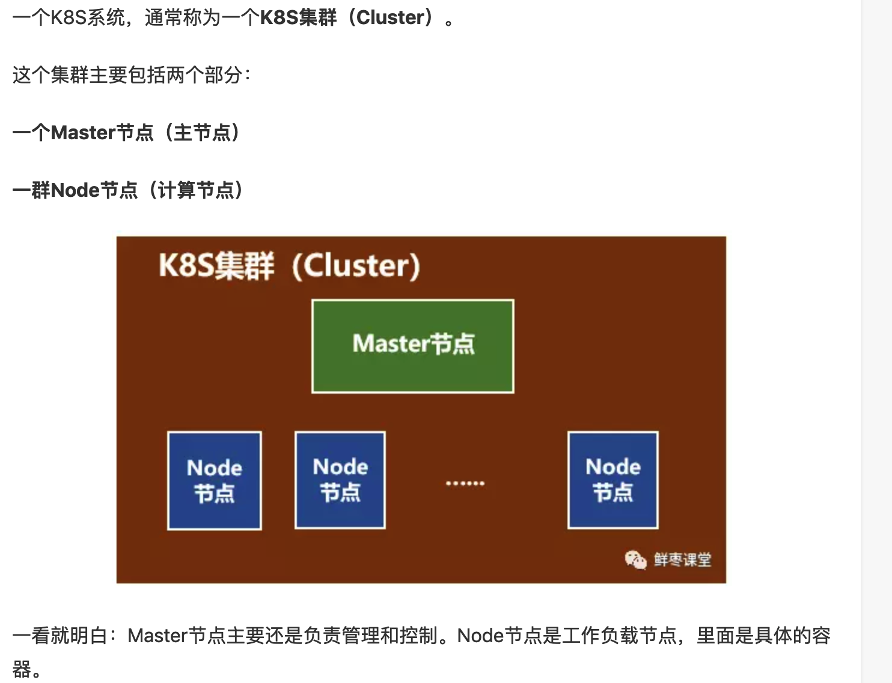

K describe node

<https://www.jianshu.com/p/f1f94c6968f5>

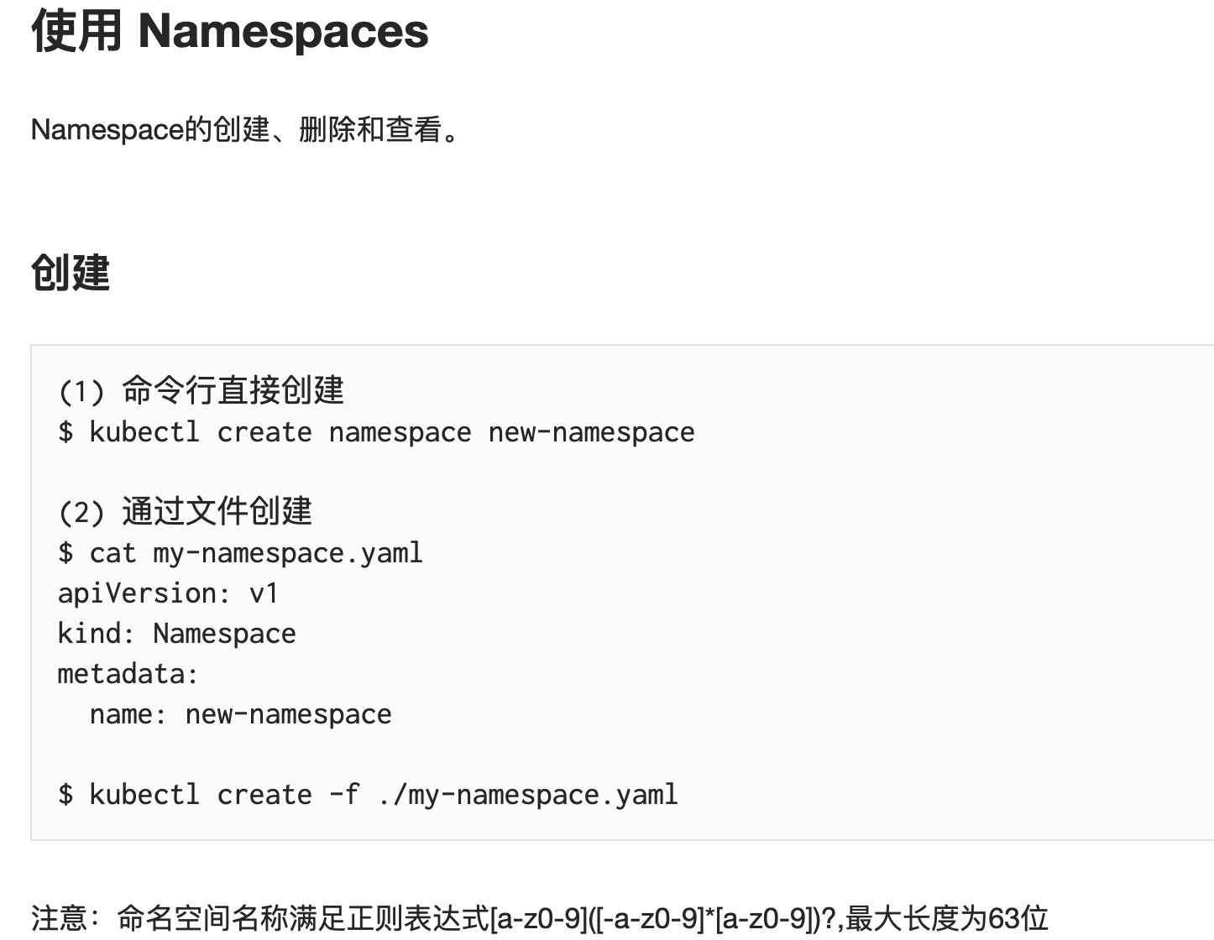

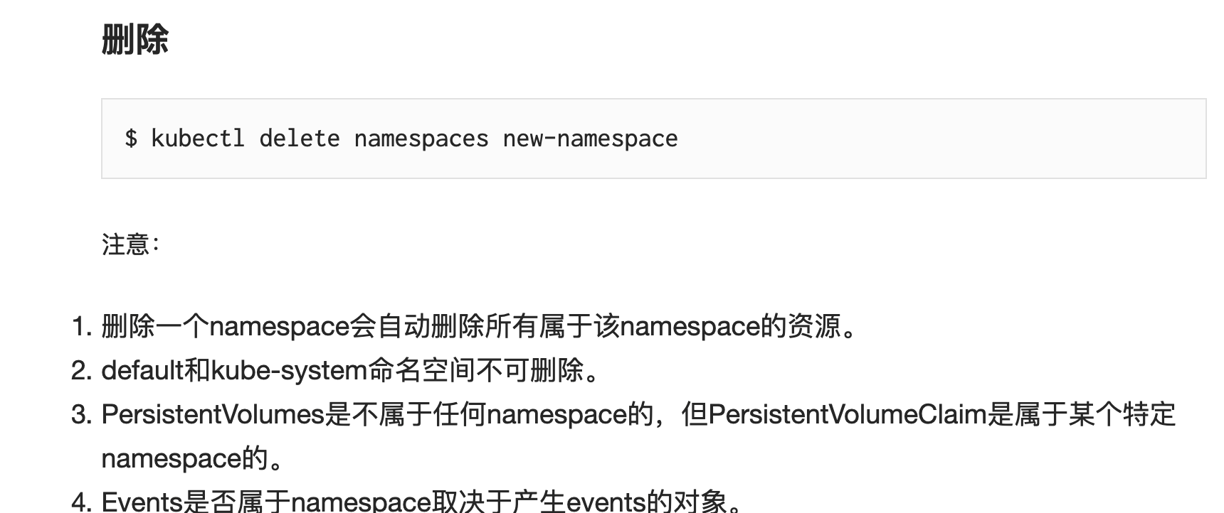

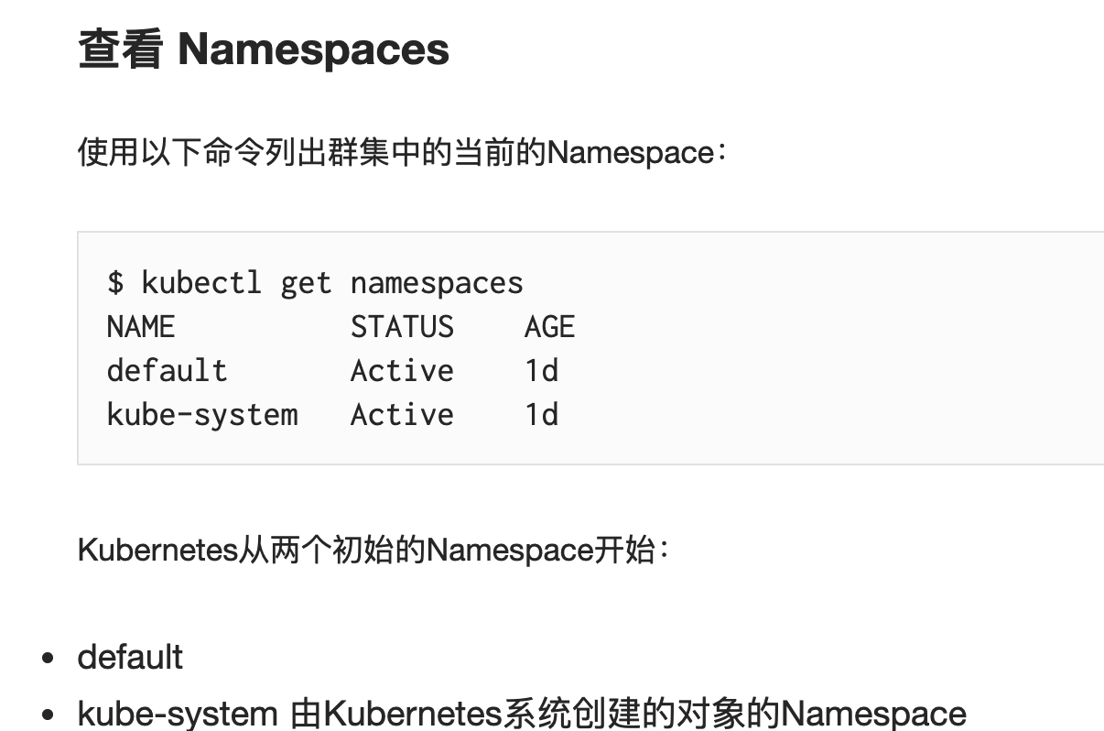

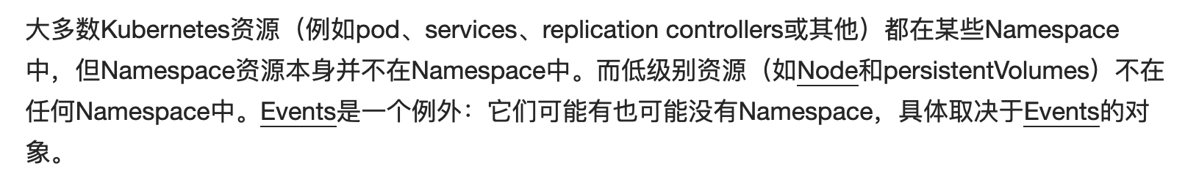

yaml文档：[https://www.yiibai.com/yaml/yaml_json_schema.html#article-start](https://www.yiibai.com/yaml/yaml_json_schema.html" \l "article-start)

<http://www.yamllint.com/>