pubgem Design

Ian Dennis Miller

Today

Table of Contents

This design document collects all of the design artifacts that are used to describe what the project will look like.

# Architecture

This is the conceptual system architecture.

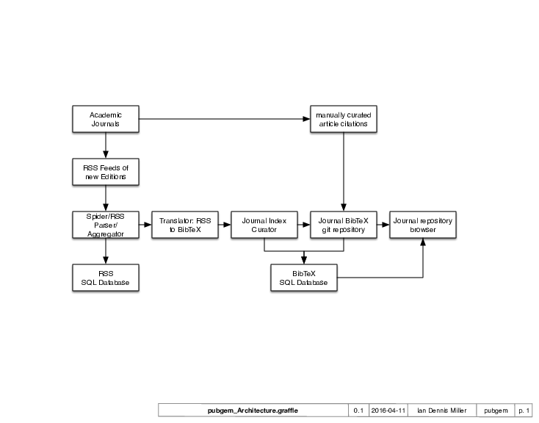

Architecture

# Wireframes

A wireframe is a depiction of the user interface. This is usually non-interactive and may not have all of the details, but the wireframe is useful for planning the web pages involved in a project.

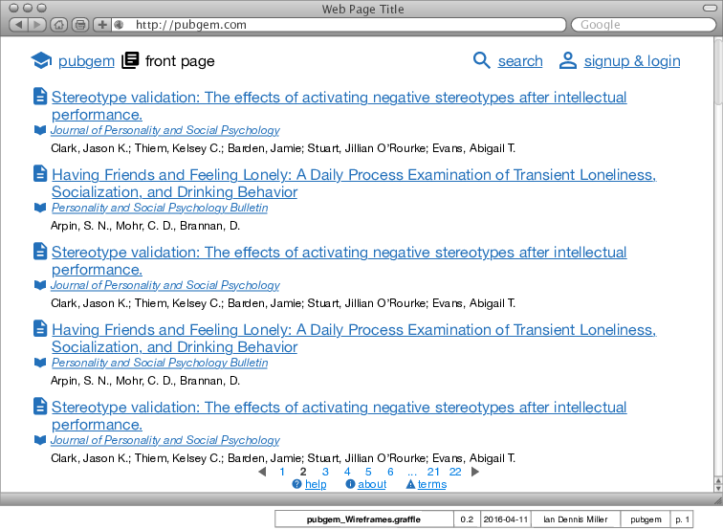

Wireframe 0

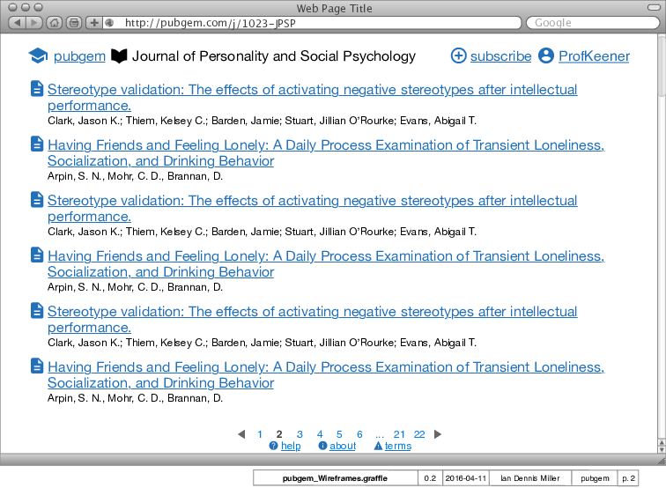

Wireframe 1

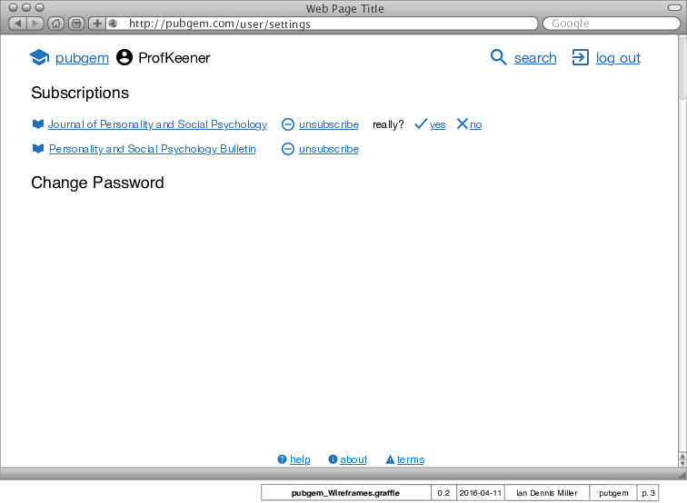

Wireframe 2

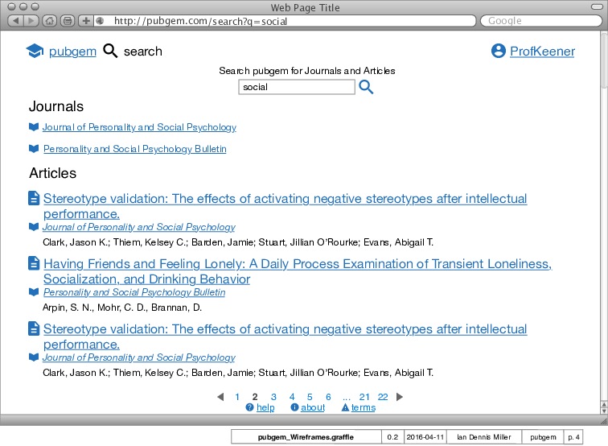

Wireframe 3

# Entity Relationship Diagram

The Entity Relationship Diagram contains the business objects that we are modeling (Entities), as well as the ways those objects connect one another (Relationships).

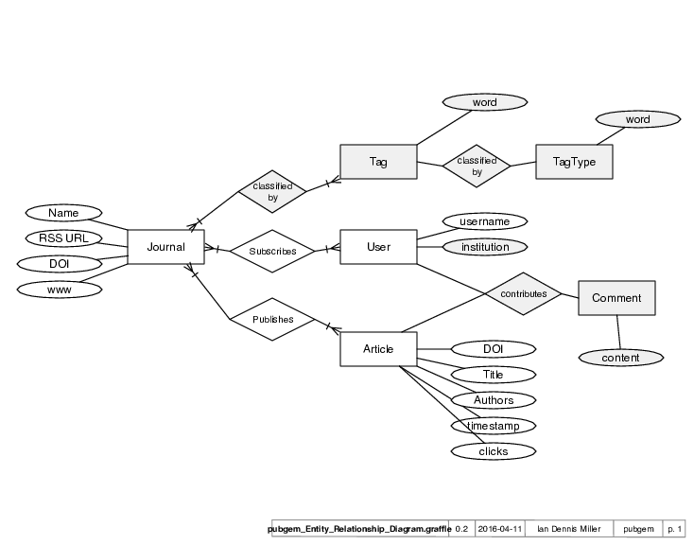

Entity Relationship Diagram

# System Map

There are usually several systems (including computers and programs) that coordinate in order to deliver the project. The System Map is a brief overview of these systems and how they relate to each other.

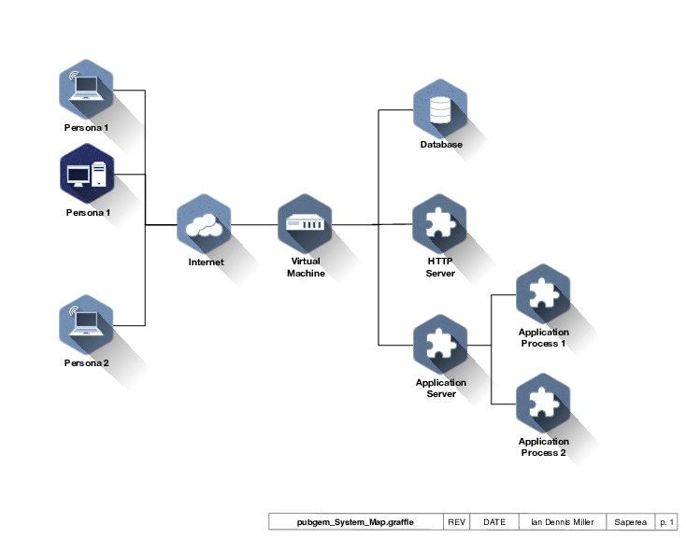

System Map