Project Title: Resilient and Scalable Web Application Deployment on AWS

Project Description
This project aims to design and implement a highly available and scalable infrastructure for a web application on AWS. The architecture will leverage AWS services to ensure the web application can efficiently handle varying loads and maintain high availability across multiple Availability Zones.

Objectives
High Availability: Achieve minimal downtime by utilizing multiple Availability Zones.
Scalability: Use AWS Auto Scaling to adjust resources automatically in response to traffic changes.
Security: Implement security measures focusing on security groups and secure communication.
Resilience: Develop an application setup that can withstand failures and traffic spikes without manual intervention.

Core AWS Services Utilization
Virtual Private Cloud (VPC): Provides an isolated section of the AWS cloud where we can launch AWS resources in a virtual network.
Elastic File System (EFS): Offers simple, scalable, elastic file storage use with AWS Cloud services.
Elastic Compute Cloud (EC2): Provides scalable computing capacity in the AWS cloud.
AWS AutoScaling: Monitors applications and automatically adjusts capacity to maintain steady, predictable performance at the lowest possible cost.
Application Load Balancer (ALB): Automatically distributes incoming application traffic across multiple targets, such as EC2 instances and containers.
Route 53: A highly available and scalable cloud Domain Name System (DNS) web service.

Detailed Component Design
VPC :
• Purpose: Isolation and provision of a secure network for AWS resources.
• Configuration: Subnet creation across multiple AZs for resilience and high availability.
EFS :
• Purpose: Provide a scalable file storage system accessible by EC2 instances.
• Configuration: Set up to ensure it is mounted on all EC2 instances for shared storage needs.
EC2 :
• Purpose: Host the web application and handle compute tasks.
• Configuration: Instance types, AMIs, and initial bootstrapping scripts.
AWS AutoScaling :
• Purpose: Dynamically adjust the number of EC2 instances based on traffic.

• Configuration: Define scaling policies based on metrics like CPU utilisation and request rates.
ALB :
• Purpose: Distribute incoming traffic across multiple targets to increase the availability and fault tolerance of your application.
•Configuration: Listener and rule setup for routing traffic to the appropriate target groups.
Route 53 :
• Purpose: Connect user requests to the infrastructure running in AWS.
Configuration: DNS management, health checks, and routing policies to ensure high availability and traffic management.
Security Measures
• Security Groups: Define inbound and outbound traffic rules for EC2 instances and other services.
• IAM Roles: Secure API calls from EC2 instances.
• Data Encryption : At rest (EFS) and in transit using TLS.

Conclusion
This document outlines the initial design for deploying a resilient and scalable web application on AWS. It emphasises high availability, scalability, security, and resilience, leveraging AWS services to achieve these objectives. The next steps include detailed planning, implementation, testing, and deployment phases, ensuring the web application meets the outlined objectives.
Implementation and Configuration Guide

Table of Contents
- Introduction
- AWS Services Configuration
- Application Deployment
- Security Configuration
- Monitoring and Logging
- Backup and Disaster Recovery

- Introduction

Purpose: The purpose of this web application is to deliver a scalable, secure, and reliable platform that leverages AWS services. The ensures high availability, robust security measures, and the ability to scale seamlessly with growing demands.
Scope: This AWS project’s scope is to deploy a scalable, secure and reliable web application, focusing on traffic distribution to maintain high availability. It serves as a demonstration of key AWS services.

- AWS Services Configuration

2.1 Virtual Private Cloud (VPC)

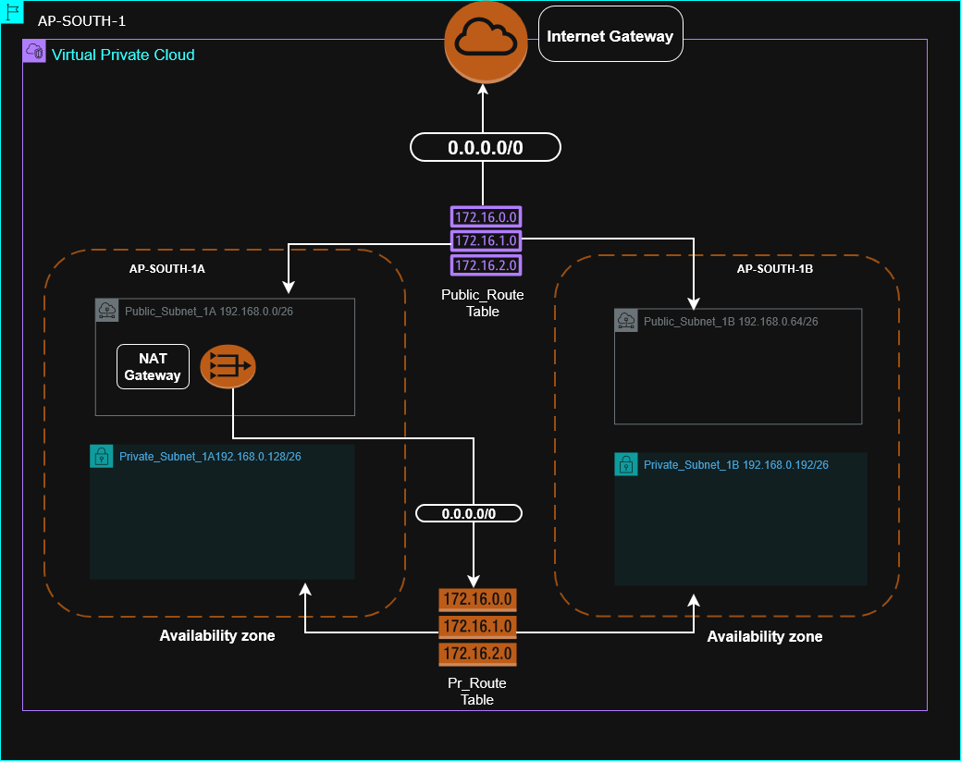
Step 1: Create the VPC
Goto the VPC Dashboard in the AWS Management Console. Click on "Create VPC". In the "Name tag" field, input a name for your VPC (e.g., "Ap-South-1"). For the IPv4 CIDR block, enter 192.168.0.0/24. Skip the IPv6 CIDR block unless you need it. Select "No" for Tenancy (unless you require a Dedicated Instance). Click "Create"
Step 2: Create Subnets
In the VPC Dashboard, click on "Subnets". Click on "Create subnet". Select the VPC you created from the dropdown list.
●For the first subnet:
● Nametag:"Public_Subnet_1A".
● Availability Zone: Select "ap-south-1a".
● IPv4CIDRblock: 192.168.0.0/26.
Click "Create" to create the first subnet. Repeat the steps for the additional subnets with the following details:
● For the second subnet:
● Nametag:"Private_Subnet_1A".
● Availability Zone: "ap-south-1a".
● IPv4CIDRblock: 192.168.0.128/26.
● For the third subnet:
● Nametag:"Public_Subnet_2B".
● Availability Zone: "ap-south-1b".
● IPv4CIDRblock: 192.168.0.64/26.
● For the fourth subnet:
● Nametag:"Private_Subnet_2B".
● Availability Zone: "ap-south-1b".
● IPv4CIDRblock: 192.168.0.192/26

Step 3: Set Up Internet Gateway
In the VPC Dashboard, click on "Internet Gateways". Click "Create internet gateway". Provide a name tag (e.g., "IGW-Ap-South-1"). Click "Create". Select the newly created internet gateway and click on "Actions".
Click "Attach to VPC" and select the VPC you have created. Click "Attach".
Step 4: Create Route Tables
In the VPC Dashboard, go to "Route Tables". Click "Create route table". Enter a name for the route table (e.g., "Main RT"). Select your VPC from the dropdown list. Click "Create". After creation, select the new route table and click on "Routes". Click "Edit routes" and add the following route to allow internet access:
● Destination: 0.0.0.0/0.
● Target: Select the Internet Gateway you created. Click "Save routes".
Step 5: Associate Route Tables with Subnets
Select the route table, click on "Subnet Associations".
Click "Edit subnet associations".
Select the public subnets ("Public_Subnet_1A" and "Public_Subnet_2B").
Click "Save". Step 6: Create NAT Gateway (for Private Subnets) Goto "NAT Gateways" in the VPC Dashboard. Click "
Step 6: Create NAT gateway
Select one of the public subnets (e.g., "Public_Subnet_1A"). Allocate an Elastic IP by clicking "Allocate Elastic IP". Click "Create a NAT Gateway".
Once created, go back to "Route Tables", and create a new route table for your private subnets.
Follow a similar process as before to add a route pointing to the NAT Gateway for internet access from the private subnets.

2.3 Elastic File System (EFS)
( When you’re going to create EFS, you’ll need to edit your VPC. Go to VPC, select your VPC, edit, and enable DNS hostname. This will ensure you don’t encounter any problems when you mount your EFS. )
NOW……
Go to amazon console and search EFS enter.
Click create file system….
Enter EFS name and choose your VPC click Custom…
Here we’re not enable automatic backup and encryption because it is only project …
Click next….
Here we shall configure mount target…
In Subnet ID section we choose we will select the subnet that we have already created.
- Private-subnet-1A
- Private-subnet-2B
And select the security group that we have created.
Click next….next…..create… done
We have created EFS..

2.4 Elastic Compute Cloud (EC2)
Now Go to amazon console and search EC2 enter…
Click lunch instances…
Enter instance name (e.g. Web-instance-Project-1)
Choose amazon machine image (on this case we have choose amazon Linux ) ….. select your keypair and edit network setting with carefully….
(Here we’ll use the public subnet because we’ll also need to create our AMI form it.
Caution: We should never create servers in a public subnet. )
Enable auto-assign public IP and select security group…
Click lunch instance….
Now we have done this …………….
2.4(1) Accessing EC2 and creating a web server
For accessing the ec2 …..
Go to your command prompt …… and change dir..
Cd /
Cd /User/Dhruv/Download
For connecting the EC2 …….. inter this command
ssh -i (your key name) ec2-@user43.205.95.127 (instance public IP ) enter……
(if everything is correct then you will be able to ssh in your instance)
Now you are in this instance…..
Now for deploying the web server for command line …..
sudo -i
yum install httpd
(after installation httpd)
systemctl start httpd
Now here comes a problem….
When we stop and restart the instance or reboot it, we will have to manually restart the web service every time.
To avoid this problem ….
systemctl enable httpd
Now we will connect EFS to EC2
First we need to install amazon-efs-utils
In commond prompt
yum install amazon_efs_utils
after this installation go to you efs ….
Click attach and copy mount helper……
sudo mount -t efs -o tls fs-03a185ae865c6f29f:/ efs
(But we have to mount EFS from the root directory of the web server.)
So for that we need to edit the efs mount helper
sudo mount -t efs -o tls fs-03a185ae865c6f29f:/ /var/www/html/
Now we need to upload our website to the web server:
(if your website or your website folder is on your local window machine then the command for it is)
scp -i formet.pem -r eLearning/eLearning ec2-user@43.205.95.127:~/
now we’ll change our web site file folder permission :
sudo chmod -R 755 /var/www/html
sudo chown -R apache:apache /var/www/html

now we can access this website thru the ec2 public ip..

EFS mount with EC2 diagram ……
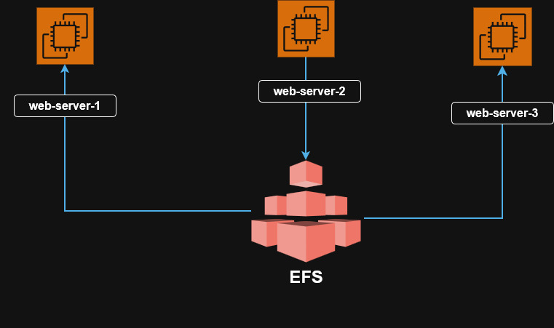

And now we create AMI with help of ec2 and after created we’ll delete this ec2 instance..
2.5 Setup Autoscaling and create Target group..
Now we will create a launch template using the AMI. We will not define the network subnet in the Network filed. We will define it later when we create auto scaling.
2.6 Application Load Balancer (ALB)
Now firstly we will create target group and after creating the target group we will create application load balancer and configure that…
Now we will attach our load balancer with auto scaling ..
Now we will edit auto scaling group ….
In auto scaling group we edit automatic scaling tab according to our requirement..
2.7 Route53
Configure and link DNS service ………

